Chapter 2: Program Flow

# The Flowchart

In order to solve difficult tasks in programming, it is often helpful to outline the program flow in a flowchart. The following symbols are used in flowcharts:

|  |  |
| --- | --- |
| **Symbol** | **Meaning** |
|  | Start / Stop |
|  | Activity |
|  | Decision / Condition |

Task 9: Aroung Tree II

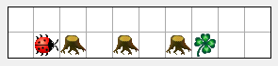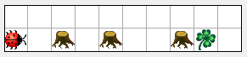

1. Complete the flow chart so that Kara reached the leaf in all worlds with the following properties:

* The leaf is always right in front of him - he only needs to walk around the trees.
* There are never two trees standing side by side

*Note: Start here means that the Act button is pressed..*

Start

treeFront()

no

goAroundTree()

move()

yes

Stop

|  |
| --- |
| **Kara** |
| ***Actions****:* move() turnLeft() turnRight()  putLeaf()  removeLeaf()  ***Sensors****:*  treeFront()  treeLeft()  treeRight()  onLeaf()  mushroomFront() |

1. Draw an extended diagram so that Kara picks up the leaf at the end if he finds it. On the right you find all the available methods of Kara as a help:

Possible soultion:

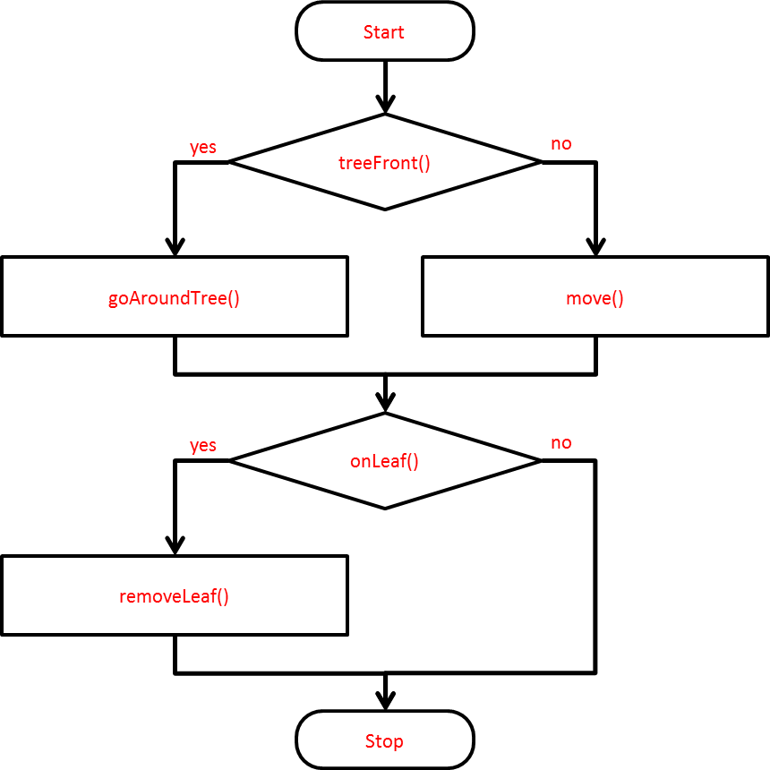

# Conditional Statements in Java[1]

Condition

**if** (treeFront())

{

Block 1, executed if the conditions is **true**.

turnLeft();

}

**else**

{

Block 2, executed if the conditions is **false**.

move();

}

**Note: The else part (block 2) may be omitted i fit is not needed.**

Task 10:

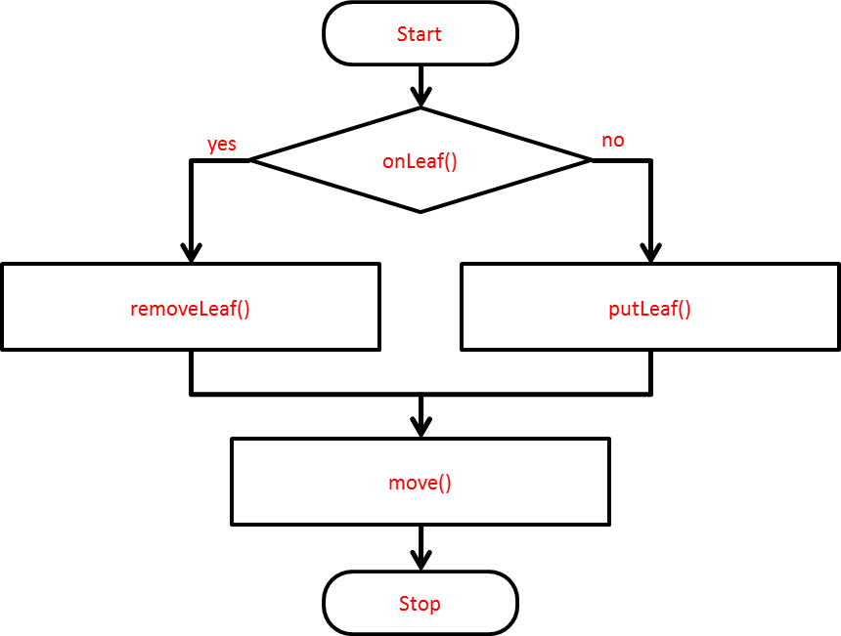First describe with words what the following code does. Then sketch each of these as a flowchart.



if (onLeaf())

{

removeLeaf();

}

else

{

putLeaf();

}

move();

Removes a leaf if there is one,

puts a leaf if there is no leaf



if (onLeaf())

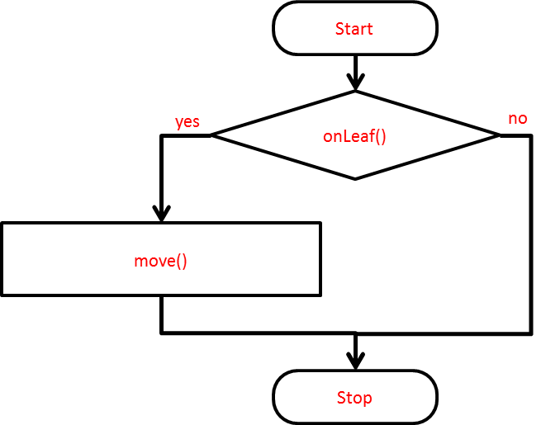{

move();

}

If Kara is on a leaf he makes one step forward

***Task 11: Nested Conditions***

1. 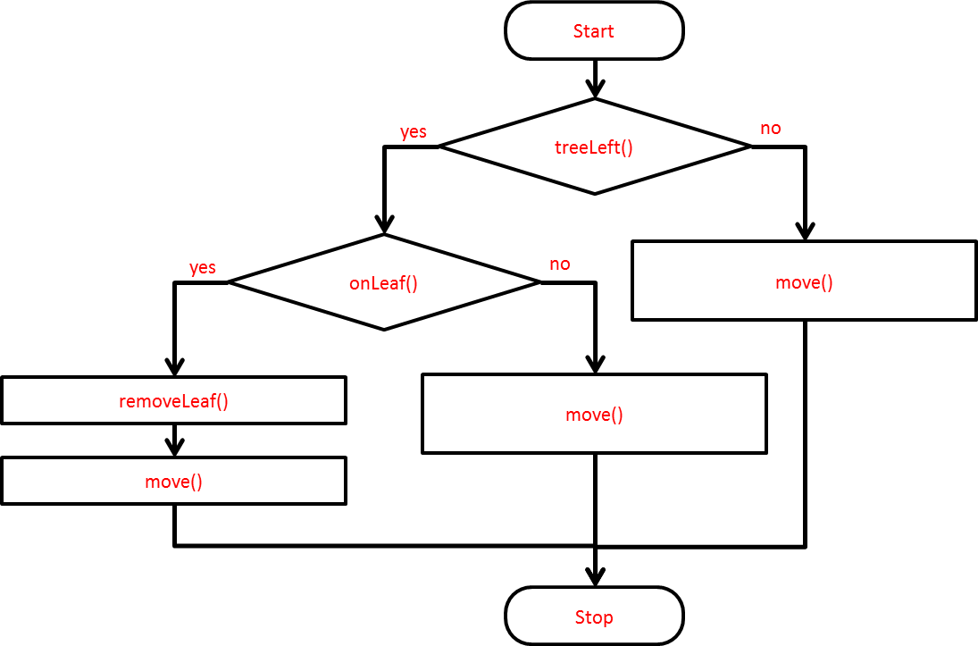 Conditional statements can be nested. Describe what happens when you run the program on the speci-fied KaraWorld. Draw a corresponding flowchart.

if (treeLeft())

{

if (onLeaf())

{

removeLeaf();

move();

}

else

{

move();

}

}

else

{

move();

}

Removes the leaf if there is a tree on the left.

## Computer Lab

Wenn Sie bis hierhin alles erledigt haben, zeigen Sie der Lehrperson Ihre Lösungen. Wenn die Lösungen korrekt waren können Sie in den Computerraum gehen.

Now you can implement the tasks that you have drawn on a computer. You should proceed as follows:

To Task 9:

* Open the scenario ***Kara 09 …*** from the folder ***scenarios-chapter-2***. In this scenario, the method is goAroundTree() already programmed and part of the act() method is prepared.
* Now program in the act() method what you have drawn in Task 9b as a flowchart. **Test using the Act-button** (pressing several times!)
* In this scenario, you have **several KaraWorlds**. To test your program in a different world, press the right mouse button on a KaraWorld (e.g. *KaraWorld_B*) and click on *new KaraWorld_B*.
* Your program should work in any of those worlds **without error messages**.

To Task 11:

* Download the scenario ***Kara 11 …*** in Greenfoot and write the program as outlined in task 11a.  
  Modify the program so that Kara only picks up the leaf if no tree is on his side.

# Logical Operations

Our Kara can already do more than just execute simple commands. He will react differently based on a test. It should also be possible for Kara to react simultaneously on two or more tests.

The following table shows the three main logical operators in Java:

|  |  |  |  |
| --- | --- | --- | --- |
| **Operator** | **Description** | **Example** | |
| **&&** | **and** | treeFront() && onLeaf() | Is only satisfied (true) if both statements are true, i.e. if Kara is facing a tree and is on a leaf. |
| **||** | **or** | treeFront() || onLeaf() | Is met (true) if either one or the other or both statements are true. |
| **!** | **not** | !treeFront() | Changes an expression of true to false and vice versa. This statement would be satisfied (true) if Kara is not facing a tree. |

An example in Java would look like this:

if (treeLeft() && onLeaf())

{

// Do something ...

}

or combined:

if (treeLeft() && !treeRight())

{

// Do something ...

}

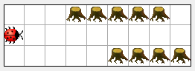

Tunnel entrance

Task 12: Afraid of Tunnel[2]

Kara has a little fear of tunnels. He should check on every field whether it is a tunnel entrance (i.e. whether it has trees on both sides). If so, he instantly lets a leaf fall because of the shock.

Load the scenario ***Kara 12*** *…*, write the program and test it with all three worlds.

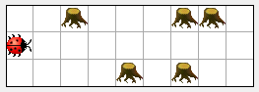Task 13: Leaf at Tree

Now let Kara go straight and lay a leaf anywhere where there is a tree on its left or right or on both sides.

Load the scenario ***Kara 13*** *…* and write the program.

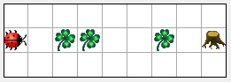Task 14: Put Leaf Track

Kara is running straight ahead and lays a leaf anywhere where there is none. When he reaches the tree he will do nothing (even if the Act-button is pressed again).

Load the scenario ***Kara 14*** *…*, write the program and test it using the **Act button**.

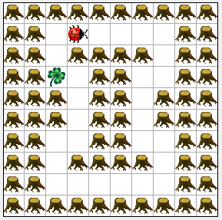Task 15: Round Trip

Each field in the tour has exactly two empty neighboring fields. One empty field always lays behind Kara which is the field he came from.

Load the scenario ***Kara 15*** *…* and write a program for it. Test your program in all three worlds.

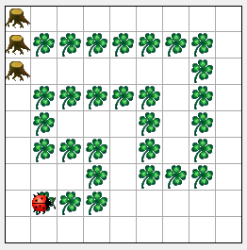*Tip: Imagine what must be done each time the Act button is pressed. Draw a flowchart as a help to find the solution.*

Additional Task 16 (difficult): Kara Plays Pacman

Kara plays Pacman: He is on the first of a long trail of leafs, ending in front of a tree. He picks up all leafs (up to the last).

As a better overview write some parts of the program in its own methods.

# Loops

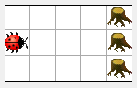Kara Kara can now react to rules set by us in different situations. He is not yet capable of **repeating** a specified set of instructions. To execute an instruction block multiple times, loops are used.

As an example, we want to do the following:   
*Kara will move forward until he hits a tree.*

In the flow chart you can see that move() is executed repeatedly, as long as no tree stands in front of Kara.

Start

! treeFront()

no

move()

yes

Stop

**Die notation in Java:**

while (!treeFront())

{

move();

}

Task 17:

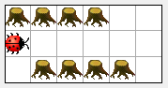

**1 2 3 4 5**

Given the following situation: Kara stands in front of a tunnel.

Describe what each of the following loops does, and how many steps Kara takes.

|  |  |  |
| --- | --- | --- |
| **Code** | **Beschreibung** | **Anzahl Schritte** |
| while (treeLeft())  {  move();  } | Move as long as ther is no tree on the left. | 4 |
| while (treeRight())  {  move();  } | Move as long as there is no tree on the right. | 0 |
| while (treeLeft() || treeRight())  {  move();  } | Move as long there is a tree either on the right or on the left side. | 5 |
| if (treeLeft())  {  move();  }  while (treeLeft() && treeRight())  {  move();  } | First, move if there is a tree on the left side.  Then move as long as there is a tree on the right and on the left side. | 4 |
| while (!treeFront)  {  if (treeLeft())  {  move();  }  } | As long as thre is no tree in front of Kara  If there is a tree on the left, make a step  **Warning: never ending loop!** | 4 |

Task 18: Around Tree III

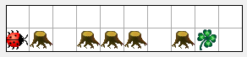

This is a similar exercise as in task 9: Kara is to find a leaf that lies ahead of him. Now, there can be any number of trees in a row.

1. Load the scenario ***Kara 18*** *…* and improve the method goAroundTree() so that Kar acan walk around several trees. Test your program in all available worlds.
2. Modify act() so that you can just press the act-button once. Kara should then automatically run around the trees until he reached the leaf. In the end he will eat it again.

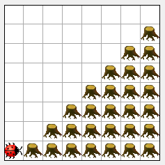Task 19: Climbing Up

Kara shall climb arbitraryily long stairs.

Write a method oneStepUp() to make Kara climb a single step. You need to figure out how Kara knows if he still has to climb a step or if he reached the top.

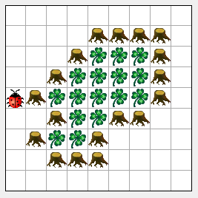Additional Task 20 (difficult): Kara as Guard

Kara wants to guard the forest. He is endlessly walking along outside the forest. To help yourself, you can draw a flowchart.

*Note: For an infinite loop, we can press the Run button.*

1. Based on: Thomas Kempe and David Tepasse, Informatik 1 - Softwareentwicklung mit Greenfoot und BlueJ, 1. Ed. (Paderborn: Schöningh, 2010), P. 36.
2. ***Note about Kara:***

   * Ideas and concepts were developed by Jürg Nievergelt, Werner Hartmann, Raimond Reichert et al., <http://www.swisseduc.ch/informatik/karatojava/>, February 2011.
   * Some Kara exercises are based on material by Horst Gierhardt, <http://www.swisseduc.ch/informatik/karatojava/javakara/material/>, February 2011.

  