

THE OPEN UNIVERSITY OF TANZANIA
Faculty of Science, Technology and Environmental Studies
Department of Information Communication Technology (ICT)

FYP PROJECT PROPOSAL

DESIGN AND IMPLEMENTATION OF A WEB-BASED CAR RENTAL MANAGEMENT SYSTEM FOR LAND VALLEY’S TRAVELS, MWANZA

Course: Bachelor of science in ICT
Student Name: ELIAS SEKA
Reg No: U23-516-0088
Course code: OIT 334
Email: eliasseka@gmail.com
Supervised by: Dr. MARY SWAI
Phone: +255 763448404

August, 2026
Table of Contents
1. Introduction 3
1.1 Project background. 3
1.2. Problem statement. 3
2. Project goals and objectives. 4
2.1 Project goal. 4
2.2 Specific objectives. 4
3. Project Beneficiaries. 5
4. Functional and Non-Functional Requirements. 6
4.1 Functional Requirements 6
4.2 Non-Functional Requirements. 8
4. Project Methodology. 9
5. Architecture and Environment. 12
5.1Hardware requirements. 12
5.2 Software requirements. 12
5.3 System Design Diagrams. 13
5.3.1 Use Case Diagram 13
5.3.2 Entity Relationship Diagram (ERD) 14
5.3.3 Data Flow Diagrams (DFD) 16
6. Project scope. 16
7. Implementation Issues and Challenges. 17
8. Expected Output. 17
9. Cost. 18
10. Timeline. 18
11. Conclusion. 19
12. References. 19

1. Introduction

1.1 Project background.
A Car Rental Management System (CRMS) is a computerized information system designed to support the management of car rental activities, including customer registration, vehicle management, reservations, rental transactions, payments, vehicle returns, and report generation. The use of computerized systems in car rental businesses can reduce dependence on manual records, improve the accuracy of information, and make vehicle and reservation management more efficient.
Car rental services are an important component of the transport and tourism sector because they provide individuals, organizations, and visitors with flexible access to vehicles for different purposes. Traditional car rental operations commonly depend on physical offices, telephone communication, paper-based records, and manual processes for managing customers, vehicles, reservations, payments, and rental returns. Such approaches can make it difficult to obtain up-to-date information about vehicle availability and may increase the possibility of errors, duplicated reservations, misplaced records, and delays in service delivery.
In Mwanza, the demand for convenient transportation services is associated with the city's role as a commercial and tourism centre in the Lake Victoria zone. Car rental businesses therefore require efficient mechanisms for managing their vehicle fleets and responding to customers who need vehicles for business, tourism, personal, and other transportation purposes. However, where rental activities are primarily managed through manual procedures or basic communication channels, customers may need to contact or physically visit the rental office to obtain information about available vehicles and make reservations.
The proposed system is intended for Land Valley’s Travels in Mwanza and will provide a centralized web-based platform for managing car rental operations. Customers will be able to register, log in, view available vehicles, obtain rental information, make reservations, and receive booking-related notifications. Authorized staff will be able to manage vehicles, customer records, reservations, payments, returns, and reports through an administrative interface.
The proposed system will also improve vehicle availability management by maintaining updated information about vehicles that are available, reserved, rented, or under maintenance. This can help reduce the possibility of double booking and provide customers with more reliable information when selecting a vehicle. The system will therefore contribute to the digitalization of rental operations at Land Valley’s Travels by replacing fragmented manual processes with a centralized computerized system.

1.2. Problem statement.
Land Valley’s Travels currently faces challenges associated with managing car rental activities through manual or partially computerized procedures. Customers who want to rent a vehicle may have limited access to information about vehicle availability, rental charges, and reservation procedures, particularly outside normal business operating hours. Manual management of customer records, vehicle information, reservations, payments, and rental returns can also require considerable administrative effort and may result in errors, delays, duplicated records, and difficulties in retrieving historical information.
Another challenge is maintaining accurate information about vehicle availability. A vehicle may be available, reserved, rented, returned, or undergoing maintenance, and failure to update its status promptly can result in incorrect information being provided to customers or the possibility of double booking. In addition, customers may find it difficult to identify a vehicle that meets their requirements based on factors such as vehicle type, seating capacity, rental period, and availability.
Although online car rental platforms can address some of these challenges, existing solutions may not be specifically designed around the operational requirements of Land Valley’s Travels and its target customers in Mwanza. There is therefore a need for a system that centralizes car rental operations and provides customers and rental staff with appropriate functions for managing the complete rental process.
The proposed project will address this gap by designing and implementing a web-based Car Rental Management System for Land Valley’s Travels. The system will provide online customer registration, vehicle search and availability checking, reservation management, rental and payment records, vehicle-status management, notifications, and administrative reporting. The expected contribution of the project is to provide a centralized platform that improves accessibility of rental services, supports accurate vehicle availability information, reduces dependence on paper-based records, and facilitates more efficient management of car rental activities.

2. Project goals and objectives.

2.1 Project goal.
The main goal of this project is to design and implement a web-based Car Rental Management System for Land Valley’s Travels in Mwanza that will computerize and centralize the management of customers, vehicles, reservations, rental transactions, payments, and related reports while improving access to car rental services.

2.2 Specific objectives.
The specific objectives of the project are:
- Database design: To design a relational database, supported by an Entity Relationship Diagram (ERD) and normalized MySQL tables, that stores and links customer, vehicle, reservation, rental, payment, vehicle return and maintenance records for Land Valley's Travels.
- System development: To develop a web-based Car Rental Management System using HTML, CSS, JavaScript, PHP (Laravel) and MySQL that provides customer registration, vehicle search and availability checking, online reservation, rental and payment recording, vehicle return management, notifications and report generation, with role-based access for each type of user.
- Testing and validation: To test the system through unit, integration, system and user acceptance testing, and to validate that it meets the specified functional and non-functional requirements and is usable by customers and staff at Land Valley's Travels.

3. Project Beneficiaries.
The proposed Car Rental Management System is expected to benefit the following stakeholders:
i. Land Valley’s Travels
The company will benefit from centralized management of its rental operations. The system will reduce dependence on paper-based records, improve access to customer and vehicle information, simplify reservation management, and support the generation of operational reports.

ii. Customers
Customers will be able to access car rental services through a web-based platform without necessarily visiting the rental office. They will be able to register, log in, view available vehicles, check vehicle information, submit reservations, and obtain information about their rental transactions more conveniently.

iii. Rental Staff
Rental staff will benefit from easier management of customer records, vehicle information, reservations, rental transactions, payments, and vehicle returns. The system will reduce repetitive manual data entry and make relevant records easier to retrieve.

iv. Vehicle/Fleet Manager
The vehicle manager will be able to monitor the status of vehicles, including available, reserved, rented, returned, and maintenance statuses. This will support better coordination of the vehicle fleet and help prevent the reservation of vehicles that are unavailable.

v. Accountant Staff
The system will support the recording and retrieval of payment information, rental charges, invoices, and financial transaction records. This will make it easier to maintain organized payment records and prepare relevant financial reports.

vi. Management
Management will have access to summarized and organized information about customers, vehicles, reservations, rentals, payments, and business activities. Such information can support operational monitoring and management decision-making.

vii. System Administrator
The system administrator will be responsible for managing user accounts, access privileges, system configuration, backups, and other technical and security-related activities. Role-based access will help ensure that users can access only the functions appropriate to their responsibilities.

4. Functional and Non-Functional Requirements.
The proposed Web-Based Car Rental Management System for Land Valley’s Travels will consist of functional and non-functional requirements. Functional requirements describe the specific services and operations that the system must perform, while non-functional requirements describe the quality attributes and constraints under which the system must operate.

4.1 Functional Requirements
Functional requirements specify what the proposed system should do. The system shall provide the following functionalities:
4.1.1 User Registration and Authentication
The system shall allow customers and authorized staff to create accounts and log into the system using valid credentials. The system shall also provide logout and password management functions.
4.1.2 Customer Profile Management
The system shall allow registered customers to view and update their personal information, including name, contact details and other required rental information.
4.1.3 Vehicle Management
The system shall allow authorized staff to add, view, update and remove vehicle records. Vehicle information shall include registration number, make, model, vehicle type, seating capacity, rental rate, status and other relevant details.
4.1.4 Vehicle Search and Viewing
The system shall allow customers to browse and search for available vehicles based on criteria such as vehicle type, rental period and other relevant characteristics. Customers shall be able to view vehicle details and rental rates before making a reservation.
4.1.5 Vehicle Availability Management
The system shall maintain the availability status of vehicles and distinguish between vehicles that are available, reserved, rented, under maintenance or otherwise unavailable.
4.1.6 Online Reservation
The system shall allow registered customers to select an available vehicle, specify the intended rental period and submit a reservation request through the web interface.
4.1.7 Reservation Management
The system shall allow authorized staff to view, confirm, modify or cancel reservations. The system shall maintain reservation records for future reference.
4.1.8 Rental Transaction Management
The system shall allow staff to create and manage rental transactions after a reservation has been confirmed. The system shall record relevant information such as customer, vehicle, rental period, rental rate and rental status.
4.1.9 Payment and Billing Management
The system shall allow authorized staff to record customer payments and generate billing information or receipts associated with rental transactions. Where an electronic payment gateway is implemented, the system shall record the corresponding payment status.
4.1.10 Vehicle Return Management
The system shall allow staff to record vehicle returns, including the return date, vehicle condition and any applicable additional charges. After a successful return, the vehicle status shall be updated accordingly.
4.1.11 Customer Management
The system shall allow authorized staff to view and manage registered customer information and their rental history.
4.1.12 User and Role Management
The system shall allow the system administrator to create, update, deactivate and manage user accounts. Different access privileges shall be assigned according to user roles, such as administrator, rental staff and management.
4.1.13 Reports Generation
The system shall generate reports related to vehicle availability, reservations, rental transactions, customers, payments and vehicle returns. Authorized users shall be able to view and, where appropriate, print or export reports.
4.1.14 Notifications
The system shall provide notifications to relevant users concerning important rental activities, such as reservation confirmation, reservation cancellation, upcoming rental periods and vehicle return information.

4.1.15 Record Searching and Retrieval
The system shall allow authorized users to search and retrieve customer, vehicle, reservation, rental and payment records using relevant search criteria.

4.2 Non-Functional Requirements.
Non-functional requirements specify the quality attributes, performance expectations and operational constraints of the proposed system.
4.2.1 Usability
The system shall provide a simple, clear and user-friendly interface that can be used by customers and staff with basic computer and internet skills.
4.2.2 Performance
The system shall process user requests efficiently and provide timely responses under normal operating conditions. Database queries and page loading shall be optimized to minimize unnecessary delays.
4.2.3 Security
The system shall protect user and business information through authentication, authorization, secure password storage, input validation and appropriate access controls. Users shall only access functions and information permitted by their assigned roles.
4.2.4 Reliability
The system shall operate consistently and accurately during normal business operations. It shall minimize system failures and prevent loss or corruption of rental, customer, vehicle and payment records.
4.2.5 Data Integrity
The system shall maintain accurate, consistent and complete records. Validation rules shall be applied to prevent invalid, duplicate or inconsistent data from being entered into the database.
4.2.6 Availability
The web-based system shall be available to authorized users whenever the hosting environment and internet connection are operational, subject to scheduled maintenance and technical interruptions.
4.2.7 Scalability
The system shall be designed so that it can accommodate an increase in the number of customers, vehicles, reservations and transactions without requiring major changes to its core architecture.

4.2.8 Maintainability
The system shall be developed using a structured and modular approach so that authorized developers can identify errors, perform maintenance and introduce future improvements with minimal disruption.
4.2.9 Compatibility
The system shall be accessible through commonly used modern web browsers and shall support common desktop and mobile screen sizes through a responsive web interface.
4.2.10 Backup and Recovery
The system shall support regular database backup procedures to reduce the risk of permanent data loss. Backup copies shall be stored securely and used to restore system data when necessary.
4.2.11 Privacy
The system shall protect customers' personal and rental information from unauthorized access, disclosure or modification.
4.2.12 Response to Invalid Input
The system shall validate information entered by users and provide clear error messages when invalid or incomplete information is submitted.

4. Project Methodology.
The project will use the Waterfall Software Development Life Cycle (SDLC) model. The Waterfall model provides a sequential development process in which the major stages are completed systematically from requirements analysis through implementation and maintenance.
The model will be appropriate for this academic project because it provides clearly defined stages and allows requirements, design decisions, implementation activities and testing results to be documented systematically.
The following stages will be followed:
4.1 Requirements Gathering and Analysis
At this stage, information will be collected from the study participants using interviews, questionnaires, observation and document review.
The researcher will identify:
- Existing car rental procedures
- Problems and limitations of the current system
- User requirements
- Functional requirements
- Non-functional requirements;
- Data requirements;
- System users and their access privileges.
4.2 System Analysis
The collected requirements will be analyzed to determine how the proposed system should operate.
System analysis will include:
- Identification of system actors
- Analysis of existing business processes
- Identification of system inputs and outputs
- Data flow analysis
- Identification of system processes
- Identification of database requirements.
4.3 System Design
The system design stage will translate the analyzed requirements into a technical design for implementation.
The design activities will include:
- Database design (Entity Relationship Diagram and table structures)
- User interface design
- System architecture design
- Module design
- User access and role design
- Input and output design
- DFD design
- Use Case modelling
4.4 System Implementation
During implementation, the proposed system will be developed based on the approved system design.
The proposed technology stack will include:
- Frontend: HTML, CSS and JavaScript
- Backend: PHP using the Laravel framework
- Database: MySQL
- Web server/development environment: Apache through XAMPP
- Development environment: Visual Studio Code
- Web browser: A modern browser such as Google Chrome or Mozilla Firefox
4.5 System Testing
Testing will be conducted to determine whether the developed system satisfies the specified requirements and operates correctly.

The following testing activities will be considered:
- Unit Testing: Individual system components or modules will be tested independently.
- Integration Testing: Connected modules will be tested to ensure that they exchange and process information correctly.
- System Testing: The complete system will be tested to determine whether it satisfies the specified functional and non-functional requirements.
- User Acceptance Testing: Selected intended users will interact with the system to determine whether it meets their operational requirements and is usable in the intended environment.
Testing will cover important functions including user authentication, vehicle registration, vehicle availability, reservations, rental transactions, payment recording, vehicle returns and report generation.
4.6 System Deployment
After successful testing, the system will be prepared for deployment in the intended operating environment.
Deployment activities will include:
- Database configuration
- System configuration
- Initial data setup
- User account creation
- User access configuration
- System installation on the selected hosting or server environment
- Basic user training.
4.7 Maintenance
After deployment, the system will require maintenance to correct errors, improve functionality and adapt to future operational requirements.
Possible maintenance activities will include:
- Corrective maintenance
- Security updates
- Database maintenance
- Performance improvements
- Addition of new system features
- Backup and recovery procedures
4.8 Ethical Considerations
The researcher will observe appropriate ethical principles during data collection and system development.
Permission will be sought from the relevant authorities before collecting information from the organization and participants. Participants will be informed about the purpose of the study and their participation will be treated appropriately.
Confidential business information and personal customer information obtained during the study will be protected and used only for academic and system development purposes. Sensitive information will not be disclosed to unauthorized persons.

5. Architecture and Environment.
The proposed project will need the software and hardware environment to support its operation.

5.1Hardware requirements.
Hardware | Requirements
Computer/Laptop | A reliable computer or laptop that meets the minimum system requirements for the development tools and technologies.
Processor and Memory (RAM) | A processor with decent processing power (e.g., Intel Core i5, AMD Ryzen) and at least 8GB of RAM (preferably more) for smooth multitasking.
Storage | Sufficient storage space, preferably a solid-state drive (SSD), with a minimum of 256GB to store project files, software tools, and documentation.
Display | A monitor or screen with a size of at least 22 inches and a resolution of 1920x1080 pixels or higher for comfortable coding and design work.

5.2 Software requirements.
Software | Requirements
Operating System | Windows 10, macOS, or Linux distributions like Ubuntu
Text Editor/IDE | Visual Studio Code, Sublime Text, Atom, or any preferred text editor/IDE for coding
Web Browser | Google Chrome, Mozilla Firefox, or any modern web browser for testing and debugging
Web Server Software | Apache HTTP Server, Xampp
Database Management System (DBMS) | MySQL, for managing and storing property and user data
Programming Languages | PHP, JavaScript, HTML, CSS, SQL,
Frameworks/Libraries | Laravel

5.3 System Design Diagrams.
The following diagrams illustrate the functionality, data relationships and information flow of the proposed system. The Use Case Diagram (Figure 5.1) shows who uses the system and what each user can do. The Entity Relationship Diagram (Figure 5.2) shows how the system's data is organised and related. The Data Flow Diagrams (Figures 5.3 and 5.4) show how information moves between the users, the processes and the system.

5.3.1 Use Case Diagram
The Use Case Diagram in Figure 5.1 shows the functions of the system from the point of view of its users. The use cases are drawn inside the system boundary, while the actors are drawn outside it and are connected to the use cases they perform. Six actors interact with the system, and each actor can only access the functions assigned to their role. All actors must log in before using any function.
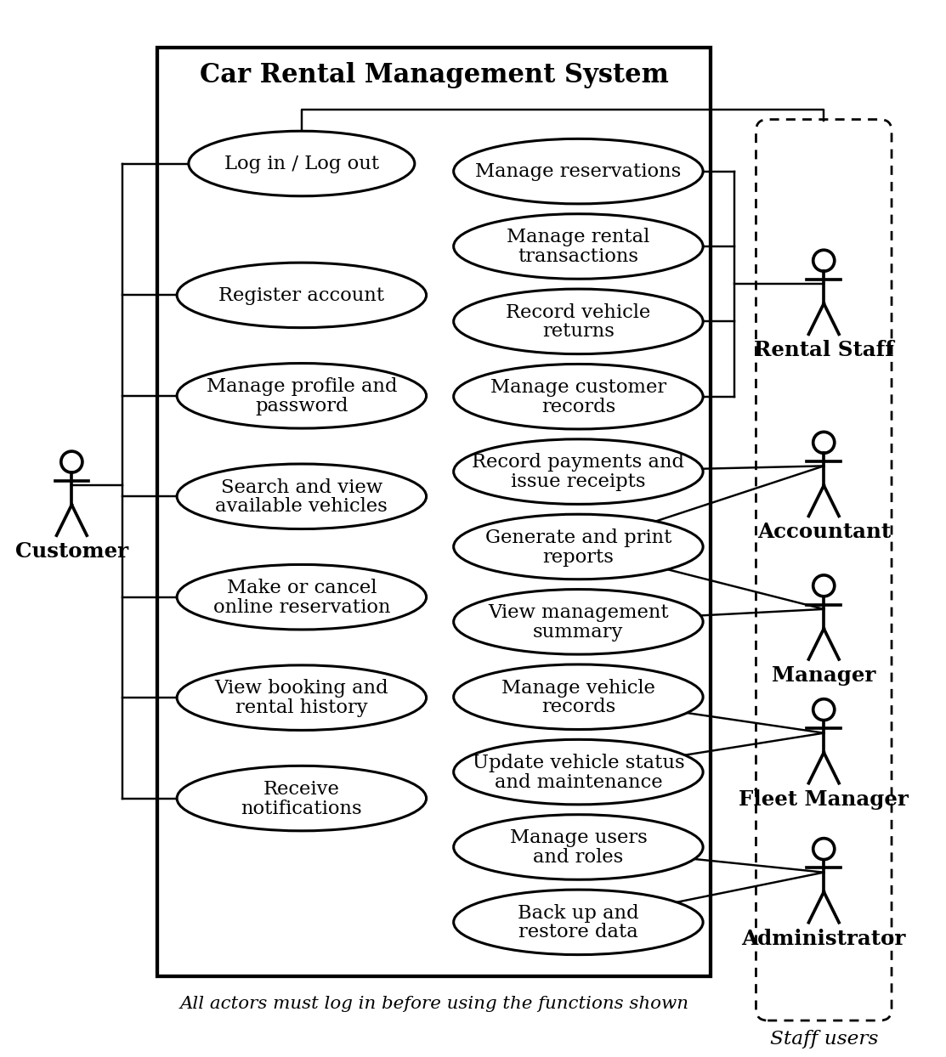
Figure 5.1: Use Case Diagram for the Car Rental Management System
Table 5.1: Actors and their main use cases
Actor | Main use cases
Customer | Registers an account, manages profile and password, searches and views available vehicles, makes or cancels online reservations, views booking and rental history, and receives notifications.
Rental Staff | Manages reservations, rental transactions, vehicle returns and customer records.
Accountant | Records payments, issues receipts and generates financial reports.
Manager | Views management summaries and generates reports to support decision-making.
Fleet Manager | Manages vehicle records and updates vehicle status and maintenance.
System Administrator | Manages user accounts and roles, and backs up and restores system data.

5.3.2 Entity Relationship Diagram (ERD)
The ERD in Figure 5.2 shows the main entities of the database, their key attributes and the relationships between them. Each entity is a database table with a primary key (PK), and foreign keys (FK) link it to related tables. The relationships use crow's foot notation: a double bar means exactly one, a circle with a bar means zero or one, and a circle with a crow's foot means zero or many. Reports are generated from these tables and are therefore not stored as a separate entity.
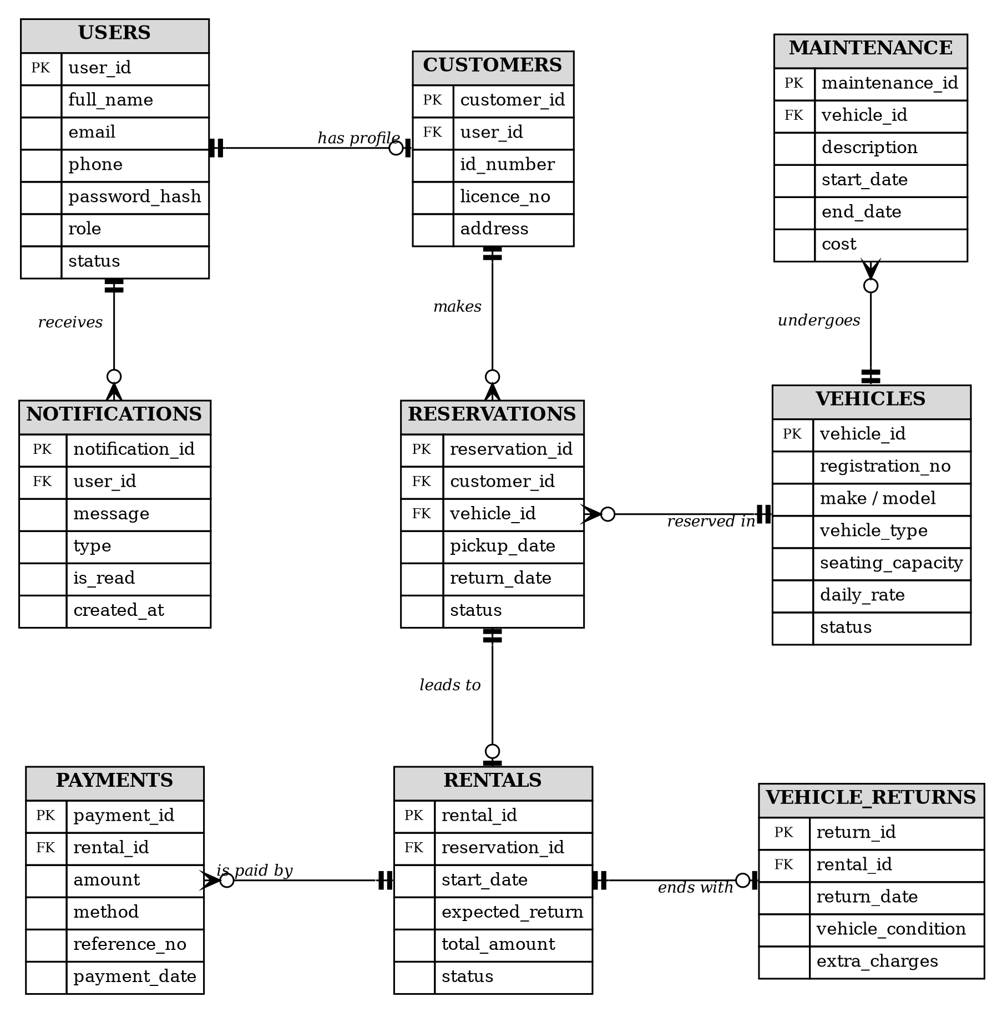
Figure 5.2: Entity Relationship Diagram for the Car Rental Management System
Table 5.2: Relationships between the entities
Relationship | Description
USERS - CUSTOMERS | A user account has at most one customer profile (for customers who register online).
USERS - NOTIFICATIONS | One user receives many notifications.
CUSTOMERS - RESERVATIONS | One customer makes many reservations.
VEHICLES - RESERVATIONS | One vehicle can be reserved many times, for different rental periods.
RESERVATIONS - RENTALS | A confirmed reservation leads to at most one rental transaction.
RENTALS - PAYMENTS | One rental can be paid for through one or more payments.
RENTALS - VEHICLE_RETURNS | One rental ends with at most one vehicle return record.
VEHICLES - MAINTENANCE | One vehicle can undergo many maintenance activities.

5.3.3 Data Flow Diagrams (DFD)
The Context Level DFD in Figure 5.3 shows the whole system as a single process (CRMS) and the external entities that send data to it and receive data from it. The Level 1 DFD in Figure 5.4 breaks the system into its main processes: login, booking, payments and reports.
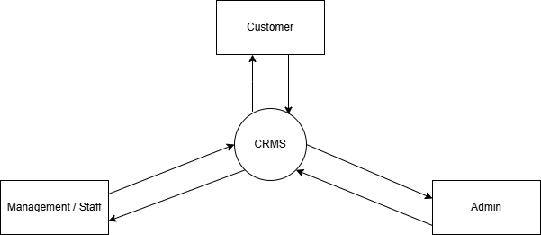
Figure 5.3: Context Level Data Flow Diagram for the Car Rental Management System
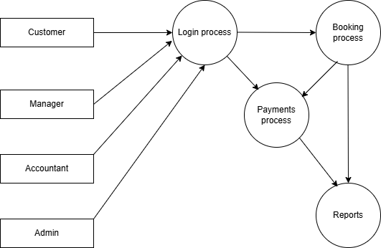
Figure 5.4: Data Flow Diagram Level 1 for the Car Rental Management System

6. Project scope.
The project will focus on the design and implementation of a Web-Based Car Rental Management System for Land Valley’s Travels in Mwanza. The scope defines the activities, users, system functions and operational boundaries that will be addressed by the project.
6.1 Geographical Scope
The project will be conducted at Land Valley’s Travels in Mwanza, Tanzania. The proposed system will primarily support the organization's car rental operations within Mwanza. Customers may access the web-based system remotely through an internet connection, while the organization will use the system to manage its rental operations.
6.2 Organizational Scope
The system will be designed specifically for the car rental operations of Land Valley’s Travels. It will address the organization's processes related to customer registration, vehicle management, reservations, rental transactions, payments, vehicle returns and reporting.
The project will not attempt to redesign all business operations of the organization. Its primary focus will remain on car rental management and related information-processing activities.

7. Implementation Issues and Challenges.
When implementing a Car Rental Management System, the organization may face several issues and challenges.
- High implementation cost: Developing, installing, maintaining, and upgrading the system may require significant financial investment.
- Staff training: Employees need training on how to use the new system. Lack of training can lead to errors and resistance.
- Resistance to change: Staffs who used manual or paper-based processes may be difficult to adopt a computerized system.
- Data migration: Existing customer, vehicle, rental, and payment records must be transferred from paper files or old systems into the new system accurately.
- Data security and privacy: The system stores sensitive information such as customer details, identification information, payment records, and rental history. This information must be protected from unauthorized access.
- System reliability: System failures, software bugs, or hardware problems can interrupt rental operations and prevent customers from making bookings.
- Integration with payment system: Connecting the system with mobile money, banks, credit/debit cards, or other payment platforms can be technically challenging.
- Vehicle availability accuracy: The system must be updated whenever a vehicle is rented, returned, reserved, or sent for maintenance. Incorrect information can cause double booking.

8. Expected Output.
The following are the key outputs expected upon successful completion of the Car Rental Management System project;
- Customer Web and Mobile Interfaces.
User-friendly platforms (website and mobile app) that allow customers to sign up, log in, make booking and reservations, make payments.
- Training Materials and User Documentation.
User manuals, FAQs, and possibly training videos to help users (customers, admins and staffs) understand how to use the system effectively.
- Centralized Car Management System.
A secure, central database that stores all customer booking, personal details, available cars and payment history. This is the core of the system that keeps everything organized and accessible.
- Admin Dashboard.
An administrative panel where staff can manage all booking, reservation, available cars, payment history and generating reports. This allows efficient business operations and customer service.
- Role-Based Access Control.
Security features that ensure only authorized users can access certain areas of the system. For example, customers can only see their own booking, while admins can view and manage all data.
- Real-Time Notifications and Alerts.
Automatic alerts sent to users via SMS, email, or in-app notifications to inform them about booking confirmations, car updates and payment receipts.

9. Cost.
Equipment | Price (Tsh.)
Computer (Laptop) | 1,200,000
Internet Service | 150,000
Travel cost | 450,000

10. Timeline.
Month | Activity
May | Writing Project Proposal
June | Presenting the Project Proposal
July | Submission of Project Proposal
August | Data Collection
September | Developing and implementation of Project
October | Implementation and Testing
November | Final Project Presentation

11. Conclusion.
Car rental business has emerged with a new goody compared to the past experience where every activity concerning car rental business is limited to a physical location only. Even though the physical location has not been totally eradicated, the nature of functions and how these functions are achieved has been reshaped by the power of internet.
Now days, customers can reserve cars online, rent car online, and have the car brought to their door step once the customer is a registered member or go to the office to pick the car. The web-based car rental system has offered an advantage to both customers as well as Car Rental Company to efficiency and effectively manage the business and satisfies customer need at the click of a button.

12. References.
Dennis, A., Wixom, B. H., & Tegarden, D. (2015). Systems Analysis and Design: An Object-Oriented Approach with UML (5th ed.). Wiley.
Laudon, K. C., & Laudon, J. P. (2022). Management Information Systems: Managing the Digital Firm (17th ed.). Pearson.
Pressman, R. S., & Maxim, B. R. (2020). Software Engineering: A Practitioner's Approach (9th ed.). McGraw-Hill Education.
Satzinger, J. W., Jackson, R. B., & Burd, S. D. (2016). Systems Analysis and Design in a Changing World (7th ed.). Cengage Learning.

