详细设计说明书
公司知识管理系统的设计与实现

修改历史
日期 | 修改人 | 版本号 | 修改描述 | 备注
2010.8.10 | 朱宇辰 | 讨论稿 |  | 继续修改请直接修订
 |  | .

目录
目录
1．引言 4
1.1编写目的 4
1.2定义 4
2．数据库详细设计 4
3 模块详细设计 9
Model 9
DAL 13
BLL 13
BLL.Search 14
Presentation 14
Presentation.Knowledge 14
4 项目依赖一览表 15
5 其他 16
5.1 知识存储格式 16
5.2 搜索词规范 16

1．引言

1.1编写目的
为明确软件需求、安排项目规划与进度、组织软件开发与测试，撰写本文档。
读者对象：
指导教师、项目组长、设计开发人员参考。

1.2定义
名词 | 解释 | 备注
系统 | 为本次开发项目《知识管理系统》的缩写
知识 | 以文字或者多媒体为载体，企业内部每个个体或团体经验的固化。
Nunit | 一个专为.net项目使用的用例测试框架。
MVC | Model-View-Controller设计模式，也指代ASP.NET MVC框架。

2．数据库详细设计
KMS的数据库Diagram如下所示：
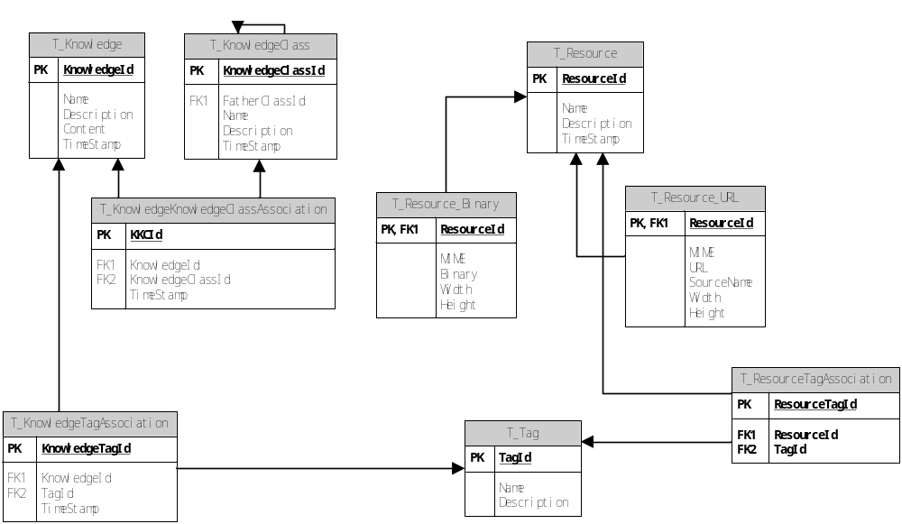

KMS数据库中建表脚本如下：
T_Knowledge:
CREATE TABLE [dbo].[T_Knowledge](
[KnowledgeId] [int] IDENTITY(1,1) NOT NULL,
[Name] [nvarchar](50) NULL,
[Description] [nvarchar](500) NULL,
[Content] [ntext] NULL,
[TimeStamp] [datetime] NULL,
CONSTRAINT [PK_Knowledge] PRIMARY KEY CLUSTERED
(
[KnowledgeId] ASC
)WITH (PAD_INDEX = OFF, STATISTICS_NORECOMPUTE = OFF, IGNORE_DUP_KEY = OFF, ALLOW_ROW_LOCKS = ON, ALLOW_PAGE_LOCKS = ON) ON [PRIMARY]
) ON [PRIMARY] TEXTIMAGE_ON [PRIMARY]

T_KnowledgeClass:
CREATE TABLE [dbo].[T_Knowledge](
[KnowledgeId] [int] IDENTITY(1,1) NOT NULL,
[Name] [nvarchar](50) NULL,
[Description] [nvarchar](500) NULL,
[Content] [ntext] NULL,
[TimeStamp] [datetime] NULL,
CONSTRAINT [PK_Knowledge] PRIMARY KEY CLUSTERED
(
[KnowledgeId] ASC
)WITH (PAD_INDEX = OFF, STATISTICS_NORECOMPUTE = OFF, IGNORE_DUP_KEY = OFF, ALLOW_ROW_LOCKS = ON, ALLOW_PAGE_LOCKS = ON) ON [PRIMARY]
) ON [PRIMARY] TEXTIMAGE_ON [PRIMARY]

T_KnowledgeKnowledgeClassAssociation:
CREATE TABLE [dbo].[T_KnowledgeKnowledgeClassAssociation](
[KKCId] [int] IDENTITY(1,1) NOT NULL,
[KnowledgeId] [int] NULL,
[KnowledgeClassId] [int] NULL,
[TimeStamp] [datetime] NULL,
CONSTRAINT [PK_KnowledgeKnowledgeClassAssociation] PRIMARY KEY CLUSTERED
(
[KKCId] ASC
)WITH (PAD_INDEX = OFF, STATISTICS_NORECOMPUTE = OFF, IGNORE_DUP_KEY = OFF, ALLOW_ROW_LOCKS = ON, ALLOW_PAGE_LOCKS = ON) ON [PRIMARY]
) ON [PRIMARY]

GO
ALTER TABLE [dbo].[T_KnowledgeKnowledgeClassAssociation] WITH CHECK ADD CONSTRAINT [FK_KnowledgeKnowledgeClassAssociation_Knowledge] FOREIGN KEY([KnowledgeId])
REFERENCES [dbo].[T_Knowledge] ([KnowledgeId])
GO
ALTER TABLE [dbo].[T_KnowledgeKnowledgeClassAssociation] CHECK CONSTRAINT [FK_KnowledgeKnowledgeClassAssociation_Knowledge]
GO
ALTER TABLE [dbo].[T_KnowledgeKnowledgeClassAssociation] WITH CHECK ADD CONSTRAINT [FK_KnowledgeKnowledgeClassAssociation_KnowledgeClass] FOREIGN KEY([KnowledgeClassId])
REFERENCES [dbo].[T_KnowledgeClass] ([KnowledgeClassId])
GO
ALTER TABLE [dbo].[T_KnowledgeKnowledgeClassAssociation] CHECK CONSTRAINT [FK_KnowledgeKnowledgeClassAssociation_KnowledgeClass]

T_KnowledgeTagAssociation：
CREATE TABLE [dbo].[T_KnowledgeTagAssociation](
[KnowledgeTagId] [int] IDENTITY(1,1) NOT NULL,
[KnowledgeId] [int] NULL,
[TagId] [int] NULL,
[TimeStamp] [datetime] NULL,
CONSTRAINT [PK_KnowledgeTagAssociation] PRIMARY KEY CLUSTERED
(
[KnowledgeTagId] ASC
)WITH (PAD_INDEX = OFF, STATISTICS_NORECOMPUTE = OFF, IGNORE_DUP_KEY = OFF, ALLOW_ROW_LOCKS = ON, ALLOW_PAGE_LOCKS = ON) ON [PRIMARY]
) ON [PRIMARY]

GO
ALTER TABLE [dbo].[T_KnowledgeTagAssociation] WITH CHECK ADD CONSTRAINT [FK_KnowledgeTagAssociation_Knowledge] FOREIGN KEY([KnowledgeId])
REFERENCES [dbo].[T_Knowledge] ([KnowledgeId])
GO
ALTER TABLE [dbo].[T_KnowledgeTagAssociation] CHECK CONSTRAINT [FK_KnowledgeTagAssociation_Knowledge]
GO
ALTER TABLE [dbo].[T_KnowledgeTagAssociation] WITH CHECK ADD CONSTRAINT [FK_KnowledgeTagAssociation_T_Tag] FOREIGN KEY([TagId])
REFERENCES [dbo].[T_Tag] ([TagId])
GO
ALTER TABLE [dbo].[T_KnowledgeTagAssociation] CHECK CONSTRAINT [FK_KnowledgeTagAssociation_T_Tag]

T_Resource：
CREATE TABLE [dbo].[T_Resource](
[ResourceId] [uniqueidentifier] NOT NULL CONSTRAINT [DF_Resource_ResourceId] DEFAULT (newid()),
[Name] [nvarchar](100) NULL,
[Description] [nvarchar](500) NULL,
[TimeStamp] [datetime] NULL,
CONSTRAINT [PK_Resource_1] PRIMARY KEY CLUSTERED
(
[ResourceId] ASC
)WITH (PAD_INDEX = OFF, STATISTICS_NORECOMPUTE = OFF, IGNORE_DUP_KEY = OFF, ALLOW_ROW_LOCKS = ON, ALLOW_PAGE_LOCKS = ON) ON [PRIMARY]
) ON [PRIMARY]

T_Resource_Binary：
CREATE TABLE [dbo].[T_Resource_Binary](
[ResourceId] [uniqueidentifier] NOT NULL,
[MIME] [nvarchar](20) NULL,
[Binary] [image] NULL,
[Width] [int] NULL,
[Height] [int] NULL,
CONSTRAINT [PK_T_ResourceBinary] PRIMARY KEY CLUSTERED
(
[ResourceId] ASC
)WITH (PAD_INDEX = OFF, STATISTICS_NORECOMPUTE = OFF, IGNORE_DUP_KEY = OFF, ALLOW_ROW_LOCKS = ON, ALLOW_PAGE_LOCKS = ON) ON [PRIMARY]
) ON [PRIMARY] TEXTIMAGE_ON [PRIMARY]

GO
ALTER TABLE [dbo].[T_Resource_Binary] WITH CHECK ADD CONSTRAINT [FK_T_Resource_Binary_T_Resource] FOREIGN KEY([ResourceId])
REFERENCES [dbo].[T_Resource] ([ResourceId])
GO
ALTER TABLE [dbo].[T_Resource_Binary] CHECK CONSTRAINT [FK_T_Resource_Binary_T_Resource]

T_Resource_URL：
CREATE TABLE [dbo].[T_Resource_URL](
[ResourceId] [uniqueidentifier] NOT NULL,
[MIME] [nvarchar](50) NULL,
[URL] [nvarchar](255) NULL,
[SourceName] [nvarchar](50) NULL,
[Width] [int] NULL,
[Height] [int] NULL,
CONSTRAINT [PK_Resource_URL] PRIMARY KEY CLUSTERED
(
[ResourceId] ASC
)WITH (PAD_INDEX = OFF, STATISTICS_NORECOMPUTE = OFF, IGNORE_DUP_KEY = OFF, ALLOW_ROW_LOCKS = ON, ALLOW_PAGE_LOCKS = ON) ON [PRIMARY]
) ON [PRIMARY]

GO
ALTER TABLE [dbo].[T_Resource_URL] WITH CHECK ADD CONSTRAINT [FK_T_Resource_URL_T_Resource] FOREIGN KEY([ResourceId])
REFERENCES [dbo].[T_Resource] ([ResourceId])
GO
ALTER TABLE [dbo].[T_Resource_URL] CHECK CONSTRAINT [FK_T_Resource_URL_T_Resource]
T_ResourceTagAssociation：
CREATE TABLE [dbo].[T_ResourceTagAssociation](
[ResourceTagId] [int] IDENTITY(1,1) NOT NULL,
[ResourceId] [uniqueidentifier] NOT NULL,
[TagId] [int] NOT NULL,
CONSTRAINT [PK_ResourceTagAssociation] PRIMARY KEY CLUSTERED
(
[ResourceTagId] ASC
)WITH (PAD_INDEX = OFF, STATISTICS_NORECOMPUTE = OFF, IGNORE_DUP_KEY = OFF, ALLOW_ROW_LOCKS = ON, ALLOW_PAGE_LOCKS = ON) ON [PRIMARY]
) ON [PRIMARY]

GO
ALTER TABLE [dbo].[T_ResourceTagAssociation] WITH CHECK ADD CONSTRAINT [FK_T_ResourceTagAssociation_T_Resource] FOREIGN KEY([ResourceId])
REFERENCES [dbo].[T_Resource] ([ResourceId])
GO
ALTER TABLE [dbo].[T_ResourceTagAssociation] CHECK CONSTRAINT [FK_T_ResourceTagAssociation_T_Resource]
GO
ALTER TABLE [dbo].[T_ResourceTagAssociation] WITH CHECK ADD CONSTRAINT [FK_T_ResourceTagAssociation_T_Tag] FOREIGN KEY([TagId])
REFERENCES [dbo].[T_Tag] ([TagId])
GO
ALTER TABLE [dbo].[T_ResourceTagAssociation] CHECK CONSTRAINT [FK_T_ResourceTagAssociation_T_Tag]

T_Tag：
CREATE TABLE [dbo].[T_Tag](
[TagId] [int] IDENTITY(1,1) NOT NULL,
[Name] [nvarchar](50) NULL,
[Description] [nvarchar](100) NULL,
CONSTRAINT [PK_Tag] PRIMARY KEY CLUSTERED
(
[TagId] ASC
)WITH (PAD_INDEX = OFF, STATISTICS_NORECOMPUTE = OFF, IGNORE_DUP_KEY = OFF, ALLOW_ROW_LOCKS = ON, ALLOW_PAGE_LOCKS = ON) ON [PRIMARY]
) ON [PRIMARY]

3 模块详细设计

Model
编写逻辑实体类以及实体类对应的Nhibernate映射xml文件如下图所示：
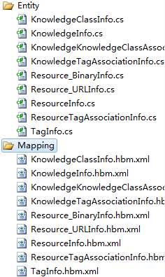
在数据库建表完成后通过工具db2hbm来生成xml映射文件。
然后再通过hbm2net生成实体类。
实际效果如下所示：
KnwoledgeInfo 映射文件
<?xml version="1.0" encoding="utf-8"?>
<hibernate-mapping namespace="KMS.Model" assembly="KMS.Model" xmlns="urn:nhibernate-mapping-2.2">
<class name="KnowledgeInfo" table="T_Knowledge" schema="dbo">
<id name="KnowledgeId" type="Int32">
<generator class="native" />
</id>
<timestamp name="TimeStamp"></timestamp>
<property name="Content" type="StringClob" length="1073741823" />
<property name="Description" type="String" length="500" />
<property name="Name" type="String" length="50" />
<bag name="KnowledgeKnowledgeClassAssociationInfos" table="T_KnowledgeKnowledgeClassAssociation" inverse="true">
<key column="KnowledgeId" />
<one-to-many class="KnowledgeKnowledgeClassAssociationInfo" />
</bag>
<bag name="KnowledgeTagAssociationInfos" table="T_KnowledgeTagAssociation" inverse="true">
<key column="KnowledgeId" />
<one-to-many class="KnowledgeTagAssociationInfo" />
</bag>
</class>
</hibernate-mapping>

KnowledgeInfo实体类
//------------------------------------------------------------------------------
// <autogenerated>
// This code was generated by NHibernate.
//
// Changes to this file may cause incorrect behavior and will be lost if
// the code is regenerated.
// </autogenerated>
//------------------------------------------------------------------------------

using System;
using System.Collections.Generic;
using System.ComponentModel.DataAnnotations;

namespace KMS.Model
{
/// <summary>
/// a class mapping for the table: dbo.Knowledge
/// </summary>
public partial class KnowledgeInfo
{

#region private fields
Int32 _knowledgeId;
String _content;
String _description;
String _name;
DateTime? _timeStamp;
IList<KnowledgeKnowledgeClassAssociationInfo> _knowledgeKnowledgeClassAssociationInfos = new List<KnowledgeKnowledgeClassAssociationInfo>();
IList<KnowledgeTagAssociationInfo> _knowledgeTagAssociationInfos = new List<KnowledgeTagAssociationInfo>();
#endregion

#region getter/setters
/// <summary>
///
/// </summary>
public virtual Int32 KnowledgeId
{
get{ return _knowledgeId; }
set{ _knowledgeId = value; }
}
/// <summary>
///
/// </summary>
[Required(ErrorMessage="必须填写内容")]
public virtual String Content
{
get{ return _content; }
set{ _content = value; }
}
/// <summary>
///
/// </summary>
public virtual String Description
{
get{ return _description; }
set{ _description = value; }
}
/// <summary>
///
/// </summary>
[Required(ErrorMessage=必须填写名称")]
public virtual String Name
{
get{ return _name; }
set{ _name = value; }
}
/// <summary>
///
/// </summary>
public virtual DateTime? TimeStamp
{
get{ return _timeStamp; }
set{ _timeStamp = value; }
}
/// <summary>
///
/// </summary>
public virtual IList<KnowledgeKnowledgeClassAssociationInfo> KnowledgeKnowledgeClassAssociationInfos
{
get{ return _knowledgeKnowledgeClassAssociationInfos; }
set{ _knowledgeKnowledgeClassAssociationInfos = value; }
}
/// <summary>
///
/// </summary>
public virtual IList<KnowledgeTagAssociationInfo> KnowledgeTagAssociationInfos
{
get{ return _knowledgeTagAssociationInfos; }
set{ _knowledgeTagAssociationInfos = value; }
}
#endregion
}
}

DAL
DAL层通过对外公开IRepository<T>以及IRepository接口实现对数据库GUID的操作。
该层中仅实现了IRepository接口。
接口定义如下：
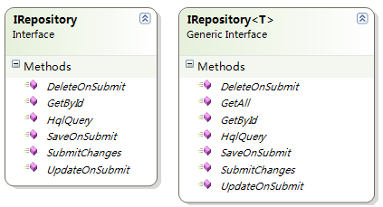

BLL
BLL通过调用DAL的接口，完成业务逻辑的处理。
该类公开了三个接口：
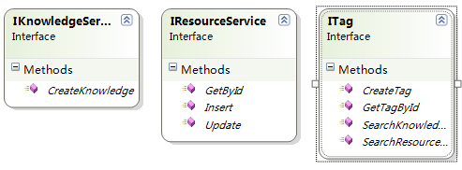
- KnowledgeService
处理知识的创建工作。
- ResourceService
提供资源服务。
- TagService
提供标签服务。

BLL.Search
该层公开并被实现的接口如下：
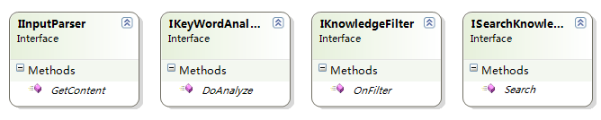
- InputParser
处理输入搜索字符串中标签解析的功能。
- KeyWordAnalyzer
处理搜索字符串的分词（包括简易中文分词）
- KnowledgeFilter
根据指定的TAG信息，过滤不相关的数据。如提交至服务器的搜索字符串中含有date：2010/9/3，则将只返回该日期的知识。
- SearchKnowledge
实现知识的搜索。

Presentation
本层为MVC Web Application的显示层。

Presentation.Knowledge
该层公开了如下接口：
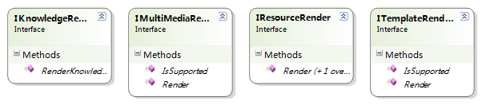
通过KnowledgeRender调用TemplateRender再调用ResourceRender实现了对Knowledge转化成可现实的Html的目的。
其中，ItemplateRender为实现如：
<KMSResource id="xxx-xxx-xxx-xxx" width="10" height="20" />
这类自定义标记的Html转化而设计的接口，具体的工作将根据具体的自定义标签交给

4 项目依赖一览表
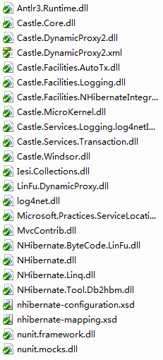

5 其他

5.1 知识存储格式

- 简介
每个知识即对应一段HTML标记语言，但其中的资源在存储进数据库的时候，必须有它自身存储的方式。因此本文定义了一个专用的标记语言，用于在后台向前台呈现的时候，将资源转换成规范的HTML，以及用户修改后，将资源存储入库的知识存储格式。

- 存储规范
语法：
<KMS:Resource
id=”xxxx-xxxxxxxx-xxxx-xxxxxxxx”, type=”resource_binary”,width=”aaa”,height=”bbb” />
在显示时，将显示为<image />等标记。

5.2 搜索词规范
- 简介
本系统实现了基于搜索词的搜索方式，使用一定的语法进行搜索，如输入time:2009~2010-8-29，即会返回2009年1月1日至2010年8月29日上传的记录。本文即说明搜索词的语法以及相应功能。
搜索的范围有两类：1，知识搜索；2，资源搜索。目前仅支持知识搜索。

- 知识搜索
  - 基于标签搜索
语法：tags:x1,x2,x3
由tags:开头的搜索词，其后方离下一个搜索标记的内容都为关键词。如果不输入tags:，默认就是标签搜索。
  - 基于日期范围搜索
语法：dateRange:yyyy(-mm-dd)~yyyy(-mm-dd)
由dateRange:开头的即是时间搜索，其后方离下一个搜索标记的内容皆为时间关键词。
例如：2009~2010-1 为合法的搜索词，其含义为：搜索2009年1月1日至2010年1月31日。
  - 基于特定日期搜索
语法：date:yyyy-mm-dd

说明：以上搜索可以同时进行，如time:1989~2010-8-29 keywords:机器猫，2个搜索标记中间以空格分隔。

