Marco Mercado

Lab 1

SID 861158858

Exercise 1

I created a function that takes in an INTERGER and that’s the number of points in the quadrant that are generated randomly. Then we used the formula to extima the value and return the estimated value. Here it’s the output of the program that

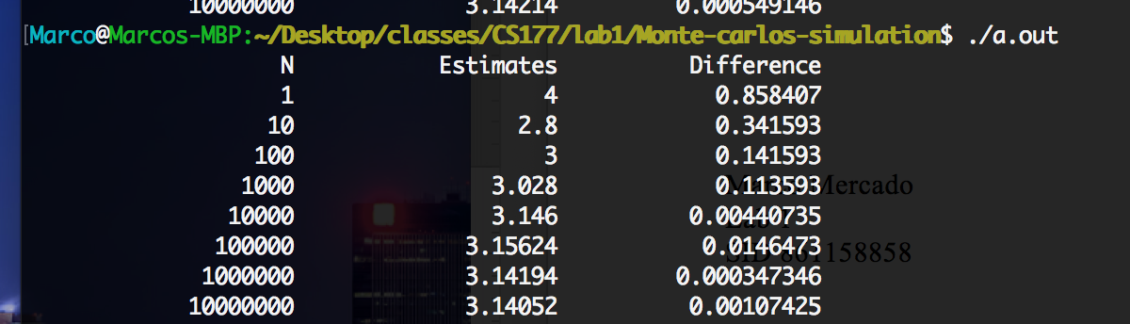

Exercise 2

Each color correspond to a sequence of 2000 points for the quadrant method

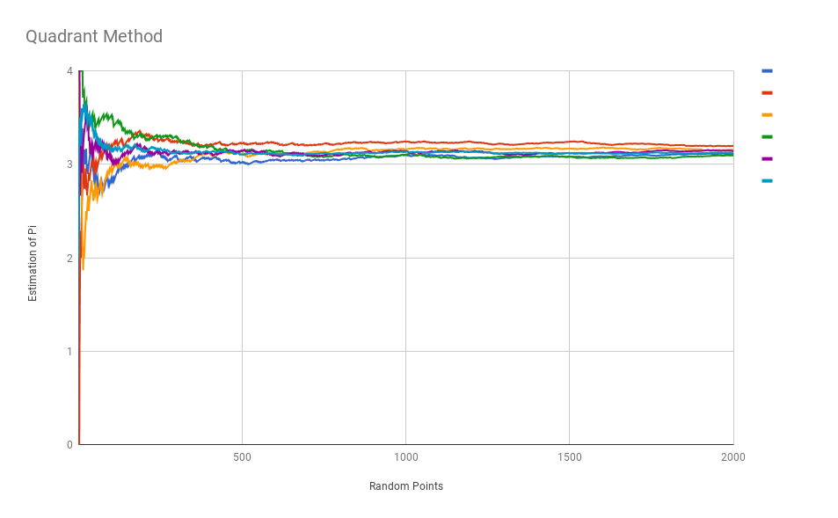

Exercise 3

Each color correspond to a sequence of 2000 points for the triangle method method

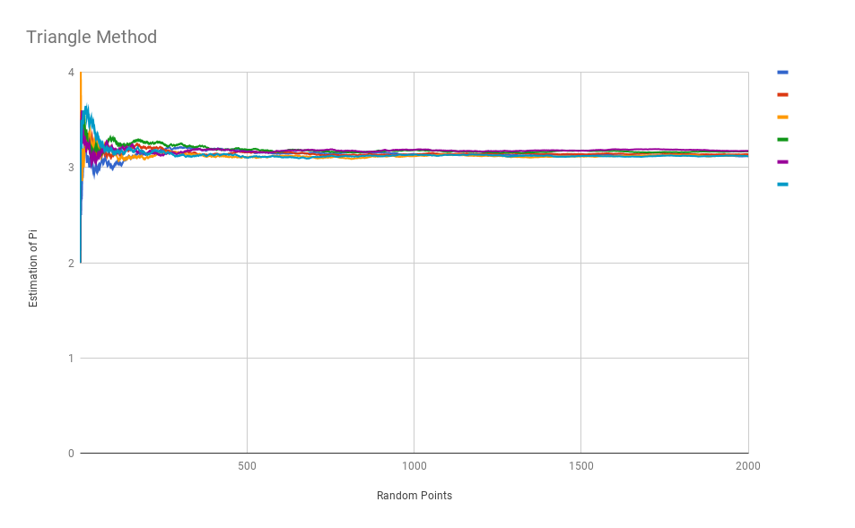

Exercise 4

*Why do you think this method is better than the one introduced in Exercise 1?*

The reason the method in exercise 3 is better is because the ratio of area between in circle and outside of circle is smaller. So more points land in a smaller area that still estimates pi so it should be more accurate so as we can see to in the graph method 3 has less variance at the beganing and at the end too.