Marco Mercado

Kyle Banda

CS152

we implement the priority scheduler we first had to implement a set priority system call. This system call gives processes a priority. To create a system call we modified the following files: sysproc.c, syscall.h, syscall.c, defs.h, user.h, usys.S and proc.c with the majority of the code for the syscall being implemented in proc.c. Next we had to modify the scheduler priority scheduler. The code that follows is our new scheduler.

The way the scheduler works is it schedules the job with the highest priority. it loops through the ptable to find the process with the lowest priority and then it schedules it. The first process have to have the highest priority.

The functions were implemented to set and get the priority from the user space.

This is what we modified for the functions in sysproc.c

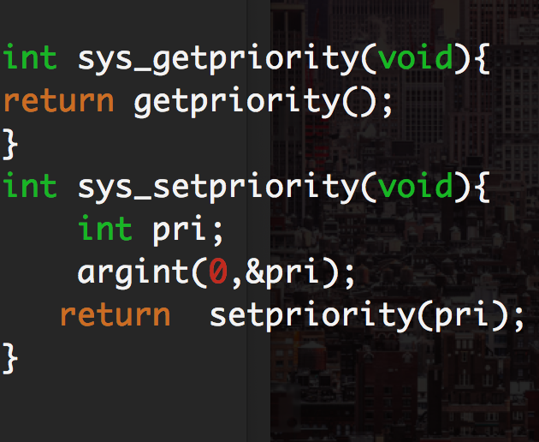

this is what we modified for the functions in proc.c

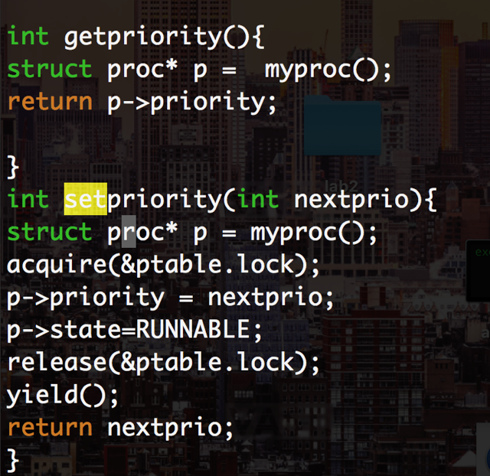

this is what we did in the scheduler. We look for the highest priority.

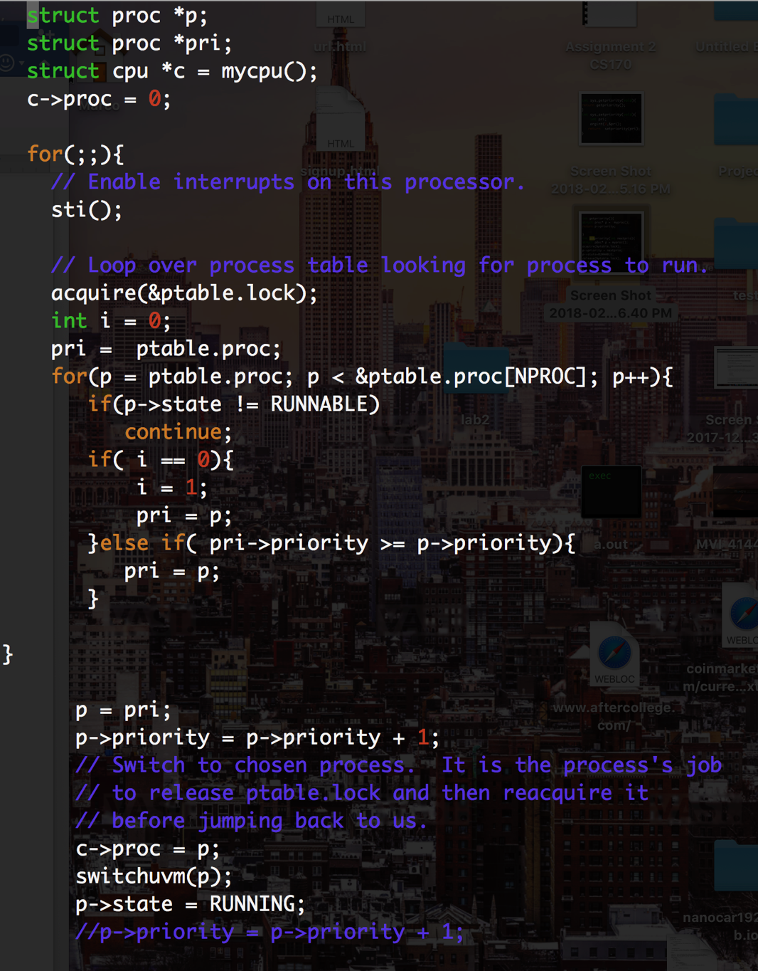

TESTED the correctes with the test filed that we were provided by the TA. It was a series of test.