COMP4
Twitter quiz bot (“twbot”)

Candidate name: Marco Scannadinari
Candidate number: 1469
Centre: Acton High School
Centre number: 12448

Contents
Analysis 4
Background and Problem Identification 4
Description of current system 4
User(s) identification 4
User needs & limitations 4
Data source(s) and destination(s) 4
Data volumes 4
Analysis data dictionary 4
DFDs existing and proposed 4
Objectives 4
Complexity 4
Potential solutions 4
Proposed solution 4
Use of formal method(s) 4
Objects 4
Design 4
Overall system design 4
Modular structure 4
Record or database structure 4
Validation including errors 5
File organisation and processing 5
Database design and E-R model 5
Storage media & format 5
Algorithms for data transformation 5
User interface 5
Security and integrity of data 5
System security 5
Outline test strategy 5
Test plan 5
Technical solution 6
System testing 7
System maintenance 8
System overview 8
Algorithms (or alternative way to document solution) 8
Annotated listings/screens showing key parts of the program 8
Objects, Methods and Data Structures 8
Appraisal 9
Evaluation of objectives 9
Further development 9
User feedback 9
Analysis of user feedback 9

Analysis

Background and Problem Identification
Currently, homework is provisioned in the form of an assignment due for a specific date in the future, known both to the teacher and the student. This is used as a form of revision.

The problem with this system is that the students have a relatively long period of time to research about and complete the homework task, which does not reflect an exam environment, where the themes of an exam are not known beforehand.

Description of current system
Students must study all aspects of the subject they are taking to prepare for an exam. This process is separate from teacher assigned homework, which creates inefficiency.

User(s) identification
My user is Mr. Mothada, a Computing teacher at Acton Sixth Form.

User needs & limitations
The current system of manually assigning and collecting homework has several flaws:
- Not as engaging due to negative connotations of homework
- Not similar to exam environment
- Difficult to keep track of homework
- Easy to cheat by befriending others who have done homework

Data source(s) and destination(s)
Key:
← (input)
→ (output)

← API key, given by Twitter to application developers used to access the API
← User authorisation, given by the user to an application to grant access to their account
← Questions and correct answers, input by the user defining questions to be sent by the application, and the correct answers to those questions
← Followers, users of Twitter who follow the application's Twitter account to be notified of questions
→ Question tweets, tweets sent by the application stating a question. Following users can respond to them
← Answer tweets, tweets sent by the followers of the application's account giving their answer (these should be private messages to avoid cheating)
→ Data, the data of users' answers (correct/incorrect answers, time to answer, …) stored in a database
→ Statistics website, generated from the database presenting the data in a clear way

Data volumes
#

Analysis data dictionary
twitter_bot database (all tables have implicit “id” fields)

DFDs existing and proposed
Your text here

Objectives
Your text here

Complexity
My solution will be quite complex since it requires synchronisation between the Twitter API, my database, and the website that will be generated. It will require implementation of a registration and login system for the administrative account used to manage questions and various parts of the application's configuration. The login system will need to be secure against common attacks against the application such as dictionary attacks. Finally, my application will constantly monitor, through the Twitter Streaming API, new tweets sent to the registered Twitter user and respond accordingly.

Potential solutions
Your text here

Proposed solution
Your text here

Use of formal method(s)
Your text here

Objects
Database connection: used as a handle to access the database when manipulating it
Twitter authentication object: used by the Twitter library to grant access to the Twitter account
UUID (session id): stored on both the client and the server to keep a record of where the administrator is logged in. The UUID is always unique guarding against forgery

Design

Overall system design
Your text here

Modular structure
Your text here

Record or database structure
Your text here.

Validation including errors
Your text here

File organisation and processing
Your text here

Database design and E-R model
Table | Comment | Data
meta | configuration for the twbot application used to run
  Field | Comment | Type
  first_run_step | The phase of the first run process/wizard the user has reached (-1 denotes completion) | integer
  consumer_key | Key used to identify as the correct Twitter application | string
  consumer_secret | Secret value used to authenticate the client to the Twitter API | string
  access_key | Key granted by the Twitter API linking the Twitter application to the API | string
  access_secret | Secret value to be used in conjunction with the access key, granting access to private Twitter API calls, such as tweeting on a user’s behalf | string
  username | Username of the administrator registered to the application | string
  password | Hashed password of the administrator | binary
users | users that are following the registered Twitter account
  Field | Comment | Type
  username | Twitter handle of a user that is following the registered admin account | string
  questions_answered | Dictionary of answered questions by the user with the question id as the key and the value as a dictionary, with two keys: time_to_answer, which is how long the user took to answer in seconds since the question was tweeted, and answer, which contains the user’s answer | dictionary ({  (question id): dictionary ({  “time_to_answer”: float,  “answer”: string,  })  })
questions | questions that have been asked by the registered Twitter account
  Field | Comment | Type
  asked_time | UNIX timestamp (seconds since 1970-01-01 (ISO 8601 format)) for the time the question was asked (-1 denotes that the question has not been asked) | integer
  question | The question text | string
  correct_answer | The correct answer, only provided if it is a multiple choice question | string
  is_multiple_choice | If true, the question is a multiple choice question | boolean
  answers | A list of possible multiple choice answers | array

Storage media & format
All of my applications data will be stored in a database, since databases are optimised for reading and writing frequently to them and are also able to be secured using a password. The database will be stored locally on the computers disk drive to preserve the data across restarts of the application.

Algorithms for data transformation
Administrator password

User interface
My application should be easy to access as many teachers are not often very technically literate, and having a clear UI will allow the administrator to work faster and more efficiently. Therefore, I will use a locally-hosted website for the UI of my application, as it is ubiquitous across most computers, and allows for a greater degree of customisation of the UI. The user interface should guide the user through the setup process of the application and subsequently administration tasks, such as creating a question to be tweeted and scheduling times to send out questions to followers, for example.
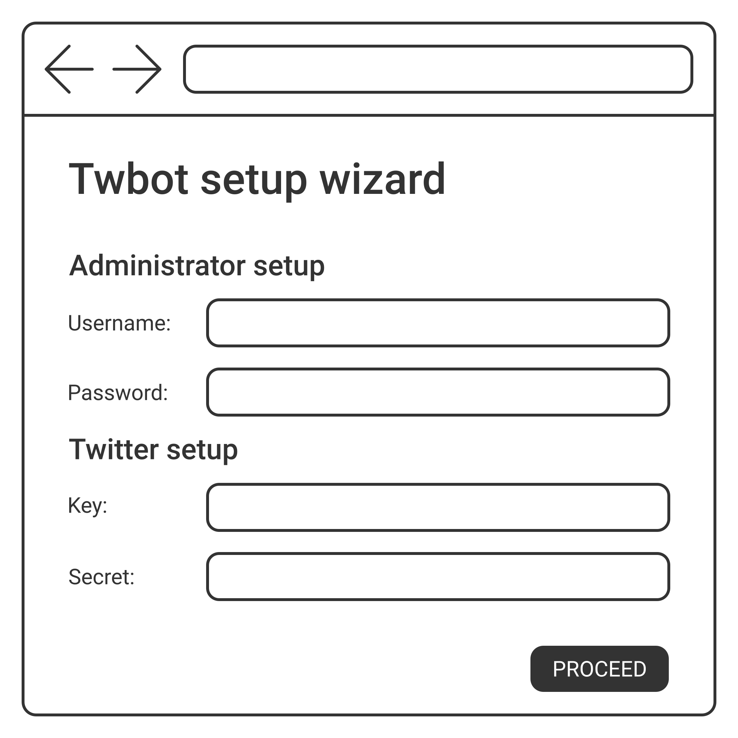Fig. 1: Tentative design for the intitial setup stage
To other users of the twbot service, my app will allow them to view statistics gathered including who has the most impressive achievements from their responses, which they can access through the public statistics section of the website.

Security and integrity of data
In the initial setup wizard stage of the website, invalid inputs will be rejected and the user will have to enter values until they are correct. For example:
- No inputs can be zero characters long
- The administrator password must be at least five characters
- Twitter API key and secret strings will be entered until the application gets a successful response from the Twitter API
- Incorrect login attempts will be rejected by the application at most eight times, at which point logins will be rejected for ten minutes

Also, private input fields will have their contents obscured by means of special filler characters such as “*” to guard against any onlookers or malicious screen recording software.

System security
My application only uses a single administrator for the main user, so only one account needs to be secured. This means there are less users that are vulnerable to attackers, however it also means that attackers are more likely to concentrate on the one user account.

First of all, to prevent any unauthorised access to the database, it will be secured with a password to protect against anyone trying to access or alter private information.

Within the database, the password will be hashed using the bcrypt algorithm. bcrypt is a one-way hash function which, given a second parameter of the ‘salt’, it generates a special value named the ‘hash’, which is not able to be reversed back to the original plaintext password. So if someone were trying to access the administrator password from the database, they would have a difficult time figuring out the original password.
Storing an encrypted password using bcrypt instead of a plaintext password has a number of benefits:
- Password is obscured should an attacker gain read access to the database
- Protects from naïve “dictionary attacks” that brute force the password value using a long list of possible words (smart attackers would know extract the salt value from the bcrypt hash, however salts generated with a high cost factor (higher costs means that it takes longer to hash the password) will make computing the hash itself not viable for an attacker to compute hashes for each entry in the “dictionary” (thousands and thousands of values)
- Protects from “rainbow table attacks” that brute force the password value by comparing the hash with a dictionary of passwords (with their hashes as the key). Since bcrypt uses an additional salt parameter, instead of just the password itself, a hash will always be different given the same password and a different salt
- The user of the application will feel more secure and confident when using the twbot software

The application does not compare the plaintext password to authenticate logons, but instead compares the hash value. This way, even if an attacker gained access to the database, they would be unable to know the actual password used by the administrator (useful if the administrator user uses the same password or same pattern of password across online services)

Outline test strategy
Your text here

Test plan
Your text here

Technical solution
This section should contain the listings of your code, and perhaps sample screenshots of solution in operation.

System testing
Include your table from the design section here, and now fill in the final column. Where there is not enough space to show the screenshot, add an extra row below the test and paste it into there.

System maintenance
Your text here

System overview
Your text here

Algorithms (or alternative way to document solution)
Your text here

Annotated listings/screens showing key parts of the program
Your text here

Objects, Methods and Data Structures
Your text here

Appraisal

Evaluation of objectives
Your text here

Further development
Your text here

User feedback
Your text here

Analysis of user feedback
Your text here
asdasd
asdf

