COMP4
Twitter quiz bot (“twbot”)

Candidate name: Marco Scannadinari
Candidate number: 1469
Centre: Acton High School
Centre number: 12448

Contents
Analysis 4
Background and Problem Identification 4
Description of current system 4
User(s) identification 4
User needs & limitations 5
Data source(s) and destination(s) 5
Data volumes 5
Analysis data dictionary 6
DFDs existing and proposed 6
Objectives 6
Complexity 6
Potential solutions 6
Proposed solution 7
Use of formal method(s) 7
Objects 7
Design 8
Overall system design 8
Modular structure 8
Record or database structure 8
Validation including errors 8
File organisation and processing 8
Database design and E-R model 8
Storage media & format 9
Algorithms for data transformation 9
User interface 10
Security and integrity of data 11
System security 11
Outline test strategy 12
Test plan 12
Technical solution 13
System testing 14
System maintenance 15
System overview 15
Algorithms (or alternative way to document solution) 15
Annotated listings/screens showing key parts of the program 15
Objects, Methods and Data Structures 15
Appraisal 16
Evaluation of objectives 16
Further development 16
User feedback 16
Analysis of user feedback 16

Analysis

Background and Problem Identification
Before the final exams take place, students have a range of tasks to complete in order to gain knowledge about the exams that are to come. Most commonly, students can revise all aspects of the subject using a comprehensive resource such as a book of the subject.

The problem studying with a large book is that it may be too expensive for some students that have a poor financial situation, due to the size of the book. Also, students can be put off by the huge amount of content that they are faced with, since it comes in such a large bundle. It can be easy to procrastinate when revising from such a resource.

Another problem with studying with physical means is that students can easily lose the book or papers, or even damage them, which means that the student won’t be able to study with that resource in the future

Description of current system
As a way to ease the book-revision problems, homework is provisioned in the form of an assignment due for a specific date in the future, known both to the teacher and the student.

With homework, the problem is that it only targets a small and specific area of the subject. Also, students are given a large amount of time to study about, and to complete that task. This does not reflect an exam environment in which all aspects of the subject are covered and students don’t know the specifics of the exam before it takes place. The traditional homework system has negative connotations and so does not engage the students in a positive way. As a way to quickly deal with the homework, students may resort to finding the answers online or taking the answers from other students.

As with books, it is also quite difficult to keep track of homework provisioned with paper, which can get lost or damaged easily.

User(s) identification
My main user is Mr. Mothada, a Computing teacher at Acton Sixth Form. He will be in charge of the application instance and therefore be able to administrate the system by adding/removing questions, and configuring tweeting behaviour, for example.

Other users will be the students, who will have access to the public website which would render the statistics of all the students that use the system. They will be able to search for and view specific students, and compare their performance with those students. Also they could view their position in the ranking section which sorts all the students based on how well they perform.

Client interview

What do you think are the problems you experience with the current solution?

What size of classroom do you typically deal with in your lessons?

How often do you set homework to your students?

What ways do you make learning fun for your students?

What features would you like to have in the application?

Do you have any other general comments?

User needs & limitations
Based on my research, I can identify the needs that my users have:

Teachers need to be able to:
- Create a single administrative account and use it to log in
- Create, read, update, and delete questions to be used by the Twitter bot
- Specify timing behaviours for the tweets to be distributed to the students

Students need to be able to:
- Access the public website
- View the rankings of the students that use the system
- View specific users and statistics

Application limitations:
- Support for multiple users or subjects, as it would require a more complex database structure and code implementation. As I have only one client, it is not a focus for me.

Data source(s) and destination(s)
Input | Source | Output
Administrator registration details | Form inputs from setup stage | Meta database table
Twitter application authorisation | Twitter API methods | Meta database table
Questions to be tweeted | Administrator user | Questions database table
Question answers | Twbot users responding to the question tweets | Users database table
Users of the system | Followers of the designated Twitter account | Users database table

Data volumes
The database would need to store:

Entity | Quantity | Justification
Student details | 30 | Typically the maximum size of a classroom
Questions | 60 | Given that:  - ~28 weeks in a school year  - A zealous teacher would provision around two questions per week  28 × 2 = 56 → 601  1N.B. Questions cannot be removed from the database after all students have given an answer to the question, since for statistical purposes, references to these question entries must be preserved in the database, in order to be displayed on the website, so the figure of 60 I believe to be accurate
Student answers | 1800 | 30 × 60 = 1800

Analysis data dictionary

DFDs existing and proposed

Objectives
Your text here

Complexity
My solution will be quite complex since it requires synchronisation between the Twitter API, my database, and the website that will be generated. It will require implementation of a registration and login system for the administrative account used to manage questions and various parts of the application's configuration. The login system will need to be secure against common attacks against the application such as dictionary attacks. Finally, my application will constantly monitor, through the Twitter Streaming API, new tweets sent to the registered Twitter user and respond accordingly.

Potential solutions
There are several ways that I could implement my application, all with different factors to consider

Potential solution | Description | Advantages | Disadvantages
Smartphone app | An app built for the Android or iOS platforms. Android uses Java and XML, while iOS uses Objective-C or Swift | - The app is portable because it can be carried around with the phone  - Almost all students own a smartphone | - Requires learning new APIs or languages  - iOS can only be developed for using a Mac, which is expensive  - Dependent on complex IDEs
Web app | An app designed to run on web browsers. Composed of HTML, JavaScript, and CSS | - Can run on any platform that has a web browser  - Easy to get started with because of the low barrier to entry of development  - Don't need to worry about different operating systems | - JavaScript is typically run in a virtual machine, which is mostly slower than compiled code used on other platforms  - User interface does not appear native to the platform that it runs on
Desktop app | An app that runs on one of the Linux, Mac OS X, or Windows platforms that run desktop PCs | - Wide choice of programming languages to implement the app in  - Will be able to run faster than on mobile devices\\ | - Difficult to attain true compatibility across platforms  - Users will be hesitant to download a desktop app to interact with a relatively simple Twitter bot

Proposed solution
I have chosen to use a web app to build my project. I am already familiar with developing websites and have previously had experience in creating a website backend with Python and the Bottle web framework, so it will be easier for me to develop my project. Web applications are able to run on any device with a browser, so I will be able to target the widest range of users, even on different operating systems (this would not be possible if I was to create a traditional native app).
Users of Twitter, who would be my target audience, are more familiar and comfortable with a web browser, since Twitter is also a web app. It would be much easier for them to access the app with their browsers than to download a software package.

Use of formal method(s)
Your text here

Objects

Design

Overall system design
The twbot application is composed of:
- Twbot program
- Database file
- Static client-side resources
- Static server-side templates

The twbot program is the code that contains the logic of the application. It will interface with the Twitter API, handle logins, and serve the user-facing website.
Since I have chosen to use SQLite as my database solution, the database is actually stored in a single file, instead of the traditional server approach used by popular SQL databases such as PostgreSQL and MySQL. SQLite’s approach will make it significantly easier for the end user to be able to get twbot running (only the main twbot program to launch), without having to launch database servers that the program is dependent on.
Static client-side resources include JavaScript and CSS files that are sent to the client’s browser. JavaScript resources will enhance the functionality of the website, while CSS resources will make the website look consistent across the different pages and components used in the site.
Static server-side templates contain each page’s HTML structure that allows the client’s browser to display the desired content. In addition to simple HTML, these templates may contain some code that is run on the server before sending the response to the client. These cases would be used where the application would need to access private data from the database, or where it would be better to offload work from the client to the server to ensure the user can use the website smoothly.

Modular structure
Your text here

Record or database structure
Your text here.

Validation including errors
When entering a username and password for the administrator account, I would have these validation checks in place:
- All inputs must be entered
- Twitter API key and secret strings will be entered until the application gets a successful response from the Twitter API

When creating questions and their corresponding answers (for multiple choice questions), I would have these validation checks in place:
- The question must be entered
- If the question is multiple choice, it must have at least two answers
- If the question is multiple choice, no two answers can be identical

File organisation and processing
Your text here

Database design and E-R model
Table | Comment | Data
meta | configuration for the twbot application used to run
  Field | Comment | Type
  first_run_step | The phase of the first run process/wizard the user has reached (-1 denotes completion) | INTEGER
  api_key | Key used to identify as the correct Twitter application | TEXT
  api_secret | Secret value used to authenticate the client to the Twitter API | TEXT
  access_key | Key granted by the Twitter API linking the Twitter application to the API | TEXT
  access_secret | Secret value to be used in conjunction with the access key, granting access to private Twitter API calls, such as tweeting on a user’s behalf | TEXT
  username | Username of the administrator registered to the application | TEXT
  password | Hashed password of the administrator | BLOB
  session | Generated session identifier for an administrator login, used to authenticate the administrator | TEXT
users | users that are following the registered Twitter account
  Field | Comment | Type
  username | Twitter handle of a user that is following the registered admin account | TEXT
answers | answers that have been given by a Twitter user
  Field | Comment | Type
  user_id | id of a user from the users table | INTEGER
  question_id | id of a question from the questions table | INTEGER
  answer | Answer given by the user. answer and answer_id are mutually_exclusive. | TEXT
  answer_id | Id of an answer from the possible_answers table. Only applicable for multiple choice answers. answer_id and answer are mutually exclusive. | INTEGER
  lag | The time in seconds from the time the question was broadcast to the time the answer was tweeted | INTEGER
  score | Administrator’s ratubg of the answer, ranging from 0 (worst) to 10 (best) | INTEGER
  comment | Additional comments provided by the administrator | TEXT
questions | questions that have been asked by the registered Twitter account
  Field | Comment | Type
  asked_time | UNIX timestamp for the time the question was asked (-1 denotes that the question has not yet been asked) | INTEGER
  question | The question text | TEXT
  answer_id | The id of the correct answer in the possible_answers table, only provided if it is a multiple choice question | INTEGER
possible_answers | possible answers to a question
  Field | Comment | Type
  question_id | id of a question from the questions table | INTEGER
  letter | The designated letter of the answer. One of “A”, “B”, “C”, or “D” | TEXT
  answer | The answer text | TEXT

Storage media & format
All of my applications data will be stored in a database, since databases are optimised for reading and writing frequently to them and can have their data stored in a structured way by means of a schema. The database will be stored locally on the computers disk drive to preserve the data across restarts of the application.

Algorithms for data transformation
Storing administrator password
- Receive plaintext password input from twbot website
- Generate a salt as an additional parameter to the hashing process
- Generate a hash of the password and salt
- Store the resulting hash in the database

User interface
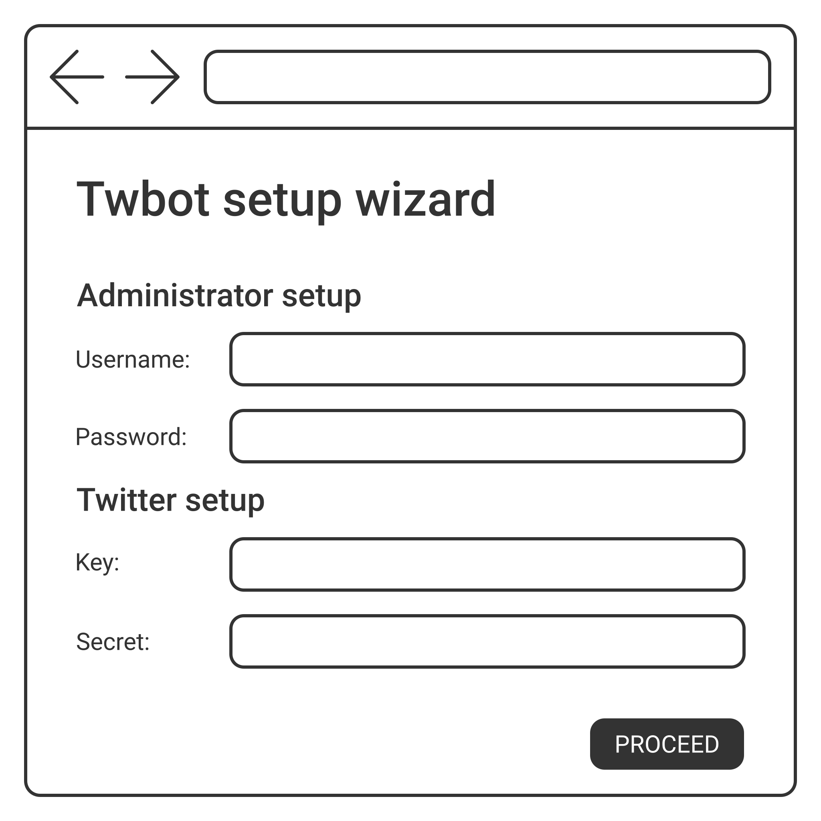Fig. 1: Tentative design for the intitial setup stage
My application should be easy to access as many teachers are not often very technically literate, and having a clear UI will allow the administrator to work faster and more efficiently. Therefore, I will use a locally-hosted website for the UI of my application, as it is ubiquitous across most computers, and allows for a greater degree of customisation of the UI. The user interface should guide the user through the setup process of the application and subsequently administration tasks, such as creating a question to be tweeted and scheduling times to send out questions to followers, for example.To other users of the twbot service, my app will allow them to view statistics gathered including who has the most impressive achievements from their responses, which they can access through the public statistics section of the website.

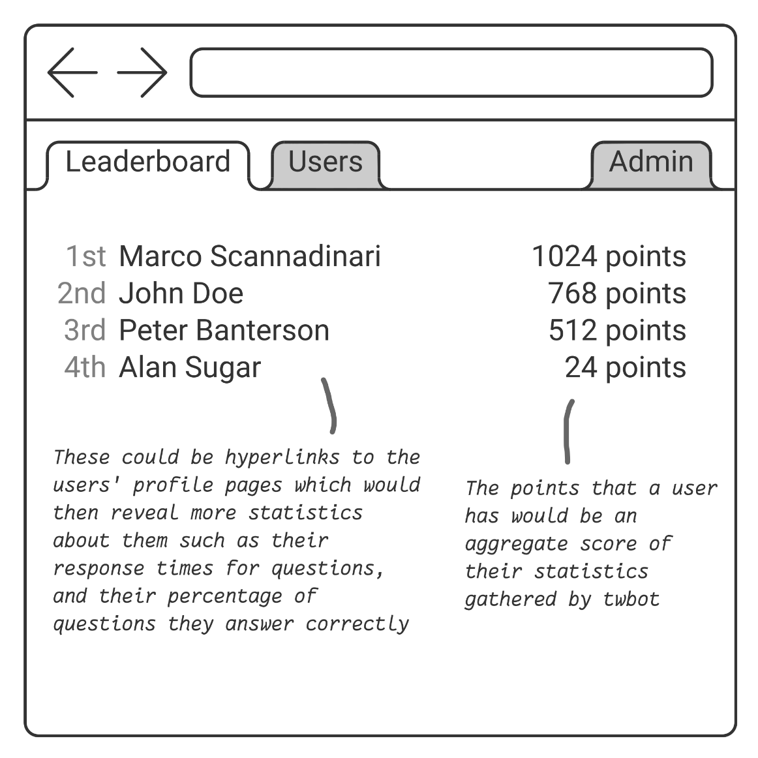
Security and integrity of data in the initial setup wizard stage of the website, invalid inputs will be rejected and the user will have to enter values until they are correct:
- The administrator password must be at least five characters, to ensure an adequate level of uniqueness
- Incorrect login attempts will be rejected by the application at most eight times, at which point logins will be rejected for ten minutes

Also, private input fields will have their contents obscured by means of special filler characters such as “*” to guard against any onlookers or malicious screen recording software.

System security
My application only uses a single administrator for the main user, so only one account needs to be secured. This means there are less users that are vulnerable to attackers, however it also means that attackers are more likely to concentrate on the one user account.

Within the database, the password will be hashed using the bcrypt algorithm. bcrypt is a one-way hash function which, given a second parameter of the ‘salt’, it generates a special value named the ‘hash’, which is not able to be reversed back to the original plaintext password. So if someone were trying to access the administrator password from the database, they would have a difficult time figuring out the original password.
Storing an encrypted password using bcrypt instead of a plaintext password has a number of benefits:
- Password is obscured should an attacker gain read access to the database
- Protects from naïve “dictionary attacks” that brute force the password value using a long list of possible words (smart attackers would know extract the salt value from the bcrypt hash, however salts generated with a high cost factor (higher costs means that it takes longer to hash the password) will make computing the hash itself not viable for an attacker to compute hashes for each entry in the “dictionary” (thousands and thousands of values)
- Protects from “rainbow table attacks” that brute force the password value by comparing the hash with a dictionary of passwords (with their hashes as the key). Since bcrypt uses an additional salt parameter, instead of just the password itself, a hash will always be different given the same password and a different salt
- The user of the application will feel more secure and confident when using the twbot software

The application does not compare the plaintext password to authenticate logons, but instead compares the hash value. This way, even if an attacker gained access to the database, they would be unable to know the actual password used by the administrator (useful if the administrator user uses the same password or same pattern of password across online services)

Outline test strategy
Your text here

Test plan
# | Test | Expected result | Actual result | Screenshot
1 | Username and password fields blank | Error that fields are required
2 | Password field blank | Error that password field is required
3 | Password field less than 5 characters long | Error that password field must be at least 5 characters long
4 | Username entered and password entered being at least 5 characters long | Proceeds to next step
5 | Consumer key, consumer secret, access key, access secret fields empty | Error that fields are required
6 | All fields but access secret non-empty | Error that access secret field is required
7 | Incorrect keys supplied | Error that keys are incorrect
8 | Correct keys supplied | Proceeds to next step
9 | Username and password fields empty on login page | Error that fields are required
10 | Password field empty on login page | Error that password field is required
11 | Username incorrect on login page | Error that username is incorrect
12 | Password incorrect on login page | Error that password is incorrect
13 | Correct username and password on login page | Redirects to questions page
14 | Empty question field on questions page | Error that question field is required
15 | Question field non-empty | Creates question
16 | Multiple choice question with 0 possible answers | Error that possible answer fields are required
17 | Multiple choice question with 1 possible answer | Error that one more possible answer must be entered
18 | Multiple choice question with 2 possible answers and no correct answer specified | Error that a correct possible answer must be specified
19 | Multiple choice question with 2 possible answers and non-existent correct answer specified | Error that correct possible answer does not exist
20 | Multiple choice question with duplicate possible answers and correct answer specified | Error that duplicate answers given
21 | Delete question | Question is deleted
22 | Wait a maximum of 15 minutes for question to be tweeted | Question is tweeted
23 | Twitter mention to the twbot user | Twbot user replies to the mention and follows the sender
24 | Twitter direct message giving incorrect to the twbot user for a multiple choice question | Twbot user responds to the direct message, stating the correctness of the answer
25 | T

Technical solution
This section should contain the listings of your code, and perhaps sample screenshots of solution in operation.

System testing
Include your table from the design section here, and now fill in the final column. Where there is not enough space to show the screenshot, add an extra row below the test and paste it into there.

# | Test | Expected result | Actual result | Screenshot
1 | Username and password fields blank | Error that fields are required | Error that fields are required | 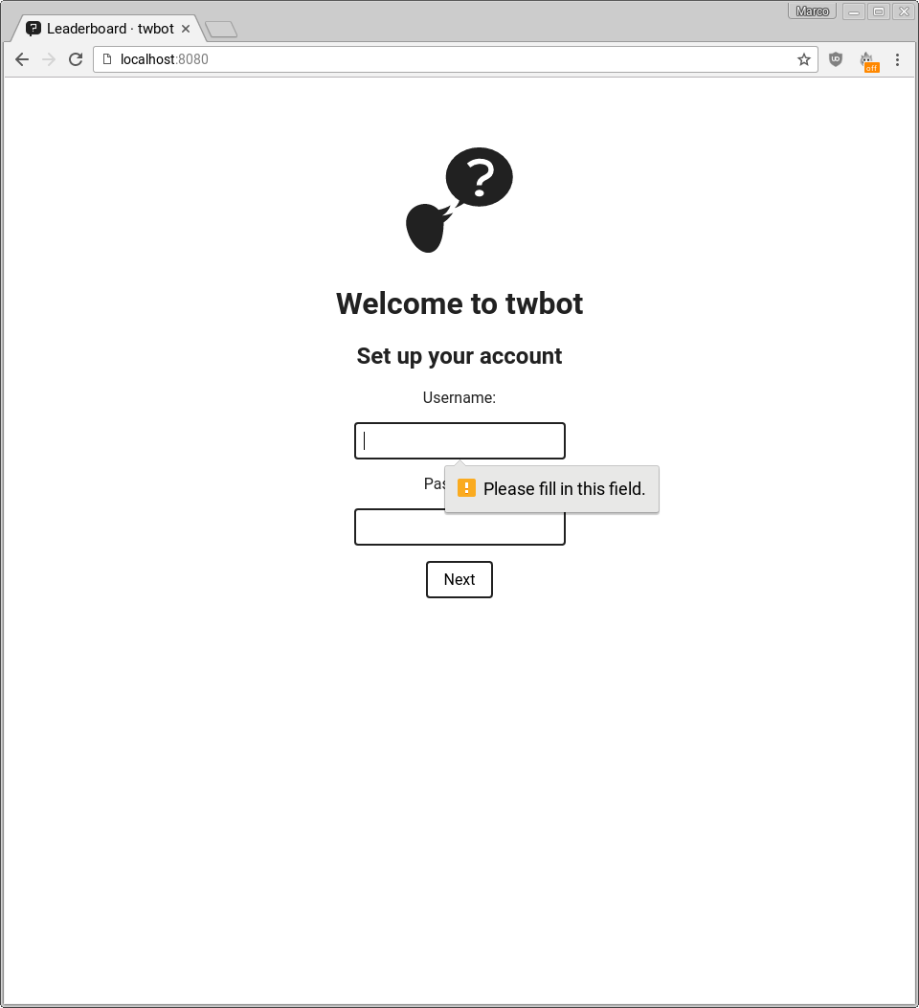
2 | Password field blank | Error that password field is required | Error that password field is required | 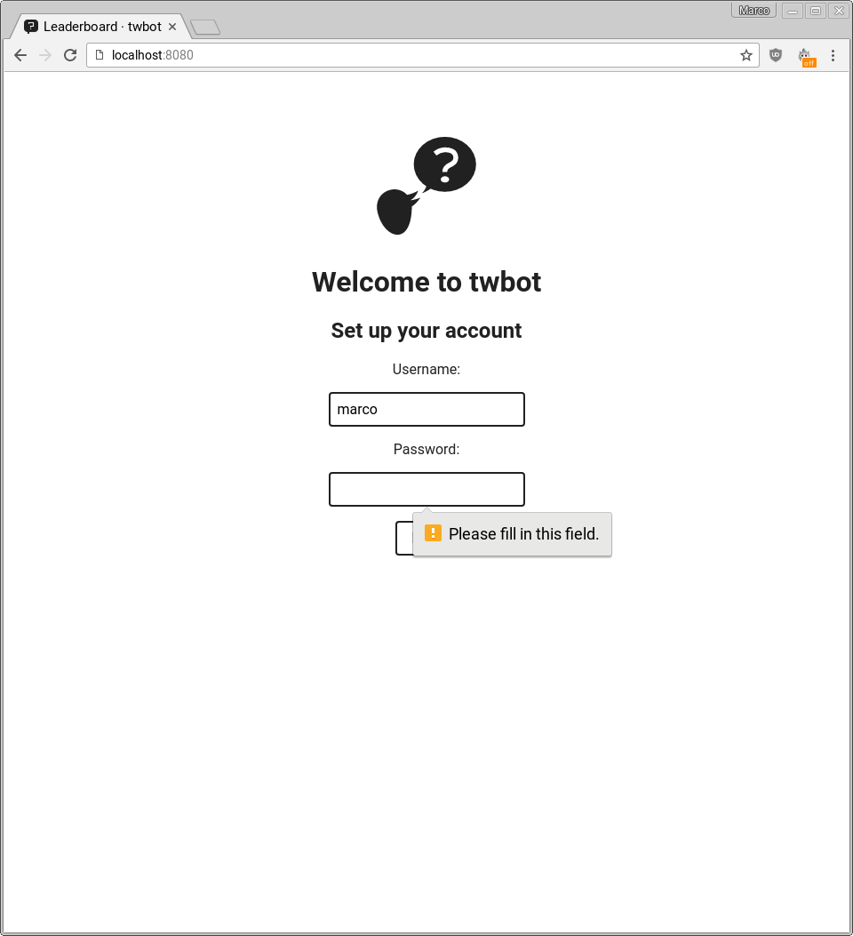
3 | Password field less than 5 characters long | Error that password field must be at least 5 characters long | Error that password field must be 5 characters long | 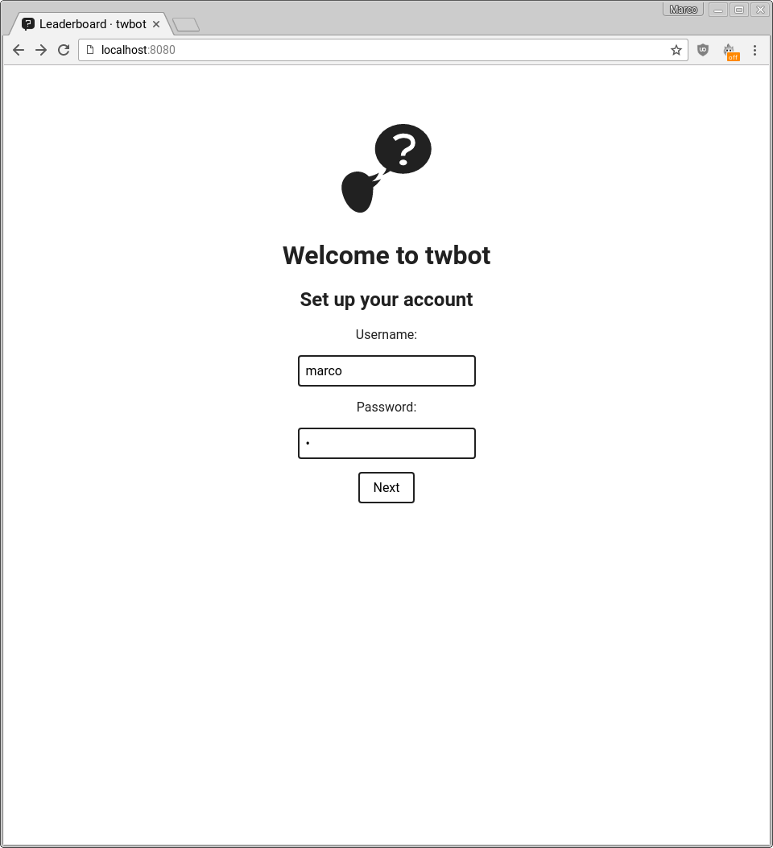  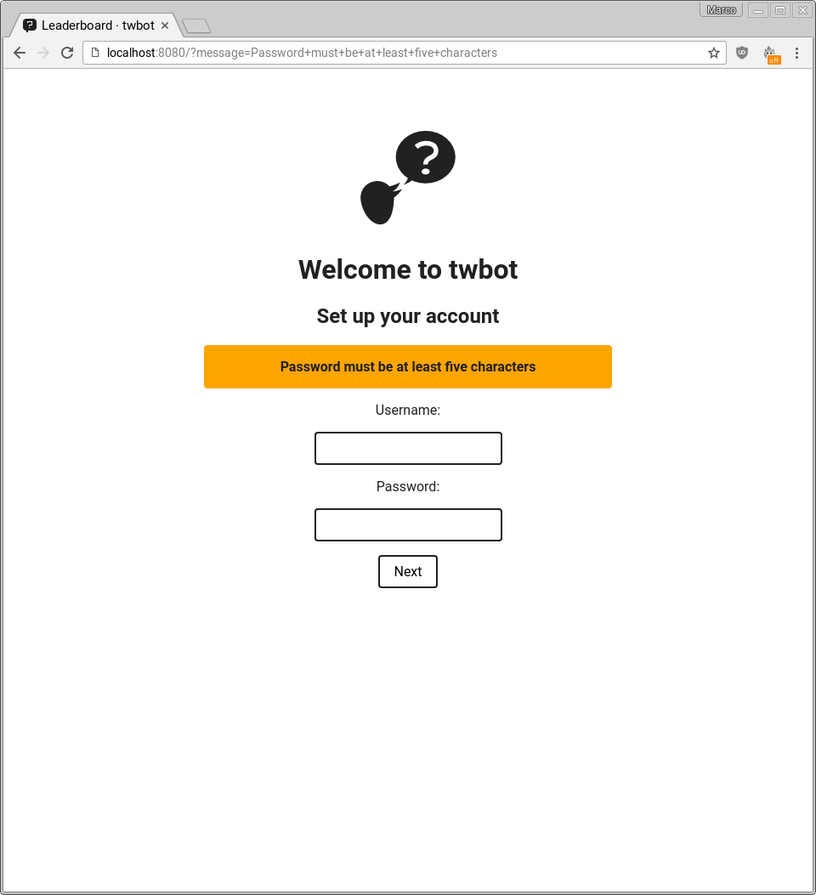
4 | Username entered and password entered being at least 5 characters long | Proceeds to next step | Proceeds to next step | 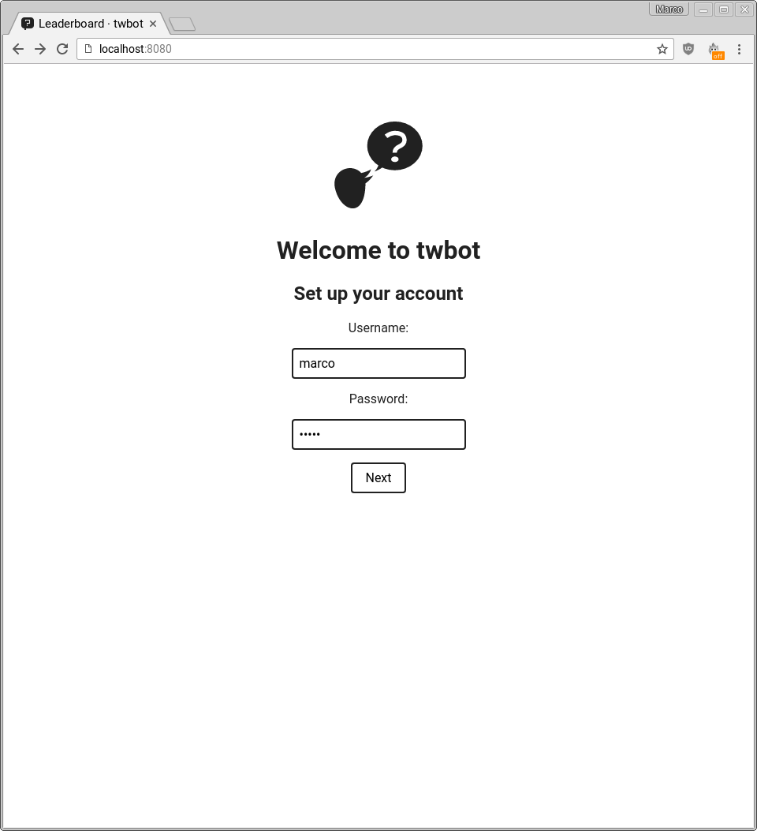  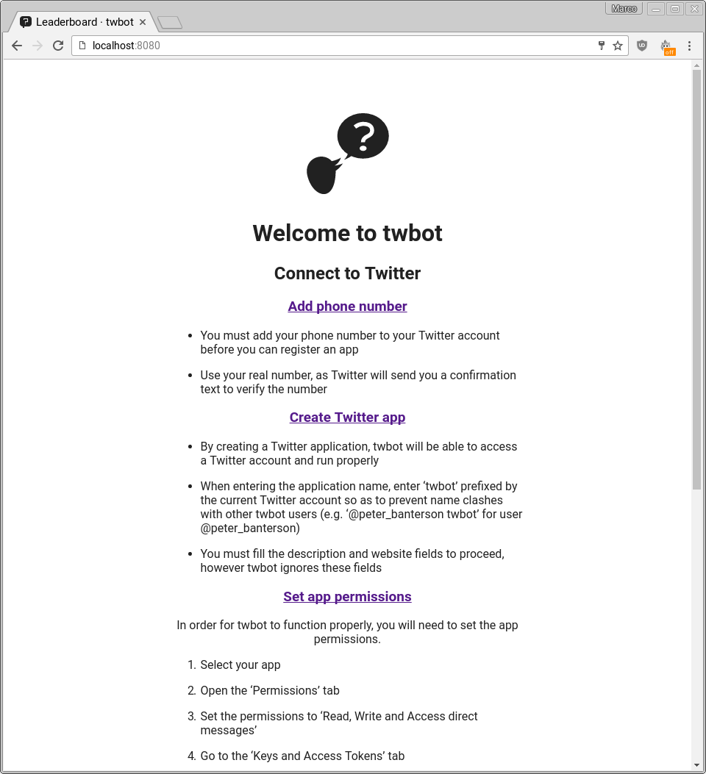
5 | Consumer key, consumer secret, access key, access secret fields empty | Error that fields are required | Error that fields are required | 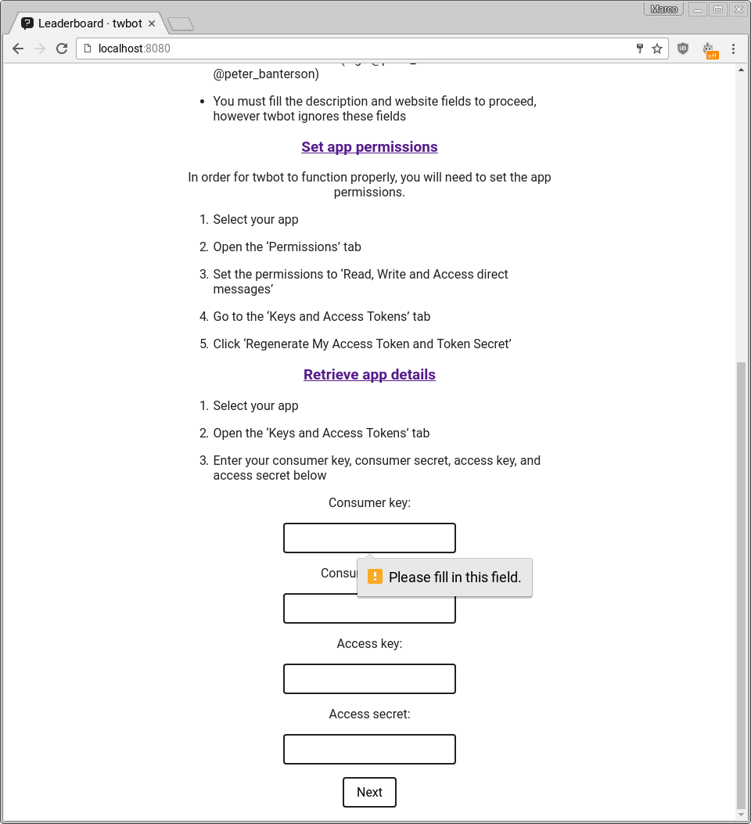
6 | All fields but access secret non-empty | Error that access secret field is required | Error that access secret field is required | 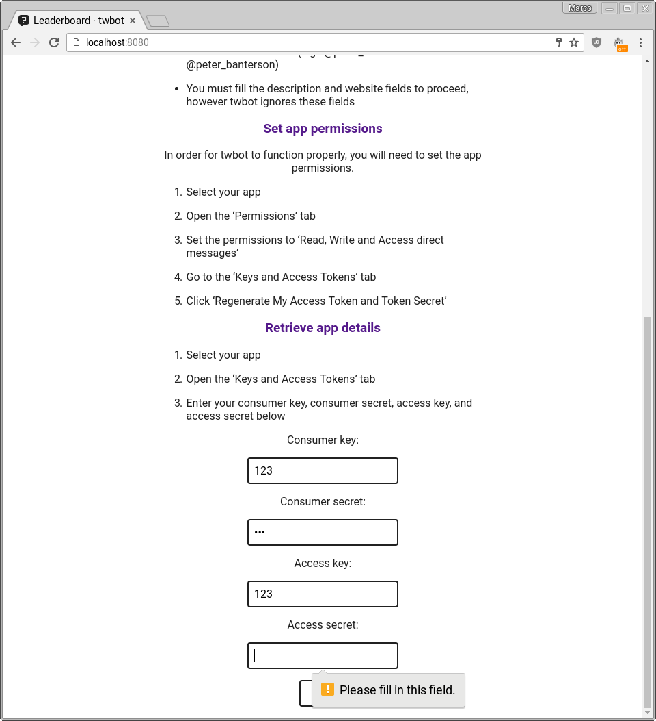
7 | Incorrect keys supplied | Error that keys are incorrect | Error that keys are incorrect | 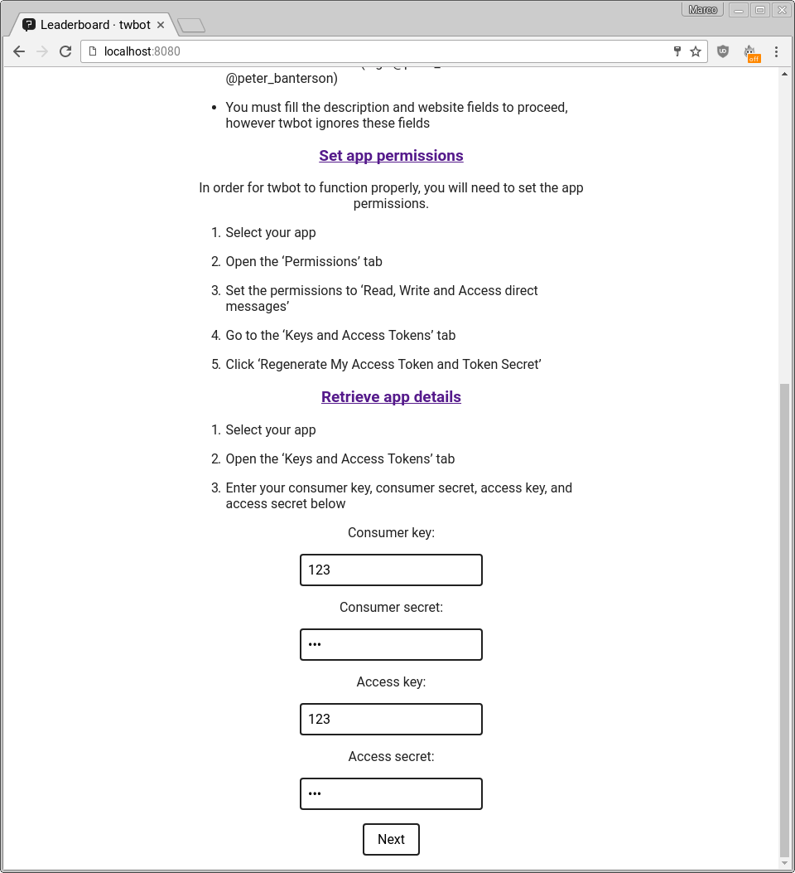  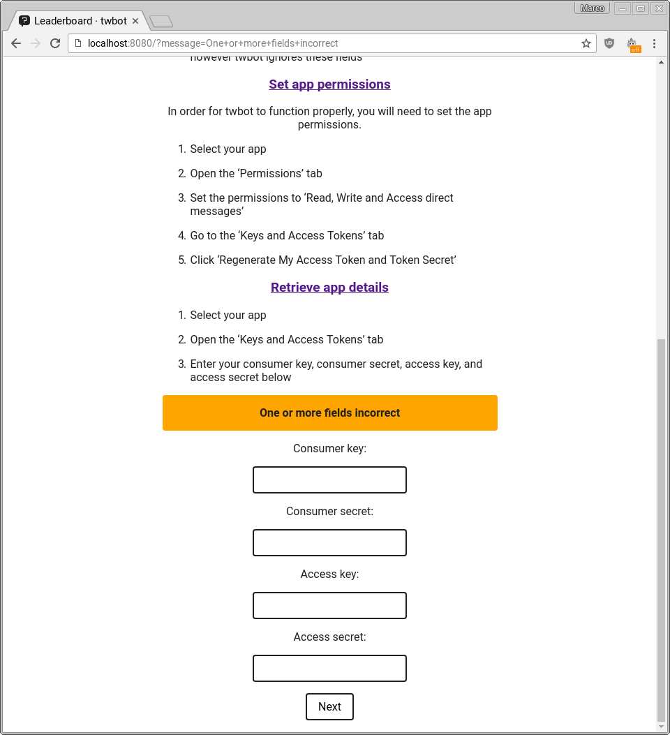
8 | Correct keys supplied | Finishes setup | Finishes setup | 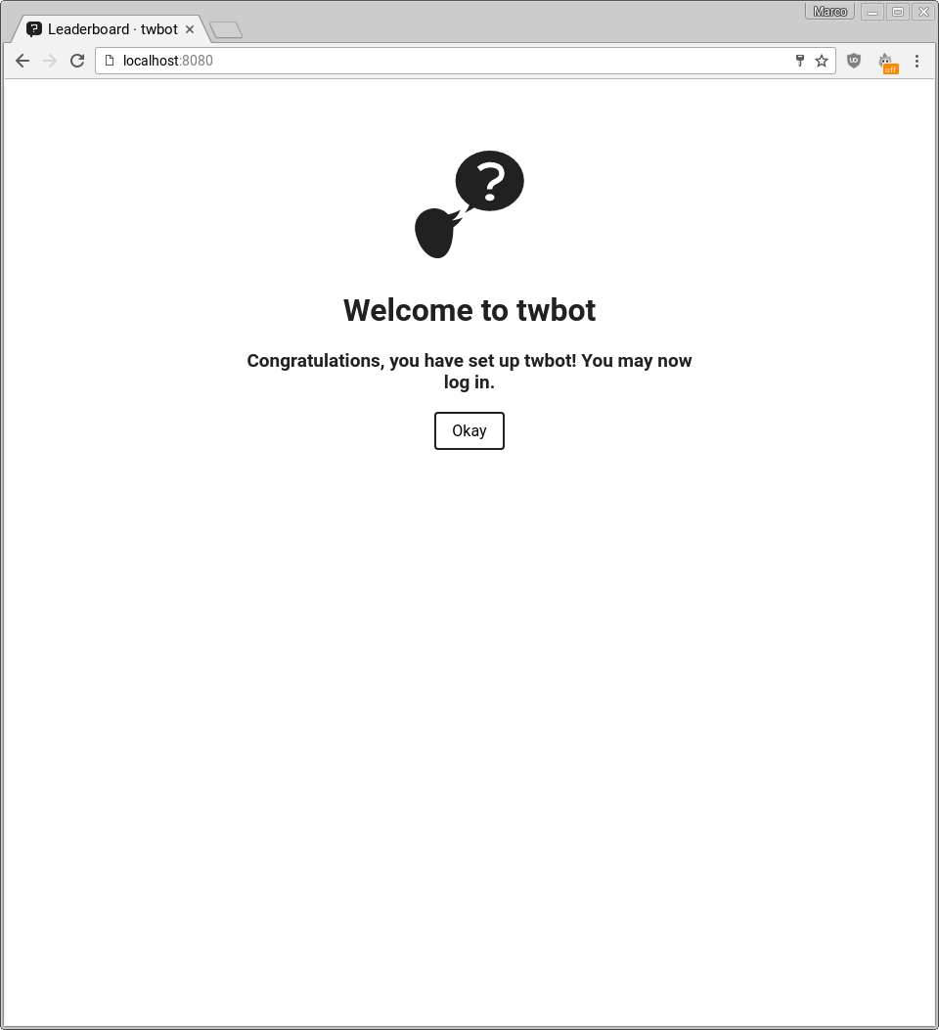
9 | Username and password fields empty on login page | Error that fields are required | Error that fields are required | 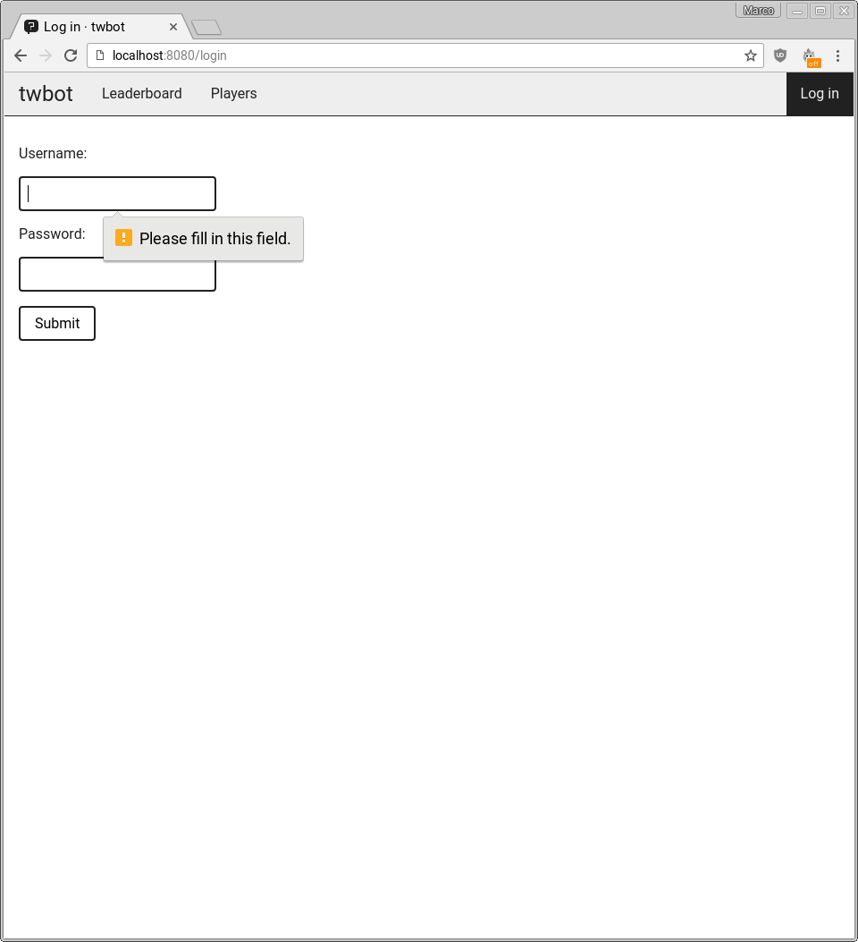
10 | Password field empty on login page | Error that password field is required | Error that password field is required | 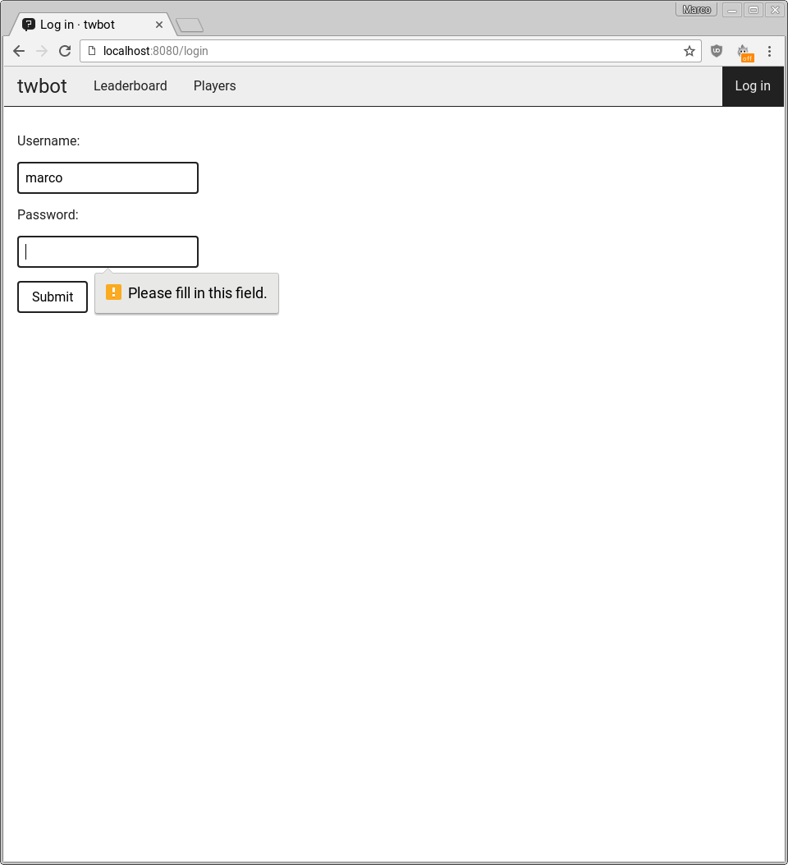
11 | Username incorrect on login page | Error that username is incorrect | Error that login is incorrect | 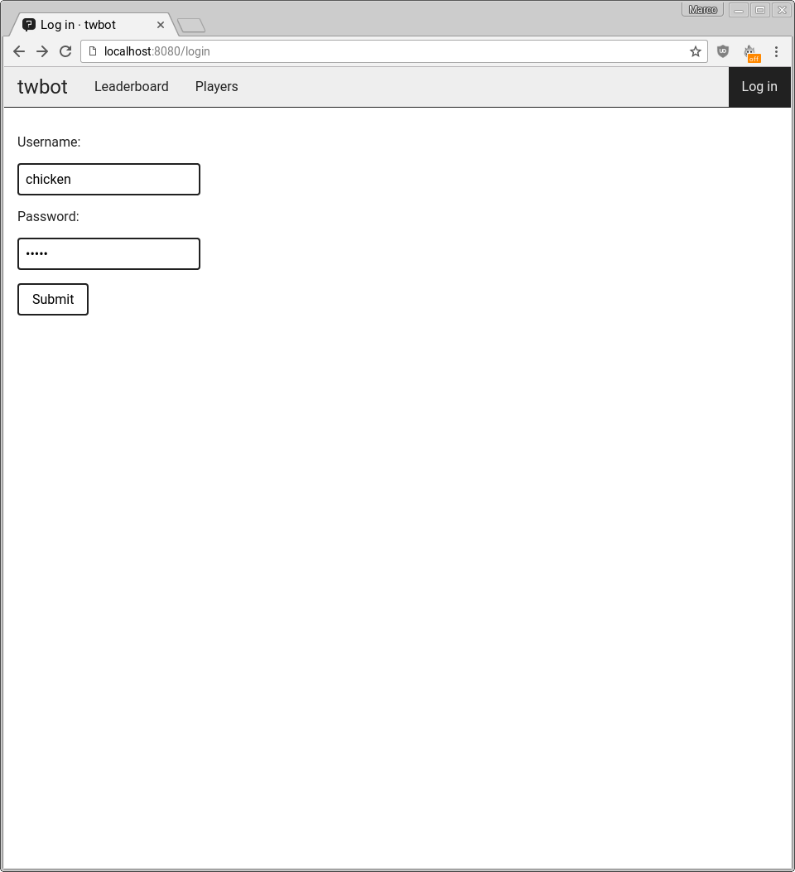  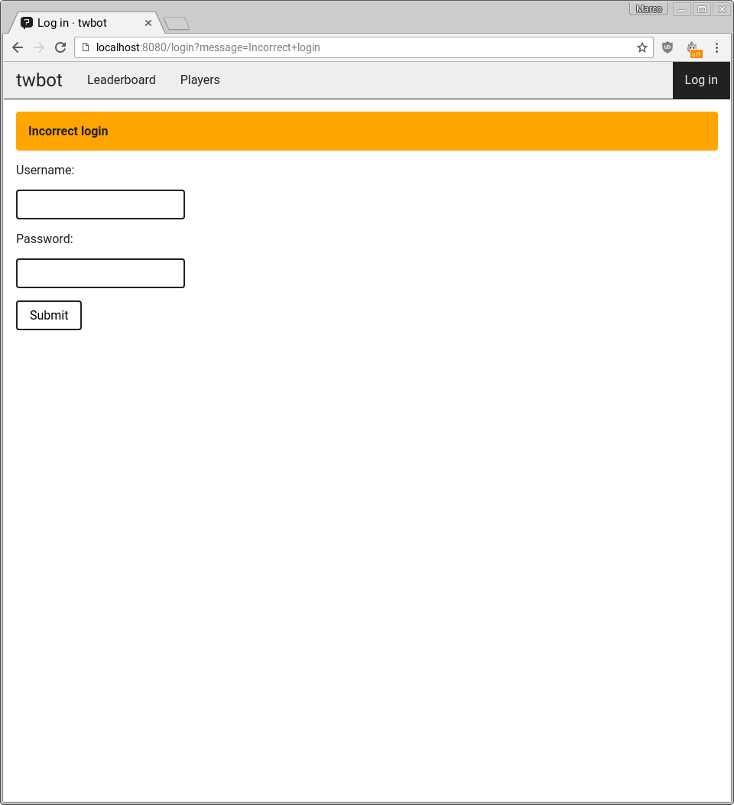
12 | Password incorrect on login page | Error that password is incorrect | Error that login is incorrect | 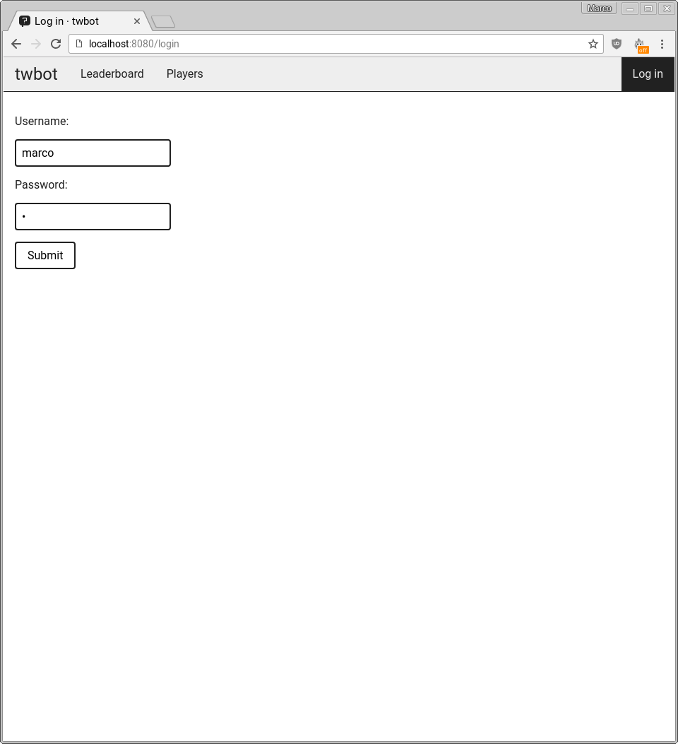
13 | Correct username and password on login page | Redirects to questions page | Redirects to questions page | 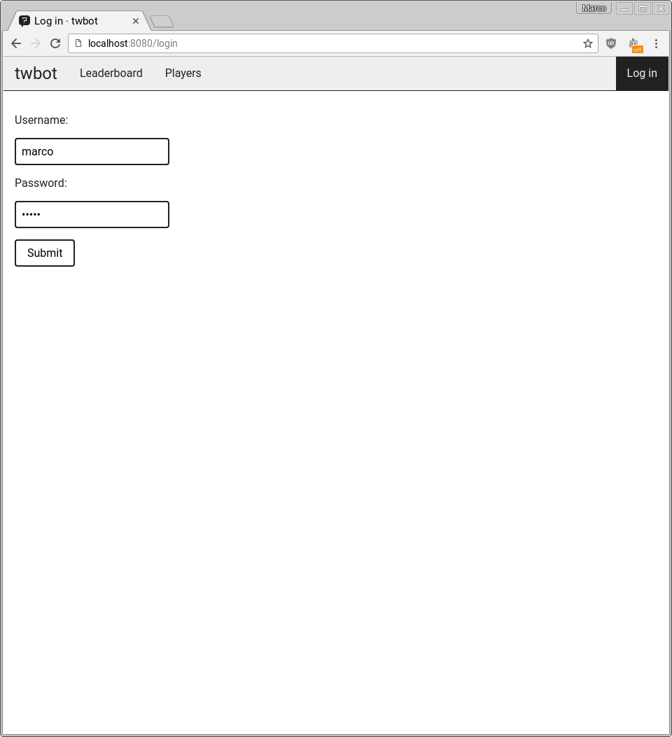  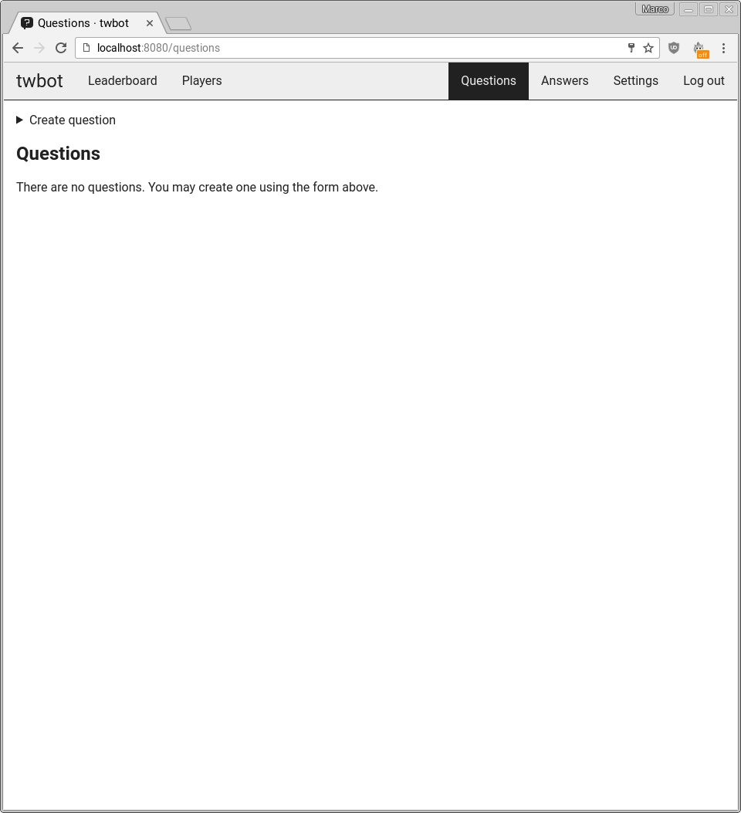
14 | Empty question field on questions page | Error that question field is required | Error that question field is required | 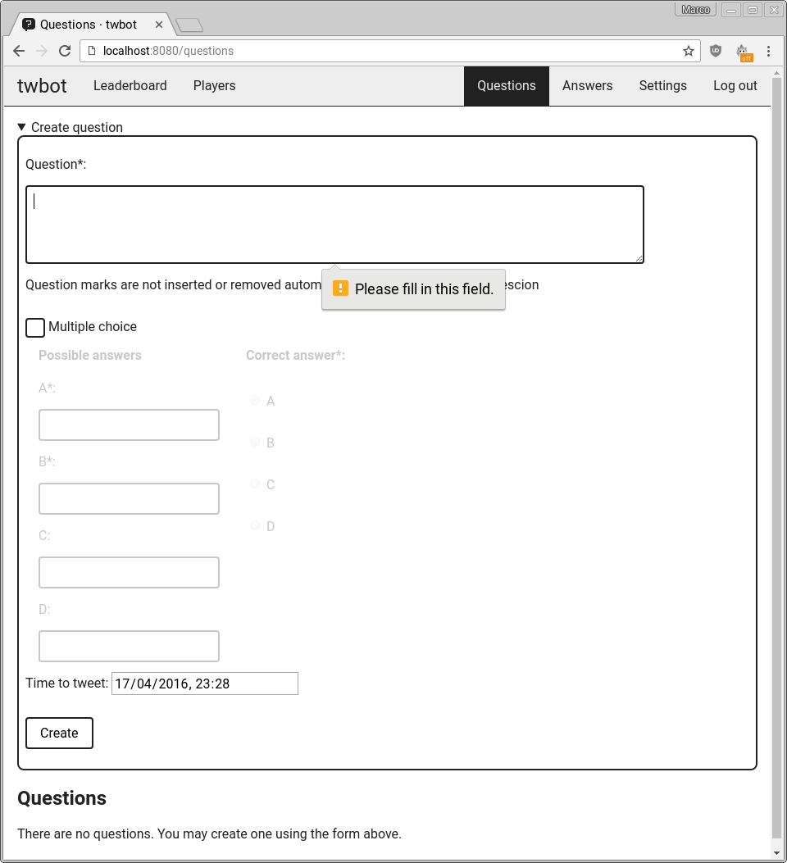
15 | Question field non-empty | Creates question | Creates question | 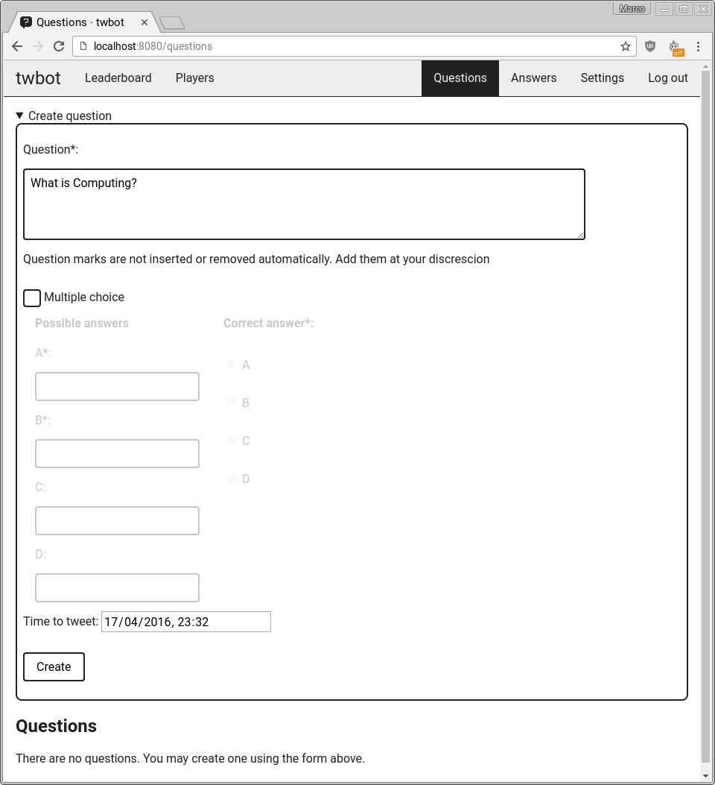  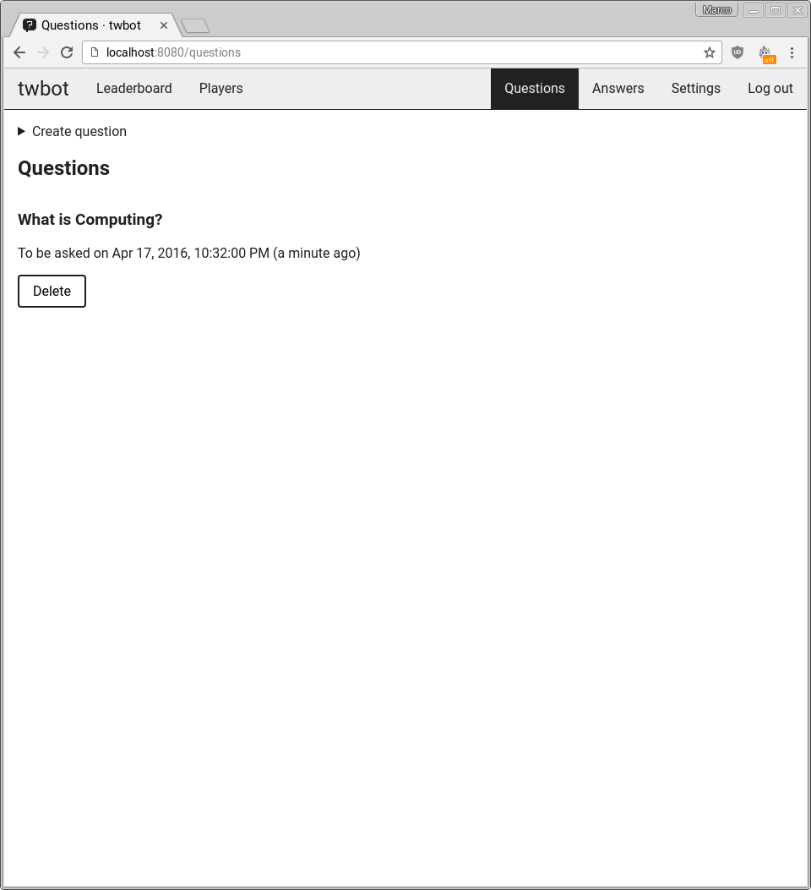
16 | Multiple choice question with 0 possible answers | Error that possible answer fields are required | Error that possible answer fields are required | 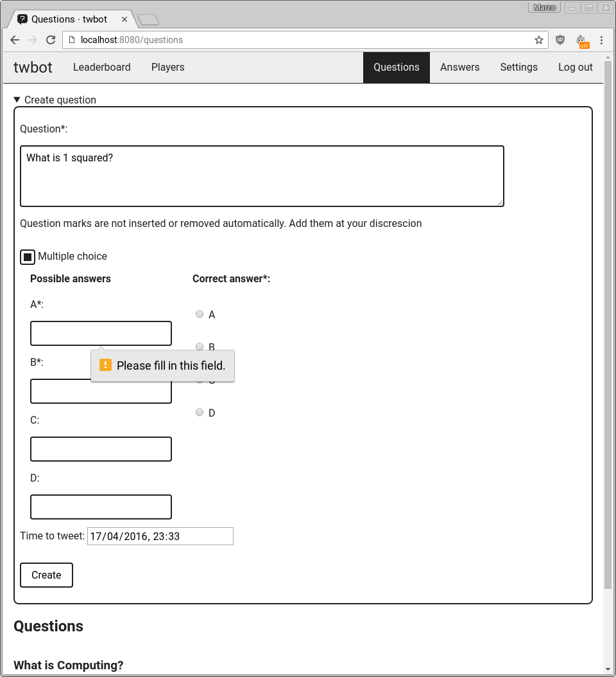
17 | Multiple choice question with 1 possible answer | Error that one more possible answer must be entered | Error that one more possible answer must be entered | 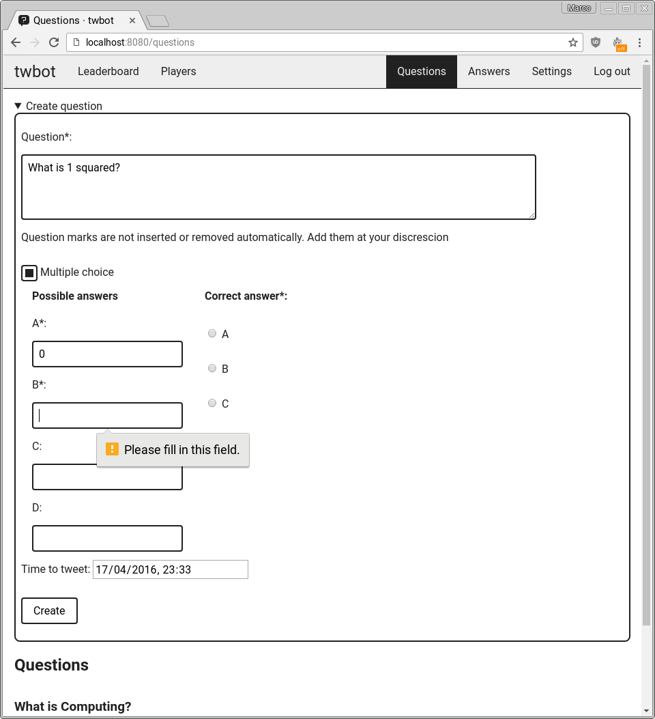
18 | Multiple choice question with 2 possible answers and no correct answer specified | Error that a correct possible answer must be specified | Error that a correct possible answer must be specified | 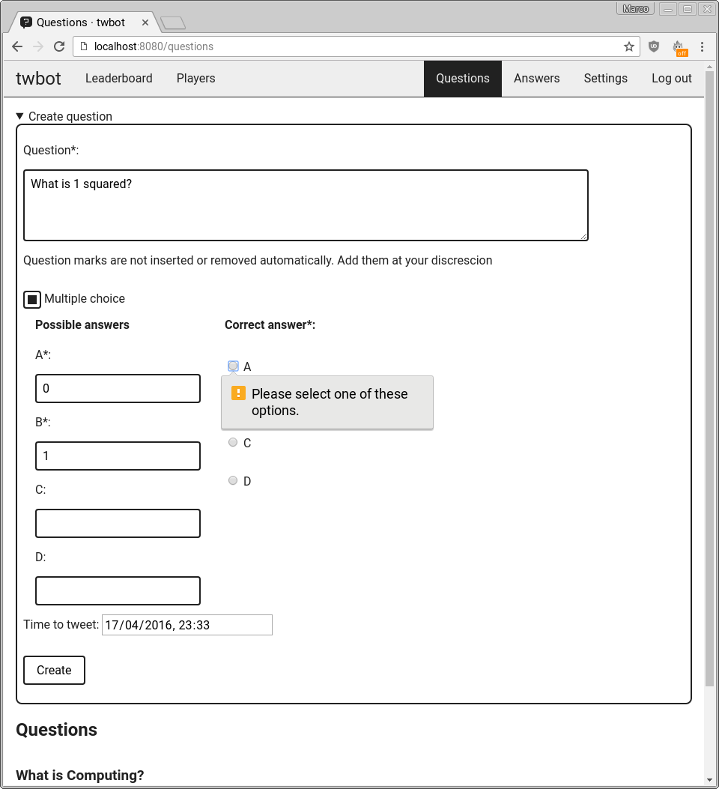
19 | Multiple choice question with 2 possible answers and non-existent correct answer specified | Error that correct possible answer does not exist | Error that correct possible answer does not exist | 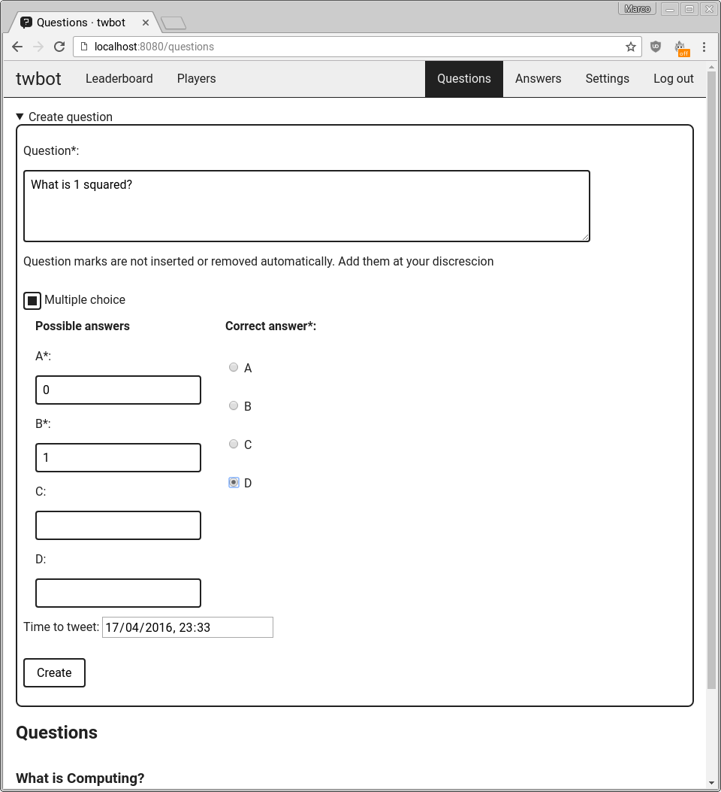  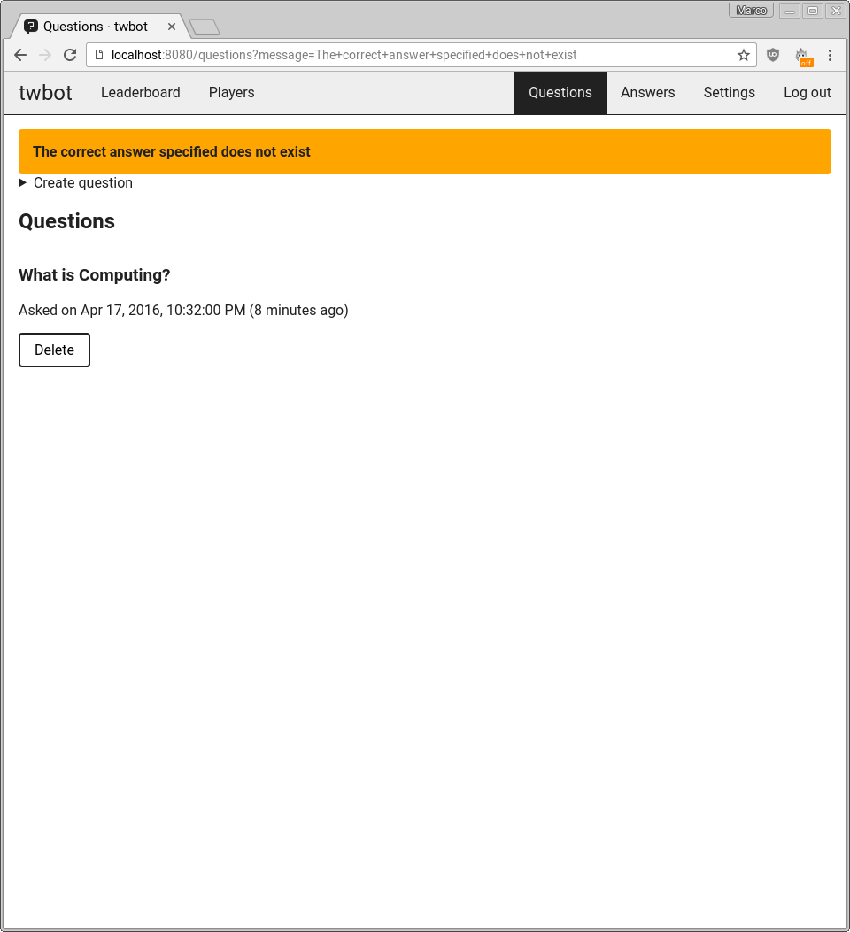
20 | Multiple choice question with duplicate possible answers and correct answer specified | Error that duplicate answers given | Error that duplicate answers given | 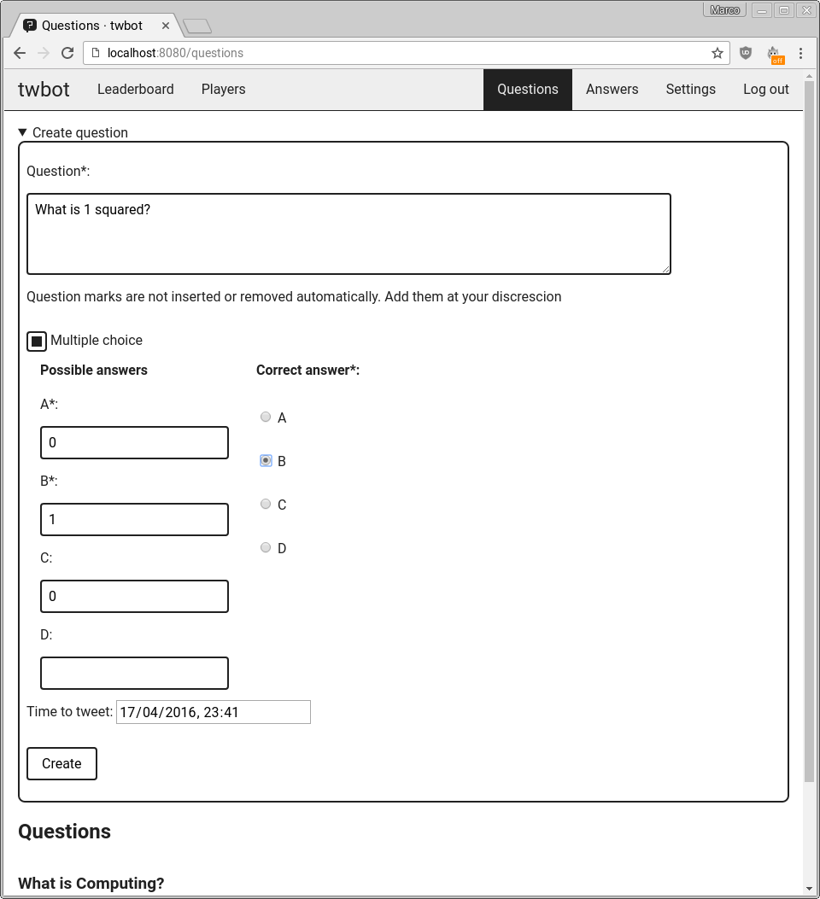  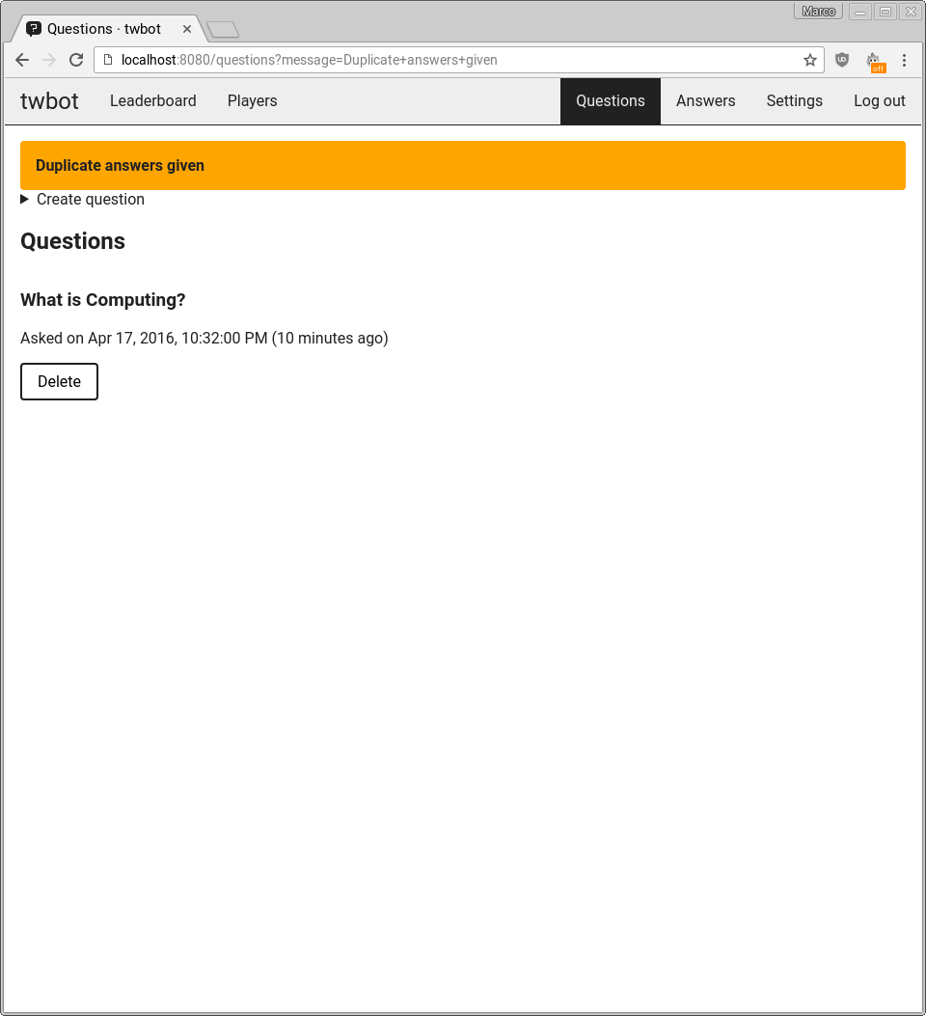
21 | Delete question | Question is deleted | Question is deleted | 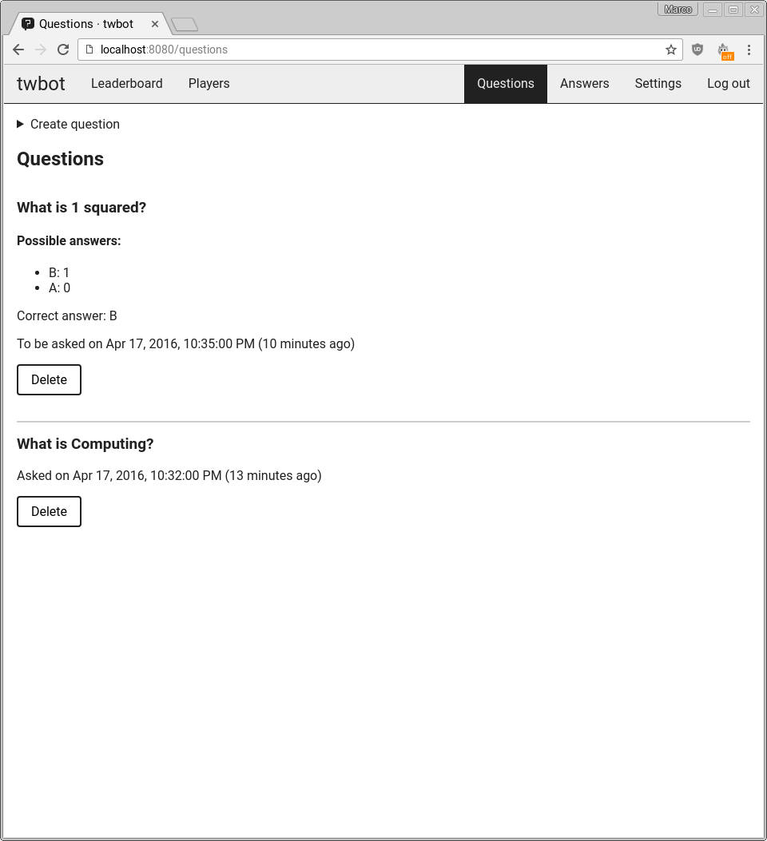  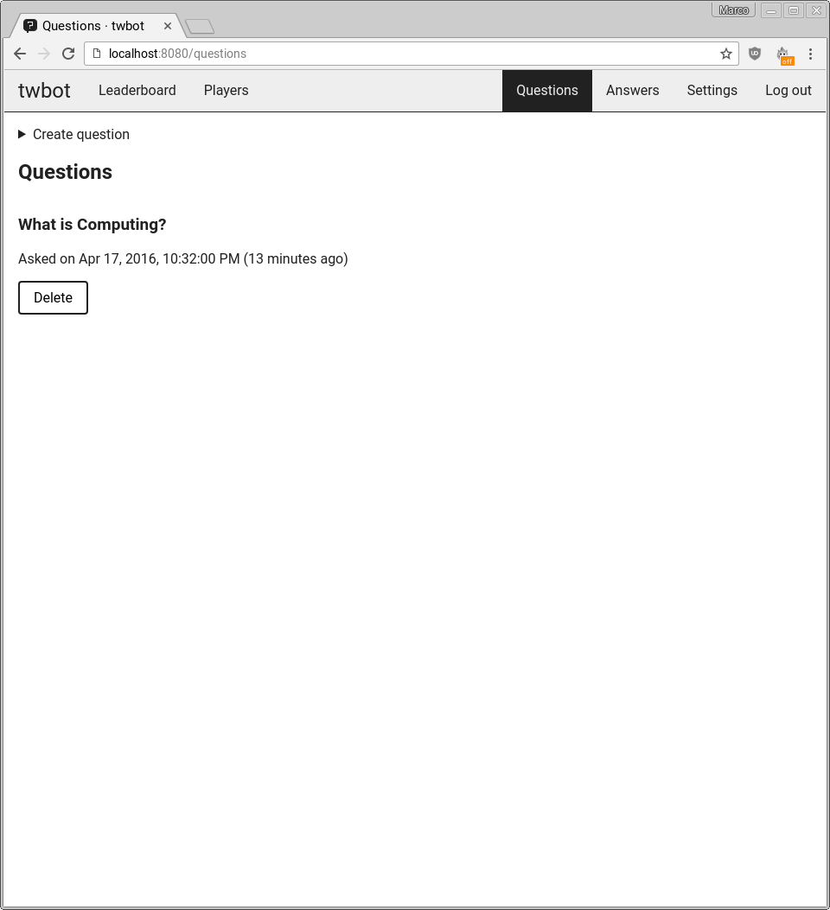
22 | Wait a maximum of 15 minutes for question to be tweeted | Question is tweeted | Question is tweeted | 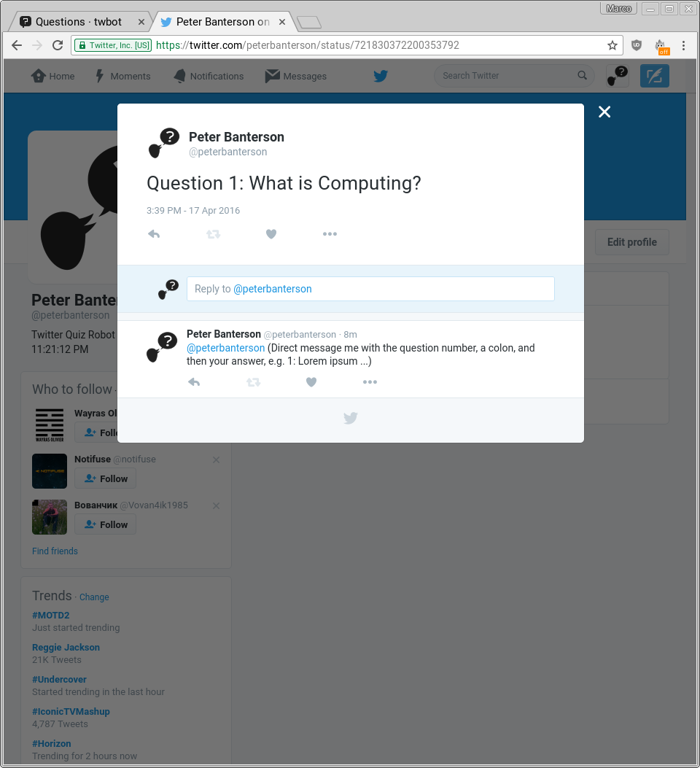
23
24
25

System maintenance
Your text here

System overview
Your text here

Algorithms (or alternative way to document solution)
Your text here

Annotated listings/screens showing key parts of the program
Your text here

Objects, Methods and Data Structures
Your text here

Appraisal

Evaluation of objectives
Your text here

Further development
Your text here

User feedback
Your text here

Analysis of user feedback
Your text here

