**3.1 printReportHeadings (inout myFile as File)**

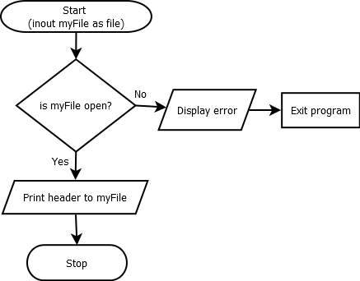

**3.2 initializeAccumulators (inout totals as Record)**

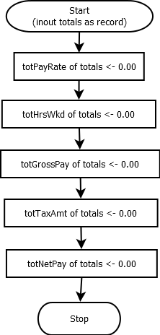

**3.3 inputEmployeeData (inout myEmployees as Array, inout empNum as Integer)**

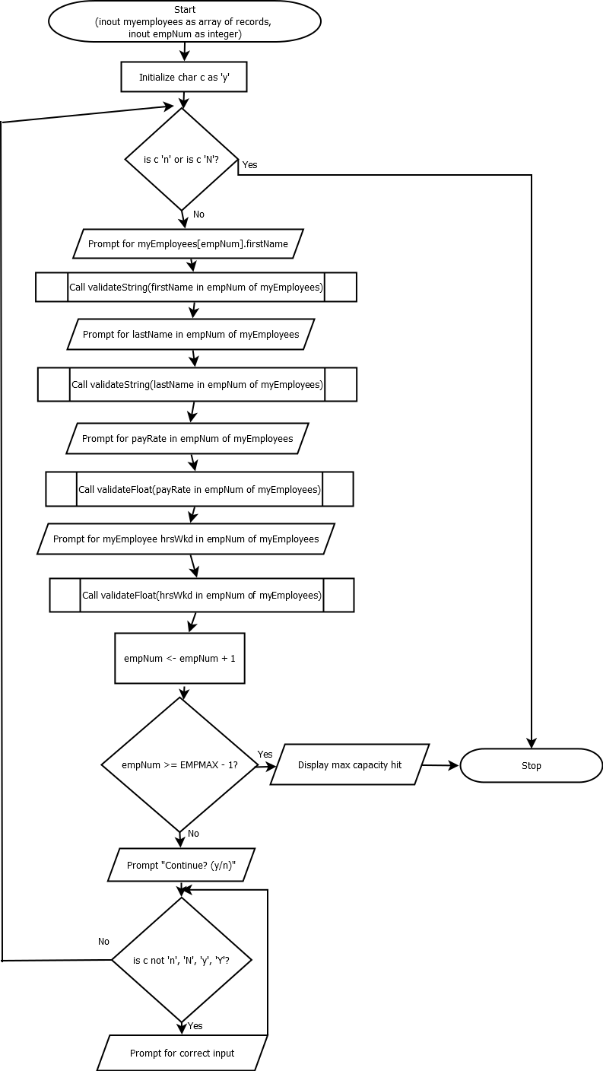

**3.3.1 validateString (inout name as String)**

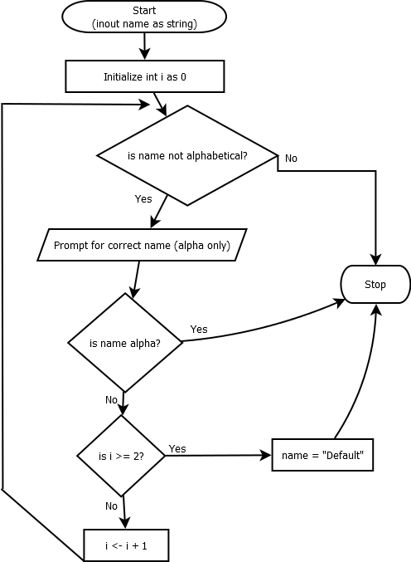

**3.3.2 validateFloat (inout value as Real)**

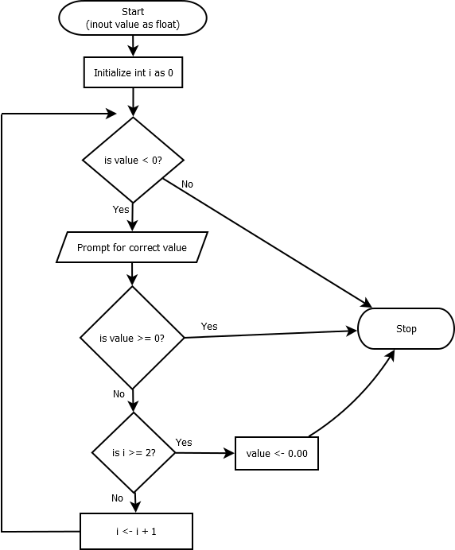

**3.4 calculateGross (inout myEmployees as Array, in empNum as Integer)**

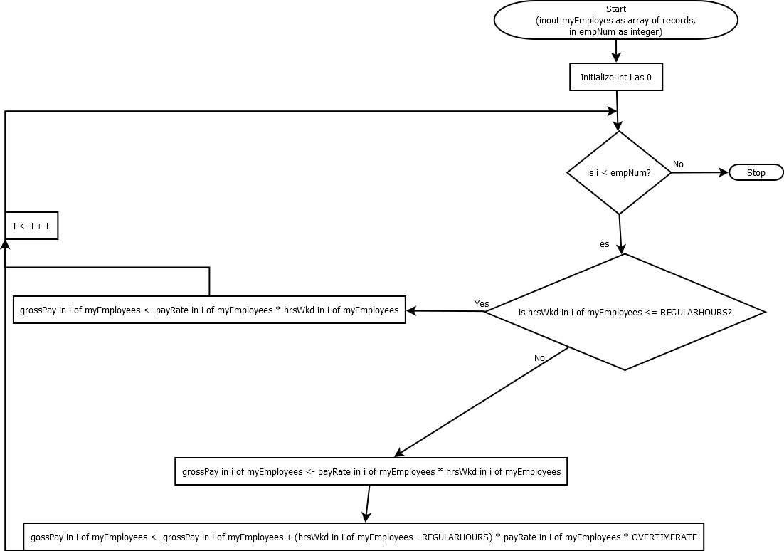

**3.5 calculateTax (inout myEmployees as Array, in empNum as Integer)**

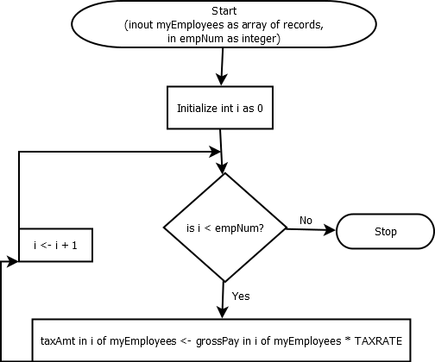

**3.6 calculateNetPay (inout myEmployees as Array, in empNum as Integer)**

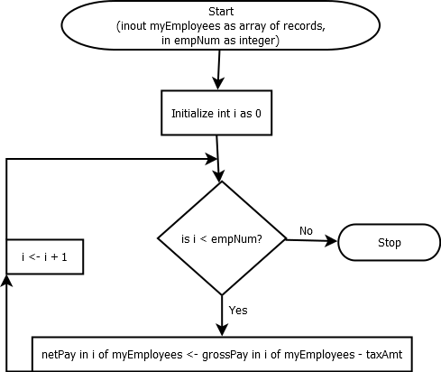

**3.7 accumulate(in myEmployees as Array, in empNum as Integer, inout totals as Record)**

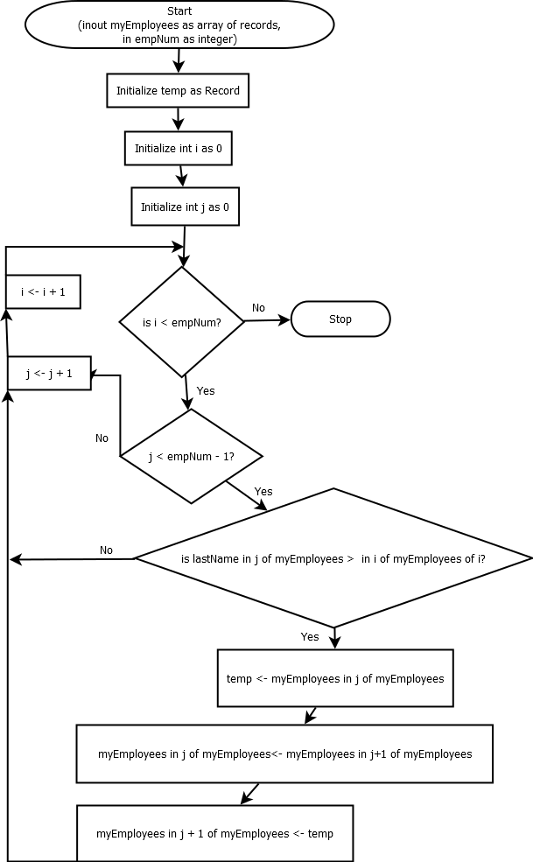

**3.8 sortData (inout myEmployees as Array, in empNum as Integer)**

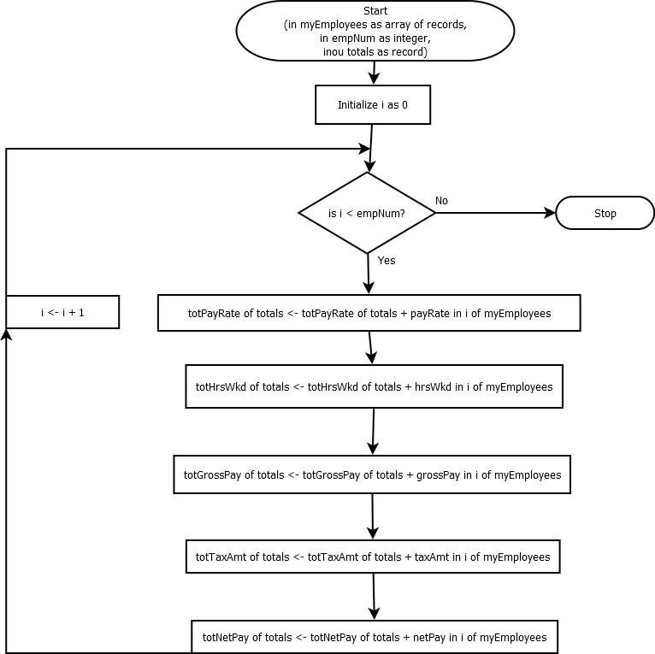

**3.9 printReport (in myEmployees as Array, in empNum as Integer, in totals as Record, inout myFile as File)**

