Group Members: IT401

Flores, Noah  
Manimtim, Robbie  
Ollero, Marco

**Database Design**

**FLAVORS TABLE**

**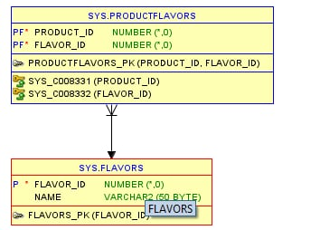  
  
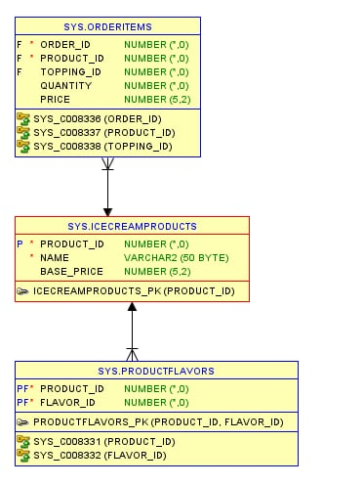  
  
  
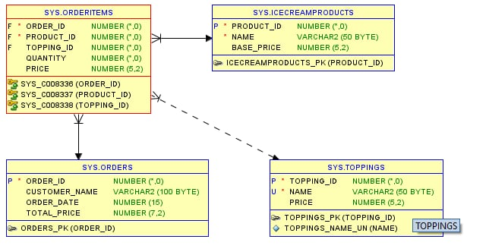  
  
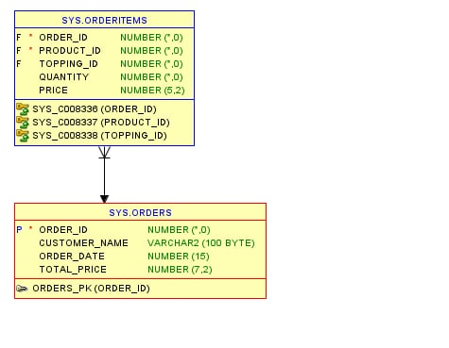  
  
  
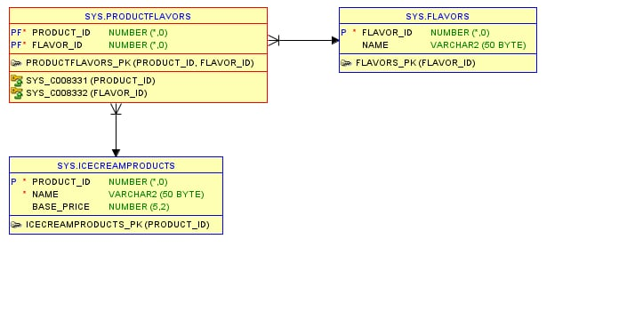  
  
  
  
  
  
  
  
  
  
  
  
  
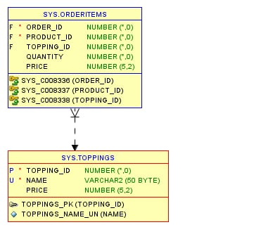**

**TOPPINGS TABLE**

**ICE CREAM PRODUCTS TABLE**

**PRODUCT TABLE**

**ORDERS TABLE**

**ORDERS ITEMS TABLE**

**USER_ACCOUNT TABLE**

