Dario LORENZONI

Raffele NOCERINO

Marco PETTORALI

Riccardo XEFRAJ

APPLICATION NAME

Task 0

Index

Description of the system 2

System requirements 2

Main actors 2

Use Cases 3

ER diagram 5

Entities: 5

Relations: 5

Tables 6

UML Diagram 7

Classes 7

User manual 7

## Description of the system

The main purpose of this project is to provide to the students of a university a booking system for using computers in informatics rooms of the campus in the spare time. Students can monitor the available computers; if a user decides to book a computer, the selected machine will provide a login screen in which only that student can put his university credentials; otherwise, the system will reject the session.

## System requirements

The system has to include these modules:

* A login service, so that the user can book computers in his name;
* A search engine, that shows the available computers at a certain moment;
* A booking system supported by a database, that stores the information about which machine is occupied and which one is not.

## Main actors

* User (a student)
* Computer (each one in the campus)

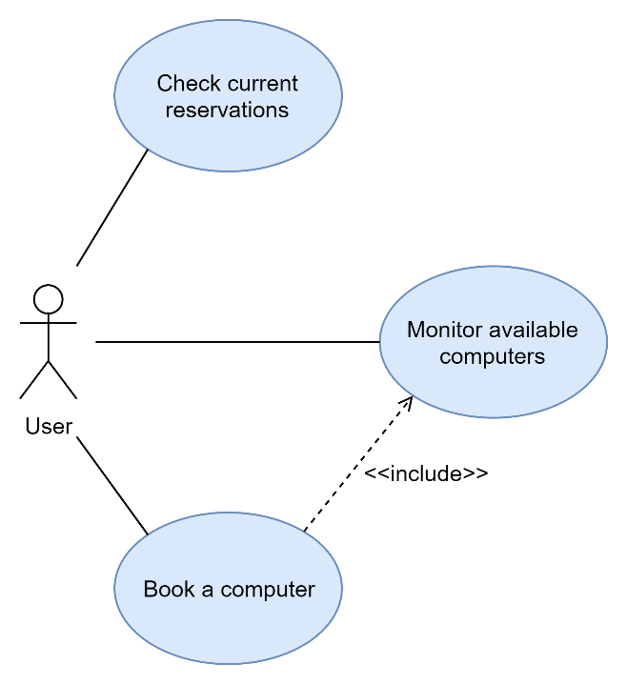

## Use Cases

1. The System shows to the user a login screen
2. The User inserts its university credentials

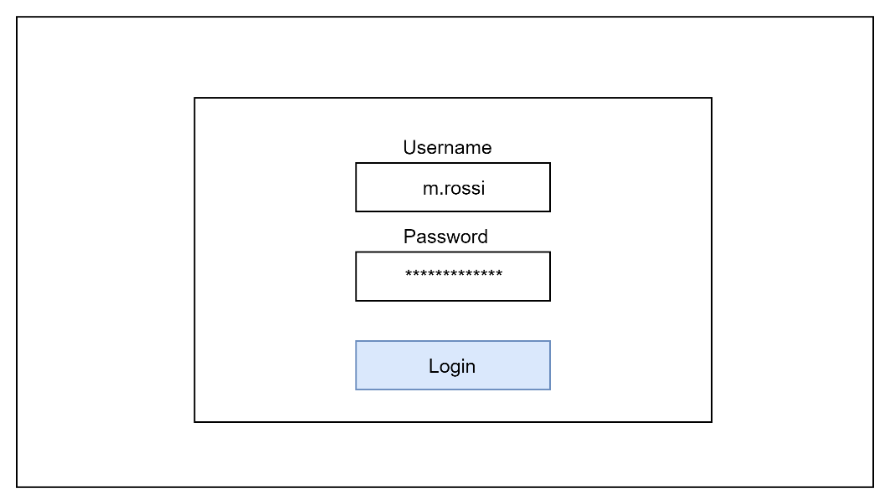

1. The System shows to the User the search form with the Date and Hour boxes
2. The System shows to the User its active reservations
3. The User inserts a Date and a Hour to book a computer

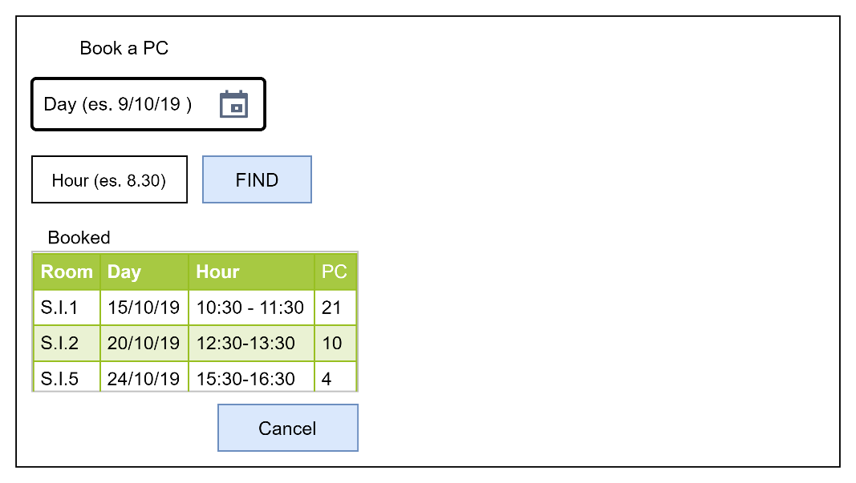

1. IF the User clicks on FIND button
   1. FOREACH available informatics rooms in the selected hour
      1. The System shows the name of the room
      2. The System shows how many computers are available in the room
      3. The System shows how many computer are already booked in the room

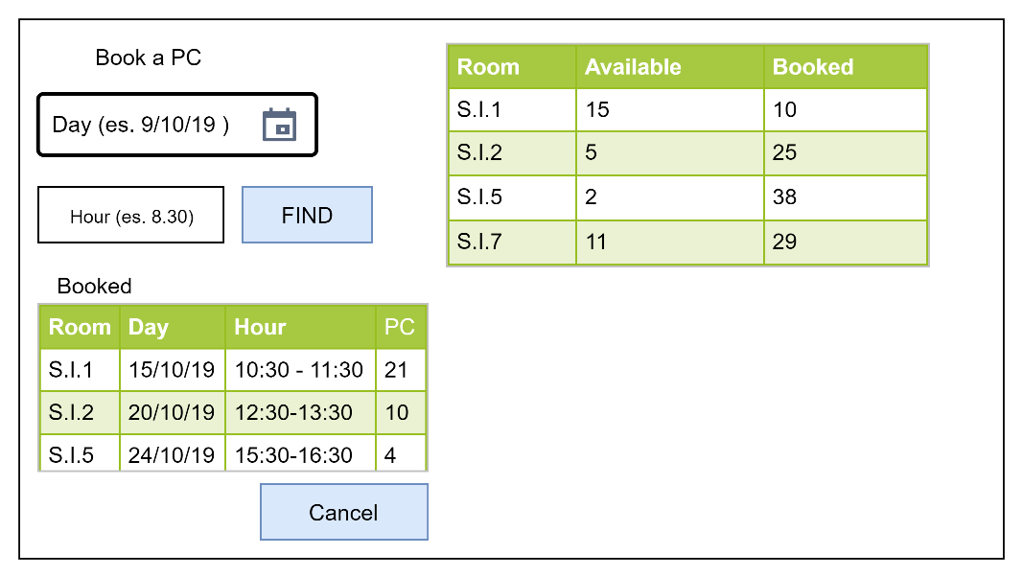

1. IF the Users clicks on a room
   1. The System shows a map of the available and not available computers

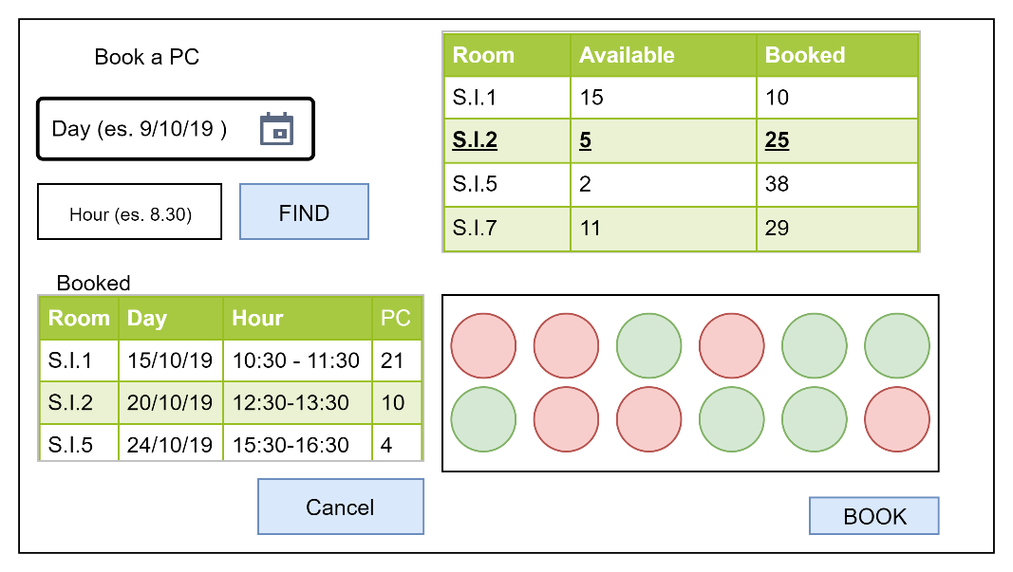

1. IF the User clicks on BOOK button
   1. The System reserves a computer for the user

## ER diagram

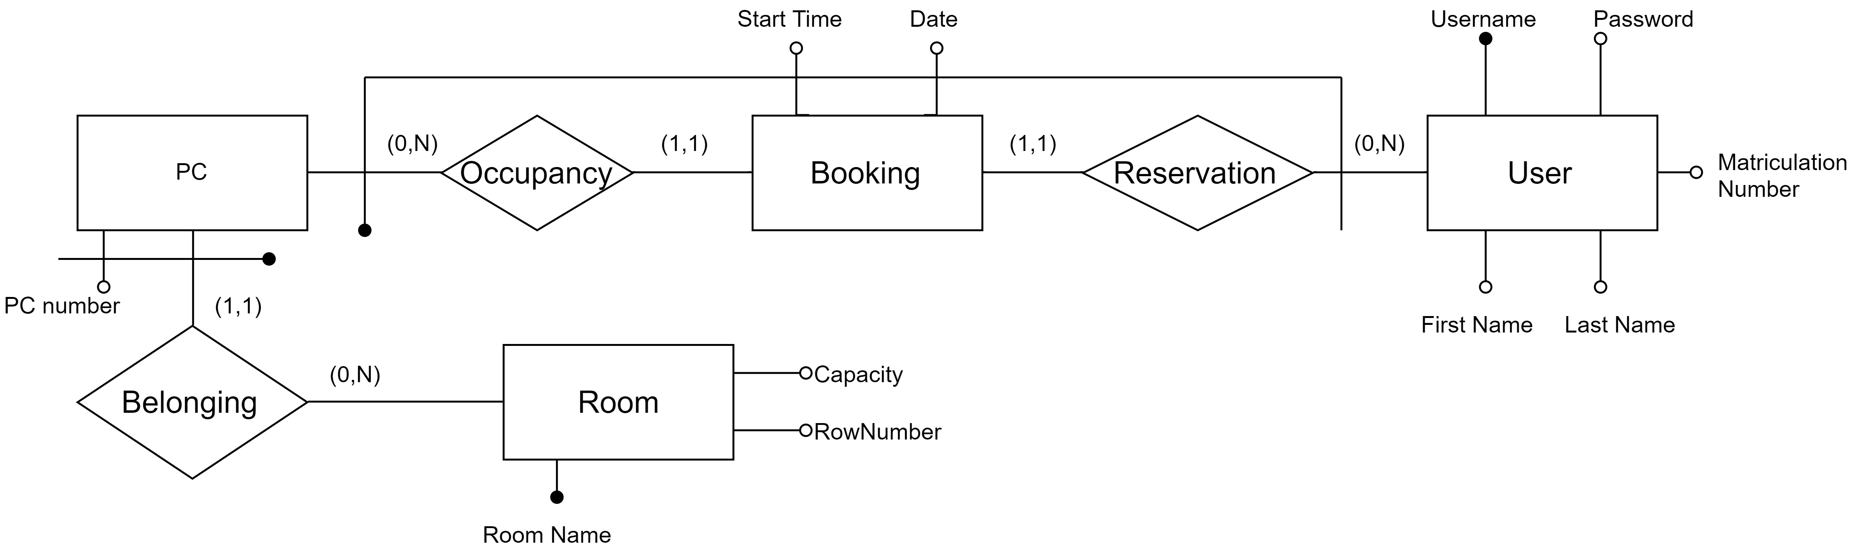

### Entities:

* PC: it collects the information about the name and the location of the computer in the college;
* Booking: it gathers all the reservations made by the students, by storing the users’ id, the selected machine’s id, and the date and time of the booking;
* User: it collects the users’ personal data, including their name, credentials and matriculation number;
* Room: it indicates name, shape and capacity of each informatics room in the campus.

### Relations:

* Occupancy: it connects a specific booking to the reserved pc
* Reservation: it connects a specific booking to the user who made it
* Belonging: it connects each PC to the room in which is collocated

## Tables

* **USER(Username, Password, First Name, Last Name, Matriculation Number)**
  + Username (primary key, string): it’s the university credentials’ username;
  + Password (string): it’s the university credentials’ username;
  + First Name (string): it’s the student’s name;
  + Last Name (string): it’s the student’s surname;
  + Matriculation Number (integer): it’s the student’s university id.
* **BOOKING(Username, Start Time, Date, PC Number, Room Name)**
  + Username (primary key, string): it’s the student’s id;
  + Start Time (primary key, time): it’s the time at which the PC was reserved;
  + Date (primary key, date): it’s the date on which the PC was reserved;
  + Pc Number (primary key, integer): it’s the reserved PC’s id;
  + Room Name (primary key, string): it’s the room in which the reserved PC is located.
* **PC(PC Number, Room)**
  + PC Number (primary key, integer): it’s the PC identifier in a certain room;
  + Room (primary key, string): it’s the name of the room in which the PC is located.
* **ROOM(Room Name, Capacity, Rows Number)**
  + Room Name (primary key, string): it’s the name of the room;
  + Capacity (integer): it represents how many PC are located in the room;
  + Rows Number (integer): it represents how many rows the room is divided in.

## UML Diagram

## Classes

## User manual