Dario LORENZONI

Raffele NOCERINO

Marco PETTORALI

Riccardo XEFRAJ

Workgroup Manager

Task 3

Index

Description of the system 2

System requirements 2

Functional requirements: 2

Non-functional requirements: 3

Main actors 3

Use Cases 3

Analysis Class Diagram 4

Data model 4

Classes 6

UML Diagram 8

Neo4j: 9

Suggested Working Group: 9

Leaders Ranking: 10

User manual 13

Login 13

Working with the application 13

Administrator case 13

User case 19

## Description of the system

The main purpose of our project is to provide a useful system for creating, managing and coordinate some working group that consist of some user that have to realize a project. The administrator of the system or rather the boss of the company has his own administrator panel where he can add new user, delete a user or create a new working group specifying also his dimension in terms of working user. The administrator will also specify the leader of the new working group selecting it from all the users of the system. The system will help the administrator on this choice giving a rank to the users, in order to do so the system will use some information about the past group headed by the user. The leader of each group will receive some application from the user for the team previously created and he can accept or discard them based on the number of works on which the users are already working or other information. The user instead accessing is own panel can visualize on which job he/she is already working, the suggested working group (not full) and some information about the completed job. Furthermore, the user can visualize all the group that he/she led (separated from the ones in which he/she work but that he/she doesn’t lead). A user can report the completion of his work for a team. If a user wants to join a new working group, he/she can send an application to the leader of the group and wait for his/her acceptance.

## System requirements

### Functional requirements:

*USER:*

* A user can login to the system using a login with the credential given by his/her service in order to visualize the eventually work in progress, the past work or send a join team request;
* A user can see in the application all its work in progress with the information about the working group, it’s passed work and the not full working group suggested;
* A user can mark his/her part of the work for a specific working group as complete;
* A user can send an application for being part of a suggested working group;
* A user can see the application from other users to the working group that he/she led;
* A user that is the leader of a working group can accept or discard the application from other users to the working group that he/she led.

*ADMINISTRATOR:*

* The administrator can login to the service;
* The administrator can view the list of all users;
* The administrator can add a new user putting the personal information in a sing-up service obtaining the username that will allow them to use the application;
* The administrator can create a new team setting its name and its dimension (number of users allowed) and elect the leader of the new group;
* An administrator can delete a user from the system;
* The administrator can visualize the users’ rank

### Non-functional requirements:

* Quality: every time an error occurs the system will show an error message which explain the problem's reason;
* Response Time: the database chosen and used by the application is developed in order to get a low response time;

## Main actors

* User
* Administrator

## Use Cases

## Analysis Class Diagram

## Data model

In our application we have used a graph database, called Neo4j, that allowed us to obtain some important advantages. We have created a database that store data in the best suitable manner for our proposal obtaining high performance representing our domain as a network of connected entities and storing some information about the relationship between different entities. An example of a part of our DB represented as a graph is the following:

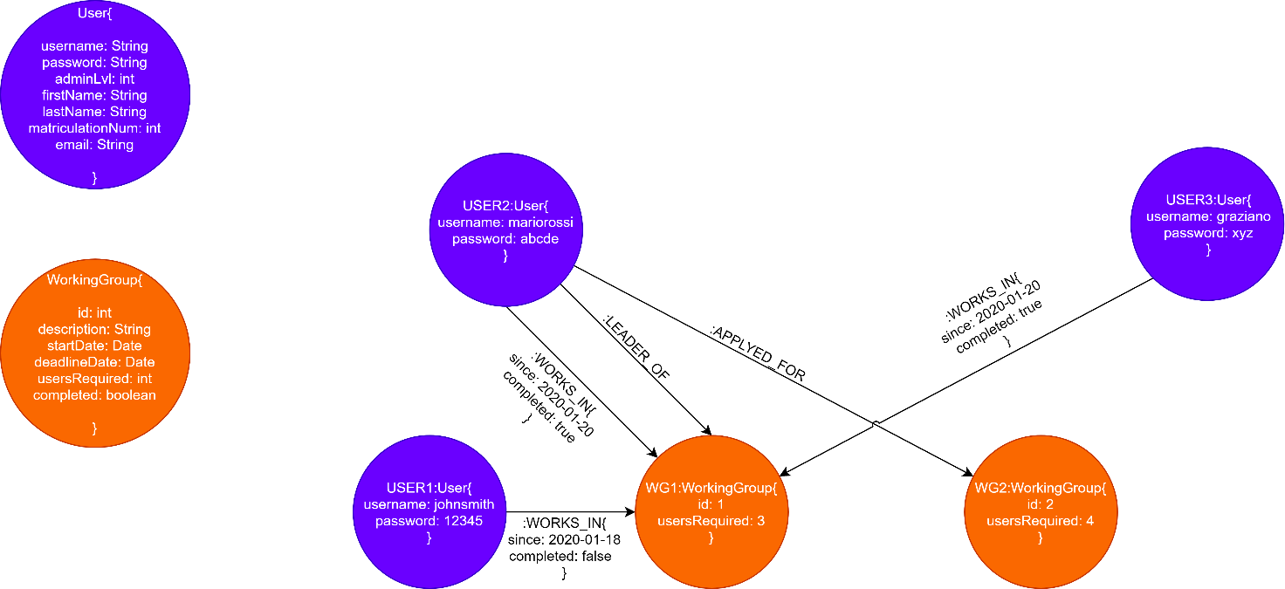

In our database, called Graph, we store 2 types of nodes :

* **Users**: in a node of this type we store the information about the users of the system. A tabular example of the information stored in this node is the following:

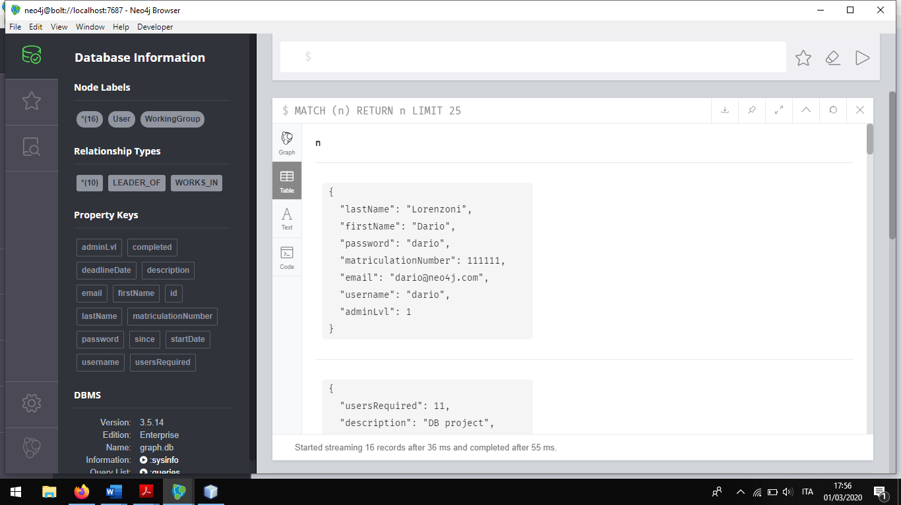

* **Working Group**: in this node we store the information about the working groups created by the administrator. Another tabular example of the information stored in this type of nodes is the following:

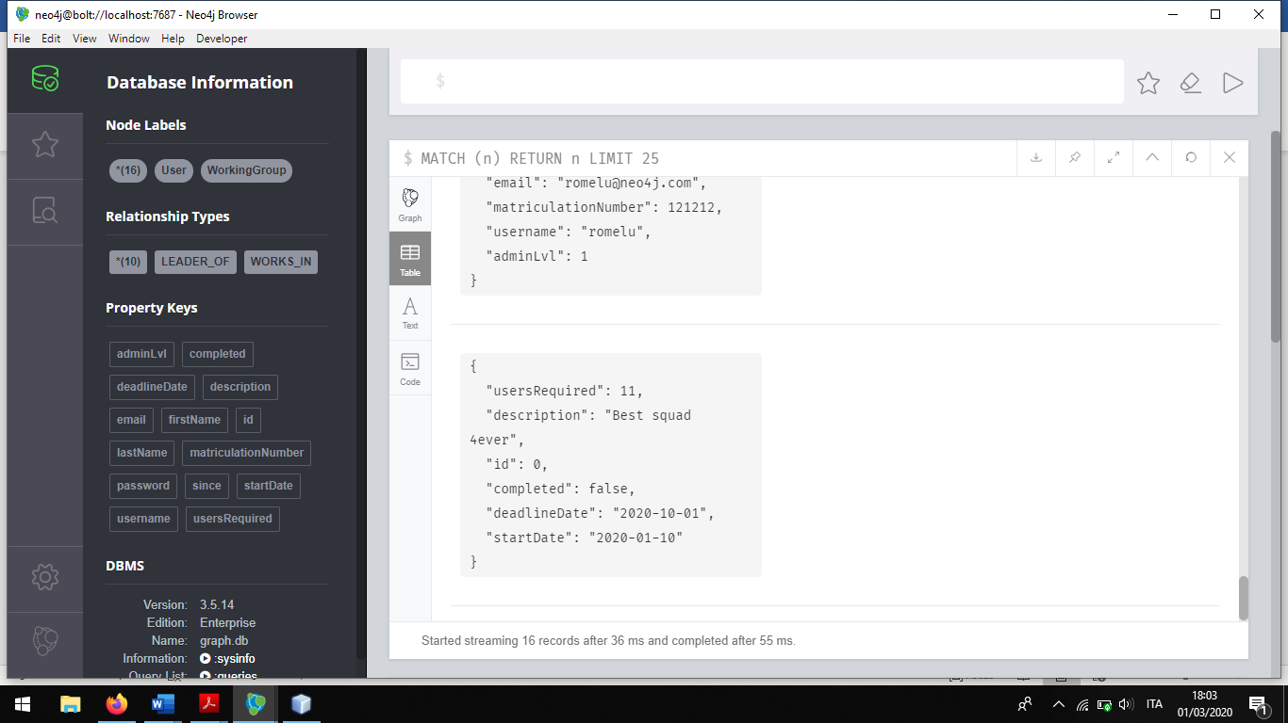

## Classes

|  |  |  |
| --- | --- | --- |
| Front-end |  |  |
| **AdminPaneGUI** | This class implement the admin control panel in which the administrator can add or remove a user, can add a new group with its leader and visualize the user’s rank. |
| **LoginPaneGUI** | That class implements the panel that can be used to perform the login |
| **UserPaneGUI** | This class implements the user panel here the user can see all the information about all its work in progress, it’s passed work and the not full working group suggested. Moreover, the user can mark a work as complete, send an application for a working group and eventually visualize and accept or discard the request for joining an application that (s)he led. |
| **ApplicationWorkingGroupTable** | This class implements the table present in the user panel used to visualize all the application for the groups that the user led. |
| **Ranking Table** | This class implements the table that the administrator visualizes in which each user and its associated rank value is reported. |
| **SuggestedWorkingGroupTable** | This class implements the table present in the user panel in which are reported the list of the suggested working group and their information. |
| **UserOverviewTable** | This class implements the table present both in the user panel and in the administrator panel in which the user’s information are shown. |
| **WorkingGroupTable** | This class implements the table present both in the user’s panel and in the administrator panel that is used in order to visualize the information about the working groups. |
| Middleware | **MainApp** | MainApp is the main class of the application. It contains the main method and the methods for the initialization of the application. |
| Back-End | **ApplicationWorkingGroup** | This class represent an application for a working group with its related information. |
| **Neo4JManager** | That class contains all the method used to communicate with the database and used to perform the queries. |
| **SuggestedWorkingGroups** | This class represent a suggested working group with all its information. |
| **User** | This class represents a user with all his/her information. |
| **UserRanking** | This class represents the ranking of a user and the associated useraname. |
| **WorkingGroup** | This class represents the working group and all its information |

## UML Diagram

## Neo4j:

The database used in our application is Neo4j we have used this graph database since it is suitable to represent our data as a network of connected entities that are linked with relationship. Moreover, some specific operation performed in our application require to rapidly traverse the path between to user. This application was designed having in mind a small/medium enterprise where the number of users, project carried out and the dimension of the working group is limited and this help us to overcome the limitation of the graph database that in general are difficult to scale. The main queries that benefits from the usage of a graph database are the following:

### Suggested Working Group:

As mentioned before one of the operation that our application need to perform is show to a specific user the list of the suggest working group, in order to identify those working group we perform the following query on the database:

String query = ""+ "MATCH (u1:User)-[:WORKS_IN]->(w1:WorkingGroup)<-[:WORKS_IN]-(u2:User)-[:WORKS_IN]->(w2:WorkingGroup) "

+ "WHERE u1.username = $name "

+ "AND NOT (w1 = w2) "

+ "RETURN DISTINCT w2.id, w2.description, w2.startDate, w2.deadlineDate, w2.usersRequired, w2.completed, count(w2.id)";

In this case the $name will be afterwards properly set to the username of the specific user. So, in order to retrieve the suggested working group, the query search for the groups with at least a member that share a group with our user and return it. Moreover, in order to give an affinity degree, the query count for each working group how many of its members have been “working group mates” with our user. If instead we realized our database as a relational database, the part interested by this query would be the following:

And the query just exposed above can be translated in SQL as follow:

SELECT WG.*,COUNT(*) as AffinityDegree

FROM working_group_member as W1

**JOIN** working_group_member as W2

ON W1.id_working_group = W2.id_working_group /*I need the first join in order to get the members of the user's working groups*/

**JOIN** working_group_member as W3

ON W2.username = W3.username /*I need the second join in order to get the working group into which the user find above work*/

**JOIN** working_groups as WG

ON WG.id_working_groups = W3.id_working_group

WHERE W1.username = 'username' AND

NOT W2.username = 'username' AND

W3.id_working_group NOT IN(

/*I need in order to find the group in which our user dosen't work*/

SELECT W4.id_working_group

FROM working_group_member as W4

WHERE W4.username = 'username'

)

GROUP BY W3.id_working_group;

As we can see the same query that in Neo4j was very simple become instead more complex in particular we have to use 3 different join operation and one nested table and this justify our choice of using a graph database.

### Leaders Ranking:

The system will also help the administrator to choose among all the possible users the ones that are more suited for leading a group, this is done computing a ranking degree for each user that at least once was elected leader of a group. The ranking degree is computed as the average of the ratio between the number of the members of the working group that (s)he led and the number of requested user of that group so we measure how the users are encouraged to join a working group with the user as leader. This results in a complex function that can be divided into three parts:

1. For each user we first find the list of working groups that (s)he led in particular we create a map that associate at each username the list of those working groups and this is stored inside the variable *user_group:*

public static Map<User, Double> loadLeadersRanking() {

try (Session session = driver.session()) {

Map<User, Double> ret = new HashMap<>();

Map<User, List<WorkingGroup>> user_group = new HashMap<>();

Map<Integer, Double> group_percentage = new HashMap<>();

Map<String, Object> params = new HashMap<>();

session.readTransaction((Transaction tx) -> {

String query = "MATCH (u:User)-[:LEADER_OF]->(w:WorkingGroup) "

+ "RETURN DISTINCT u.username,u.password,u.adminLvl,u.firstName,u.lastName, "

+ " u.email "

+ ",w.id,w.description,w.startDate,w.deadlineDate,w.usersRequired,w.completed ";

StatementResult sr = tx.run(query);

while (sr.hasNext()) {

Record rec = sr.next();

int id = rec.get(6).asInt();

String descr = rec.get(7).asString();

String d1 = rec.get(8).asLocalDate().toString();

String d2 = rec.get(9).asLocalDate().toString();

int userReq = rec.get(10).asInt();

boolean compl = rec.get(11).asBoolean();

WorkingGroup temp = new WorkingGroup(id, descr, d1, d2, userReq, compl);

String usern = rec.get(0).asString();

String passw = rec.get(1).asString();

int adminLvl = rec.get(2).asInt();

String first = rec.get(3).asString();

String last = rec.get(4).asString();

String email = rec.get(5).asString();

User u = new User(usern, passw, adminLvl, first, last, email);

boolean b = false;

for (Map.Entry<User, List<WorkingGroup>> entry : user_group.entrySet()) {

if (entry.getKey().getUsername().equals(u.getUsername())) {

b = true;

entry.getValue().add(temp);

break;

}

}

if (!b) {

user_group.put(u, new ArrayList<WorkingGroup>());

user_group.get(u).add(temp);

}

}

1. Then for each user we take into consideration all it’s working group and we first compute the ratio between the actual member of the group and the member needed in this group and then we compute the average of this ratios. And so, after this second point we have computed the leader rank for each user.

String query2 = "MATCH (u:User)-[wi:WORKS_IN]->(w:WorkingGroup) "

+ "RETURN DISTINCT w.id,w.usersRequired,count(wi) ";

StatementResult sr1 = tx.run(query2);

while (sr1.hasNext()) {

Record rec = sr1.next();

int id = rec.get(0).asInt();

double req = rec.get(1).asDouble();

double count = rec.get(2).asDouble();

double percentage = (count / req) * 100;

group_percentage.put(id, percentage);

}

return 1;

});

for (Map.Entry<User, List<WorkingGroup>> entry : user_group.entrySet()) {

double somma = 0;

List<WorkingGroup> appoggio = entry.getValue();

for (int i = 0; i < appoggio.size(); i++) {

somma += group_percentage.get(appoggio.get(i).getId());

}

somma = somma / appoggio.size();

if (somma != 100) {

ret.put(entry.getKey(), somma);

}

}

1. Finally, we order the list of users in the system in the leader ranking descending order and return it to show this list to the administrator in its panel.

List<Entry<User, Double>> list = new ArrayList<>(ret.entrySet());

list.sort(Entry.comparingByValue());

Map<User, Double> result = new LinkedHashMap<>();

for (Entry<User, Double> entry : list) {

result.put(entry.getKey(), entry.getValue());

}

return result;

}

}

## User manual

### Login

When the application is launched, the system will display a login form. The user has to put in its username and password and then to click on “LOGIN” button. If desired, the user can also see its password as plain text by clicking on the “Show/Hide Password” radio button.

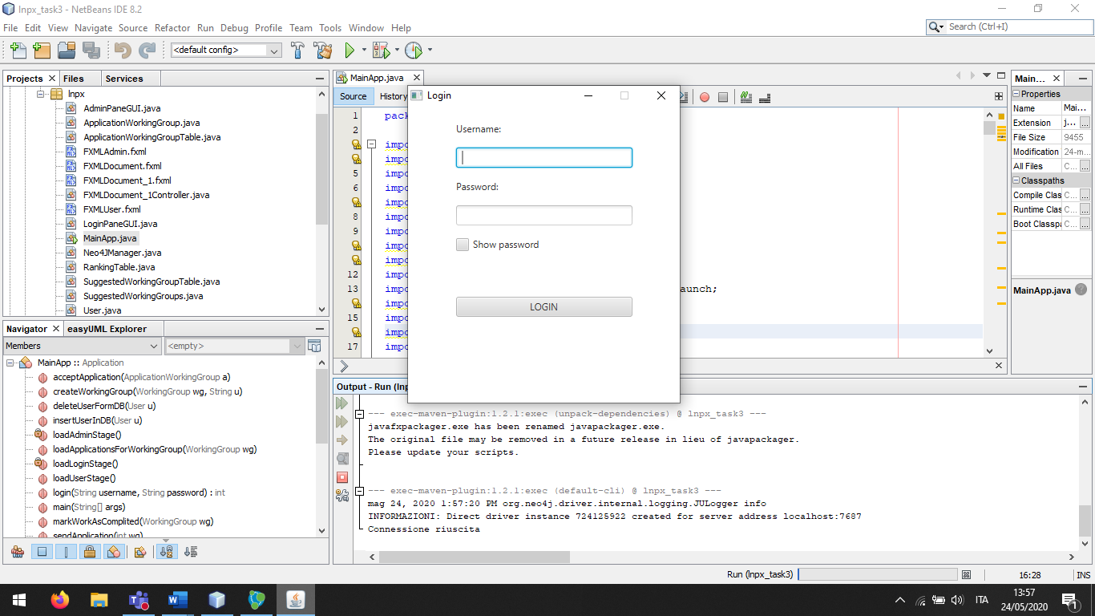

### Working with the application

### Administrator case

If the user is the administrator of the application, the main page showed will be the administrator control panel in which the administrator can:

* Visualize the list of the user currently present in the database
* Delete a user selecting it from the list
* Add a new user through the appropriate from
* Visualize the ranking of the users
* Add a new working group
* Visualize the list of the working groups and their members.

Visualize the list of the user:

The list of the user in the system is shown on the left side of the administrator panel as highlighted in the following figure:

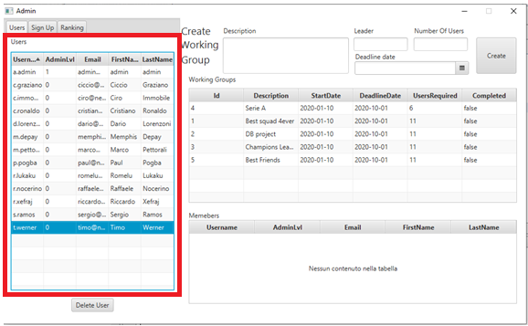

If the above table with the information of the users is not shown the administrator can click in the label Users in order to shown it.

Delete a user:

The administrator can also delete a user selecting it from the list of the users just shown and clicking on the delete button as it is shown in the follow:

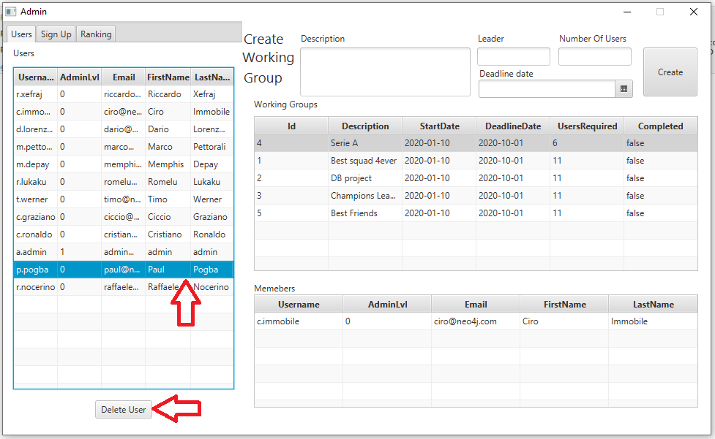

The list of the user before the deletion of a user

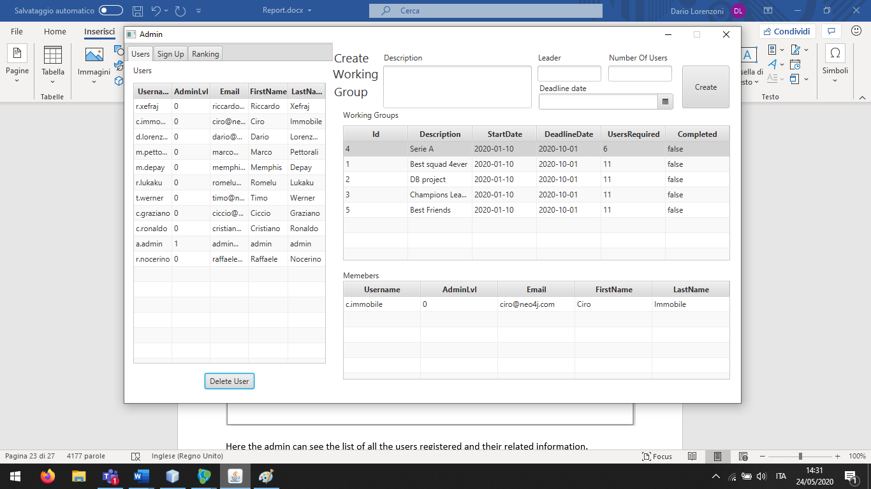

The list of the users after the deletion of the selected user

Add a new user:

The administrator can add a new user in order to do so it have first to click on the Sign Up in order to show the form that can be used in order to add a new user, then it has to fill all the field with the information of the new user in particular the Admin Level has shown in picture can be set to 0 is the user is a normal one or to 1 if the new user is an administrator and finally it can click on the sign up button in order to add the new user. If something is missing an error message will be shown.

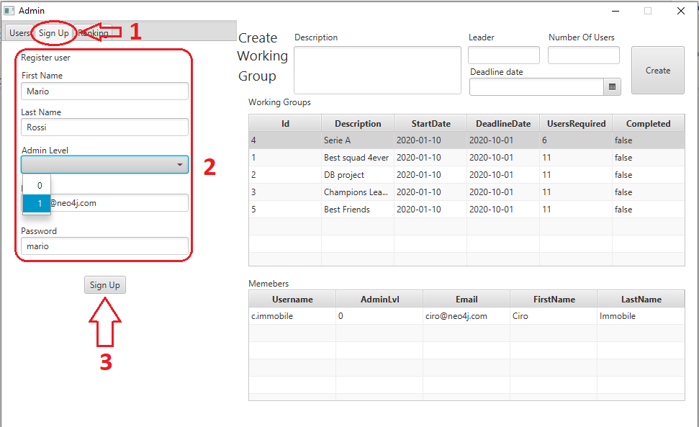

If the addition of the new user is correctly performed the system will show the message: “User saved!”.

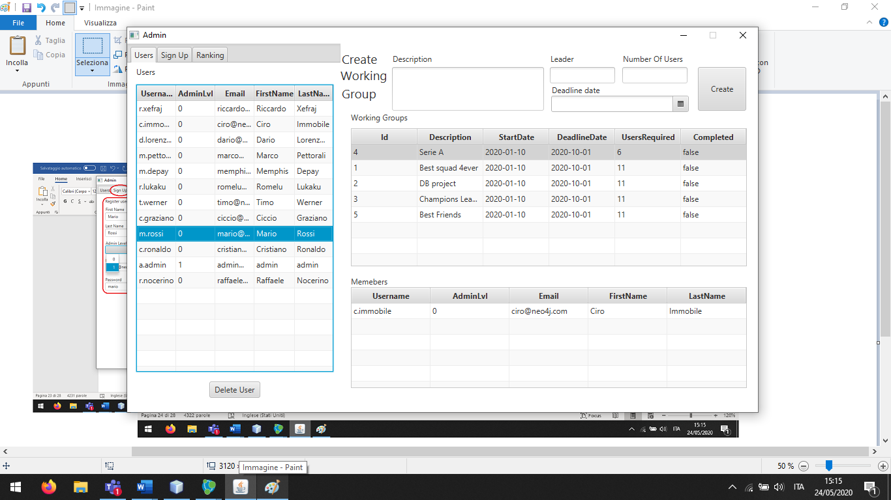

The list of the user after that the user is added

Visualize the list of the user:

In order to visualize the ranking of the users the administrator can click on the ranking button in order to visualize the user and the associated ranking. The users have never been administrator of a group are omitted from this table:

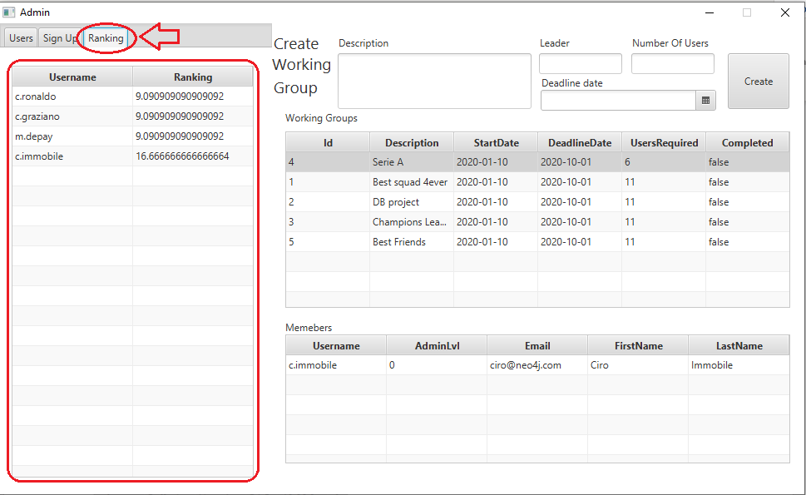

Add a new working group:

Using the form highlighted in the following picture the user is able to add a new working group filling the various field:

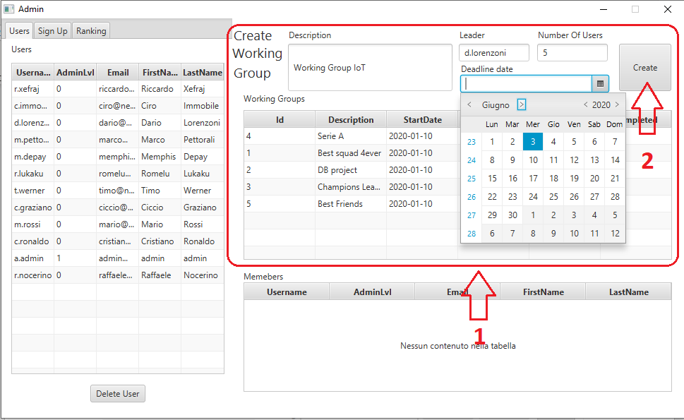

If everything goes well the message “Working group saved successfully” will appear in the bottom of the panel and the new working group will appear in the list of the working group(the groupID is automatically computed in an incremental manner) otherwise an error message will be displayed.

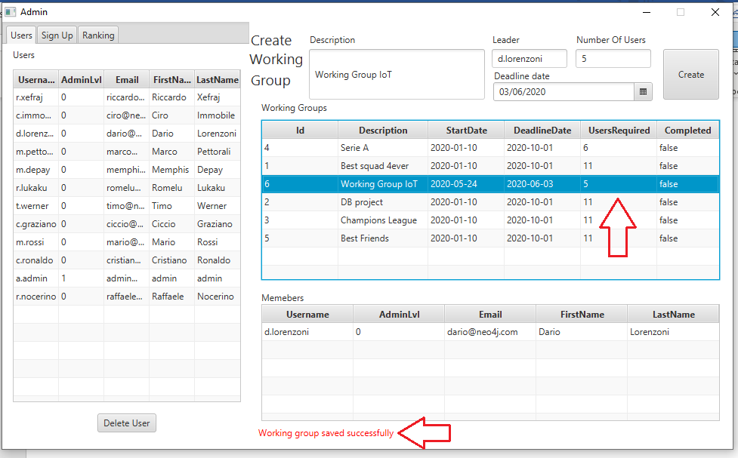

The list of working groups after the insertion of the new one

Visualize the working groups and their information:

The list of the working group that were created by the administrator are always shown in the rigth bottom side of the administrator panel like in the following picture:

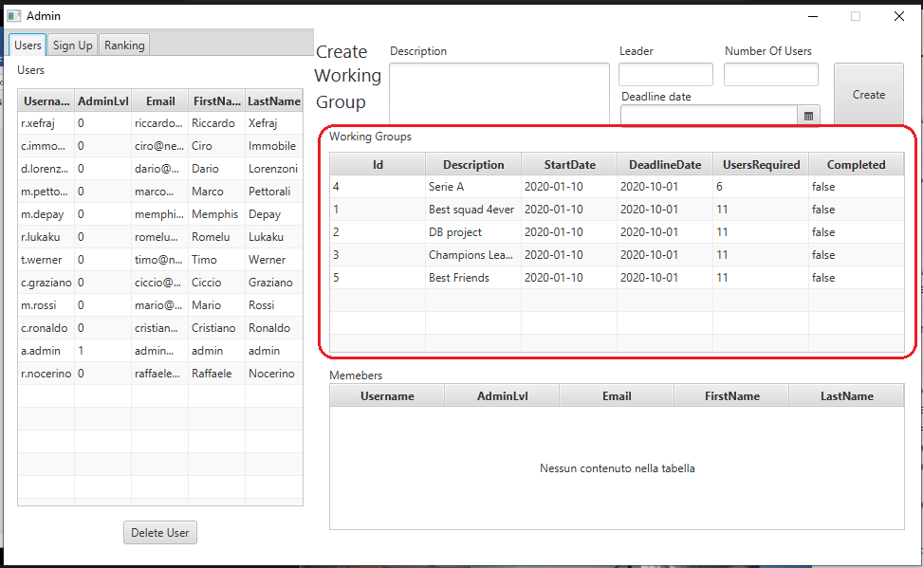

The administrator can click on a working group in order to display in the table below the information about the member of the group.

### User case

If the user is a normal user, the main page showed will be the user control panel in which the (s)he can:

* Visualize the eventually work in progress with their information
* Mark his(her) part of the work for a specific working group as complete
* Visualize the past work
* Visualize the information about the group that (s)he led and the application from the other users to this working group and accept and discard them
* Visualize the not full working group suggested and eventually send an application for them

Visualize the eventually work in progress with their information:

At the startup the user panel will show the list of the current working group to which the user belong to with all their general information.

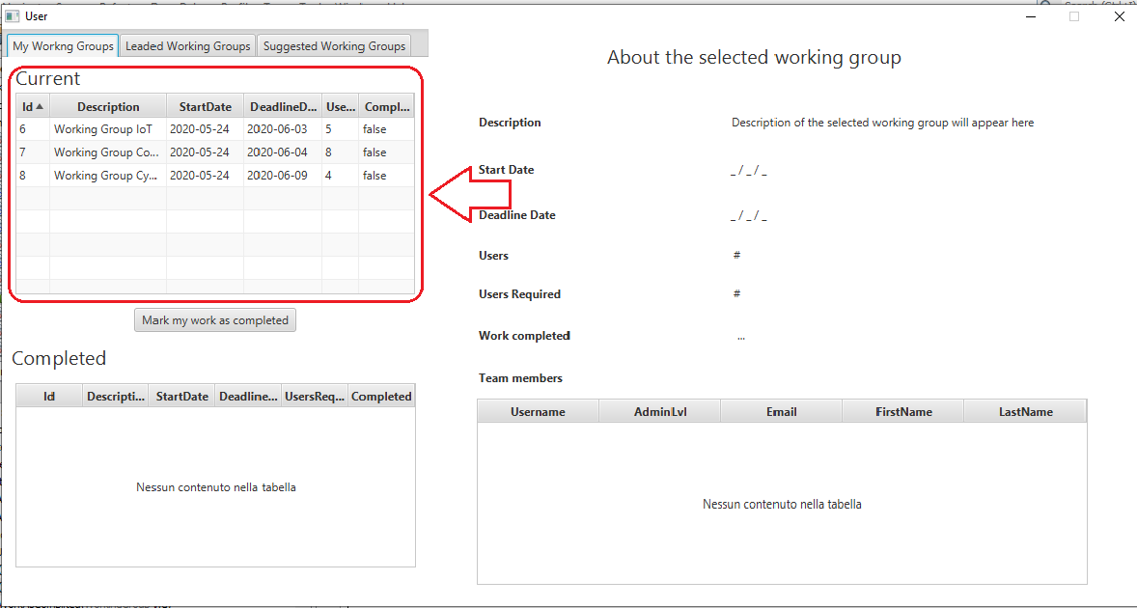

The user can select a working group from the list in order to have more detailed information in the right side of the panel in particular a list of the current member of the working group is reported in the table in the bottom.

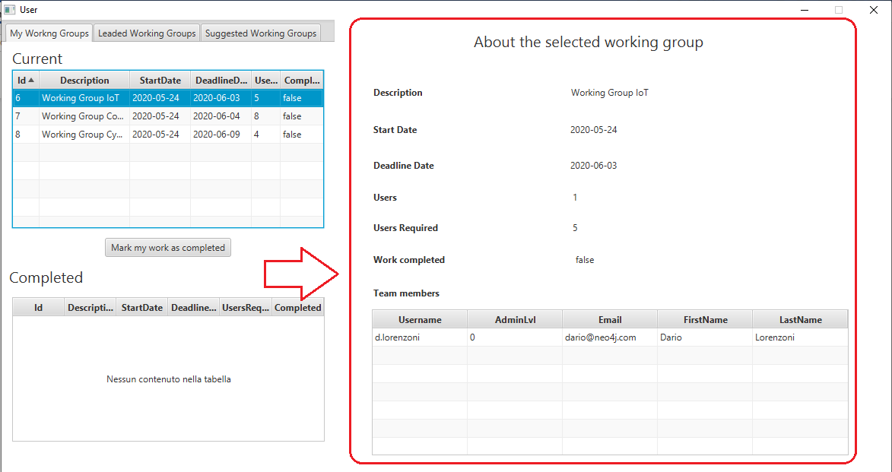

Mark his(her) part of the work for a specific working group as complete and visualize the past group:

Always from this panel the user can mark its part of the working group as complete, it can perform this operation using the button “Mark my work as complete” like in the following picture:

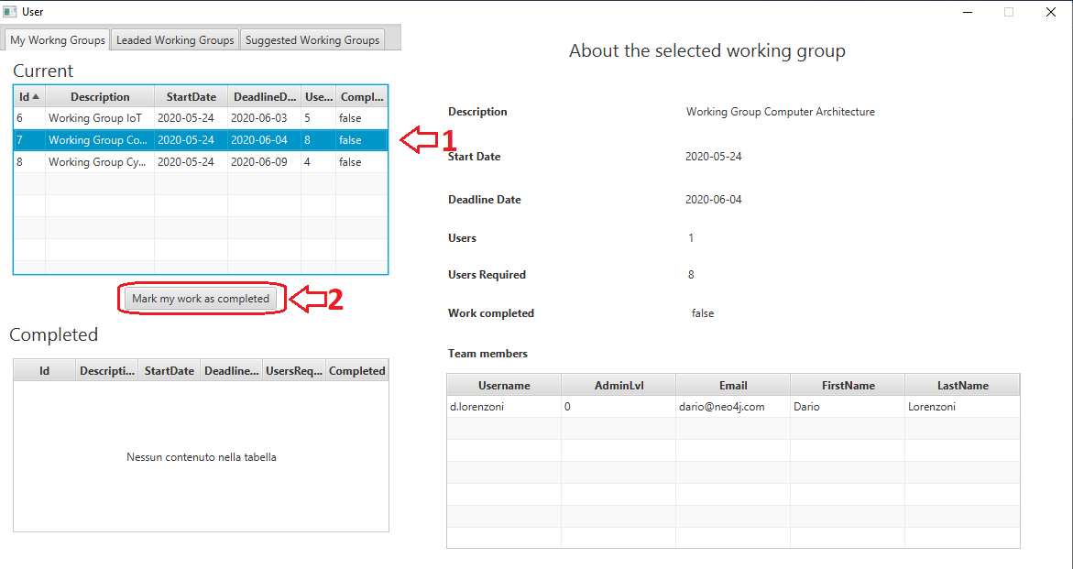

This operation will add this working group in the list of the working group completed:

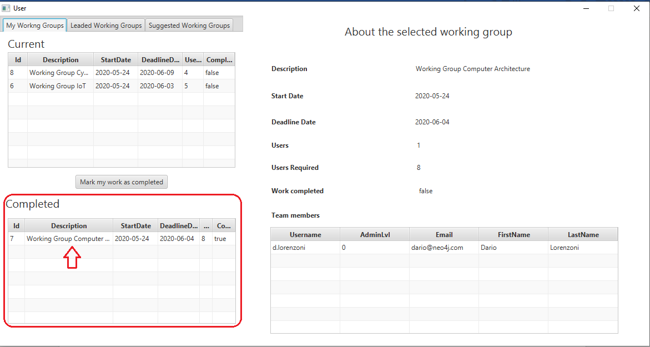

Manage the leaded working group:

First of all in order to mange the working group that the user led the user has to click on the button “Leaded working group” this will change the content of the right side of the panel displaying the list of the working group that the user led. From this table the user can select one of the working groups in order to display the list of application for the selected group. After that (s)he can select one of this application and click the “Accept selected application button” in order to add the relative user to the member of the working group.

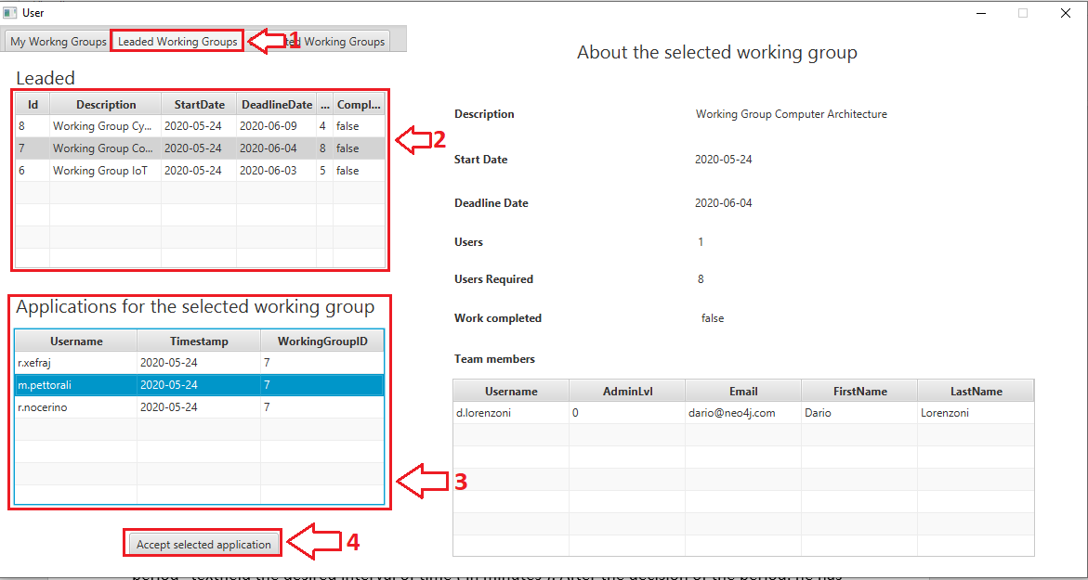

The list of the member of the working group that is present on the right side of the panel will then display the updated list of the member of the working group.

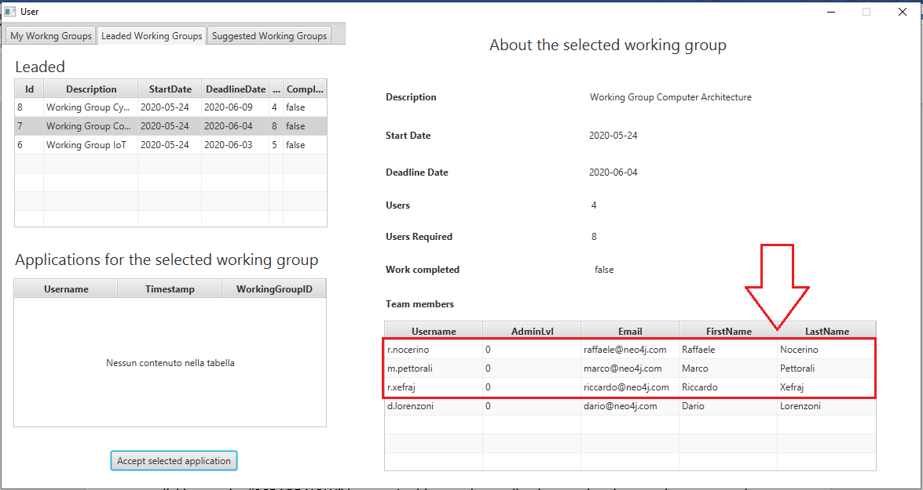

Visualization of the suggested working group and the application sending:

In order to display the suggested group for a user the latter has first to click on the button “Suggested Working Group” this will one more time change the content of the left side of the panel this time it will show the list of the not full suggested working group order by the affinity grade and give the possibility to the user to send an application for the selected working group clicking on the button “Send application for the selected working group”.

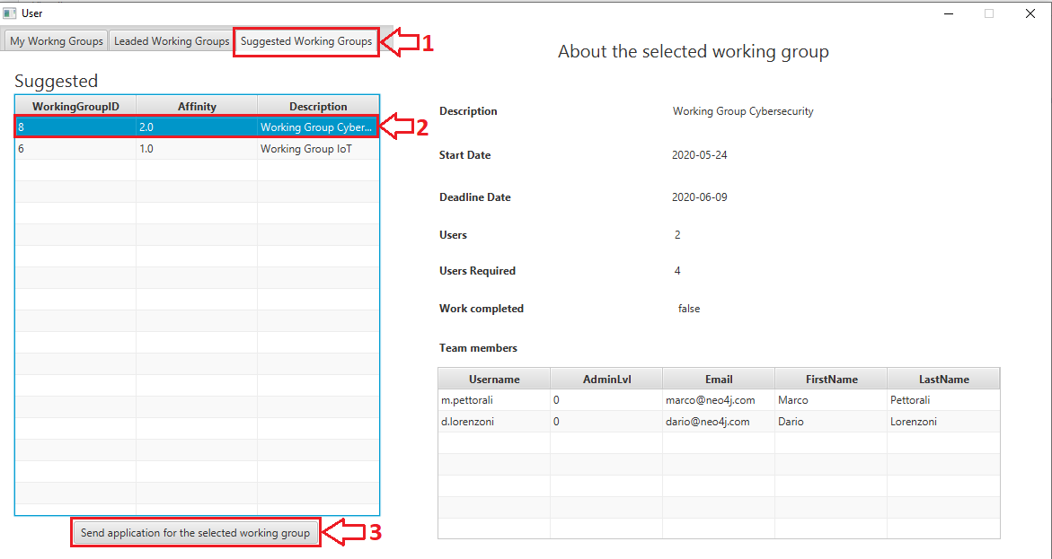

If the user clicks on a recommended article in the table, the application will open in the browser the newspaper web page containing the entire article.