# Image Corrections for LM - OSEM

## Randoms Correction

Already installed in the LM-MLEM program.

## Scatter and Attenuation Corrections for LM

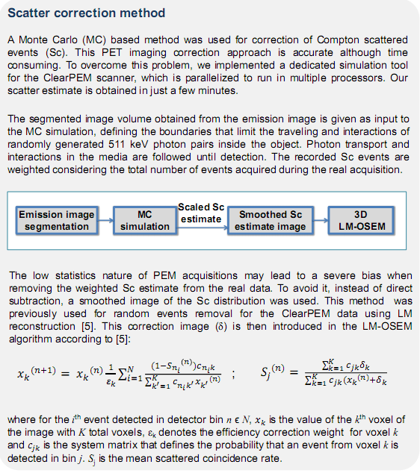

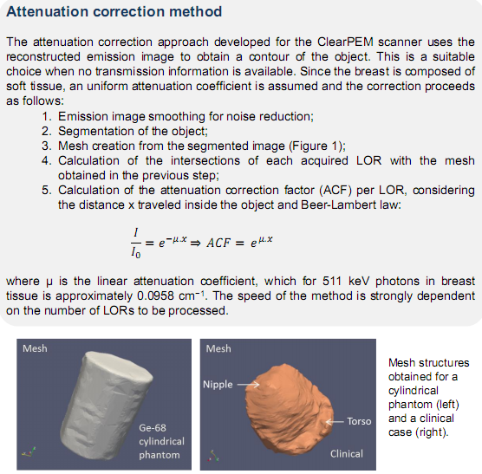

### Installation

1. Install Cmake ([www.cmake.org](http://www.cmake.org))

For instructions see README.rst

1. Install ITK (www.itk.org)
   1. Cmake [dir]
   2. Make