Python Hydrological Model

Object Orientated Software Engineering

Spatial Algorithms



INDEX

[INTRODUCTION 3](#_Toc511033164)

[TASK 1 3](#_Toc511033165)

[Code additions – Task 1 4](#_Toc511033166)

[TASK 2 4](#_Toc511033167)

[Code additions – Task 2 5](#_Toc511033168)

[TASK 3 7](#_Toc511033169)

[Code additions – Task 3 8](#_Toc511033170)

[TASK 4 8](#_Toc511033171)

[Pseudo code – Method calculate Lakes 10](#_Toc511033172)

[TASK 5 11](#_Toc511033173)

[Code additions – Task 5 14](#_Toc511033174)

[OVERALL DISCUSSION 16](#_Toc511033175)

[Lakes 16](#_Toc511033176)

[Outflow Cells selection 16](#_Toc511033177)

[Other outflows 16](#_Toc511033178)

[Additional Datasets 16](#_Toc511033179)

[Seasons and snow 16](#_Toc511033180)

[Land cover 17](#_Toc511033181)

[Soil 17](#_Toc511033182)

[Final considerations 17](#_Toc511033183)

[Code 18](#_Toc511033184)

[CourseWork1 18](#_Toc511033185)

[Flow 21](#_Toc511033186)

[Raster 29](#_Toc511033187)

[Points – no modifications 30](#_Toc511033188)

[RasterHandler – no modifications 30](#_Toc511033189)

# INTRODUCTION

The present report explains the functioning of an algorithm that calculates a hydrological model, starting from a Digital Elevation model and an annual Rainfall data raster.

# TASK 1

The algorithm is showing a fragmented flow network. At this stage, the catchment cells called “pits” are displayed in red. Per each one of these cells is displayed the drainage basin. Different colours distinguish different basins; colours are assign with the method **plotstreams** called by **plotFlowNetwork**.

To get this the algorithm starts from the Digital Elevation Model, applying the **FlowRaster** method from the **Flow.py** module. The **FlowRaster** method generates an array with the same size of the original DTM in which each cell is represented by a Point2D element (FlowNode).

When creating the flownodes grid (from now on named **fr**) the method **setDownCells** is called. Per each flownode this method set the down cell, which uses in turn **lowestNeighbour** and **getNeighbours**. **SetDownCells** is also calling the method **setDownnode,** which both check the correctness of the relationship upnode-downnode but also compile the list of upnodes per each cell. The result is displayed in Figure 1.

Figure – output for Task 1.

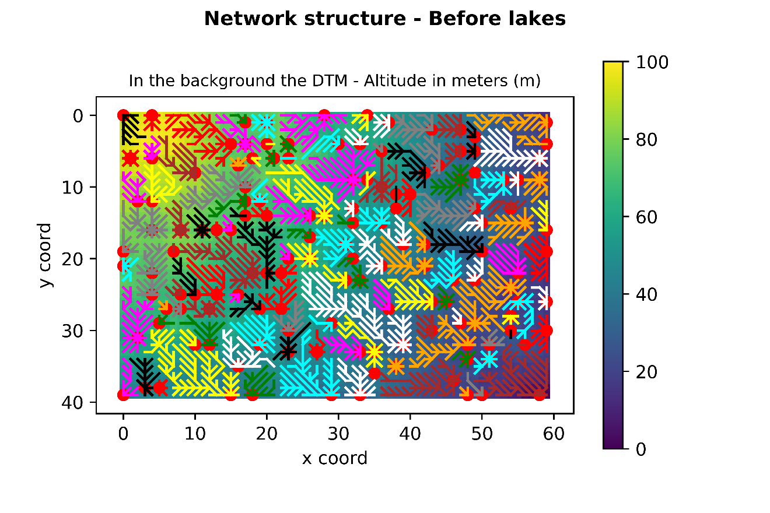

## Code additions – Task 1

Few additions were made to the code to complete Task 1.

1. In **Flow**.**py** was imported the **Raster** method from the **Raster**.**py** module with the following code:

### TASK 1 ###

# Import class Raster from Module Raster.py

**from** Raster **import** Raster

1. It was added a method **setDownCells** in **Flow.py**:

**def** setDownCells**(**self**):**

''' Look for the lowest neighbour around the cell and set the

downnodes '''

# Loop through the raster of Point2D

**for** r **in** range**(**self**.**getRows**()):**

**for** c **in** range**(**self**.**getCols**()):**

# Get the lowest neighbour

lowestN **=** self**.**lowestNeighbour**(**r**,**c**)**

# if its elevation is LOWER than the one of the center cell

**if** **(**lowestN**.**getElevation**()** **<** self**.**\_data**[**r**,**c**].**getElevation**()):**

# Set the DownNode of that Point2D as the lowestN

self**.**\_data**[**r**,**c**].**setDownnode**(**lowestN**)**

**else:**

# if the center cell is a Pitflag than DownNode is NONE

self**.**\_data**[**r**,**c**].**setDownnode**(None)**

### Added trying to do task 4 ###

self**.**\_data**[**r**,**c**].**setPitFlag**(True)**

3) Uncommented the following lines in **CourseWork1**.**py**:

################# Step 1 find and plot the initial network #######

# Create the FlowRaster

fr**=**flow**.**FlowRaster**(**resampledElevations**)**

# Plot the network between points #

plotFlowNetwork**(**elevation**,** fr**,** "Network structure - before lakes"**,** plotLakes**=False)**

# TASK 2

In the module **CourseWork1**.**py** is called the method **plotExtractedData**, which accepts as arguments (1) a raster and (2) an extractor function.

In this case, the raster is **fr,** the grid of flownodes previously created, and the function is the class **Flow.FlowExtractor**, which contains the method **getValue**. The method **getValue** returns the flow of the node under examination, calling the method **getFlow** locatedin the class **FlowNodes**. This last method uses the recursion to calculate the total flow of each cell summing the rain in the cell and the flow coming from the upnodes (recursion).

The recursive method **getFlow** was built immediately to be adaptable for task 3. To test it with one mm of rain the attribute **self.\_rain** was set to 1.

In addition, it was added a method **printFlow** in the class **FlowRaster** to create an array of flow values and crosscheck the correctness of the algorithm.

Figure – Output Task 2.

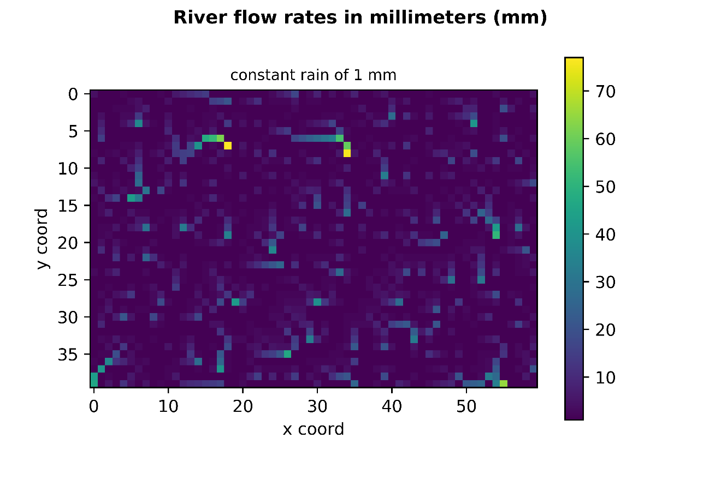

## Code additions – Task 2

1. Uncommented the following lines in **CourseWork1**.**py**:

################ Step 2 ######################################

# Plot the extrated data - the second arg is the extractor function

plotExtractedData**(**fr**,** flow**.**FlowExtractor**(),** "River flow rates - constant rain"**)**

# Check # Get an array of flow values

**print(**fr**.**printFlow**())**

1. Added the following attributes to the class **FlowNodes**:

self**.**\_rain**=**1

self**.**\_flow**=**0

1. Add the method **GetValues** to the class **FlowExtractor**:

**class** **FlowExtractor():**

**def** getValue**(**self**,** node**):**

''' Method that extract the flow value from a specific node

Args: Array of flownodes, the node of interest'''

**return** node**.**getFlow**()**

1. Create the method **GetFlow** in the **FlowNode** class:

**def** getFlow**(**self**):**

''' Method that adds the rain to the flownodes using a recursive process

Arg: the array of flownodes '''

upnodes **=** self**.**getUpnodes**()**

# stores the initial flow

self**.**\_flow **=** self**.**getRain**()**

# if there are no upnodes return the flow

**if** upnodes **==** **[]:**

**return** self**.**\_flow

# if there are more upnodes calculate the flow for these (recursion)

**else:**

**for** node **in** upnodes**:**

self**.**\_flow **=** self**.**\_flow **+** node**.**getFlow**()**

# return the flow

**return** self**.**\_flow

1. Create the method **printFlow** in the **FlowRaster** Class:

**def** printFlow **(**self**):**

''' prints the flow value for each cell '''

flowdata **=** **[]**

**for** r **in** range**(**self**.**getRows**()):**

**for** c **in** range**(**self**.**getCols**()):**

flowdata**.**append**(**self**.**\_data**[**r**,**c**].**getFlow2**())**

valuesarray**=**np**.**array**(**flowdata**)**

valuesarray**.**shape**=**self**.**\_data**.**shape

**return** valuesarray

1. Create auxiliary methods in **FlowNode** Class:

**def** getFlow2**(**self**):**

'''Method that returns the value of the flow'''

**return** self**.**\_flow

**def** getRain**(**self**):**

**return** self**.**\_rain

# TASK 3

The method **addRainfall** is called on **fr** in the module **CourseWork1**.**py**.

The method **addRainfall** was built in the class **FlowRaster** and accepts as arguments **fr** itself and the method **getData** applied to the **rainrasterA**, introduced as the argument “rain” in the function **calculateFlowsAndPlot.**

### RAIN RANDOM DATA ###

fr**.**addRainfall**(**rain**.**getData**())**

The **rainrasterA** is a randomly generated raster that represent random precipitations. Different parameters can be changed. In this case, the maximum rain has been set at 400 mm (0.4 m). At first the method **addRainfall** checks that the array of rain values and **fr** are of the same size using the “assert” statement. Following this the method goes over all the cells of **fr** one by one, retrieving the coordinates [r,c]. While vising a specific cell in **fr** the method visits a cell in the same position in the rain raster (same coordinates [r,c]), retrieving the rain value and inserting this in the flownode attribute **self.\_rain**. The initial value of zero in **self.\_rain** is overwritten with the new one through the method **setRain**.

In addition, it was added a method **printRain** in the class **FlowRaster** to create an array of rain values and crosscheck the correctness of the algorithm.

Figure - Output Task 3.

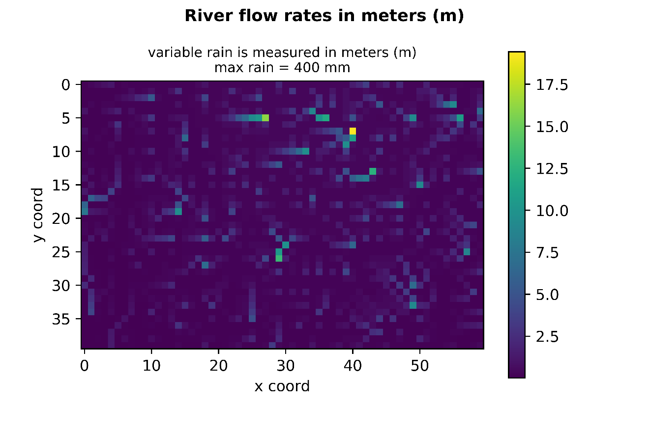

## Code additions – Task 3

1. Uncommented the following lines in CourseWork1.py:

################# Step 3 #######################################

### RAIN RANDOM DATA ###

fr**.**addRainfall**(**rain**.**getData**())**

plotExtractedData**(**fr**,** flow**.**FlowExtractor**(),** "River flow rates - variable rainfall"**)**

# Check # Get an array of flow values

**print(**fr**.**printRain**())** # returns the values of the rain loaded in the flowraster

1. Added the method AddRain:

### TASK 3 ###

**def** addRainfall **(**self**,**rainArray**):**

''' method that traverses the rainfall raster and load the values in self.\_rain in meters

Args: flownode raster, array with rain values'''

# Ensure rain and data have the same size

**assert** self**.**\_data**.**shape **==** rainArray**.**shape

# print (self.\_data.shape)

# print (rainArray.shape)

rainValue **=** 0

**for** r **in** range**(**self**.**getRows**()):**

**for** c **in** range**(**self**.**getCols**()):**

rainValue **=** rainArray**[**r**,**c**]**

self**.**\_data**[**r**,**c**].**setRain**(**rainValue**/**1000**)**

1. Added the auxiliary method setRain:

**def** setRain**(**self**,** value**):**

self**.**\_rain **=** value

# TASK 4

The method **calculateLakes** processes the initial fragmented flow network to obtain a final hydrological model. To achieve this the method starts calculating all the natural ‘depression’ that are lakes identifying (1) the flownodes part of each lake (2) the flownode where the lake discharges the outflow (3) the highest wall before the sea and according to this (4) the depth of the lake.

The algorithm first orders the pits from the highest to the lowest, and in this order start identifying the lakes. All the pits included in one lake will not be considered while creating the next one. Once all the lakes are completed each cell of the lake is linked (setDownNode) with the first lower cell after the highest wall (the highest wall is the last cell of the lake). The depth of the lake is calculated against the highest wall of the lake.

To achieve this the method uses a new class Lake, plus other new methods and attributes in the class FlowNode. All the sessions added for Task 4 are clearly tagged in the code in the appendix. The code is also properly commented.

Figure - Output 1 Task 4 Network structure – With lakes

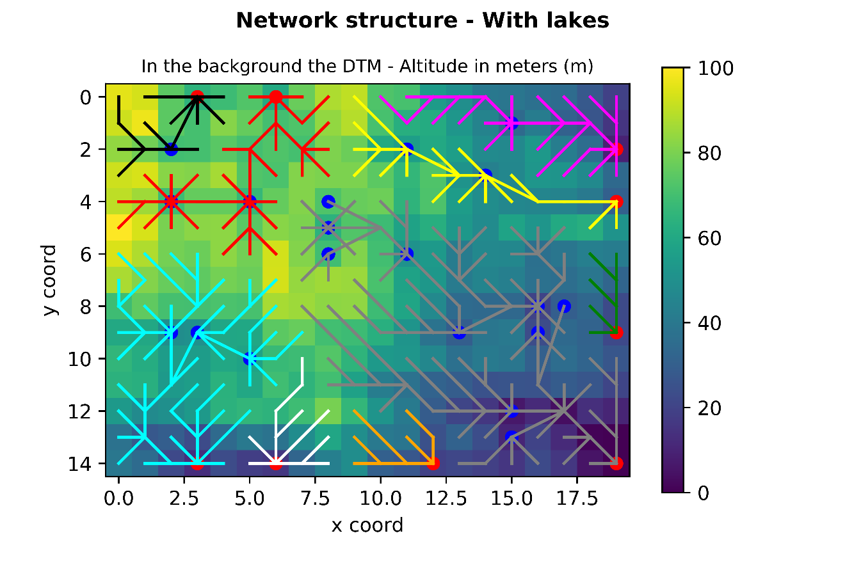

Figure - Output 2 Task 4 Flow rates

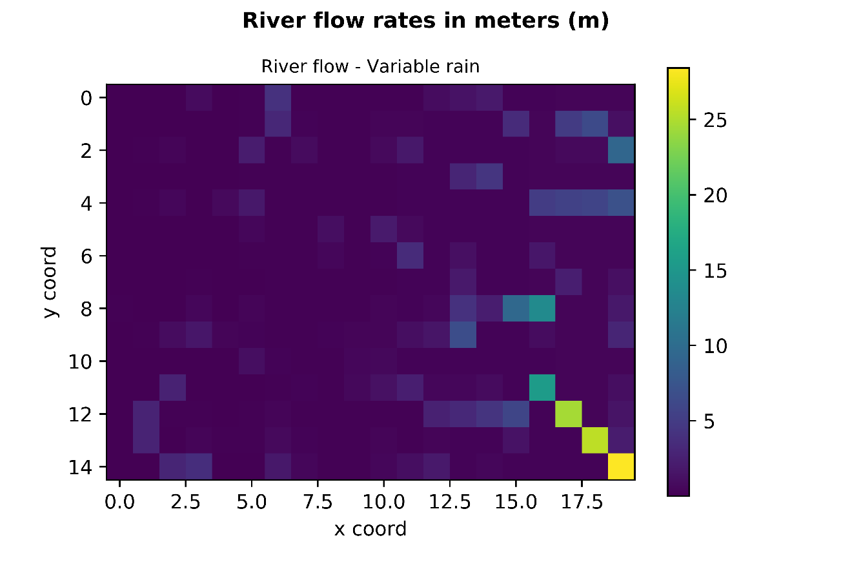

Figure - Output 3 Task 4 Lake Depth **NB: it does not match with the previous figures because it was exported in a separate session**

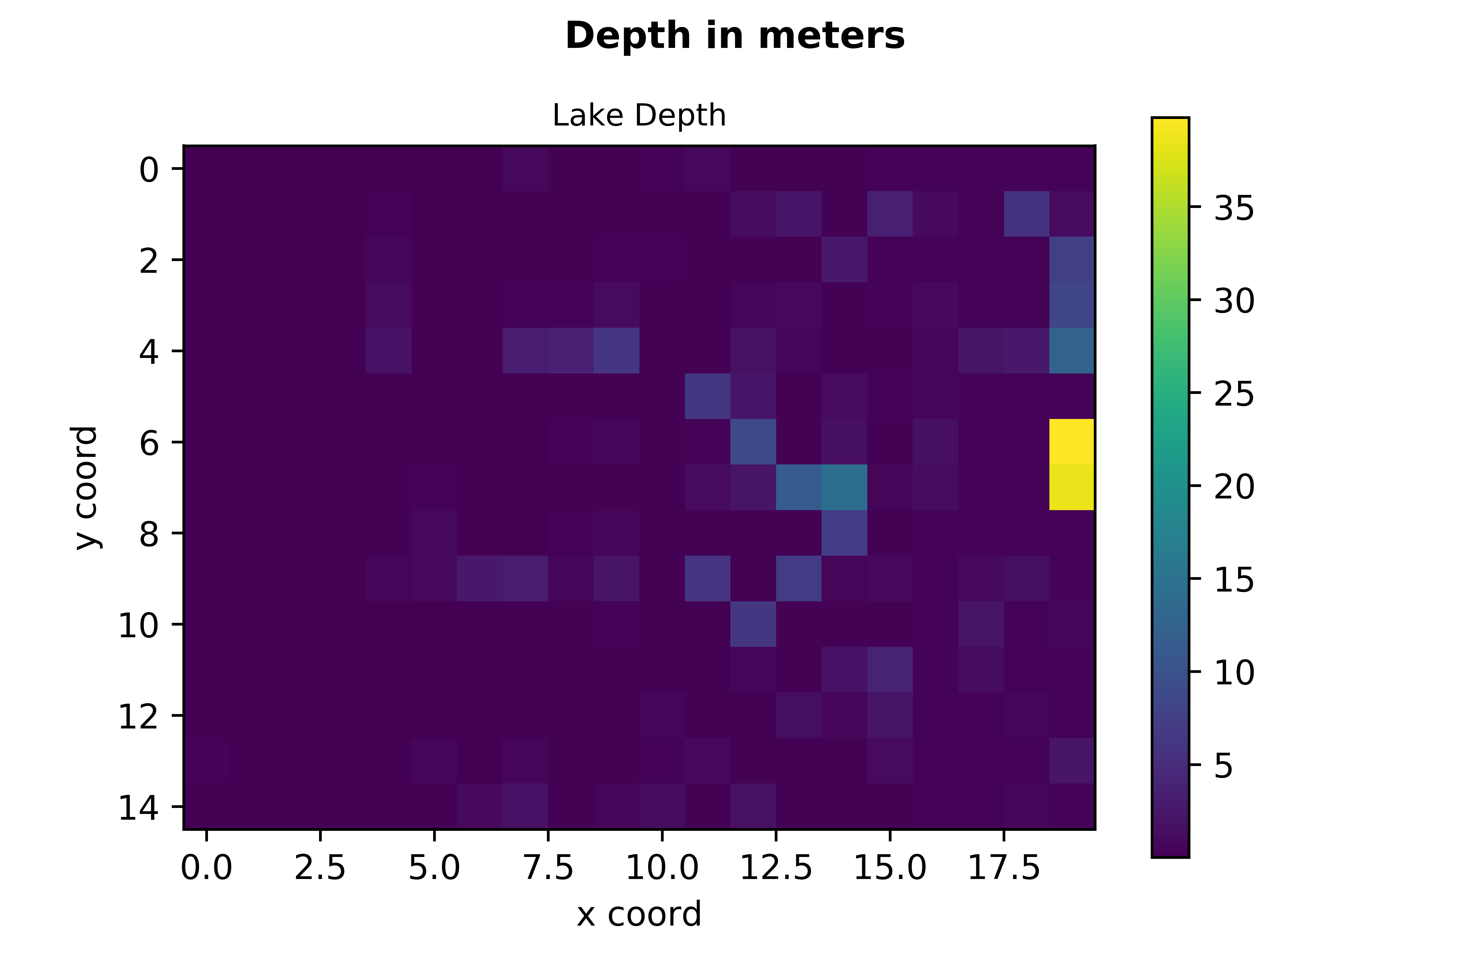

## Pseudo code – Method calculate Lakes

**No pseudo code for additional methods – please refer to code at the end of the docuemnt.**

**Create method** calculateLakes:

- Create a list of Pits ordered highest to lowest

- For each pit in the list

- if the Pit has not been marked as lake

- Set the attribute Lake as True

- making the pit as part of a lake

- create instance of the class Lake

- add lake to a list of lakes (attrib of class FlowRaster)

- add the Pit to a list of lake nodes (attrib of class Lake)

- get coordinates of the cell

- while both the cell is not at the margin at is a pit keep looping (while loop)

- set lownode as none

- go over all the flownodes part of the lake

- get the coordinates of the flownode in the lake

- find the lowest neighbour to the cell - ! lowestNeighbour method has been modified !

- memorize the lowest neighbour

- Set the Flag True for the lowest

- Set the depth to one

- Append the cell to the list

- Get the high wall after the lake

- create two lists to split the lake according to the high wall

- select bad half of flownodes after high wall

- select good half of flownodes before high wall

- High wall included in the good half

- Turns the attribute Lake to false for the badhalf

- keep only the nodes before the high wall included (this is the lake)

- Set the attributes down node and high wall

- append the lake to a list of lakes

- go over each element in the list of lakes

- Go over the cells in each lake

- Set Lake depth

- Set the new downNode

# TASK 5

Since the original raster had a resolution that was to fine (530 \* 830 = 439900 cells) it was necessary to resample it. This is done modifying the method **createWithIncreasedCellsize** in **Raster.py.**

Figure – Originael Raster Task 5

D:\GoogleDrive\ObjectOriented\Assignment\Assignment2StarterStudents\Capture1.PNG

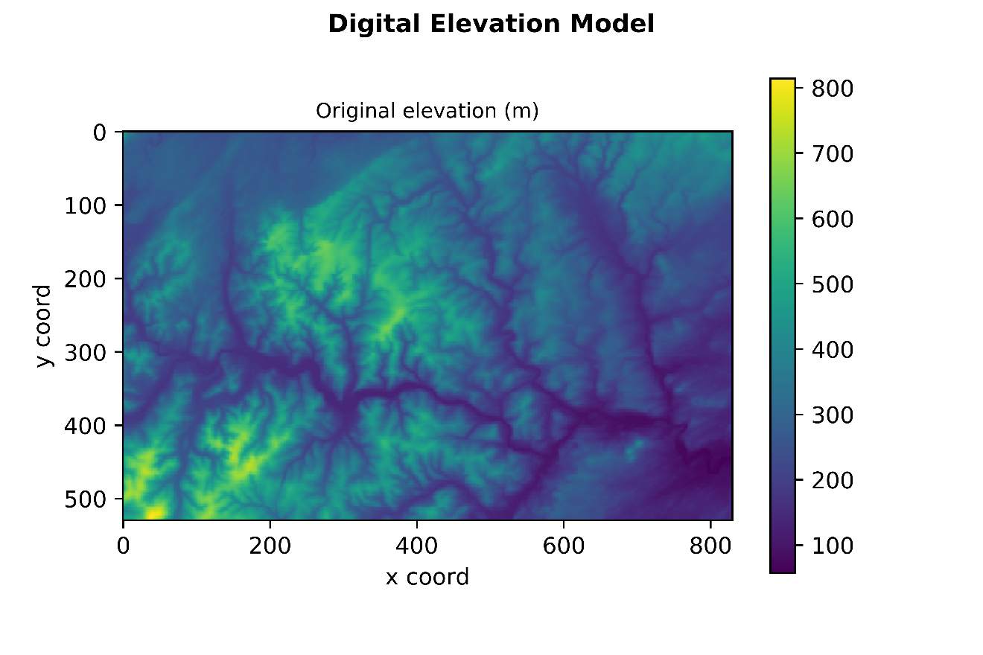

Figure - Resampled Raster Task 5

D:\GoogleDrive\ObjectOriented\Assignment\Assignment2StarterStudents\Image_archive\ResEl1.PNG

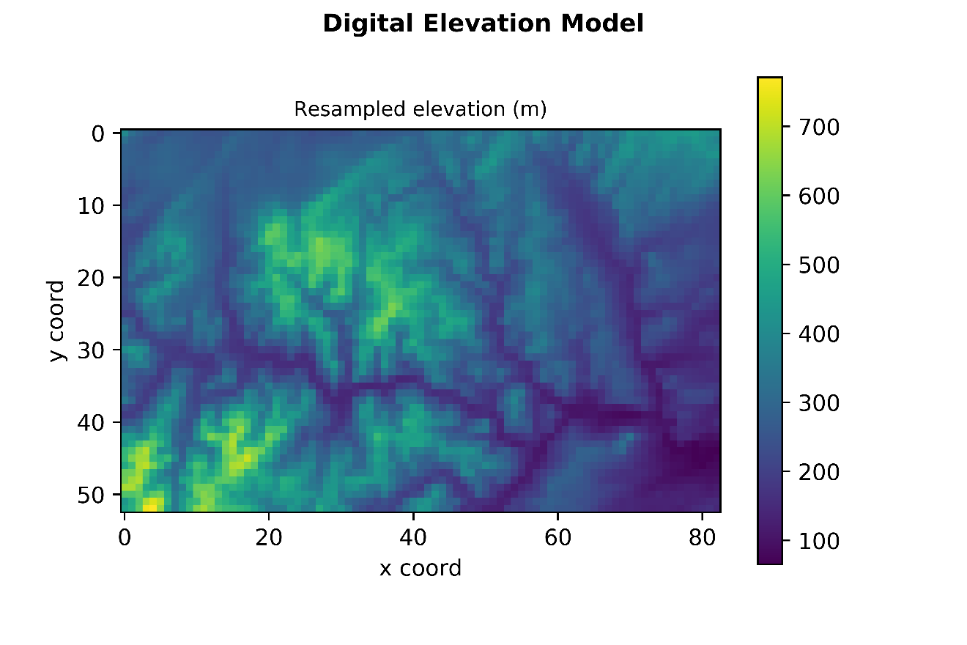

**The maximum flow rate in the DEM is of 3042.19 m of rain/ year.**

**The location of this flow is at the geographical location x = 820 and y = 440, which corresponds to the cell x = 82 and y = 44 of the resampled raster.**

Figure - Final Output Task 5



Figure - Output 1 Task 5 Network structure – With lakes

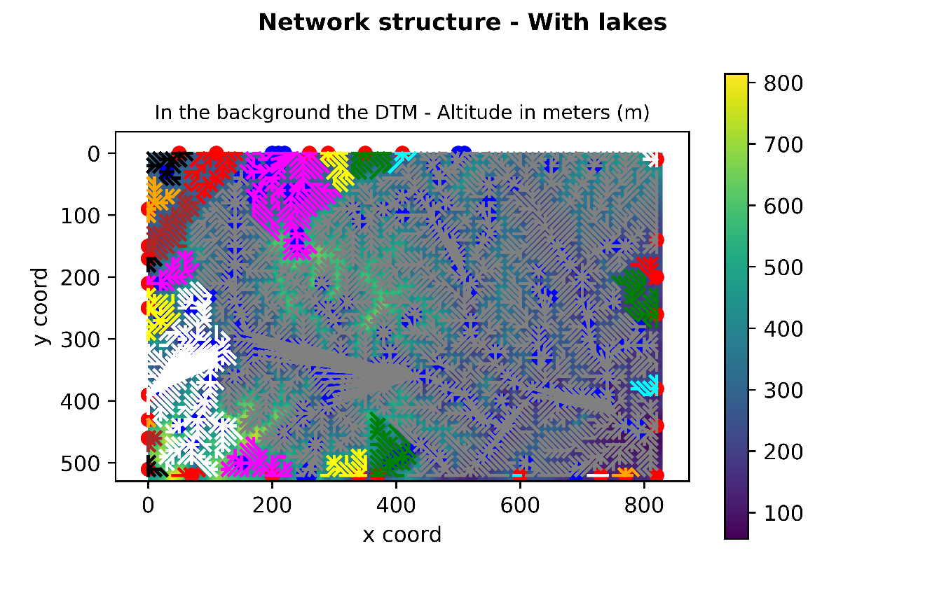

Figure - Output 2 Task 5 Flow rates

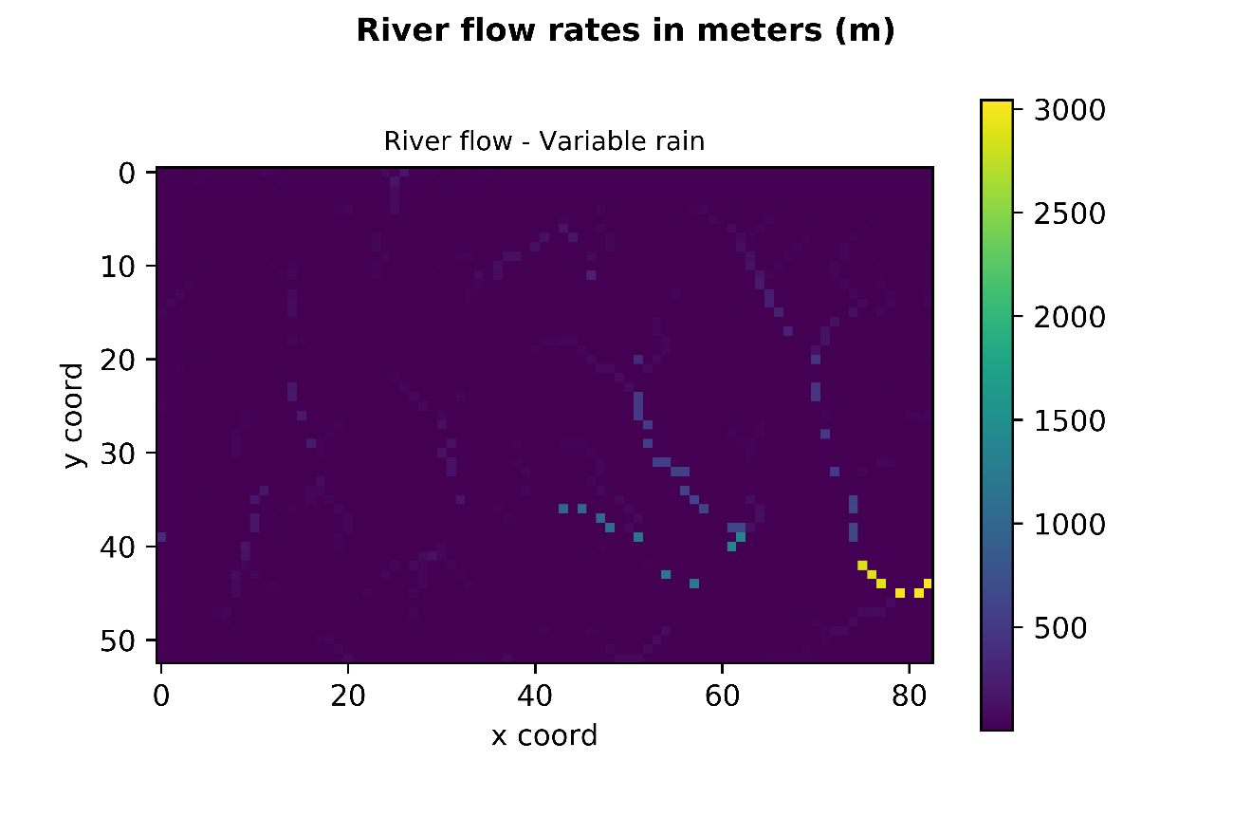

Figure - Output 3 Task 5 Lake Depth

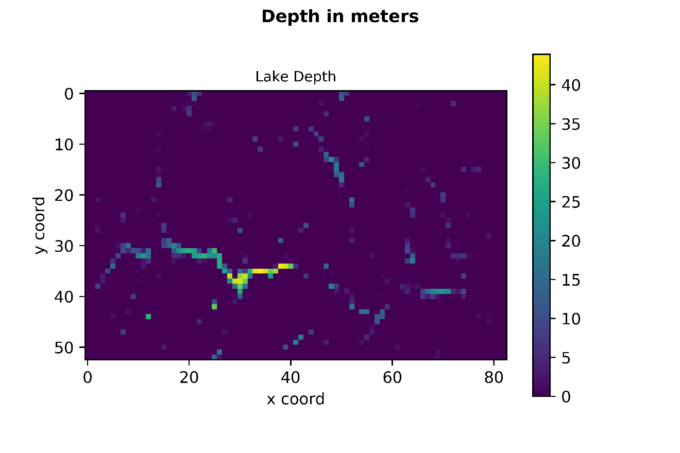

## Code additions – Task 5

1. Uncommented/Commented the following lines in CourseWork1.py:

############# step 4 and step 5 #######################################

## handle lakes # - orig

fr**.**calculateLakes**()** # - orig

#print(fr.printFlow())

plotFlowNetwork**(**elevation**,** fr**,** "Network structure (i.e. watersheds) - with lakes"**)** # - orig

plotExtractedData**(**fr**,** flow**.**LakeDepthExtractor**(),** "Lake depth"**)** # - orig

plotExtractedData**(**fr**,** flow**.**FlowExtractor**(),** "River flow rates - variable rainfall"**)** # - orig

#print(fr.printFlow())

### Task 5 ###

nomi **=** fr**.**finalCell**()** #finds the cell with the highest value and it's coordinate

**print** **(**type**(**nomi**))**

**print** **(**"Result: \n{} m of rain in x={} y={}"**.**format**(**nomi**[**0**],**nomi**[**1**],**nomi**[**2**]))**

1. And:

# Swap the Rasters

#calculateFlowsAndPlot(elevationRasterA, rainrasterA, resampleFactorA)

############# step 5 #######################################

calculateFlowsAndPlot**(**readRaster**(**'ascifiles/dem\_hack.txt'**),** readRaster**(**'ascifiles/rain\_small\_hack.txt'**),** 10**)**

1. Resample method in Raster.py:

**def** createWithIncreasedCellsize**(**self**,** factor**):**

''' Methid that resamples the raster according to a resample factor

Args: rater(self) and factor'''

newRowNum **=** self**.**getRows**()** **//** factor

newColNum **=** self**.**getCols**()** **//** factor

newdata **=** np**.**zeros**([**newRowNum**,** newColNum**])**

**for** i **in** range **(**newRowNum**):**

**for** j **in** range **(**newColNum**):**

sumCellValue **=** 0.0

**for** k **in** range **(**factor**):**

**for** l **in** range **(**factor**):**

sumCellValue **+=** self**.**\_data**[**i**\***factor **+** k**,** j**\***factor **+** l**]**

newdata**[**i**,**j**]** **=** sumCellValue **/** factor **/** factor

**return** Raster**(**newdata**,** self**.**\_orgs**[**0**],** self**.**\_orgs**[**1**],** self**.**\_cellsize**\***factor**)**

1. Methods to find the final cell and the maximum flow

### TASK 5 ###

**def** finalCell **(**self**):**

''' Method that returns the Max flow and the position of the cell

Arg: flownode raster'''

listPits **=** self**.**getPits2**()** #list of flownodes PITS ordered from the highest to the lowest

lastPit **=** round**(**listPits**[-**1**].**getFlow2**(),**2**)** # get the flow

cellCoordX **=** listPits**[-**1**].**get\_x**()** # get the coordinates

cellCoordY **=** listPits**[-**1**].**get\_y**()** # get the coordinates

**return** lastPit**,**cellCoordX**,**cellCoordY

#print ("\n{} m of rain in x={} y={}".format(lastPit,cellCoordX,cellCoordY))

**def** getPits2 **(**self**):**

''' Method that identifies the pits on the boundary and return a list

Arg: flownode raster'''

listPits3 **=** **[]**

listPits4 **=** **[]**

**for** r **in** range**(**self**.**getRows**()):**

**for** c **in** range**(**self**.**getCols**()):**

pitFlag **=** self**.**\_data**[**r**,**c**].**getPitFlag**()** # checking if is a pitflag

**if** pitFlag**==True** **and** len**(**self**.**getNeighbours**(**r**,**c**))** **<** 8 **:** # ok - selecting only the pits that are on the border

listPits3**.**append**(**self**.**\_data**[**r**,**c**])** # creates a list with all the outer nodes

# sort the list with an inbuilt function

listPits4 **=** sorted**(**listPits3**,** key**=lambda** FlowNode**:** FlowNode**.**getFlow2**(),** reverse**=False)**

**return** listPits4

# OVERALL DISCUSSION

The developed code overall fulfils its task of calculating the final volume of water that every year passes through the point of maximum outflow. However, have been identified some limitations that can be turned in further developments.

### Lakes

The algorithm correctly identifies the water bodies according to the highest wall that can stop the water before the sea. However, at this stage each cell of the lake directly connects with the outflow cell of the lake, generating direct links. This is technically not correct, since the water should move from one cell to the other. This particular also visually affects the final flow output, in which the water appears to jump over the raster. Possible solutions would be to: (1) starting from the outflow cell proceed upstream linking all the cells’ upnodes; (2) less elegantly playing with the attributes and assign a fixed flow value to all the cells of the lake. This flow value should be equal to the lake outflow, so that the cells will appear as a smooth surface in the plot. However, this solution implies the modifications of other methods to avoid errors when calling **flow.FlowExtractor()**.

### Outflow Cells selection

At the boundaries of the raster the algorithm looks for a Pit, considering it the point of outflow. Of course here there is an obvious assumption that the water does not go straight “in the sea”.

### Other outflows

At this stage the algorithm correctly identifies the final outflow cells with the highest annual flow. However, it does not detect the other outflow cells. This means that other parts of the hydrological network remain unknown. A possible solution would be to change the **finalCell** method so that it returns all the outflow points, with their annual flow, plus a calculation of the total outflow, which should match with the total annual rain. This will give a more complete picture of the hydrological network of the DTM.

## Additional Datasets

A more complete and realistic model should also consider other factors that might influence the final outflow of the water.

### Seasons and snow

In case the calculation is not done on a year basis but with a higher frequency it is necessary to take into account the seasonality. If the DTM reaches altitudes where there is snow accumulation, or it is located at high latitudes where there is a considerable accumulation of snow, this needs to be taken into account. The accumulation of the snow (which counts as precipitation) delays the outflow which will be higher in the spring. This dataset can be represented by a raster with values that represent the rate of snow accumulation (es: at sea level accumulation = 0, at 8000m accumulation = 1). Appropriate methods and attributes will after handle and combine this raster with the rain raster, taking into account seasonality, snow accumulation and discharge delay.

### Land cover

The land cover is an important factor to take into account. Aside from the run off speed, which in a seasonal or yearly model does not count much, the land cover can considerably influence the amount of water that reaches the water bodies. This is because different types of vegetation have different water needs.

### Soil

Strictly linked with the land cover and vegetation information the type of soil is also important, because it can influence the infiltration of the water (es: clay infiltration = 0, sand infiltration = 1). However, the introduction of this variable adds another dimension to the model, because it starts looking at the underground circulation. It is not said that the water that that percolates is “lost”. Normally water bodies such as lakes are recharged (and discharged) also through deep circulation. However high levels of infiltrations might alters the immediate/quick flow, since the movement of the underground water is slower that surface water.

## Final considerations

In general the model does not take into account groundwater circulation, however, starting from the assumption that the lakes are full at the beginning of the iteration we can also consider the groundwater system as in equilibrium (saturated). In addition we did not consider any human interference with the model (e.s. agriculture activities pumping water from lakes or human infrastructures such as dams).

So concluding a model mimicking more the reality would be extremely more complex, however, the scope of the models are to simplify the reality, trying to represent it in a simple manner. The important thing is to be aware of the assumptions made and communicate these to the client/users.

# Code

## CourseWork1

**from** RasterHandler **import** createRanRasterSlope

**from** RasterHandler **import** readRaster

**import** matplotlib**.**pyplot **as** mp

**import** Flow **as** flow

**def** plotstreams**(**flownode**,**colour**):**

''' Retrieve the upnodes of a point and plot the network '''

**for** node **in** flownode**.**getUpnodes**():**

x1**=**flownode**.**get\_x**()**

y1**=**flownode**.**get\_y**()**

x2**=**node**.**get\_x**()**

y2**=**node**.**get\_y**()**

mp**.**plot**([**x1**,**x2**],[**y1**,**y2**],**color**=**colour**)**

**if** **(**node**.**numUpnodes**()>**0**):**

plotstreams**(**node**,**colour**)**

**def** plotFlowNetwork**(**originalRaster**,** flowRaster**,** title**=**""**,** plotLakes**=True):**

''' Plot the flow network. Args: backgrond raster, flow raster, title '''

**print** **(**"\n\n{}"**.**format**(**title**))**

mp**.**imshow**(**originalRaster**.**\_data**)**

mp**.**colorbar**()**

colouri**=-**1

colours**=[**"black"**,**"red"**,**"magenta"**,**"yellow"**,**"green"**,**"cyan"**,**"white"**,**"orange"**,**"grey"**,**"brown"**]**

**for** i **in** range**(**flowRaster**.**getRows**()):**

**for** j **in** range**(**flowRaster**.**getCols**()):**

node **=** flowRaster**.**\_data**[**i**,**j**]**

# if the point is a pitflag it calls the plotstream

**if** **(**node**.**getPitFlag**()):** # dealing with a pit

mp**.**scatter**(**node**.**get\_x**(),**node**.**get\_y**(),** color**=**"red"**)**

colouri**+=**1

plotstreams**(**node**,** colours**[**colouri**%**len**(**colours**)])**

**if** **(**plotLakes **and** node**.**getLakeDepth**()** **>** 0**):**

mp**.**scatter**(**node**.**get\_x**(),**node**.**get\_y**(),** color**=**"blue"**)**

# Code to output the figure with good resolution and captions

# mp.title('In the background the DTM - Altitude in meters (m)', fontsize=9)

# mp.suptitle('Network structure - With lakes', fontsize=11, fontweight='bold')

# mp.xlabel('x coord')

# mp.ylabel('y coord')

# mp.savefig('./Network\_structure3.png', dpi=900)

mp**.**show**()**

**def** plotExtractedData**(**flowRaster**,** extractor**,** title**=**""**):**

''' Plots the flow rate

args: flow Raster, Extraction function '''

**print** **(**"\n\n{}"**.**format**(**title**))**

mp**.**imshow**(**flowRaster**.**extractValues**(**extractor**))**

mp**.**colorbar**()**

# Code to output the figure with good resolution and captions

# mp.title('Lake Depth', fontsize=9)

mp**.**title**(**'River flow - Variable rain'**,** fontsize**=**9**)**

mp**.**suptitle**(**'River flow rates in meters (m)'**,** fontsize**=**11**,** fontweight**=**'bold'**)**

# mp.suptitle('Depth in meters', fontsize=11, fontweight='bold')

mp**.**xlabel**(**'x coord'**)**

mp**.**ylabel**(**'y coord'**)**

# mp.savefig('./FlowRates\_constrain1.png', dpi=900)

# mp.savefig('./FlowRates\_variable1.png', dpi=900)

mp**.**savefig**(**'./RiverFlow\_task52.png'**,** dpi**=**900**)**

#

mp**.**show**()**

**def** plotRaster**(**araster**,** title**=**""**):**

''' Plot a Raster. Args: raster, title '''

**print** **(**"\n\n{}, shape is {}"**.**format**(**title**,** araster**.**shape**))**

mp**.**imshow**(**araster**)**

mp**.**colorbar**()**

# mp.title('Original elevation (m)', fontsize=9)

# mp.title('Resampled elevation (m)', fontsize=9)

# mp.suptitle('Digital Elevation Model', fontsize=11, fontweight='bold')

# mp.xlabel('x coord')

# mp.ylabel('y coord')

# mp.savefig('./OriginalDTM\_task5.png', dpi=900)

# mp.savefig('./ResampleDTM\_task5.png', dpi=900)

# mp.show()

**def** calculateFlowsAndPlot**(**elevation**,** rain**,** resampleF**):**

### PLOT INPUT RASTER ----

# plotRaster(elevation.getData(), "Original elevation (m)")

# plotRaster(rain.getData(), "Rainfall")

resampledElevations **=** elevation**.**createWithIncreasedCellsize**(**resampleF**)**

# plotRaster(resampledElevations.getData(), "Resampled elevation (m)")

################# Step 1 find and plot the intial network #######

# Create the FlowRaster

fr**=**flow**.**FlowRaster**(**resampledElevations**)**

# Plot the network between points #

# plotFlowNetwork(elevation, fr, "Network structure - before lakes", plotLakes=False)

################ Step 2 ######################################

# Plot the extrated data - the second arg is the extractor function

# plotExtractedData(fr, flow.FlowExtractor(), "River flow rates - constant rain")

# Check # Get an array of flow values

# print(fr.printFlow()) # returns the values of the rain loaded in the flowraster

################# Step 3 #######################################

### RAIN RANDOM DATA ###

fr**.**addRainfall**(**rain**.**getData**())**

# plotExtractedData(fr, flow.FlowExtractor(), "River flow rates - variable rainfall")

# Check # Get an array of flow values

# print(fr.printRain()) # returns the values of the rain loaded in the flowraster

############# step 4 and step 5 #######################################

## handle lakes # - orig

fr**.**calculateLakes**()** # - orig

#print(fr.printFlow())

plotFlowNetwork**(**elevation**,** fr**,** "Network structure (i.e. watersheds) - with lakes"**)** # - orig

plotExtractedData**(**fr**,** flow**.**LakeDepthExtractor**(),** "Lake depth"**)** # - orig

plotExtractedData**(**fr**,** flow**.**FlowExtractor**(),** "River flow rates - variable rainfall"**)** # - orig

#print(fr.printFlow())

### Task 5 ###

nomi **=** fr**.**finalCell**()** #finds the cell with the highest value and it's coordinate

**print** **(**"Result: \n{} m of rain in x={} y={}"**.**format**(**nomi**[**0**],**nomi**[**1**],**nomi**[**2**]))**

############# step 1 to 4 #######################################

# Create Random Raster

rows**=**15

cols**=**20

xorg**=**0.

yorg**=**0.

xp**=**1 #100

yp**=**1 #100

nodata**=-**999.999

cellsize**=**1.

levels**=**4

datahi**=**100.

datalow**=**0

randpercent**=**0.4

resampleFactorA **=** 1

# Create random Elevation Raster

elevationRasterA**=**createRanRasterSlope**(**rows**,**cols**,**cellsize**,**xorg**,**yorg**,**nodata**,**levels**,**datahi**,**datalow**,**xp**,**yp**,**randpercent**)**

# Create random Rain Raster

rainrasterA**=**createRanRasterSlope**(**rows**//**resampleFactorA**,**cols**//**resampleFactorA**,**cellsize**\***resampleFactorA**,**xorg**,**yorg**,**nodata**,**levels**,**400**,**1**,**36**,**4**,**.1**)**

# Swap the Rasters

#calculateFlowsAndPlot(elevationRasterA, rainrasterA, resampleFactorA)

############# step 5 #######################################

calculateFlowsAndPlot**(**readRaster**(**'ascifiles/dem\_hack.txt'**),** readRaster**(**'ascifiles/rain\_small\_hack.txt'**),** 10**)**

## Flow

**import** numpy **as** np

**from** Points **import** Point2D

### TASK 1 ###

# Import class Raster from Module Raster.py

**from** Raster **import** Raster

**class** **FlowNode(**Point2D**):**

''' FlowNode is an instance of the Point2D Class '''

**def** \_\_init\_\_**(**self**,**x**,**y**,** value**):**

Point2D**.**\_\_init\_\_**(**self**,**x**,**y**)**

self**.**\_downnode**=None**

self**.**\_upnodes**=[]**

self**.**\_pitflag**=False**

self**.**\_value**=**value

self**.**\_rain**=**0

self**.**\_flow**=**0

self**.**\_lakeDepth**=**0

self**.**\_lakeFlag**=False**

**def** \_\_repr\_\_**(**self**):**

**return** 'x{} y{} z{}'**.**format**(**self**.**get\_x**(),**self**.**get\_y**(),**self**.**getElevation**())**

**def** setDownnode**(**self**,** newDownNode**):**

''' ensures that there are no provblems when setting a down node'''

self**.**\_pitflag**=(**newDownNode**==None)**

**if** **(**self**.**\_downnode**!=None):** # change previous

self**.**\_downnode**.**\_removedUpnode**(**self**)**

**if** **(**newDownNode**!=None):**

newDownNode**.**\_addUpnode**(**self**)**

self**.**\_downnode**=**newDownNode

# return the downnode

**def** getDownnode**(**self**):**

**return** self**.**\_downnode

# return the upnode

**def** getUpnodes**(**self**):**

**return** self**.**\_upnodes

# remove one upnode - I need ot specify which node

**def** \_removedUpnode**(**self**,** nodeToRemove**):**

self**.**\_upnodes**.**remove**(**nodeToRemove**)**

# add an upnode - append to list

**def** \_addUpnode**(**self**,** nodeToAdd**):**

self**.**\_upnodes**.**append**(**nodeToAdd**)**

# number of upnodes

**def** numUpnodes**(**self**):**

**return** len**(**self**.**\_upnodes**)**

# Returns True or False according of the pitflag is true or false

**def** getPitFlag**(**self**):**

**return** self**.**\_pitflag

# Get the other atribute, which in this case is elevation

**def** getElevation**(**self**):**

**return** self**.**\_value

# print the coordinate of itself

**def** \_\_str\_\_**(**self**):**

**return** self**.**\_\_repr\_\_**()**

### TASK 2 ###

**def** getFlow**(**self**):**

''' Method that adds the rain to the flownodes using a recursive process

Arg: the array of flownodes '''

upnodes **=** self**.**getUpnodes**()**

self**.**\_flow **=** self**.**getRain**()**

**if** upnodes **==** **[]:**

**return** self**.**\_flow

**else:**

**for** node **in** upnodes**:**

self**.**\_flow **=** self**.**\_flow **+** node**.**getFlow**()**

**return** self**.**\_flow

**def** getFlow2**(**self**):**

'''Method that returns the value of the flow'''

**return** self**.**\_flow

**def** getRain**(**self**):**

**return** self**.**\_rain

### TASK 3 ###

**def** setRain**(**self**,** value**):**

self**.**\_rain **=** value

### TASK 4 ###

**def** setLakeDepth**(**self**,** value**):**

self**.**\_lakeDepth **=** value

**def** getLakeDepth**(**self**):**

**return** self**.**\_lakeDepth

**def** setLakeFlag**(**self**,** value**):**

self**.**\_lakeFlag **=** value

**def** getLakeFlag**(**self**):**

**return** self**.**\_lakeFlag

**def** setPitFlag**(**self**,** value**):**

self**.**\_pitflag **=** value

**def** setLakeOverflow**(**self**,** value**):**

self**.**\_lakeOverflow **=** value

**def** getLakeOverflow**(**self**):**

**return** self**.**\_lakeOverflow

**def** setOverFlag**(**self**,** value**):**

self**.**\_overflag **=** value

**def** getOverFlag**(**self**):**

**return** self**.**\_overflag

**def** setNewFlow**(**self**,** value**):**

self**.**\_newflow **=** value

**def** getNewFlow**(**self**):**

**return** self**.**\_newflow

#return x,y tupel

**def** get\_xys**(**self**):**

**return** **(**self**.**x**,**self**.**\_y**)**

**class** **FlowRaster(**Raster**):**

''' It creates a raster grid of flow nodes

Raster stores the values as ARRAY of values

FlowRastes stores the values as ARRAY of Point2D with elevation data '''

**def** \_\_init\_\_**(**self**,**araster**):**

# inherit the carachteristics of the parent class Raster

super**().**\_\_init\_\_**(None,**araster**.**getOrgs**()[**0**],**araster**.**getOrgs**()[**1**],**araster**.**getCellsize**())**

# extract the data from a Raster as an ARRAY (see Raster.py)

data **=** araster**.**getData**()**

# set node as empty list

nodes**=[]**

# loop trough raster and create a grid of flownodes

**for** i **in** range**(**data**.**shape**[**0**]):**

**for** j **in** range**(**data**.**shape**[**1**]):**

y**=(**i**)\***self**.**getCellsize**()+**self**.**getOrgs**()[**0**]**

x**=(**j**)\***self**.**getCellsize**()+**self**.**getOrgs**()[**1**]**

nodes**.**append**(**FlowNode**(**x**,**y**,** data**[**i**,**j**]))**

# array of points2D with elevation

nodearray**=**np**.**array**(**nodes**)**

# gives the nodearray the same shape as the origin raster and load self.\_data with nodearray

nodearray**.**shape**=**data**.**shape

self**.**\_data **=** nodearray

self**.**\_listino**=[]**

#initialize with a random lake

# set the coordinates of the points in the sorounding box

self**.**\_\_neighbourIterator**=**np**.**array**([**1**,-**1**,**1**,**0**,**1**,**1**,**0**,-**1**,**0**,**1**,-**1**,-**1**,-**1**,**0**,-**1**,**1**]** **)**

self**.**\_\_neighbourIterator**.**shape**=(**8**,**2**)**

self**.**setDownCells**()**

**def** getNeighbours**(**self**,** r**,** c**):**

''' Method that get the eigh lowest neighbours '''

neighbours**=[]**

**for** i **in** range**(**8**):**

rr**=**r**+**self**.**\_\_neighbourIterator**[**i**,**0**]**

cc**=**c**+**self**.**\_\_neighbourIterator**[**i**,**1**]**

**if** **(**rr**>-**1 **and** rr**<**self**.**getRows**()** **and** cc**>-**1 **and** cc**<**self**.**getCols**()):**

neighbours**.**append**(**self**.**\_data**[**rr**,**cc**])**

**return** neighbours

### modified task 4 ##

**def** lowestNeighbour**(**self**,**r**,**c**):**

''' Method that finds the lowest neighbour '''

# initially set the lownode to none

lownode**=None**

# loops through a list of sorrounding point2D given by getNeighbours

**for** neighbour **in** self**.**getNeighbours**(**r**,**c**):**

# if the 1st iteration or the Point2D assessed is lower than the actual one it changes it

**if** **(**lownode**==None** **or** neighbour**.**getElevation**()** **<** lownode**.**getElevation**())** **:**

**if** len**(**self**.**\_listino**)** **==** 0 **or** **not** self**.**\_listino**[-**1**].**isLake**(**neighbour**)** **:**

lownode**=**neighbour

**return** lownode

**def** setDownCells**(**self**):**

''' Look for the lowest neighbour around the cell and set the

downnodes '''

# Loop through the raster of Point2D

**for** r **in** range**(**self**.**getRows**()):**

**for** c **in** range**(**self**.**getCols**()):**

# Get the lowest neighbour

lowestN **=** self**.**lowestNeighbour**(**r**,**c**)**

# if its elevation is LOWER than the one of the center cell

**if** **(**lowestN**.**getElevation**()** **<** self**.**\_data**[**r**,**c**].**getElevation**()):**

# Set the DownNode of that Point2D as the lowestN

self**.**\_data**[**r**,**c**].**setDownnode**(**lowestN**)**

**else:**

# if the center cell is a Pitflag than DownNode is NONE

self**.**\_data**[**r**,**c**].**setDownnode**(None)**

### Added trying to do task 4 ###

self**.**\_data**[**r**,**c**].**setPitFlag**(True)**

**def** extractValues**(**self**,** extractor**):**

''' extract values from the raster according to the extractor function'''

values**=[]**

# goes through the raster

**for** i **in** range**(**self**.**\_data**.**shape**[**0**]):** # columns

**for** j **in** range**(**self**.**\_data**.**shape**[**1**]):** # rows

# extracts the values of each point

values**.**append**(**extractor**.**getValue**(**self**.**\_data**[**i**,**j**]))**

# transform the values in an array and gives to it the same shape as the data

valuesarray**=**np**.**array**(**values**)**

valuesarray**.**shape**=**self**.**\_data**.**shape

**return** valuesarray

### TASK 2 ###

**def** printFlow **(**self**):**

''' prints the flow value for each cell '''

flowdata **=** **[]**

**for** r **in** range**(**self**.**getRows**()):**

**for** c **in** range**(**self**.**getCols**()):**

flowdata**.**append**(**self**.**\_data**[**r**,**c**].**getFlow2**())**

valuesarray**=**np**.**array**(**flowdata**)**

valuesarray**.**shape**=**self**.**\_data**.**shape

**return** valuesarray

### TASK 3 ###

**def** addRainfall **(**self**,**rainArray**):**

''' Method that traverses the rainfall raster and load the values in self.\_rain in meters

Args: flownode raster, aray with rain values'''

# Ensure rain and data have the same size

**assert** self**.**\_data**.**shape **==** rainArray**.**shape

# print (self.\_data.shape)

# print (rainArray.shape)

rainValue **=** 0

**for** r **in** range**(**self**.**getRows**()):**

**for** c **in** range**(**self**.**getCols**()):**

rainValue **=** rainArray**[**r**,**c**]**

self**.**\_data**[**r**,**c**].**setRain**(**rainValue**/**1000**)**

**def** printRain **(**self**):**

''' Method that prints the flow value for each cell

Arg: flownode raster'''

# TO ADD # Way to check the two aster are the same size

raindata **=** **[]**

**for** r **in** range**(**self**.**getRows**()):**

**for** c **in** range**(**self**.**getCols**()):**

#print(self.\_data[r,c].getFlow2())

raindata**.**append**(**self**.**\_data**[**r**,**c**].**getRain**())**

valuesarray**=**np**.**array**(**raindata**)**

valuesarray**.**shape**=**self**.**\_data**.**shape

**return** valuesarray

### TASK 4 ###

**def** calculateLakes **(**self**):**

''' Method that calculates the lakes on the DTM linking different pits in bigger water basins

according to the topography. Arg: flownode raster

'''

# Create a list of pits ordered highest to lowest

ListPits **=** self**.**getPits**()** #list of flownodes PITS ordered from the highest to the lowest

# For each pit in the list

**for** i **in** ListPits**:**

# if the Pit has not been marked as lake

**if** i**.**getLakeFlag**()** **==** **False:**

# Set the attribute Lake as True

i**.**setLakeFlag**(True)** # making the pit as part of a lake

mylake **=** lake**()** # create instance of the class Lake

self**.**\_listino**.**append**(**mylake**)** # add lake to a list of lakes (attrib of class FlowRaster)

mylake**.**\_lakeNodes**.**append**(**i**)** # add the Pit to a list of lake nodes (attrib of class Lake)

# get coordinates of the cell

c **=** int**(**mylake**.**\_lakeNodes**[-**1**].**get\_x**()/**self**.**getCellsize**())**

r **=** int**(**mylake**.**\_lakeNodes**[-**1**].**get\_y**()/**self**.**getCellsize**())**

# while both the cell is not at the margin at is a pit keep looping (while loop)

**while** **not** **(** **(** len**(**self**.**getNeighbours**(**int**(**mylake**.**\_lakeNodes**[-**1**].**get\_y**()/**self**.**getCellsize**()),**int**(**mylake**.**\_lakeNodes**[-**1**].**get\_x**()/**self**.**getCellsize**())))** **<** 8**)** **and** **(**mylake**.**\_lakeNodes**[-**1**].**getPitFlag**()** **==** **True)):**

lownode2 **=** **None** # set lownode as none

**for** mm **in** mylake**.**\_lakeNodes**:** # go over all the flownodes part of the lake

# get the coordinates of the flownode in the lake

c **=** int**(**mm**.**get\_x**()/**self**.**getCellsize**())**

r **=** int**(**mm**.**get\_y**()/**self**.**getCellsize**())**

# fin the lowest neighbour to the cell

# ! lowestNeighbour method has been modified

lastCellNeigh **=** self**.**lowestNeighbour**(**r**,**c**)**

# memorize the lowest neighbour

**if** **(**lownode2**==None** **or** **(**lastCellNeigh **!=** **None** **and** lastCellNeigh**.**getElevation**()** **<** lownode2**.**getElevation**())):**

lownode2**=**lastCellNeigh

lownode2**.**setLakeFlag**(True)** # Set the Flag True for the lowest

mylake**.**\_lakeNodes**[-**1**].**setLakeDepth**(**1**)** # Set the depth to one

mylake**.**\_lakeNodes**.**append**(**lownode2**)** # Apend the cell to the list

# Get the high wall after the lake

highWall **=** mylake**.**explicit**()**

# create two lists to split the lake according to the high wall

badHalf**=[]**

goodHalf**=[]**

badHalf **=** mylake**.**\_lakeNodes**[**highWall**[-**1**]+**1**:]** # select bad half after high wall

goodHalf **=** mylake**.**\_lakeNodes**[:**highWall**[-**1**]+**1**]** # select good half before high wall

# High wall included in the good half

# un-lake the badhalf setting attribute Lake to false

**for** m **in** badHalf**:**

m**.**setLakeFlag**(False)**

m**.**setLakeDepth**(**0**)**

# keep only the nodes before the high wall included

mylake**.**\_lakeNodes **=** goodHalf

# Set the attributes down node and high wall

**if** len**(**badHalf**)** **>** 0**:**

mylake**.**setLakeDownnode**(**badHalf**[**0**])**

mylake**.**setHighWall**(**goodHalf**[-**1**])**

# append the lake to a list

self**.**\_listino**.**append**(**mylake**)** #this is a list of lakes, not a list of nodes

# do over each element in the list of lakes

**for** l **in** self**.**\_listino**:**

# Go over the cells in each lake

**for** k **in** l**.**\_lakeNodes**:**

# Set Lake depth

**if** l**.**getHighWall**()** **!=** **None:**

depth **=** l**.**getHighWall**().**getElevation**()** **-** k**.**getElevation**()**

k**.**setLakeDepth**(**depth**)**

# Set the new downNode

k**.**setDownnode**(**l**.**getLakeDownnode**())**

**def** getPits **(**self**):**

''' Method to order the pits from the highest one (in altitude) to the lowest

Arg: flownodes raster'''

listPits **=** **[]**

listPits2 **=** **[]**

**for** r **in** range**(**self**.**getRows**()):**

**for** c **in** range**(**self**.**getCols**()):**

pitFlag **=** self**.**\_data**[**r**,**c**].**getPitFlag**()** # checking if is a pitflag

**if** pitFlag**==True** **and** len**(**self**.**getNeighbours**(**r**,**c**))** **==** 8 **:** # ok - selecting only the pits that are within the raster

listPits**.**append**(**self**.**\_data**[**r**,**c**])** # checked - it creates a list with all the inner nodes

listPits2 **=** sorted**(**listPits**,** key**=lambda** FlowNode**:** FlowNode**.**getElevation**(),** reverse**=True)**

**return** listPits2

### TASK 5 ###

**def** finalCell **(**self**):**

''' Method that returns the Max flow and the position of the cell

Arg: flownode raster'''

listPits **=** self**.**getPits2**()** #list of flownodes PITS ordered from the highest to the lowest

lastPit **=** round**(**listPits**[-**1**].**getFlow2**(),**2**)** # get the flow

cellCoordX **=** listPits**[-**1**].**get\_x**()** # get the coordinates

cellCoordY **=** listPits**[-**1**].**get\_y**()** # get the coordinates

**return** lastPit**,**cellCoordX**,**cellCoordY

#print ("\n{} m of rain in x={} y={}".format(lastPit,cellCoordX,cellCoordY))

**def** getPits2 **(**self**):**

''' Method that identifies the pits on the boundary and return a list

Arg: flownode raster'''

listPits3 **=** **[]**

listPits4 **=** **[]**

**for** r **in** range**(**self**.**getRows**()):**

**for** c **in** range**(**self**.**getCols**()):**

pitFlag **=** self**.**\_data**[**r**,**c**].**getPitFlag**()** # checking if is a pitflag

**if** pitFlag**==True** **and** len**(**self**.**getNeighbours**(**r**,**c**))** **<** 8 **:** # ok - selecting only the pits that are on the border

listPits3**.**append**(**self**.**\_data**[**r**,**c**])** # creates a list with all the outer nodes

# sort the list with an inbuilt function

listPits4 **=** sorted**(**listPits3**,** key**=lambda** FlowNode**:** FlowNode**.**getFlow2**(),** reverse**=False)**

**return** listPits4

### END TASK 5 ###

### TASK 4 ###

**class** **lake(**list**):**

**def** \_\_init\_\_**(**self**):**

self**.**\_lakeNodes**=[]**

self**.**\_highWall**=None** # last cell belonging to the lake

self**.**\_lakeUpnodes**=[]**

self**.**\_lakeDownnode**=None**

**def** explicit**(**self**):**

''' Method that return list of position(s) of largest element '''

seq **=** **[]**

listin**=[]**

**for** n **in** self**.**\_lakeNodes**:**

seq**.**append**(**n**.**getElevation**())**

max\_val **=** max**(**seq**)**

max\_idx **=** seq**.**index**(**max\_val**)**

listin**.**append**(**max\_idx**)**

**return** listin

**def** maxelements**(**self**):**

''' Method that return list of position(s) of largest element '''

max\_indices **=** **[]**

seq **=** **[]**

**for** n **in** self**.**\_lakeNodes**:**

seq**.**append**(**n**.**getElevation**())**

**if** seq**:**

max\_val **=** seq**[**0**]**

**for** i**,**val **in** **((**i**,**val**)** **for** i**,**val **in** enumerate**(**seq**)** **if** val **>=** max\_val**):**

**if** val **==** max\_val**:**

max\_indices**.**append**(**i**)**

**else:**

max\_val **=** val

max\_indices **=** **[**i**]**

**return** max\_indices

**def** splitLakeNodes**(**self**,**index**):**

begin**=[]**

end**=[]**

begin**=**self**.**\_allPoints**[:**index**]**

end**=**self**.**\_allPoints**[**index**:]**

# v contains two polylines

#v=[Polyline(list1a),Polyline(list1b)]

**return** begin**,**end

**def** getHighWall**(**self**):**

**return** self**.**\_highWall

**def** setHighWall**(**self**,** value**):**

self**.**\_highWall **=** value

**def** getLakeDownnode**(**self**):**

**return** self**.**\_lakeDownnode

**def** setLakeDownnode**(**self**,** value**):**

self**.**\_lakeDownnode **=** value

**def** isLake**(**self**,** node**):**

**return** node **in** self**.**\_lakeNodes

**class** **LakeDepthExtractor():**

**def** getValue**(**self**,** node**):**

**return** node**.**getLakeDepth**()**

### END TASK 4 ###

**class** **FlowExtractor():**

**def** getValue**(**self**,** node**):**

''' Method that extract the flow value from a specific node

Args: Array of flownodes, the node of interest'''

**return** node**.**getFlow**()**

## Raster

**import** numpy **as** np

**class** **Raster(**object**):**

'''A class to represent 2-D Rasters'''

# Basic constuctor method

**def** \_\_init\_\_**(**self**,**data**,**xorg**,**yorg**,**cellsize**,**nodata**=-**999.999**):**

self**.**\_data**=**np**.**array**(**data**)**

self**.**\_orgs**=(**xorg**,**yorg**)**

self**.**\_cellsize**=**cellsize

self**.**\_nodata**=**nodata

# returns the data in the raster - it is an array

**def** getData**(**self**):**

**return** self**.**\_data

**def** getData2**(**self**):**

values**=[]**

**for** r **in** range**(**self**.**getRows**()):**

**for** c **in** range**(**self**.**getCols**()):**

values**.**append**(**round**(**self**.**\_data**[**r**,**c**],**2**))**

**return** values

#return the shape of the data array

**def** getShape**(**self**):**

**return** self**.**\_data**.**shape

**def** getRows**(**self**):**

**return** self**.**\_data**.**shape**[**0**]**

**def** getCols**(**self**):**

**return** self**.**\_data**.**shape**[**1**]**

**def** getOrgs**(**self**):**

**return** self**.**\_orgs

**def** getCellsize**(**self**):**

**return** self**.**\_cellsize

**def** getNoData**(**self**):**

**return** self**.**\_nodata

# returns a new Raster with cell size larger by a factor (which must be an integer)

**def** createWithIncreasedCellsize**(**self**,** factor**):**

''' Methid that resamples the raster according to a resample factor

Args: rater(self) and factor'''

newRowNum **=** self**.**getRows**()** **//** factor

newColNum **=** self**.**getCols**()** **//** factor

newdata **=** np**.**zeros**([**newRowNum**,** newColNum**])**

**for** i **in** range **(**newRowNum**):**

**for** j **in** range **(**newColNum**):**

sumCellValue **=** 0.0

**for** k **in** range **(**factor**):**

**for** l **in** range **(**factor**):**

sumCellValue **+=** self**.**\_data**[**i**\***factor **+** k**,** j**\***factor **+** l**]**

newdata**[**i**,**j**]** **=** sumCellValue **/** factor **/** factor

**return** Raster**(**newdata**,** self**.**\_orgs**[**0**],** self**.**\_orgs**[**1**],** self**.**\_cellsize**\***factor**)**

#if factor== 1:

# return self

#else:

#raise ValueError("createWithIncreasedCellsize: not fully implemented so only works for scaling by factor 1!")

## Points – no modifications

**This file has not been modified – therefore not attached**

## RasterHandler – no modifications

**This file has not been modified – therefore not attached**