Model Data in Power BI Desktop, Part 1

# Exercise 1: Create Model Relationships

In this exercise you will create model relationships.

## Task 1: Get started

In this task you will setup the environment for the lab.

*Important: If you are continuing on from the previous lab (and you completed that lab successfully), do not complete this task; instead, continue from the next task.*

1. To open the Power BI Desktop, on the taskbar, click the Microsoft Power BI Desktop shortcut.

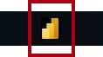

1. To close the getting started window, at the top-left of the window, click **X**.



1. To open the starter Power BI Desktop file, click the **File** ribbon tab to open the backstage view.
2. Select **Open Report**.

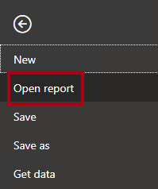

1. Click **Browse Reports**.



1. Select the **Sales Analysis** file.
2. Click **Open**.



## sk 2: Create model relationships

In this task you will create model relationships.

1. In Power BI Desktop, at the left, click the **Model** view icon.



1. If you do not see all seven tables, scroll horizontally to the right, and then drag and arrange the tables more closely together so they can all be seen at the same time.

*Tip: You can also use the zoom control located at the bottom of the window.*

*In Model view, it’s possible to view each table and relationships (connectors between tables). Presently, there are no relationships because in the* ***Prepare Data in Power BI Desktop*** *lab, you disabled the data load relationship options.*

1. To return to Report view, at the left, click the **Report** view icon.



1. To view all table fields, in the **Fields** pane, right-click an empty area, and then select **Expand All**.

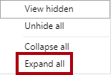

1. To create a table visual, in the **Fields** pane, from inside the **Product** table, check the **Category** field.

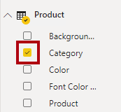

*The labs use a shorthand notation to reference a field. It will look like this:* ***Product | Category****. In this example,* ***Product*** *is the table name and* ***Category*** *is the field name.*

1. To add an additional column to the table, in the **Fields** pane, check the **Sales | Sales** field.
2. Notice that the table visual lists four product categories, and that the sales value is the same for each, and the same for the total.

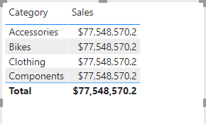

*The issue is that the table is based on fields from different tables. The expectation is that each product category displays the sales for that category. however, because there isn’t a model relationship between these tables, the* ***Sales*** *table is not filtered. You’ll now add a relationship to propagate filters between the tables.*

1. On the **Modeling** ribbon tab, from inside the **Relationships** group, click **Manage Relationships**.

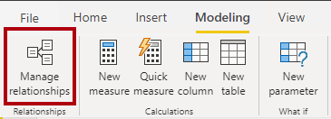

1. In the **Manage Relationships** window, notice that no relationships are yet defined.
2. To create a relationship, click **New**.

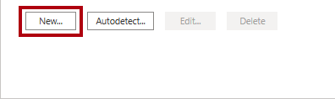

1. In the **Create Relationship** window, in the first dropdown list, select the **Product** table.

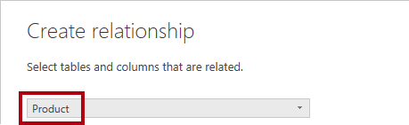

1. In the second dropdown list (beneath the **Product** table grid), select the **Sales** table.

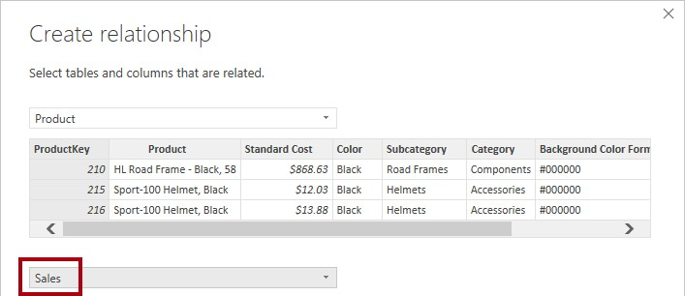

1. Notice the **ProductKey** columns in each table have been automatically selected.

*The columns were selected because they share the same name and data type.*

1. In the **Cardinality** dropdown list, notice that **One To Many (1:*)** is selected.

*The cardinality was automatically detected, because Power bI understands that the* ***Productkey*** *column from the* ***Product*** *table contains unique values. One-to-many relationships are the most common cardinality, and all relationship you create in this lab will be this type*

In the **Cross Filter Direction** dropdown list, notice that **Single** is selected.

*Single filter direction means that filters propagate from the “one side” to the “many side”. In this case, it means filters applied to the* ***Product*** *table will propagate to the* ***Sales*** *table, but not in the opposite direction. You’ll work with a bi-directional relationship in the* ***next part of*** *lab.*

1. Notice that the **Mark This Relationship Active** is checked.

*Active relationships propagate filters. It’s possible to mark a relationship as inactive so filters don’t propagate. Inactive relationships can exist when there are multiple relationship paths between tables. In this case, model calculations can use special functions to activate them. You’ll work with an inactive relationship in the* ***Model next part of*** *lab.*

1. Click **OK**.

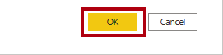

1. In the **Manage Relationships** window, notice that the new relationship is listed, and then click **Close**.

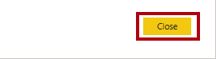

1. In the report, notice that the table visual updated to display different values for each product category.

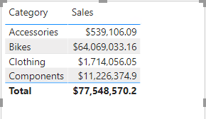

*Filters applied to the* ***Product*** *table now propagate to the* ***Sales*** *table.*

1. Switch to Model view, and then notice there is now a connector between the two tables (it does not matter if the tables are positioned next to each other).

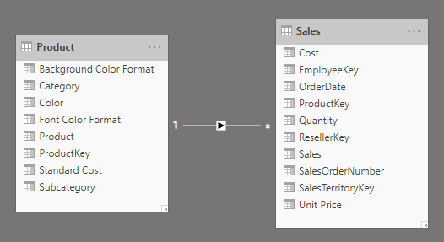

1. In the diagram, notice that you can interpret the cardinality which is represented by the **1** and ***** indicators.

*Filter direction is represented by the arrow head. A solid line represents an active relationship; a dashed line represents an inactive relationship.*

1. Hover the cursor over the relationship to highlight the related columns.

*There’s an easier way to create a relationship. In the model diagram, you can drag and drop columns to create a new relationship.*

1. To create a new relationship using a different technique, from the **Reseller** table, drag the **ResellerKey**

column on to the **ResellerKey** column of the **Sales** table.

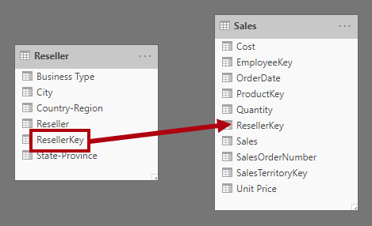

*Tip: Sometime a column doesn’t want to be dragged. If this situation arises, select a different column, and then select the column you intend to drag again, and then try again. Ensure that you see the new relationship added to the diagram.*

1. Use the new technique to create the following two model relationships: **Region | SalesTerritoryKey** to **Sales | SalesTerritoryKey Salesperson | EmployeeKey** to **Sales | EmployeeKey**

*In this lab the* ***Salespersonregion*** *and* ***targets*** *tables will remain disconnected. There’s a many-to-many relationship between salespeople and regions, and you’ll work with this advanced scenario in the* ***the next part of lab****.*

1. In the diagram, arrange the tables so that the **Sales** table is positioned in the center of the diagram, and the related tables are arranged about it. Position the disconnected tables to the side.

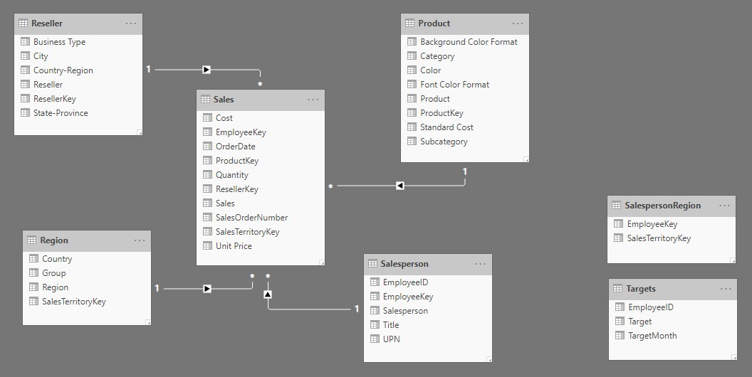

1. Save the Power BI Desktop file.

# Exercise 2: Configure Tables

In this exercise you will configure each table by creating hierarchies, and hiding, formatting, and categorizing columns.

## Task 1: Configure the Product table

In this task you will configure the **Product** table.

1. In Model view, in the **Fields** pane, if necessary, expand the **Product** table to reveal all fields.
2. To create a hierarchy, in the **Fields** pane, right-click the **Category** column, and then select **Create Hierarchy**.

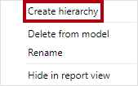

1. In the **Properties** pane (to the left of the **Fields** pane), in the **Name** box, replace the text with **Products**.

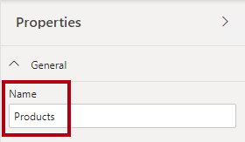

1. To add the second level to the hierarchy, in the **Properties** pane, in the **Hierarchy** dropdown list, select

**Subcategory** (you might need to scroll down inside the pane).

1. To add the third level to the hierarchy, in the **Hierarchy** dropdown list, select **Product**.
2. To complete the hierarchy design, click **Apply Level Changes**.

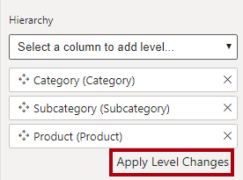

*Tip: Don’t forget to click* ***Apply Level Changes****—it’s a common mistake to overlook this step.*

1. In the **Fields** pane, notice the **Products** hierarchy.

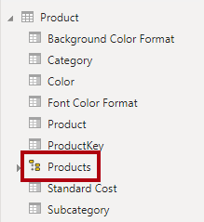

1. To reveal the hierarchy levels, expand the **Products** hierarchy.

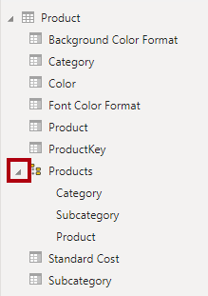

1. To organize columns into a display folder, in the **Fields** pane, first select the **Background Color Format**

column.

1. While pressing the **Ctrl** key, select the **Font Color Format** column.
2. In the **Properties** pane, in the **Display Folder** box, enter **Formatting**.

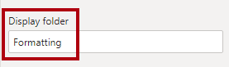

1. In the **Fields** pane, notice that the two columns are now inside a folder.

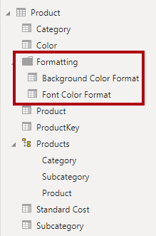

*Display folders are a great way to declutter tables—especially for tables that comprise many fields.*

## Task 2: Configure the Region table

In this task you will configure the **Region** table.

1. In the **Region** table, create a hierarchy named **Regions**, with the following three levels: Group

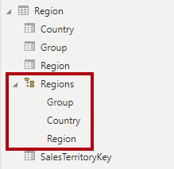Country Region

1. Select the **Country** column (not the **Country** hierarchy level).
2. In the **Properties** pane, expand the **Advanced** section (at the bottom of the pane), and then in the **Data Category** dropdown list, select **Country/Region**.

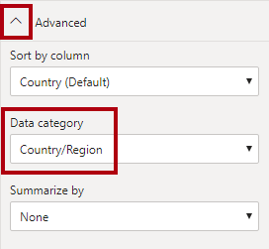

*Data categorization can provide hints to the report designer. In this case, categorizing the column as country or region provides more accurate information to Power bI when it renders a map visualization.*

## Task 3: Configure the Reseller table

In this task you will configure the **Reseller** table.

1. In the **Reseller** table, create a hierarchy named **Resellers**, with the following two levels: Business Type

Reseller

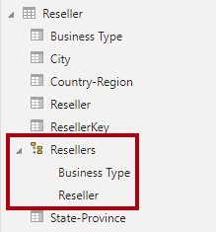

1. Create a second hierarchy named **Geography**, with the following four levels: Country-Region

State-Province City

Reseller

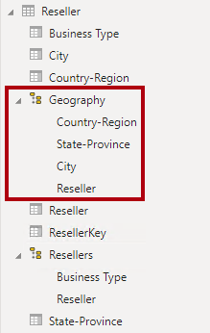

1. Categorize the following three columns: **Country-Region** as **Country/Region State-Province** as **State or Province City** as **City**

## Task 4: Configure the Sales table

In this task you will configure the **Sales** table.

1. In the **Sales** table, select the **Cost** column.
2. In the **Properties** pane, in the **Description** box, enter: **Based on standard cost**

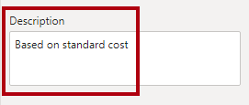

*Descriptions can be applied to tables, columns, hierarchies, or measures. In the* ***Fields*** *pane, description text is revealed in a tooltip when a report author hovers their cursor over the field.*

1. Select the **Quantity** column.
2. In the **Properties** pane, from inside the **Formatting** section, slide the **Thousands Separator** property to

**On**.

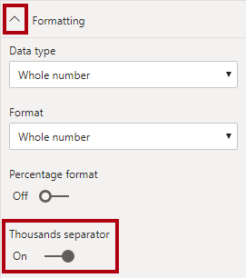

1. Select the **Unit Price** column.
2. In the **Properties** pane, from inside the **Formatting** section, slide the **Decimal Places** property to **2**.
3. In the **Advanced** group (you may need to scroll down to locate it), in the **Summarize By** dropdown list, select **Average**.

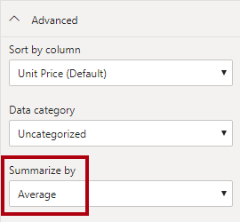

*by default, numeric columns will summarize by summing values together. This default behavior is not suitable for a column like* ***Unit Price****, which represents a rate. Setting the default summarization to average will produce a meaningful result.*

## Task 5: Bulk update properties

In this task you will update multiple columns using single bulk updates. You will use this approach to hide columns, and format column values.

1. In the **Fields** pane, select the **Product | ProductKey** column.
2. While pressing the **Ctrl** key, select the following 13 columns (spanning multiple tables): Region | SalesTerritoryKey

Reseller | ResellerKey Sales | EmployeeKey

Sales | ResellerKey

Sales | SalesOrderNumber Sales | SalesTerritoryKey Salesperson | EmployeeID Salesperson | EmployeeKey Salesperson | UPN

SalespersonRegion | EmployeeKey SalespersonRegion | SalesTerritoryKey Targets | EmployeeID

1. In the **Properties** pane, slide the **Is Hidden** property to **On**.

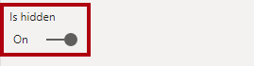

*The columns were hidden because they’re either used by relationships or will be used in row-level security configuration or calculation logic.*

*You’ll define row-level security in the* ***Model Data in Power BI Desktop, Part 2*** *lab using the* ***UPn*** *column. You’ll use the* ***SalesOrdernumber*** *in a calculation in the* ***other lab.***

1. Multi-select the following three columns: Product | Standard Cost

Sales | Cost Sales | Sales

1. In the **Properties** pane, from inside the **Formatting** section, set the **Decimal Places** property to **0** (zero).

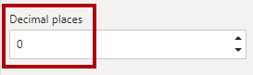

# Exercise 3: Review the Model Interface

In this exercise you will switch to Report view, and review the model interface.

## Task 1: Review the model interface

In this task you will switch to Report view, and review the model interface.

1. Switch to Report view.
2. In the **Fields** pane, notice the following:

Columns, hierarchies and their levels are fields, which can be used to configure report visuals Only fields relevant to report authoring are visible

The **SalespersonRegion** table is not visible—because all of its fields are hidden

Spatial fields in the **Region** and **Reseller** table are adorned with a spatial icon Fields adorned with the sigma symbol (Ʃ) will summarize, by default

A tooltip appears when hovering the cursor over the **Sales | Cost** field

1. Expand the **Sales | OrderDate** field, and then notice that it reveals a date hierarchy.

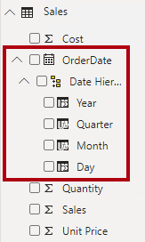

*The* ***targets | targetMonth*** *field delivers a similar hierarchy. These hierarchies were not created by you. They were created automatically. There is a problem, however. The Adventure Works financial year commences on July 1 of each year. but, in these automatically created date hierarchies, the date hierarchy year commences on January 1 of each year.*

*You’ll now turn this automatic behavior off. In the* ***next lab***

*lab, you’ll use DAX to create a date table, and configure it define the Adventure Works’ calendar.*

1. To turn off auto/date time, click the **File** ribbon tab to open the backstage view.
2. At the left, select **Options and Settings**, and then select **Options**.

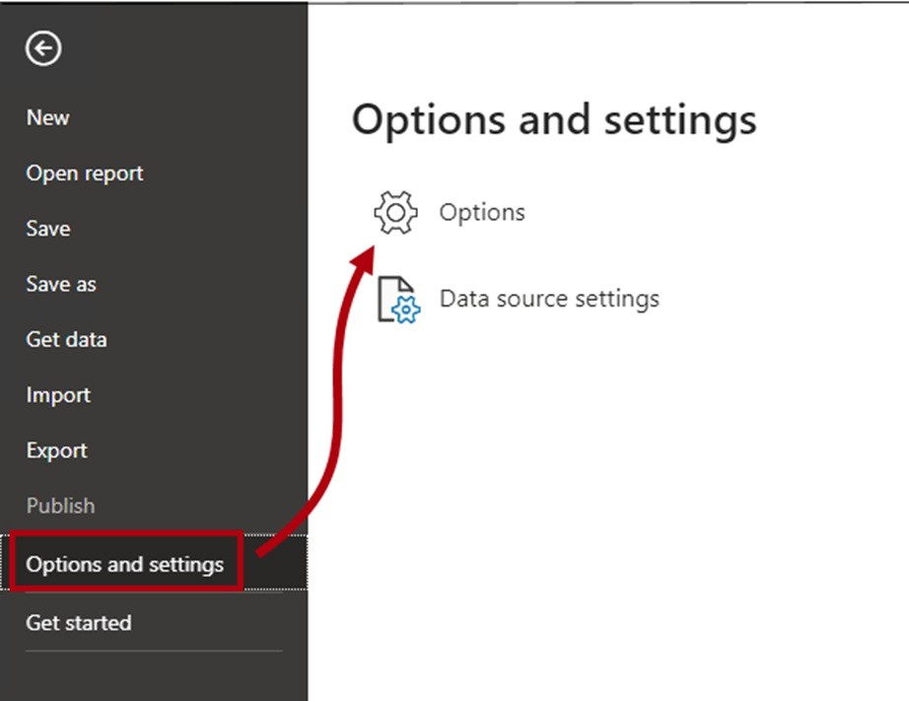

1. In the **Options** window, at the left, in the **Current File** group, select **Data Load**.

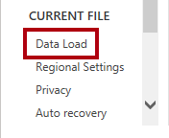

1. In the **Time Intelligence** section, uncheck **Auto Date/Time**.



1. Click **OK**.

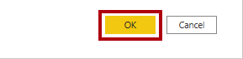

1. In the **Fields** pane, notice that the date hierarchies are no longer available.

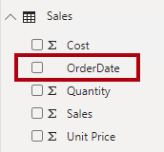

# Exercise 4: Test

1. To test the two measures, first select the table visual on the report page.
2. In the **Fields** pane, check the two measures.

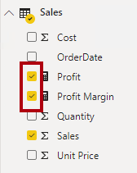

1. Click and drag the right guide to widen the table visual.

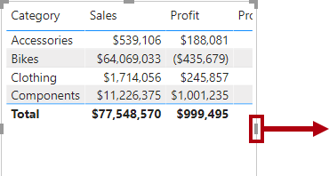

1. Verify that the measures produce reasonable results that are correctly formatted.

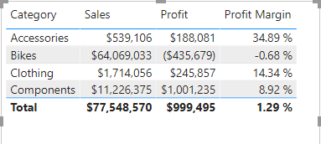

Model Data in Power BI Desktop, Part 2

**Exercise 1: Create a Many-to many Relationship**

In this exercise you will create a many-to-many relationship between the **Salesperson** table and the **Sales** table.

# Task 1: Get started

In this task you will setup the environment for the lab.

*Important: If you are continuing on from the previous lab (and you completed that lab successfully), do not complete this task; instead, continue from the next task.*

1. To open the Power BI Desktop, on the taskbar, click the Microsoft Power BI Desktop shortcut.



1. To close the getting started window, at the top-left of the window, click **X**.



1. To open the starter Power BI Desktop file, click the **File** ribbon tab to open the backstage view.
2. Select **Open Report**.



1. Click **Browse Reports**.



1. Select the **Sales Analysis** file.
2. Click **Open**.



# Task 2: Create a many-to-many relationship

In this task you will create a many-to-many relationship between the **Salesperson** table and the **Sales** table.

1. In Power BI Desktop, in Report view, in the **Fields** pane, check the follow two fields to create a table visual: Salesperson | Salesperson

Sales | Sales

*The labs use a shorthand notation to reference a field. It will look like this:* ***Salesperson | Salesperson*** *. In this example,* ***Salesperson*** *is the table name and* ***Salesperson*** *is the field name.*

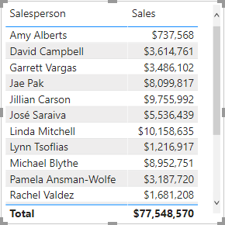

*The table displays sales made by each salesperson. however, there’s another relationship between salespeople and sales. Some salespeople belong to one, two, or possibly more sales regions. In addition, sales regions can*

*have multiple salespeople assigned to them.*

*From a performance management perspective, a salesperson’s sales (based on their assigned territories) need to be analyzed and compared with sales targets. you’ll create relationships to support this analysis in the next exercise.*

1. Notice that Michael Blythe has sold almost $9 million.
2. Switch to Model view.



1. Drag the **SalespersonRegion** table to position it between the **Region** and **Salesperson** tables.
2. Use the drag-and-drop technique to create the following two model relationships: **Salesperson | EmployeeKey** to **SalespersonRegion | EmployeeKey Region | SalesTerritoryKey** to **SalespersonRegion | SalesTerritoryKey**

*The* ***Salespersonregion*** *table can be considered to be a bridging table.*

1. Switch to Report view, and then notice that the visual has not updated—the sales result for Michael Blythe has not changed.
2. Switch back to Model view, and then follow the relationship filter directions (arrowhead) from the

**Salesperson** table.

*Consider that the* ***Salesperson*** *table filters the* ***Sales*** *table. It also filters the* ***Salespersonregion*** *table, but it does not continue by propagating filters to the* ***region*** *table (the arrowhead is pointing the wrong direction).*

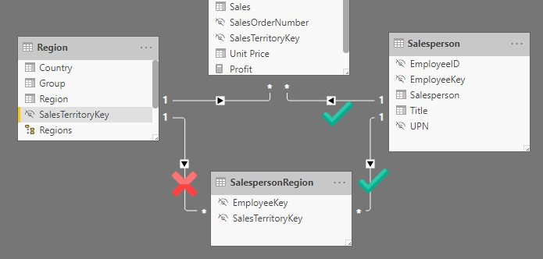

1. To edit the relationship between the **Region** and **SalespersonRegion** tables, double-click the relationship.
2. In the **Edit Relationship** window, in the **Cross Filter Direction** dropdown list, select **Both**.
3. Check the **Apply Security Filter in Both Directions** checkbox.

*This setting will ensure that bi-directional filtering is applied when row-level security is enforced. you’ll configure a security role in the next exercise.*

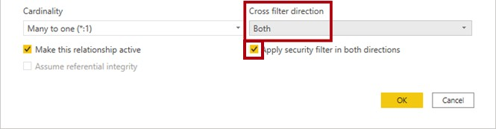

1. Click **OK**.



1. Notice that the relationship has a double arrowhead.



1. Switch to Report view, and then notice that the sales values have still not changed.

*The issue now relates to the fact that there are two possible filter propagation paths between the* ***Salesperson*** *and* ***Sales*** *tables. This ambiguity is internally resolved, based on a “least number of tables” assessment. To be clear, you shouldn’t design models with this type of ambiguity—the issue will be addressed in part later in this lab, and by the completion of the* ***another lab*** *lab.*

1. Switch to Model view.
2. To force filter propagation via the bridging table, edit (double-click) the relationship between the

**Salesperson** and **Sales** tables.

1. In the **Edit Relationship** window, uncheck the **Make This Relationship Active** checkbox.

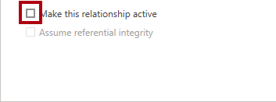

1. Click **OK**.



*The filter propagation will now follow the only active path.*

1. In the diagram, notice that the inactive relationship is represented by a dashed line.



1. Switch to Report view, and then notice that the sales for Michael Blythe is now nearly $22 million.

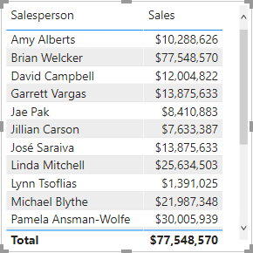

1. Notice also, that the sales for each salesperson—if added—would exceed the table total.

*It’s a common observation of a many-to-many relationship due to the double, triple, etc. counting of regional sales results. Consider Brian Welcker, the second salesperson listed. his sales amount equals the total sales amount. It’s the correct result simply due to the fact the he’s the Director of Sales; his sales are measured by the sales of all regions.*

*While the many-to-many relationship is now working, it’s now not possible to analyze sales made by a salesperson (because the relationship is inactive). you’ll be able to reactive the relationship when you introduce a calculated table that to represent salesperson for performance analysis (of their regions) in the* ***next lab****.*

1. Switch to Modeling view, and then in the diagram, select the **Salesperson** table.
2. In the **Properties** pane, in the **Name** box, replace the text with **Salesperson (Performance)**.

*The renamed table now reflects its purpose: it’s used to report and analyze the performance of salespeople based on the sales of their assigned sales regions.*

# Task 3: Relate the Targets table

In this task you will create a relationship to the **Targets** table

1. Create a relationship from the **Salesperson (Performance) | EmployeeID** column and the **Targets | EmployeeID** column.
2. In Report view, add the **Targets | Target** field to the table visual.
3. Resize the table visual so all columns are visible.

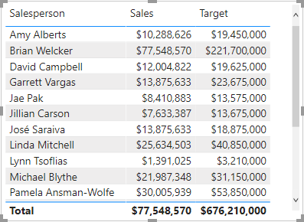

*It’s now possible to visualize sales and targets—but take care for two reasons. First, there’s no filter on a time period, and so targets also include future target amounts. Second, targets are not additive, and so the total should not be displayed. They can either disabled by formatting the visual or removed by using calculation logic. you’ll follow the second approach by creationg a target measure in* ***next lab*** *that’ll return BLAnk when more than one salesperson is filtered.*