Laboratorio 1 – Unidad 1

Marco Pérez – Julián Enciso

FUNCTIONAL REQUIREMENTS

|  |  |
| --- | --- |
| Name | Choose difficulty R1 |
| summary | It allows the user to select the level of difficulty that they want. |
| Entries | Integer corresponding to the difficulty |
| Departures | Generates the game board corresponding to the difficulty chosen. |

|  |  |
| --- | --- |
| Name | Give clue R2 |
| summary | It gives the user a clue and uncovers a box that is not mine |
| Entries |  |
| Departures | Opens a new box randomly |

|  |  |
| --- | --- |
| Name | Show solution R3 |
| summary | It allows the user to visualize the solution for the given board. |
| Entries |  |
| Departures | Show the board with all the solutions given for the board. |

|  |  |
| --- | --- |
| Name | Visualize board R4 |
| summary | It allows the user to visualize the required number of buttons for the difficulty desired. |
| Entries |  |
| Departures | Initializes the FXML file related to the desired difficulty and displays it. |

|  |  |
| --- | --- |
| Name | Select box by click R5 |
| summary | It allows the user to select a desired box to uncover by clicking on it. |
| Entries | ActionEvent event: referring to the action of clicking on such button. |
| Departures | Changes the text of the desired button depending on surrounding mines and if is a mine per se. |

|  |  |
| --- | --- |
| Name | Select box by index R6 |
| summary | It allows the user to select a box without clicking on said box, by introducing the indexes of its location. |
| Entries | Integer i: row index, integer j: column index. |
| Departures | Changes the text of the desired button depending on surrounding mines and if is a mine per se. |

|  |  |
| --- | --- |
| Name | Warn about wrong index R7 |
| summary | It displays a message to let the user know he or she has introduced an index (for either column or row) which isn’t contained in the board or a string instead of an int. |
| Entries |  |
| Departures | Displays the message detailing the misuse of the select box by index related method. |

|  |  |
| --- | --- |
| Name | Warn about already opened box R8 |
| summary | It displays a message to let the user know he or she has tried opening a box (either by clikcing or by index) which is already open. |
| Entries |  |
| Departures | Displays a message with a short description about the error. |

|  |  |
| --- | --- |
| Name | Warn about open box while game done R9 |
| summary | It displays a message to let the user know he or she has tried opening a box (either by clickng or by index) but the game has already ended. |
| Entries |  |
| Departures | Displays a message with a short description about the error. |

CLASS DIAGRAM

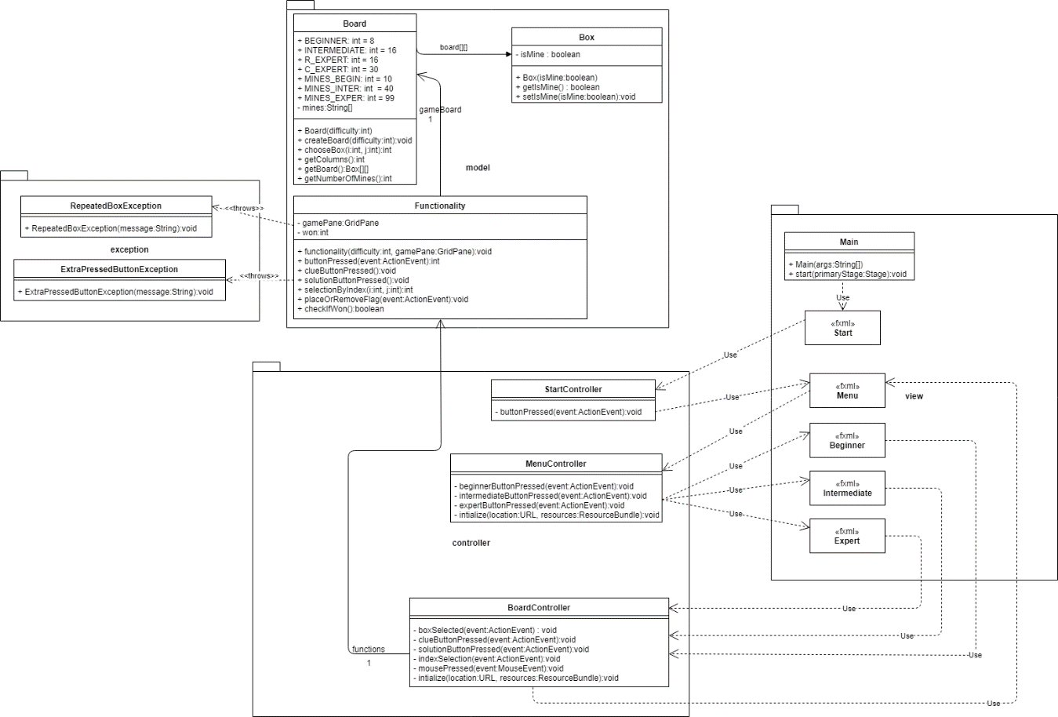

Traceability

|  |  |  |
| --- | --- | --- |
| **Requirement** | **Class** | **Method** |
| **R1** | MenuController | beginnerButtonPressed()  intermediateButtonPressed()  expertButtonPressed() |
| **R2** | BoardController  Functionality  Board | clueButtonPressed()  clueButtonPressed()  chooseBox() |
| **R3** | BoarController  Functionaility  Board | solutionButtonPressed()  solutionButtonPressed()  chooseBox() |
| **R4** | BoardController | initialize() |
| **R5** | BoardController  Functionality  Board | boxSelected()  buttonPressed()  chooseBox() |
| **R6** | BoardController  Functionality  Board | indexSelection()  selectionByIndex()  chooseBox() |
| **R7** | BoardController  Functionality | indexSelection()  selectionByIndex() |
| **R8** | BoardController  Functionality | indexSelection()  boxSelected()  selectionByIndex()  buttonPressed() |
| **R9** | BoardController  Functionality | indexSlection()  selectionByIndex() |

Tests

**Test number 1 – Test if the size of the Board is properly created and matches that expected.**

|  |  |  |  |  |
| --- | --- | --- | --- | --- |
| **Class** | **Method** | **Scenario** | **Inputs** | **Result** |
| Board | createBoard() | A Board with a difficulty of 1(beginner). | difficulty = 1 | True. The size of the Board matches that expected. |
| Board | createBoard() | A Board with a difficulty of 2 (intermediate). | difficulty = 2 | True. The size of the Board matches that expected. |
| Board | createBoard() | A Board with a difficulty of 3 (expert). | difficulty = 3 | True. The size of the Board matches that expected. |

**Test number 2 – Test if the number of mines matches which is expected.**

|  |  |  |  |  |
| --- | --- | --- | --- | --- |
| **Class** | **Method** | **Scenario** | **Inputs** | **Result** |
| Board | createBoard() | A Board with a difficulty of 1(beginner). | difficulty = 1 | True. The number of mines matches that expected. |
| Board | createBoard() | A Board with a difficulty of 2 (intermediate). | difficulty = 2 | True. The number of mines matches that expected. |
| Board | createBoard() | A Board with a difficulty of 3 (expert). | difficulty = 3 | True. The number of mines matches that expected. |

**Test number 3 – Test if the number returned by the method “chooseBox()” matches the number expected.**

|  |  |  |  |  |
| --- | --- | --- | --- | --- |
| **Class** | **Method** | **Scenario** | **Inputs** | **Result** |
| Board | chooseBox() | A Board with a difficulty of 1(beginner). | difficulty = 1 | True. The number returned by the method matches that expected. |
| Board | chooseBox() | A Board with a difficulty of 2 (intermediate). | difficulty = 2 | True. The number returned by the method matches that expected. |
| Board | chooseBox() | A Board with a difficulty of 3 (expert). | difficulty = 3 | True. The number returned by the method matches that expected. |