**Documentation**

**Functional requirements**

|  |  |
| --- | --- |
| Name | Select a game mode - R1 |
| summary | It allows the player to select the game mode, be it throw or catch. |
| Entries |  |
| Output | Takes the player to a pokemon selection menu and sets the game mode before doing so. |

|  |  |
| --- | --- |
| Name | Select a pokemon – R2 |
| summary | It allows the player to select the pokemon he or she wants to throw or catch |
| Entries |  |
| Output | Saves the selected pokemon and opens the throw or catch arena depending on which was selected before. |

|  |  |
| --- | --- |
| Name | Throw pokemon – R3 |
| summary | It allows the player to click on the pokeball and start the pokemon’s movement. |
| Entries |  |
| Output | Changes the pokeball image to the pokemon selected and initiates its movement. |

|  |  |
| --- | --- |
| Name | Catch Pokemon – R4 |
| summary | It allows the player to catch the pokemon while it hasn’t arrived at the flag. |
| Entries |  |
| Output | Enables the possibility to click on the image so the movement stops. |

|  |  |
| --- | --- |
| Name | Save name R-5 |
| summary | It allows the player to save his or her name when the pokemon has been caught. |
| Entries | String name |
| Output | Displays a dialog po-up window in which the player can introduce his or her name. |

|  |  |
| --- | --- |
| Name | Disable capacity to catch – R6 |
| summary | It disables the player’s capacity to catch a pokemon once it has gone past the flag. |
| Entries |  |
| Output | Continues the pokemon’s movement to the finish and disables the possibility to click on it. |

|  |  |
| --- | --- |
| Name | Display field – R7 |
| summary | It displays the field in which the game will take place. |
| Entries |  |
| Output | Displays all the graphical content of the desired game. |

|  |  |
| --- | --- |
| Name | Move pokemon – R8 |
| summary | It initializes the animation for the movement of the pokemon the player selected. |
| Entries |  |
| Output | Starts the movement of the pokemon image. |

|  |  |
| --- | --- |
| Name | Set speed – R9 |
| summary | It modifies the duration of the animation randomly. |
| Entries |  |
| Output | Sets the duration to the randomly calculated number; |

|  |  |
| --- | --- |
| Name | Modify score – R10 |
| summary | It modified the existing score of the selected player. |
| Entries | Int points |
| Output | Adds an amount of points to the existing score. |

|  |  |
| --- | --- |
| Name | Create a player – R11 |
| summary | It allows the player to create a new profile with which he or she can play. |
| Entries | String nickname |
| Output | Creates a new Player object |

|  |  |
| --- | --- |
| Name | Select a player – R12 |
| summary | It allows the player to select one of the existing players. |
| Entries | String nickname |
| Output | Selects the player desired. |

|  |  |
| --- | --- |
| Name | Organize Natural Order – R12 |
| summary | It allows the player to view the list of players ranked by score. |
| Entries |  |
| Output | Displays the organized list of players. |

|  |  |
| --- | --- |
| Name | Organize Partial Order – R13 |
| summary | It allows the player to view the list of players in alphabetical order. |
| Entries |  |
| Output | Displays the organized list of players. |

|  |  |
| --- | --- |
| Name | Search Player – R14 |
| summary | It allows the player to search for a player by nickname. |
| Entries | String nickname |
| Output | Looks in the list of players if the nickname belongs to an existing instance of a player. |

|  |  |
| --- | --- |
| Name | Search Pokemon – R15 |
| summary | It allows the player to search for a pokemon by name. |
| Entries | String nickname |
| Output | Looks in the list of pokemons if the name belongs to an existing instance of a pokemon. |

**Class Diagram**

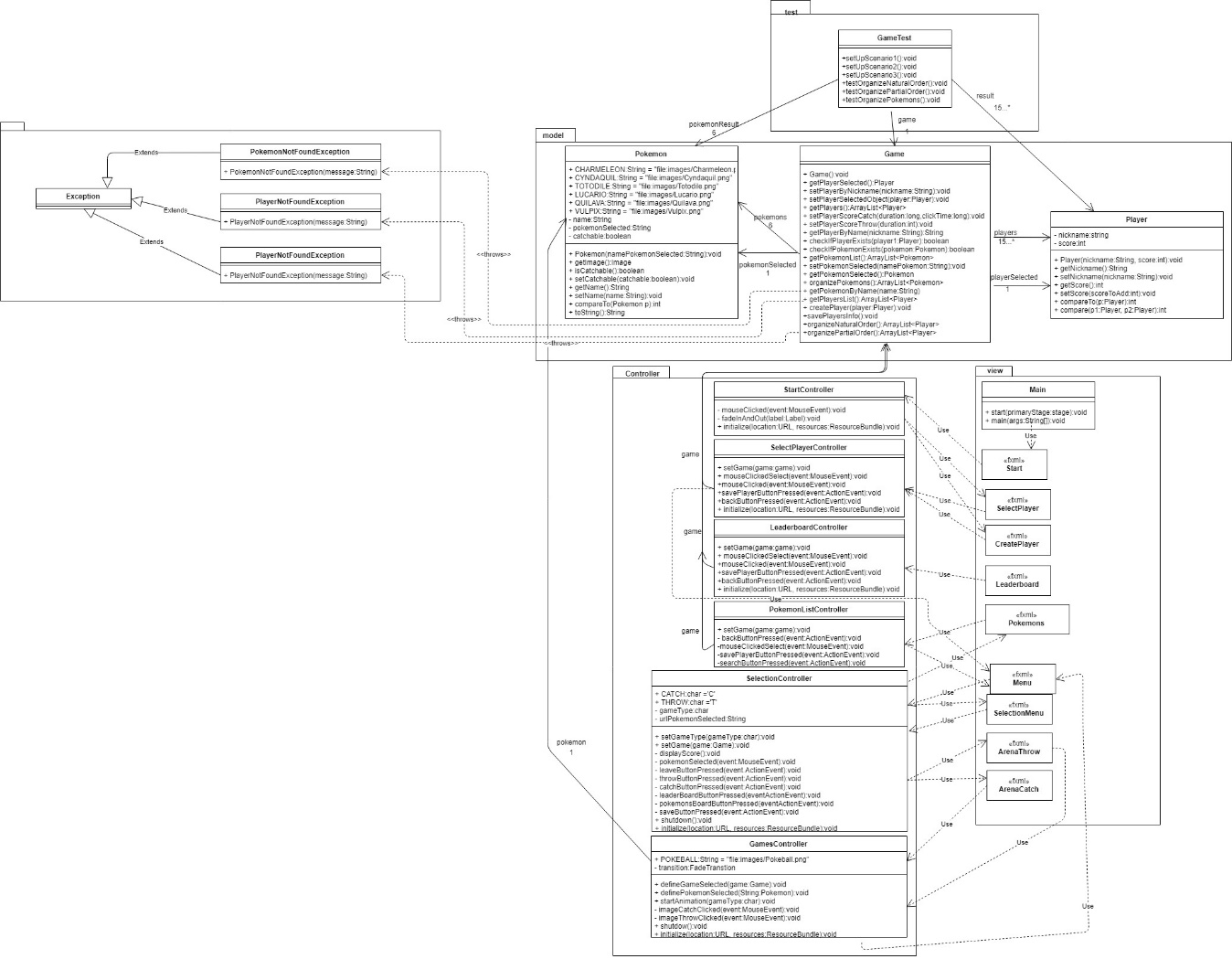

**Traceability**

|  |  |  |
| --- | --- | --- |
| **Requirement** | **Class** | **Method** |
| **R1** | Selection controller | setGameType()  throwButtonPressed()  catchButtonPressed() |
| **R2** | SelectionController | pokemonSelected() |
| **R3** | SelectionController  GamesController | throwButtonPressed()  pokemonSelected()  imageThrowClicked() |
| **R4** | SelectionController | throwButtonPressed()  pokemonSelected()  imageCatchClicked() |
| **R5** | GamesController | imageCatchClicked() |
| **R6** | GamesController | definePokemonSelected() |
| **R7** | GamesController | initialize() |
| **R8** | GamesController | startAnimation ()  imageThrowClicked() |
| **R9** | GamesController | startAnimation ()  imageThrowClicked() |
| **R10** | GamesController  Game  Player | imageThrowClicked()  imageCatchClicked()  setPlayerScoreCatch()  setPlayerScoreThrow()  setScore() |
| **R11** | SelectPlayerController  Game | savePlayerButton()  savePlayersInfo() |
| **R12** | Game | oragnizeNaturalOrder() |
| **R13** | Game | organizePartialOrder |
| **R14** | SelectPlayerController  Game | searchButtonPressed()  getPlayerByName() |
| **R15** | PokemonListController  Game | searchButtonPressed()  getPokemonByName() |

Tests

**Test number 1 – Test if the array is properly organized in natural order.**

|  |  |  |  |  |
| --- | --- | --- | --- | --- |
| **Class** | **Method** | **Scenario** | **Inputs** | **Result** |
| Game | organizeNaturalOrder() | Creates a game with no selected player and organizes it. Obtains the organized player array. | Creates an array in the order expected and using a loop, compares each value asserting if the nicknames are equal. | True. For each iteration, the values conceded. |

**Test number 1 – Test if the array is properly organized in partial order.**

|  |  |  |  |  |
| --- | --- | --- | --- | --- |
| **Class** | **Method** | **Scenario** | **Inputs** | **Result** |
| Game | organizePartialOrder() | Creates a game with no selected player and organizes it. Obtains the organized player array. | Creates an array in the order expected and using a loop, compares each value asserting if the nicknames are equal. | True. For each iteration, the values conceded. |

**Test number 3 – Test if the array of pokemon’s is properly organized in partial order.**

|  |  |  |  |  |
| --- | --- | --- | --- | --- |
| **Class** | **Method** | **Scenario** | **Inputs** | **Result** |
| Game | organizePokemons() | Creates a game with no selected player and organizes it. Obtains the organized pokemon array. | Creates an array in the order expected and using a loop, compares each value asserting if the names are equal. | True. For each iteration, the values conceded. |