Debugging Notes for SQL Generation Operation with MartBuilder Using Vega_51.xml

- Before updating the schema via live connection to ensembl DB, modify vega_51.xml to point DB connection URL to the right location. Otherwise, the update GUI will hang.

<jdbcSchema uniqueId="1" driverClassName="com.mysql.jdbc.Driver" url="jdbc:mysql://martdb.ensembl.org:5316/vega_mart_50" databaseName="vega_mart_50" schemaName="vega_mart_50" username="anonymous" password="" name="vega_gene" keyguessing="true" masked="false" hideMasked="true" partitionRegex="" partitionExpression="">

- Once the DB URL in the XML file is updated, the schema can be updated without error.
- Select the radio button “DataSet” and then run the operation “Generate SQL”. Target schema specified by the XML is “vega_mart_51” that will be rejected by the application. In addtion, the schema diagram will disappear in a minute or so if no button click action is taken (memory issue?):

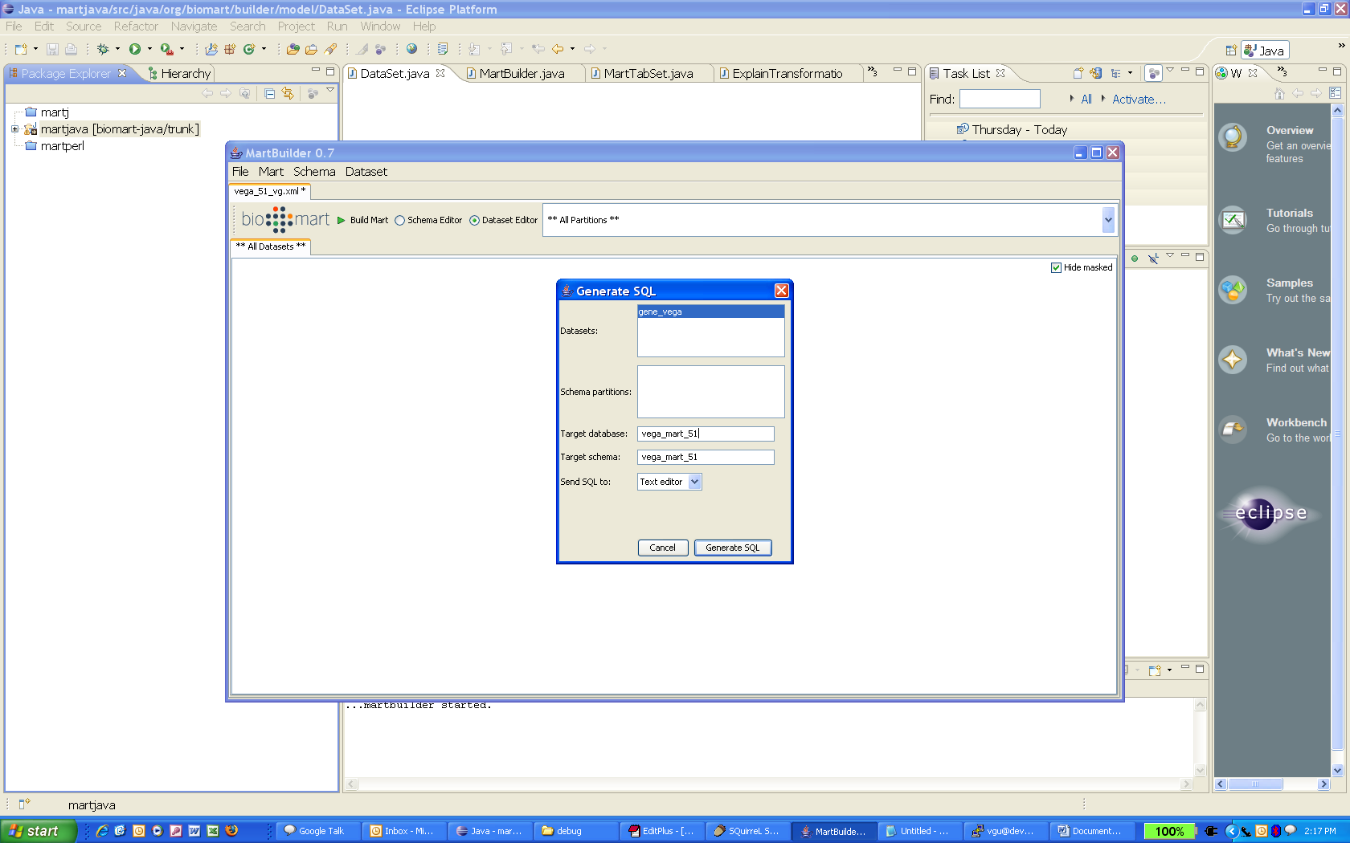

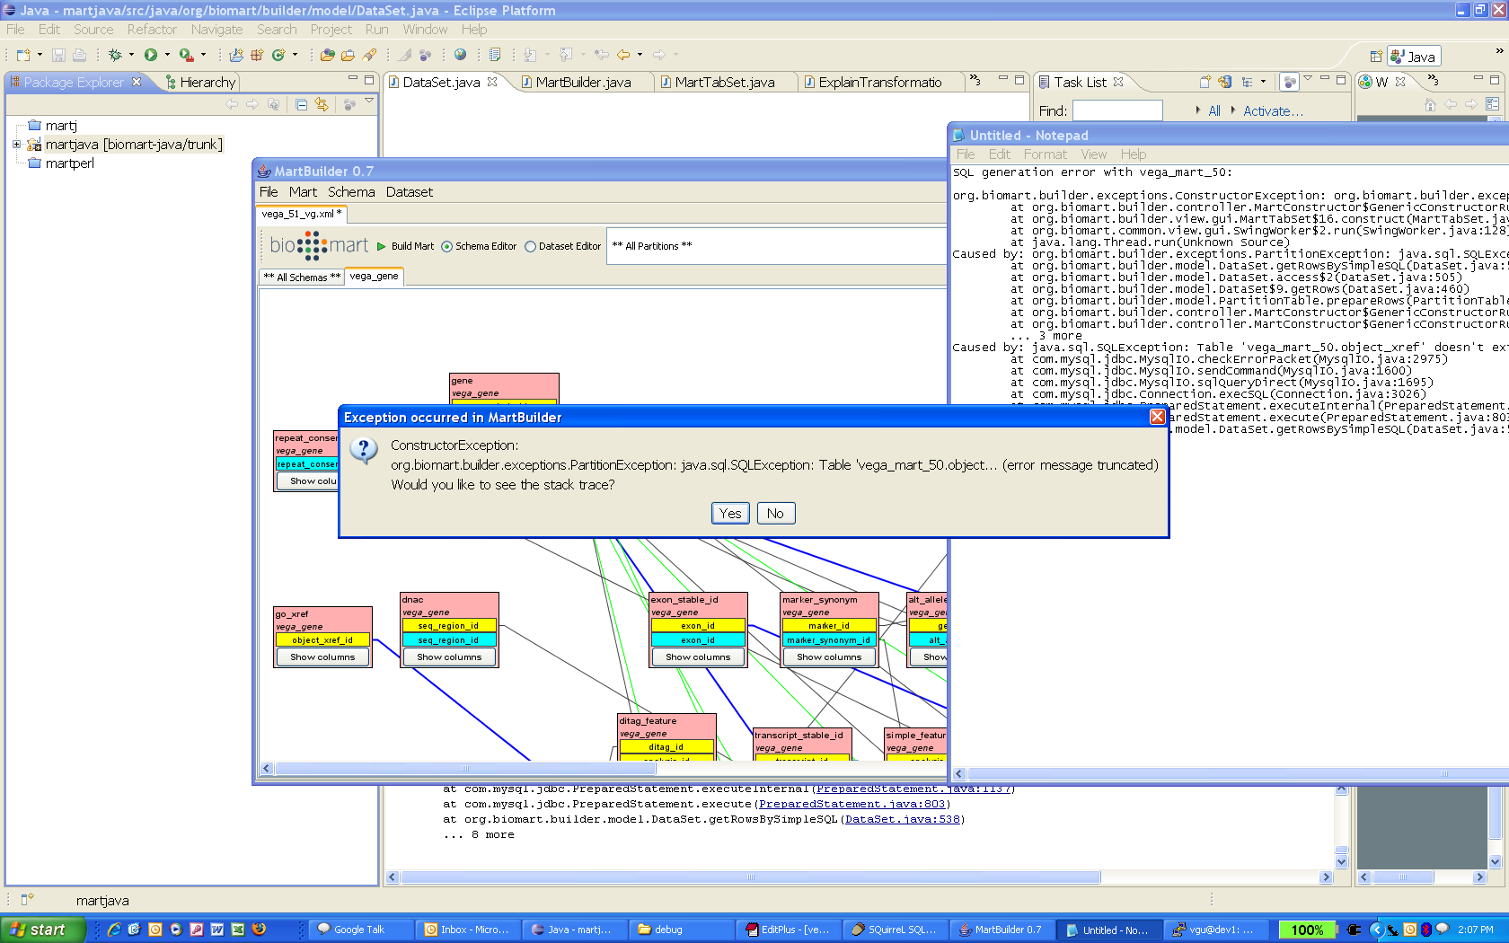

org.biomart.builder.exceptions.ConstructorException: org.biomart.builder.exceptions.PartitionException: java.sql.SQLException: Table 'vega_mart_50.object_xref' doesn't exist
at org.biomart.builder.controller.MartConstructor$GenericConstructorRunnable.run(MartConstructor.java:1986)
at org.biomart.builder.view.gui.MartTabSet$16.construct(MartTabSet.java:684)
at org.biomart.common.view.gui.SwingWorker$2.run(SwingWorker.java:128)
at java.lang.Thread.run(Unknown Source)
Caused by: org.biomart.builder.exceptions.PartitionException: java.sql.SQLException: Table 'vega_mart_50.object_xref' doesn't exist
at org.biomart.builder.model.DataSet.getRowsBySimpleSQL(DataSet.java:561)
at org.biomart.builder.model.DataSet.access$2(DataSet.java:505)
at org.biomart.builder.model.DataSet$9.getRows(DataSet.java:460)
at org.biomart.builder.model.PartitionTable.prepareRows(PartitionTable.java:255)
at org.biomart.builder.controller.MartConstructor$GenericConstructorRunnable.makeActionsForDataset(MartConstructor.java:384)
at org.biomart.builder.controller.MartConstructor$GenericConstructorRunnable.run(MartConstructor.java:1974)
... 3 more
Caused by: java.sql.SQLException: Table 'vega_mart_50.object_xref' doesn't exist
at com.mysql.jdbc.MysqlIO.checkErrorPacket(MysqlIO.java:2975)
at com.mysql.jdbc.MysqlIO.sendCommand(MysqlIO.java:1600)
at com.mysql.jdbc.MysqlIO.sqlQueryDirect(MysqlIO.java:1695)
at com.mysql.jdbc.Connection.execSQL(Connection.java:3026)
at com.mysql.jdbc.PreparedStatement.executeInternal(PreparedStatement.java:1137)
at com.mysql.jdbc.PreparedStatement.execute(PreparedStatement.java:803)
at org.biomart.builder.model.DataSet.getRowsBySimpleSQL(DataSet.java:538)
... 8 more

