Consumption analysis of transponder lora32u4II, firmware bsf32u4_01
Author: Marco Rainone
Document Version: 1.0
Date: 2019-08-28

index
1 Transponder lora32u4II. Firmware bsf32u4_01 1
1.1 first active phase after power up 1
1.2 Second active phase: read of the second message. Send data to TTN 5
1.3 Following operating cycles 8

This document analyzes a series of measurements with the Otii tool to illustrate the various operating phases of the Acurite 5in1 weather station acquisition firmware and the transponder consumption during these phases.

Transponder lora32u4II. Firmware bsf32u4_01
Otii Supply voltage: 3.7V to simulate the power supply through lipo battery.
Hardware elements connected:
- module BsFrance Lora32u4II
- RXB6, OOK Etherodina receiver
- Bosh BMP180, pressure and temperature sensor

first active phase after power up
In this phase are carried out these operations:
- hardware setup
- TTN join
- reading the first weather station message

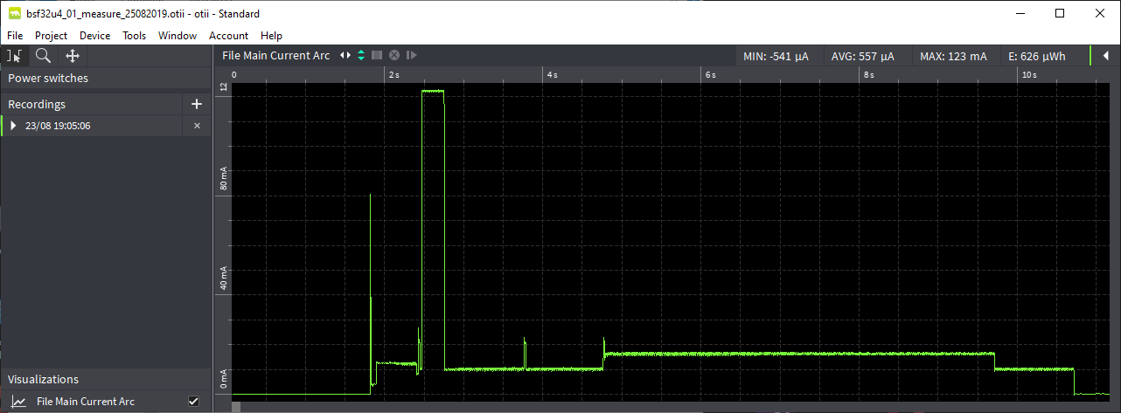

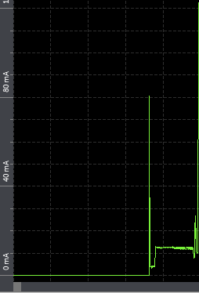 | Turning on the Lora32u4II module. The setup() is executed and proceeds with hardware configuration.
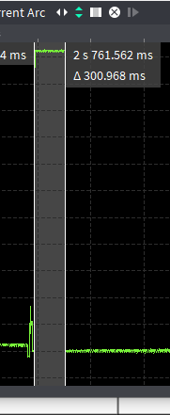 | TTN join phase via ABP.  The duration of this phase is about 300msec.  The consumption reaches 120mA
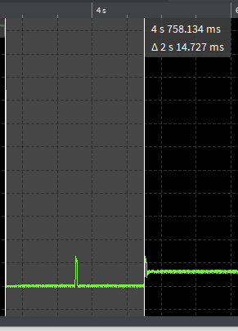 | After the TTN join phase, a preparation phase begins to receive messages of weather station.  Except for a few very brief consumption peaks, consumption depends only on active phase of Lora32u4II.  The the active phase average consumption of Lora32U4II is 10mA
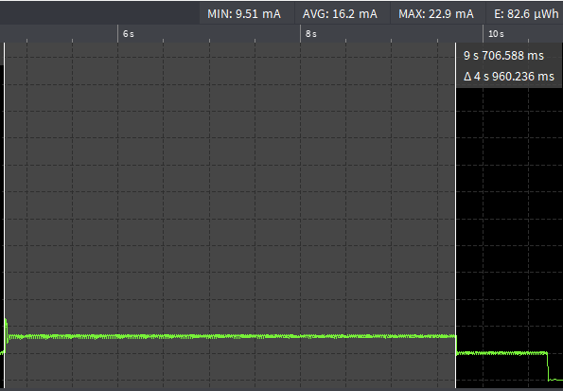 | In this phase the microcontroller turns on the RXB6 receiver.  It remains on until it receives the first message from the weather station.  The total consumption is the sum of the microcontroller and the etherodyne receiver consumption.  In this phase the average consumption is 16.2mA.  When the correct reception of the message is complete, the receiver is switched off and the consumption returns to 10mA again.
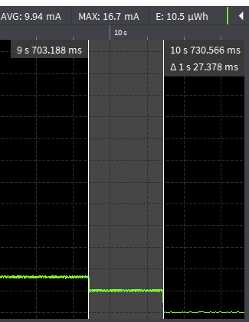 | Here we analyze the first weather station message.  After that, we go in deep sleep waiting a specific time before to receive the second message.  With the second message, the weather station has completed the delivery of its data.

Second active phase: read of the second message. Send data to TTN
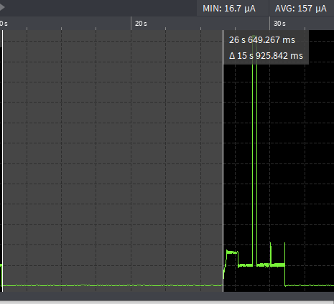 | The ws sends the second message 18 seconds after the first one.  To reduce consumption, the microcontroller is sent in deep sleep before starting the second phase.  In this case the consumption drops to 157uA.
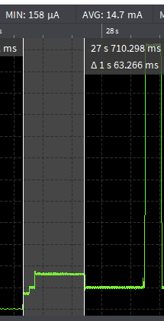 | The microcontroller wakes up and turns on the etherodyne receiver, which remains on until a message is completely received.  The receiver is now turned off.
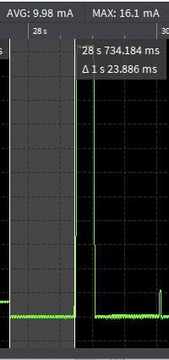 | The second message is analyzed.  The BMP180 sensor data is acquired and the LoraWAN message is prepared to be sent to TTN.  In this phase the consumption is around 10mA.
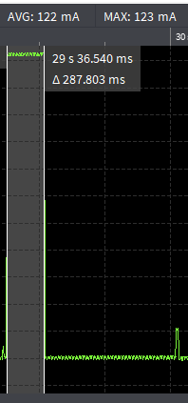 | Message transmission phase to TTN:  this phase lasts 288msec and consumption results 122mA
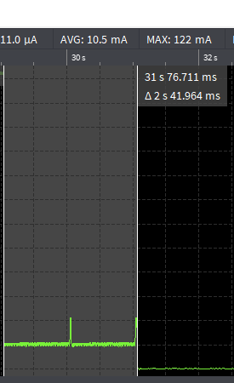 | Completed the transmission of the LoraWAN message, the lora chip is set to sleep.  The consumption returns to the average of 10mA.  the software has completed the steps.  Finally, the deep sleep is activated before proceeding with the execution of a new cycle.
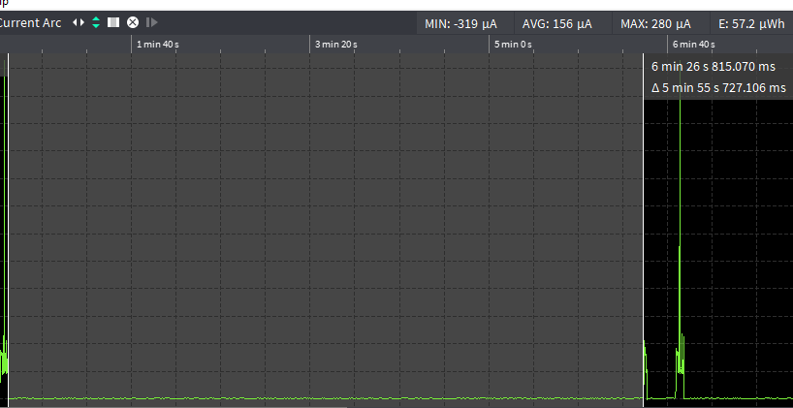 | The calculation of the duration of the deep sleep is based on the time set between message transmissions to TTN.  In this phase, which in the example lasts 5min 55s, consumption is 156uA.  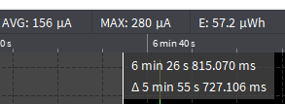

Following operating cycles

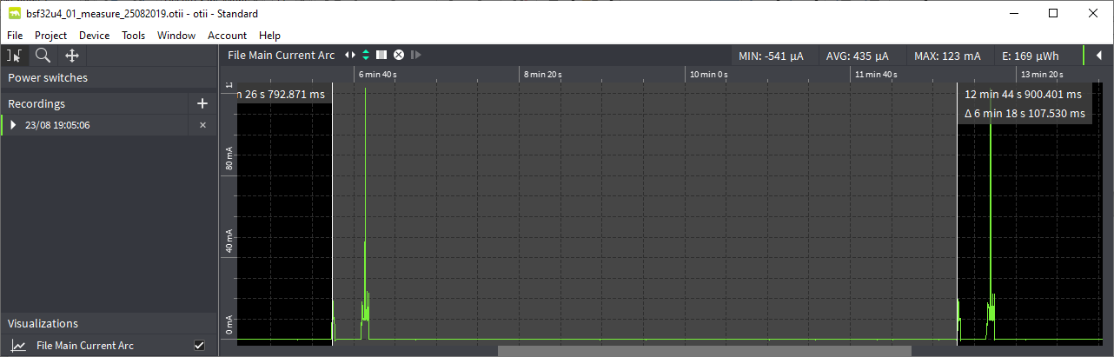
After the first cycle, they follow an indefinite series of successive cycles of equal duration, composed of the following phases:
- Active phase of receiving the first message: it is different from that of the first cycle, because the TTN join is not re-executed.
- deep sleep before proceeding to receive the second message
- Active phase of receiving the second message and sending data to TTN: this phase is the same as that of the first cycle
- Deep sleep phase before repeating the operating cycle again.

