Otii, developer tool for IoT energy optimisation
Author: Marco Rainone
Document Version: 1.0
Date: 2019-08-28

index
1 Description 1
1.1 Product site 1
1.2 FEATURES 2
2 Consumption analysis 3
2.1 Selection Tool 5
2.2 Zoom Tool 5
2.3 Drag Tool 5
3 Examples 5
4 References 8
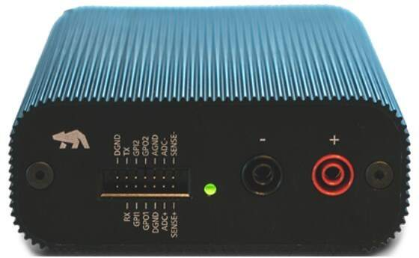

Description
Otii is a portable developer tool designed by Qoitech that simplifies measurement and analysis of energy consumption.
It can be used to enable battery energy optimization in application firmware developed for IoT devices.

Product site
https://www.qoitech.com/
the Otii Standard model was used during the firmware development phases of the various projects.
https://www.qoitech.com/products/standard
https://www.qoitech.com/support

FEATURES
- Continuous system level current and voltage measurements
- Current auto-range for 0.5 µA to 5 A
- sample rate of up to 4 ksps
- Power supply, 0.5 - 3.75 V (up to 5.0 V with DC adapter)
- Real time energy consumption analysis
- Record and compare multiple recordings

Even if the instrument is not available, the software can be installed on a PC to proceed with the analysis of the measurements taken.
The ver_240 subdirectory contains the installation programs for the version used during the development of transponder.

https://www.qoitech.com/download
VERSION 2.4.0 / DECEMBER 19TH 2018
- Add Set Height... to the graph context menu. This enables you to specify the min and max value for the Y-axis.
- Add Goto Time... to the graph context menu.
- Add a preference to enable HighDPI support.
- Move visualizations to the bottom of the sidebar to allow more space for recordings.
- Always show decimal format in statistics. Avoid scientific notation and prevent showing ridiculously small numbers.
- Clear uart buffer when starting new recording. Sometimes data from a previous recording was added in the beginning.
- Fail opening a project instantly if there's insufficient space in the temporary storage location.
- Fix a bug which caused statistics not to be updated when a recording was unhidden.
- Add a new and improved battery profiling example script.
- Help updates.
Download Version 2.4.0
https://www.qoitech.com/downloads/Setup_otii_x64_2.4.0.exe
https://www.qoitech.com/downloads/otii_2.4.0.dmg
https://www.qoitech.com/downloads/otii_2.4.0.deb

The sample_otii_measurements_transponder subdirectory contains the files of some transponder consumption measurements with various firmware versions installed.

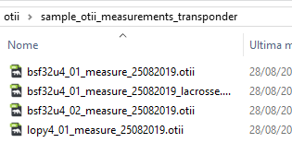
Consumption analysis
Once the Otii Standard program has been installed, launch the program. At this point the initial screen appears.
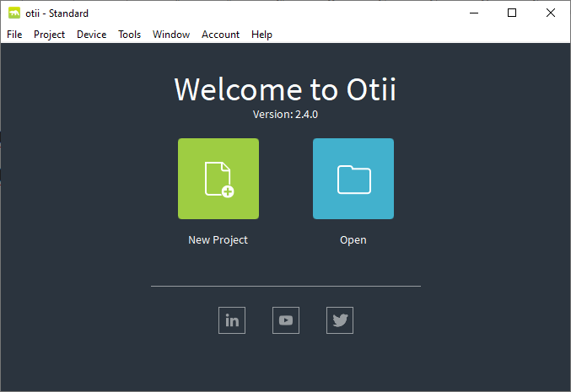

Select File – Open Project
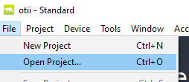
and select a file with .otii file extension.
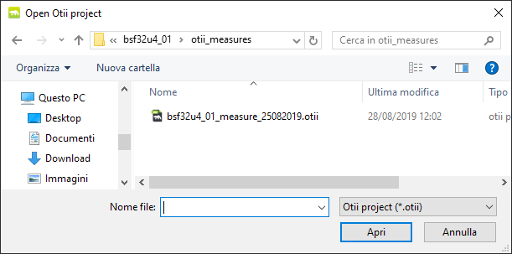
At this point the main screen displays the graph of the measurements taken by the instrument.

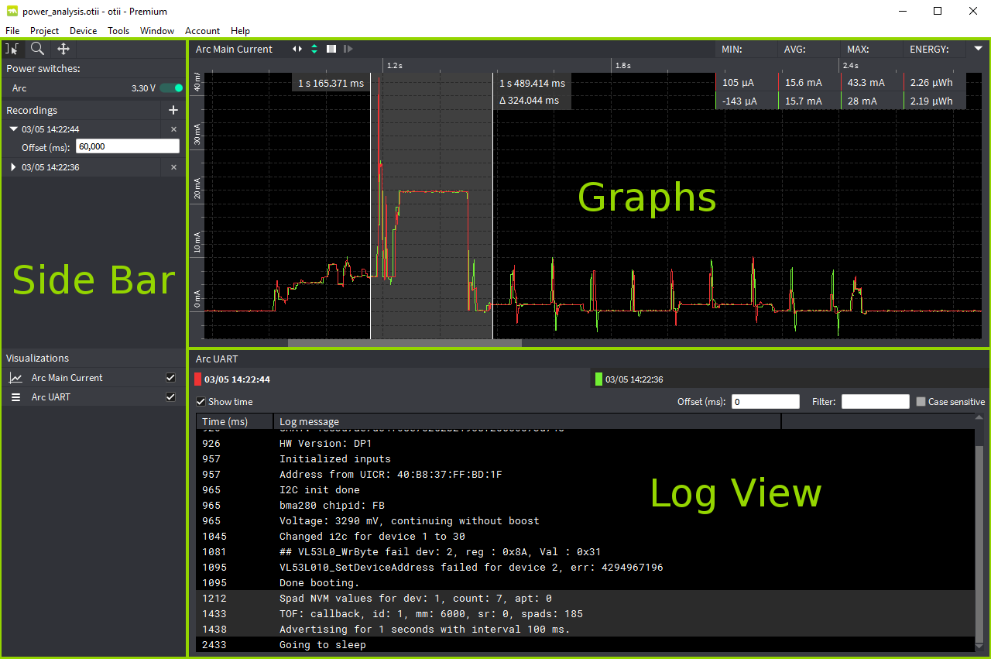
The application comprises three main areas, the side bar, the graphs, and the log view.
One or more of these might be missing depending on your configuration.

The Graphs show data streams of the measurements you have chosen in the settings window.
Each data stream has its own graph window.
Multiple recordings of the same stream will be shown in the same graph, but with different colors.
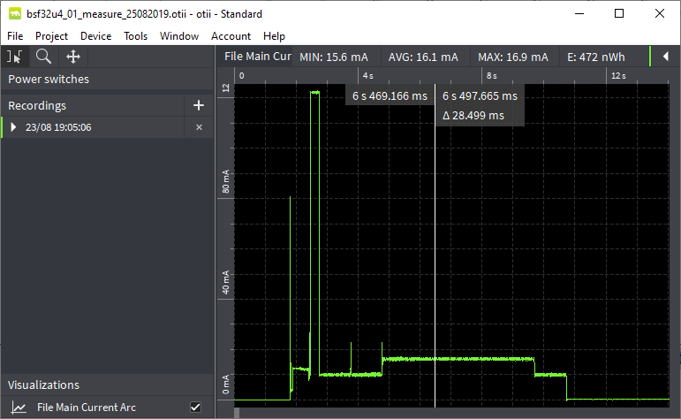

Selection Tool
Choose the Selection tool Mark at the top of the Side Bar or by pressing S on the keyboard to draw a selection in the graphs.
Statistics for the selected time are shown in the top right corner of each graph and the corresponding log lines are highlighted, if available.

Zoom Tool
To zoom in the graphs, select the Zoom tool at the top of the Side Bar or by pressing Z on the keyboard and use the mouse to click and draw a zoom area.
The mouse wheel can also be used to zoom in and out at any time.
By default the mouse wheel zooms the X axis. Hold Alt to zoom the Y axis instead.

Drag Tool
The Drag tool Drag can be used if you want to move the graph around and don't want to use the scrollbars. Activate the Drag tool at the top of the Side Bar or by pressing D on the keyboard, then click and drag the graph in desired direction.

Examples

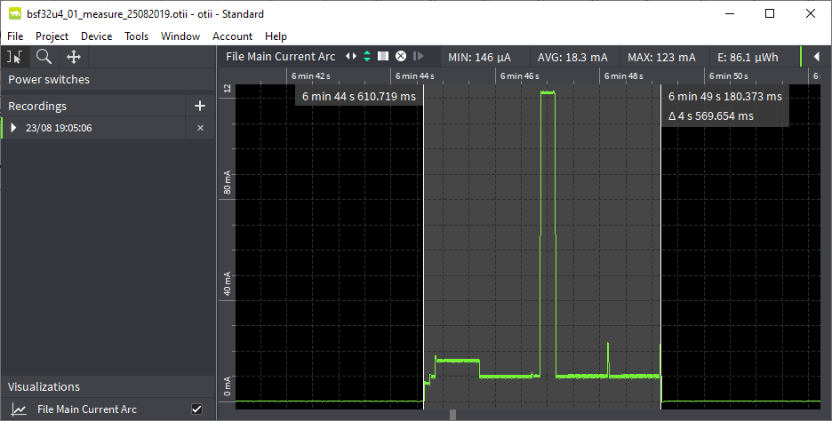
the image shows a selection of an active transponder phase.
The selection starts about 6min 44sec from the beginning of the measurements and the active phase lasts about 4.5sec.
On the upper bar appear the values of consumption of minimum, average, maximum current and the value of energy consumed.

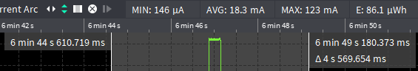

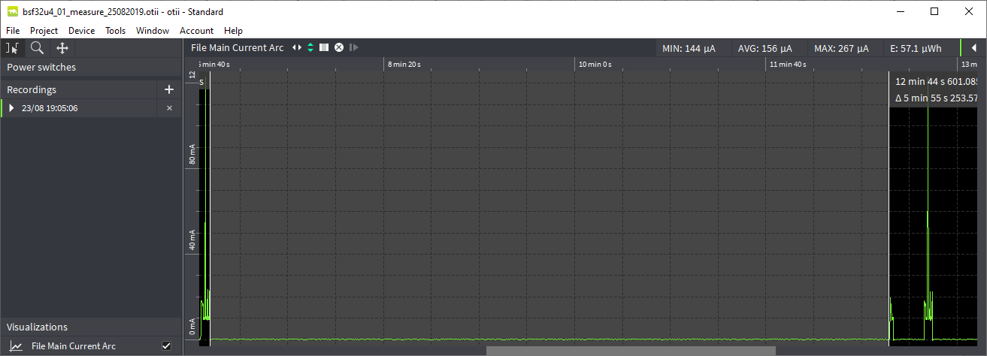
The image shows a phase in low-power deep-sleep between two active phases of the Lora32U4II transponder.
This phase lasts about 5min 55sec and average current consumption is 156uA.
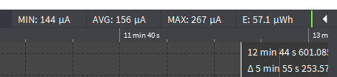

References
- https://www.qoitech.com/
Web page of the Otii instrument manufacturer
- Help in html format of the analysis program

