Transponder connection to The Things Network
Author: Marco Rainone
Document Version: 1.0
Date: 2019-08-28

index
1 If you don't have a TTN account ... 1
2 Prerequisite for the next steps … 1
3 Creating an application 3
4 Registration of transponder in the TTN application 5
4.1 get the ABP activation keys generated by TTN application 8
5 Transponder configuration with the ABP activation keys 9
5.1 WS Acurite projects bsf32u4_01, lopy4_01 and LaCrosse bsf32u4_01 project 9
5.2 WS Acurite project bsf32u4_02 for Lora32u4II module 11
5.2.1 Configuration variables for bsf32u4_02 firmware 12
5.2.2 Example of configuration file for bsf32u4_02 firmware 12
6 Setting the payload decoding function 14
6.1 Decoder of the transponder messages for Acurite 5in1 15
6.2 Decoder of the transponder messages for LaCrosse WS2300 16
7 Example of messages sent on TTN 17
7.1 Data page transponder for Acurite 5in1 17
7.2 Data page transponder for LaCrosse WS2300 18

This tutorial describes the steps necessary to allow the transponder to transmit the Weather Station data to The Things Network.

If you don't have a TTN account ...
- Go to TTN and create a TTN account.
- After Login, Choose “Console” to enter the TTN console page.

Prerequisite for the next steps …
In order to transfer data to the application registered on TTN, it is necessary to have a LoraWAN Gateway registered on TTN in the vicinity of the transponder, able to receive its messages.
LoraWAN gateways are in fact a bridge between LoraWAN end-devices and the TTN servers.
If necessary, the introductions for the TTN network structure can be found on this link:
https://www.thethingsnetwork.org/docs/

If we are not near any TTN registered gateway, you need to get a gateway (buy it or build it) and proceed with its registration on TTN.
For this operation follow the tutorial:
https://www.thethingsnetwork.org/docs/gateways/registration.html

Creating an application
Go to https://www.thethingsnetwork.org
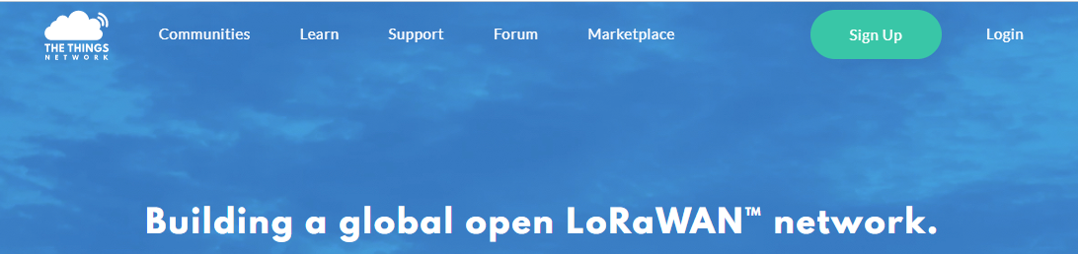
Login to TTN: https://account.thethingsnetwork.org/users/login

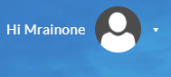

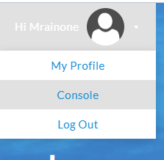
Click on the right icon.
Select “Console”

https://console.thethingsnetwork.org
Select “Applications”


https://console.thethingsnetwork.org/applications
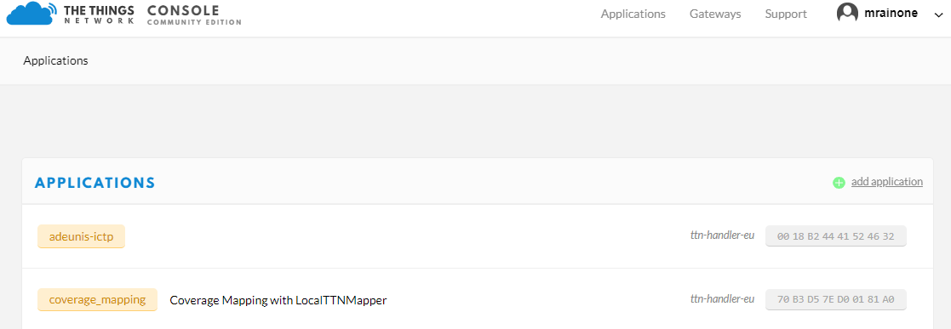

On right, press “Add application”
https://console.thethingsnetwork.org/applications/add
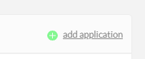
Set these parameters:
- Application ID (The unique identifier of your application on the network)
Example: weather_station_data
- Description (A human readable description of your new app)
Example: WS data acquisition through Lorawan transponder

At the bottom of the page press "Add application"
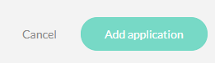

https://console.thethingsnetwork.org/applications/weather_station_data

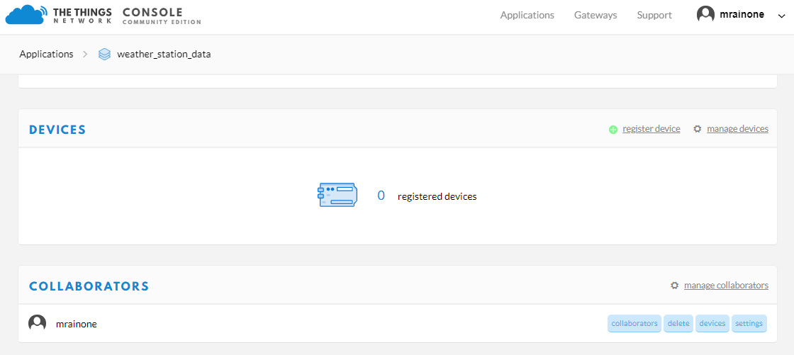

Registration of transponder in the TTN application
On the top right of web page, press “register device”
https://console.thethingsnetwork.org/applications/weather_station_data/devices/register

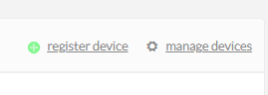
Set the “Device ID”: this is the unique identifier for the device in this app. The device ID will be immutable.
Example:
a possible name could be:
tr_5in1_01
where:
- tr: device is transponder
- 5in1: the type of WS to which the transponder is connected
- 01: a number that identifies the transponder within the application

Device EUI: The device EUI is the unique identifier for this device on the network. You can change the EUI later.
Click on the symbol to the left of the box to generate the Device EUI automatically.

Finally, press Register at the bottom of the page on the right.
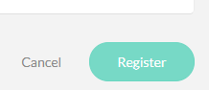
https://console.thethingsnetwork.org/applications/weather_station_data/devices/tr_5in1_01

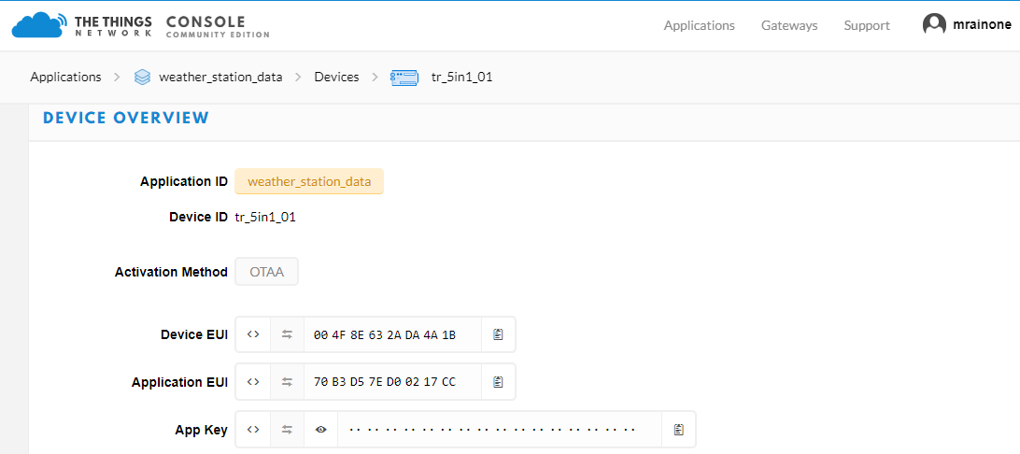
The activation method actually used is “Over-the-Air Activation” (OTAA).
All the transponder projects described here use the “Activation by Personalization” (ABP)
For info about the activation methods, see:
https://www.thethingsnetwork.org/forum/t/what-is-the-difference-between-otaa-and-abp-devices/2723/2

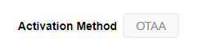
To change the type of activation, select Settings at the top right.
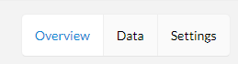
https://console.thethingsnetwork.org/applications/weather_station_data/devices/tr_5in1_01/settings

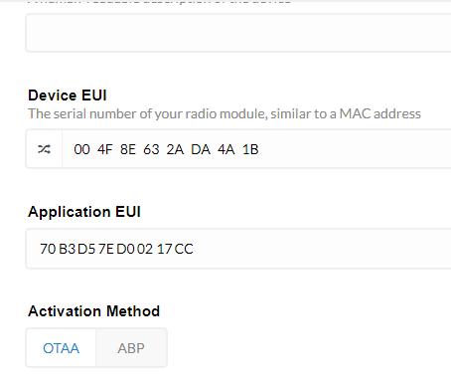
Click on ABP
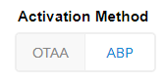
Uncheck Frame Counter Checks

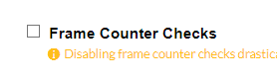
Finally, press Save at the bottom right.
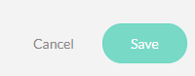
Return to the main page of the device.

https://console.thethingsnetwork.org/applications/weather_station_data/devices/tr_5in1_01

get the ABP activation keys generated by TTN application
At the bottom of the main page of the device, you will find the ABP activation keys.
https://console.thethingsnetwork.org/applications/weather_station_data/devices/tr_5in1_01
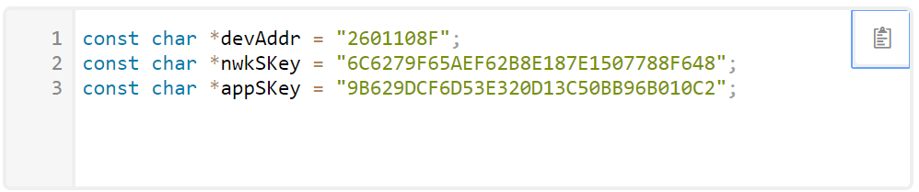
Press the icon
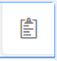
to copy the ABP keys to clipboard:

const char *devAddr = "2601108F";
const char *nwkSKey = "6C6279F65AEF62B8E187E1507788F648";
const char *appSKey = "9B629DCF6D53E320D13C50BB96B010C2";

Transponder configuration with the ABP activation keys
Transponder project list actually in repository:
Relative path | Project Name | Weather Station | HW Module
software/acurite5in1/BSFranceLora32u4II | bsf32u4_01 | Acurite 5in1 | Lora32u4II
software/acurite5in1/BSFranceLora32u4II | bsf32u4_02 | Acurite 5in1 | Lora32u4II
software/acurite5in1/PyComLopy4 | lopy4_01 | Acurite 5in1 | Lopy4
software/lacrossews2300/BSFranceLora32u4II | bsf32u4_01 | LaCrosse WS2300 | Lora32u4II

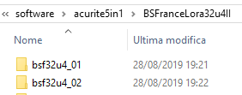

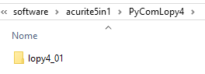
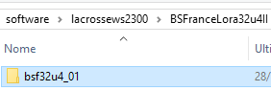

WS Acurite projects bsf32u4_01, lopy4_01 and LaCrosse bsf32u4_01 project

These three projects are configured in the same way.
For example, in case of bsf32u4_01 project:
software/acurite5in1/BSFranceLora32u4II
├───bsf32u4_01
│ │ bsf32u4_01.h
│ │ bsf32u4_01.ino

With Arduino ide (or another text editor) open bsf32u4_01.ino file.
Look for the following code section:
// -------------------------------------------------------------
// KEYS FOR ABP ACCESS

// Application ID: demo_ttn
// LoRaWAN NwkSKey, network session key
static u1_t NWKSKEY[16] = { 0x00, .. , 0x00 };
// LoRaWAN AppSKey, application session key
static u1_t APPSKEY[16] = { 0x00, .. , 0x00 };
// LoRaWAN end-device address (DevAddr)
static u4_t DEVADDR = 0x00000000; // Put here the device id in hexadecimal form.

convert the ABP application keys previously generated:

const char *devAddr = "2601108F";
const char *nwkSKey = "6C6279F65AEF62B8E187E1507788F648";
const char *appSKey = "9B629DCF6D53E320D13C50BB96B010C2";

to the format provided by the code c:

static u1_t NWKSKEY[16] = { 0x6C, 0x62, 0x79, 0xF6,
0x5A, 0xEF, 0x62, 0xB8,
0xE1, 0x87, 0xE1, 0x50,
0x77, 0x88, 0xF6, 0x48};
static u1_t APPSKEY[16] = { 0x9B, 0x62, 0x9D, 0xCF,
0x6D, 0x53, 0xE3, 0x20,
0xD1, 0x3C, 0x50, 0xBB,
0x96, 0xB0, 0x10, 0xC2};
static u4_t DEVADDR = 0x2601108F;

Recompile the project with Arduino IDE and finally transfer the new firmware version to the board.

WS Acurite project bsf32u4_02 for Lora32u4II module
The firmware of this project, derived from bsf32u4_01, is configured using the bsfcfg program executed in linux environment (the operation was verified with the distribution ubuntu 18:04).
The sources are located in the following repository directory:
software/acurite5in1/BSFranceLora32u4II/cfglinux_02
To compile the bsfcfg project:
~/cfglinux_02$ make clean
rm -f bsfcfg bsf32u4.ini
~/cfglinux_02$ make
gcc -g -I../src -o bsfcfg bsfcfg.c dictionary.c iniparser.c -I./
~/cfglinux_02$

To get help, run the command without parameters:
~/cfglinux_02$ ./bsfcfg
=====================================================================================Linux configuration tool for Acurite transponder with BsFrance Lora32u4II.
Version:1.00
Use:
./bsfcfg <serial port name> <configuration filename>
OR
./bsfcfg <serial port name>
in this case a default configuration file bsf32u4.ini is automatically generated.
Example:
./bsfcfg ttyUSB0 ./bsf32u4.ini
where:
ttyUSB0: USB serial port where the transponder Lora32u4II is connected
bsf32u4.ini: configuration file name

Run this tool in Windows 10 (using WSL, Windows Subsystem for Linux compatibility layer):
If the program run in a bash shell of windows10, use the WSL name
of the serial to which the Lora32u4II module is connected.
In WSL, the serial port COM<n> port is available at /dev/ttyS<n>
For example, if the board is connected to the windows serial port COM3,
use ttyS3 as serial port name
In bash shell launch the program with these parameters:
./bsfcfg ttyS3 ./bsf32u4.ini
For info, see:
https://blogs.msdn.microsoft.com/wsl/2017/04/14/serial-support-on-the-windows-subsystem-for-linux/
=====================================================================================
~/cfglinux_02$

The parameters are saved in the EEprom memory of the Lora32u4II device.
An external configuration program for the firmware has the advantage of disconnecting the code from the configuration parameters (it is no longer necessary to recompile the firmware to change important system parameters) and to have a single firmware equal for all units of the same kind.
Of course the main disadvantage is that it increases the code occupation for the addition of configuration management functions.
For example, the starting project bsf32u4_01 generates these messages at the end of the compilation:
Sketch uses 25282 bytes (88%) of program storage space. Maximum is 28672 bytes.
Global variables use 1350 bytes of dynamic memory.
For the firmware bsf32u4_02, managed by the external configuration program:
Sketch uses 28210 bytes (98%) of program storage space. Maximum is 28672 bytes.
Global variables use 1457 bytes of dynamic memory.

Configuration variables for bsf32u4_02 firmware

NAME | USE | Note
NWKSKEY | LoRaWAN Network Session Keys | ABP application key1
APPSKEY | LoRaWAN APP Key | ABP application key2
DEVADDR | LoRaWAN end-device address | ABP application key3
TX_INTERVAL | LoRaWAN tx data interval | corresponds to the duration of the operating cycle time in seconds of the transponder (Tattivo + Tsleep).
IdWs | Id Acurite 5in1 | identification code of the Acurite 5in1 weather control unit to which the transponder is associated (12bit)
PVarFWdog | +/- max tolerance percentage of the watchdog frequency | Configuration variable used during debugging. Do not change.

Example of configuration file for bsf32u4_02 firmware

# LoRaWAN Network Session Keys
NWKSKEY = "A5EC135CBA37A2C55266E77B0B948982" ;
# LoRaWAN Network Session Keys
APPSKEY = "7D5821DB815148C2A3139BE3BB0678FA" ;
# LoRaWAN end-device 4 byte hex address (DevAddr)
DEVADDR = "26011824" ;
#
# This is the base ini file for bsf32u4 lora controller
#
[Lorawan]
# =========================== bsf32u4 lorawan parameters
# LoRaWAN Network Session Keys
NWKSKEY = "A5EC135CBA37A2C55266E77B0B948982" ;
# LoRaWAN Network Session Keys
APPSKEY = "7D5821DB815148C2A3139BE3BB0678FA" ;
# LoRaWAN end-device 4 byte hex address (DevAddr)
DEVADDR = "26011824" ;
# LoRaWAN tx data interval (sec)
TX_INTERVAL = 300 ;
[Ws]
# =========================== weather station parameters
# Id weather station
IdWs = "0C24" ;
[Micro]
# =========================== bsf32u4 micro parameters
# +/- max tolerance percentage of the watchdog frequency
PVarFWdog = 15 ;

Setting the payload decoding function
The data sent via LoraWAN by transponder to The Things Network are all in bytes. We need to decode it into a usable values.
Go to the main page of the TTN application.
On the top bar press “Payload Formats”

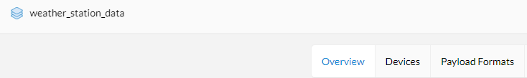
https://console.thethingsnetwork.org/applications/weather_station_data/payload-formats
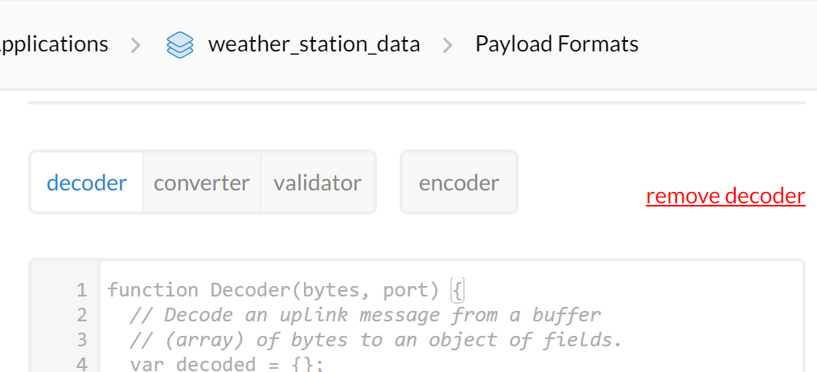
Open the transponder project folder.
Inside it there is the ttn_decoder subfolder:
it contains a text file with the correct decoder function.
Replace it on the web page.
Finally, at the bottom of the page press "Save".

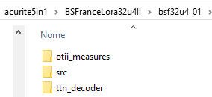

Decoder of the transponder messages for Acurite 5in1

function Decoder(bytes, port) {
var deco = {};
var wordValue;
deco.idMsg = (bytes[0]<<24) + (bytes[1]<<16) + (bytes[2]<<8) + (bytes[3]);
deco.time = (bytes[4]<<24) + (bytes[5]<<16) + (bytes[6]<<8) + (bytes[7]);
deco.SensorId = (bytes[8]<<8) + (bytes[9]);
deco.WindSpeed_kph = (bytes[10]<<8) + (bytes[11]);
deco.WindSpeed_kph = deco.WindSpeed_kph / 10.0;
deco.WindDirection_Pos = bytes[12] & 0x0F;
deco.Rainfall = (bytes[13]<<8) + (bytes[14]);
deco.Rainfall = deco.Rainfall / 100.0;
deco.ActiveRain = bytes[15] & 0x01;
deco.RainTmSpan = (bytes[16]<<24) + (bytes[17]<<16) + (bytes[18]<<8) + (bytes[19]);
deco.Temp = (bytes[20]<<8) + (bytes[21]);
var sign = bytes[20] & (1 << 7);
if(sign)
{
deco.Temp = 0xFFFF0000 | deco.Temp;
}
deco.Temp = deco.Temp / 10.0;
deco.Hum = bytes[22];
if(deco.Hum > 99)
deco.Hum = 99;
deco.BattLow = bytes[23] & 0x01;
deco.VBatt = bytes[24];
deco.VBatt = deco.VBatt / 10.0;
deco.Bmp180temp = (bytes[25]<<8) + (bytes[26]);
deco.Bmp180temp = deco.Bmp180temp / 10.0;
deco.Bmp180press = (bytes[27]<<8) + (bytes[28]);
deco.Bmp180press = deco.Bmp180press / 10.0;
return deco;
}

Decoder of the transponder messages for LaCrosse WS2300
function Decoder(bytes, port) {
var deco = {};
var wordValue;
deco.idMsg = (bytes[0]<<24) + (bytes[1]<<16) + (bytes[2]<<8) + (bytes[3]);
deco.time = (bytes[4]<<24) + (bytes[5]<<16) + (bytes[6]<<8) + (bytes[7]);
deco.SensorId = (bytes[8]<<8) + (bytes[9]);
deco.WindSpeed = (bytes[10]<<8) + (bytes[11]);
deco.WindSpeed = deco.WindSpeed / 10.0;
deco.WindDirection = bytes[12] & 0x0F;
deco.GustSpeed = (bytes[13]<<8) + (bytes[14]);
deco.GustSpeed = deco.GustSpeed / 10.0;
deco.GustDirection = bytes[15] & 0x0F;
deco.Rainfall = (bytes[16]<<8) + (bytes[17]);
deco.Rainfall = deco.Rainfall * 0.5180;
deco.Temp = (bytes[18]<<8) + (bytes[19]);
var sign = bytes[18] & (1 << 7);
if(sign)
{
deco.Temp = 0xFFFF0000 | deco.Temp;
}
deco.Temp = deco.Temp / 10.0;
deco.Hum = (bytes[20]<<8) + (bytes[21]);
if(deco.Hum > 99)
deco.Hum = 99;
deco.VBatt = bytes[22];
deco.VBatt = deco.VBatt / 10.0;
deco.Bmp180temp = (bytes[23]<<8) + (bytes[24]);
deco.Bmp180temp = deco.Bmp180temp / 10.0;
deco.Bmp180press = (bytes[25]<<8) + (bytes[26]);
deco.Bmp180press = deco.Bmp180press / 10.0;
return deco;
}

Example of messages sent on TTN

Data page transponder for Acurite 5in1

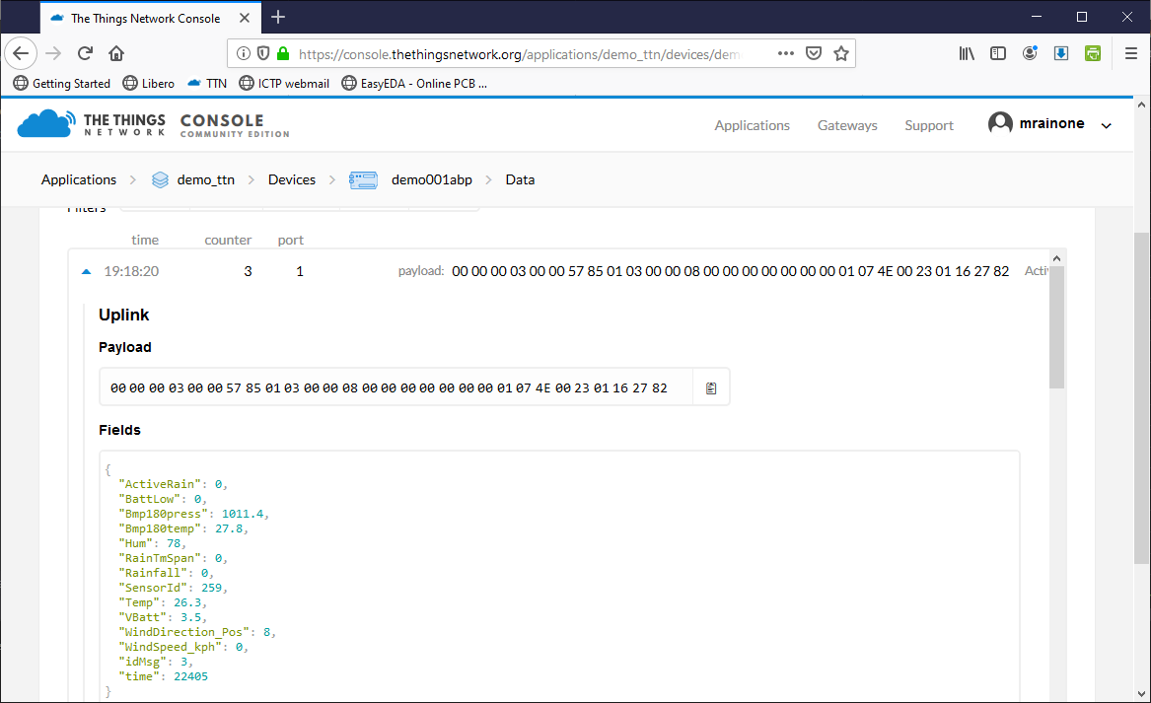

Data page transponder for LaCrosse WS2300

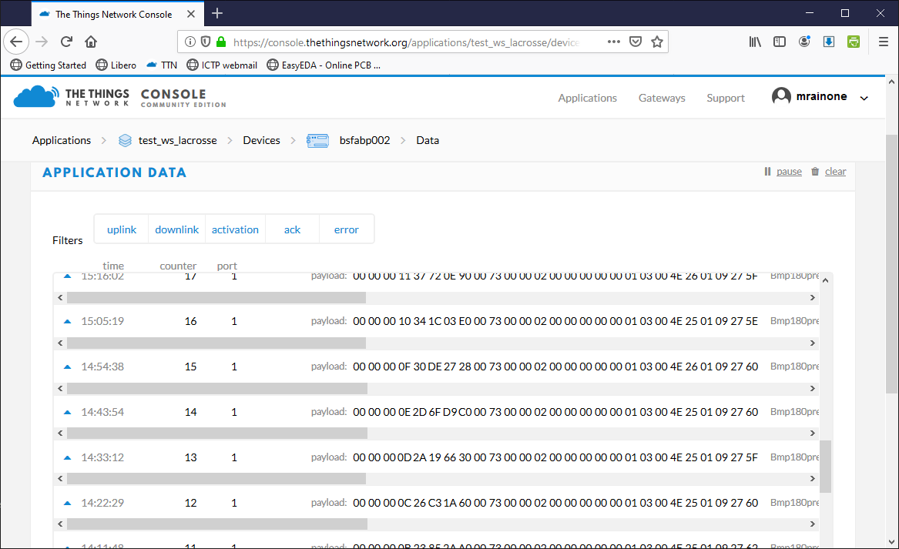
15:05:19161
Payload
00000010341C03E0007300000200000000000103004E250109275E
Fields
{
"Bmp180press": 1007.8,
"Bmp180temp": 26.5,
"GustDirection": 0,
"GustSpeed": 0,
"Hum": 78,
"Rainfall": 0,
"SensorId": 115,
"Temp": 25.9,
"VBatt": 3.7,
"WindDirection": 2,
"WindSpeed": 0,
"idMsg": 16,
"time": 874251232
}

