Release Management Process
Multi-Process Java Application · GitHub + Gradle + GitHub Packages

Property | Value
Team Size | 5 developers
Tech Stack | Java 21, Gradle, GitHub Actions, Linux (systemd)
Artifact Registry | GitHub Packages (Maven)
Environments | DEV → QA → PROD
Versioning | Semantic Versioning (SemVer 2.0)
Branching | Trunk-Based Development

Version 2.0 · February 2026

Table of Contents

1. Versioning Strategy

1.1 SemVer with Pre-Release Tags
Each deployable JAR follows SemVer 2.0: MAJOR.MINOR.PATCH[-prerelease].
Component | Meaning | When to Bump
MAJOR | Breaking changes | API contract, config format, cross-process protocol breaks
MINOR | New features (backward-compatible) | New endpoint, new capability, new config option
PATCH | Bug fixes (backward-compatible) | Defect fix, performance tweak, dependency security patch

Environment | Version Pattern | Example
DEV | MAJOR.MINOR.PATCH-dev.SHORT_SHA | 1.5.0-dev.a3f9c2
QA | MAJOR.MINOR.PATCH-rc.N | 1.5.0-rc.1
PROD | MAJOR.MINOR.PATCH (clean) | 1.5.0

1.2 SNAPSHOT Lifecycle
Q: When is a new SNAPSHOT version generated? Is each PR merge bumping the version?
No. PR merges do NOT bump the SNAPSHOT version. The SNAPSHOT in gradle.properties represents the next planned release and stays constant across all feature merges until a production release occurs.
1) After releasing 1.4.0 to production, CI commits a version bump on main: version=1.5.0-SNAPSHOT.
2) Every subsequent PR merge builds from this same 1.5.0-SNAPSHOT base. CI strips -SNAPSHOT and appends -dev.{SHORT_SHA} to produce unique build versions like 1.5.0-dev.a3f9c2, 1.5.0-dev.b7d1e4.
3) The SNAPSHOT stays at 1.5.0-SNAPSHOT until 1.5.0 ships to production, then bumps to 1.6.0-SNAPSHOT.
The SNAPSHOT is a planning marker, not a build version. The actual deployable version is always the -dev.{SHA} tag.

1.3 Feature Traceability
Q: How do I know what features a SNAPSHOT version contains?
Traceability works at the commit and PR level, not the version level. Four mechanisms:
1) Git log between tags: git log billing-engine/v1.4.0..HEAD --oneline shows every commit since last release.
2) GitHub auto-generated release notes: QA promotion creates a pre-release with auto-generated notes listing every included PR.
3) The `-dev.{SHORT_SHA}` tag: Each DEV version encodes the merge commit SHA. Compare two DEV builds: git log a3f9c2..b7d1e4.
4) GitHub Milestones: Optionally, assign tickets to a milestone named billing-engine v1.5.0. Verify all are closed before QA promotion.

1.4 Version Source of Truth
The version lives in one place only — gradle.properties at each process root:
# billing-engine/gradle.properties
version=1.5.0-SNAPSHOT
Developers never manually edit version strings in feature branches. Version bumps happen exclusively via automated CI commit after production release.

1.5 Multi-Process Version Independence
Each process gets its own version lifecycle. billing-engine can be at 3.1.0 while notification-service is at 1.9.2. No requirement to keep versions in sync.

2. Branching Model

2.1 Trunk-Based Development
The team uses a trunk-based model where main is always releasable. Feature branches live 1–3 days maximum.
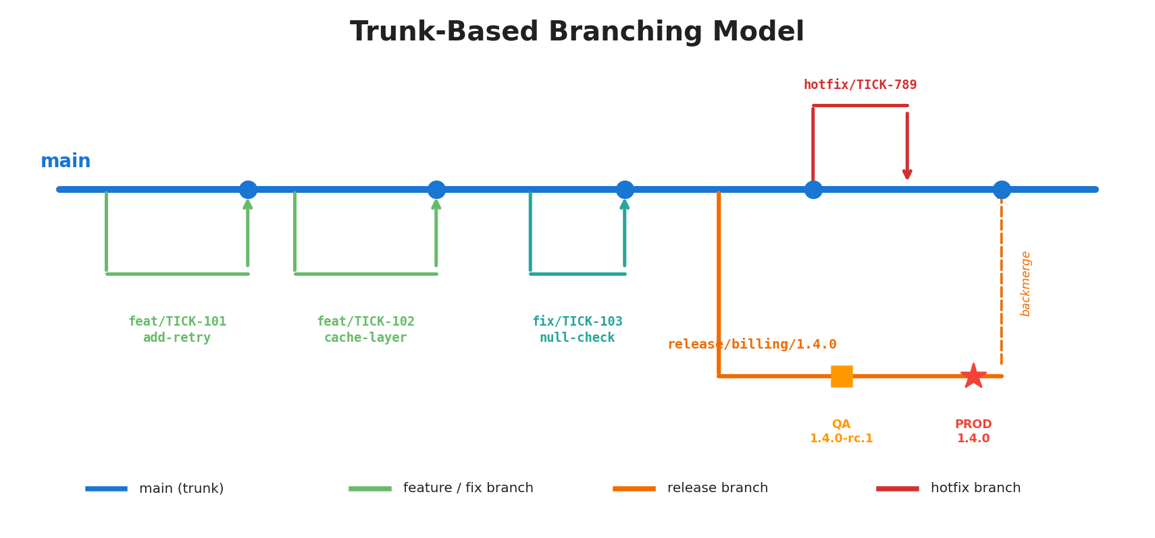
Figure 1: Trunk-Based Branching Model
Branch Pattern | Purpose | Lifetime | Merges Into
main | Integration trunk. Always builds green. | Permanent | —
feat/TICK-* | Developer work. One ticket, one branch. | 1–3 days | main (via PR)
fix/TICK-* | Bug fixes | < 1 day | main (via PR)
release/{process}/{ver} | QA stabilization | Days to ~1 week | main (backmerge)
hotfix/{process}/{tick} | Emergency production fix | Hours | release/* + main

2.2 Branch Protection on main
Require 1 approving review. Require all CI status checks to pass. Require linear history (squash merge). No direct pushes. No force pushes.

2.3 Hotfix Branch Origins
Q: Where is the hotfix branch taken from — during QA testing vs. post-production release?
Scenario A — Bug found during QA (release branch exists): The fix is committed directly onto the release branch release/billing-engine/1.4.0. No separate hotfix branch needed. A new RC is cut (e.g., 1.4.0-rc.2), re-tested, and the fix is backmerged into main.
Scenario B — Bug found after production release (release branch deleted): Create hotfix/billing-engine/TICK-NNN branched from the production release tag on main (e.g., billing-engine/v1.4.0). Fix, review, create release/billing-engine/1.4.1, smoke test on QA, deploy to PROD, backmerge into main.
Key distinction: If the release branch still exists, fix there. If gone, branch from the release tag.

2.4 Process Isolation in Release Branches
Q: How do you enforce that a release branch only contains changes for that process?
Four mechanisms:
1) Path-based CI validation: CI on the release branch uses detect-changes. If someone pushes notification-service/ changes to release/billing-engine/*, the build fails with a clear error.
2) CODEOWNERS file: Requires specific reviewers for each process directory.
3) Branch naming convention: Promotion workflows extract the process name from the branch and only build/deploy that process. Unrelated changes are ignored.
4) Squash merge discipline: Features merge to main as atomic per-process commits, so the release branch naturally contains only whole-feature changes.

3. Environment Promotion Pipeline

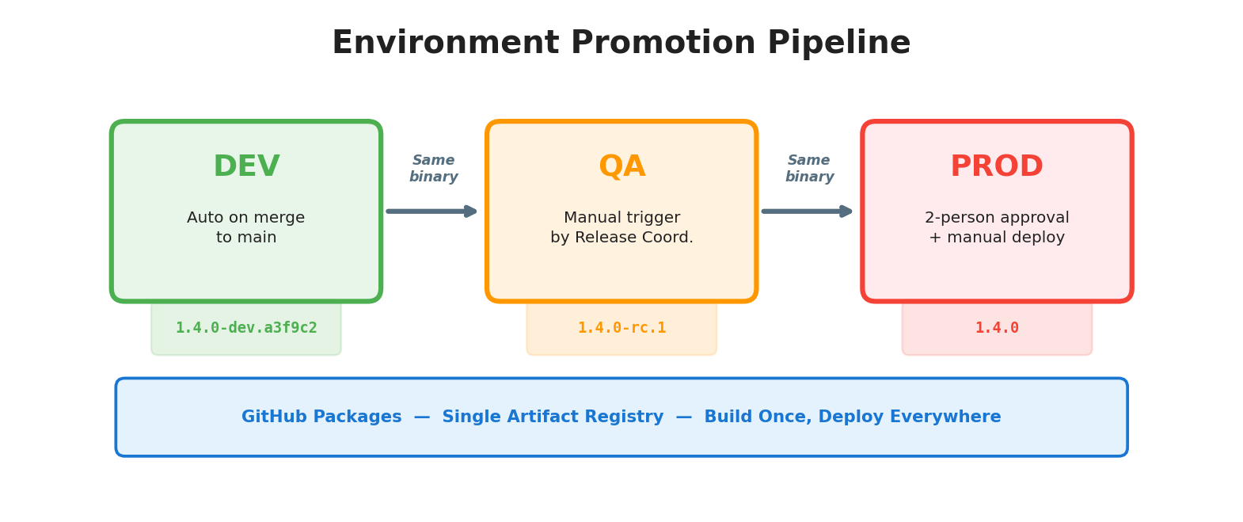
Figure 2: Environment Promotion Pipeline
Environment | Trigger | Artifact Version | Who | Purpose
DEV | Auto on merge to main | 1.5.0-dev.a3f9c2 | CI (automatic) | Integration testing
QA | Manual workflow dispatch | 1.5.0-rc.1 | Release Coordinator | Regression + acceptance
PROD | Manual + 2 approvals | 1.5.0 | Coord. + 2 approvers | Live traffic

Artifact Immutability Principle: The same JAR binary that passes QA is the exact binary deployed to production. No rebuilding. What you tested is what you ship.

4. Full Promotion Sequence — DEV to PROD

Q: Show me the complete sequence from SNAPSHOT selection through to production release.
Below is the end-to-end sequence. Assumes billing-engine at 1.5.0-SNAPSHOT with several feature PRs merged to DEV.

Phase 1: Preparation
Step | Who | Action | Result
1 | Release Coord. | Runs list-dev-versions.yml for billing-engine | Gets list of -dev.* versions
2 | Release Coord. | Picks latest green DEV version (e.g., 1.5.0-dev.b7d1e4) | Version selected
3 | Release Coord. | Cuts release branch from that commit | main continues for next release

Phase 2: QA Promotion
Step | Who | Action | Result
4 | Release Coord. | Triggers promote-qa.yml | Workflow starts
5 | CI | Pulls exact JAR from GitHub Packages — NO rebuild | Same binary downloaded
6 | CI | Re-tags as 1.5.0-rc.1 in GitHub Packages | RC artifact exists
7 | CI | Deploys 1.5.0-rc.1 to QA server | QA running new version
8 | CI | Creates GitHub pre-release with notes | Changelog visible

Phase 3: QA Testing
Step | Who | Action | Result
9 | QA / Team | Regression tests, acceptance tests, manual verification | Issues or sign-off
10a | Developer | If bugs: commits fix to release branch | Fix on release branch
10b | Release Coord. | Re-promotes → 1.5.0-rc.2 | New RC on QA
10c | Release Coord. | Backmerges fix into main | Fix preserved
11 | QA / Team | Signs off on final RC | QA approved

Phase 4: Production Release
Step | Who | Action | Result
12 | Release Coord. | Triggers release-prod.yml with rc_version=1.5.0-rc.2 | Awaits approval
13 | 2 Team Members | Approve via GitHub environment protection | Gate passed
14 | CI | Pulls 1.5.0-rc.2 JAR — still NO rebuild | Same binary as QA
15 | CI | Re-tags as 1.5.0 in GitHub Packages | Final artifact exists
16 | CI | Deploys 1.5.0 to PROD | Production updated
17 | CI | Creates final GitHub Release | Audit trail complete
18 | CI | Bumps main: 1.5.0-SNAPSHOT → 1.6.0-SNAPSHOT | Next cycle begins
19 | Release Coord. | Deletes the release branch | Cleanup done

Key insight: The binary built at Step 5 (DEV) is the SAME binary deployed at Step 16 (PROD). Never recompiled. Only the metadata tag changed: dev.b7d1e4 → rc.2 → 1.5.0.

5. CI/CD Workflow Architecture

5.1 Build Once Clarification
Q: ci-validate.yml and deploy-dev.yml both build. Doesn't that violate 'build once'?
No. The "build once" principle applies from deploy-dev.yml onward.
ci-validate.yml is a throwaway quality gate. It compiles and tests to give fast PR feedback. The build output is discarded — no artifact is published. Think of it as a dress rehearsal.
deploy-dev.yml is the official build. It produces the versioned, immutable JAR that travels through all environments unchanged.
From deploy-dev.yml onward, the binary is NEVER rebuilt.

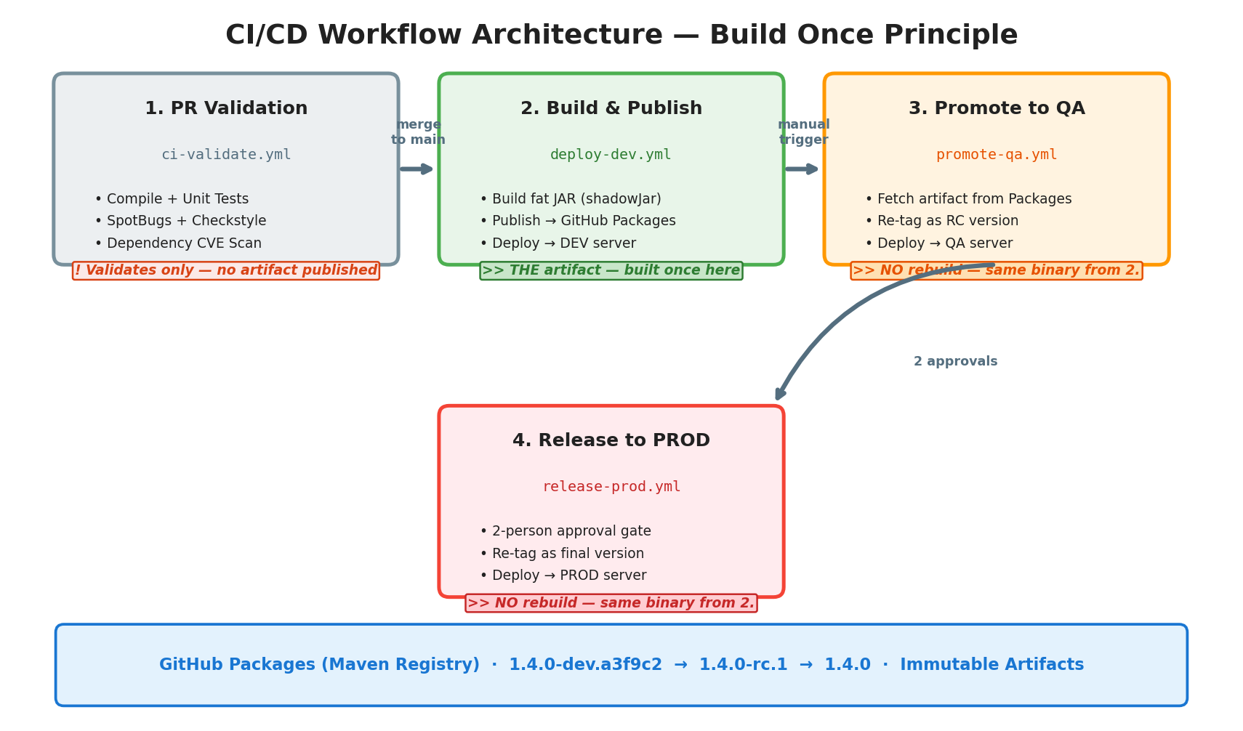
Figure 3: CI/CD Workflow Architecture

5.2 CI Validation Failures
Q: What happens when ci-validate.yml fails?
1) PR is blocked. Branch protection requires CI to pass. The merge button is disabled.
2) Developer gets immediate feedback. GitHub shows which step failed with full logs.
3) Developer fixes and pushes. Additional commits to the same branch re-trigger CI automatically.
4) No impact on main or DEV. Code never reached main, so no broken build on DEV. Other developers are unaffected.

5.3 Integration Test Failures on DEV
Q: What if a merged feature branch causes errors during DEV integration testing?
Response follows fix-forward or revert:
Option A — Fix forward (if fix is quick, < 2 hours): Developer creates fix/TICK-NNN-integration-failure, applies fix, expedited PR + 1 review, merges to main, auto-deploys to DEV.
Option B — Revert (if fix is not obvious): Any team member creates a revert PR: git revert <merge-sha>. Expedited 1 review, squash-merge. DEV is restored. Developer works on proper fix in new branch.
Key point: DEV is expected to occasionally break — that is its purpose. Broken code on DEV never reaches QA because QA promotion is a manual, deliberate action.

5.4 PR Validation — ci-validate.yml (Full Implementation)
# .github/workflows/ci-validate.yml
name: PR Validation
on:
pull_request:
branches: [main]

jobs:
detect-changes:
runs-on: ubuntu-latest
outputs:
matrix: ${{ steps.detect.outputs.matrix }}
has-changes: ${{ steps.detect.outputs.has_changes }}
steps:
- uses: actions/checkout@v4
with:
fetch-depth: 0
- id: detect
uses: ./.github/actions/detect-changes
with:
compare-mode: pr

validate:
needs: detect-changes
if: needs.detect-changes.outputs.has-changes == 'true'
runs-on: ubuntu-latest
strategy:
matrix: ${{ fromJson(needs.detect-changes.outputs.matrix) }}
steps:
- uses: actions/checkout@v4
- uses: actions/setup-java@v4
with: { distribution: temurin, java-version: '21', cache: gradle }
- name: Build & Unit Test
run: ./gradlew :${{ matrix.process }}:build
- name: Static Analysis
run: ./gradlew :${{ matrix.process }}:check
- name: Dependency Vulnerability Scan
run: ./gradlew :${{ matrix.process }}:dependencyCheckAnalyze

5.5 Build & Deploy to DEV — deploy-dev.yml
# .github/workflows/deploy-dev.yml
name: Build & Deploy to DEV
on:
push:
branches: [main]
jobs:
detect-changes:
runs-on: ubuntu-latest
outputs:
matrix: ${{ steps.detect.outputs.matrix }}
has-changes: ${{ steps.detect.outputs.has_changes }}
steps:
- uses: actions/checkout@v4
with: { fetch-depth: 2 }
- id: detect
uses: ./.github/actions/detect-changes
with: { compare-mode: push }

build-publish-deploy:
needs: detect-changes
if: needs.detect-changes.outputs.has-changes == 'true'
runs-on: ubuntu-latest
strategy:
matrix: ${{ fromJson(needs.detect-changes.outputs.matrix) }}
steps:
- uses: actions/checkout@v4
- uses: actions/setup-java@v4
with: { distribution: temurin, java-version: '21', cache: gradle }
- name: Compute Dev Version
run: |
BASE=$(grep '^version=' ${{ matrix.process }}/gradle.properties \
| cut -d= -f2 | sed 's/-SNAPSHOT//')
echo "VERSION=${BASE}-dev.${GITHUB_SHA::7}" >> $GITHUB_ENV
- name: Build Fat JAR
run: ./gradlew :${{ matrix.process }}:shadowJar -Pversion=${{ env.VERSION }}
- name: Publish to GitHub Packages
run: ./gradlew :${{ matrix.process }}:publish -Pversion=${{ env.VERSION }}
env: { GITHUB_TOKEN: "${{ secrets.GITHUB_TOKEN }}" }
- name: Deploy to DEV Server
uses: appleboy/ssh-action@v1
with:
host: ${{ vars.DEV_SERVER_HOST }}
username: ${{ vars.DEPLOY_USER }}
key: ${{ secrets.DEV_SSH_KEY }}
script: /opt/deploy/deploy.sh ${{ matrix.process }} ${{ env.VERSION }}

5.6 Promote to QA — promote-qa.yml
# .github/workflows/promote-qa.yml
name: Promote to QA
on:
workflow_dispatch:
inputs:
process:
description: 'Process to promote'
required: true
type: choice
options: [billing-engine, notification-service, data-processor]
version:
description: 'Dev version (e.g., 1.5.0-dev.b7d1e4)'
required: true
type: string
jobs:
promote:
runs-on: ubuntu-latest
environment: qa
steps:
- name: Compute RC Version
run: |
BASE=$(echo "${{ inputs.version }}" | sed 's/-dev\..*//')
EXISTING=$(gh api "/repos/${{ github.repository }}/releases" \
--jq "[.[].tag_name | select(startswith(\"${{ inputs.process }}/v${BASE}-rc.\"))] | length")
echo "RC_VERSION=${BASE}-rc.$((EXISTING + 1))" >> $GITHUB_ENV
env: { GH_TOKEN: "${{ secrets.GITHUB_TOKEN }}" }
- name: Download Artifact (NO REBUILD)
run: |
mvn dependency:copy \
-Dartifact=com.company:${{ inputs.process }}:${{ inputs.version }}:jar \
-DoutputDirectory=./artifacts
- name: Republish as RC
run: |
mvn deploy:deploy-file \
-Dfile=./artifacts/${{ inputs.process }}-${{ inputs.version }}.jar \
-DgroupId=com.company -DartifactId=${{ inputs.process }} \
-Dversion=${{ env.RC_VERSION }} -Dpackaging=jar \
-Durl=https://maven.pkg.github.com/${{ github.repository }}
- name: Deploy to QA
uses: appleboy/ssh-action@v1
with:
host: ${{ vars.QA_SERVER_HOST }}
key: ${{ secrets.QA_SSH_KEY }}
script: /opt/deploy/deploy.sh ${{ inputs.process }} ${{ env.RC_VERSION }}
- name: Create Pre-Release
uses: softprops/action-gh-release@v2
with:
tag_name: ${{ inputs.process }}/v${{ env.RC_VERSION }}
prerelease: true
generate_release_notes: true

5.7 Release to Production — release-prod.yml
# .github/workflows/release-prod.yml
name: Release to Production
on:
workflow_dispatch:
inputs:
process:
type: choice
options: [billing-engine, notification-service, data-processor]
rc_version:
description: 'RC version (e.g., 1.5.0-rc.2)'
required: true
type: string
jobs:
release:
runs-on: ubuntu-latest
environment: production # Requires 2 approvals
steps:
- uses: actions/checkout@v4
- name: Compute Release Version
run: |
RELEASE=$(echo "${{ inputs.rc_version }}" | sed 's/-rc\..*//')
echo "RELEASE_VERSION=${RELEASE}" >> $GITHUB_ENV
- name: Download RC Artifact (NO REBUILD)
run: |
mvn dependency:copy \
-Dartifact=com.company:${{ inputs.process }}:${{ inputs.rc_version }}:jar \
-DoutputDirectory=./artifacts
- name: Republish as Final Version
run: |
mvn deploy:deploy-file \
-Dfile=./artifacts/${{ inputs.process }}-${{ inputs.rc_version }}.jar \
-DgroupId=com.company -DartifactId=${{ inputs.process }} \
-Dversion=${{ env.RELEASE_VERSION }} -Dpackaging=jar \
-Durl=https://maven.pkg.github.com/${{ github.repository }}
- name: Deploy to Production
uses: appleboy/ssh-action@v1
with:
host: ${{ vars.PROD_SERVER_HOST }}
key: ${{ secrets.PROD_SSH_KEY }}
script: /opt/deploy/deploy.sh ${{ inputs.process }} ${{ env.RELEASE_VERSION }}
- name: Create GitHub Release
uses: softprops/action-gh-release@v2
with:
tag_name: ${{ inputs.process }}/v${{ env.RELEASE_VERSION }}
prerelease: false
generate_release_notes: true
- name: Bump Version on main
run: |
git checkout main && git pull
MINOR=$(echo ${{ env.RELEASE_VERSION }} | cut -d. -f2)
MAJOR=$(echo ${{ env.RELEASE_VERSION }} | cut -d. -f1)
NEXT="${MAJOR}.$((MINOR+1)).0-SNAPSHOT"
sed -i "s/^version=.*/version=${NEXT}/" ${{ inputs.process }}/gradle.properties
git add . && git commit -m "chore: bump to ${NEXT} [skip ci]" && git push

6. GitHub Packages — Artifact Organization

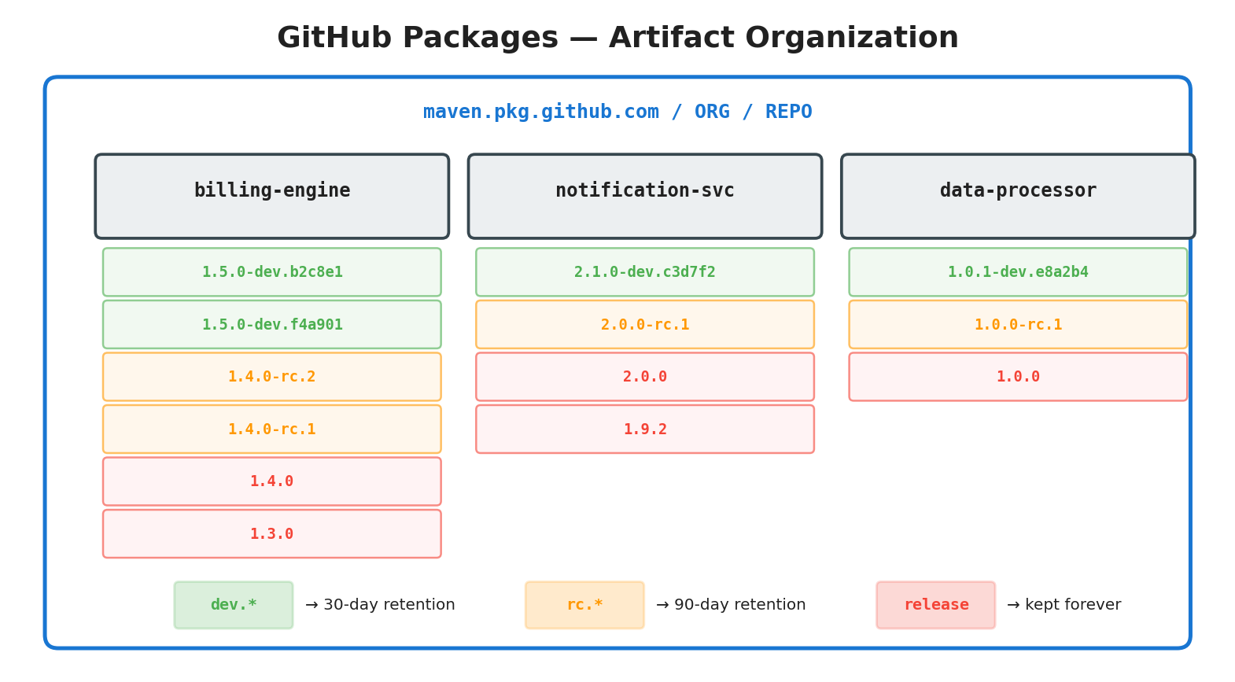
Figure 4: GitHub Packages Organization

6.1 Maven Coordinates
groupId: com.company
artifactId: <process-name> # billing-engine | notification-service
version: <semver-tag> # 1.5.0-dev.a3f9c2 | 1.5.0-rc.1 | 1.5.0

# Registry: https://maven.pkg.github.com/ORG/REPO

6.2 Retention Policy
Pattern | Example | Retention | Cleanup
-dev.* | 1.5.0-dev.a3f9c2 | 30 days | Scheduled weekly workflow
-rc.* | 1.5.0-rc.1 | 90 days | Scheduled monthly workflow
Release | 1.5.0 | Indefinite | Manual only

6.3 Gradle Publishing Config
publishing {
publications {
maven(MavenPublication) {
from components.java
groupId = 'com.company'
artifactId = project.name
version = project.version
}
}
repositories {
maven {
name = "GitHubPackages"
url = uri("https://maven.pkg.github.com/ORG/REPO")
credentials {
username = System.getenv("GITHUB_ACTOR")
password = System.getenv("GITHUB_TOKEN")
}
}
}
}

7. Dynamic QA Promotion

Q: Can we populate the version input dynamically in promote-qa.yml?
GitHub Actions workflow_dispatch choice inputs are statically defined in YAML — they cannot query an API at render time. The solution is a two-stage workflow pattern: a discovery workflow queries available versions, then the coordinator triggers promotion with the selected version.

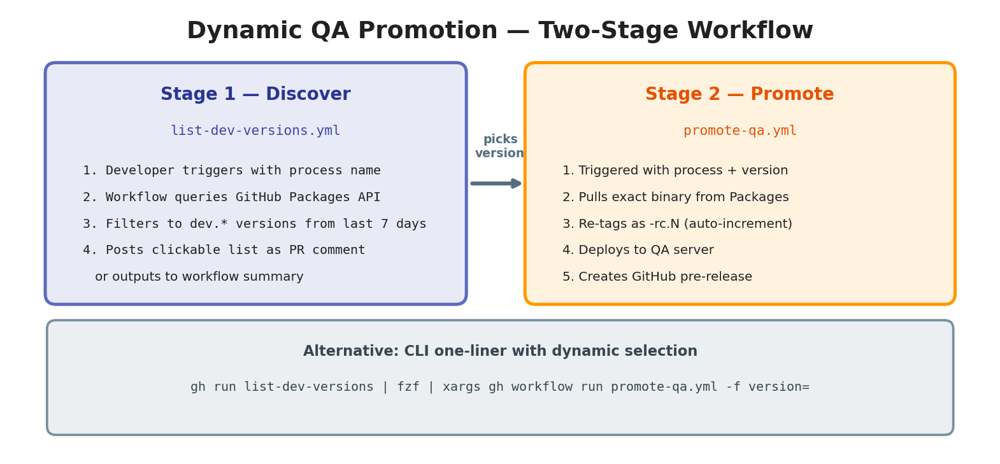
Figure 5: Two-Stage Dynamic QA Promotion

7.1 Discovery Workflow
# .github/workflows/list-dev-versions.yml
name: List Available Dev Versions
on:
workflow_dispatch:
inputs:
process:
type: choice
options: [billing-engine, notification-service, data-processor]
jobs:
list:
runs-on: ubuntu-latest
steps:
- name: Query GitHub Packages API
env: { GH_TOKEN: "${{ secrets.GITHUB_TOKEN }}" }
run: |
echo "## Dev Versions for ${{ inputs.process }}" >> $GITHUB_STEP_SUMMARY
echo "| Version | Created |" >> $GITHUB_STEP_SUMMARY
echo "|---------|---------|" >> $GITHUB_STEP_SUMMARY
gh api "/orgs/ORG/packages/maven/com.company.${{ inputs.process }}/versions" \
--jq '.[] | select(.name | contains("dev")) | "| \(.name) | \(.created_at[:10]) |"' \
| head -15 >> $GITHUB_STEP_SUMMARY

7.2 CLI One-Liner
gh api "/orgs/ORG/packages/maven/com.company.billing-engine/versions" \
--jq '.[].name | select(contains("dev"))' \
| fzf --prompt="Select version> " \
| xargs -I{} gh workflow run promote-qa.yml -f process=billing-engine -f version={}

8. Deployment Mechanics

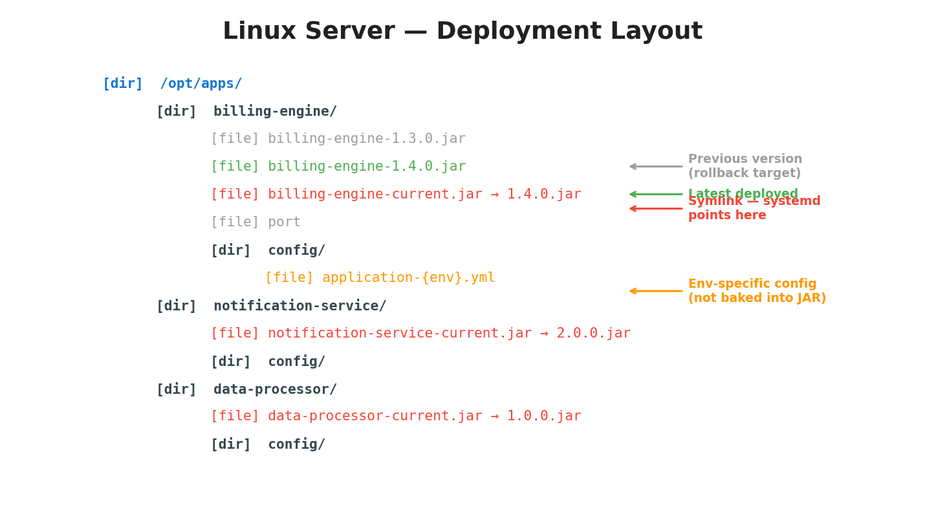
Figure 6: Linux Server Layout

8.1 deploy.sh
#!/usr/bin/env bash
set -euo pipefail
PROCESS=$1; VERSION=$2; ROOT="/opt/apps"
URL="https://maven.pkg.github.com/ORG/REPO/com/company/${PROCESS}/${VERSION}/${PROCESS}-${VERSION}.jar"

curl -sL -H "Authorization: token ${GITHUB_TOKEN}" -o "${ROOT}/${PROCESS}/${PROCESS}-${VERSION}.jar" "${URL}"
ln -sfn "${ROOT}/${PROCESS}/${PROCESS}-${VERSION}.jar" "${ROOT}/${PROCESS}/${PROCESS}-current.jar"
sudo systemctl restart "${PROCESS}"

for i in $(seq 1 30); do
curl -sf "http://localhost:$(cat ${ROOT}/${PROCESS}/port)/health" && echo "Healthy" && exit 0
sleep 2
done

echo "FAILED - rolling back"
PREV=$(ls -t "${ROOT}/${PROCESS}/"*.jar | grep -v "${VERSION}" | head -1)
ln -sfn "${PREV}" "${ROOT}/${PROCESS}/${PROCESS}-current.jar"
sudo systemctl restart "${PROCESS}"; exit 1

8.2 Systemd Service Unit
[Unit]
Description=Billing Engine
After=network.target
[Service]
User=appuser
ExecStart=/usr/bin/java -jar /opt/apps/billing-engine/billing-engine-current.jar \
--spring.profiles.active=${ENVIRONMENT}
Restart=on-failure
RestartSec=10
SuccessExitStatus=143
[Install]
WantedBy=multi-user.target

9. detect-changes Implementation

Reusable composite action to avoid duplicating detection logic across workflows:
# .github/actions/detect-changes/action.yml
name: 'Detect Changed Processes'
inputs:
compare-mode:
description: '"pr" for pull requests, "push" for push events'
required: true
default: 'push'
outputs:
matrix:
value: ${{ steps.detect.outputs.matrix }}
has-changes:
value: ${{ steps.detect.outputs.has_changes }}
runs:
using: 'composite'
steps:
- id: detect
shell: bash
run: |
if [ "${{ inputs.compare-mode }}" = "pr" ]; then
CHANGED=$(git diff --name-only origin/${{ github.base_ref }}...HEAD)
else
CHANGED=$(git diff --name-only HEAD~1 HEAD)
fi
echo "Changed files:"; echo "$CHANGED"

PROCESSES=("billing-engine" "notification-service" "data-processor")

# Shared build files affect ALL processes
SHARED=false
if echo "$CHANGED" | grep -qE "^(buildSrc/|gradle/|build\.gradle|settings\.gradle|gradle\.properties)"; then
SHARED=true
echo "Shared build files changed - all processes affected"
fi

ENTRIES=()
for proc in "${PROCESSES[@]}"; do
if [ "$SHARED" = true ] || echo "$CHANGED" | grep -q "^$proc/"; then
ENTRIES+=("{\"process\":\"$proc\"}")
fi
done

if [ ${#ENTRIES[@]} -eq 0 ]; then
echo "matrix={\"include\":[]}" >> $GITHUB_OUTPUT
echo "has_changes=false" >> $GITHUB_OUTPUT
else
JOINED=$(IFS=,; echo "${ENTRIES[*]}")
echo "matrix={\"include\":[$JOINED]}" >> $GITHUB_OUTPUT
echo "has_changes=true" >> $GITHUB_OUTPUT
fi

9.1 Output Examples
# Only billing-engine changed
{"include":[{"process":"billing-engine"}]}

# Multiple processes changed
{"include":[{"process":"billing-engine"},{"process":"data-processor"}]}

# Shared files changed (all rebuild)
{"include":[{"process":"billing-engine"},{"process":"notification-service"},{"process":"data-processor"}]}

# Only docs changed
{"include":[]}

10. Team Roles & Responsibilities

Role | Count | Responsibility
Release Coordinator (rotating) | 1 | Triggers QA/Prod promotions, coordinates timing
PR Reviewer | Any 1 peer | Every PR gets exactly 1 review
On-Call (rotating) | 1 | First responder for prod issues
All Developers | 5 | Write code, write tests, own features through to prod

Gate | Approvers | Mechanism
PR to main | 1 team member | GitHub PR review
DEV to QA | Release Coordinator | Workflow dispatch
QA to PROD | 2 members (not author) | Environment protection rule
Hotfix to PROD | 1 peer + Coordinator | Expedited review

11. Release Cadence

Day | Activity
Monday EOD | Feature freeze: features for this train must be merged
Tuesday AM | Cut release branch, promote RC to QA
Tue–Wed | Regression and acceptance tests
Wednesday PM | QA sign-off, PROD deployment
This cadence is a guideline, not an obligation.

12. Hotfix Workflow

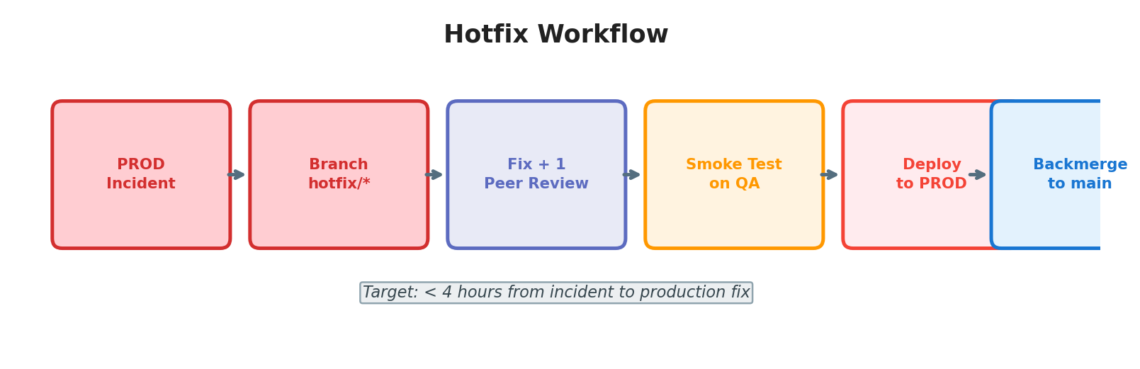
Figure 7: Hotfix Workflow
Step | Action | Details
1 | Identify origin | Release branch exists? Fix there. Deleted? Branch from release tag.
2 | Fix + review | 1-person expedited peer review
3 | Smoke test | Minimal QA regression
4 | Deploy to PROD | 1 approval (expedited)
5 | Backmerge | Ensure fix lands on main

13. Rollback Procedure

13.1 Automatic
Deploy script auto-rolls back if health check fails within 60 seconds.

13.2 Manual
/opt/deploy/rollback.sh billing-engine
# Reverts symlink, restarts service, verifies health
Any team member can initiate a rollback in an emergency. Post-rollback: async retrospective via GitHub Issue labeled post-mortem.

14. Observability & Validation

GET /health
{ "status": "UP", "version": "1.5.0", "deployedAt": "2026-02-26T14:30:00Z", "commitSha": "b7d1e4f" }
Post-deploy: health check 200 with correct version, no ERROR logs for 5 minutes, smoke tests pass.

15. Security Practices

Practice | Implementation
Secrets | GitHub Actions Secrets + Environment Secrets. Never in code.
SSH keys | Per-environment, rotated quarterly. Minimal sudo.
Dependencies | OWASP Dependency Check on every PR. Critical CVEs block merge.
SBOM | Generated per release, attached to GitHub Release.
Signed commits | Encouraged (GPG/SSH). Not enforced for 5-person team.

16. Quick Reference

Developer Flow
branch from main --> code --> PR --> 1 review --> squash merge --> auto-deploy DEV

Promotion Flow
DEV (auto) --> QA (manual, same binary) --> PROD (2 approvals, same binary)

Version Lifecycle
1.5.0-SNAPSHOT --> 1.5.0-dev.b7d1e4 --> 1.5.0-rc.1 --> 1.5.0

SNAPSHOT Bump Lifecycle
version=1.5.0-SNAPSHOT
feat/A merged --> 1.5.0-dev.a3f9c2 (SNAPSHOT unchanged)
feat/B merged --> 1.5.0-dev.b7d1e4 (SNAPSHOT unchanged)
QA promotion --> 1.5.0-rc.1 (SNAPSHOT unchanged)
PROD release --> 1.5.0 (SNAPSHOT bumps to 1.6.0-SNAPSHOT)

Review and update this document quarterly or when processes change.

