TECHNICAL ARCHITECTURE

Build, Release &
Deployment Pipeline

A comprehensive technical architecture document describing the design, component interactions, pipeline mechanics, artifact lifecycle, and release process for a Java/Gradle application deployed through GitHub Actions.

SIMPLIFIED This revision consolidates release concerns into the production pipeline. QA validates and deploys; Prod tags, releases, and promotes. Three workflows, three concerns.

Technology Stack Java 17 · Gradle · GitHub Actions · GitHub Packages · Linux
Environments Development · QA · Production
Version v4.0 (Simplified) · March 2026

Contents

1. Executive Summary
2. Architecture Overview
3. Component Architecture
4. Pipeline Architecture
5. Pipeline Mechanics
6. Artifact Lifecycle
7. Release Process
8. Traceability & Audit Model
9. Environment Architecture
10. Security Model
11. Walkthrough: Feature from Dev to Prod
A. Appendix: File Inventory & Source Code

1. Executive Summary

This document defines the technical architecture for a continuous integration and deployment pipeline serving a Java 17 application. The system is built on three core principles:
- Build once, deploy many. A SNAPSHOT artifact is compiled and published to GitHub Packages once during the Dev build. Both QA and Production fetch that same binary from Packages, verified by SHA-256 checksum. No environment ever rebuilds the artifact.
- Checksum as identity. The SHA-256 hash of the artifact is computed at build time and published alongside it. Every downstream environment verifies this checksum before deployment. If the checksum passes, the binary is mathematically identical to what was built and tested.
- Minimal moving parts. The architecture avoids external infrastructure like Nexus or Artifactory. It relies entirely on Gradle, GitHub Actions, GitHub Packages, and GitHub Releases. Each workflow has a single, clear responsibility.

The pipeline supports three deployment environments (Development, QA, Production) with a clear promotion model:
- Dev — Automatic. Every push to main builds, publishes, and deploys the SNAPSHOT artifact.
- QA — Manual dispatch. Fetches a specific SNAPSHOT from Packages, validates it, strips the SNAPSHOT suffix from the jar name, and deploys. No release ceremony.
- Prod — Manual dispatch. Fetches the same binary from Packages, tags the commit, generates release notes, creates a GitHub Release, deploys, and bumps the version for the next cycle.

2. Architecture Overview

2.1 System Context
The pipeline operates within the GitHub ecosystem and interacts with three external deployment targets:
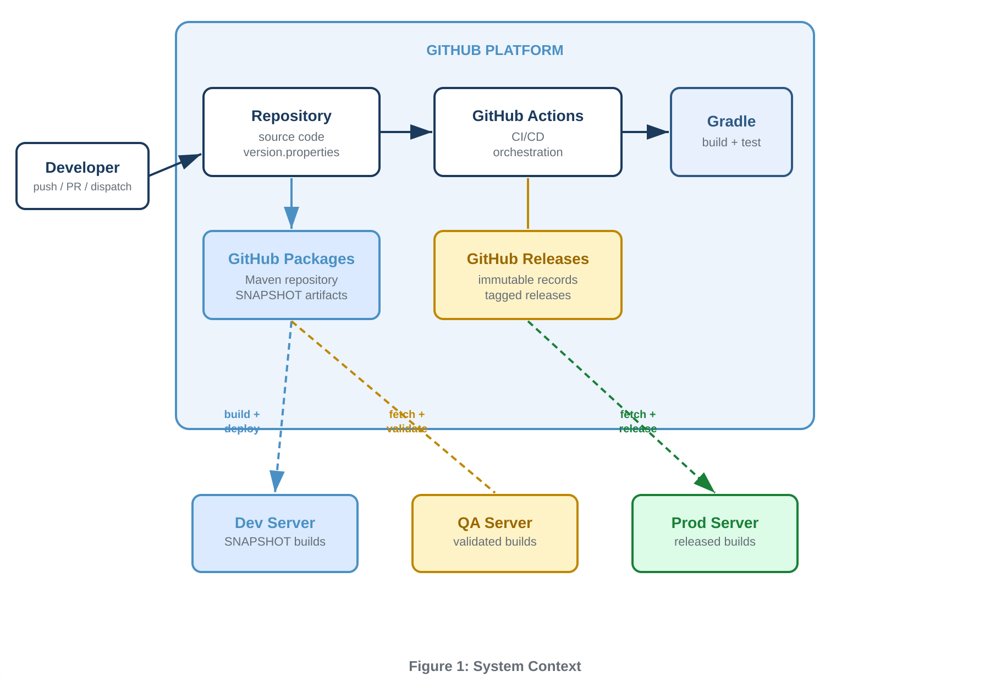

2.2 Key Design Decisions

GitHub Packages as Single Artifact Store
GitHub Packages serves as the single source of truth for all deployable artifacts. The Dev workflow builds and publishes the SNAPSHOT jar along with its SHA-256 checksum. Both QA and Prod fetch from this same location. There are no workflow artifacts passed between jobs, no GitHub Release intermediaries during QA — just one artifact repository that every downstream consumer pulls from.
QA Fetches, Does Not Build
The QA pipeline never touches source code. It fetches the pre-built SNAPSHOT jar from GitHub Packages, verifies the checksum, validates the manifest metadata, runs automated tests against the artifact, renames the jar (stripping the -SNAPSHOT suffix), and deploys to the QA server. This guarantees QA tests the exact same binary that was built during the Dev stage.
Prod Owns All Release Concerns
Earlier iterations split release concerns across QA and Prod workflows. Tagging happened at QA time, but release notes and GitHub Releases were finalized at Prod. This led to orphaned tags and releases for versions that never shipped. In the simplified pipeline, all release ceremony — tagging, release notes generation, GitHub Release creation — happens exclusively in the Prod workflow. If a version never reaches production, no release artifacts exist.
SNAPSHOT Stays SNAPSHOT in version.properties
The version.properties file on main always contains a SNAPSHOT version, except briefly during the Prod release when it’s bumped to the next SNAPSHOT. There is no intermediate commit that sets a clean version. The clean version (X.Y.Z without -SNAPSHOT) exists only in the git tag, the GitHub Release, and the renamed jar deployed to QA and Prod servers.
Jar Rename Instead of Version Commit
Rather than committing a version change to strip -SNAPSHOT and rebuilding, both QA and Prod simply rename the jar file after fetching it. The binary content is identical — only the filename changes. This eliminates an entire git commit per release cycle and avoids the complexity of coordinating version state across workflows.

3. Component Architecture

The system comprises five logical components that interact to form the complete build and deployment pipeline.

3.1 Version Management Subsystem

Purpose: Maintain a single source of truth for the project version and provide version information to all other components.
Components: version.properties (source of truth), build.gradle (consumer), release-prod.yml (mutator).
The version.properties file follows Semantic Versioning (MAJOR.MINOR.PATCH) with a -SNAPSHOT qualifier. In the simplified pipeline, the version state machine has only two transitions:
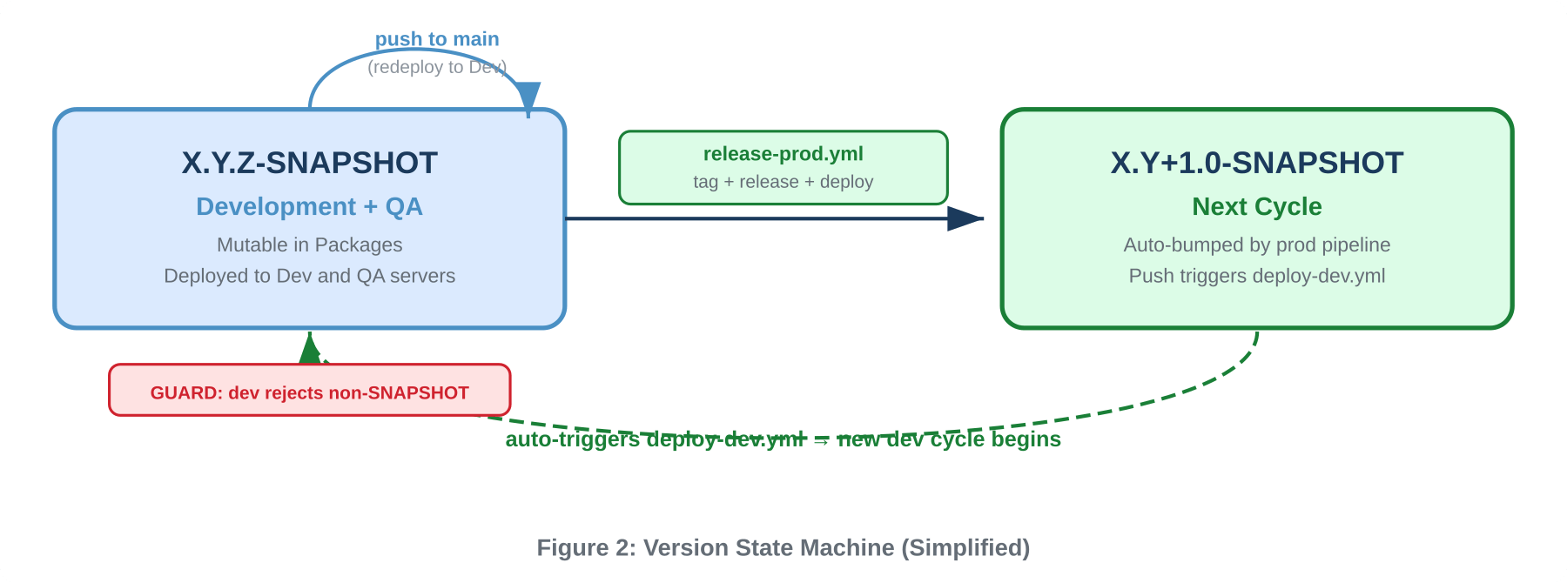
The SNAPSHOT version persists on main through both Dev and QA deployments. Only the Prod release workflow mutates it, bumping directly to the next SNAPSHOT. The clean version number is derived at release time by stripping the suffix — it never exists as a commit in version.properties.

3.2 Build Subsystem

Purpose: Compile source code, run tests, produce versioned artifacts, and stamp metadata into the jar manifest.
Components: build.gradle, Gradle wrapper, JDK 17.
The build subsystem stamps the following metadata into META-INF/MANIFEST.MF:
Manifest Key | Example Value | Purpose
Implementation-Title | myapp | Application identifier
Implementation-Version | 1.2.3-SNAPSHOT | Semantic version
Built-Timestamp | 2026-03-02T14:30:00 | Build time for audit
Build-Jdk | 17.0.10 | JDK version used
Git-Commit | a1b2c3d | Source commit SHA

This metadata enables any deployed jar to be introspected on any server to determine exactly what code it contains and when it was built.

3.3 Artifact Storage Subsystem

Purpose: Store, version, and distribute build artifacts through two complementary channels.
- GitHub Packages acts as a Maven repository. SNAPSHOT artifacts are published here during the Dev build. Both QA and Prod fetch from Packages. SNAPSHOT artifacts are mutable — each push to main overwrites the previous SNAPSHOT with a fresh build.
- GitHub Releases act as immutable release records created at production release time. The clean-named jar, SHA-256 checksums, and release notes are attached. GitHub Releases serve as the permanent archive of what shipped to production.
The distinction matters: Packages is the deployment source (mutable, overwritten frequently); Releases is the historical record (immutable, created once per version).

3.4 Deployment Subsystem

Purpose: Transfer artifacts to target servers, restart services, and write deployment receipts.
Each deployment follows a consistent three-step pattern:
- Transfer: The jar is copied via SCP to /opt/app/ on the target server.
- Receipt: A deploy-info.json is written containing the version, environment, timestamp, commit SHA, and relevant metadata.
- Restart: The application service is restarted via systemctl.

3.5 Release Notes Subsystem

Purpose: Automatically generate categorized release notes from git commit history using Conventional Commits prefixes.
Invoked by: release-prod.yml at production release time (not during QA).
Release notes are generated from the git log between the previous tag and the newly created tag. They are attached to the GitHub Release as part of the production release ceremony.
NOTE The generator requires Conventional Commits discipline. Non-conventional commits are categorized under “Other Changes” — nothing is silently dropped.

4. Pipeline Architecture

The CI/CD system comprises four GitHub Actions workflows. Each has a single responsibility and a clearly defined trigger:
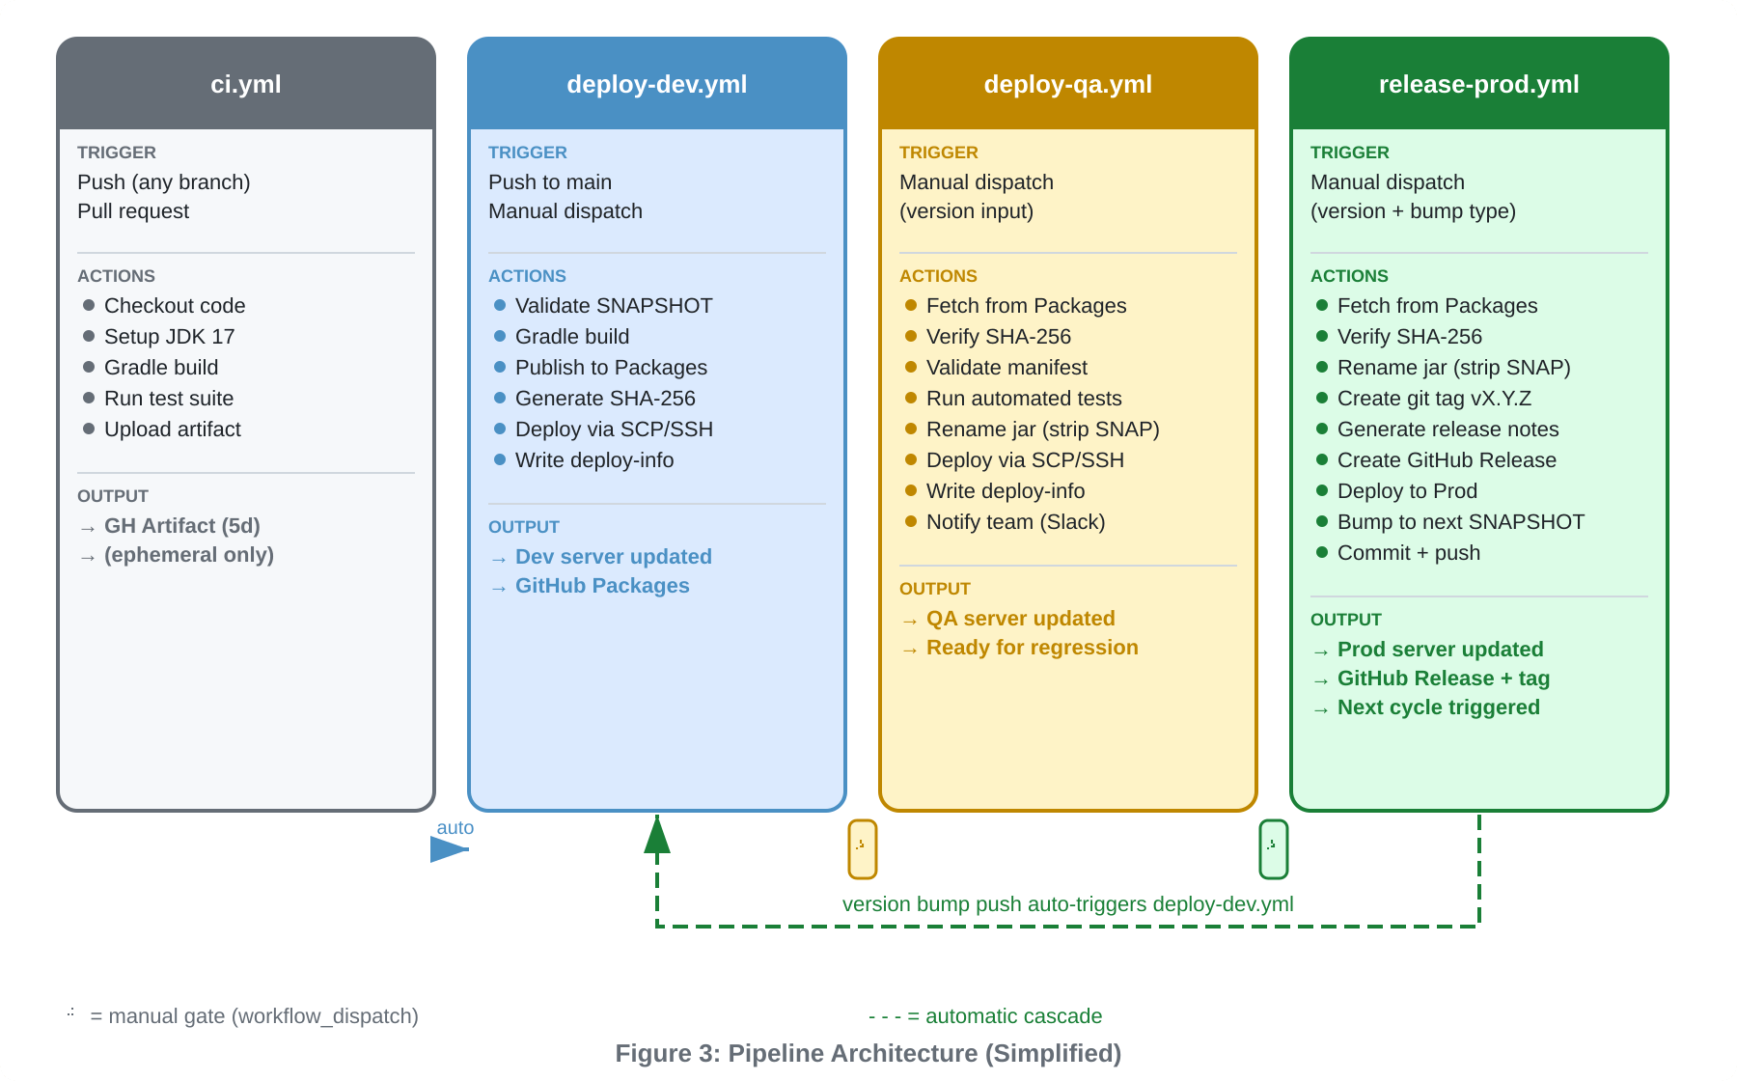

The key simplification: deploy-qa.yml does not build, tag, or create releases. It only fetches, validates, and deploys. All release concerns are consolidated in release-prod.yml.
INTERACTION ci.yml and deploy-dev.yml both trigger on push to main but are independent workflows. deploy-qa.yml and release-prod.yml are always manual. After Prod, the version bump push re-triggers deploy-dev.yml automatically.

5. Pipeline Mechanics

5.1 CI Pipeline (ci.yml)
Trigger: Push to main, develop, feature/** branches; pull requests to main.
Scope: Read-only. Does not modify the repository, publish to Packages, or deploy anywhere.
The CI pipeline is the quality gate. Every code change must pass before deployment. The resulting jar is uploaded as an ephemeral GitHub Actions artifact (5-day retention) for debugging only — never used for deployment. The CI pipeline is deliberately separated from Dev deployment so feature branches get validation without triggering deployments.

5.2 Dev Deployment Pipeline (deploy-dev.yml)
Trigger: Push to main (automatic), workflow_dispatch (manual).
Scope: Builds, generates SHA-256 checksum, publishes to GitHub Packages, deploys to Dev server.
This pipeline has one critical validation gate: it rejects any version that does not end in -SNAPSHOT. After validation, it builds a fresh jar, generates a SHA-256 checksum file, publishes both to Packages, and deploys to the Dev server. The checksum published here is what QA and Prod will verify against later.

5.3 QA Deployment Pipeline (deploy-qa.yml)
Trigger: Manual workflow_dispatch with version input (e.g., 1.0.0-SNAPSHOT).
Scope: Fetches from GitHub Packages, validates, deploys to QA server. Does NOT build, tag, or release.
This is the simplest deployment workflow. A dev lead triggers it with the SNAPSHOT version to test. The pipeline:
- Fetches the specified jar from GitHub Packages.
- Verifies the SHA-256 checksum against the published checksum file.
- Validates the jar’s manifest metadata (Implementation-Version must match the input).
- Runs the automated test suite against the fetched artifact.
- Renames the jar by stripping the -SNAPSHOT suffix (e.g., myapp-1.0.0-SNAPSHOT.jar → myapp-1.0.0.jar).
- Deploys the clean-named jar to the QA server via SCP.
- Notifies the team via Slack that the artifact is ready for manual regression testing.
SIMPLICITY The QA workflow completes here. There is no approval gate, no tag, no release. Manual regression testing happens outside the pipeline. The decision to release to production is simply whether someone triggers release-prod.yml.

5.4 Production Release Pipeline (release-prod.yml)
Trigger: Manual workflow_dispatch with version and bump type selection.
Scope: Fetches from Packages, tags, generates release notes, creates GitHub Release, deploys to Prod, bumps version.
This pipeline owns the entire release ceremony. The sequence:
- Fetch the SNAPSHOT jar from GitHub Packages (same binary QA tested).
- Verify the SHA-256 checksum.
- Compute the release version by stripping -SNAPSHOT, and the next SNAPSHOT based on bump type.
- Create git tag vX.Y.Z (annotated) on the current commit.
- Generate release notes from git log since the previous tag, categorized by Conventional Commits.
- Create GitHub Release with the clean-named jar and release notes attached.
- Deploy the clean-named jar to the Prod server via SCP.
- Bump version.properties to the next SNAPSHOT (e.g., 1.1.0-SNAPSHOT).
- Commit and push to main, which auto-triggers deploy-dev.yml for the next cycle.
BUILD ONCE Neither QA nor Prod ever compile source code. The binary built during the Dev stage is fetched from Packages and verified by checksum. The only difference is the filename — the SNAPSHOT suffix is stripped before deployment.

6. Artifact Lifecycle

An artifact progresses through a well-defined lifecycle from creation to production. At each stage, its integrity is verified by SHA-256 checksum:
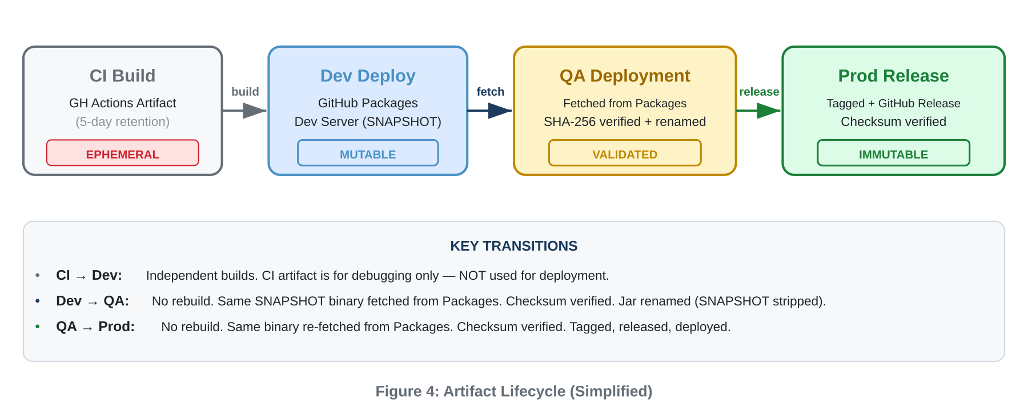

7. Release Process

The release process involves two human decision points and one automated cascade.

7.1 Decision Points

Decision 1: Promote to QA
When Dev is stable and feature-complete, a dev lead triggers deploy-qa.yml with the SNAPSHOT version to validate. The pipeline fetches, verifies, tests, and deploys. After deployment, the team conducts manual regression testing outside of any pipeline.
Decision 2: Release to Production
After manual regression passes, a release manager triggers release-prod.yml with the version and bump type. This creates the official release: tag, release notes, GitHub Release, and production deployment. The audit trail is the GitHub Actions run history: who triggered the workflow, when, and with what inputs.

7.2 Automated Cascade

Prod Deploy → Next Cycle
The Prod workflow bumps version.properties to the next SNAPSHOT and pushes to main. This triggers deploy-dev.yml, deploying the new SNAPSHOT to Dev. Development continues immediately with no manual intervention.

7.3 Release Notes Generation

Release notes are auto-generated during the production release, categorized by Conventional Commits prefix:
Prefix | Category | Example
feat: | New Features | feat: add CSV export
fix: | Bug Fixes | fix: handle null pointer
docs: | Documentation | docs: update API guide
refactor: | Refactoring | refactor: simplify query
test: | Tests | test: add integration tests
ci: / build: | CI / Build | ci: add checksum step
chore: | Maintenance | chore: update deps
(other) | Other Changes | update README

Each entry includes the commit message, short hash, and author. Notes are attached to the GitHub Release at production time.

8. Traceability & Audit Model

The system provides four independent, complementary traceability layers to answer: “What exactly is running on this server?”

8.1 Binary Identity (SHA-256)
At Dev build time, SHA-256 checksums are computed and published to GitHub Packages. Both QA and Prod verify the checksum before deployment. If it fails, deployment aborts. This provides cryptographic proof that QA and Prod run the exact same binary that was built during Dev.

8.2 Embedded Metadata (MANIFEST.MF)
The jar carries its identity: version, git commit, build timestamp, and JDK version. On any server: unzip -p /opt/app/myapp.jar META-INF/MANIFEST.MF reveals everything. No external lookup needed.

8.3 Server-Side Receipt (deploy-info.json)
Every deployment writes a JSON file to /opt/app/deploy-info.json recording version, environment, timestamp, commit, and deployment source. Answers “when was this deployed?” without GitHub access.

8.4 Platform Audit Trail (GitHub)
Git tags, GitHub Releases, and workflow run history create a complete chronological record. The production audit trail is simply: who triggered release-prod.yml, when, and with what inputs.

9. Environment Architecture

Env | Version | Trigger | Source | Built? | Notes? | Checksum
Dev | X.Y.Z-SNAP | Push main | Source code | Yes | No | Generated
QA | X.Y.Z | Manual | GH Packages | No | No | Verified
Prod | X.Y.Z | Manual | GH Packages | No | Generated | Verified

Both QA and Prod environments receive the same binary from GitHub Packages. Neither rebuilds. The jar is renamed (SNAPSHOT suffix stripped) before deployment so the filename on the server reflects the clean version.
Only two GitHub Environments are needed: qa (for QA server credentials) and production (for Prod server credentials). No approval gates or reviewer rules are required — access control is managed through who has permission to trigger the workflow.

10. Security Model

10.1 Authentication & Secrets
Secret | Used By | Purpose
GITHUB_TOKEN | All workflows | Publish to Packages, read Packages, create Releases, push tags
DEV_USER / DEV_HOST | deploy-dev.yml | SSH credentials for Dev server
QA_USER / QA_HOST | deploy-qa.yml | SSH credentials for QA server
PROD_USER / PROD_HOST | release-prod.yml | SSH credentials for Prod server
SLACK_WEBHOOK | deploy-qa.yml | QA deployment notification

10.2 Permissions Model
Each workflow declares minimum required permissions. CI needs only contents: read. Dev adds packages: write. QA needs only packages: read. Prod needs contents: write and packages: read. No workflow has admin permissions.

10.3 Supply Chain Integrity
The SHA-256 checksum chain ensures binary integrity from build to production. The checksum is generated at Dev build time, published to Packages, and verified at every subsequent deployment stage. Any tampering — whether in transit or in Packages — breaks the checksum and halts deployment.

11. Walkthrough: Feature from Dev to Prod

The following diagram shows the complete flow from developer push through production deployment:
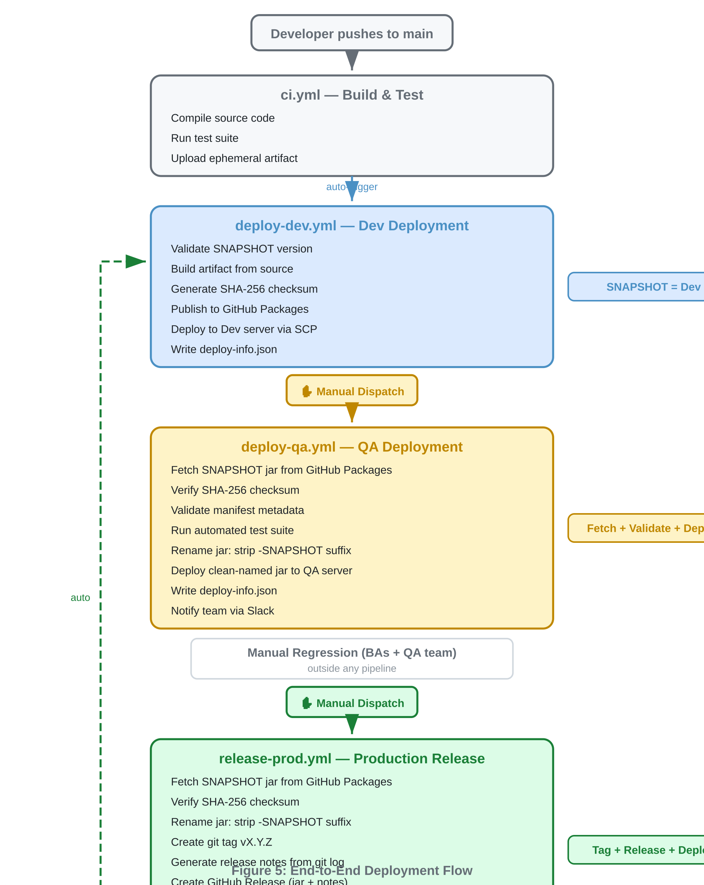

Phase 1 — Feature Development
A developer creates a feature branch with Conventional Commits. A PR is opened, ci.yml validates the build. The team reviews, approves, and merges to main.

Phase 2 — Automatic Dev Deployment
The merge triggers deploy-dev.yml. It validates SNAPSHOT, builds the jar, generates a SHA-256 checksum, publishes both to GitHub Packages, and deploys to the Dev server. Dev server now runs myapp-1.2.3-SNAPSHOT.jar with deploy-info.json confirming the environment.

Phase 3 — QA Deployment
A dev lead triggers deploy-qa.yml with version = 1.2.3-SNAPSHOT. The workflow fetches the jar from GitHub Packages, verifies the SHA-256 checksum, validates the manifest, runs automated tests, renames the jar to myapp-1.2.3.jar, and deploys to QA. Slack notification goes out. BAs and QA team begin manual regression testing — completely outside any pipeline.

Phase 4 — Production Release
After QA sign-off, a release manager triggers release-prod.yml with version = 1.2.3-SNAPSHOT and bump_type = minor. The workflow fetches the same jar from Packages, verifies the checksum, renames it to myapp-1.2.3.jar, creates git tag v1.2.3, generates release notes from git log, creates GitHub Release v1.2.3 (with the jar and notes), deploys to Prod, bumps version.properties to 1.3.0-SNAPSHOT, and pushes to main.

Phase 5 — Next Cycle
The push triggers deploy-dev.yml automatically. Dev now runs myapp-1.3.0-SNAPSHOT.jar. The entire process involved exactly two manual clicks (QA dispatch and Prod dispatch). Everything else was fully automated.

Final State Across All Environments

Environment | Jar on Server | version.properties | deploy-info.json
Dev | myapp-1.3.0-SNAP | 1.3.0-SNAPSHOT | env: dev
QA | myapp-1.2.3.jar | 1.3.0-SNAPSHOT | env: qa
Prod | myapp-1.2.3.jar | 1.3.0-SNAPSHOT | env: prod, tag: v1.2.3

KEY INSIGHT QA and Prod have the same jar (myapp-1.2.3.jar). The checksum proves they are byte-identical. version.properties on main has already moved to 1.3.0-SNAPSHOT for the next cycle.

Appendix A: File Inventory

The following files comprise the complete implementation. Full source listings for each file are provided in the appendices below.

File | Description
version.properties | Single source of truth for project version. Mutated only by release-prod.yml.
build.gradle | Reads version.properties, configures jar manifest, defines GitHub Packages publishing and generateReleaseNotes task.
.github/workflows/ci.yml | CI pipeline. Builds, tests, uploads ephemeral artifact. Read-only.
.github/workflows/deploy-dev.yml | Dev pipeline. Validates SNAPSHOT, builds, generates checksum, publishes to Packages, deploys to Dev.
.github/workflows/deploy-qa.yml | QA deployment. Fetches from Packages, validates checksum + manifest, runs tests, renames jar, deploys to QA.
.github/workflows/release-prod.yml | Prod release. Fetches from Packages, tags, generates notes, creates GitHub Release, deploys, bumps version.
scripts/generate-release-notes.sh | Release notes generator with Conventional Commits categorization. Invoked by release-prod.yml.

Appendix B: version.properties

Single source of truth for the project version. Lives at the project root. Read by Gradle at build time. Mutated only by release-prod.yml (bump to next SNAPSHOT).

# Project version - single source of truth
# Format: MAJOR.MINOR.PATCH-SNAPSHOT
#
# SNAPSHOT suffix = active development
# Clean version derived at release time (jar rename only)
#
# Updated automatically by CI:
# release-prod.yml -> bumps to next SNAPSHOT

version=1.0.0-SNAPSHOT

Appendix C: build.gradle

Complete build script. Reads version from version.properties, configures jar manifest with traceability metadata, defines GitHub Packages publishing with checksum artifact, and provides a local release notes generation task.

plugins {
id 'java'
id 'application'
id 'maven-publish'
}

// -- Read version from version.properties --
def versionProps = new Properties()
file('version.properties').withInputStream { versionProps.load(it) }
version = versionProps['version']

group = 'com.example'

java {
sourceCompatibility = JavaVersion.VERSION_17
targetCompatibility = JavaVersion.VERSION_17
}

repositories { mavenCentral() }

jar {
archiveBaseName = project.name
archiveVersion = version
manifest {
attributes(
'Implementation-Title': project.name,
'Implementation-Version': version,
'Built-Timestamp': new Date().format("yyyy-MM-dd'T'HH:mm:ss"),
'Build-Jdk': System.getProperty('java.version'),
'Git-Commit': 'git rev-parse --short HEAD'.execute().text.trim()
)
}
}

// -- Publishing to GitHub Packages --
publishing {
repositories {
maven {
name = 'GitHubPackages'
url = uri("https://maven.pkg.github.com/" +
(System.env.GITHUB_REPOSITORY ?: 'OWNER/REPO'))
credentials {
username = System.env.GITHUB_ACTOR ?: ''
password = System.env.GITHUB_TOKEN ?: ''
}
}
}
publications {
maven(MavenPublication) {
from components.java
artifact("build/checksums.txt") {
classifier = 'checksums'
extension = 'txt'
}
}
}
}

// -- Print version (used by CI) --
tasks.register('printVersion') {
doLast { println version }
}

// -- Release notes generation (local use) --
tasks.register('generateReleaseNotes') {
description = 'Generate release notes from git log'
doLast {
def lastTag = 'git describe --tags --abbrev=0 2>/dev/null'
.execute().text.trim()
def range = lastTag ? "${lastTag}..HEAD" : 'HEAD'
def releaseVer = version.replace('-SNAPSHOT', '')

def commits = "git log ${range} --pretty=format:%s --no-merges"
.execute().text.trim()
def authors = "git log ${range} --pretty=format:%an --no-merges"
.execute().text.trim()
def commitLines = commits ? commits.split('\\n') : []
def authorLines = authors ? authors.split('\\n') : []

def feat = [], fix = [], maint = [], other = []
commitLines.each { m ->
if (m.startsWith('feat')) feat << m
else if (m.startsWith('fix')) fix << m
else if (m =~ /^(chore|ci|docs|refactor|test)/) maint << m
else other << m
}

def sb = new StringBuilder()
sb.append("# Release Notes - v${releaseVer}\n")
sb.append("**Date:** ${new Date().format('yyyy-MM-dd')}\n\n")
if (feat) { sb.append('## Features\n')
feat.each { sb.append("- ${it}\n") }; sb.append('\n') }
if (fix) { sb.append('## Bug Fixes\n')
fix.each { sb.append("- ${it}\n") }; sb.append('\n') }
if (maint) { sb.append('## Maintenance\n')
maint.each { sb.append("- ${it}\n") }; sb.append('\n') }
if (other) { sb.append('## Other\n')
other.each { sb.append("- ${it}\n") }; sb.append('\n') }
sb.append('## Contributors\n')
authorLines.toList().unique().sort().each {
sb.append("- ${it}\n") }

def f = file("build/release-notes-v${releaseVer}.md")
f.parentFile.mkdirs()
f.text = sb.toString()
println "Release notes: ${f.path}"
}
}

Appendix D: CI Workflow - ci.yml

Runs on every push and pull request. Read-only: builds, tests, and uploads an ephemeral artifact. Does not deploy or modify the repository.

name: CI - Build & Test

on:
push:
branches: [main, develop, 'feature/**']
pull_request:
branches: [main]

permissions:
contents: read

jobs:
build:
runs-on: ubuntu-latest
steps:
- uses: actions/checkout@v4

- name: Set up JDK 17
uses: actions/setup-java@v4
with:
distribution: temurin
java-version: '17'

- uses: gradle/actions/setup-gradle@v4

- name: Read version
id: ver
run: |
V=$(grep '^version=' version.properties | cut -d= -f2)
echo "v=$V" >> "$GITHUB_OUTPUT"

- name: Build & Test
run: ./gradlew build test

- name: Upload artifact
uses: actions/upload-artifact@v4
with:
name: app-${{ steps.ver.outputs.v }}
path: build/libs/*.jar
retention-days: 5

Appendix E: Dev Deploy - deploy-dev.yml

Deploys the SNAPSHOT artifact to the Dev server. Validates that the version contains -SNAPSHOT before proceeding. Builds, generates SHA-256 checksum, publishes both jar and checksum to GitHub Packages, and writes a deployment receipt on the server.

name: Deploy to Dev

on:
push:
branches: [main]
workflow_dispatch:

permissions:
contents: read
packages: write

jobs:
deploy-dev:
runs-on: ubuntu-latest
environment: development
steps:
- uses: actions/checkout@v4

- name: Set up JDK 17
uses: actions/setup-java@v4
with:
distribution: temurin
java-version: '17'

- uses: gradle/actions/setup-gradle@v4

- name: Read version
id: ver
run: |
V=$(grep '^version=' version.properties | cut -d= -f2)
echo "v=$V" >> "$GITHUB_OUTPUT"

- name: Validate SNAPSHOT
run: |
if [[ "${{ steps.ver.outputs.v }}" != *-SNAPSHOT ]]; then
echo "::error::Dev requires SNAPSHOT. Got: ${{ steps.ver.outputs.v }}"
exit 1
fi

- name: Build
run: ./gradlew clean build -x test

- name: Generate checksums
run: |
cd build/libs
sha256sum *.jar > ../checksums.txt
echo 'SHA-256 checksums:'
cat ../checksums.txt

- name: Publish to GitHub Packages
run: ./gradlew publish
env:
GITHUB_TOKEN: ${{ secrets.GITHUB_TOKEN }}

- name: Deploy to Dev server
run: |
V="${{ steps.ver.outputs.v }}"
JAR="build/libs/${{ github.event.repository.name }}-${V}.jar"

scp "$JAR" ${{ secrets.DEV_USER }}@${{ secrets.DEV_HOST }}:/opt/app/

ssh ${{ secrets.DEV_USER }}@${{ secrets.DEV_HOST }} << 'DEPLOY'
cat > /opt/app/deploy-info.json << EOF
{
"version": "$V",
"environment": "dev",
"deployed_at": "$(date -u +%Y-%m-%dT%H:%M:%SZ)",
"commit": "${{ github.sha }}",
"branch": "${{ github.ref_name }}"
}
EOF
sudo systemctl restart app
DEPLOY

- name: Summary
run: |
echo '## Dev Deployment' >> $GITHUB_STEP_SUMMARY
echo '| Property | Value |' >> $GITHUB_STEP_SUMMARY
echo '|----------|-------|' >> $GITHUB_STEP_SUMMARY
echo "| Version | \`${{ steps.ver.outputs.v }}\` |" >> $GITHUB_STEP_SUMMARY
echo "| Commit | \`${{ github.sha }}\` |" >> $GITHUB_STEP_SUMMARY

Appendix F: QA Deploy - deploy-qa.yml

Simplified QA deployment. Fetches a specific SNAPSHOT version from GitHub Packages, validates the checksum and manifest metadata, runs automated tests, renames the jar (strips -SNAPSHOT), and deploys to the QA server. Does not build, tag, or create releases.

name: Deploy to QA

on:
workflow_dispatch:
inputs:
version:
description: 'Version to fetch from GitHub Packages (e.g. 1.0.0-SNAPSHOT)'
required: true
type: string

permissions:
packages: read

jobs:
deploy-to-qa:
runs-on: ubuntu-latest
environment: qa
steps:
- uses: actions/checkout@v4

- name: Set up JDK 17
uses: actions/setup-java@v4
with:
distribution: temurin
java-version: '17'

- uses: gradle/actions/setup-gradle@v4

# -- Fetch from GitHub Packages --
- name: Download artifact from GitHub Packages
run: |
V="${{ inputs.version }}"
ARTIFACT="${{ github.event.repository.name }}"

echo "Fetching ${ARTIFACT}-${V}.jar from GitHub Packages..."

mvn dependency:copy \
-Dartifact=com.example:${ARTIFACT}:${V}:jar \
-DoutputDirectory=./artifacts/ \
-DrepositoryId=github \
-s settings.xml

# Also fetch the checksums file
mvn dependency:copy \
-Dartifact=com.example:${ARTIFACT}:${V}:txt:checksums \
-DoutputDirectory=./artifacts/ \
-DrepositoryId=github \
-s settings.xml
env:
GITHUB_TOKEN: ${{ secrets.GITHUB_TOKEN }}

# -- Validate --
- name: Verify SHA-256 checksum
run: |
cd artifacts
sha256sum --check *-checksums.txt
echo "Checksum verified - artifact matches published build"

- name: Validate version metadata
run: |
V="${{ inputs.version }}"
JAR=$(ls artifacts/*.jar | head -1)
MANIFEST_VER=$(unzip -p "$JAR" META-INF/MANIFEST.MF \
| grep 'Implementation-Version' | cut -d' ' -f2 | tr -d '\r')
if [[ "$MANIFEST_VER" != "$V" ]]; then
echo "::error::Version mismatch. Expected: $V, Got: $MANIFEST_VER"
exit 1
fi
echo "Version verified: $V"

# -- Automated testing --
- name: Run automated test suite
run: |
echo "Running automated tests against the fetched artifact..."
java -jar artifacts/*.jar --server.port=8090 &
APP_PID=$!
sleep 30

./gradlew integrationTest -Penv=qa \
-PbaseUrl=http://localhost:8090

kill $APP_PID || true

# -- Rename jar (strip SNAPSHOT) --
- name: Strip SNAPSHOT suffix from jar name
run: |
V="${{ inputs.version }}"
CLEAN="${V%-SNAPSHOT}"
ARTIFACT="${{ github.event.repository.name }}"
mv "artifacts/${ARTIFACT}-${V}.jar" \
"artifacts/${ARTIFACT}-${CLEAN}.jar"
echo "Renamed: ${ARTIFACT}-${V}.jar -> ${ARTIFACT}-${CLEAN}.jar"

# -- Deploy --
- name: Deploy to QA server
run: |
V="${{ inputs.version }}"
CLEAN="${V%-SNAPSHOT}"
JAR=$(ls artifacts/*.jar | head -1)

scp "$JAR" ${{ secrets.QA_USER }}@${{ secrets.QA_HOST }}:/opt/app/

ssh ${{ secrets.QA_USER }}@${{ secrets.QA_HOST }} << DEPLOY
cat > /opt/app/deploy-info.json << EOF
{
"version": "$CLEAN",
"snapshot_version": "$V",
"environment": "qa",
"deployed_at": "$(date -u +%Y-%m-%dT%H:%M:%SZ)",
"commit": "${{ github.sha }}",
"status": "testing"
}
EOF
sudo systemctl restart app
DEPLOY

- name: Notify team
run: |
CLEAN="${V%-SNAPSHOT}"
curl -X POST ${{ secrets.SLACK_WEBHOOK }} \
-H 'Content-type: application/json' \
-d '{"text":"v'$CLEAN' deployed to QA (from '${{ inputs.version }}'). Automated tests passed. Ready for manual regression."}'

- name: Summary
run: |
V="${{ inputs.version }}"
CLEAN="${V%-SNAPSHOT}"
echo '## QA Deployment' >> $GITHUB_STEP_SUMMARY
echo '| Property | Value |' >> $GITHUB_STEP_SUMMARY
echo '|----------|-------|' >> $GITHUB_STEP_SUMMARY
echo "| Deployed | \`${CLEAN}\` |" >> $GITHUB_STEP_SUMMARY
echo "| From SNAPSHOT | \`${V}\` |" >> $GITHUB_STEP_SUMMARY
echo "| Checksum | Verified |" >> $GITHUB_STEP_SUMMARY

Appendix G: Prod Release - release-prod.yml

Owns all release concerns. Fetches the QA-tested SNAPSHOT artifact from GitHub Packages, verifies the checksum, creates a git tag, generates release notes, creates a GitHub Release, deploys to Prod, then bumps version.properties to the next SNAPSHOT and pushes to main to start the next development cycle.

name: Release to Production

on:
workflow_dispatch:
inputs:
version:
description: 'Version to release (e.g. 1.0.0-SNAPSHOT -> tags as v1.0.0)'
required: true
type: string
bump_type:
description: 'Next version bump'
required: true
type: choice
options: [minor, patch, major]
default: minor

permissions:
contents: write
packages: read

jobs:
release-to-prod:
runs-on: ubuntu-latest
environment: production
steps:
- uses: actions/checkout@v4
with:
fetch-depth: 0
token: ${{ secrets.GITHUB_TOKEN }}

- name: Set up JDK 17
uses: actions/setup-java@v4
with:
distribution: temurin
java-version: '17'

- name: Compute release and next versions
id: ver
run: |
RAW="${{ inputs.version }}"
REL="${RAW%-SNAPSHOT}"
echo "rel=$REL" >> "$GITHUB_OUTPUT"

IFS="." read -r MA MI PA <<< "$REL"
case "${{ inputs.bump_type }}" in
major) NX="$((MA+1)).0.0" ;;
minor) NX="${MA}.$((MI+1)).0" ;;
patch) NX="${MA}.${MI}.$((PA+1))" ;;
esac
echo "next=${NX}-SNAPSHOT" >> "$GITHUB_OUTPUT"

# -- Fetch from GitHub Packages --
- name: Download artifact from GitHub Packages
run: |
V="${{ inputs.version }}"
ARTIFACT="${{ github.event.repository.name }}"

mvn dependency:copy \
-Dartifact=com.example:${ARTIFACT}:${V}:jar \
-DoutputDirectory=./artifacts/ \
-DrepositoryId=github \
-s settings.xml

mvn dependency:copy \
-Dartifact=com.example:${ARTIFACT}:${V}:txt:checksums \
-DoutputDirectory=./artifacts/ \
-DrepositoryId=github \
-s settings.xml
env:
GITHUB_TOKEN: ${{ secrets.GITHUB_TOKEN }}

- name: Verify SHA-256 checksum
run: |
cd artifacts
sha256sum --check *-checksums.txt
echo "Checksum verified - binary matches QA-tested build"

# -- Rename jar (strip SNAPSHOT) --
- name: Strip SNAPSHOT suffix from jar name
run: |
V="${{ inputs.version }}"
REL="${{ steps.ver.outputs.rel }}"
ARTIFACT="${{ github.event.repository.name }}"
mv "artifacts/${ARTIFACT}-${V}.jar" \
"artifacts/${ARTIFACT}-${REL}.jar"

# -- Tag --
- name: Create git tag
run: |
V="${{ steps.ver.outputs.rel }}"
git config user.name 'github-actions[bot]'
git config user.email \
'github-actions[bot]@users.noreply.github.com'
git tag -a "v${V}" -m "Release v${V}"
git push origin "v${V}"

# -- Release notes --
- name: Generate release notes
run: |
V="${{ steps.ver.outputs.rel }}"
PREV_TAG=$(git tag --sort=-v:refname \
| grep -v "v${V}" | head -1)
RANGE="${PREV_TAG:+${PREV_TAG}..}v${V}"

echo "# Release Notes - v${V}" > release-notes.md
echo "" >> release-notes.md
echo "**Release Date:** $(date +%Y-%m-%d)" >> release-notes.md
echo "**Previous:** ${PREV_TAG:-(initial)}" >> release-notes.md
echo "" >> release-notes.md

for CAT in "feat:New Features" "fix:Bug Fixes" \
"docs:Documentation" "refactor:Refactoring" \
"test:Tests" "ci:CI/Build" "chore:Maintenance"; do
PREFIX="${CAT%%:*}"
TITLE="${CAT##*:}"
COMMITS=$(git log $RANGE --oneline \
--no-merges --grep="^$PREFIX" || true)
if [[ -n "$COMMITS" ]]; then
echo "## $TITLE" >> release-notes.md
echo "$COMMITS" | while read -r line; do
echo "- $line" >> release-notes.md
done
echo "" >> release-notes.md
fi
done

echo '---' >> release-notes.md
echo '*Auto-generated at production release.*' \
>> release-notes.md
cat release-notes.md

# -- GitHub Release --
- name: Create GitHub Release
uses: softprops/action-gh-release@v2
with:
tag_name: v${{ steps.ver.outputs.rel }}
name: v${{ steps.ver.outputs.rel }}
body_path: release-notes.md
files: |
artifacts/*.jar

# -- Deploy --
- name: Deploy to Prod
run: |
V="${{ steps.ver.outputs.rel }}"
JAR=$(ls artifacts/*.jar | head -1)

scp "$JAR" \
${{ secrets.PROD_USER }}@${{ secrets.PROD_HOST }}:/opt/app/

ssh ${{ secrets.PROD_USER }}@${{ secrets.PROD_HOST }} << DEPLOY
cat > /opt/app/deploy-info.json << EOF
{
"version": "$V",
"environment": "production",
"deployed_at": "$(date -u +%Y-%m-%dT%H:%M:%SZ)",
"tag": "v${V}",
"promoted_from": "qa"
}
EOF
sudo systemctl restart app
DEPLOY

# -- Bump version for next cycle --
- name: Bump to next SNAPSHOT
run: |
NEXT="${{ steps.ver.outputs.next }}"
sed -i "s/^version=.*/version=${NEXT}/" \
version.properties
git add version.properties
git commit -m "chore: bump to ${NEXT} for next dev cycle"
git push origin main

- name: Summary
run: |
echo '## Production Release' >> $GITHUB_STEP_SUMMARY
echo '' >> $GITHUB_STEP_SUMMARY
cat release-notes.md >> $GITHUB_STEP_SUMMARY

Appendix H: Release Notes Generator

Standalone bash script for local release notes generation. The production pipeline generates notes inline, but this script is available for local use and testing. Also available as a Gradle task (./gradlew generateReleaseNotes).

#!/usr/bin/env bash
set -euo pipefail

# -----------------------------------------------------------
# generate-release-notes.sh
# Usage: ./scripts/generate-release-notes.sh <version> <o>
# -----------------------------------------------------------

VERSION="${1:?Usage: $0 <version> <output-file>}"
OUTPUT="${2:?Usage: $0 <version> <output-file>}"

# Determine commit range from previous tag
PREV_TAG=$(git describe --tags --abbrev=0 HEAD^ 2>/dev/null || echo "")
RANGE="${PREV_TAG:+${PREV_TAG}..HEAD}"

GIT_LOG_ARGS="--pretty=format:%s|%an|%h --no-merges"
if [[ -n "$RANGE" ]]; then
COMMITS=$(git log $RANGE $GIT_LOG_ARGS || echo "")
CONTRIBS=$(git log $RANGE --pretty=format:"%an" --no-merges | sort -u)
TOTAL=$(git log $RANGE --oneline --no-merges | wc -l | tr -d " ")
else
COMMITS=$(git log $GIT_LOG_ARGS || echo "")
CONTRIBS=$(git log --pretty=format:"%an" --no-merges | sort -u)
TOTAL=$(git log --oneline --no-merges | wc -l | tr -d " ")
fi

# Category accumulators
FEAT="" FIX="" DOCS="" REFACTOR="" TEST="" CI="" CHORE="" OTHER=""

# Categorize each commit
while IFS="|" read -r MSG AUTHOR HASH; do
[[ -z "$MSG" ]] && continue
L="- ${MSG} (\`${HASH}\`) *${AUTHOR}*"
case "$MSG" in
feat*|Feature*) FEAT+="${L}"$'\n' ;;
fix*|Fix*|bug*) FIX+="${L}"$'\n' ;;
docs*|Docs*) DOCS+="${L}"$'\n' ;;
refactor*) REFACTOR+="${L}"$'\n' ;;
test*|Test*) TEST+="${L}"$'\n' ;;
ci*|build*|Build*) CI+="${L}"$'\n' ;;
chore*|Chore*) CHORE+="${L}"$'\n' ;;
*) OTHER+="${L}"$'\n' ;;
esac
done <<< "$COMMITS"

# Write output
mkdir -p "$(dirname "$OUTPUT")"

cat > "$OUTPUT" << EOF
# Release Notes - v${VERSION}

**Release Date:** $(date +%Y-%m-%d)
**Previous Release:** ${PREV_TAG:-"(initial)"}
**Commits:** ${TOTAL}

---

EOF

# Append non-empty sections
sec() {
[[ -n "$2" ]] && printf "## %s\n\n%s\n" "$1" "$2" >> "$OUTPUT"
}

sec "New Features" "$FEAT"
sec "Bug Fixes" "$FIX"
sec "Documentation" "$DOCS"
sec "Refactoring" "$REFACTOR"
sec "Tests" "$TEST"
sec "CI / Build" "$CI"
sec "Maintenance" "$CHORE"
sec "Other Changes" "$OTHER"

echo -e "## Contributors\n" >> "$OUTPUT"
echo "$CONTRIBS" | sed 's/^/- /' >> "$OUTPUT"
echo -e "\n---\n*Auto-generated by CI.*" >> "$OUTPUT"

echo "Release notes: $OUTPUT ($TOTAL commits)"

End of document. All source listings above are ready to be placed in your project repository. Run chmod +x scripts/generate-release-notes.sh before first use.

