Final Report

Project: Smart Bike

### **Members**

Burak Gök

Marcos Castrillo Sarmiento

Serhii Korzh

### **Goal**

Help the cyclists to control their bikes and have a satisfactory riding experience.

### **Potential application users**

The project is built for daily bike commuters as well as bicycle enthusiast of age 13 or older.

### **Description of the implementation**

#### System:

The core device of our project is Raspberry Pi 3 Model B+. We use it primarily to read the data from sensors such as light intensity and vibration, and to control the lights on a bike, which we modified to receive on/off commands from the RPi. The system is powered with a regular power bank.

#### Application:

Our app is based on a mobile application development framework called PhoneGap. This eliminates most of the problems related to specific platforms (Android, iOS, Windows Phone) and allows to build applications using CSS3, HTML5 and JavaScript. Consistent design is achieved by integrating jQuery Mobile into the app.

#### Communication:

The technology used to transmit data is Bluetooth Low Energy. In our case, RPi acts as a *bluetooth peripheral device* (server), while a phone is a *bluetooth central module* (client). BLE allows us to not spend a lot of energy to constantly listen for new packets of data due to the optimizations made in the new standard of Bluetooth technology.

### **Screenshots and pictures**

|  |  |  |
| --- | --- | --- |
| tapToConnect.png | enableBluetooth.png | startRide.png |

|  |  |  |
| --- | --- | --- |
| rideStarted.png | map.png | weather.png |

### **Photos of the mounted system**

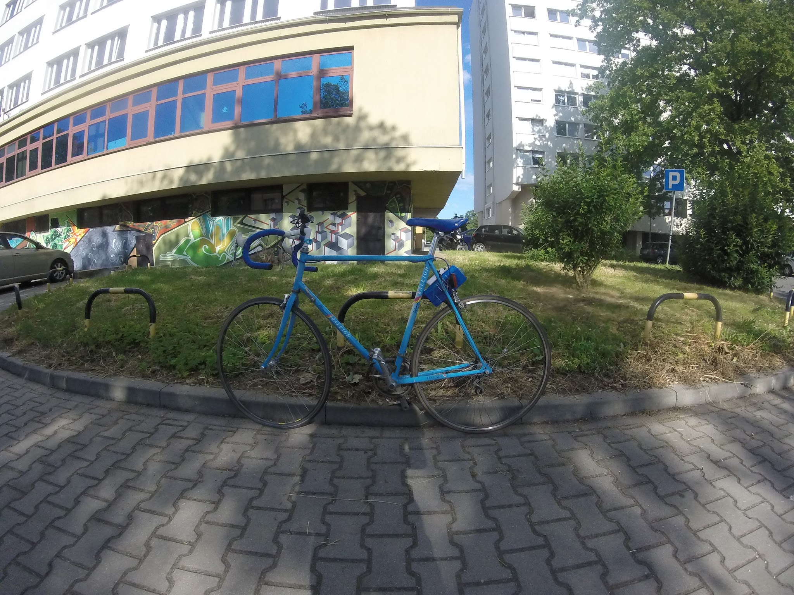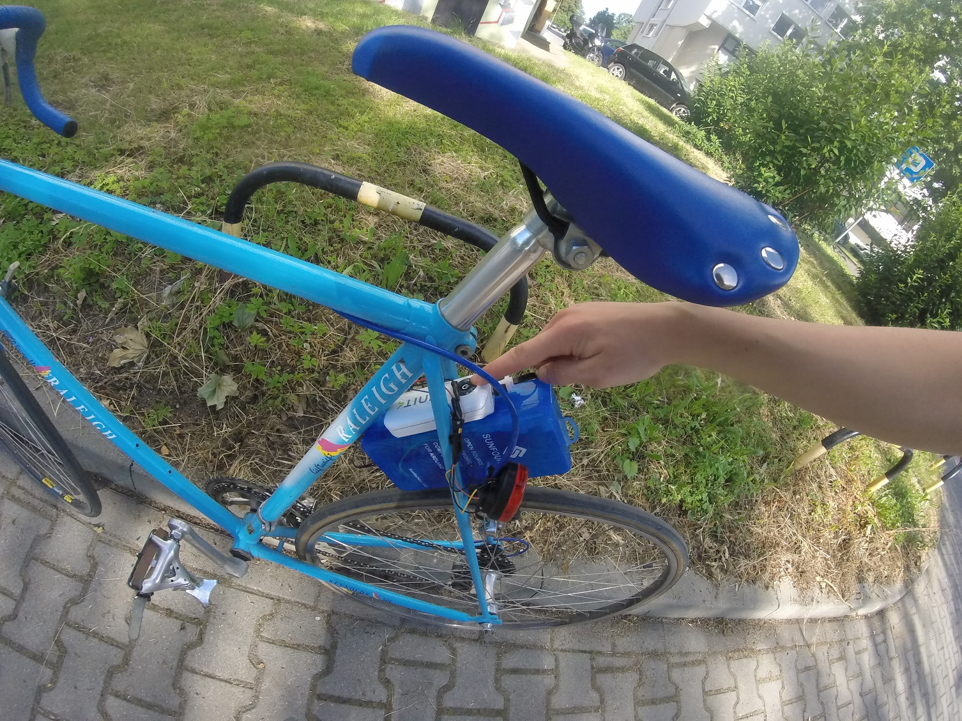

### **Implemented Improvements**

* We considered the problem of inaccurate GPS which may sometimes give quite unexpected results and applied a simple “sanity check” after receiving position parameters from GPS: we check if the acceleration between two updates is feasible for a bicycle and if it is not, assume that the bicycle did not change its speed.
* The second compliant we had is related to slow startup time of the device. We fixed it by moving the RPi from Raspbian to Minibian, which is a lighter version of the former. As a result, our booting time has decreased by more than 2 times.

### **Specification of our work**

All the parts of the system are tightly interconnected, thus we were obliged to work very closely in order to optimally integrate the components together. Nevertheless, we divided the responsibilities in order to have a structured workflow.

##### ***Marcos Castrillo Sarmiento*** – Application developer, Software tester

##### ***Burak Gök*** – Hardware engineer, System administrator

##### ***Serhii Korzh*** – Server-side programmer, System architect