Tutorial k-Nearest Neighbours Regression
Marcos del Cueto
August 2020

In the last years, there has been an explosion on data science and machine learning tools that make their use much more affordable to users. The spread of languages like python, with scientific libraries like scikit-learn^{R1}, made data analysis much more affordable. However, a risk of such advancements is that it is easier to treat these machine learning tools as a black box. One of the simplest techniques used in machine learning, whether to perform data classification or regression, is the k-nearest neighbours (k-NN) method. I have seen several online posts explaining how this method works and dealing with k-NN classification capabilities.

However, one must remember that k-NN can also be used as a regression technique, to estimate values of a continuous target property. Given how extended the use of regression methods are in all branches of science, it is surprising that it is so uncommon to find tutorials of such a basic (yet useful) method as k-NN regression. I wrote this short tutorial to give a simple example that data science beginners beginners could follow to see a direct application of this method, and hopefully more advanced users can still get something from the tutorial and use code snippets for their specific applications of k-NN.

Classification vs regression
The goal of any machine learning model is to be able to detect trends of a target property whose value is determined by a set of descriptors (also referred to as features), and then try to make predictions of the target property for new descriptor values. For example, one could build a machine learning model that is trained with how expected salary (target property) changes as a function of different descriptors: industry sector, location, worker’s age etc. and then tries to predict the average salary that a worker would likely have at some other conditions. k-NN is an example of supervised learning method, that is able to perform both classification and regression tasks.

Classification tasks have a discrete target property. For example, we can have a machine learning model that tries to predict the outcome of sports events, so the target property would have only the discrete values win, loss and possibly draw, but one cannot e.g. define any value between win and draw.

Regression tasks have a continuous target property. For example, we can build a machine learning model that tries to predict how a specific stock market is going to change in the future, so any possible value is in principle possible.

In a nutshell, when trying to predict the target property of a new point, k-NN takes a look at nearby points and averages them to estimate the target property value at the new point. There are numerous posts online on how k-NN classification works - see for example recent posts by Italo José^{R2} and Afroz Chakure^{R3}. In this tutorial, I will deal with k-NN regression, which seems to get less attention. I will discuss some specifics about how k-NN regression does predictions, and I provide a simple and complete example.

Tutorial overview
I have prepared this short tutorial as a direct way to:
- Provide a simple example on how to prepare data for regression.
- Show how to perform k-NN regression and optimize k.
- Exemplify how k-NN regression works.
- Show how different weight functions can affect k-NN prediction.
- Discuss some limitations of k-NN regression.

Anyone with a basic python knowledge could use this tutorial, and complete python codes are provided to help understanding the specific implementation. We will use python’s scikit-learn^{R1} library, which provides a very useful documentation about the k-NN regressor^{R4}.

Generate data
To simplify things here, we will create a one-dimensional dataset. This means that we have only one descriptor x, and a target property f(x). As a generic example, I am going to use in this tutorial a small database formed by ten points that follow the function: f(x) = e^{x}.

The points considered in this example are shown in Table 1, as well as in Figure 1. The complete code to generate this data is given in Code 1.

Table 1: Caption
x_{n} | f(x_{n})
5.00 | 148.41
5.20 | 181.27
5.40 | 221.41
5.60 | 270.43
5.80 | 330.30
6.00 | 403.43
6.20 | 492.75
6.40 | 601.85
6.60 | 735.10
6.80 | 897.85

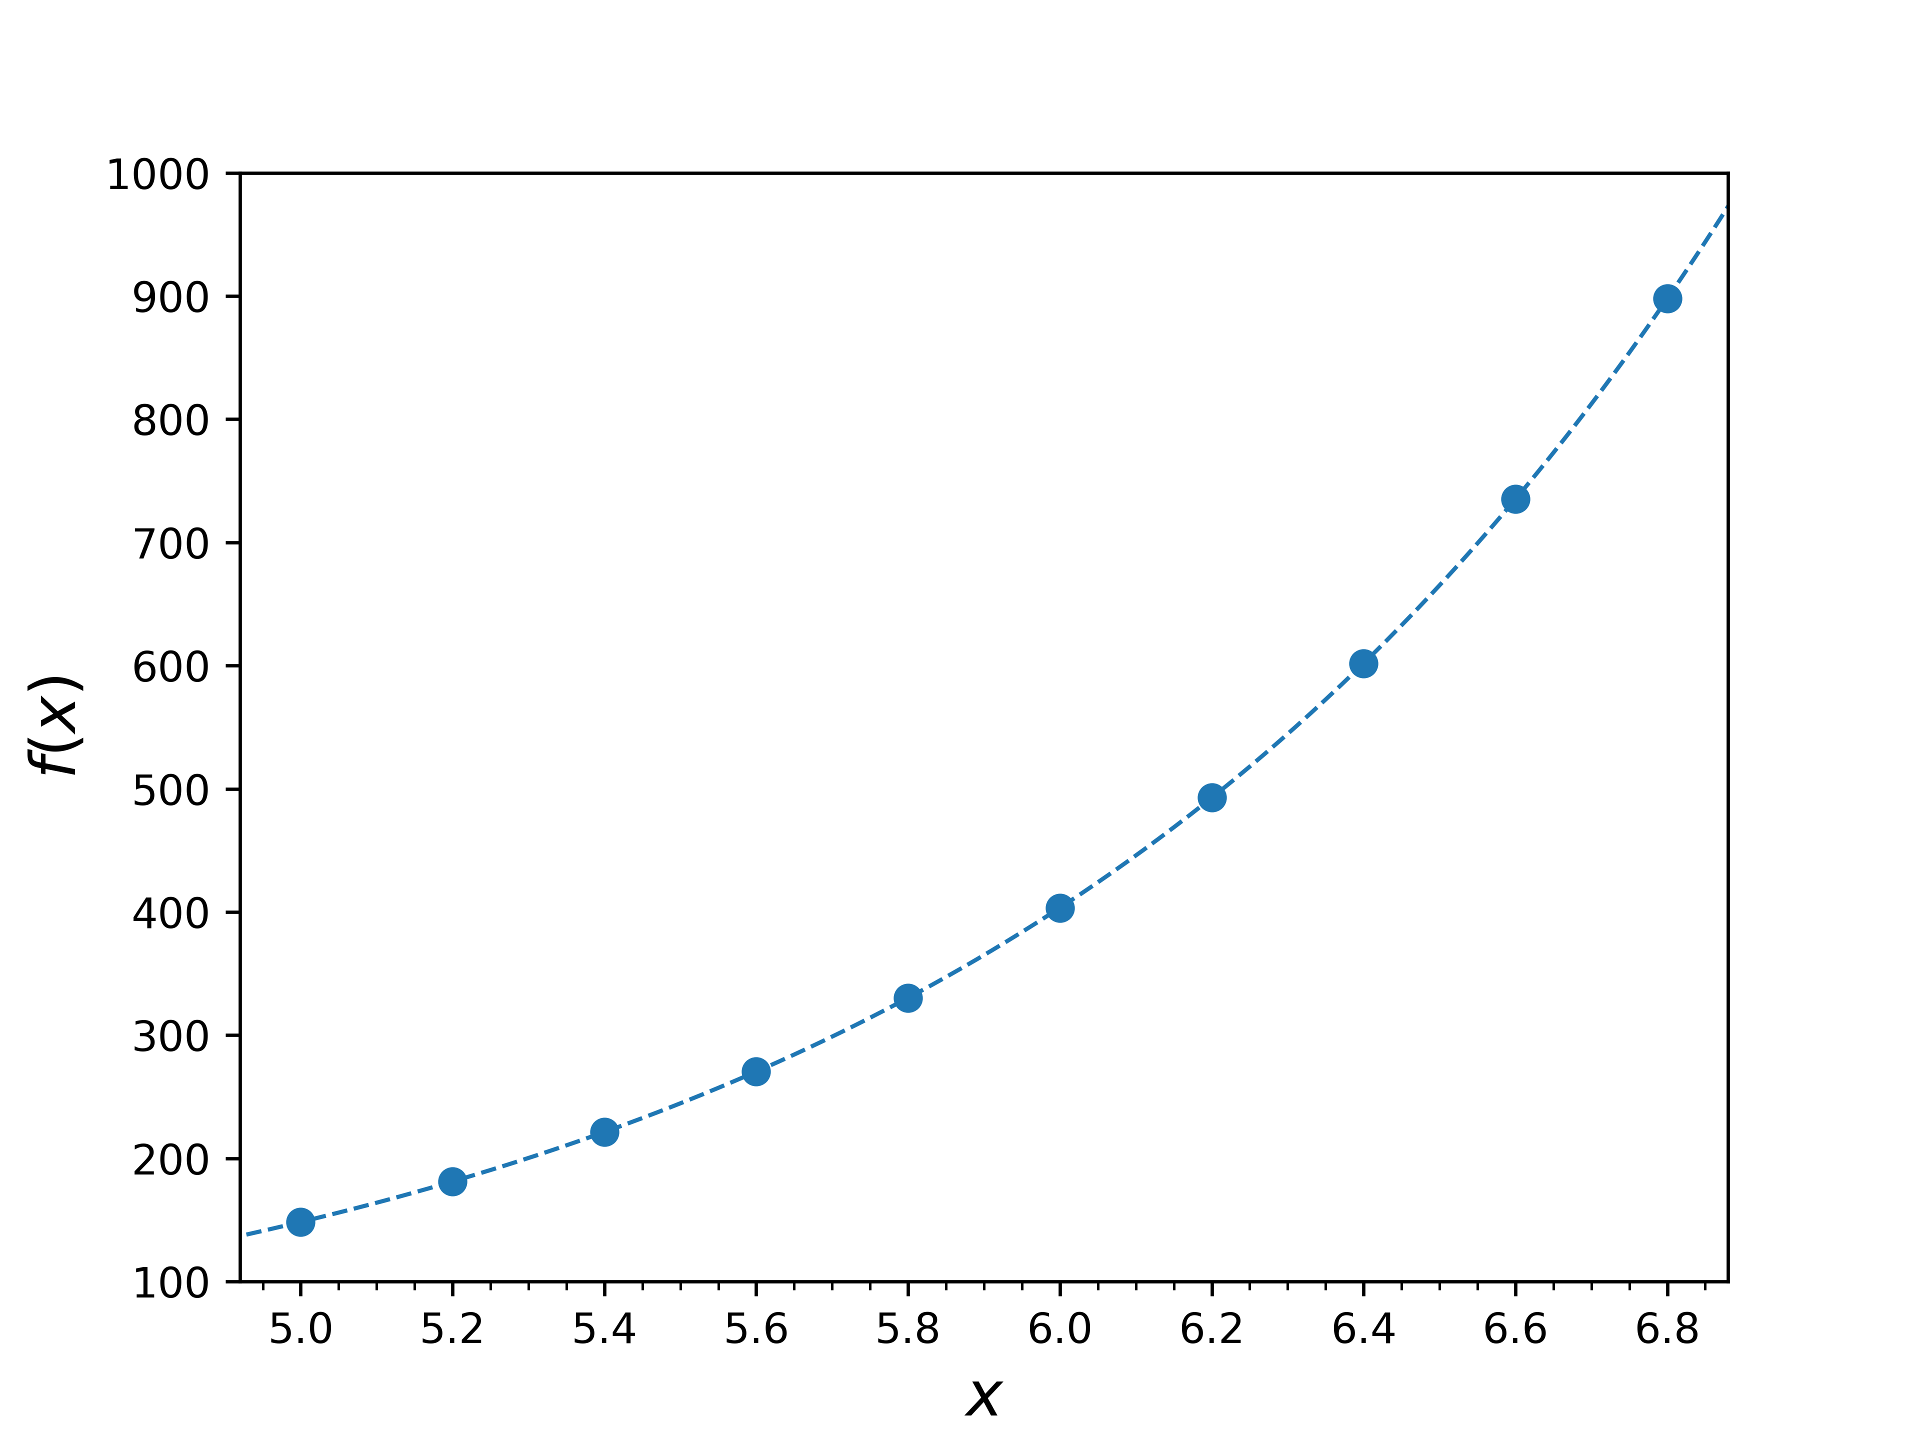Figure 1: Caption

Code 1: Caption
import math
import matplotlib.pyplot as plt
from matplotlib.ticker import (MultipleLocator)
import numpy as np

### 1) Generate data
list_x = []
list_y = []
for i in np.arange(5, 7, 0.2):
x = i
y = math.exp(x)
list_x.append(x)
list_y.append(y)
print("%.2f,%.6f" %(x, y))
list_x = np.array(list_x).reshape(-1, 1)
list_y = np.array(list_y)
basic_x = np.arange(4.9, 7.0, 0.01)
basic_y = [math.exp(x) for x in basic_x]
# Plot graph
plt.plot(basic_x,basic_y,color='C0',linestyle='dashed',linewidth=1)
plt.scatter(list_x, list_y,color='C0')
plt.xlabel('$x$',fontsize=15)
plt.ylabel('$f(x)$',fontsize=15)
plt.xticks(np.arange(5,7,0.2))
plt.xlim(4.92,6.88)
plt.ylim(100,1000)
axes = plt.gca()
axes.xaxis.set_minor_locator(MultipleLocator(0.05))
# Save plot into png
file_name='Fig1.png'
plt.savefig(file_name,format='png',dpi=600)
plt.close()

With k-NN regression, the y value at any given x configuration is given as an average of nearby neighbours. When using k-NN regression, one has to make two main considerations:

- How many near-neighbours are considered.
- How the average of the neighbours is calculated.

Cross-validation to optimize k
Regarding the first of these points, a simple method to select the optimum number of k nearest neighbours to make accurate predictions is to use a grid search. A grid search involves trying different k values and finally choosing the one that minimizes the prediction error. As with any machine learning model, one is faced with the task of how to select the data that will be used to train the model and the data that will be used to test the model accuracy.

Since we have a small amount of data here (only N=10 data points), we will use the leave-one-out (LOO) cross-validation (for more complex datasets, one may opt for a k-fold cross-validation). For a dataset with N samples, one trains the machine learning model with N-1 points, and uses the remaining point as a test. This procedure is repeated N times, so each point is used exactly once as a test (see Figure 2). As a result, one ends with a predicted value for each point. Then, the predicted value of each point is compared with its actual value. As an error metric, we have used the root mean square error (rmse). Finally, we can compare the (rmse) obtained for different k values, and select as an optimum k value the one that minimizes the rmse. The code implementing this grid search is shown in Code 3, and the resulting output is shown in Figure 3.

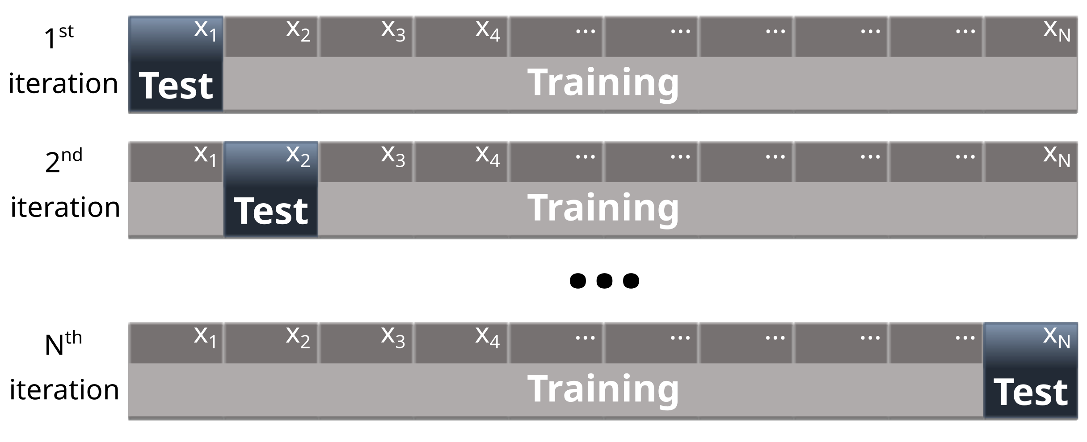
Figure 2: Caption

Figure 3: Caption
k: 1, RMSE: 95.55
k: 2, RMSE: 74.87
k: 3, RMSE: 105.13
k: 4, RMSE: 122.74
k: 5, RMSE: 152.07
k: 6, RMSE: 173.34
k: 7, RMSE: 202.04
k: 8, RMSE: 230.51
k: 9, RMSE: 264.38
Optimum: kNN, k=2, RMSE: 74.87

Code 2: Caption
import math
import matplotlib.pyplot as plt
import numpy s np
from sklearn import preprocessing
from sklearn.model_selection import LeaveOneOut
from sklearn.metrics import mean_squared_error
from sklearn import neighbors
from matplotlib.ticker import (MultipleLocator)

### 1) Generate data
list_x = []
list_y = []
for i in np.arange(5, 7, 0.2):
x = i
y = math.exp(x)
list_x.append(x)
list_y.append(y)
list_x = np.array(list_x).reshape(-1, 1)
list_y = np.array(list_y)
basic_x = np.arange(4.9, 7.0, 0.01)
basic_y = [math.exp(x) for x in basic_x]
### 2) Leave one out
best_rmse = 0
best_k = 0
possible_k = [1,2,3,4,5,6,7,8,9]
for k in possible_k:
y_pred = []
x_pred = []
X = np.array(list_x).reshape(-1, 1)
validation=LeaveOneOut().split(X)
for train_index, test_index in validation:
X_train, X_test = list_x[train_index], list_x[test_index]
y_train, y_test = list_y[train_index], list_y[test_index]
# scale data
scaler = preprocessing.StandardScaler().fit(X_train)
X_train_scaled = scaler.transform(X_train)
X_test_scaled = scaler.transform(X_test)
knn = neighbors.KNeighborsRegressor(n_neighbors=k, weights='uniform')
pred = knn.fit(X_train_scaled, y_train).predict(X_test_scaled)
y_pred.append(pred)
x_pred.append(X_test)
mse = mean_squared_error(y_pred,list_y)
rmse = np.sqrt(mse)
print('k: %i, RMSE: %.2f' %(k, rmse))
if rmse < best_rmse or k==possible_k[0]:
best_rmse = rmse
best_k = k
print("Optimum: kNN, k=%i, RMSE: %.2f" %(best_k,best_rmse))

We can use this optimum case, with k=2, to visualize how the k-NN regression algorithm is working. In Figure 4, we show how, when trying to predict the value of y₁, the predicted value for y’₁ is calculated as the average of its nearest neighbours, y₂ and y₃; y’₂ is predicted as the average of its two nearest neighbours, y₁ and y₃ and so on.

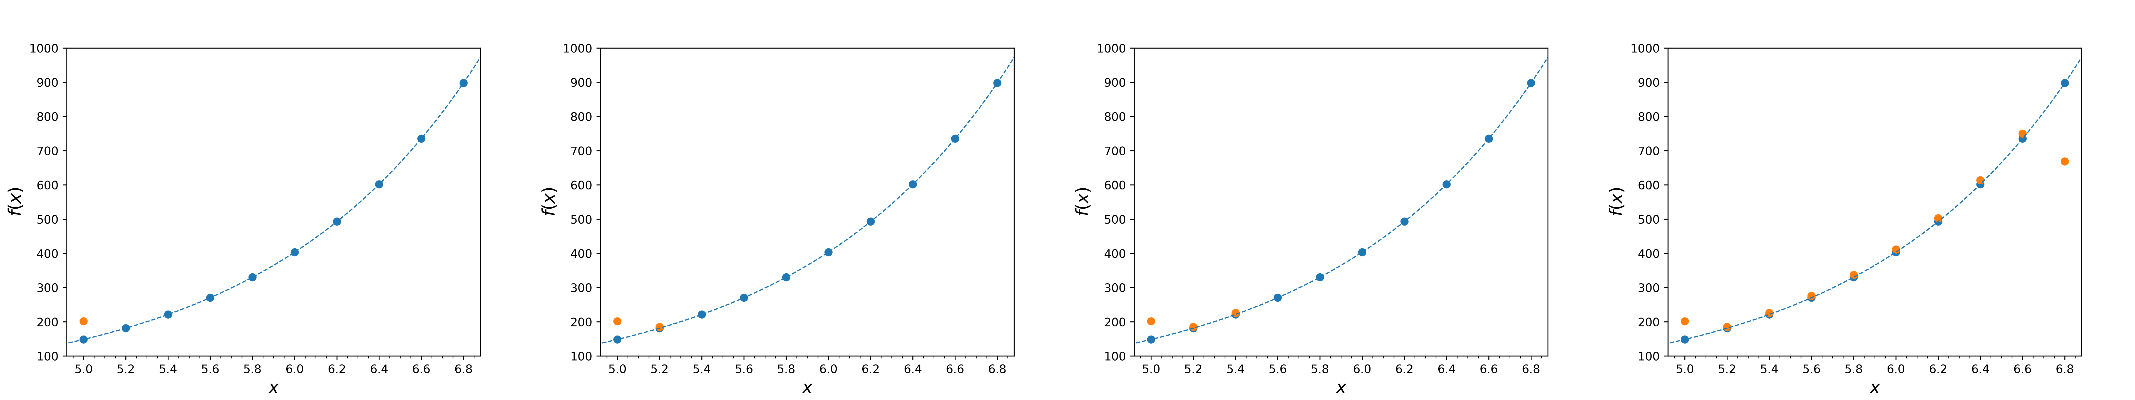Figure 4: Caption
In Figure 4, one can see how the predicted values behave reasonably well for the whole range, except on the extremes. This is because the prediction at the extremes will be biased due to the knowledge along the interval, i.e. there is only neighbours to one side of the extreme. There is also an additional issue that can't be observed in the previous Figure, since our x values are equidistant. We can for example train the model with all our ten points, and make predictions for all values inside the studied range. The code to make all these predictions is shown in Code 3, and the results are shown in Figure 5.

import math
import matplotlib.pyplot as plt
import numpy as np
from sklearn import preprocessing
from sklearn.model_selection import LeaveOneOut
from sklearn.metrics import mean_squared_error
from sklearn import neighbors
from matplotlib.ticker import (MultipleLocator)
### 1) Generate data
list_x = []
list_y = []
for i in np.arange(5, 7, 0.2):
x = i
y = math.exp(x)
list_x.append(x)
list_y.append(y)
list_x = np.array(list_x).reshape(-1, 1)
list_y = np.array(list_y)
basic_x = np.arange(4.9, 7.0, 0.01)
basic_y = [math.exp(x) for x in basic_x]
best_k = 2
### 3) Do kNN regression
X_train = np.array(list_x).reshape(-1, 1)
y_train = np.array(list_y)
X_test = np.arange(5.0, 6.81, 0.01).reshape(-1, 1)
# scale data
scaler = preprocessing.StandardScaler().fit(X_train)
X_train_scaled = scaler.transform(X_train)
X_test_scaled = scaler.transform(X_test)
knn = neighbors.KNeighborsRegressor(n_neighbors=best_k, weights='uniform')
file_name='Fig3_1.png'
label_kNN = "k-NN regression (uniform)"
# kNN regression
y_test = knn.fit(X_train_scaled, y_train).predict(X_test_scaled)
# Plot graph
plt.plot(basic_x,basic_y,color='C0',linestyle='dashed',linewidth=1)
plt.scatter(list_x, list_y,color='C0',label='$x_n$')
plt.plot(X_test, y_test,color='C1',label=label_kNN)
plt.legend()
plt.xlabel('$x$',fontsize=15)
plt.ylabel('$f(x)$',fontsize=15)
plt.xticks(np.arange(5,7,0.2))
plt.xlim(4.92,6.88)
plt.ylim(100,1000)
axes = plt.gca()
axes.xaxis.set_minor_locator(MultipleLocator(0.05))
# Save plot into png
plt.savefig(file_name,format='png',dpi=600)
plt.close()

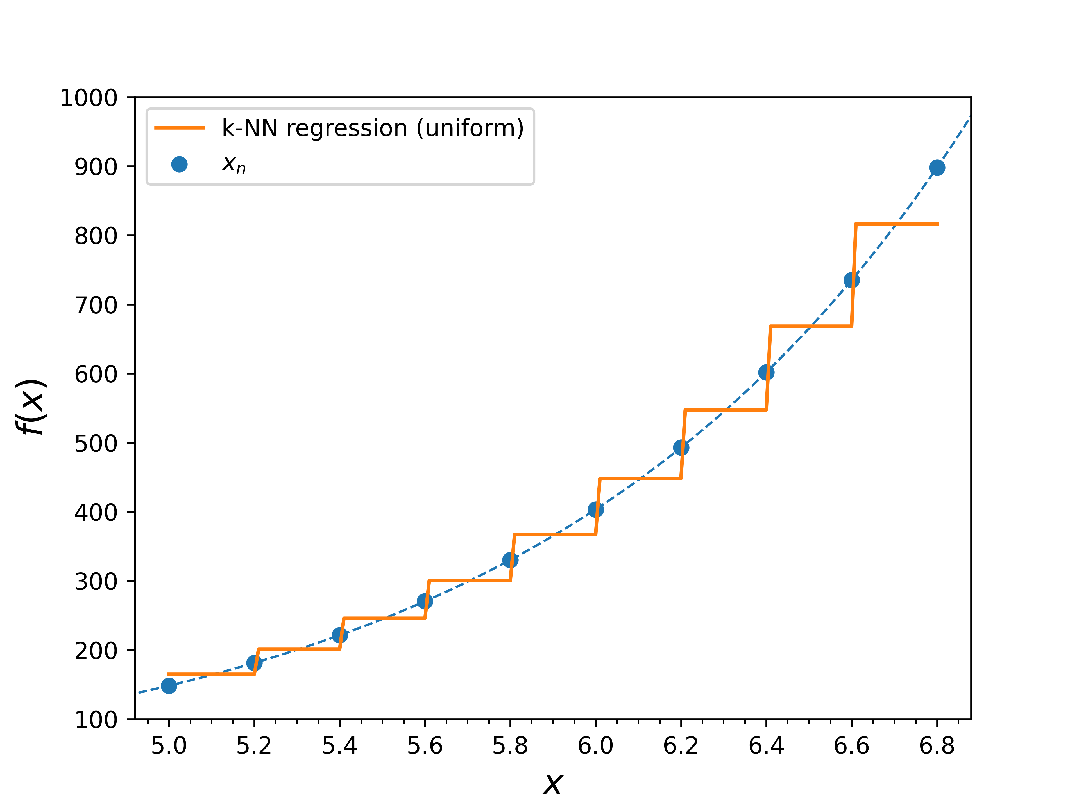Figure 5: Caption
In Figure 5 we can see how the predicted values in between the training points x_{n} is constant, and it corresponds exactly to the average of the k nearest neighbours. This means that all k nearest neighbours have the same weight, which we specified with weights='uniform' (default option in scikit-learn’s k-NN regressor). However, one can clearly see how, in a case like this, it would be more accurate to give a larger weight to the neighbours that are closer.

Different weights for nearest neighbours
When using k-NN regression, one has to select a sensible weight function. In our case, one can see how it would be better to give a larger weight to points that are closer. This can achieved by simply using the weights='distance' options, that calculates weights as the inverse of the distance between the studied i^{th} point and the neighbour n in the training set:

where d_{n} corresponds to the Euclidean distance between x_{i} and x_{n}. Note that one could use any other non-Euclidean metric, which might be more beneficial in other specific cases. I plan on writing another post about how to use user-defined metrics soon.

The result of using these new weights is shown in Figure 6 and we can observe how it behaves much better for the whole studied range.
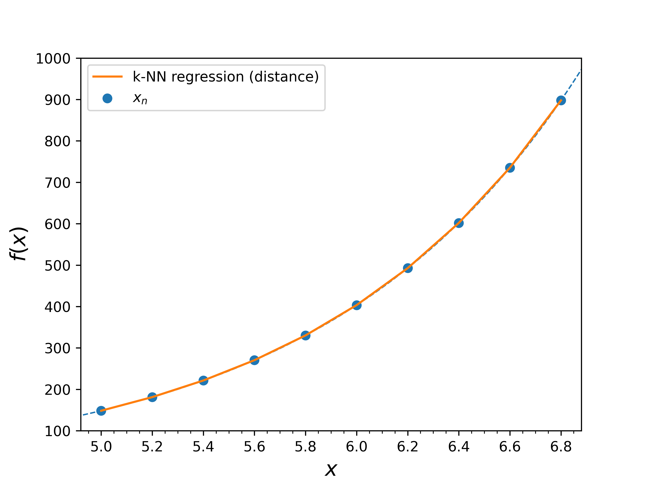Figure 6: Caption

Limitations of k-NN regression
The example that we have seen here is extremely simple, and can be seen in Figure 6 how k-NN is able to make very accurate predictions within the studied range. However, one should note that even with such a simple algorithm as k-NN, one can make very accurate predictions (similar to much more sophisticated regression algorithms) in real cases in different branches of science.

However, it is worth mentioning a type of problem where k-NN performs particularly bad. This problematic task is extrapolation (i.e. predicting values that are outside the range of the training set). In general, this kind of extrapolation task is a challenge for all ML algorithms, but k-NN does particularly bad, since it purely relies in the information of neighbours in the training set, but there are no training points in that region.

We show in Figure 7 how k-NN regression (with different weights) performs for some regions outside of the training range. We can see how k-NN completely fails to predict the exponential behaviour expected outside the training range and it simply returns the weighted average value of the two nearest neighbours. The code used to generate Figure 7 is provided in Code 4.

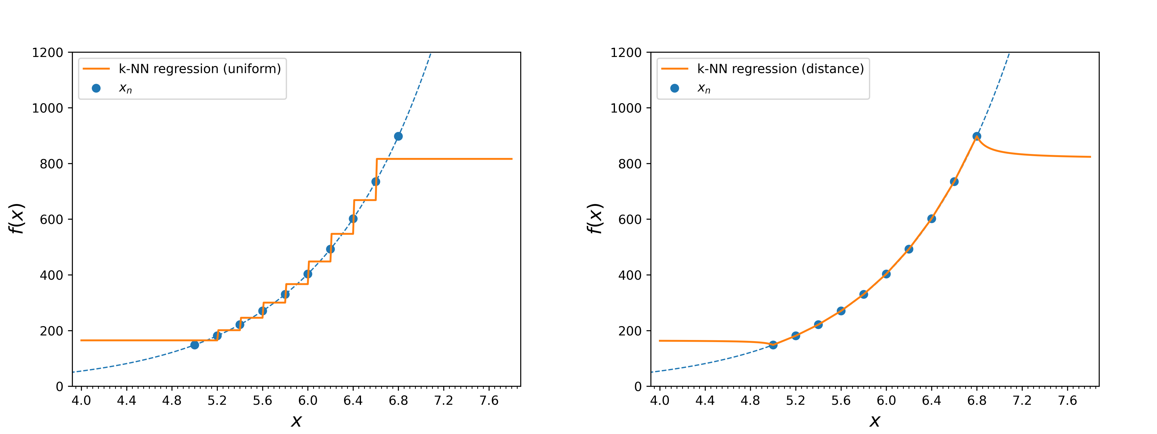Figure 7: Caption

import math
import matplotlib.pyplot as plt
import numpy as np
from sklearn import preprocessing
from sklearn.model_selection import LeaveOneOut
from sklearn.metrics import mean_squared_error
from sklearn import neighbors
from matplotlib.ticker import (MultipleLocator)

### 1) Generate data
list_x = []
list_y = []
for i in np.arange(5, 7, 0.2):
x = i
y = math.exp(x)
list_x.append(x)
list_y.append(y)
list_x = np.array(list_x).reshape(-1, 1)
list_y = np.array(list_y)
basic_x = np.arange(3.9, 8.0, 0.01)
basic_y = [math.exp(x) for x in basic_x]

best_k = 2

### 4) Do kNN regression extrapolation
X_train = np.array(list_x).reshape(-1, 1)
y_train = np.array(list_y)
X_test = np.arange(4.0, 7.81, 0.01).reshape(-1, 1)
# scale data
scaler = preprocessing.StandardScaler().fit(X_train)
X_train_scaled = scaler.transform(X_train)
X_test_scaled = scaler.transform(X_test)
################################################################################
############# UNIFORM #############
#knn = neighbors.KNeighborsRegressor(n_neighbors=best_k, weights='uniform')
#file_name='Fig4_1.png'
#label_kNN = "k-NN regression (uniform)"
############# DISTANCE #############
knn = neighbors.KNeighborsRegressor(n_neighbors=best_k, weights='distance')
file_name='Fig4_2.png'
label_kNN = "k-NN regression (distance)"
################################################################################
# kNN regression
y_test = knn.fit(X_train_scaled, y_train).predict(X_test_scaled)
# Plot graph
plt.plot(basic_x,basic_y,color='C0',linestyle='dashed',linewidth=1)
plt.scatter(list_x, list_y,color='C0',label='$x_n$')
plt.plot(X_test, y_test,color='C1',label=label_kNN)
plt.legend()
plt.xlabel('$x$',fontsize=15)
plt.ylabel('$f(x)$',fontsize=15)
plt.xticks(np.arange(4,8,0.4))
plt.xlim(3.92,7.88)
plt.ylim(0,1200)
axes = plt.gca()
axes.xaxis.set_minor_locator(MultipleLocator(0.05))
# Save plot into png
plt.savefig(file_name,format='png',dpi=600)
plt.close()

References
R1. https://scikit-learn.org/stable/index.html
R2. https://towardsdatascience.com/knn-k-nearest-neighbors-1-a4707b24bd1d
R3. https://towardsdatascience.com/k-nearest-neighbors-knn-algorithm-bd375d14eec7
R4. https://scikit-learn.org/stable/modules/generated/sklearn.neighbors.KNeighborsRegressor.html

