Infyom:

https://infyom.com/open-source/laravelgenerator/docs/9.0/installation

instalar laravel versión 9

Laravel now requires PHP 8.0.2 or greater

composer create-project laravel/laravel infyom02 "9.0"

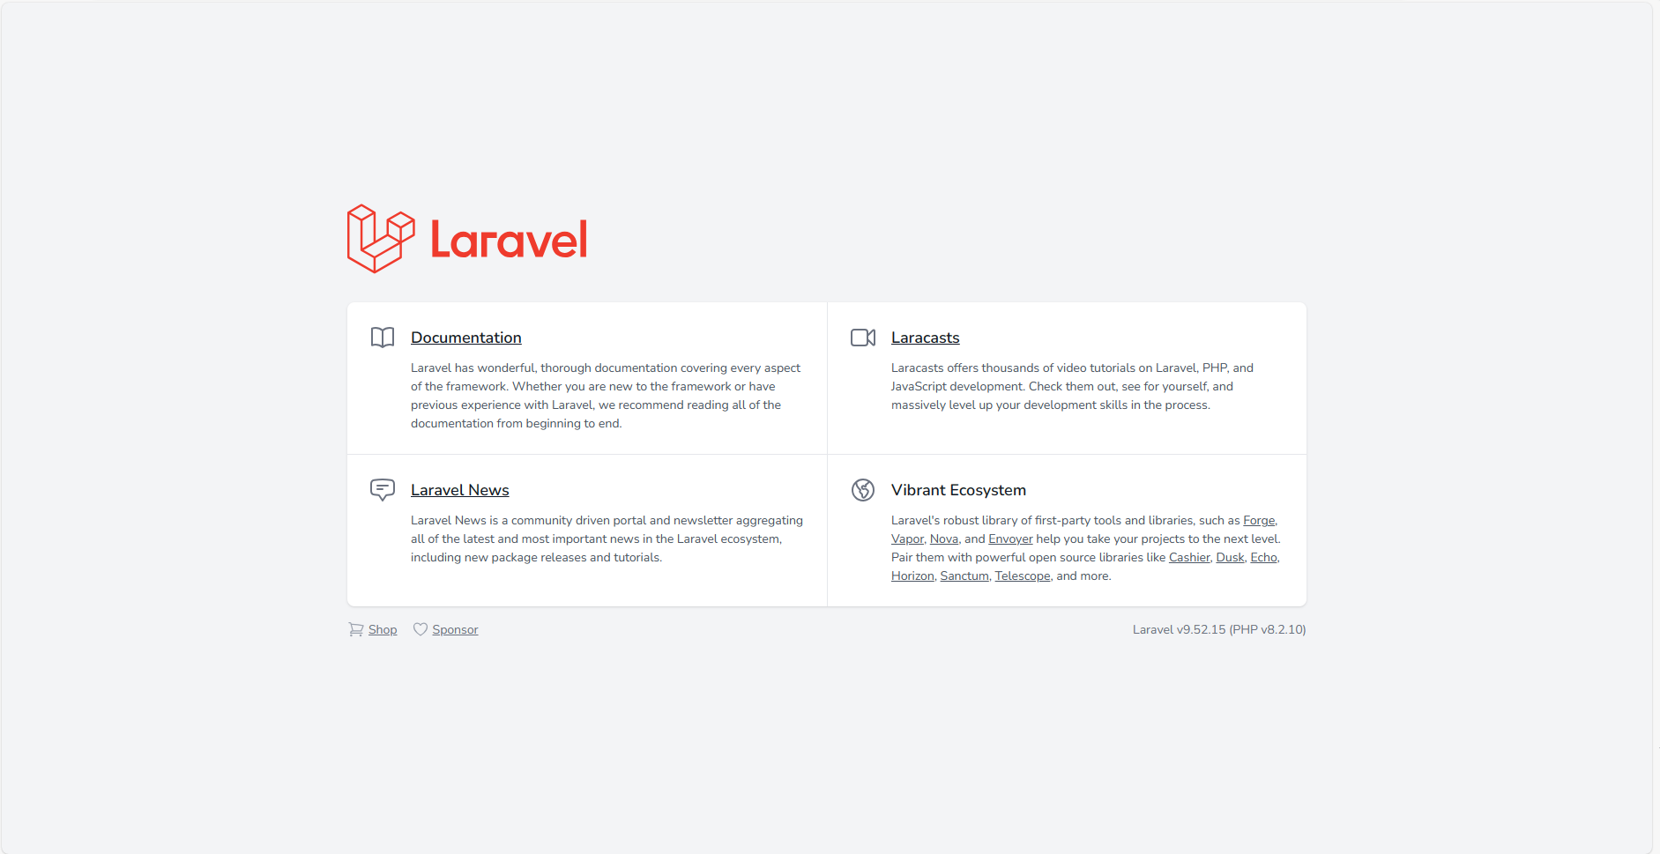

composer.json:

"require": {

"infyomlabs/laravel-generator": "^5.0",

"infyomlabs/adminlte-templates": "^5.0",

"doctrine/dbal": "~2.3"

}

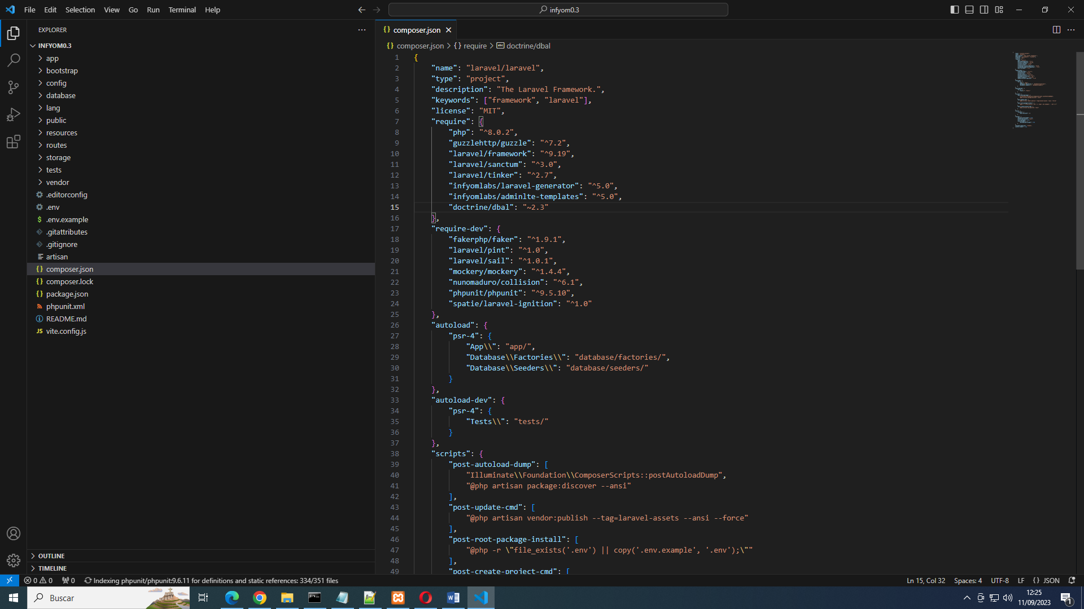

composer update

PUBLICAR FICHERO CONFIGURACIÓN:

php artisan vendor:publish --provider="InfyOm\Generator\InfyOmGeneratorServiceProvider"

Publicar instalación

php artisan infyom:publish

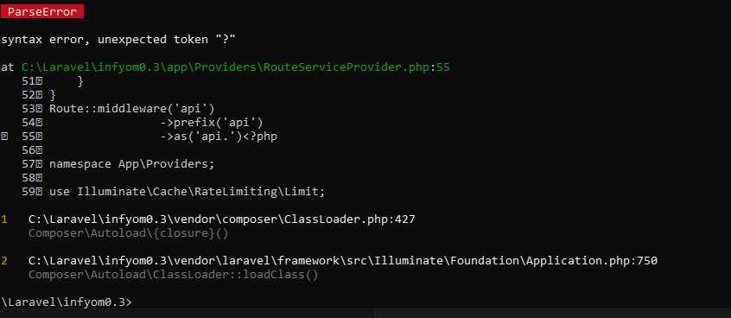

Clase corregida:

<?php

namespace App\Providers;

use Illuminate\Cache\RateLimiting\Limit;

use Illuminate\Foundation\Support\Providers\RouteServiceProvider as ServiceProvider;

use Illuminate\Http\Request;

use Illuminate\Support\Facades\RateLimiter;

use Illuminate\Support\Facades\Route;

class RouteServiceProvider extends ServiceProvider

{

    /**

     * The path to the "home" route for your application.

     *

     * Typically, users are redirected here after authentication.

     *

     * @var string

     */

    public const HOME = '/home';

    /**

     * Define your route model bindings, pattern filters, and other route configuration.

     *

     * @return void

     */

    public function boot()

    {

        $this->configureRateLimiting();

        $this->routes(function () {

            Route::middleware('api')

                ->prefix('api')

                ->group(base_path('routes/api.php'))

                ->as('api.');

            Route::middleware('web')

                ->group(base_path('routes/web.php'));

        });

    }

    /**

     * Configure the rate limiters for the application.

     *

     * @return void

     */

    protected function configureRateLimiting()

    {

        RateLimiter::for('api', function (Request $request) {

            return Limit::perMinute(60)->by($request->user()?->id ?: $request->ip());

        });

    }

}

Run the following command to create basic scaffolding from it.

composer require infyomlabs/laravel-ui-adminlte

Then Generate a full authentication UI,

php artisan ui adminlte –auth

This will generate Auth Controllers and layout files along with authentication blade view files.

It uses the same configuration as per laravel/ui package for auth scaffold generation.

Instalar los cambios

npm install && npm run dev

generar modelos:

php artisan infyom:api_scaffold Pedido

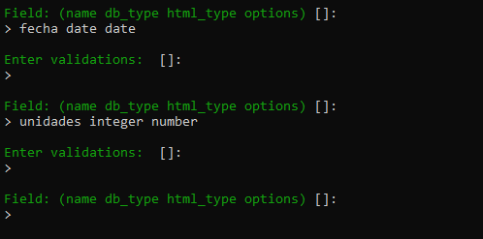

Fichero .env

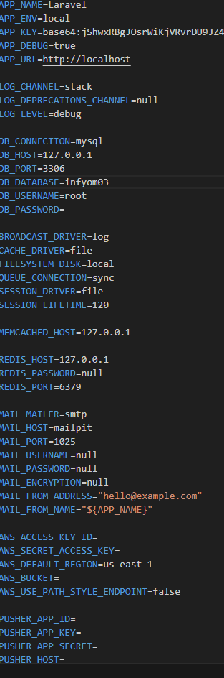

Migrar Base de datos.

php artisan migrate