**Requisitos y tecnologías**

[**https://laravel.com/docs/9.x**](https://laravel.com/docs/9.x)

**https://larainfo.com/blogs/how-to-use-material-dashboard-in-laravel-9?utm_content=cmp-true**

composer create-project laravel/laravel:^9.0 material-infyom-9

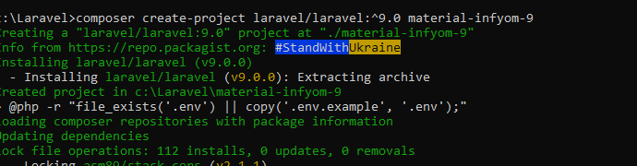

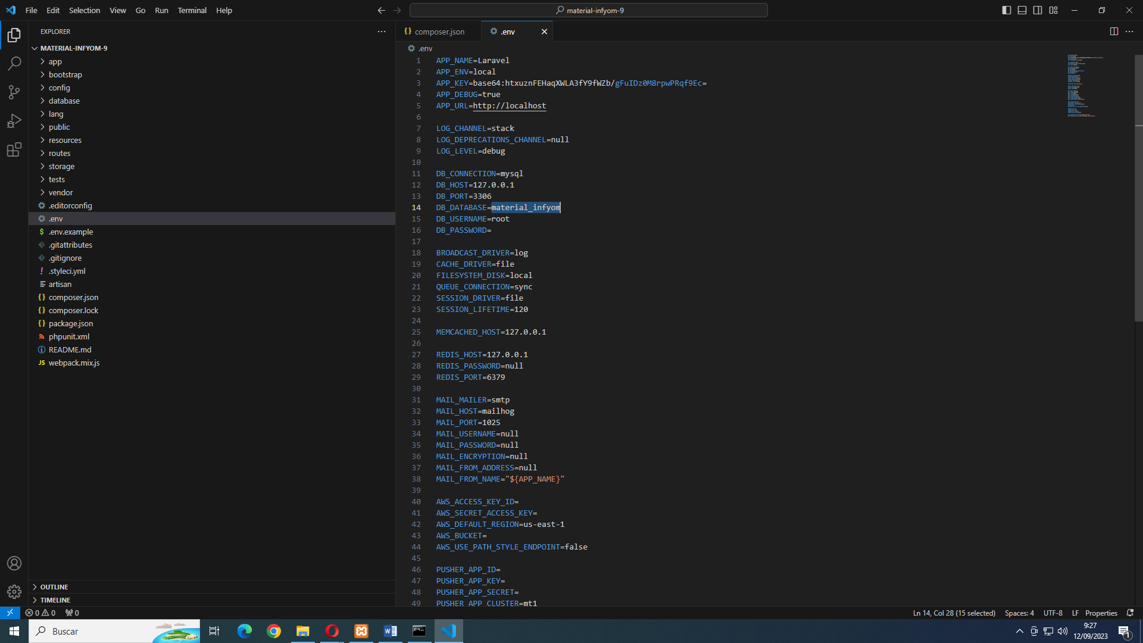

**Instalar laravel ui**

composer require laravel/ui

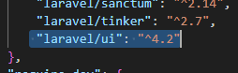

**Instalar plantillas material dashboard**

composer require laravel-frontend-presets/material-dashboard

**se instalan con el comando**

php artisan ui material

**borramos las entradas duplicadas de auth**

composer dump-autoload

**Ejecutamos la semilla.**

**Creamos la base de dato**

php artisan migrate:fresh --seed

**Modificar depencias**

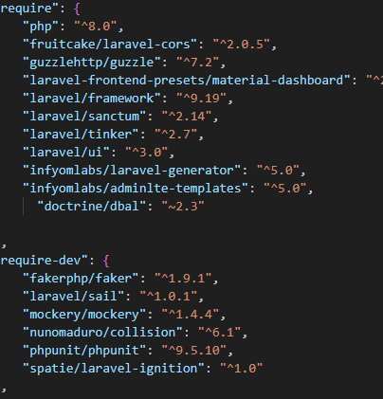

**Actualizar.**

**Composer update**

PUBLICAR FICHERO CONFIGURACIÓN:

php artisan vendor:publish --provider="InfyOm\Generator\InfyOmGeneratorServiceProvider"

Publicar instalación

php artisan infyom:publish

Clase corregida:

<?php

namespace App\Providers;

use Illuminate\Cache\RateLimiting\Limit;

use Illuminate\Foundation\Support\Providers\RouteServiceProvider as ServiceProvider;

use Illuminate\Http\Request;

use Illuminate\Support\Facades\RateLimiter;

use Illuminate\Support\Facades\Route;

class RouteServiceProvider extends ServiceProvider

{

    /**

     * The path to the "home" route for your application.

     *

     * Typically, users are redirected here after authentication.

     *

     * @var string

     */

    public const HOME = '/home';

    /**

     * Define your route model bindings, pattern filters, and other route configuration.

     *

     * @return void

     */

    public function boot()

    {

        $this->configureRateLimiting();

        $this->routes(function () {

            Route::middleware('api')

                ->prefix('api')

                ->group(base_path('routes/api.php'))

                ->as('api.');

            Route::middleware('web')

                ->group(base_path('routes/web.php'));

        });

    }

    /**

     * Configure the rate limiters for the application.

     *

     * @return void

     */

    protected function configureRateLimiting()

    {

        RateLimiter::for('api', function (Request $request) {

            return Limit::perMinute(60)->by($request->user()?->id ?: $request->ip());

        });

    }

}

Run the following command to create basic scaffolding from it.

composer require infyomlabs/laravel-ui-adminlte

Then Generate a full authentication UI,

php artisan ui adminlte –auth

**Update**

npm install && npm run dev