Predicting Driver Drowsiness Using Brain Wave Data

Project Link : https://xcelerator.ninja/myQuests/188730/myProjects/23421

Dataset : <https://www.kaggle.com/datasets/naddamuhhamed/sleepy-driver-eeg-brainwave-data>

Problem statement : Analyze the relation between different brain waves and sleepiness to understand which factors are most predictive of driver drowsiness.

Team : [ATHARV VADEHRA](mailto:atharv.v@atriauniversity.edu.in), [LAKSHAY KUMAR](mailto:lakshay.k@atriauniversity.edu.in), [SHYAM SINDHIA](mailto:shyam.s@atriauniversity.edu.in)

1. Features :

| Wave Name | When They Are High | When They Are Low |
| --- | --- | --- |
| Attention | High values indicate high mental focus or concentration. | Low values indicate poor focus or distraction. |
| Meditation | High values indicate high levels of relaxation or calmness. | Low values indicate stress or agitation.s |
| Delta (1-3 Hz) | High values are prominent during deep sleep and restorative states. | Low values are seen during awake states and light sleep. |
| Theta (4-7 Hz) | High values are associated with light sleep, drowsiness, and meditative states. | Low values are seen during alert, wakeful states. |
| Low Alpha (8-11 Hz) | High values indicate a relaxed but alert state, often seen with eyes closed. | Low values are seen during active mental engagement or stress. |
| High Alpha (8-11 Hz) | High values indicate deep relaxation and calmness. | Low values are observed during active cognitive tasks or stress. |
| Low Beta (12-29 Hz) | High values are associated with active thinking, problem-solving, and alertness. | Low values are seen during relaxation or passive states. |
| High Beta (12-29 Hz) | High values indicate high alertness, stress, and intense mental activity. | Low values are observed during relaxation or low engagement. |
| Low Gamma (30-100 Hz) | High values reflect heightened cognitive processing and complex mental tasks. | Low values are seen during low cognitive demand or relaxation. |
| High Gamma (30-100 Hz) | High values indicate advanced cognitive functions, perception, and high focus. | Low values are observed during states of reduced cognitive activity or relaxation. |

1. **Correlation**

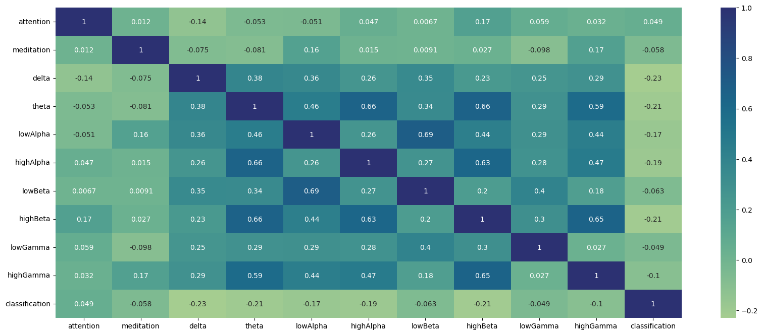

Insights:

* Delta waves show a negative correlation (-0.23), indicating higher values are associated with lower drowsiness likelihood, aligning with their presence in deep sleep.
* Theta and High Beta waves exhibit moderate negative correlations (-0.21), suggesting higher values also indicate lower drowsiness likelihood.
* Low Alpha and Low Beta features have weaker correlations, implying minimal impact on drowsiness prediction.

Brainwave Interactions:

* Theta waves strongly correlate with Low Alpha (0.66), High Alpha (0.66), and High Beta (0.66), indicating concurrent increases, likely reflecting transitional states between wakefulness and drowsiness.

High Gamma waves positively correlate with High Beta (0.65) and Theta (0.59), highlighting their role in cognitive processing and alertness.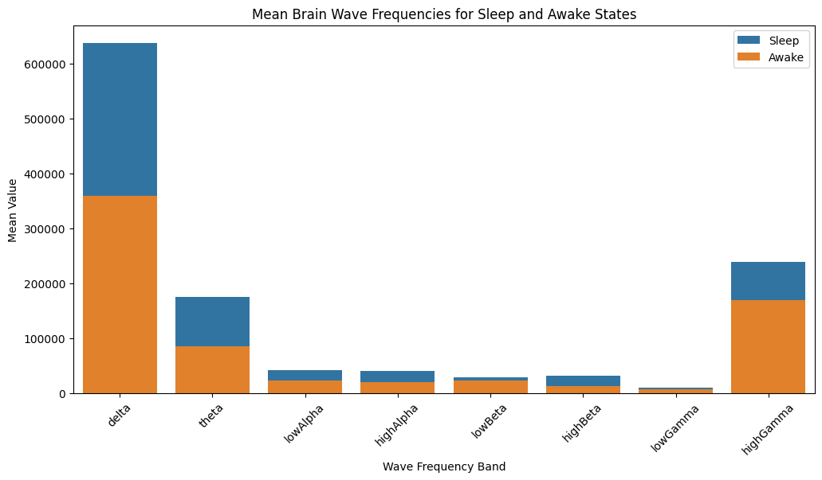

The brain's neural oscillations can be grouped into distinct frequency bands, each corresponding to specific states of consciousness, cognitive processes, and functional roles.

* Delta Waves (1-3 Hz): The Restoration Band

High-amplitude, low-frequency delta waves dominate during deep sleep, unconsciousness, and restorative states, facilitating rejuvenation and recovery.

* Theta Waves (4-7 Hz): The Transition Zone

Theta waves emerge during light sleep, drowsiness, and meditative states, serving as a bridge between sleep and wakefulness, and enabling the brain to transition smoothly between states.

Alpha Waves (8-11 Hz): The Relaxation Spectrum

Alpha waves comprise two sub-bands:

* Low Alpha (8-10 Hz): The Calm Focus - Associated with relaxed yet alert states, closed eyes, and decreased cortical activity, promoting a sense of calm focus.
* High Alpha (10-11 Hz): The Serene State - Reflecting deep relaxation, calmness, and reduced cortical activity, ideal for unwinding and recharging.

Beta Waves (12-29 Hz): The Engagement Band

Beta waves encompass two sub-bands:

* Low Beta (12-15 Hz): The Active Mind - Linked to active thinking, problem-solving, and alertness, facilitating mental clarity and focus.
* High Beta (15-29 Hz): The Intense Focus - Characterized by high alertness, stress, and intense mental activity, driving concentrated mental effort.

Gamma Waves (30-100 Hz): The Integration Zone

* High-frequency gamma waves facilitate advanced cognitive processing, sensory integration, and information synthesis, enabling the brain to assimilate and process complex information.

**Logistic Regression**

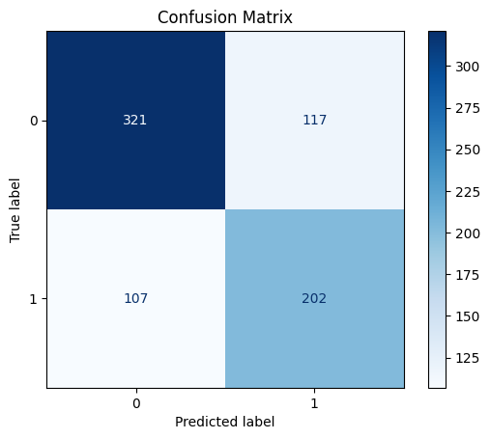

Correct Predictions : 0.70013

Logistic Regression achieved 70.01% accuracy in predicting driver drowsiness from brainwave data, indicating that brainwave patterns like Theta and Delta are useful indicators. However, its simplicity assumes a linear relationship between features and output, which may not be accurate for this problem.

Limitations:

* Assumes linear relationship between brainwaves and drowsiness
* Fails to capture intricate patterns in data

Non-Linear Models:

* Outperform Logistic Regression in predicting driver drowsiness
* Capture complex relationships between brainwaves and drowsiness

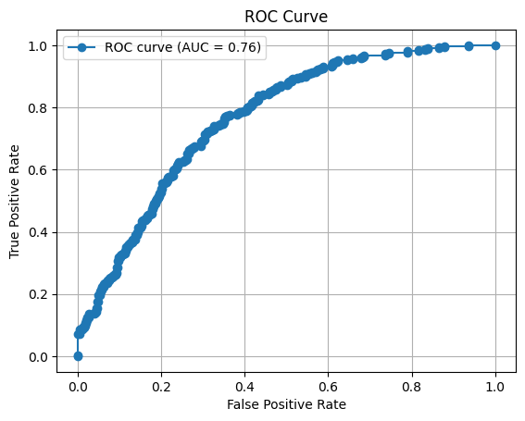

the classification model's effectiveness in predicting driver drowsiness by plotting **True Positive Rate** **(TPR)** against **False Positive Rate (FPR)**. the key components:

**True Positive Rate (Y-axis):**

Measures the model's ability to accurately detect drowsy drivers, showcasing its sensitivity.

**False Positive Rate (X-axis): The Error Rate**

Represents the proportion of non-drowsy drivers misclassified as drowsy, highlighting potential false alarms.

**Area Under the Curve (AUC = 0.76): Discriminatory Power Revealed**

With an AUC of 0.76, the model demonstrates a fairly strong ability to differentiate between drowsy and non-drowsy drivers, indicating:

**A perfect classifier would score 1.0**

**Random guessing would yield 0.5**

Our model has a 76% chance of correctly distinguishing between a randomly chosen drowsy driver and a non-drowsy driver

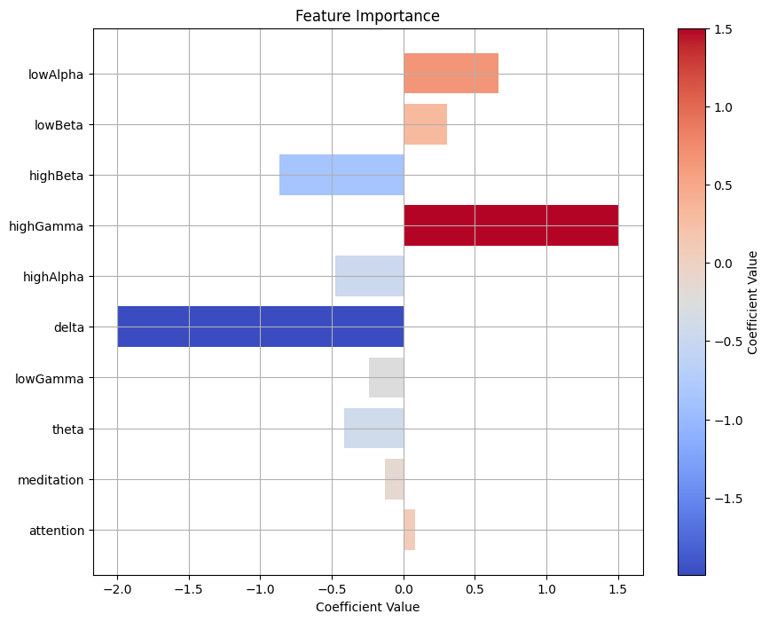

**Key Brainwave Features Influencing Drowsiness**

Our model reveals the significance of various brainwave features in predicting driver drowsiness, ranked by importance:

**Highly Influential Features**:

* High Gamma Waves: Strongly correlated with drowsiness, high gamma waves may indicate mental fatigue and cognitive overload, leading to drowsiness.
* Delta Waves: Show a significant inverse relationship with drowsiness, suggesting that low delta wave activity during wakefulness may indicate alertness.

**Moderately Influential Features:**

* High Beta Waves: Positively associated with drowsiness, high beta waves may reflect stress or intense mental engagement, leading to brief periods of alertness.
* High Alpha Waves: Contribute to predictions, but to a lesser extent, potentially indicating deep relaxation.

**Less Influential Features:**

* Low Alpha and Low Beta Waves: Moderate to small coefficients suggest a lesser impact on predictions.
* Theta, Low Gamma, and Attention: Minimal influence on drowsiness predictions.
* Meditation: Shows a negligible impact, indicating that relaxation levels do not strongly predict drowsiness in this dataset.

**Decision Tree Classifier**

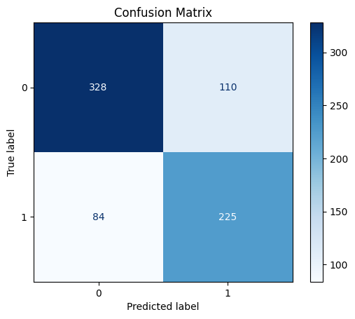

**Correct Predictions - 0.7402**

the performance of our Decision Tree Classifier, achieving an accuracy of 74.02%:

**True Negatives (TN) - 328**: Correctly predicted alert drivers, showcasing the model's ability to identify non-drowsy states.

**False Positives (FP) - 110**: Incorrectly predicted drowsy drivers, highlighting a moderate False Positive Rate and potential for false alarms.

**False Negatives (FN) - 84:** Missed drowsy drivers, indicating a relatively low False Negative Rate and strong performance in detecting drowsiness.

**True Positives (TP) - 225**: Correctly predicted drowsy drivers, demonstrating the model's strength in identifying drowsy states.

Performance Insights:

* More correct predictions (553) than incorrect ones (194)
* Moderate False Positive Rate, suggesting some false alarms
* Relatively low False Negative Rate, indicating strong drowsiness detection

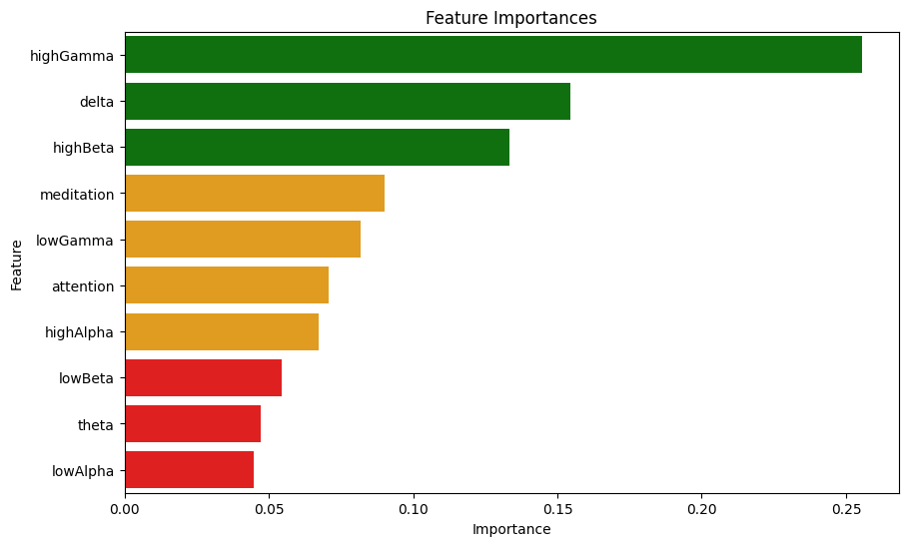

Random forest classifier

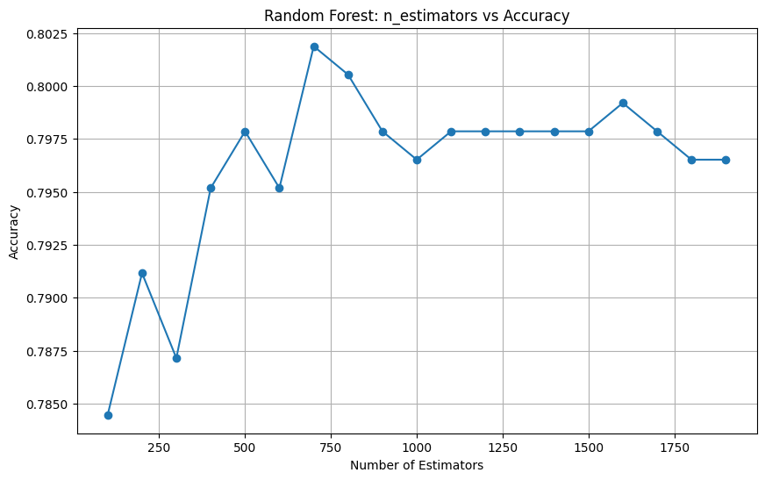

**Max Accuracy at 700 trees ~ 80.19%**  
The plot reveals:

* Peak accuracy of 80.19% achieved with approximately 700 trees
* 1No significant improvement beyond 700 trees, indicating an optimal point

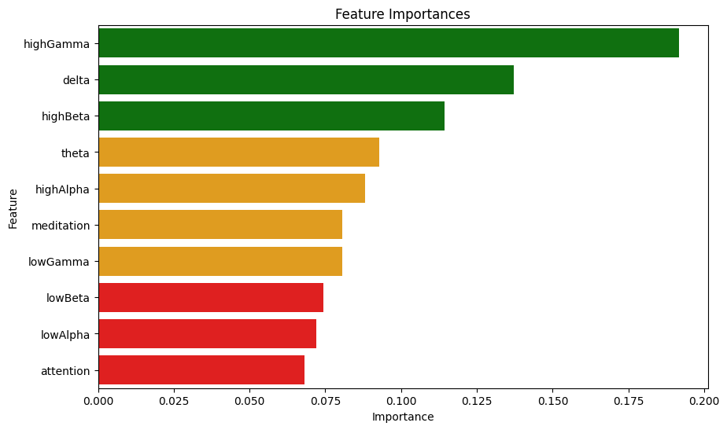

**Feature Importance (Random Forest Classifier)**

The Random Forest model reaffirms the importance of:

* High Gamma, Delta, and High Beta waves
* Theta, High Alpha, and Meditation, contributing less significantly
* Low Beta, Low Alpha, and Attention, having minimal impact

**Overall conclusion:**

Our analysis successfully used brainwave data and machine learning models to predict driver drowsiness, showing valuable insights:

**Key Findings:**

* High Gamma, Delta, and High Beta waves are the most crucial predictors of drowsiness, showing their role in cognitive processing, deep sleep, and alertness.
* Logistic Regression achieved 70% accuracy, while Decision Tree Classifier improved to 74%, showing complex relationships in the data.
* Random Forest Classifier succeeded with 80.19% accuracy, effectively capturing patterns in brainwaves.

**Validation:**

* The ROC curve (AUC = 0.76) confirms the model's ability to differentiate between drowsy and non-drowsy drivers.
* The confusion matrix highlights the model's strengths and weaknesses, with room for improvement.

**Real-World applications:**

Our research shows that predicting driver drowsiness using EEG brainwave data is possible, giving the way for:

* Integration into driver-monitoring systems to prevent accidents caused by drowsiness
* Further enhancements through feature refinement or exploration of advanced models

By leveraging machine learning and brainwave analysis, we can create safer roads and save lives.