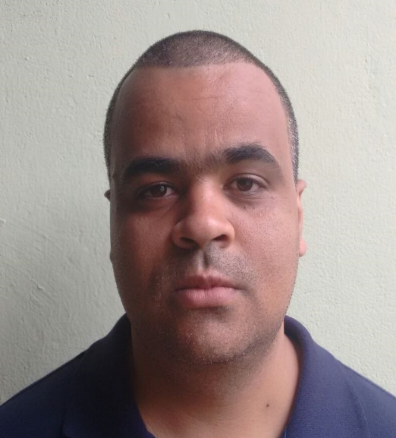

Marcos **Papa**

**Front-End free lancer**

## About me

Front-End developer graduated in Technology in Systems Analysis and Development by UNIFRAN. Technician in Business Management by SENAC-MG. I took several preparatory and professional improvement courses through UDEMY, ORIGAMID, CFB Cursos and Curso em Vídeo.

## ContACT

370 Domingos Vaz de Oliveira Street, Araxá, MG 38181-549, Brazil

+55 34 98884-7402

[marcos_papa@hotmail.com](mailto:marcos_papa@hotmail.com)

## Projects

**GHOSTBUSTERS** The project is a fictional service page of the company GHOSTBUSTER. It was created based on a layout provided by w3schools in order to practice and demonstrate my knowledge in HTML, CSS and JS. Can be accessed at: https://chipper-mooncake-77b378.netlify.app/

**NUBANK COPY** A copy of the NUBANK website. Responsive website created to demonstrate and practice my knowledge in the front-end area. It can be accessed at: https://marcosamanciopapa.github.io/nuCopy/

**Responsive Modal**  A modal that adapts to various screen types. Created to practice the concept of responsiveness. It can be accessed at: https://marcosamanciopapa.github.io/modalResponsivo/

## EDUCATION

**2016 - 2018** **Technology in System Analysis and Development**

Universidade de Franca

**2008 – 2010 Technician in Business Management**

SENAC-MG

## COURSES

**JavaScript from Beginner to Master**

UDEMY

**Complete web development course**

UDEMY

**HTML5, CSS and JavaScript in practice**

UDEMY

**Graphic Design and UI/UX**

UDEMY