Airline Ticket Reservation

Introduction

We’re being requested by a customer to create the Architecture and Design of an Airline Ticket Reservation and then implement it’s framework.

System Requirements

The requirements for our airline ticket reservation services include:
- User Management
  - Public users and air line staff users
- Social Login: Google+, Twitter, or LinkedIn
- Reservation Management
- Payment Management
- Flight Management
- Email Alerts
- API Based

From the high-level requirement services we’ll be able to identify detailed services in the following sections of this document.

Data Model

In this section we’ll see a high-level presentation of the data model.
Due the nature of the business we’ll be using a relational database to store the data of the entire system.

Data Model Overview
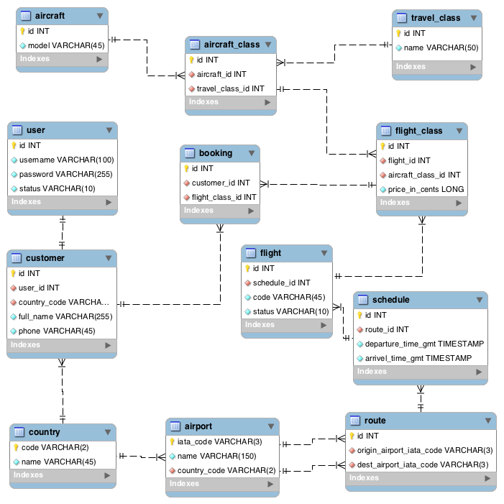

Entity Description

User
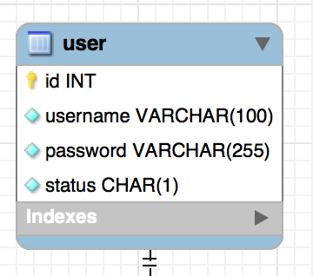

This entity will store the users data to authentication and also it’s own status, which can be a char of some of the following values:
- P – Pending
- B – Blocked
- A – Active
The attributes are id, username, password and status.

Country
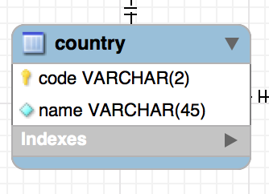

This entity will store the country data and it’s code will be the primary key.
The attributes are code and name.

Customer
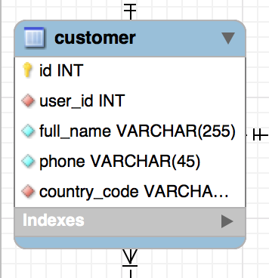

This entity will store the customer data of an user.
The attributes are id, user_id, full_name, phone, country_code.

Airport
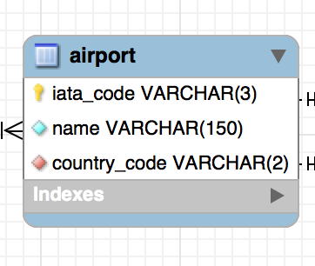
This entity will store the airport data and it’s country
The attributes are id, name and country_code.

Route
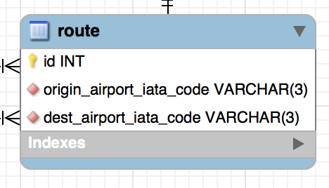

This entity will store the routes of the flight’s schedule making a link between two airports.
The attributes are id, origin_airport_iata_code and dest_airport_iata_code.

Schedule
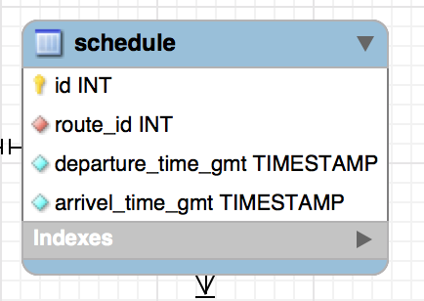

This entity will store the schedule for the flights making a like to the route.
The attributes are id, route_id, departure_time_gmt and arrivel_time_gmt.

Flight
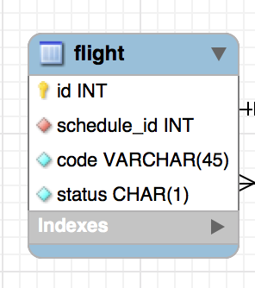

This entity will store the flight data making a link to schedule.
The attributes are id, schedule_id, code and status.

Aircraft
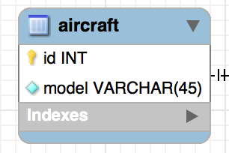

This entity will store the aircraft data.
The attributes are id and model.

Travel Class
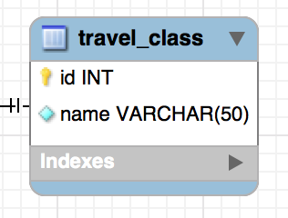

This entity will store the travel class data.
The attributes are id and name

Aircraft class
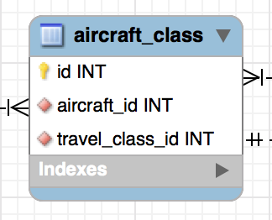
This entity will store the data of the class of an aircraft and a travel class.
The attributes are id, aircraft_id and travel_class_id.

Flight class
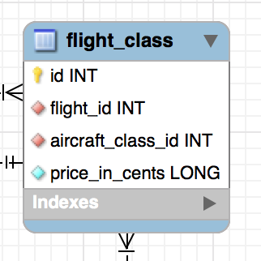

This entity will store the price of a class for given flight.
The attributes are id, flight_id, aircraft_class_id and price_in_cents.

Booking
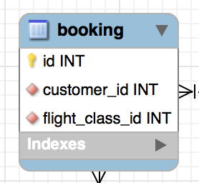

This entity will store the booking data for given customer and flight.
The attributes are id, customer_id and flight_class_id.

Architecture Blueprint

In this section we’ll cover a high-level architecture components.

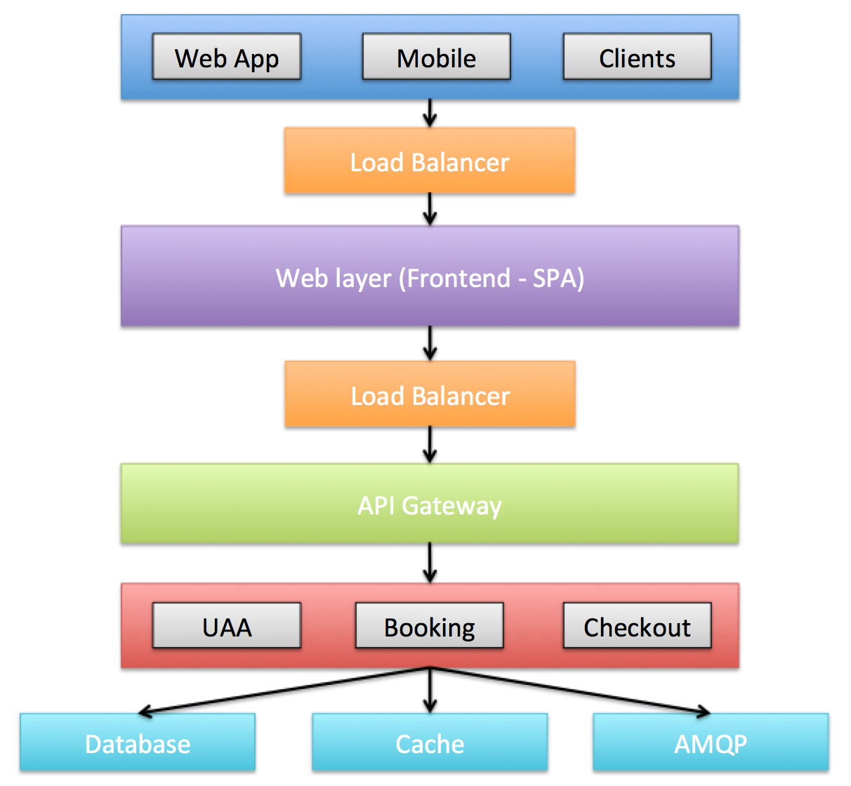

In this blue print we can find all layers of our airline ticket reservation marked by different colors.
- Dark Blue: Contains any of our clients that will be consuming our API to build it’s interface, it can be webapps, mobile or anyone possible to consume our API
- Orange: Represents a Load Balancer
- Purple: A cluster of our Single Page App
- Green: An API Gateway responsible to secure and route the requests to the proper service.
- Red: Backend layer containing all web services to build the system’s API.
- Light Blue: Any external dependency of our backend apps.

