CSS Architecture

What is CSS Architecture?

CSS architecture is a set of guidelines and best practices to help developers write code.

https://cheesecakelabs.com/br/blog/css-architecture-first-steps/

Designing pages vs designing components

Designing pages is no longer the best approach; we should build design systems. Page-based CSS won’t suit our needs on building flexible and scalable products. Working with reusable components is the way to go.

“We’re not designing pages, we’re designing systems of components.”
— Stephen Hay

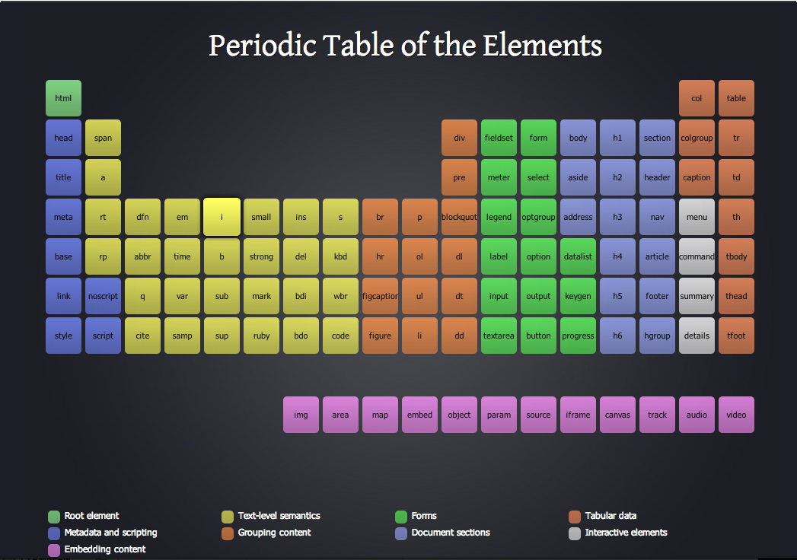

Atomic Design

Atomic design is a methodology that creates multiples stacks of components, with different hierarchies of complexity and dependence.
It is based on chemistry, and it follows the following hierarchy:

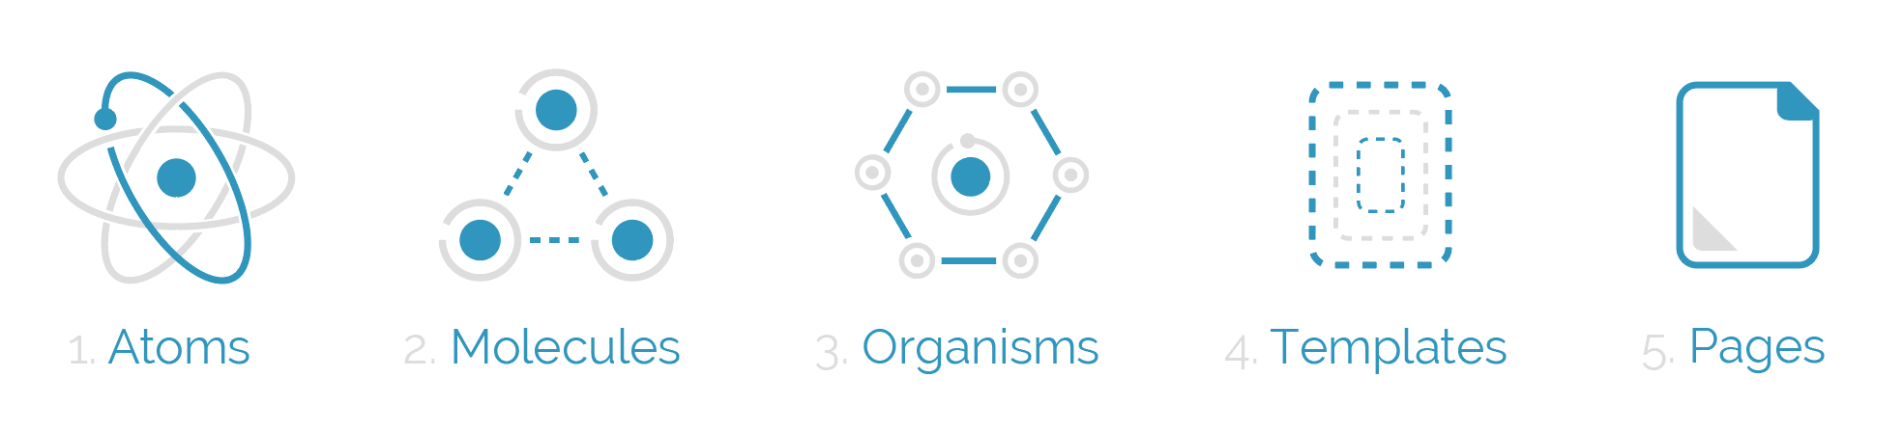
1. Atoms: the smallest possible components, such as buttons, titles, inputs or event color pallets, animations, and fonts. They can be applied on any context, globally or within other components and templates, besides having many states, such as this example of button: disabled, hover, different sizes, etc.

Example: button

2. Molecules: composition of one or more components of atoms. Here we begin to compose complex components and reuse some of those components. Molecules can have their own properties and create functionalities by using atoms, which don’t have any function or action by themselves.

Example: a product card – with an image, labels, etc.

3. Organisms: combination of molecules that work together or even with atoms that compose more elaborate interfaces. At this level, the components begin to have the final shape, but they are still ensured to be independent, portable and reusable enough to be reusable in any content.

Example: a header – with logo, a navbar, a search bar, etc.

4. Templates: In this state we stop composing components and begin to set their context. Moreover, the templates create relationships between the organisms and others components through positions, placements and patterns of the pages but it doesn’t have any style, color or component rendered. That’s why it looks like a wireframe.

A template looks like a wireframe. It is like a prototype of the page, one that must be refined and stylized, added functionality, and added real content to become a page.

5. Pages: Pages are the navigate parts of the application and it’s where the components are distributed in one specific template. The components get real content and they’re connected with the whole application. At this stage, we can test the efficiency of the design system to analyse if all the components are independent enough or if we need to split them in smaller parts.

https://bradfrost.com/blog/post/atomic-web-design/

https://danilowoz.com/blog/atomic-design-with-react

Modularity: a core concept, and it can be applied on several levels. The three basic steps to start structuring your CSS that way are by:

- breaking the code into smaller chunks and separating them by scope;
- coding components in a independent and encapsulated manner;
- naming CSS selectors according to their purpose and relationship with each other.

1. Separate and categorize your code

To keep the architecture modular, it’s important to break the code into smaller parts. Multiple files make the code easier to read, navigate and track.

A good way to do this is by using a pre-processor such as Sass, LESS or Stylus, or a post-processor such as PostCSS

Famous methodologies for CSS:

SMACSS, ITCSS, MVCSS, OOCSS

Now it’s time to categorize each code block according to its scope on the project. One of the first methodologies out there to introduce selector categorization was SMACSS. The layers proposed by SMACSS are Base, Layout, Module, State and Theme. ITCSS expanded this concept, introducing other layers, such as Settings and Trumps. MVCSS has a similar approach, but with different naming conventions.

2. Define your Components

Each component should be encapsulated on its own file. For consistency reasons, it’s a good practice to use the same name for the file and main selector.

3. Apply a naming convention

A class naming convention, A pattern such as BEM (Block, Element, Modifier) will clarify the intention and relationship between a component (the Block) and its elements, as well as reinforce predictability when compared with other components.

