DAVID SONG VSL — Transcrição EN + Tradução PT-BR + Prints
Fonte: arquivo '3034632a-576a-41cf-b0e2-b726d3e6d7ab' (Drive, .ts, 41:18, 1280x720). Produto: David Song (Joe Dispenza). Transcrição: AssemblyAI (speaker labels). Tradução fiel: nomes, marcas, valores em dólares, versículos e referências mantidos como falados. Personagens dos clipes identificados pelas imagens (avatares de Kanye West, Jim Carrey, Elon Musk, Kim Kardashian, Dr. Oz, Oprah Winfrey e Joe Rogan).
Timing: cada mini-bloco traz o intervalo x → y em que a fala acontece no vídeo. Prints: frames dos momentos mais importantes (letterings, provas, personagens, produto, oferta), nomeados bNN_descricao_HH-MM-SS.jpg na pasta frames/.
Falantes: JOE DISPENZA (narrador, avatar) · KANYE WEST (avatar, podcast) · JIM CARREY (avatar) · ELON MUSK (avatar) · KIM KARDASHIAN (avatar) · DR. OZ (avatar) · OPRAH WINFREY (avatar) · JOE ROGAN (avatar, podcast) · HOMEM (depoimento, promoção) · DEPOIMENTO (diabetes tipo 2) · IMIGRANTE MEXICANO (depoimento, Powerball) · NEUROCIENTISTA (depoimento) · MÃE (depoimento, sonho do acidente) · O CÉTICO DA FAMÍLIA (depoimento)
Correções de transcrição (ASR): Gaguejos e palavras repetidas removidos ('would would', 'played, played', 'button, button', 'to to', 'always always'); trecho solto 'What? land.' em 14:47 removido; 'Kinner/Kin'er/kinner' mantido como kinnor; reticências (…) marcam cortes de edição no áudio original (ex.: 18:05, 28:54). O roteiro mistura $40.000 por sessão (0:27) e $50.000 por mês/retiro, e cita 'more than 2,000 in bonuses' e $2.076 — mantidos como falados.

Estrutura da VSL (18 blocos)
BLOCO 1 — LEAD: o botão da manifestação, o sistema Rockefeller, celebridades a $40.000 por sessão, Epstein e Bohemian Grove — 0:00 → 2:21
BLOCO 2 — O capítulo censurado de The Secret, o episódio com Joe Rogan derrubado, o ritual de 15 segundos e as 2 pílulas — 2:22 → 3:32
BLOCO 3 — QUEM É JOE DISPENZA: o botão nasceu com você, as 6 vértebras fraturadas, a glândula pineal e a pinha do Vaticano — 3:32 → 5:43
BLOCO 4 — O ESCÂNDALO MAIOR QUE O DE EPSTEIN: as 3 famílias, os Rockefeller, os nazistas, o segredo dos judeus e 1945 — 5:43 → 7:37
BLOCO 5 — O SISTEMA: a corrida dos ratos, celebridades fantoches, rituais de iniciação e o programa tirado do ar — 7:38 → 9:15
BLOCO 6 — MECANISMO: a antena (TV), as vibrações do universo e por que os judeus prosperam (Nobel, Forbes) — 9:16 → 10:48
BLOCO 7 — A HARPA DO REI DAVI: Salomão, Saul (1 Samuel 16:23) e Eliseu (2 Reis 3:15) — 10:49 → 12:23
BLOCO 8 — MICROCRISTAIS E PIEZOELETRICIDADE: a pineal como antena, a gota d'água e Jobs, Taylor Swift e Michael Jordan — 12:23 → 14:24
BLOCO 9 — A RECONSTRUÇÃO: arquivos queimados, os fragmentos, o kinnor, a afinação (432 Hz) e a IA dos pergaminhos do Vesúvio — 14:24 → 18:57
BLOCO 10 — O DAVID SONG: 7 vibrações em 7 noites, como usar e os primeiros sinais — 18:58 → 20:12
BLOCO 11 — DEPOIMENTOS: a promoção, o diabetes e o Powerball de $4,7 milhões — 20:12 → 22:00
BLOCO 12 — A NEUROCIENTISTA, os retiros de $50.000 e o depoimento de Elon Musk — 22:01 → 24:13
BLOCO 13 — O PACTO DAS 7 NOITES e o future pacing — 24:13 → 26:33
BLOCO 14 — PREÇO: de $5.000 para $39, e por que não é de graça — 26:33 → 29:44
BLOCO 15 — ACESSO DIGITAL VITALÍCIO e GARANTIA de 60 dias — 29:45 → 31:57
BLOCO 16 — DEPOIMENTOS: a mãe que sonhou com o acidente e o cético da família — 31:57 → 33:30
BLOCO 17 — ESCASSEZ e OS 7 BÔNUS (valor total de $2.076) — 33:30 → 38:27
BLOCO 18 — FECHAMENTO: as 2 portas — 38:27 → 41:16

PARTE 1 — TRANSCRIÇÃO EM INGLÊS POR BLOCOS

BLOCO 1 — LEAD: o botão da manifestação, o sistema Rockefeller, celebridades a $40.000 por sessão, Epstein e Bohemian Grove [0:00 – 2:21]

1.1 ⏱ 0:00 → 0:46
JOE DISPENZA (narrador, avatar): I'm recording this video in case something happens to me. In the next few minutes, I'm going to show you the manifestation button that frees anyone from the Rockefeller system, the one that keeps you poor and them rich. This video is being wiped from the platforms at this very moment, so I'll get straight to the point before it disappears for good. For the last 30 years of my life, I've been sought out by some of the most powerful people on the planet. Hollywood celebrities who paid up to $40,000 per session just so I would activate their third eye before signing multimillion-dollar movie deals. Wall Street billionaires who asked to visit my home before every major market decision. Believe me, the way celebrities manifest everything they want is not what it seems.

1.2 ⏱ 0:46 → 1:31
JOE DISPENZA (narrador, avatar): They all hide what they were doing on Epstein's Island or at retreats like Bohemian Grove.
KANYE WEST (avatar, podcast): They switch on a button in your brain. After that, you start attracting everything you want— cars, money, But they charge a price for it.
JIM CARREY (avatar): I had to disappear for 2 years after I started talking about how celebrities awaken the third eye. I got blacklisted in Hollywood.
JOE DISPENZA (narrador, avatar): I'm gonna show you what they do to activate the manifestation button that God left hidden in your brain when you were born, but only 2% of people have ever activated it. When it's switched on, you awaken almost superhuman abilities, all the ones you've heard about— manifestation, Reading the room, knowing exactly which decisions to make, the law of attraction.

1.3 ⏱ 1:31 → 2:21
ELON MUSK (avatar): Everything I desire simply materializes the moment this manifestation button is active. Joe Dispenza showed me this years ago.
KIM KARDASHIAN (avatar): When you press this button, money flows differently. Opportunities show up out of nowhere. You start operating on a frequency most people will never access.
DR. OZ (avatar): There's a gland in the center of your brain that emits a wave of energy No other part of your body emits. Scientists are calling it the bridge to God.
JOE DISPENZA (narrador, avatar): When this button switches on, money stops running from you. Your body heals from things doctors can't explain, and you start receiving the answers before the questions. And if you've tried the law of attraction and nothing changed, it wasn't a lack of faith. They didn't want you to know. The Rockefeller system spent billions to make sure you never found out this button exists.

BLOCO 2 — O capítulo censurado de The Secret, o episódio com Joe Rogan derrubado, o ritual de 15 segundos e as 2 pílulas [2:22 – 3:32]

2.1 ⏱ 2:22 → 3:09
OPRAH WINFREY (avatar): There's a part of the book The Secret that was never published. Nobody has the courage to talk about it. It's something about a button that manifests everything your heart desires. The original uncut book even showed how to activate this button in your brain.
JOE DISPENZA (narrador, avatar): I need you to pay close attention. This video will most likely be taken down today. Nobody talks about this. I was silenced for years. My episode with Joe Rogan was pulled off the air. But now you have the chance to watch it. I'm gonna show you, uh, the 15-second ancient ritual that activates this manifestation button in the center of your brain to attract things on demand. It's the same ritual the Jewish people have used for thousands of years to ask God for blessings and attract prosperity.

2.2 ⏱ 3:10 → 3:32
JOE DISPENZA (narrador, avatar): Hollywood celebrities pay up to $50,000 a month for access to this ritual. From this moment on, you get to choose between 2 pills. With one, you stay in the rat race built by the Rockefeller system. With the other, you discover how to activate the button that turns your brain into a magnet, attracting the blessings that were locked away and stolen from you.

BLOCO 3 — QUEM É JOE DISPENZA: o botão nasceu com você, as 6 vértebras fraturadas, a glândula pineal e a pinha do Vaticano [3:32 – 5:43]

3.1 ⏱ 3:32 → 4:14
JOE DISPENZA (narrador, avatar): You might know me from my books, my talks, or my meditation retreats, but what I'm about to reveal now, I was silenced from speaking about for years. Your ability to manifest and create your own reality is not a gift only a few people have. You were born with it. And here's why the law of attraction works for the Hollywood elite but never worked for you. The deep state, celebrities, and elite athletes know how to activate the manifestation button to attract everything they want. Meanwhile, yours was silently switched off. That manifestation button is the real reason I walked out of a hospital bed with 6 fractured vertebrae in my spine.

3.2 ⏱ 4:15 → 4:58
JOE DISPENZA (narrador, avatar): It's what made Taylor Swift manifest success, what let Elon Musk switch on his brain's superintelligence to build his empire, and it's what the 3 most powerful families have been hiding for over 100 years to keep you under control. It's this button in the center of your brain that, once activated, turns whatever you manifest into reality. When the doctors told me I'd need 4 surgeries, metal rods in my spine, and even then I might never walk again, I decided to go against everything they said. The night before surgery, I heard a voice in my head speaking the words that changed everything for me. The same power that made the body heals the body. I worked as a chiropractor, and I'd always been fascinated by how the human body works.

3.3 ⏱ 4:58 → 5:43
JOE DISPENZA (narrador, avatar): And after so many years of studying it, there was one thing I knew for certain. It was a design so perfect it couldn't be an accident. Some higher intelligence created the system, and there was one specific structure That always caught my attention. The pineal gland. Ancient civilizations called it the third eye or the Eye of Horus. The Egyptians drew it inside the pyramids. The Vatican has a 13-foot pine cone sitting right in the center of its main courtyard, the exact same shape as this gland. The Pope carries a staff with a pine cone on it too. They all knew this part of your brain carries a higher power. So why was it forgotten? The truth is, it wasn't forgotten. It was erased on purpose so you would never hear about it.

BLOCO 4 — O ESCÂNDALO MAIOR QUE O DE EPSTEIN: as 3 famílias, os Rockefeller, os nazistas, o segredo dos judeus e 1945 [5:43 – 7:37]

4.1 ⏱ 5:43 → 6:25
JOE DISPENZA (narrador, avatar): When I started digging into this, I discovered I was getting involved in one of the biggest scandals in recent history, bigger than Epstein's. That's why it took me 30 years to come forward and talk about this. I was silenced for years, and this is where the story gets dark. Every single time I started speaking about it, I was shut down. I recorded a Podcast with Joe Rogan a while back exposing everything, and in less than 24 hours it was pulled off the air. A scandal bigger than Epstein's is about to come to light. There are 3 families that run the world, and the main one is the Rockefellers. They stole from the Jews a knowledge of how to attract things on demand and hid it from the rest of the population to control you.

4.2 ⏱ 6:26 → 7:09
JOE DISPENZA (narrador, avatar): They erased and burned every book that held this knowledge.
JOE ROGAN (avatar, podcast): Oh, fuck! I've been talking about this for years. The deep state controls us so we work for them. They make us sick, then sell us the cure. But what knowledge are you talking about?
JOE DISPENZA (narrador, avatar): Exactly that, Joe. The Rockefellers financed the Nazi regime, and in return, they gained access to files containing the secret of the Jews, the secret that made them prosper for centuries. Rockefeller used that secret to grow his empire and shared it with 3 other families that Today hold 97% of the world's entire fortune.
JOE ROGAN (avatar, podcast): The Jews have always been among the richest people on the planet. They own the big banks. So they were always prosperous because they had some kind of ritual to activate the third eye?

4.3 ⏱ 7:09 → 7:37
JOE ROGAN (avatar, podcast): Is that why they were persecuted?
JOE DISPENZA (narrador, avatar): Yes. Hitler believed that whoever controlled the power of the pineal would control entire nations. He mentions the third eye and the pineal about 33 times in his diary, found years later.
JOE ROGAN (avatar, podcast): What did the Rockefellers get out of it?
JOE DISPENZA (narrador, avatar): After the war, they took control of both the pharmaceutical industry and the financial system. Or do you think it's a coincidence that the dollar became the world's currency and health problems skyrocketed right after 1945?

BLOCO 5 — O SISTEMA: a corrida dos ratos, celebridades fantoches, rituais de iniciação e o programa tirado do ar [7:38 – 9:15]

5.1 ⏱ 7:38 → 8:21
JOE DISPENZA (narrador, avatar): From birth, we've been conditioned to believe life comes down to working, retiring, and trying to stay healthy. I'm sure that at some point in your life you've felt like something's missing. something about that wasn't right. But how can you question it when you're always busy trying to pay the bills with no time to stop and think? The most disturbing part is that this was always their plan— keep you trapped, busy, and mentally exhausted so you never have time to question the system. They created the problem and hid the solution. That way, all the power stayed in the hands of a very few. That's why you see hundreds of celebrities hitting sudden fame, many of them tied to cases like Epstein's. To get access to the secret of the third eye, they had to become puppets of the powerful.

5.2 ⏱ 8:22 → 9:06
JOE ROGAN (avatar, podcast): I know what goes on behind the scenes. Every one of these celebrities has to do something like an initiation ritual, a tattoo, or they show up with a black eye, or subliminal messages hidden in their records. Only those who accept their control get to succeed, and everyone who tried to expose it disappeared. In other words, the elite built a system where, one way or another, everyone is controlled by them.
JOE DISPENZA (narrador, avatar): But just like the Jews, most people can escape this system too. They inherited, thousands of years ago, a secret that activates this manifestation button. It was at this exact moment, when I was about to reveal everything about how to activate the pineal, that the show was cut off the air.

5.3 ⏱ 9:06 → 9:15
JOE DISPENZA (narrador, avatar): Not a single file survived on the internet. But that ends today. I'm gonna show you how to break free from the Rockefeller system.

BLOCO 6 — MECANISMO: a antena (TV), as vibrações do universo e por que os judeus prosperam (Nobel, Forbes) [9:16 – 10:48]

6.1 ⏱ 9:16 → 10:00
JOE DISPENZA (narrador, avatar): We were born with a direct connection to the Creator, the bridge he left behind so we could keep communicating with him. And here's the key that ties it all together: the entire universe runs on vibrations. Think about the TV in your house. It picks up the signal of something happening live somewhere else and turns it into a real image in your living room. The camera filming it and your TV aren't connected by any cable. The vibrations travel from one device to the other. When you press this manifestation button, it does exactly that. It picks up and sends out the vibrations of the universe. When it's working, your body translates those higher frequencies into prosperity, health, good relationships, intuition, and luck right here in this reality.

6.2 ⏱ 10:01 → 10:48
JOE DISPENZA (narrador, avatar): But if you don't activate this button, you simply get forgotten by the universe. Things that were already destined for you, that only needed to materialize, vanish. It's as if God couldn't hear you. But there is a way to switch this button on, one the Jewish people have known for thousands of years. It's no accident that even in the face of persecution, they remain the most prosperous people on the planet. They hold 37% of all Nobel Prize Despite making up only 0.2% of the world's population, and for every 4 billionaires on the Forbes list, 1 is Jewish. Want to know their secret? How they keep prospering even through persecution? The exact sound vibration that activates the manifestation button, putting you in a state where anything you desire can be manifested.

BLOCO 7 — A HARPA DO REI DAVI: Salomão, Saul (1 Samuel 16:23) e Eliseu (2 Reis 3:15) [10:49 – 12:23]

7.1 ⏱ 10:49 → 11:33
JOE DISPENZA (narrador, avatar): Don't think this is just some sound frequency you've seen on YouTube. It's a vibration described in the Bible, but its true power was erased from the modern versions. So where does this vibration come from? From the most famous harp in history, the Harp of King David. Think of the richest man who ever lived. It's not any billionaire alive today, it's Solomon, son of David. Both were Jewish. His fortune was so staggering that entire nations handed him their gold. And Solomon didn't just inherit his father's throne, he inherited The Bible mentions the power of this harp again and again. David would take the harp and play it with his hand, then Saul would find relief. 1 Samuel 16:23.

7.2 ⏱ 11:33 → 12:23
JOE DISPENZA (narrador, avatar): But David's harp didn't just soothe Saul with pretty music. In 2 Kings 3:15, the prophet Elisha needed to see the future, but he couldn't. So he said, bring me a harpist. And as the harpist played, the hand of the Lord came upon Elisha and he saw everything. The sound switched on his prophetic vision. That is the manifestation button being turned on. Ancient records show there was a specific sequence of notes that made the inner eye awaken, and this knowledge was passed down from generation to generation by the Jewish people. The sequence of vibrations from David's harp is an exact key made to activate what's been switched off. This manifestation button, or pineal gland if you prefer, is what sends your desire out to the universe.

BLOCO 8 — MICROCRISTAIS E PIEZOELETRICIDADE: a pineal como antena, a gota d'água e Jobs, Taylor Swift e Michael Jordan [12:23 – 14:24]

8.1 ⏱ 12:23 → 13:06
JOE DISPENZA (narrador, avatar): Inside your pineal gland, there are microcrystals, and these crystals have a rare property called piezoelectricity. What's fascinating is that these crystals work a lot like the quartz in a stove lighter, the kind that shoots out a spark when you press the button. When these tiny crystals feel a slight natural pressure inside your head, they generate small electrical impulses, which means that when the right kind of vibration reaches them, they fire off an electrical charge and literally turn into an antenna. And it's this antenna that sends out frequencies capable of turning your thoughts into reality. That's what I call activating the manifestation button. Your brain starts operating in a state of creation with the universe.

8.2 ⏱ 13:06 → 13:52
JOE DISPENZA (narrador, avatar): Take this experiment, for example. Watch how, depending on the sound vibration, this drop of water changes its shape. Or this one, where inside a room with zero interference, we played the exact sequence of notes David used on his harp to activate the manifestation button. Watch how each vibration is able to alter reality itself. This is the secret passed down among the Jewish people for thousands of years. Not just any frequency, but an exact sequence of notes played by David on the harp, one that presses this button at the precise moment and opens your third eye. When Steve Jobs invented the iPhone, his manifestation button was switched on. When Taylor Swift performs in front of 80,000 people, she's activating this manifestation button.

8.3 ⏱ 13:52 → 14:24
JOE DISPENZA (narrador, avatar): It's what Michael Jordan called the zone, that moment when the game slowed down for him, and he could see the next play 2 seconds ahead of every opponent. His button was already activated in his brain. I've spent the last 30 years studying how each vibration behaves inside the human brain, measuring with electrodes and real-time brain mapping the brains of thousands of people at my retreats. And when I understood that the key wasn't a frequency but a sequence of vibrations, David's sequence.

BLOCO 9 — A RECONSTRUÇÃO: arquivos queimados, os fragmentos, o kinnor, a afinação (432 Hz) e a IA dos pergaminhos do Vesúvio [14:24 – 18:57]

9.1 ⏱ 14:24 → 15:09
JOE DISPENZA (narrador, avatar): That's when the hardest part of my life began, because the original records no longer exist. The archives the Jewish people kept were burned. What survived was scattered fragment by fragment, and the little that resurfaced in the modern era, the Rockefeller system bought it, locked it away in private collections, and erased it from the books the same way they erased the knowledge of your pineal gland. But they made one mistake. You can't erase everything. A few citations of David's compositions remained scattered around the world. Jews who fled and went into hiding in different corners of the globe, some rabbis in small Jewish communities held on to a few manuscripts. A Jewish banker in New York who once worked for Donald Trump kept a few others.

9.2 ⏱ 15:09 → 15:54
JOE DISPENZA (narrador, avatar): And after years of gathering every scattered piece, I managed to fit together the parts that formed David's compositions. 7 vibrations played by David himself, the exact sequence identical to the original, verified symbol by symbol against the oldest fragments in existence. I was holding in my hands the sheet music that activates the manifestation button, and that's when I discovered the problem that almost made me give up on everything. What good is the sheet music if the instrument no longer exists? Because David's harp wasn't just any harp. The Kinner, as it was called, was built by David's own hands. The wood, the strings, and above all, the tuning, which follows no standard we know of.

9.3 ⏱ 15:55 → 16:45
JOE DISPENZA (narrador, avatar): No instrument on the planet today produces that sound, not even close. And you know why? Because in, uh, the last century, all the music in the world was standardized to a single tuning, the same one in your piano, your guitar, Spotify, YouTube. Everything your ears have ever heard plays inside that standard. The sound David played has nothing to do with it. That's why that 432 Hz audio on YouTube never worked for you. It's the wrong sheet music played on the wrong instrument in the wrong tuning. I had David's exact sequence and no way to make the universe play it again until technology caught up with me. I saw a news story about scientists using artificial intelligence to read scrolls carbonized by the Vesuvius volcano 2,000 years ago.

9.4 ⏱ 16:46 → 17:43
JOE DISPENZA (narrador, avatar): Scrolls so burned they had turned to charcoal, impossible to open without destroying them. The AI read them closed word by word. It made headlines All over the world. That's exactly the kind of people I went after. I put together a team that had never worked together before— forensic acoustics engineers, specialists in ancient instruments, and data scientists from the same circle that deciphered the Vesuvius Scrolls. And we built an artificial intelligence with a single mission for its entire existence: to play the way David played. First, It devoured everything in existence. Every ancient harp ever scanned in the world's museums, every description of the kinner in historical records, the physics of the wood from that region, of the strings from that era, even the climate of Jerusalem, because temperature and humidity changed the sound of an instrument.

9.5 ⏱ 17:43 → 18:25
JOE DISPENZA (narrador, avatar): Then it did what no living man could. It rebuilt David's kinnor from the inside, a complete acoustic model string by string of the instrument David's hands built, and then note by note it played the seven vibrations from the fragments on the reconstructed instrument in the original tuning. It took months of processing, running day and night on a supercomputer until one Tuesday in the early hours of the morning at the lab, my lead engineer handed me a… [corte na edição] I pressed play, and I heard what no human being had heard in 3,000 years. The sound that soothed Saul. The sound that opened Elisha's vision.

9.6 ⏱ 18:26 → 18:57
JOE DISPENZA (narrador, avatar): But I'm a scientist. I don't even trust my own goosebumps. I trust data. So I did what I've done for 30 years. I took the recording to my lab, hooked electrodes up to volunteers, turned off the lights, and pressed play. And on the screen, I saw the same thing. On the screen, in real time, I saw what I had only ever seen in monks with decades of meditation: the manifestation button switching on one by one in ordinary people who were just lying there listening. It was the only time in 30 years of my career that I cried in front of my team.

BLOCO 10 — O DAVID SONG: 7 vibrações em 7 noites, como usar e os primeiros sinais [18:58 – 20:12]

10.1 ⏱ 18:58 → 19:42
JOE DISPENZA (narrador, avatar): I call this exact sequence of vibrations the David Song. It's David's 7 vibrations rebuilt Note by note in the original sound of the Kin'er, arranged in the exact order the fragments indicate. One vibration per night for 7 nights. Each night, one vibration prepares the next. The first begins to awaken the microcrystals in your pineal gland. The second goes deeper, and so on until the 7th night when the full sequence plays and the button switches on. It's simple. You turn off your bedroom lights because the pineal gland is sensitive to light, and in the dark it awakens. You put on your headphones, press play, and go to sleep.

10.2 ⏱ 19:43 → 20:12
JOE DISPENZA (narrador, avatar): That's it. The sound does the work, exactly like it did for Saul, who made no effort either. He just listened. On the very first night, you'll feel the most refreshing sleep of your life, the kind you haven't felt in years. These are the first signs your button is switching on: deep sleep, vivid dreams, clarity when you wake up, and the first coincidences. The first people to test the David Song outside the lab weren't celebrities. They were people just like you.

BLOCO 11 — DEPOIMENTOS: a promoção, o diabetes e o Powerball de $4,7 milhões [20:12 – 22:00]

11.1 ⏱ 20:12 → 20:56
HOMEM (depoimento, promoção): I did the 7 nights. The following Friday, my boss called me into his office and I froze. I thought I was getting fired. It was a promotion I had given up waiting for with a 40% raise. But that wasn't the strangest part. The strangest part was that the night before, I had dreamed about that conversation. I walked into that office knowing what he was going to say.
DEPOIMENTO (diabetes tipo 2): The first time I went back to my doctor after I started listening to the David song every night, he had no explanation. My type 2 diabetes was under control. I didn't cut sugar or change my diet. The doctor took me off insulin and kept me on just one medication.
IMIGRANTE MEXICANO (depoimento, Powerball): Look, I came Mexico 22 years ago with nothing. I worked 12-hour days in construction and the money never stretched far enough.

11.2 ⏱ 20:57 → 21:40
IMIGRANTE MEXICANO (depoimento, Powerball): I prayed every night and felt like my prayers hit a ceiling and bounced back. A friend of mine, a gardener for rich folks in Scottsdale, told me his boss heard the David song and said it was the secret to his good luck. I thought, what have I got to lose? I listened to it religiously For 23 days. On day 24, a voice inside me told me to buy a Powerball ticket. I never play. I bought one for $2. 3 days later, my wife called me screaming, $4.7 million! Gracias, Joe Dispenza. You didn't give me luck. You opened the channel that had been closed for 22 years.
JOE DISPENZA (narrador, avatar): And new stories come in every single day.

11.3 ⏱ 21:40 → 22:00
JOE DISPENZA (narrador, avatar): Bills paid off with money that showed up from where no one expected. Opportunities knocking on the doors of people who had already given up. Test results coming back clean. Couples who stopped fighting about money because the money stopped running out. Ordinary people with the button switched on, living what the elite has always lived in silence.

BLOCO 12 — A NEUROCIENTISTA, os retiros de $50.000 e o depoimento de Elon Musk [22:01 – 24:13]

12.1 ⏱ 22:01 → 22:47
JOE DISPENZA (narrador, avatar): And, and it's not just ordinary people.
NEUROCIENTISTA (depoimento): I've spent my career studying the brain and altered States, and I was skeptical of Dr. Dispenza's work until I saw the data. What happens to the brain activity of volunteers listening to this recording shouldn't be possible in untrained people. We measured coherence patterns that the literature had only ever described in monks with tens of thousands of hours of meditation showing up in a matter of nights. As a scientist, I can't ignore that. The pineal gland The most underestimated structure in modern neuroscience.
JOE DISPENZA (narrador, avatar): And, uh, remember what I told you about my retreats? Celebrities paid $50,000 each to sit in a room with me and learn how to activate this gland.

12.2 ⏱ 22:47 → 23:33
JOE DISPENZA (narrador, avatar): They arrived in private jets, signed NDAs at the door. Actors you see in movies, athletes you see lifting trophies, CEOs of companies that are inside your pocket right now on your phone. One of them, an investor you've seen on magazine covers, told me during a break, Joe, if people knew what the David Song does for someone's net worth, nobody would ever buy a finance course again. They paid $50 grand without blinking because word started spreading among the elite about the success they had once they activated their pineal. When an actor switches this button on before an audition, he gets the part. When an athlete switches it on before the final, he enters the zone on purpose while everyone else prays for it to show up.

12.3 ⏱ 23:33 → 24:13
JOE DISPENZA (narrador, avatar): When an investor switches it on before a decision, he feels the move before the market does. They're not better than you. They just had access to a door that has always been locked for the rest of the world. And the richest man on the planet is already saying in public what the elite has always known in silence.
ELON MUSK (avatar): Joe Dispenza showed me what he was rebuilding— the sound of a 3,000-year-old harp. He put the headphones on me, turned off the lights, and within 2 minutes I understood why they hid this for a century. I listen to this frequency every day. Many of my business ideas came right after listening to the sound. People think I'm some kind of genius. I'm not. Um, I just activate a button in the brain that makes things happen naturally for me.

BLOCO 13 — O PACTO DAS 7 NOITES e o future pacing [24:13 – 26:33]

13.1 ⏱ 24:13 → 24:55
JOE DISPENZA (narrador, avatar): So I want to make a pact with you right here, right now. Do you believe your brain is capable of creating more than the life you're living? If there's even one part of you that has always known you were born for more, maybe it's exactly this button that needs to be activated over the next 7 nights. That's it, 7 nights, one vibration per night, in the dark, with headphones on, without changing your routine. Write down every coincidence, the call that comes at the exact right time, The idea that shows up fully formed. The person you needed to meet who happens to cross your path. The money that appears from a source you had forgotten about. On day 1, you'll call it chance. On day 3, luck.

13.2 ⏱ 24:56 → 25:41
JOE DISPENZA (narrador, avatar): On the 7th night, you'll understand what the elite has always known. There's no such thing as chance for those in the right state. There's a button, and yours, for the first time in your life, will be switched on. I wouldn't be putting my name, my face, and 30 years of science on this, knowing they already took down my Rogan episode and are dying to turn me into a joke, if I weren't absolutely certain of what happens when an ordinary person presses play on that first night. Now imagine your life with this button switched on. Can you see yourself a few months from now waking up from deep sleep, no alarm, Your body rested and your mind clear, realizing that the anxiety that used to live in your chest simply isn't there anymore?

13.3 ⏱ 25:41 → 26:23
JOE DISPENZA (narrador, avatar): Can you see yourself opening your banking app without that knot in your stomach because the debts that were suffocating you have been paid off, one by one, with money that came through doors you didn't even know existed? Can you imagine your partner looking at you differently because the fights about money ended along with the lack of it? The trip you postponed for 10 years finally booked? The car in the garage? The gift given without checking the price tag? And more than all of that, can you imagine the feeling of walking through the world knowing, not hoping, not wishing, knowing that your mind commands your reality and not the other way around? That feeling has a name.

13.4 ⏱ 26:23 → 26:33
JOE DISPENZA (narrador, avatar): It's your third eye awake. It's the state the 1% wakes up in every single day, and the button is inside your head right now, just waiting for you to activate it.

BLOCO 14 — PREÇO: de $5.000 para $39, e por que não é de graça [26:33 – 29:44]

14.1 ⏱ 26:33 → 27:25
JOE DISPENZA (narrador, avatar): Like I said, I've been paid as much as $50,000 for a retreat to teach how to activate this gland, and they paid it because in less than 3 months they had already multiplied that amount 3 times over. Rebuilding the David Song took months on a supercomputer, an international team, and a good chunk of my own money. I needed the elite to pay me that much just to cover the cost of it all, because if I had to charge regular people what it cost, I'd have to charge at least $5,000. But I refused, because if the David Song goes out at $5,000, who buys it? The same people as always. The ones who already have access. Tycoons, celebrities, and the mom doing math in the grocery store the dad with a maxed-out credit card, the person who needs their pineal activated the most, gets left out again.

14.2 ⏱ 27:26 → 28:18
JOE DISPENZA (narrador, avatar): That would be repeating, with my name on it, exactly what the Rockefellers did for 100 years: locking the key in a vault and handing it only to those who agree to live inside their system. So today, on this page, the David Song will not cost $5,000. It won't cost $1,000. It won't cost $500. Not $250. Not even $100. While this video is still up, you get the complete David Song, all 7 vibrations, plus every bonus I'm about to show you for a single payment of $39. $39. Less than 50 cents a day. Less than a dinner out. For the sound celebrities paid $50,000 just to get While signing NDAs, if you feel your time has come, click the button below this video right now and secure your access.

14.3 ⏱ 28:19 → 29:06
JOE DISPENZA (narrador, avatar): And I know someone out there is thinking, Joe, if this is your mission, why not give it away for free? That's a fair question, and there are two reasons. Reason number one: keeping this online has a cost, and it's not a small one. You saw what they did to my Joe Rogan episode. 24 hours and it was gone. Since this page went live, it has already been taken down and attacked more than once. To keep this page standing, my team runs everything on maximum security servers, the same infrastructure the big banks use, with backups outside the country. Every day this video stays online is paid out of my own pocket against people with much deeper pockets than Reason number 2, and this one I discovered by measuring brains, not by selling courses.

14.4 ⏱ 29:06 → 29:44
JOE DISPENZA (narrador, avatar): What's free, the brain throws away. Um, I saw it in the data, black and white. Commitment changes the electrical current of the brain. When a person invests even a symbolic amount, they're actually willing to follow through with the process. If I would release the David Song for free on the internet. It would become just another open tab you never look at again, and your button would stay switched off, this time with the key sitting right in your hand. I can't let that happen. The $39 isn't the price of the David Song. It's the price of your commitment to yourself.

BLOCO 15 — ACESSO DIGITAL VITALÍCIO e GARANTIA de 60 dias [29:45 – 31:57]

15.1 ⏱ 29:45 → 30:28
JOE DISPENZA (narrador, avatar): When you click the button below, you'll be taken to a 100% secure encrypted payment page protected by the same technology Amazon and the big banks use. None of your data is stored improperly. You fill in your details, confirm, and the minute your payment is approved, the complete access arrives in your email. The 7 vibrations of the David Song, along with every bonus, all digital. No waiting for delivery, no shipping. You listen on your phone, tablet, or computer. And the access is lifetime, yours forever. Even if this video disappears, the David Song will now be yours. No government or powerful player can take the truth away from you.

15.2 ⏱ 30:28 → 31:11
JOE DISPENZA (narrador, avatar): That means in just a few minutes, you could already be in a dark room, headphones on, pressing play on the first of your 7 nights. And, uh, if anything goes wrong, my support team answers 24 hours a day and solves it on the spot. But I want to remove even the last trace of doubt from your path because I know you've been burned before by promises of courses, methods, secrets. So I'm gonna do something that made my finance team's hair stand on end. By law, every online purchase comes with a 7-day guarantee. I'm giving you 60 days, 2 full months. Do the 7 nights, Then do 7 weeks if you want.

15.3 ⏱ 31:11 → 31:57
JOE DISPENZA (narrador, avatar): Watch your sleep, your dreams, your clarity, the coincidences, the opportunities. At any point within 2 months, you look at your life and feel that nothing has changed, you don't have to justify anything. Send one single email to my team and every cent goes back to your account. No questions, no red tape, no buts. And there's more. I won't ask for anything back. The access stays yours. If the David song didn't work for you, every last cent comes back, but I still want you to keep the key. Think about what that means. There are only 2 possible endings to this story. Either your button switches on and your reality starts bending in your favor, or you pay absolutely nothing. You don't have to say yes today. You only have to say maybe. The risk is all mine.

BLOCO 16 — DEPOIMENTOS: a mãe que sonhou com o acidente e o cético da família [31:57 – 33:30]

16.1 ⏱ 31:57 → 32:41
MÃE (depoimento, sonho do acidente): I was exhausted, stuck in my work routine, And raising my little boy with no energy, no mental clarity, and barely sleeping. A friend told me about the David Song, and even though I was skeptical, I decided to try it. In the first week, I felt profound changes. I finally slept through the night, woke up with a light mind and more focus. But what really marked me was a dream I had a few days later. I dreamed about a car accident. Extremely real, every detail. I woke up shaken, and deep down I knew it wasn't just a dream. A few days later, as I was about to get into a car I had booked, the scene from the dream repeated itself.

16.2 ⏱ 32:41 → 33:30
MÃE (depoimento, sonho do acidente): My instincts stopped me, and I decided not to get in that car. Later, I saw on the news that this same car had been involved in a serious accident exactly like in my dream. That's when I understood. The David song didn't just transform my mind, it may have saved my life and my son's. I've listened every night since. My energy, my focus, and my intuition are on another level.
O CÉTICO DA FAMÍLIA (depoimento): I was the skeptic of the family. I did the 7 nights just to prove it was nonsense. On day 8, I got a letter from the bank. A billing error going back years had been corrected, and they were Refunding me $4,200 with interest. Coincidence? Maybe. But then came the second week. And the third. At some point you stop calling it coincidence.

BLOCO 17 — ESCASSEZ e OS 7 BÔNUS (valor total de $2.076) [33:30 – 38:27]

17.1 ⏱ 33:30 → 34:17
JOE DISPENZA (narrador, avatar): But I need to be honest with you about one thing, and I wish I didn't have to. I don't control how long this page stays online. You saw what they did to the Rogan episode. 24 hours. This page has gone down before. And the pressure for it to go down again keeps growing because every person who switches their button on is one more person leaving the rat race, and the rat race is the most profitable product in history. If you close this video to think about it and come back tomorrow, I can't promise you it will still be here. And if it is, I can't promise it will still be $39. And there's one more thing for those who act now. When you secure your access today, You don't just get the David song. I've included everything I've seen make a difference at my retreats at no extra cost.

17.2 ⏱ 34:17 → 35:11
JOE DISPENZA (narrador, avatar): Bonus 1: The censored chapter of Becoming Supernatural. You may have read my book Becoming Supernatural, the bestseller that sold millions of copies worldwide. What you don't know is that the chapter about the pineal gland that got published is not the chapter I wrote. The publisher forced me to cut the most important pages. The exact ones explaining the relationship between sound vibration and the activation of the gland. I reveal another kind of ritual the elites perform in closed communities to manifest money that should be going into your pocket. Today you get the original chapter, complete, uncut, the way I wrote it, the way they wouldn't let you read it. Bonus 2: The book How to Decalcify Your Pineal Gland, the step-by-step guide to reversing the damage from the additives in your food and water that weaken your pineal, plus other ancient guidelines to activate your pineal even faster.

17.3 ⏱ 35:12 → 35:58
JOE DISPENZA (narrador, avatar): The cleaner the crystal, the stronger it responds to the vibration. Bonus 3: The Dream Life Guided Visualization. A visualization guided by me. Maybe even with your manifestation button active, you've lived trapped for so long that you don't even know the potential of what you could receive. I'll help you mentally picture everything you can manifest so it can turn into reality. Listen with your manifestation button switched on, and let your brain rehearse the future until it becomes the present. Bonus 4: The Past Release Technique. The guided meditation I use at my retreats to erase the marked trauma left on your body. Because trauma doesn't The past doesn't live in your memory, it lives in your body, and a body stuck in the past keeps your buttons switched off.

17.4 ⏱ 35:58 → 36:43
JOE DISPENZA (narrador, avatar): In this practice, you switch off the emotional charge of the memories that hurt you, and your body, finally free, stops pulling you back. It's the part of the retreats where the tissues get passed around the room and people walk out lighter than after decades of therapy. You use the potential of your active pineal to release the weight of the past. of the bad energy you've accumulated, so you can now live your new life without the weight of the past. Bonus 5: The Manifestation Journal. The same journal every student receives on day 1 of my retreats, now in a guided version. You record night after night every coincidence, every opportunity, every result. Those who record their synchronicities receive more of them.

17.5 ⏱ 36:44 → 37:28
JOE DISPENZA (narrador, avatar): And your journal becomes the proof, written by your own hand, that your button is switched on. Bonus 6: the walking meditation. The David song switches your button on at night. This practice keeps it on during the day. You activate your button while walking or doing any activity, and you learn to hold that state of coherence with your eyes open out in the real world. You open your 6th sense because that's what That's where the opportunities show up. Not in your bedroom, out in the world. Bonus 7, the weekly live coherence session. Every Sunday, a live group meditation led by me, the same one that closes out each day of my retreats. It's not a recording, it's you and me together at the same time.

17.6 ⏱ 37:28 → 38:15
JOE DISPENZA (narrador, avatar): It was the one part of the retreat nobody could take home. Now you can. Adding it all up, that's over 2,000 in bonuses, and today they're yours for free. So let me lay everything on the table, black and white. By securing your access today, you receive the David Song, the 7 Vibrations of David, the original sound of the kinner rebuilt note by note, one vibration per night, plus the 7 bonuses people want most from my retreats, plus an unconditional 60-day guarantee, and the access stays yours even if you request a refund. The total value of everything combined is $2,076. What some celebrities have paid me to learn, this is over $50,000. What you invest today, one single time, while this page is still up, is just $39.

17.7 ⏱ 38:16 → 38:27
JOE DISPENZA (narrador, avatar): And you get instant access in your email for life. You can save it to your phone, your computer, and no one can ever take your access away. Click the button below now. And start tonight.

BLOCO 18 — FECHAMENTO: as 2 portas [38:27 – 41:16]

18.1 ⏱ 38:27 → 39:12
JOE DISPENZA (narrador, avatar): Right now you're standing in front of 2 doors, and I've seen thousands of people standing exactly where you are. The first door is closing this video, going back to the routine. Tomorrow the alarm rings, survival mode kicks in, the rat race starts over— taxes, rent, credit cards, interest— and everything you saw here becomes a strange memory of some video I watched once. Your button stays where it's always been. Inside your head, the size of a grain of rice, switched off. And the only thing that changes is that now you know. That's the cruel part of the first door. You can live without knowing, but knowing and choosing not to press it, that doubt never goes away.

18.2 ⏱ 39:12 → 39:56
JOE DISPENZA (narrador, avatar): The second door is the button below this video. You click, secure the David Song for $39. Protected by a full 60-day guarantee where the only one risking anything is me. And, uh, tonight in the dark of your room, headphones on, you hear David's first vibration. And that's where the story from the testimonials in this video begins. The sleep, the clarity, the coincidences, the doors opening, the version of you with the button switched on. 2 doors, the same person, 2 completely different lives. I've already opened the second door for you against the will of some very powerful people. Walking through it is the only part no one can do for you.

18.3 ⏱ 39:56 → 40:42
JOE DISPENZA (narrador, avatar): I hope that by now you have no doubt left about what's in front of you. This is the sound that stayed silent for 3,000 years, that survived hidden thanks to some of the most quietly prosperous Jews in history that the Rockefeller system locked away, bought up, and erased for over 100 years. That celebrities pay $50,000 just to get near. And that got taken off the air within 24 hours when I tried to tell the world, you know, my work. You know, I wouldn't put my name, my story, and 30 years of science on this if it didn't work. The button has always been there inside your head, the size of a grain of rice, waiting while they did everything to make sure you never found out it exists.

18.4 ⏱ 40:43 → 41:16
JOE DISPENZA (narrador, avatar): Today that ends. Click the button below, secure the David Song with all the bonuses and the 60-day guarantee. And tonight in your room, headphones on, press play and hear the sound played by the Jews 3,000 years ago, the one that let thousands of men speak directly with God and receive blessings no one could explain. I'll see you on the inside. And on Sunday at our first Coherence session. I want to hear your story. Do it for yourself. Do it for your family. Do it for the life that's always been waiting for your button to switch on. Joe.

LER AQUI

PARTE 2 — TRADUÇÃO PT-BR + PRINTS

BLOCO 1 — LEAD: o botão da manifestação, o sistema Rockefeller, celebridades a $40.000 por sessão, Epstein e Bohemian Grove [0:00 – 2:21]

1.1 ⏱ 0:00 → 0:46
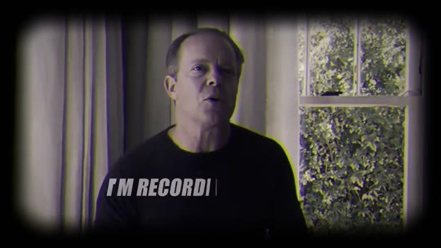  📷 0:00 — Abertura: Joe Dispenza (avatar) de suéter escuro diante de janela, com vinheta; lettering 'I'M RECORDING… IN CASE SOMETHING'  b01_dispenza_im_recording_vinheta_00-00-00.jpg | 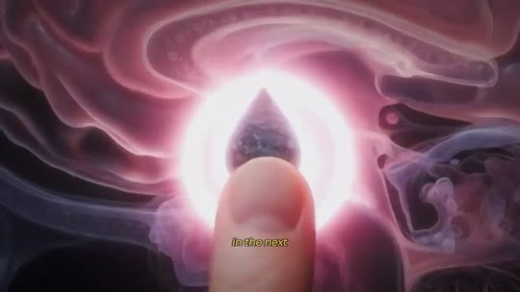  📷 0:04 — Dedo apertando botão brilhante rosa (o 'botão da manifestação')  b01_dedo_botao_rosa_manifestation_button_00-00-04.jpg
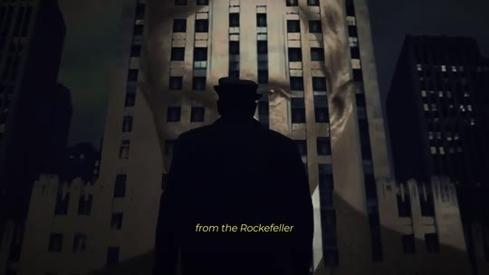  📷 0:08 — Silhueta diante do Rockefeller Center; legenda 'from the Rockefeller'  b01_rockefeller_center_silhueta_00-00-08.jpg | 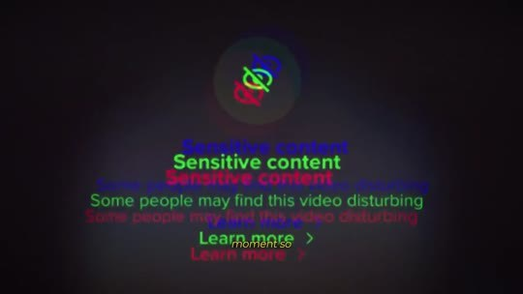  📷 0:16 — Tela 'Sensitive content — Some people may find this video disturbing' com efeito glitch  b01_tela_sensitive_content_00-00-16.jpg
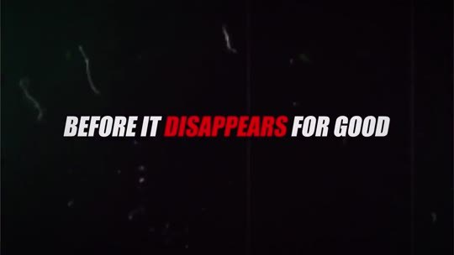  📷 0:20 — Lettering 'BEFORE IT DISAPPEARS FOR GOOD'  b01_lettering_before_it_disappears_00-00-20.jpg | 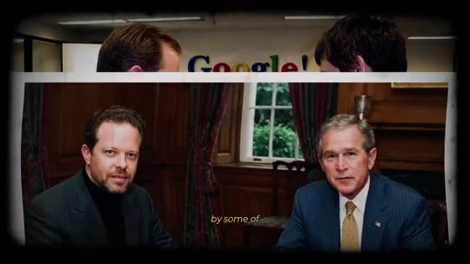  📷 0:24 — Foto de Dispenza ao lado de George W. Bush; legenda 'by some of'  b01_dispenza_com_bush_00-00-24.jpg
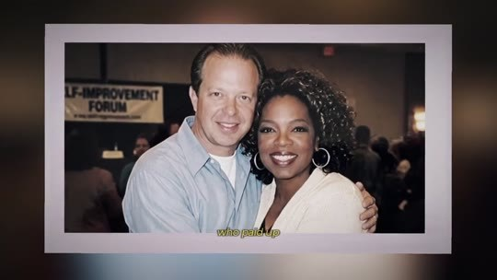  📷 0:28 — Foto de Dispenza com Oprah Winfrey  b01_dispenza_com_oprah_foto_00-00-28.jpg | 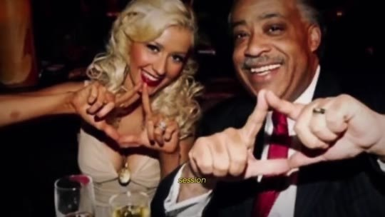  📷 0:30 — Christina Aguilera e Al Sharpton fazendo o triângulo com as mãos  b01_celebridades_triangulo_maos_00-00-30.jpg
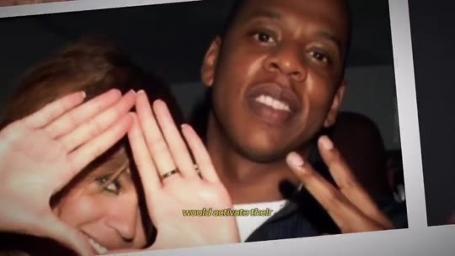  📷 0:32 — Jay-Z fazendo triângulo com as mãos  b01_jay_z_triangulo_maos_00-00-32.jpg | 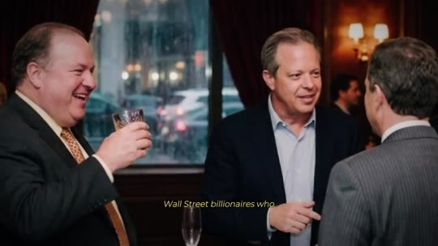  📷 0:36 — Homens de terno brindando; legenda 'Wall Street billionaires who'  b01_wall_street_brinde_00-00-36.jpg
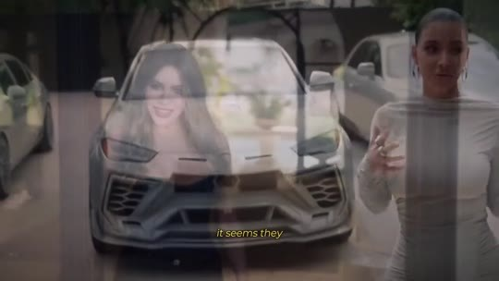
📷 0:46 — Mulher num carro de luxo; legenda 'manifest everything they'
b01_mulher_lamborghini_manifest_00-00-46.jpg

JOE DISPENZA (narrador, avatar): Estou gravando este vídeo caso algo aconteça comigo. Nos próximos minutos, vou te mostrar o botão da manifestação que liberta qualquer pessoa do sistema Rockefeller, aquele que mantém você pobre e eles ricos. Este vídeo está sendo apagado das plataformas neste exato momento, então vou direto ao ponto antes que ele suma de vez. Nos últimos 30 anos da minha vida, fui procurado por algumas das pessoas mais poderosas do planeta. Celebridades de Hollywood que pagavam até $40.000 por sessão só para que eu ativasse o terceiro olho delas antes de assinar contratos milionários de filmes. Bilionários de Wall Street que pediam para visitar a minha casa antes de cada grande decisão de mercado. Acredite em mim: o jeito como as celebridades manifestam tudo o que querem não é o que parece.

1.2 ⏱ 0:46 → 1:31
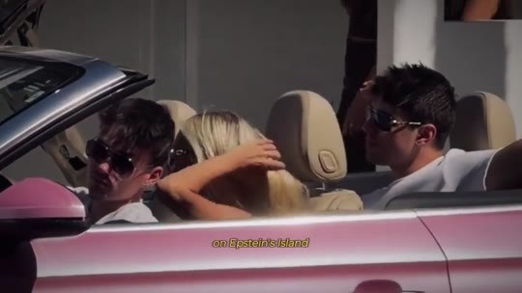  📷 0:50 — Casal num conversível rosa; legenda 'on Epstein's island'  b01_carro_rosa_epstein_island_00-00-50.jpg | 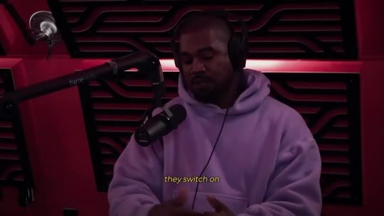  📷 0:54 — Kanye West (avatar) de moletom roxo em podcast; legenda 'they switch on'  b01_kanye_podcast_moletom_roxo_00-00-54.jpg
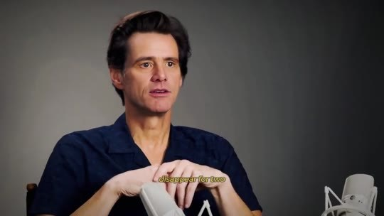  📷 1:02 — Jim Carrey (avatar) em entrevista  b01_jim_carrey_entrevista_00-01-02.jpg | 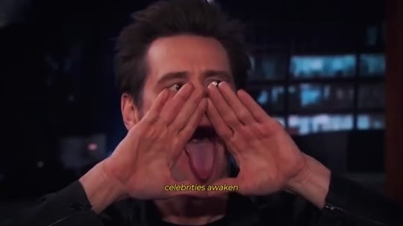  📷 1:06 — Jim Carrey fazendo o triângulo nos olhos num talk show  b01_jim_carrey_triangulo_talk_show_00-01-06.jpg
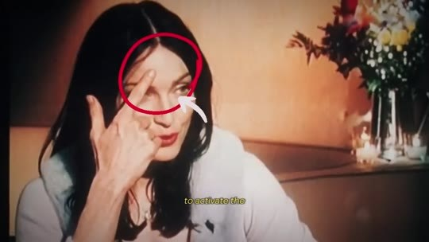  📷 1:12 — Mulher com círculo vermelho no terceiro olho  b01_mulher_circulo_terceiro_olho_00-01-12.jpg | 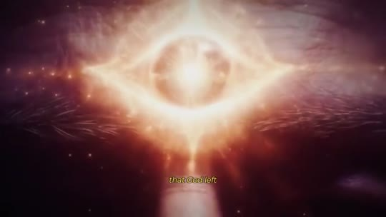  📷 1:14 — Olho cósmico de luz  b01_olho_cosmico_luz_00-01-14.jpg
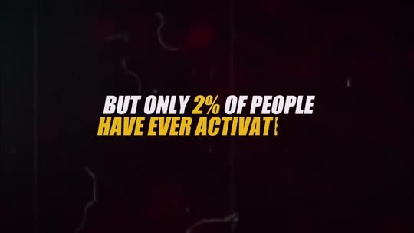  📷 1:18 — Lettering 'BUT ONLY 2% OF PEOPLE HAVE EVER ACTIVAT…'  b01_lettering_only_2_percent_00-01-18.jpg | 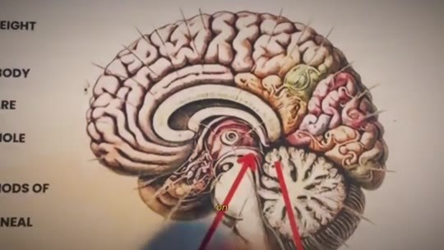  📷 1:20 — Desenho anatômico do cérebro com seta para a pineal  b01_cerebro_pineal_seta_00-01-20.jpg
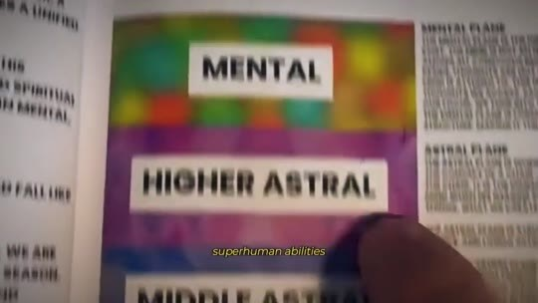
📷 1:22 — Livro com planos 'MENTAL / HIGHER ASTRAL'
b01_livro_mental_higher_astral_00-01-22.jpg

JOE DISPENZA (narrador, avatar): Todos escondem o que faziam na ilha do Epstein ou em retiros como o Bohemian Grove.
KANYE WEST (avatar, podcast): Eles ligam um botão no seu cérebro. Depois disso, você começa a atrair tudo o que quer: carros, dinheiro… Mas eles cobram um preço por isso.
JIM CARREY (avatar): Eu tive que sumir por 2 anos depois que comecei a falar sobre como as celebridades despertam o terceiro olho. Entrei na lista negra de Hollywood.
JOE DISPENZA (narrador, avatar): Vou te mostrar o que eles fazem para ativar o botão da manifestação que Deus deixou escondido no seu cérebro quando você nasceu, mas que só 2% das pessoas já ativaram. Quando ele está ligado, você desperta habilidades quase sobre-humanas, todas aquelas de que você já ouviu falar: manifestação, ler o ambiente, saber exatamente quais decisões tomar, a lei da atração.

1.3 ⏱ 1:31 → 2:21
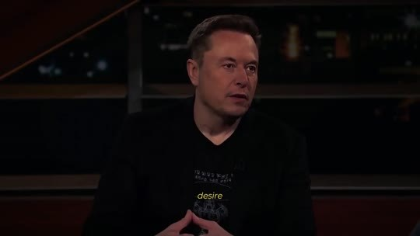  📷 1:32 — Elon Musk (avatar) em entrevista; legenda 'the moment this'  b01_elon_musk_entrevista_00-01-32.jpg | 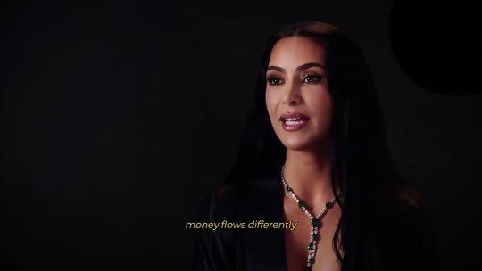  📷 1:40 — Kim Kardashian (avatar); legenda 'money flows differently'  b01_kim_kardashian_entrevista_00-01-40.jpg
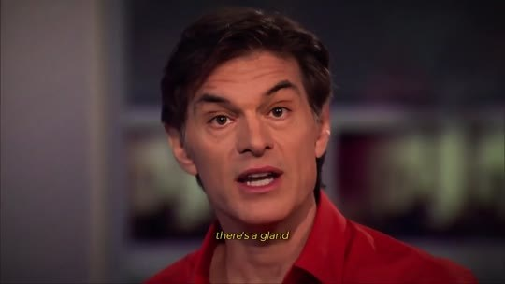  📷 1:48 — Dr. Oz (avatar) de camisa vermelha; legenda 'there's a gland'  b01_dr_oz_camisa_vermelha_00-01-48.jpg | 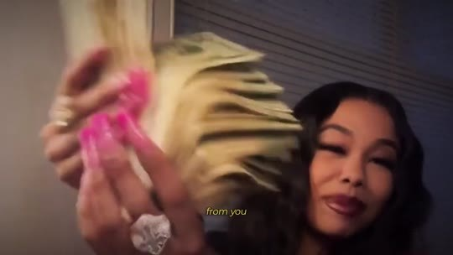  📷 2:00 — Mulher com leque de dinheiro; legenda 'from you'  b01_mulher_dinheiro_leque_00-02-00.jpg
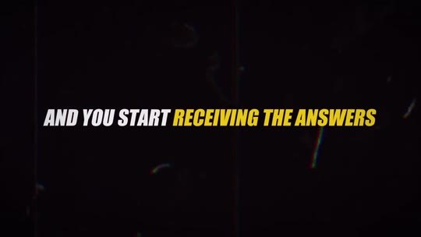  📷 2:06 — Lettering 'AND YOU START RECEIVING THE ANSWERS BEFORE THE QUESTIONS'  b01_lettering_receiving_the_answers_00-02-06.jpg | 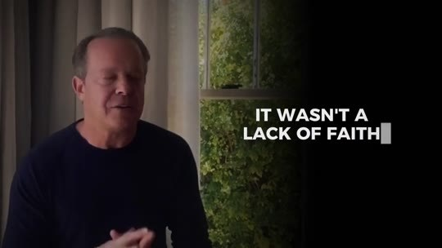  📷 2:12 — Dispenza; lettering 'IT WASN'T A LACK OF FAITH'  b01_lettering_lack_of_faith_00-02-12.jpg
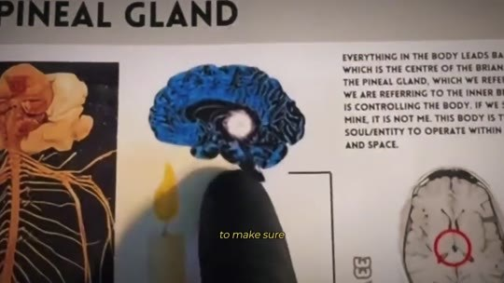
📷 2:18 — Infográfico 'PINEAL GLAND' com cérebro
b01_infografico_pineal_gland_00-02-18.jpg

ELON MUSK (avatar): Tudo o que eu desejo simplesmente se materializa no momento em que esse botão da manifestação está ativo. O Joe Dispenza me mostrou isso anos atrás.
KIM KARDASHIAN (avatar): Quando você aperta esse botão, o dinheiro flui de outro jeito. Oportunidades aparecem do nada. Você começa a operar numa frequência que a maioria das pessoas nunca vai acessar.
DR. OZ (avatar): Existe uma glândula no centro do seu cérebro que emite uma onda de energia que nenhuma outra parte do seu corpo emite. Os cientistas estão chamando-a de ponte para Deus.
JOE DISPENZA (narrador, avatar): Quando esse botão liga, o dinheiro para de fugir de você. O seu corpo se cura de coisas que os médicos não conseguem explicar, e você começa a receber as respostas antes das perguntas. E se você já tentou a lei da atração e nada mudou, não foi falta de fé. Eles não queriam que você soubesse. O sistema Rockefeller gastou bilhões para garantir que você nunca descobrisse que esse botão existe.

BLOCO 2 — O capítulo censurado de The Secret, o episódio com Joe Rogan derrubado, o ritual de 15 segundos e as 2 pílulas [2:22 – 3:32]

2.1 ⏱ 2:22 → 3:09
  📷 2:22 — Oprah Winfrey (avatar) falando sobre The Secret  b02_oprah_entrevista_the_secret_00-02-22.jpg | 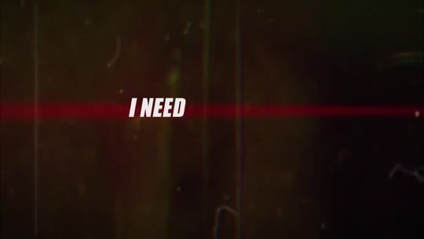  📷 2:38 — Lettering 'I NEED YOU TO PAY CLOSE ATTENTION'  b02_lettering_pay_close_attention_00-02-38.jpg
  📷 2:41 — Tela 'Video removed — Your video has been removed because it infringes on someone else's copyright'  b02_video_removed_copyright_00-02-41.jpg | 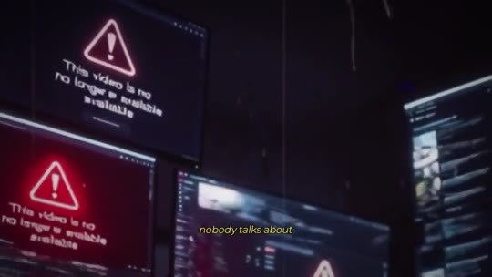  📷 2:45 — Telas com alerta 'This video is no longer available'  b02_telas_video_no_longer_available_00-02-45.jpg
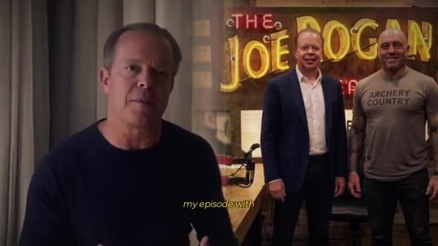  📷 2:48 — Dispenza com foto ao lado de Joe Rogan no letreiro 'The Joe Rogan'  b02_dispenza_joe_rogan_foto_00-02-48.jpg | 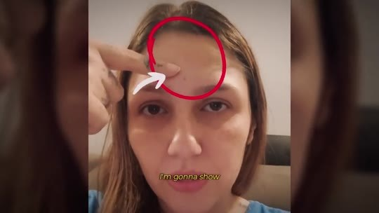  📷 2:54 — Mulher com os dedos no terceiro olho (círculo vermelho)  b02_mulher_dedos_testa_circulo_00-02-54.jpg
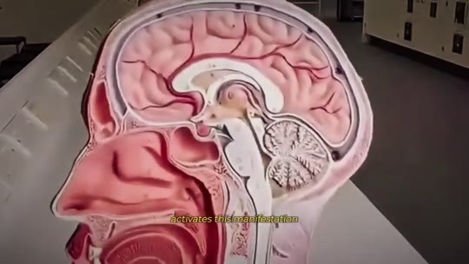  📷 2:59 — Modelo anatômico da cabeça mostrando a pineal  b02_anatomia_cabeca_pineal_00-02-59.jpg | 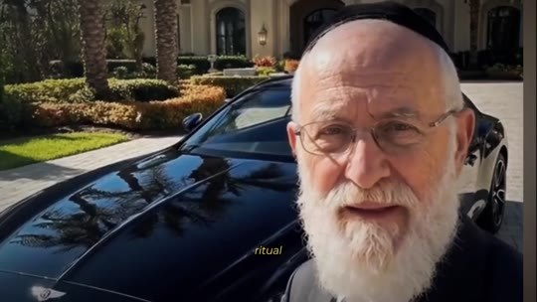  📷 3:04 — Rabino idoso diante de carro de luxo; legenda 'it's the same ritual'  b02_rabino_carro_luxo_00-03-04.jpg
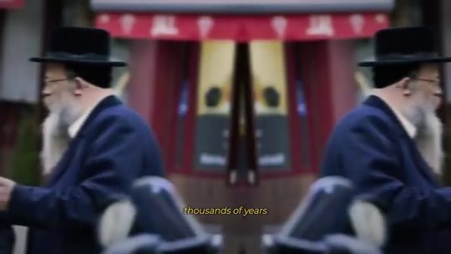  📷 3:06 — Judeus ortodoxos na rua; legenda 'have used for'  b02_judeus_ortodoxos_multidao_00-03-06.jpg | 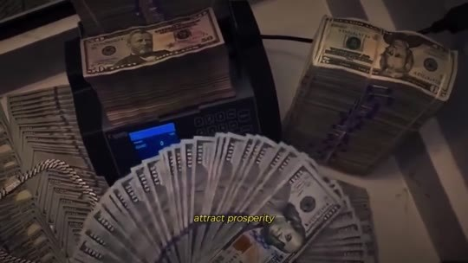  📷 3:09 — Máquina contando notas de dólar; legenda 'attract prosperity'  b02_maquina_contar_dinheiro_00-03-09.jpg

OPRAH WINFREY (avatar): Existe uma parte do livro O Segredo que nunca foi publicada. Ninguém tem coragem de falar sobre ela. É algo sobre um botão que manifesta tudo o que o seu coração deseja. O livro original, sem cortes, mostrava até como ativar esse botão no seu cérebro.
JOE DISPENZA (narrador, avatar): Preciso que você preste muita atenção. Este vídeo muito provavelmente vai ser derrubado hoje. Ninguém fala sobre isso. Fui silenciado por anos. O meu episódio com o Joe Rogan foi tirado do ar. Mas agora você tem a chance de assistir. Vou te mostrar, é, o ritual ancestral de 15 segundos que ativa esse botão da manifestação no centro do seu cérebro para atrair coisas sob demanda. É o mesmo ritual que o povo judeu usa há milhares de anos para pedir bênçãos a Deus e atrair prosperidade.

2.2 ⏱ 3:10 → 3:32
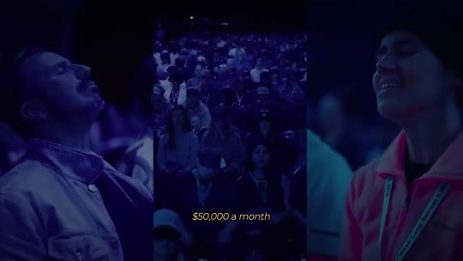  📷 3:12 — Plateia em show; legenda '$50,000 a month'  b02_celebridades_show_50000_month_00-03-12.jpg | 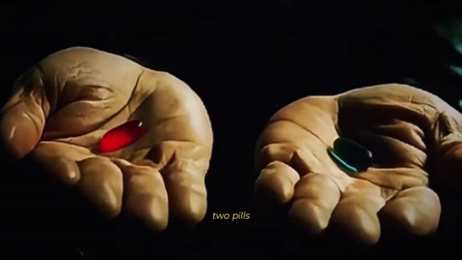  📷 3:18 — Mãos com as pílulas vermelha e azul; legenda 'two pills'  b02_maos_pilula_vermelha_azul_00-03-18.jpg
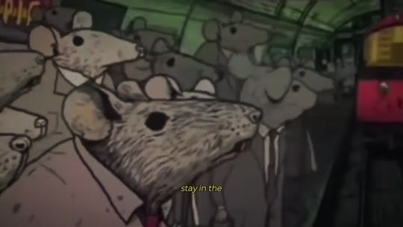  📷 3:20 — Desenho de ratos na corrida (rat race)  b02_ratos_corrida_cartoon_00-03-20.jpg |   📷 3:28 — Homem comemorando diante de caminhonete com laço; legenda 'magnet'  b02_homem_carro_presente_laco_00-03-28.jpg

JOE DISPENZA (narrador, avatar): Celebridades de Hollywood pagam até $50.000 por mês para ter acesso a esse ritual. A partir deste momento, você pode escolher entre 2 pílulas. Com uma, você fica na corrida dos ratos construída pelo sistema Rockefeller. Com a outra, você descobre como ativar o botão que transforma o seu cérebro num ímã, atraindo as bênçãos que foram trancadas e roubadas de você.

BLOCO 3 — QUEM É JOE DISPENZA: o botão nasceu com você, as 6 vértebras fraturadas, a glândula pineal e a pinha do Vaticano [3:32 – 5:43]

3.1 ⏱ 3:32 → 4:14
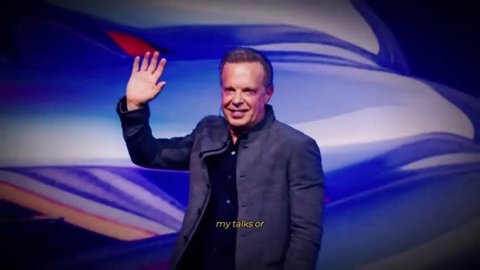  📷 3:34 — Dispenza num palco acenando; legenda 'my books'  b03_palestra_dispenza_palco_00-03-34.jpg | 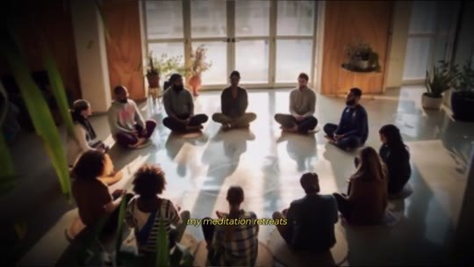  📷 3:36 — Grupo meditando numa sala ensolarada (retiro)  b03_retiro_meditacao_sala_00-03-36.jpg
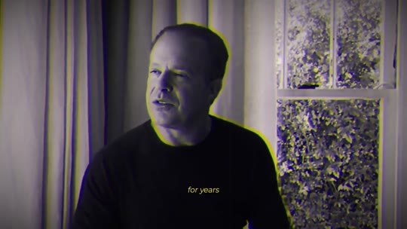  📷 3:42 — Cabeça cósmica roxa com luz na testa; legenda 'manifest'  b03_cabeca_cosmica_manifest_00-03-42.jpg | 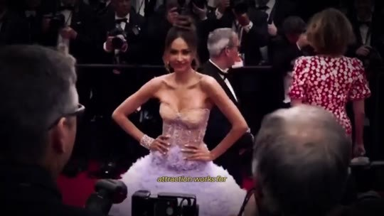  📷 3:52 — Celebridades em tapete vermelho com fotógrafos  b03_tapete_vermelho_celebridades_00-03-52.jpg
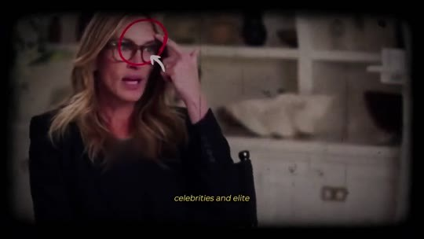  📷 3:58 — Jim Carrey num talk show com círculo na testa; legenda 'know how to'  b03_jim_carrey_circulo_testa_00-03-58.jpg | 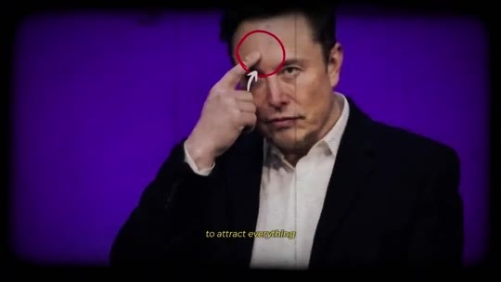  📷 4:02 — Elon Musk com o dedo na testa (círculo vermelho)  b03_elon_musk_dedo_testa_00-04-02.jpg
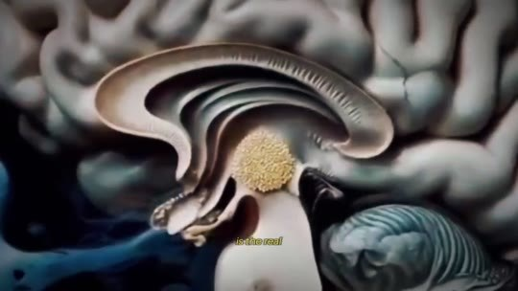  📷 4:10 — Corte do cérebro com pineal destacada em laranja; legenda 'manifestation button'  b03_cerebro_pineal_laranja_00-04-10.jpg | 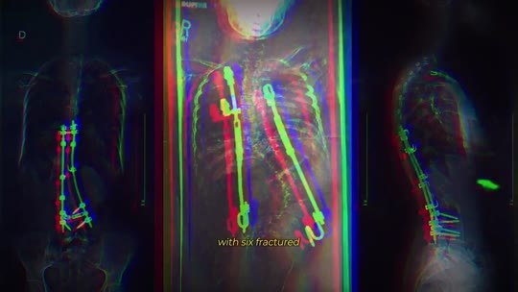  📷 4:12 — Raio-x da coluna com hastes metálicas; legenda 'with six fractured'  b03_raio_x_coluna_parafusos_00-04-12.jpg

JOE DISPENZA (narrador, avatar): Você talvez me conheça dos meus livros, das minhas palestras ou dos meus retiros de meditação, mas o que vou revelar agora fui impedido de falar por anos. A sua capacidade de manifestar e criar a sua própria realidade não é um dom que só algumas pessoas têm. Você nasceu com ela. E aqui está o motivo pelo qual a lei da atração funciona para a elite de Hollywood, mas nunca funcionou para você. O deep state, as celebridades e os atletas de elite sabem como ativar o botão da manifestação para atrair tudo o que querem. Enquanto isso, o seu foi desligado silenciosamente. Esse botão da manifestação é o verdadeiro motivo pelo qual eu saí de uma cama de hospital com 6 vértebras fraturadas na coluna.

3.2 ⏱ 4:15 → 4:58
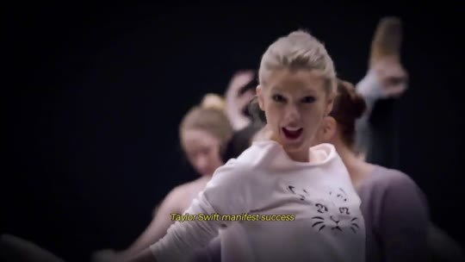  📷 4:16 — Taylor Swift no palco  b03_taylor_swift_palco_00-04-16.jpg | 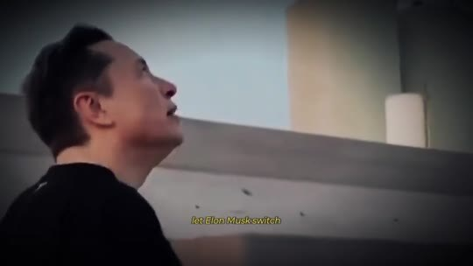  📷 4:18 — Elon Musk olhando para cima; legenda 'superintelligence'  b03_elon_musk_olhando_cima_00-04-18.jpg
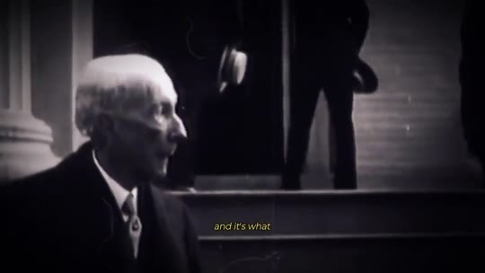  📷 4:22 — Foto antiga em preto e branco (Rockefeller)  b03_rockefeller_pb_00-04-22.jpg | 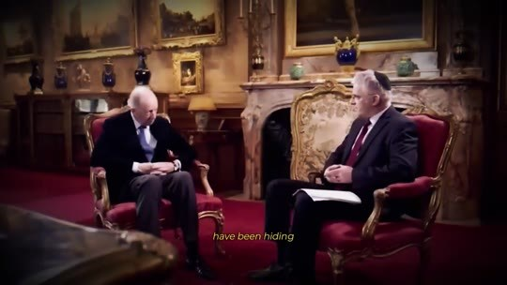  📷 4:24 — Homens idosos sentados num salão; legenda 'have been hiding'  b03_senhores_salao_familias_00-04-24.jpg
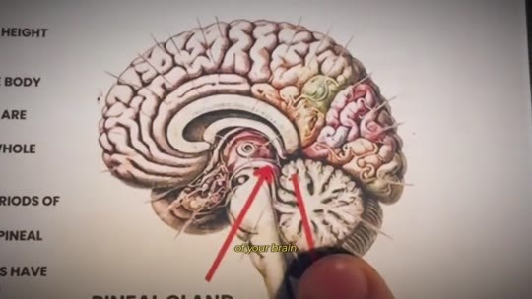  📷 4:30 — Livro com planos 'PHYSICAL / ETHERIC / MENTAL'  b03_livro_planos_physical_etheric_00-04-30.jpg | 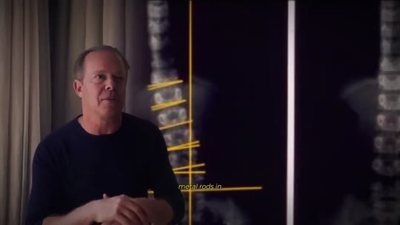  📷 4:38 — Raio-x da coluna; legenda 'four surgeries'  b03_raio_x_coluna_four_surgeries_00-04-38.jpg
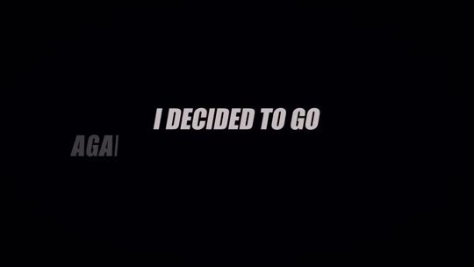  📷 4:42 — Lettering 'I DECIDED TO GO AGAINST'  b03_lettering_i_decided_to_go_00-04-42.jpg | 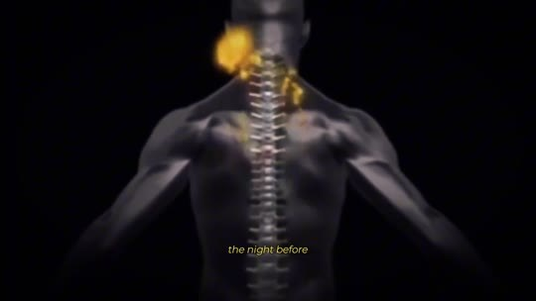  📷 4:44 — Corpo 3D com coluna iluminada; legenda 'the night before'  b03_corpo_3d_coluna_luz_00-04-44.jpg
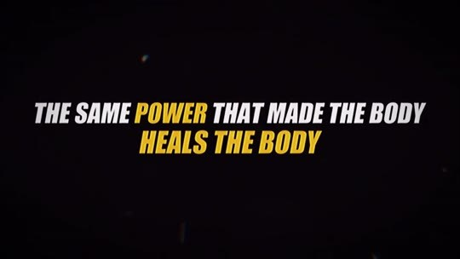
📷 4:52 — Lettering 'THE SAME POWER THAT MADE THE BODY HEALS THE BODY'
b03_lettering_same_power_heals_00-04-52.jpg

JOE DISPENZA (narrador, avatar): Foi o que fez a Taylor Swift manifestar o sucesso, o que permitiu ao Elon Musk ligar a superinteligência do cérebro para construir o seu império, e é o que as 3 famílias mais poderosas vêm escondendo há mais de 100 anos para manter você sob controle. É esse botão no centro do seu cérebro que, uma vez ativado, transforma em realidade tudo o que você manifesta. Quando os médicos me disseram que eu precisaria de 4 cirurgias, hastes de metal na coluna, e que mesmo assim talvez eu nunca mais andasse, decidi ir contra tudo o que eles disseram. Na noite anterior à cirurgia, ouvi uma voz na minha cabeça dizendo as palavras que mudaram tudo para mim. O mesmo poder que criou o corpo cura o corpo. Eu trabalhava como quiroprata e sempre fui fascinado por como o corpo humano funciona.

3.3 ⏱ 4:58 → 5:43
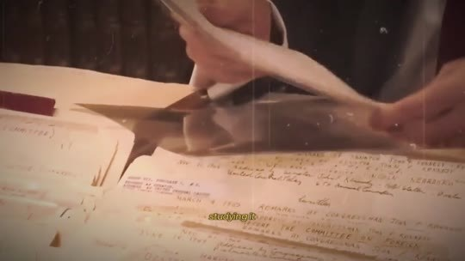  📷 5:00 — Livros antigos sendo folheados  b03_livros_antigos_manuscrito_00-05-00.jpg | 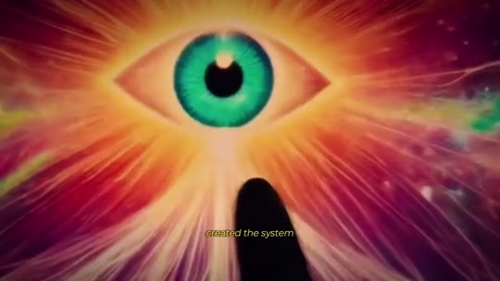  📷 5:08 — Olho colorido gigante com dedo apontando  b03_olho_colorido_dedo_00-05-08.jpg
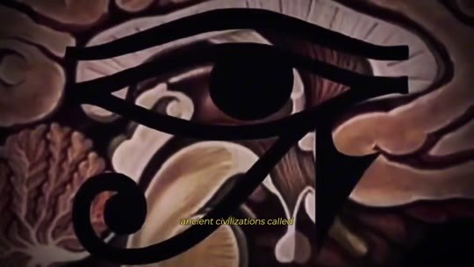  📷 5:16 — Desenho do Olho de Hórus  b03_olho_de_horus_desenho_00-05-16.jpg | 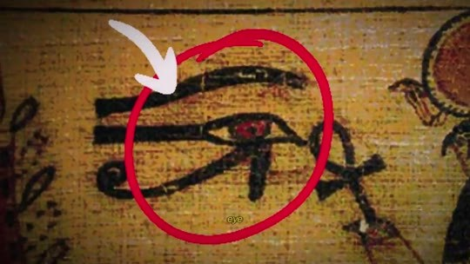  📷 5:18 — Olho de Hórus em parede egípcia (círculo vermelho)  b03_olho_de_horus_parede_egipcia_00-05-18.jpg
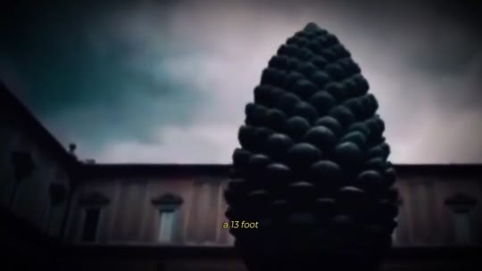  📷 5:24 — Pinha gigante do Vaticano  b03_pinha_gigante_vaticano_00-05-24.jpg | 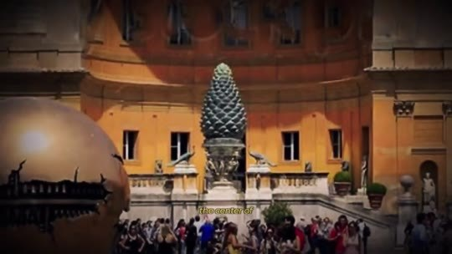  📷 5:26 — Pátio do Vaticano com a pinha  b03_patio_pinha_vaticano_00-05-26.jpg
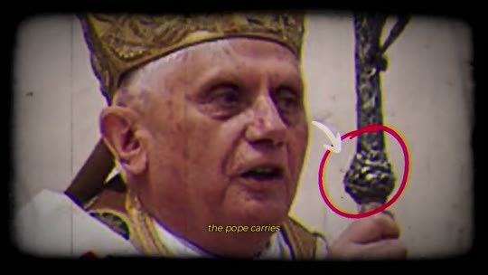  📷 5:30 — Papa Bento XVI com cajado (círculo vermelho na pinha)  b03_papa_bento_cajado_pinha_00-05-30.jpg | 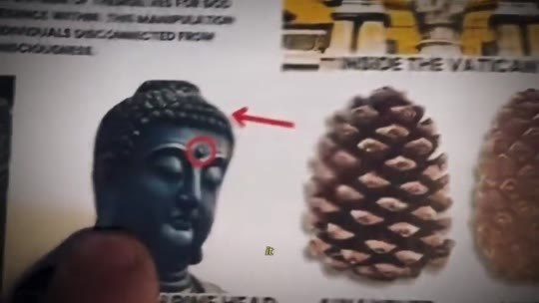  📷 5:43 — Ilustração: Buda com ponto na testa e pinha 'INSIDE THE VATICAN'  b03_buda_pinha_inside_vatican_00-05-43.jpg

JOE DISPENZA (narrador, avatar): E, depois de tantos anos estudando, havia uma coisa de que eu tinha certeza. Era um design tão perfeito que não podia ser um acidente. Alguma inteligência superior criou o sistema, e havia uma estrutura específica que sempre me chamou a atenção. A glândula pineal. Civilizações antigas a chamavam de terceiro olho ou Olho de Hórus. Os egípcios a desenhavam dentro das pirâmides. O Vaticano tem uma pinha de 4 metros bem no centro do seu pátio principal, exatamente com o formato dessa glândula. O Papa também carrega um cajado com uma pinha. Todos sabiam que essa parte do seu cérebro carrega um poder superior. Então por que ela foi esquecida? A verdade é que ela não foi esquecida. Foi apagada de propósito para que você nunca ouvisse falar dela.

BLOCO 4 — O ESCÂNDALO MAIOR QUE O DE EPSTEIN: as 3 famílias, os Rockefeller, os nazistas, o segredo dos judeus e 1945 [5:43 – 7:37]

4.1 ⏱ 5:43 → 6:25
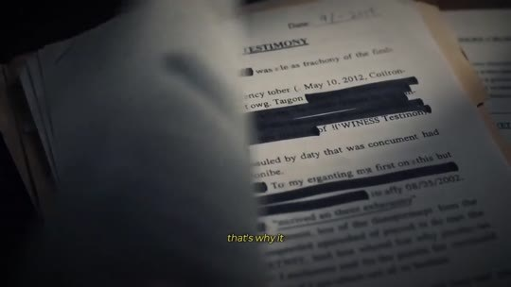  📷 5:51 — Documento tarjado 'WITNESS TESTIMONY'  b04_documento_tarjado_witness_00-05-51.jpg | 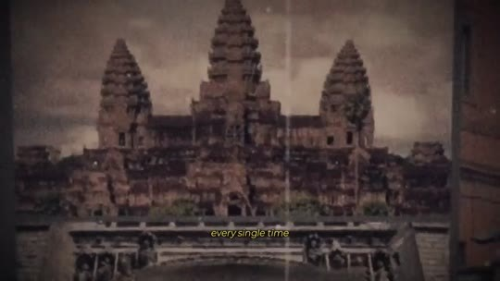  📷 5:59 — Templo com torres em forma de pinha  b04_templo_angkor_pinha_00-05-59.jpg
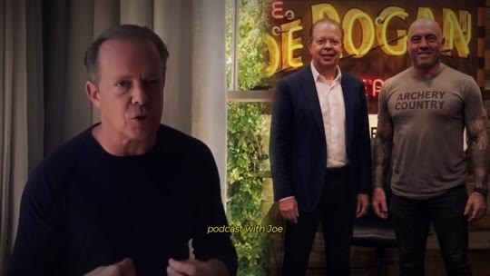  📷 6:05 — Dispenza com o letreiro do Joe Rogan ao fundo; legenda 'podcast with'  b04_joe_rogan_letreiro_dispenza_00-06-05.jpg | 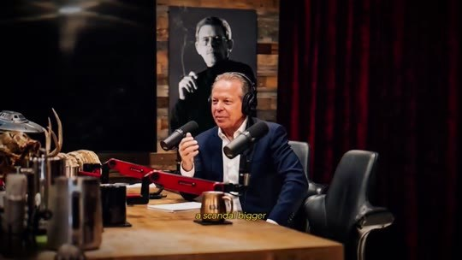  📷 6:11 — Estúdio do Joe Rogan: Dispenza à mesa com microfone  b04_rogan_estudio_dispenza_mesa_00-06-11.jpg
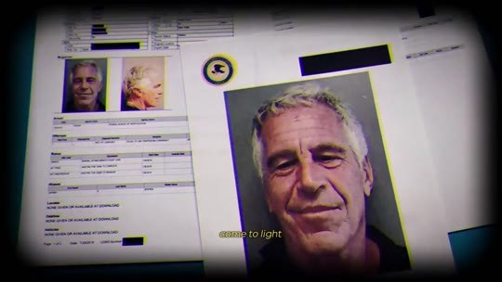  📷 6:13 — Ficha policial de Jeffrey Epstein  b04_epstein_ficha_00-06-13.jpg | 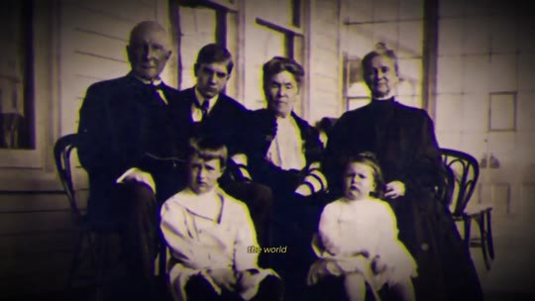  📷 6:15 — Família antiga em preto e branco (Rockefeller)  b04_familia_rockefeller_pb_00-06-15.jpg
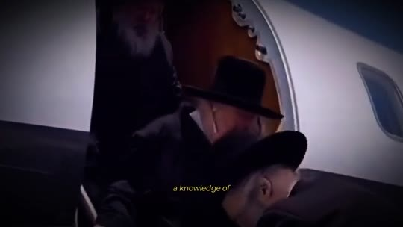
📷 6:19 — Rabino num avião; legenda 'a knowledge of'
b04_rabino_aviao_00-06-19.jpg

JOE DISPENZA (narrador, avatar): Quando comecei a investigar isso, descobri que estava me envolvendo num dos maiores escândalos da história recente, maior que o de Epstein. Foi por isso que levei 30 anos para vir a público falar sobre isso. Fui silenciado por anos, e é aqui que a história fica sombria. Toda vez que eu começava a falar sobre isso, era calado. Gravei um podcast com o Joe Rogan um tempo atrás expondo tudo, e em menos de 24 horas ele foi tirado do ar. Um escândalo maior que o de Epstein está prestes a vir à tona. Existem 3 famílias que comandam o mundo, e a principal é a dos Rockefeller. Eles roubaram dos judeus um conhecimento sobre como atrair coisas sob demanda e o esconderam do resto da população para controlar você.

4.2 ⏱ 6:26 → 7:09
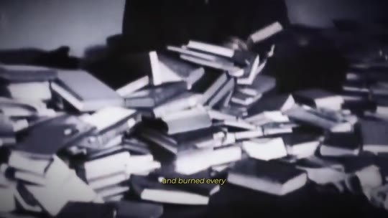  📷 6:27 — Pilha de livros (queima); legenda 'and burned every'  b04_livros_queimados_pilha_00-06-27.jpg | 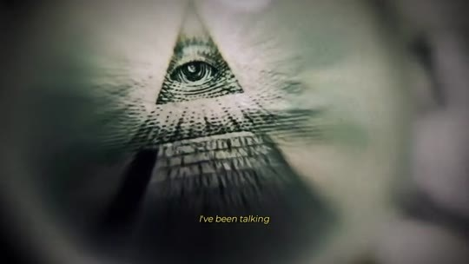  📷 6:31 — Olho na pirâmide da nota de dólar  b04_olho_piramide_nota_dolar_00-06-31.jpg
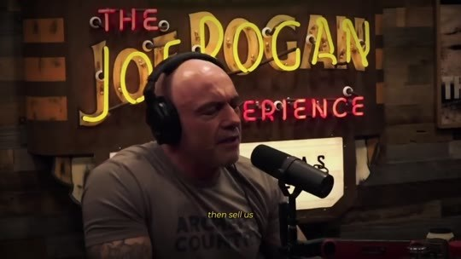  📷 6:37 — Joe Rogan (avatar) no estúdio, letreiro 'The Joe Rogan Experience'  b04_joe_rogan_microfone_00-06-37.jpg | 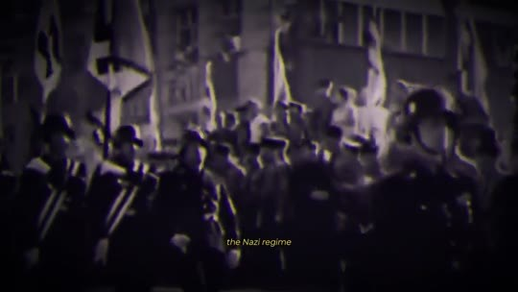  📷 6:43 — Marcha em preto e branco; legenda 'the Nazi regime'  b04_regime_nazista_pb_00-06-43.jpg
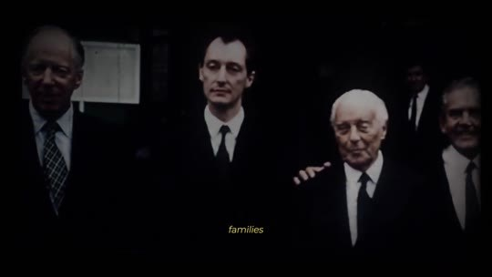  📷 6:55 — Retrato em preto e branco de George Soros; legenda '97% of the'  b04_soros_pb_00-06-55.jpg | 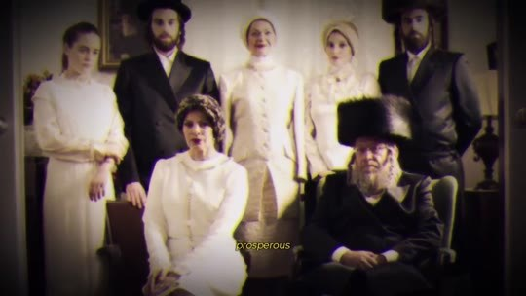  📷 7:05 — Família judaica em casamento; legenda 'among the'  b04_familia_judaica_casamento_00-07-05.jpg
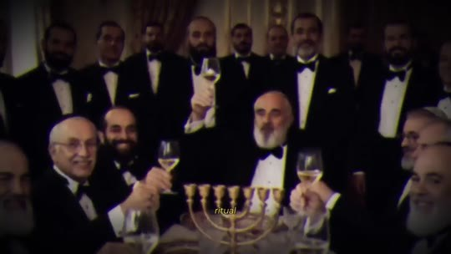
📷 7:07 — Homens à mesa com menorá
b04_judeus_mesa_menora_00-07-07.jpg

JOE DISPENZA (narrador, avatar): Eles apagaram e queimaram todos os livros que guardavam esse conhecimento.
JOE ROGAN (avatar, podcast): Puta merda! Eu falo disso há anos. O deep state nos controla para que a gente trabalhe para eles. Eles nos deixam doentes e depois nos vendem a cura. Mas de que conhecimento você está falando?
JOE DISPENZA (narrador, avatar): Exatamente isso, Joe. Os Rockefeller financiaram o regime nazista e, em troca, ganharam acesso a arquivos com o segredo dos judeus, o segredo que os fez prosperar por séculos. Rockefeller usou esse segredo para fazer o seu império crescer e o compartilhou com outras 3 famílias que hoje detêm 97% de toda a fortuna do mundo.
JOE ROGAN (avatar, podcast): Os judeus sempre estiveram entre as pessoas mais ricas do planeta. Eles são donos dos grandes bancos. Então eles sempre foram prósperos porque tinham algum tipo de ritual para ativar o terceiro olho?

4.3 ⏱ 7:09 → 7:37
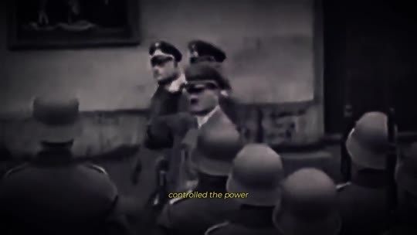  📷 7:13 — Hitler com tropas em preto e branco  b04_hitler_tropas_pb_00-07-13.jpg | 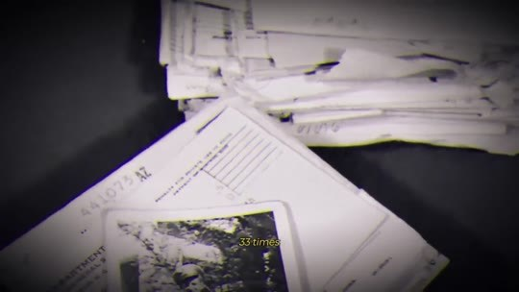  📷 7:19 — Papéis do 'diário' espalhados; legenda 'in his diary'  b04_diario_hitler_papeis_00-07-19.jpg
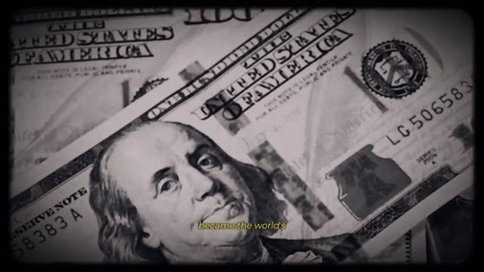  📷 7:31 — Nota de 100 dólares; legenda 'the world's currency'  b04_nota_dolar_dollar_became_00-07-31.jpg | 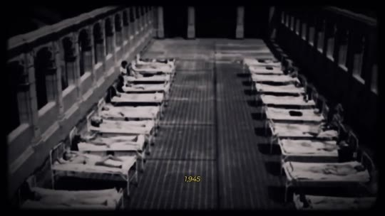  📷 7:35 — Enfermaria antiga; legenda '1945'  b04_hospital_antigo_1945_00-07-35.jpg

JOE ROGAN (avatar, podcast): É por isso que eles foram perseguidos?
JOE DISPENZA (narrador, avatar): Sim. Hitler acreditava que quem controlasse o poder da pineal controlaria nações inteiras. Ele menciona o terceiro olho e a pineal cerca de 33 vezes no seu diário, encontrado anos depois.
JOE ROGAN (avatar, podcast): E o que os Rockefeller ganharam com isso?
JOE DISPENZA (narrador, avatar): Depois da guerra, eles assumiram o controle tanto da indústria farmacêutica quanto do sistema financeiro. Ou você acha que é coincidência o dólar ter virado a moeda mundial e os problemas de saúde terem disparado logo depois de 1945?

BLOCO 5 — O SISTEMA: a corrida dos ratos, celebridades fantoches, rituais de iniciação e o programa tirado do ar [7:38 – 9:15]

5.1 ⏱ 7:38 → 8:21
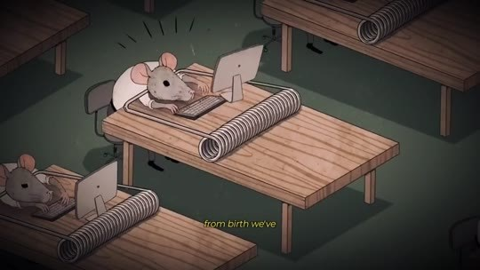  📷 7:38 — Desenho de ratos trabalhando em mesas; legenda 'from birth we've'  b05_ratos_mesa_escritorio_cartoon_00-07-38.jpg | 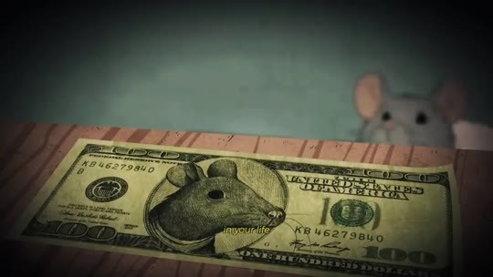  📷 7:46 — Rato com nota de dólar  b05_rato_nota_dolar_00-07-46.jpg
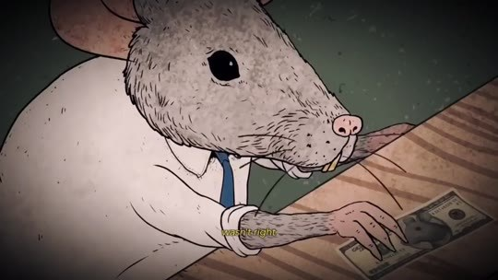  📷 7:48 — Rato de terno na mesa; legenda 'pay the bills'  b05_rato_terno_mesa_00-07-48.jpg | 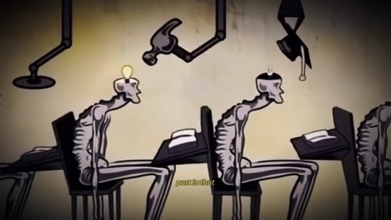  📷 7:56 — Esqueletos trabalhando sentados (cartoon)  b05_esqueletos_trabalhando_00-07-56.jpg
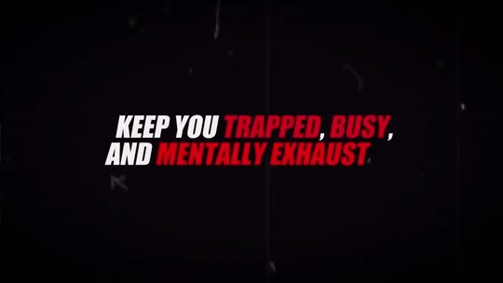  📷 8:01 — Lettering 'KEEP YOU TRAPPED, BUSY, AND MENTALLY EXHAUSTED'  b05_lettering_keep_you_trapped_00-08-01.jpg | 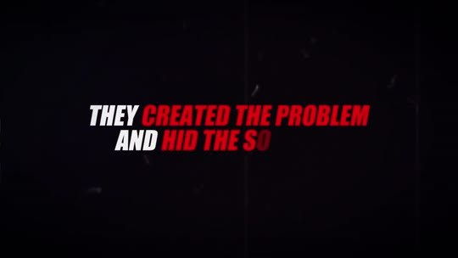  📷 8:06 — Lettering 'THEY CREATED THE PROBLEM AND HID THE SOLUTION'  b05_lettering_created_problem_00-08-06.jpg
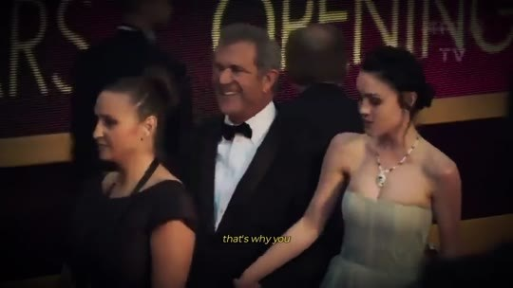  📷 8:11 — Celebridades no Oscar; legenda 'see hundreds of'  b05_oscar_celebridades_00-08-11.jpg | 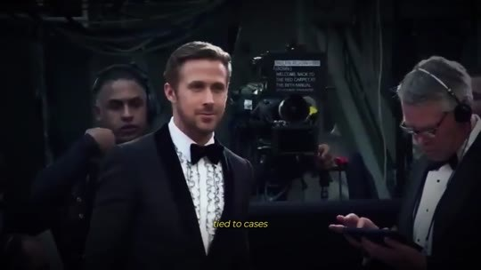  📷 8:15 — Ryan Gosling no Oscar; legenda 'like Epstein's'  b05_ryan_gosling_oscar_00-08-15.jpg

JOE DISPENZA (narrador, avatar): Desde o nascimento, fomos condicionados a acreditar que a vida se resume a trabalhar, se aposentar e tentar se manter saudável. Tenho certeza de que, em algum momento da vida, você sentiu que faltava alguma coisa, que algo não estava certo. Mas como questionar isso quando você está sempre ocupado tentando pagar as contas, sem tempo para parar e pensar? A parte mais perturbadora é que esse sempre foi o plano deles: manter você preso, ocupado e mentalmente exausto, para que você nunca tenha tempo de questionar o sistema. Eles criaram o problema e esconderam a solução. Assim, todo o poder ficou nas mãos de pouquíssimos. É por isso que você vê centenas de celebridades alcançando fama repentina, muitas delas ligadas a casos como o de Epstein. Para ter acesso ao segredo do terceiro olho, elas tiveram que virar fantoches dos poderosos.

5.2 ⏱ 8:22 → 9:06
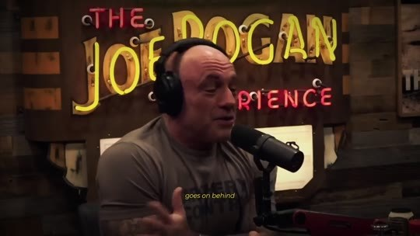  📷 8:22 — Joe Rogan; legenda 'goes on behind the scenes'  b05_rogan_behind_the_scenes_00-08-22.jpg | 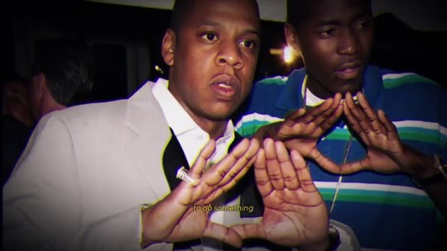  📷 8:25 — Jay-Z fazendo triângulo com as mãos  b05_jay_z_triangulo_00-08-25.jpg
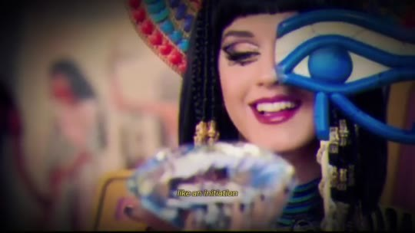  📷 8:27 — Katy Perry com o Olho de Hórus  b05_katy_perry_olho_horus_00-08-27.jpg | 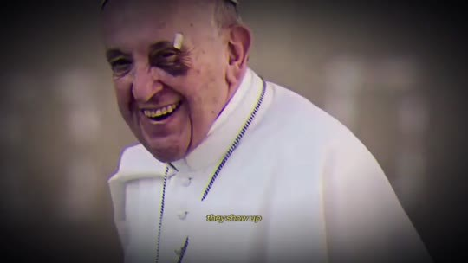  📷 8:30 — Papa Francisco com olho roxo; legenda 'show up with a black eye'  b05_papa_olho_roxo_00-08-30.jpg
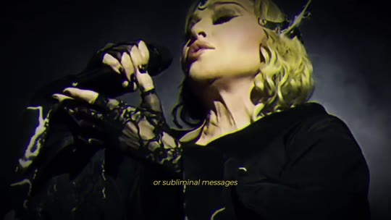  📷 8:33 — Madonna; legenda 'or subliminal messages'  b05_madonna_mensagens_subliminares_00-08-33.jpg | 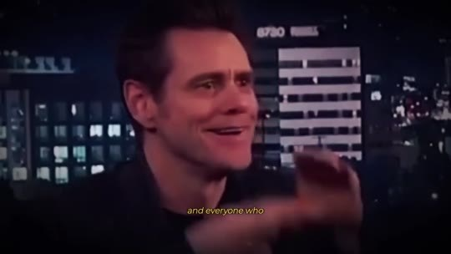  📷 8:38 — Jim Carrey fazendo triângulo no talk show; legenda 'and everyone who'  b05_jim_carrey_triangulo_kimmel_00-08-38.jpg

JOE ROGAN (avatar, podcast): Eu sei o que acontece nos bastidores. Cada uma dessas celebridades tem que fazer algo como um ritual de iniciação, uma tatuagem, ou aparecem com um olho roxo, ou com mensagens subliminares escondidas nos discos. Só quem aceita o controle deles consegue ter sucesso, e todo mundo que tentou expor isso desapareceu. Em outras palavras, a elite construiu um sistema em que, de um jeito ou de outro, todos são controlados por ela.
JOE DISPENZA (narrador, avatar): Mas, assim como os judeus, a maioria das pessoas também pode escapar desse sistema. Eles herdaram, milhares de anos atrás, um segredo que ativa esse botão da manifestação. Foi exatamente neste momento, quando eu estava prestes a revelar tudo sobre como ativar a pineal, que o programa foi tirado do ar.

5.3 ⏱ 9:06 → 9:15
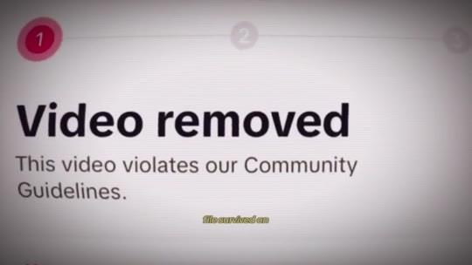
📷 9:08 — Tela 'Video removed — This video violates our Community Guidelines'; legenda 'not a single'
b05_video_removed_community_guidelines_00-09-08.jpg

JOE DISPENZA (narrador, avatar): Nem um único arquivo sobreviveu na internet. Mas isso acaba hoje. Vou te mostrar como se libertar do sistema Rockefeller.

BLOCO 6 — MECANISMO: a antena (TV), as vibrações do universo e por que os judeus prosperam (Nobel, Forbes) [9:16 – 10:48]

6.1 ⏱ 9:16 → 10:00
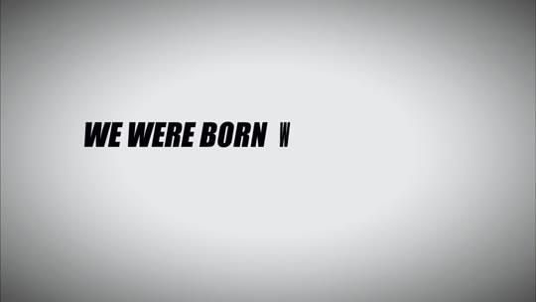  📷 9:16 — Lettering 'WE WERE BORN WITH A DIRECT CONNECTION TO THE CREATOR'  b06_lettering_born_direct_connection_00-09-16.jpg | 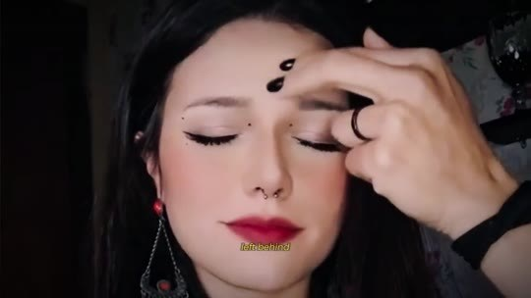  📷 9:19 — Mulher com os dedos na testa e pontos marcados  b06_mulher_dedos_testa_pontos_00-09-19.jpg
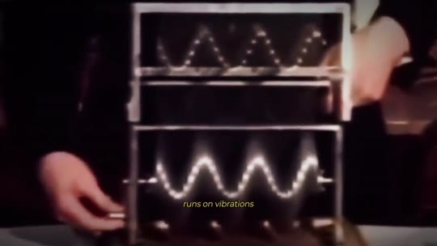  📷 9:26 — Onda num aparelho; legenda 'the entire universe runs on vibrations'  b06_onda_osciloscopio_vibracoes_00-09-26.jpg | 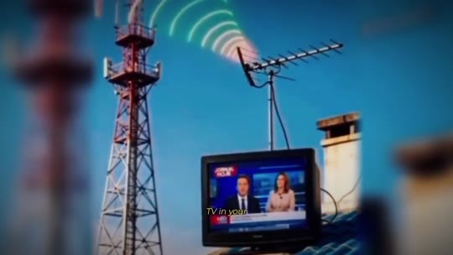  📷 9:28 — Torre de transmissão e TV; legenda 'think about the TV'  b06_antena_tv_transmissao_00-09-28.jpg
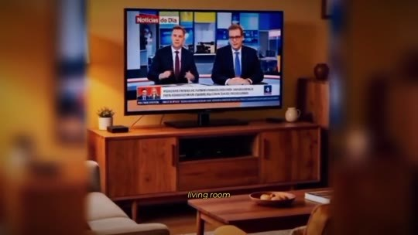  📷 9:35 — TV na sala com telejornal  b06_tv_sala_noticias_00-09-35.jpg | 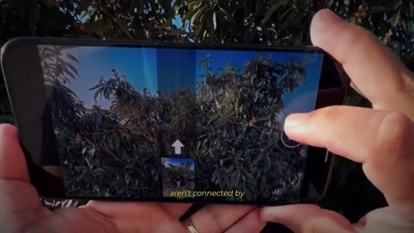  📷 9:38 — Celular gravando árvore; legenda 'the camera filming it'  b06_celular_gravando_arvore_00-09-38.jpg
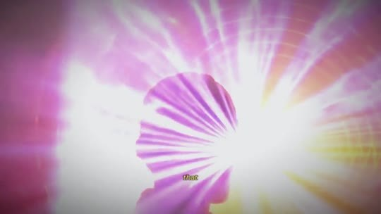  📷 9:46 — Silhueta de cabeça com explosão de luz  b06_silhueta_cabeca_explosao_luz_00-09-46.jpg | 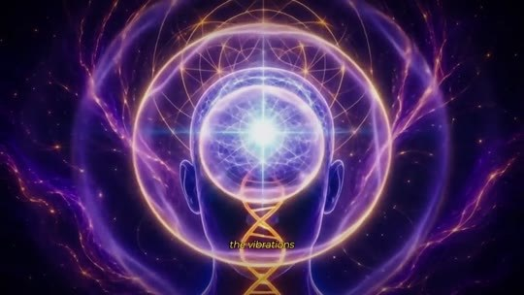  📷 9:48 — Cérebro cósmico com DNA; legenda 'it picks up and sends out'  b06_cerebro_dna_cosmico_00-09-48.jpg
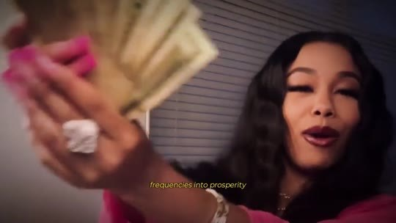
📷 9:54 — Mulher jogando dinheiro; legenda 'into prosperity'
b06_mulher_dinheiro_prosperity_00-09-54.jpg

JOE DISPENZA (narrador, avatar): Nós nascemos com uma conexão direta com o Criador, a ponte que Ele deixou para que pudéssemos continuar nos comunicando com Ele. E aqui está a chave que liga tudo: o universo inteiro funciona por vibrações. Pense na TV da sua casa. Ela capta o sinal de algo que está acontecendo ao vivo em outro lugar e o transforma numa imagem real na sua sala. A câmera que filma e a sua TV não estão ligadas por nenhum cabo. As vibrações viajam de um aparelho para o outro. Quando você aperta esse botão da manifestação, ele faz exatamente isso. Ele capta e envia as vibrações do universo. Quando está funcionando, o seu corpo traduz essas frequências mais altas em prosperidade, saúde, bons relacionamentos, intuição e sorte, aqui mesmo nesta realidade.

6.2 ⏱ 10:01 → 10:48
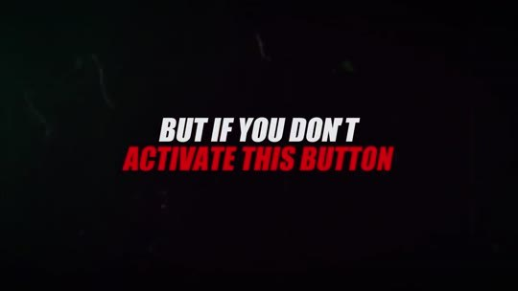  📷 10:02 — Lettering 'BUT IF YOU DON'T ACTIVATE THIS BUTTON'  b06_lettering_but_if_you_dont_00-10-02.jpg | 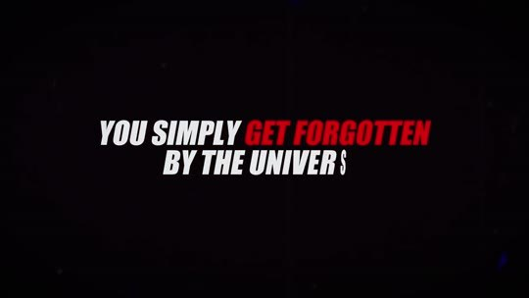  📷 10:04 — Lettering 'YOU SIMPLY GET FORGOTTEN BY THE UNIVERSE'  b06_lettering_forgotten_by_universe_00-10-04.jpg
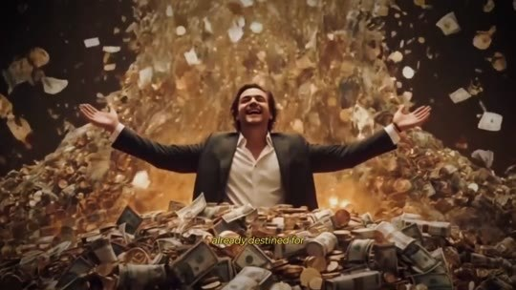  📷 10:06 — Homem de braços abertos sob chuva de dinheiro  b06_homem_chuva_dinheiro_00-10-06.jpg | 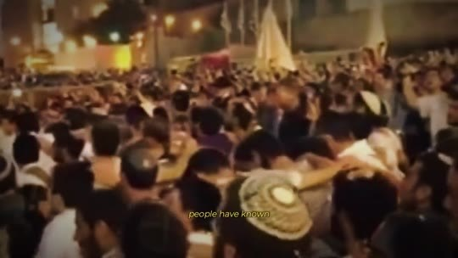  📷 10:15 — Multidão judaica; legenda 'people have'  b06_multidao_judaica_rua_00-10-15.jpg
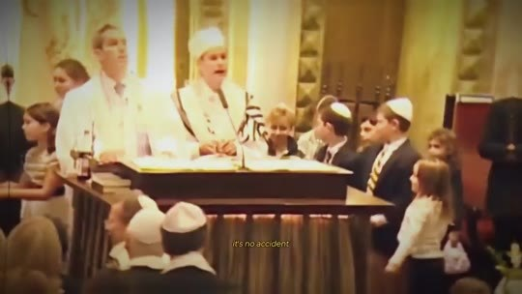
📷 10:17 — Rabinos numa sinagoga; legenda 'it's no accident'
b06_sinagoga_rabinos_00-10-17.jpg

JOE DISPENZA (narrador, avatar): Mas se você não ativa esse botão, simplesmente é esquecido pelo universo. Coisas que já estavam destinadas a você, que só precisavam se materializar, desaparecem. É como se Deus não conseguisse te ouvir. Mas existe um jeito de ligar esse botão, um que o povo judeu conhece há milhares de anos. Não é por acaso que, mesmo diante da perseguição, eles continuam sendo o povo mais próspero do planeta. Eles têm 37% de todos os prêmios Nobel, apesar de serem só 0,2% da população mundial, e, a cada 4 bilionários da lista da Forbes, 1 é judeu. Quer saber o segredo deles? Como continuam prosperando mesmo sob perseguição? A vibração sonora exata que ativa o botão da manifestação, colocando você num estado em que tudo o que deseja pode ser manifestado.

BLOCO 7 — A HARPA DO REI DAVI: Salomão, Saul (1 Samuel 16:23) e Eliseu (2 Reis 3:15) [10:49 – 12:23]

7.1 ⏱ 10:49 → 11:33
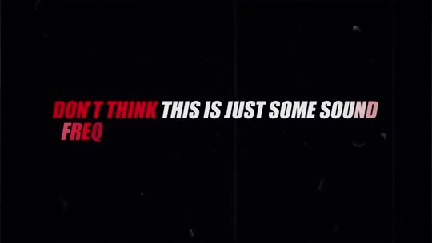  📷 10:50 — Lettering 'DON'T THINK THIS IS JUST SOME SOUND FREQUENCY YOU'VE SEEN ON YOUTUBE'  b07_lettering_dont_think_frequency_00-10-50.jpg | 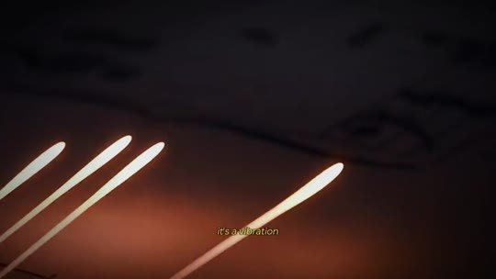  📷 10:53 — Partitura com notas brilhando  b07_partitura_brilho_00-10-53.jpg
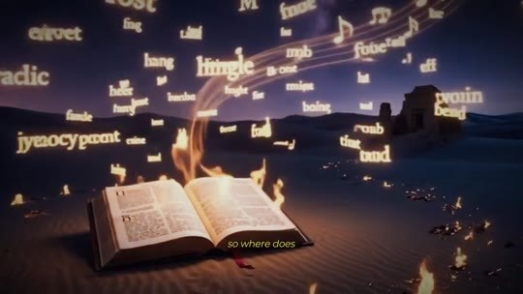  📷 10:59 — Bíblia aberta com palavras voando; legenda 'so where does'  b07_biblia_palavras_voando_00-10-59.jpg | 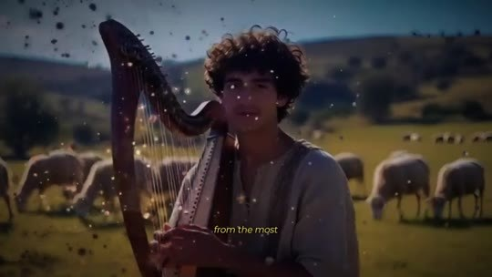  📷 11:01 — Jovem Davi com harpa entre ovelhas  b07_jovem_harpa_ovelhas_00-11-01.jpg
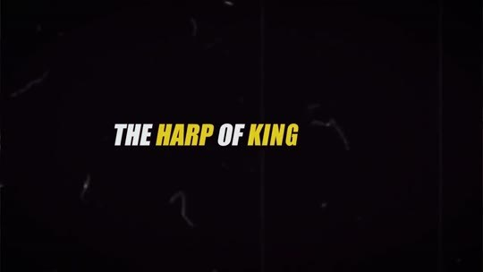  📷 11:04 — Lettering 'THE HARP OF KING'  b07_lettering_harp_of_king_david_00-11-04.jpg | 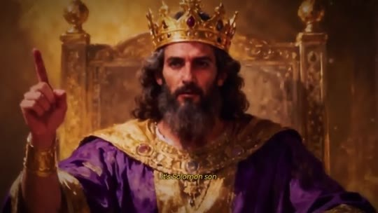  📷 11:09 — Rei de coroa no trono (Salomão)  b07_rei_trono_salomao_00-11-09.jpg
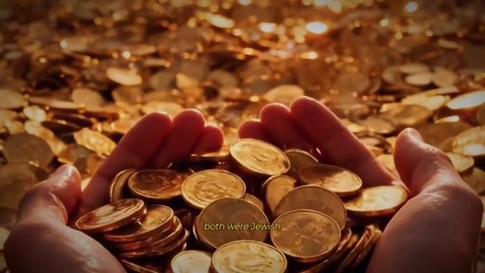  📷 11:11 — Mãos cheias de moedas de ouro  b07_maos_moedas_ouro_00-11-11.jpg | 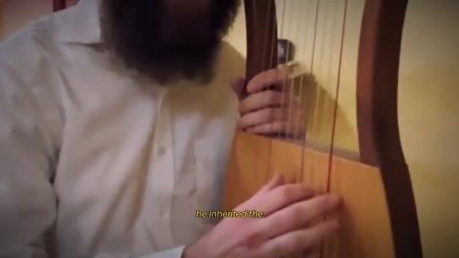  📷 11:20 — Close de harpa sendo tocada  b07_harpa_tocada_close_00-11-20.jpg
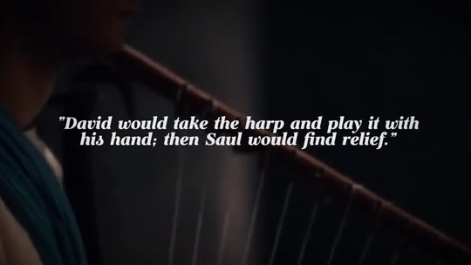
📷 11:30 — Lettering '“David would take the harp and play it with his hand; then Saul would find relief.” 1 Samuel 16:23'
b07_versiculo_1_samuel_16_23_00-11-30.jpg

JOE DISPENZA (narrador, avatar): Não pense que isso é só mais uma frequência sonora que você viu no YouTube. É uma vibração descrita na Bíblia, mas o seu verdadeiro poder foi apagado das versões modernas. Então de onde vem essa vibração? Da harpa mais famosa da história, a Harpa do Rei Davi. Pense no homem mais rico que já existiu. Não é nenhum bilionário vivo hoje, é Salomão, filho de Davi. Os dois eram judeus. A fortuna dele era tão impressionante que nações inteiras lhe entregavam o seu ouro. E Salomão não herdou só o trono do pai, ele herdou… A Bíblia menciona o poder dessa harpa várias e várias vezes. Davi pegava a harpa e tocava com a mão, e então Saul encontrava alívio. 1 Samuel 16:23.

7.2 ⏱ 11:33 → 12:23
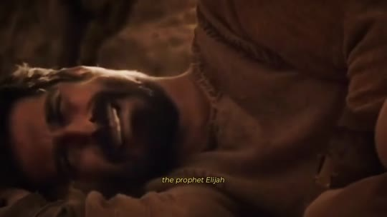  📷 11:40 — Profeta Eliseu deitado; legenda 'the prophet Elijah'  b07_eliseu_profeta_00-11-40.jpg | 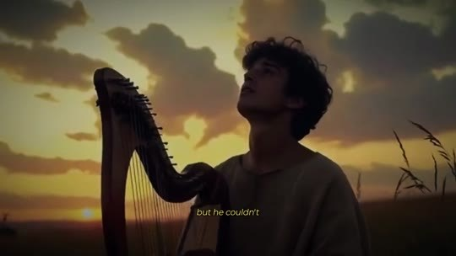  📷 11:43 — Jovem tocando harpa ao pôr do sol  b07_jovem_harpa_por_do_sol_00-11-43.jpg
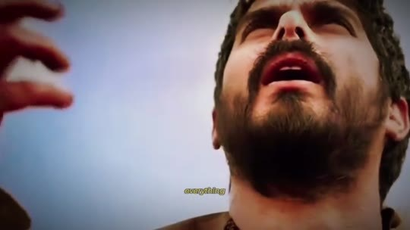  📷 11:51 — Homem olhando para cima em êxtase; legenda 'everything'  b07_homem_rosto_luz_extase_00-11-51.jpg | 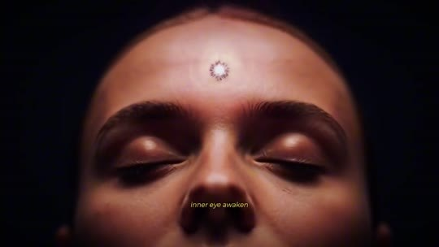  📷 12:03 — Ilustração de rosto com terceiro olho e molécula 'DMT'  b07_rosto_terceiro_olho_dmt_00-12-03.jpg
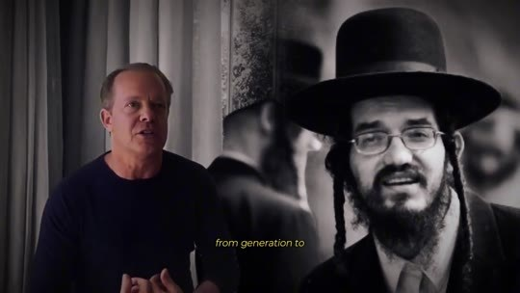  📷 12:07 — Microcristal na microscopia; legenda 'and these crystals'  b07_microcristal_microscopia_00-12-07.jpg | 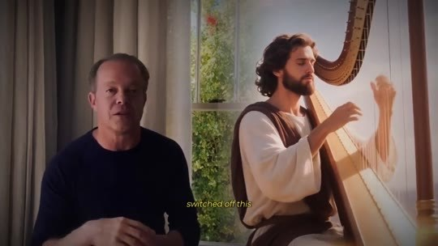  📷 12:15 — Dispenza com cristais dourados ao lado  b07_cristais_dourados_dispenza_00-12-15.jpg
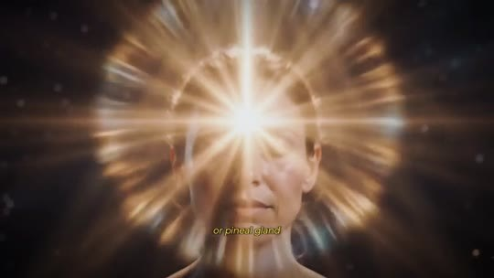
📷 12:19 — Acendedor do fogão com chama azul; legenda 'natural pressure inside'
b07_isqueiro_fogao_chama_00-12-19.jpg

JOE DISPENZA (narrador, avatar): Mas a harpa de Davi não acalmava Saul só com música bonita. Em 2 Reis 3:15, o profeta Eliseu precisava ver o futuro, mas não conseguia. Então disse: tragam-me um harpista. E, enquanto o harpista tocava, a mão do Senhor veio sobre Eliseu, e ele viu tudo. O som ligou a sua visão profética. Isso é o botão da manifestação sendo ligado. Registros antigos mostram que havia uma sequência específica de notas que despertava o olho interior, e esse conhecimento foi passado de geração em geração pelo povo judeu. A sequência de vibrações da harpa de Davi é uma chave exata feita para ativar o que foi desligado. Esse botão da manifestação, ou glândula pineal, se preferir, é o que envia o seu desejo para o universo.

BLOCO 8 — MICROCRISTAIS E PIEZOELETRICIDADE: a pineal como antena, a gota d'água e Jobs, Taylor Swift e Michael Jordan [12:23 – 14:24]

8.1 ⏱ 12:23 → 13:06
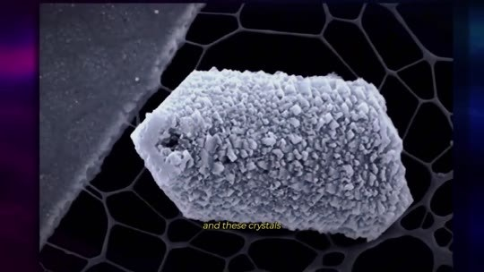  📷 12:27 — Ondas sonoras entre cérebro e harpa  b08_ondas_cerebro_harpa_00-12-27.jpg | 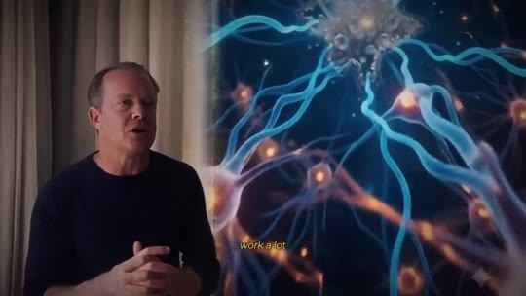  📷 12:33 — Dispenza; lettering 'CAPABLE OF TURNING YOUR THOUGHTS INTO REALITY'  b08_lettering_thoughts_into_reality_00-12-33.jpg
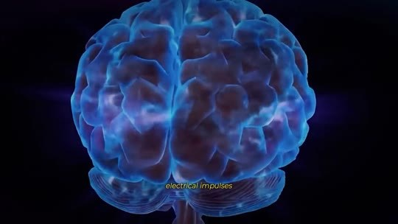  📷 12:45 — Mulher com terceiro olho vermelho brilhando  b08_mulher_terceiro_olho_vermelho_00-12-45.jpg | 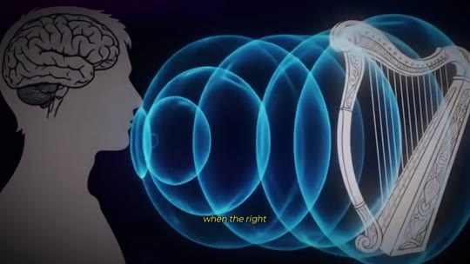  📷 12:47 — Gota d'água mudando de forma; legenda 'this drop of water'  b08_gota_agua_forma_00-12-47.jpg
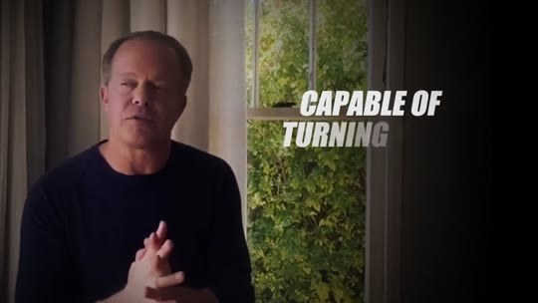
📷 12:57 — Padrão de areia em placa vibrando (cimática)
b08_cimatica_areia_00-12-57.jpg

JOE DISPENZA (narrador, avatar): Dentro da sua glândula pineal existem microcristais, e esses cristais têm uma propriedade rara chamada piezoeletricidade. O fascinante é que esses cristais funcionam de forma muito parecida com o quartzo de um acendedor de fogão, aquele que solta uma faísca quando você aperta o botão. Quando esses cristais minúsculos sentem uma leve pressão natural dentro da sua cabeça, geram pequenos impulsos elétricos, o que significa que, quando o tipo certo de vibração chega até eles, disparam uma carga elétrica e literalmente se transformam numa antena. E é essa antena que envia frequências capazes de transformar os seus pensamentos em realidade. É isso que eu chamo de ativar o botão da manifestação. O seu cérebro passa a operar num estado de criação junto com o universo.

8.2 ⏱ 13:06 → 13:52
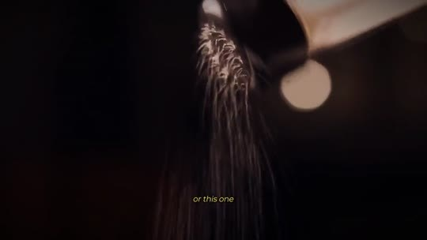  📷 13:13 — Harpista judeu tocando; legenda 'played by David'  b08_harpista_close_00-13-13.jpg | 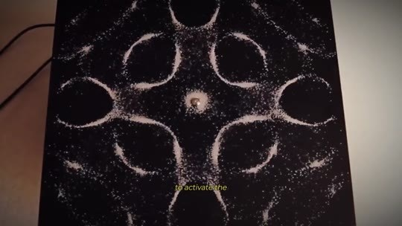  📷 13:21 — Tela 'iPhone' do lançamento  b08_iphone_lancamento_00-13-21.jpg
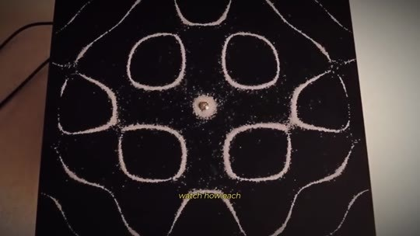  📷 13:23 — Steve Jobs no palco; legenda 'the iPhone'  b08_steve_jobs_palco_00-13-23.jpg | 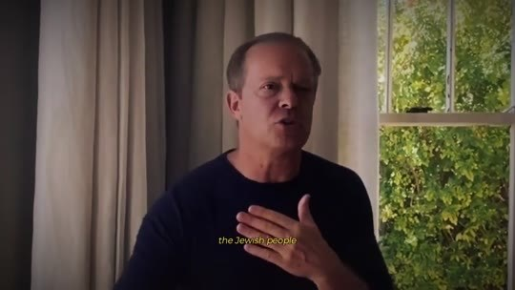  📷 13:29 — Show da Taylor Swift no estádio; legenda '80,000 people'  b08_taylor_swift_estadio_00-13-29.jpg
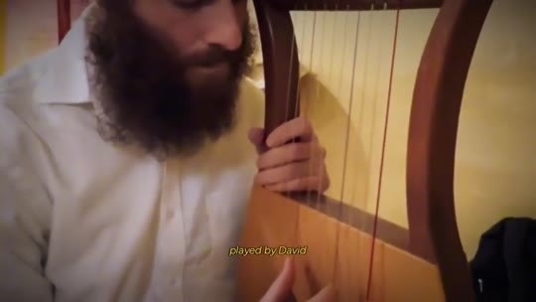
📷 13:35 — Michael Jordan pelo Bulls
b08_michael_jordan_bulls_00-13-35.jpg

JOE DISPENZA (narrador, avatar): Veja este experimento, por exemplo. Observe como, dependendo da vibração sonora, esta gota d'água muda de forma. Ou este, em que, dentro de uma sala com zero interferência, tocamos a sequência exata de notas que Davi usava na harpa para ativar o botão da manifestação. Veja como cada vibração é capaz de alterar a própria realidade. Esse é o segredo passado entre o povo judeu por milhares de anos. Não uma frequência qualquer, mas uma sequência exata de notas tocadas por Davi na harpa, que aperta esse botão no momento preciso e abre o seu terceiro olho. Quando Steve Jobs inventou o iPhone, o botão da manifestação dele estava ligado. Quando Taylor Swift se apresenta diante de 80.000 pessoas, ela está ativando esse botão da manifestação.

8.3 ⏱ 13:52 → 14:24
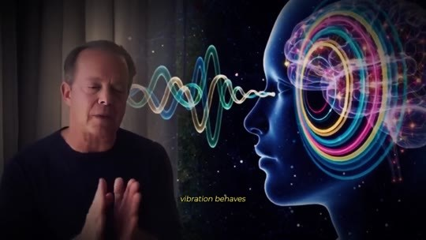  📷 14:05 — Dispenza com cabeça e ondas de som ao lado; legenda 'vibration behaves'  b08_dispenza_ondas_cerebro_00-14-05.jpg | 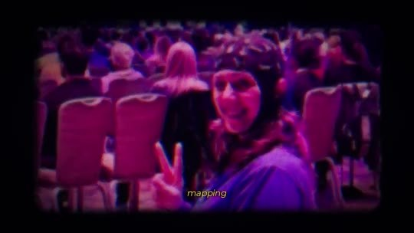  📷 14:11 — Plateia de retiro; legenda 'measuring with electrodes'  b08_plateia_retiro_eletrodos_00-14-11.jpg

JOE DISPENZA (narrador, avatar): É o que Michael Jordan chamava de 'a zona', aquele momento em que o jogo ficava mais lento para ele e ele conseguia ver a próxima jogada 2 segundos antes de todos os adversários. O botão dele já estava ativado no cérebro. Passei os últimos 30 anos estudando como cada vibração se comporta dentro do cérebro humano, medindo com eletrodos e mapeamento cerebral em tempo real o cérebro de milhares de pessoas nos meus retiros. E foi quando entendi que a chave não era uma frequência, mas uma sequência de vibrações, a sequência de Davi.

BLOCO 9 — A RECONSTRUÇÃO: arquivos queimados, os fragmentos, o kinnor, a afinação (432 Hz) e a IA dos pergaminhos do Vesúvio [14:24 – 18:57]

9.1 ⏱ 14:24 → 15:09
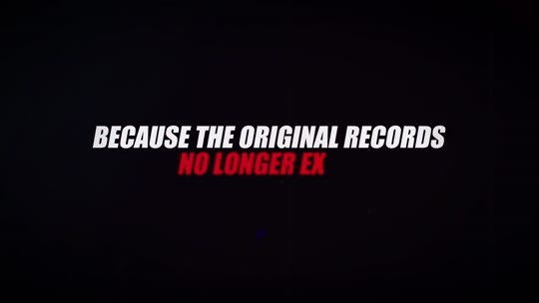  📷 14:28 — Lettering 'BECAUSE THE ORIGINAL RECORDS NO LONGER EXIST'  b09_lettering_original_records_00-14-28.jpg | 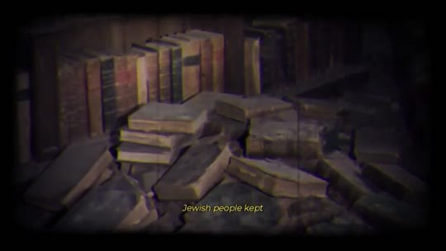  📷 14:30 — Biblioteca antiga com livros empilhados; legenda 'Jewish people kept'  b09_biblioteca_livros_antigos_00-14-30.jpg
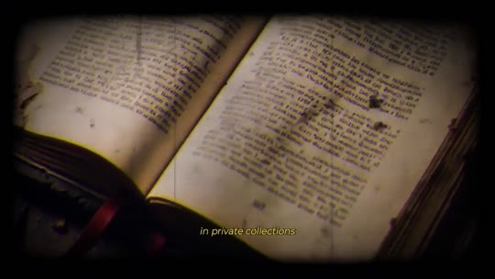  📷 14:42 — Livro antigo aberto; legenda 'in private collections'  b09_livro_antigo_aberto_private_00-14-42.jpg | 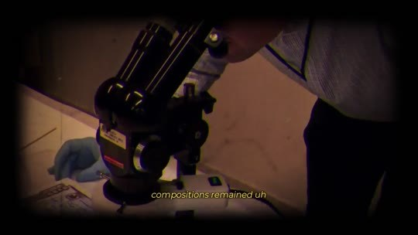  📷 14:54 — Microscópio sobre manuscrito; legenda 'compositions remained'  b09_microscopio_compositions_00-14-54.jpg
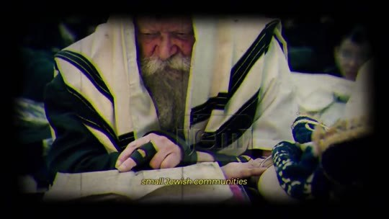  📷 15:02 — Rabino de talit lendo manuscritos  b09_rabino_talit_manuscritos_00-15-02.jpg | 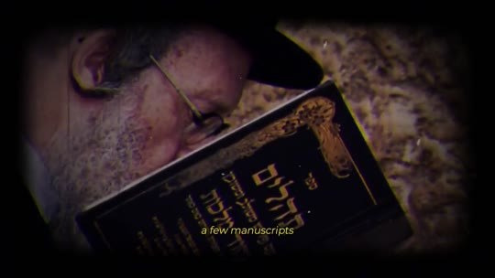  📷 15:04 — Rabino com livro em hebraico; legenda 'a few manuscripts'  b09_rabino_livro_hebraico_00-15-04.jpg

JOE DISPENZA (narrador, avatar): Foi aí que começou a parte mais difícil da minha vida, porque os registros originais não existem mais. Os arquivos que o povo judeu guardava foram queimados. O que sobreviveu ficou espalhado, fragmento por fragmento, e o pouco que ressurgiu na era moderna, o sistema Rockefeller comprou, trancou em coleções particulares e apagou dos livros, do mesmo jeito que apagaram o conhecimento sobre a sua glândula pineal. Mas eles cometeram um erro. Não dá para apagar tudo. Algumas citações das composições de Davi ficaram espalhadas pelo mundo. Judeus que fugiram e se esconderam em diferentes cantos do planeta, alguns rabinos em pequenas comunidades judaicas, guardaram alguns manuscritos. Um banqueiro judeu de Nova York que já trabalhou para Donald Trump guardou outros.

9.2 ⏱ 15:09 → 15:54
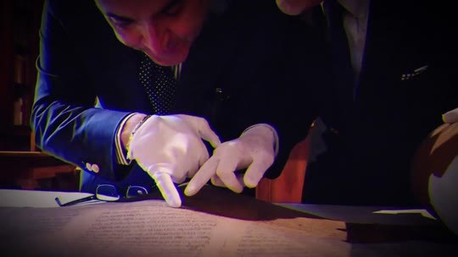  📷 15:12 — Mãos de luva manuseando manuscrito  b09_luvas_manuscrito_fragmento_00-15-12.jpg | 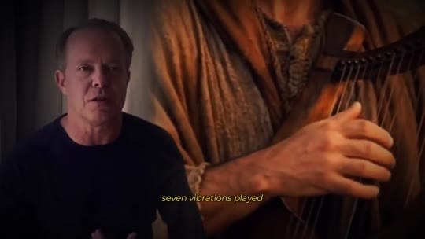  📷 15:18 — Mãos tocando harpa; legenda 'seven vibrations played'  b09_maos_harpa_seven_vibrations_00-15-18.jpg
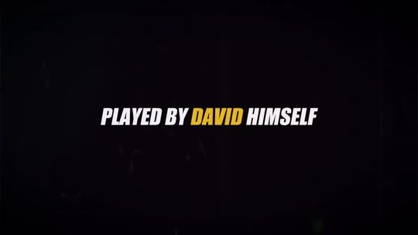  📷 15:20 — Lettering 'PLAYED BY DAVID HIMSELF'  b09_lettering_played_by_david_00-15-20.jpg | 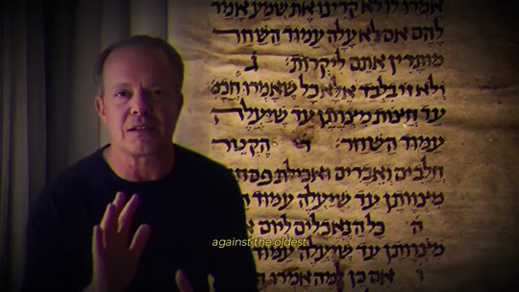  📷 15:26 — Dispenza com texto em hebraico ao fundo  b09_dispenza_texto_hebraico_00-15-26.jpg
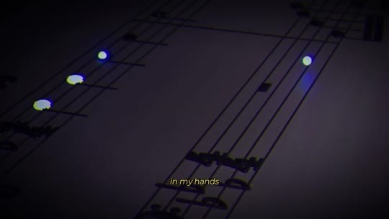  📷 15:30 — Partitura com notas iluminadas; legenda 'in my hands'  b09_partitura_luzes_00-15-30.jpg | 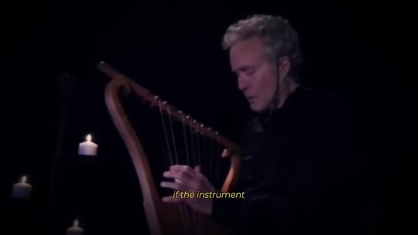  📷 15:40 — Homem tocando harpa à luz de vela; legenda 'the instrument'  b09_harpista_vela_00-15-40.jpg
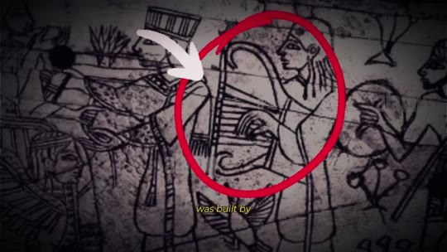  📷 15:46 — Desenho antigo com harpa circulada em vermelho  b09_desenho_antigo_harpa_circulo_00-15-46.jpg | 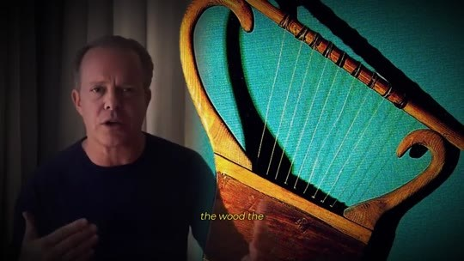  📷 15:48 — Dispenza com ilustração do kinnor (harpa azul e dourada)  b09_dispenza_kinnor_azul_00-15-48.jpg

JOE DISPENZA (narrador, avatar): E, depois de anos reunindo cada peça espalhada, consegui encaixar as partes que formavam as composições de Davi. 7 vibrações tocadas pelo próprio Davi, a sequência exata, idêntica à original, verificada símbolo por símbolo contra os fragmentos mais antigos que existem. Eu tinha nas mãos a partitura que ativa o botão da manifestação, e foi aí que descobri o problema que quase me fez desistir de tudo. De que adianta a partitura se o instrumento não existe mais? Porque a harpa de Davi não era uma harpa qualquer. O kinnor, como era chamado, foi construído pelas próprias mãos de Davi. A madeira, as cordas e, acima de tudo, a afinação, que não segue nenhum padrão que conhecemos.

9.3 ⏱ 15:55 → 16:45
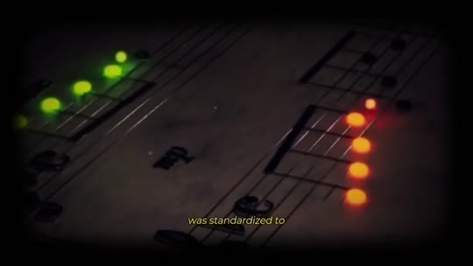  📷 16:04 — Onda sonora verde; legenda 'single tuning'  b09_onda_verde_single_tuning_00-16-04.jpg | 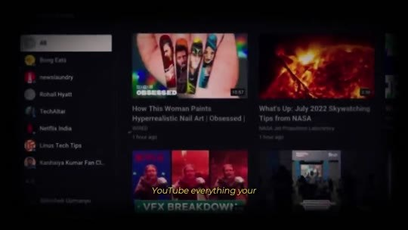  📷 16:10 — Tela do YouTube; legenda 'YouTube'  b09_tela_youtube_00-16-10.jpg
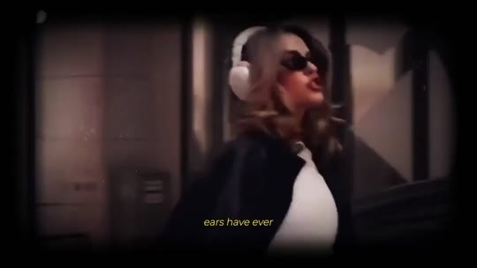  📷 16:12 — Mulher de fones; legenda 'ears have ever'  b09_mulher_fones_ears_00-16-12.jpg | 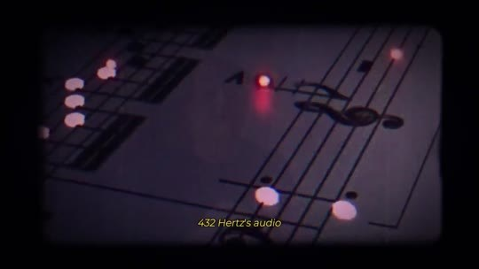  📷 16:20 — Partitura com notas vermelhas; legenda '432 Hertz audio'  b09_partitura_432hz_00-16-20.jpg
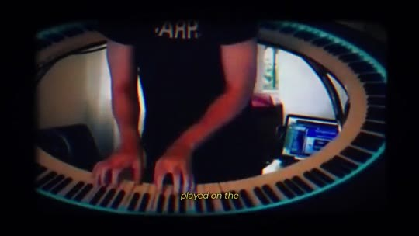  📷 16:26 — Teclado circular; legenda 'played on the wrong instrument'  b09_teclado_circular_wrong_instrument_00-16-26.jpg | 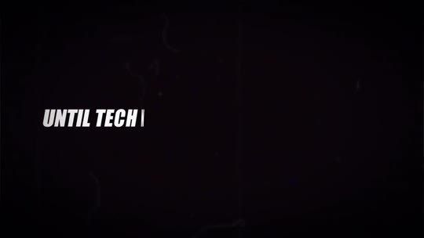  📷 16:34 — Lettering 'UNTIL TECHNOLOGY CAUGHT UP'  b09_lettering_until_technology_00-16-34.jpg
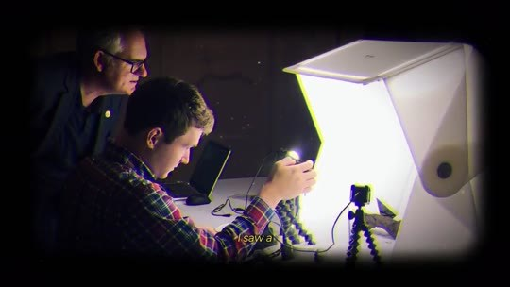  📷 16:36 — Cientistas escaneando pergaminho  b09_cientistas_scanner_pergaminho_00-16-36.jpg | 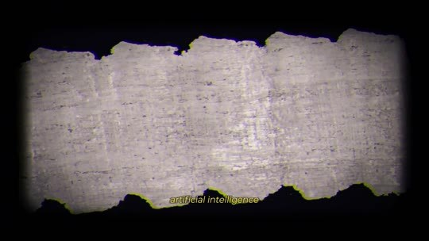  📷 16:40 — Pergaminho carbonizado do Vesúvio  b09_pergaminho_carbonizado_00-16-40.jpg
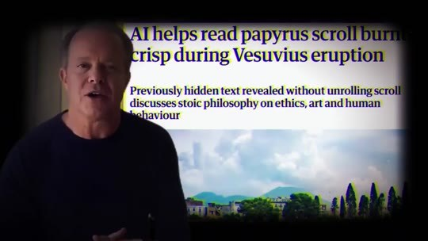
📷 16:42 — Matéria 'AI helps read papyrus scroll burnt crisp during Vesuvius eruption'
b09_materia_ai_papyrus_vesuvius_00-16-42.jpg

JOE DISPENZA (narrador, avatar): Nenhum instrumento no planeta hoje produz aquele som, nem de perto. E sabe por quê? Porque, no século passado, toda a música do mundo foi padronizada numa única afinação, a mesma do seu piano, do seu violão, do Spotify, do YouTube. Tudo o que os seus ouvidos já escutaram toca dentro desse padrão. O som que Davi tocava não tem nada a ver com isso. É por isso que aquele áudio de 432 Hz do YouTube nunca funcionou para você. É a partitura errada, tocada no instrumento errado, na afinação errada. Eu tinha a sequência exata de Davi e nenhum jeito de fazer o universo tocá-la de novo, até a tecnologia me alcançar. Vi uma notícia sobre cientistas usando inteligência artificial para ler pergaminhos carbonizados pelo vulcão Vesúvio há 2.000 anos.

9.4 ⏱ 16:46 → 17:43
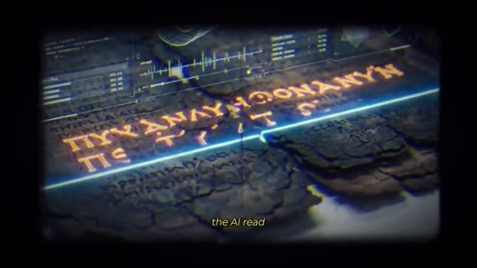  📷 16:52 — Pergaminho com texto revelado pela IA; legenda 'the AI read'  b09_pergaminho_ia_lendo_00-16-52.jpg | 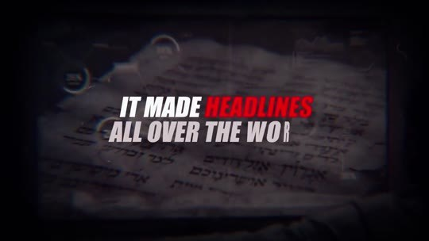  📷 16:56 — Lettering 'IT MADE HEADLINES ALL OVER THE WORLD'  b09_lettering_made_headlines_00-16-56.jpg
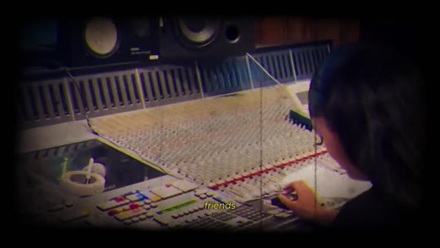  📷 17:04 — Mesa de som com engenheiros de acústica  b09_mesa_de_som_engenheiros_00-17-04.jpg | 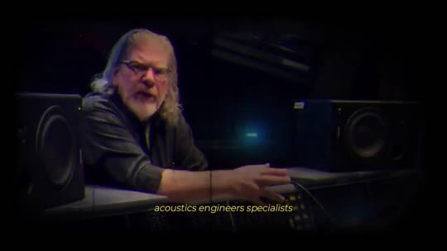  📷 17:06 — Especialista de cabelo grisalho no estúdio  b09_especialista_instrumentos_antigos_00-17-06.jpg
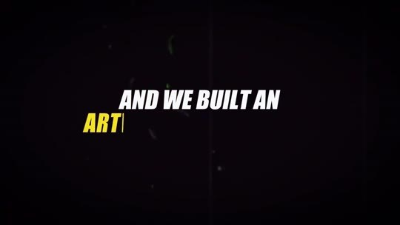  📷 17:14 — Lettering 'AND WE BUILT AN ARTIFICIAL INTELLIGENCE'  b09_lettering_built_an_artificial_00-17-14.jpg | 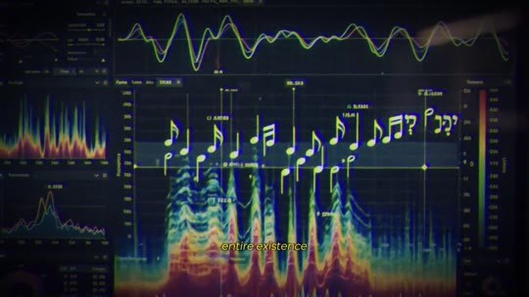  📷 17:18 — Espectrograma de áudio com notas  b09_espectro_audio_notas_00-17-18.jpg
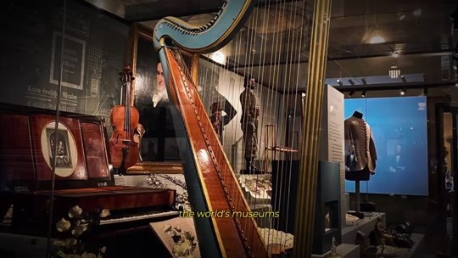  📷 17:28 — Harpas num museu; legenda 'ever scanned in'  b09_harpa_museu_00-17-28.jpg | 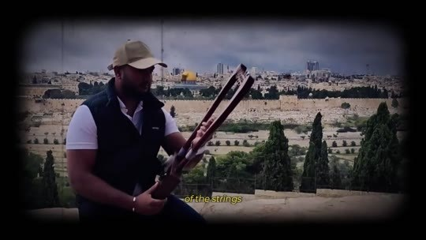  📷 17:36 — Homem com instrumento diante de Jerusalém; legenda 'even the climate'  b09_homem_jerusalem_clima_00-17-36.jpg

JOE DISPENZA (narrador, avatar): Pergaminhos tão queimados que tinham virado carvão, impossíveis de abrir sem destruí-los. A IA os leu fechados, palavra por palavra. Isso virou manchete no mundo inteiro. Foi exatamente esse tipo de gente que fui buscar. Montei uma equipe que nunca tinha trabalhado junta: engenheiros de acústica forense, especialistas em instrumentos antigos e cientistas de dados do mesmo círculo que decifrou os Pergaminhos do Vesúvio. E construímos uma inteligência artificial com uma única missão para toda a sua existência: tocar do jeito que Davi tocava. Primeiro, ela devorou tudo o que existe. Cada harpa antiga já escaneada nos museus do mundo, cada descrição do kinnor nos registros históricos, a física da madeira daquela região, das cordas daquela época, até o clima de Jerusalém, porque temperatura e umidade mudavam o som de um instrumento.

9.5 ⏱ 17:43 → 18:25
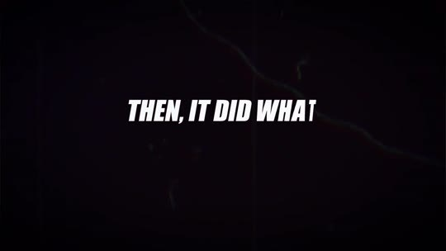  📷 17:44 — Lettering 'THEN, IT DID WHAT NO LIVING MAN COULD'  b09_lettering_no_living_man_00-17-44.jpg | 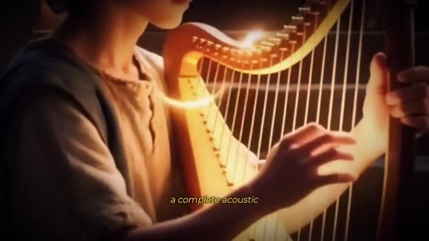  📷 17:50 — Rei Davi tocando harpa ao lado de Dispenza; legenda 'David's hands built'  b09_rei_davi_harpa_reconstrucao_00-17-50.jpg
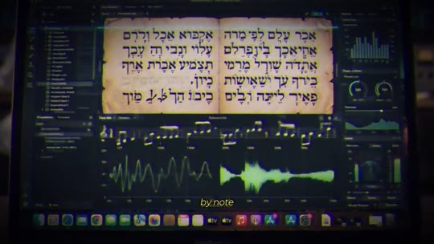  📷 17:56 — Software com texto hebraico e ondas sonoras; legenda 'by note'  b09_software_texto_hebraico_ondas_00-17-56.jpg | 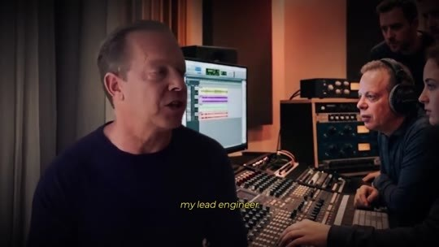  📷 18:12 — Dispenza no estúdio com engenheiro de fones  b09_dispenza_estudio_engenheiro_00-18-12.jpg
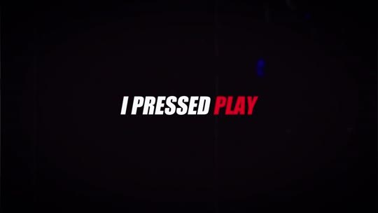  📷 18:16 — Lettering 'I PRESSED PLAY'  b09_lettering_i_pressed_play_00-18-16.jpg | 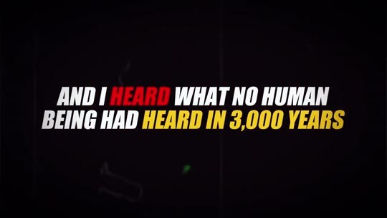  📷 18:20 — Lettering 'AND I HEARD WHAT NO HUMAN BEING HAD HEARD IN 3,000 YEARS'  b09_lettering_heard_3000_years_00-18-20.jpg

JOE DISPENZA (narrador, avatar): Então ela fez o que nenhum homem vivo conseguiria. Reconstruiu o kinnor de Davi por dentro, um modelo acústico completo, corda por corda, do instrumento que as mãos de Davi construíram, e então, nota por nota, tocou as sete vibrações dos fragmentos no instrumento reconstruído, na afinação original. Foram meses de processamento, rodando dia e noite num supercomputador, até que numa terça-feira, de madrugada, no laboratório, o meu engenheiro-chefe me entregou um… [corte na edição] Apertei o play e ouvi o que nenhum ser humano tinha ouvido em 3.000 anos. O som que acalmava Saul. O som que abriu a visão de Eliseu.

9.6 ⏱ 18:26 → 18:57
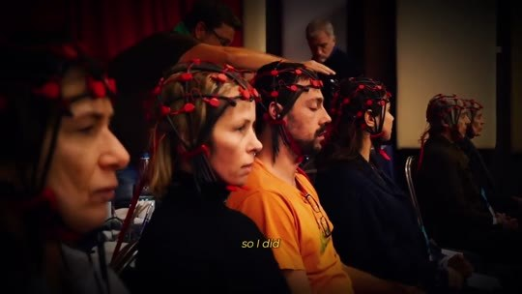  📷 18:30 — Dispenza; lettering 'I DON'T EVEN TRUST MY OWN GOOSEBUMPS… I TRUST DATA'  b09_lettering_dont_trust_goosebumps_00-18-30.jpg | 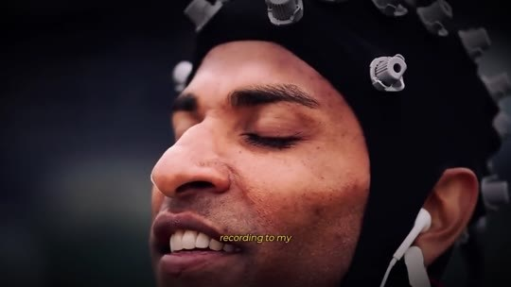  📷 18:32 — Voluntários com toucas de eletrodos  b09_voluntarios_eletrodos_00-18-32.jpg
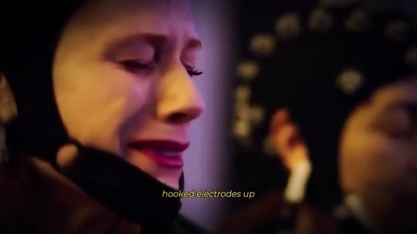  📷 18:34 — Homem com eletrodos de olhos fechados  b09_homem_eletrodos_olhos_fechados_00-18-34.jpg | 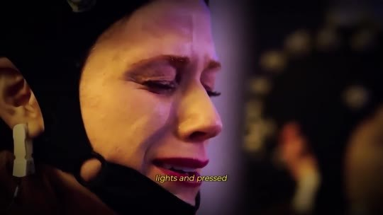  📷 18:36 — Mulher chorando; legenda 'hooked electrodes up'  b09_mulher_chorando_luz_00-18-36.jpg

JOE DISPENZA (narrador, avatar): Mas eu sou cientista. Não confio nem nos meus próprios arrepios. Confio em dados. Então fiz o que faço há 30 anos. Levei a gravação para o meu laboratório, conectei eletrodos em voluntários, apaguei as luzes e apertei o play. E, na tela, vi a mesma coisa. Na tela, em tempo real, vi o que eu só tinha visto em monges com décadas de meditação: o botão da manifestação ligando, um por um, em pessoas comuns que só estavam ali deitadas ouvindo. Foi a única vez em 30 anos de carreira que chorei na frente da minha equipe.

BLOCO 10 — O DAVID SONG: 7 vibrações em 7 noites, como usar e os primeiros sinais [18:58 – 20:12]

10.1 ⏱ 18:58 → 19:42
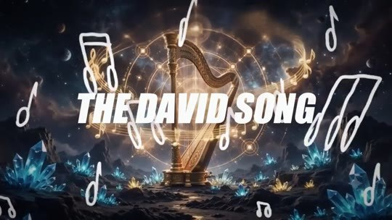  📷 19:01 — Lettering 'THE DAVID SONG' sobre harpa dourada  b10_lettering_the_david_song_harpa_00-19-01.jpg | 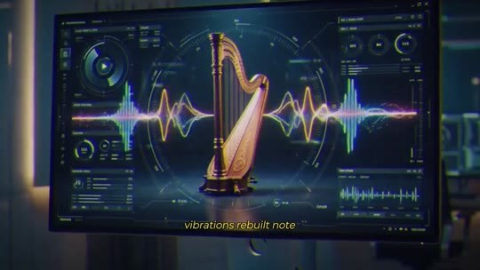  📷 19:04 — Tela com harpa e ondas sonoras; legenda 'rebuilt note'  b10_tela_harpa_ondas_00-19-04.jpg
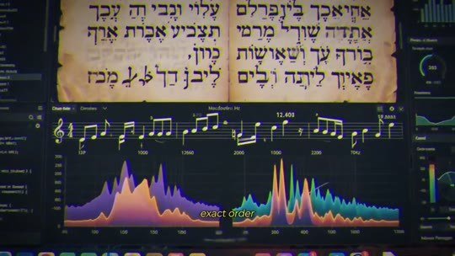  📷 19:08 — Manuscrito hebraico ao lado de espectros  b10_manuscrito_espectro_00-19-08.jpg | 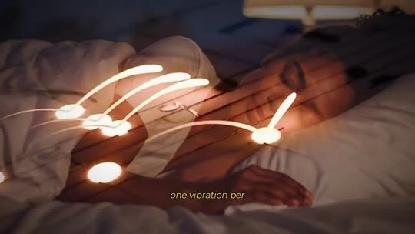  📷 19:11 — Notas de luz sobre a cama; legenda 'one vibration per night'  b10_cama_notas_luz_00-19-11.jpg
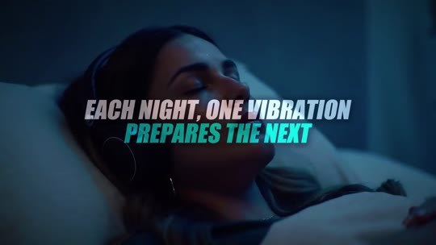  📷 19:17 — Mulher dormindo; lettering 'EACH NIGHT, ONE VIBRATION PREPARES THE NEXT'  b10_lettering_each_night_one_vibration_00-19-17.jpg | 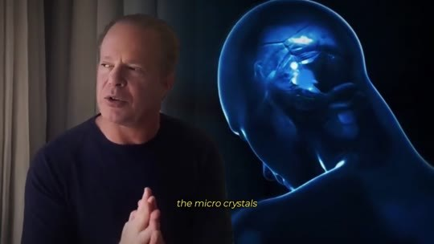  📷 19:20 — Dispenza com cabeça azul holográfica; legenda 'the micro crystals'  b10_dispenza_cabeca_azul_microcristais_00-19-20.jpg
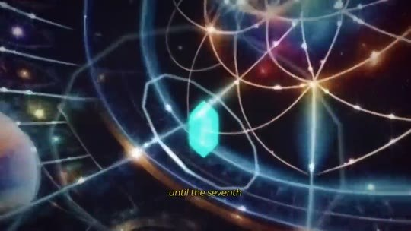  📷 19:25 — Cabeça com geometria sagrada  b10_geometria_sagrada_cerebro_00-19-25.jpg | 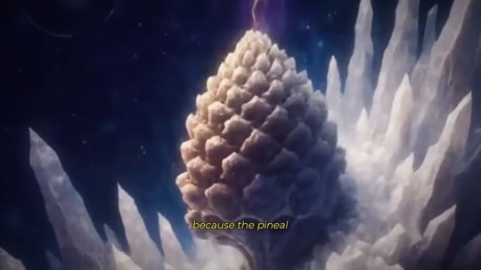  📷 19:33 — Pinha de cristal (pineal); legenda 'because the pineal gland is sensitive'  b10_pinha_cristal_pineal_00-19-33.jpg
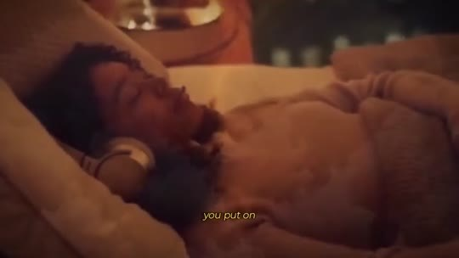
📷 19:38 — Mulher dormindo de fones; legenda 'your headphones'
b10_mulher_fones_dormindo_00-19-38.jpg

JOE DISPENZA (narrador, avatar): Eu chamo essa sequência exata de vibrações de David Song. São as 7 vibrações de Davi reconstruídas nota por nota no som original do kinnor, organizadas na ordem exata que os fragmentos indicam. Uma vibração por noite, durante 7 noites. A cada noite, uma vibração prepara a próxima. A primeira começa a despertar os microcristais da sua glândula pineal. A segunda vai mais fundo, e assim por diante, até a 7ª noite, quando a sequência completa toca e o botão liga. É simples. Você apaga as luzes do quarto, porque a glândula pineal é sensível à luz e, no escuro, ela desperta. Põe os fones, aperta o play e vai dormir.

10.2 ⏱ 19:43 → 20:12
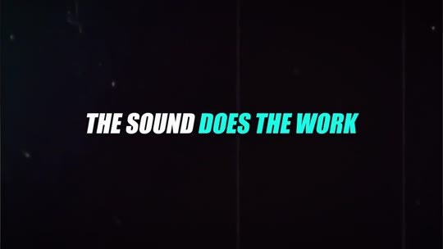  📷 19:45 — Lettering 'THE SOUND DOES THE WORK'  b10_lettering_sound_does_the_work_00-19-45.jpg | 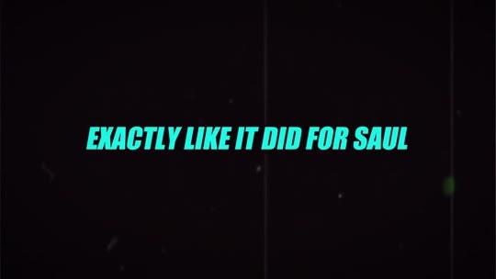  📷 19:47 — Lettering 'EXACTLY LIKE IT DID FOR SAUL'  b10_lettering_like_it_did_for_saul_00-19-47.jpg
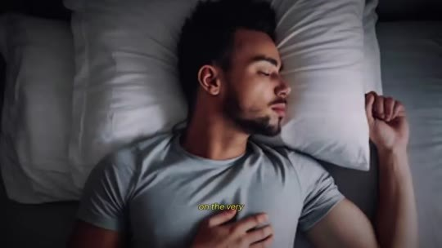
📷 19:50 — Homem dormindo profundamente
b10_homem_dormindo_deep_sleep_00-19-50.jpg

JOE DISPENZA (narrador, avatar): É só isso. O som faz o trabalho, exatamente como fazia por Saul, que também não fazia esforço nenhum. Ele só ouvia. Já na primeira noite, você vai sentir o sono mais revigorante da sua vida, do tipo que não sente há anos. Esses são os primeiros sinais de que o seu botão está ligando: sono profundo, sonhos vívidos, clareza ao acordar e as primeiras coincidências. As primeiras pessoas a testar o David Song fora do laboratório não eram celebridades. Eram pessoas como você.

BLOCO 11 — DEPOIMENTOS: a promoção, o diabetes e o Powerball de $4,7 milhões [20:12 – 22:00]

11.1 ⏱ 20:12 → 20:56
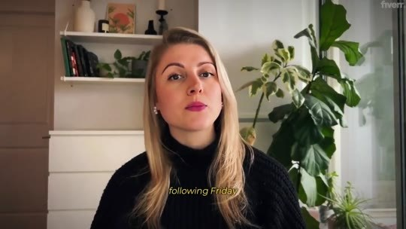  📷 20:14 — Mulher loira de blusa preta (depoimento da promoção)  b11_depoimento_promocao_mulher_loira_00-20-14.jpg | 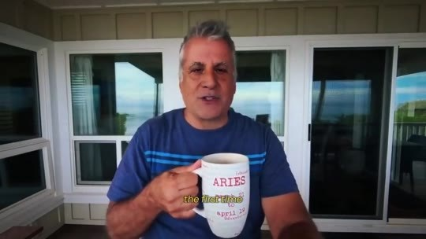  📷 20:32 — Homem de camiseta azul com caneca (depoimento do diabetes)  b11_depoimento_diabetes_caneca_00-20-32.jpg
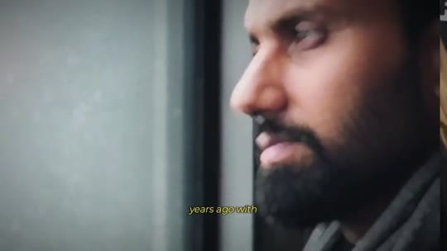
📷 20:50 — Imigrante com colete de obra; legenda 'construction'
b11_imigrante_obra_capacete_00-20-50.jpg

HOMEM (depoimento, promoção): Eu fiz as 7 noites. Na sexta-feira seguinte, o meu chefe me chamou na sala dele e eu congelei. Achei que ia ser demitido. Era uma promoção pela qual eu já tinha desistido de esperar, com 40% de aumento. Mas essa não foi a parte mais estranha. A parte mais estranha foi que, na noite anterior, eu tinha sonhado com aquela conversa. Entrei naquela sala sabendo o que ele ia dizer.
DEPOIMENTO (diabetes tipo 2): Na primeira vez que voltei ao médico depois de começar a ouvir o David Song todas as noites, ele não tinha explicação. O meu diabetes tipo 2 estava sob controle. Não cortei açúcar nem mudei a dieta. O médico tirou a minha insulina e me deixou com um só remédio.
IMIGRANTE MEXICANO (depoimento, Powerball): Olha, eu vim do México há 22 anos sem nada. Trabalhava 12 horas por dia na construção e o dinheiro nunca dava.

11.2 ⏱ 20:57 → 21:40
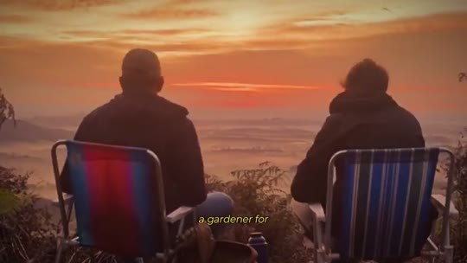  📷 21:02 — Dois homens ao pôr do sol; legenda 'Scottsdale'  b11_amigos_por_do_sol_scottsdale_00-21-02.jpg | 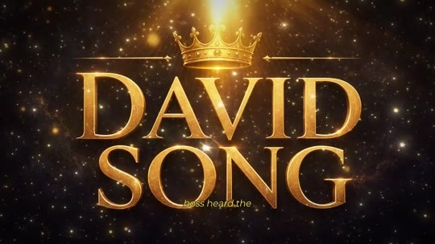  📷 21:06 — Logo dourado 'DAVID SONG'  b11_logo_david_song_dourado_00-21-06.jpg
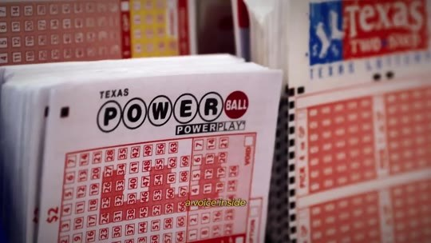  📷 21:18 — Bilhetes da Powerball  b11_bilhete_powerball_00-21-18.jpg | 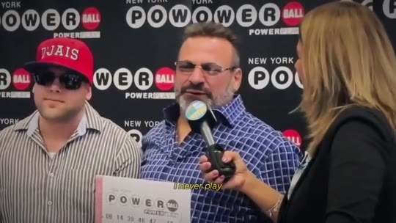  📷 21:22 — Ganhadores da Powerball em entrevista  b11_ganhador_powerball_entrevista_00-21-22.jpg
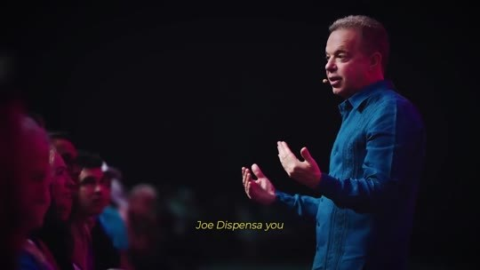
📷 21:32 — Dispenza num palco; legenda 'Joe Dispenza, you'
b11_dispenza_palco_gracias_00-21-32.jpg

IMIGRANTE MEXICANO (depoimento, Powerball): Eu rezava toda noite e sentia que as minhas orações batiam num teto e voltavam. Um amigo meu, jardineiro de gente rica em Scottsdale, me contou que o patrão dele ouviu o David Song e disse que era o segredo da sorte dele. Pensei: o que eu tenho a perder? Ouvi religiosamente por 23 dias. No dia 24, uma voz dentro de mim me disse para comprar um bilhete da Powerball. Eu nunca jogo. Comprei um por $2. 3 dias depois, a minha esposa me ligou gritando: $4,7 milhões! Gracias, Joe Dispenza. Você não me deu sorte. Você abriu o canal que estava fechado havia 22 anos.
JOE DISPENZA (narrador, avatar): E novas histórias chegam todos os dias.

11.3 ⏱ 21:40 → 22:00
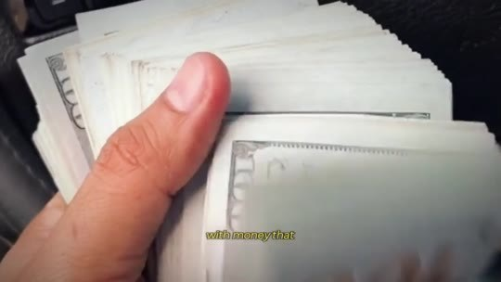  📷 21:42 — Maço de notas de 100  b11_maco_notas_100_00-21-42.jpg | 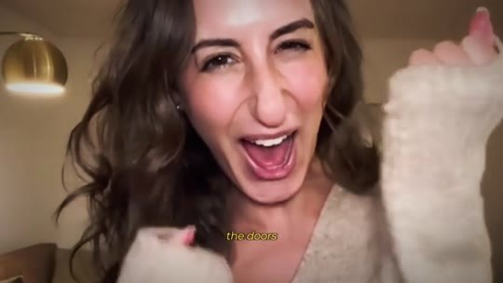  📷 21:46 — Mulher comemorando; legenda 'test results'  b11_mulher_comemorando_00-21-46.jpg
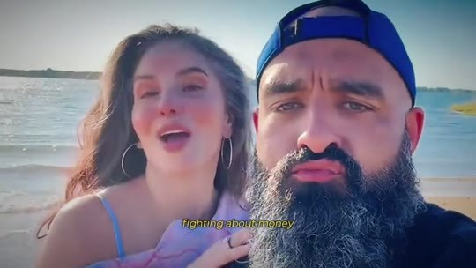
📷 21:52 — Casal em selfie na praia; legenda 'couples who stopped fighting'
b11_casal_selfie_praia_00-21-52.jpg

JOE DISPENZA (narrador, avatar): Contas pagas com dinheiro que apareceu de onde ninguém esperava. Oportunidades batendo na porta de pessoas que já tinham desistido. Resultados de exames voltando limpos. Casais que pararam de brigar por dinheiro porque o dinheiro parou de acabar. Pessoas comuns com o botão ligado, vivendo o que a elite sempre viveu em silêncio.

BLOCO 12 — A NEUROCIENTISTA, os retiros de $50.000 e o depoimento de Elon Musk [22:01 – 24:13]

12.1 ⏱ 22:01 → 22:47
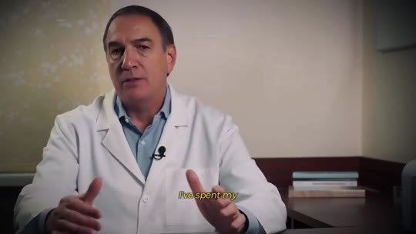  📷 22:03 — Neurocientista de jaleco (depoimento)  b12_neurocientista_jaleco_00-22-03.jpg | 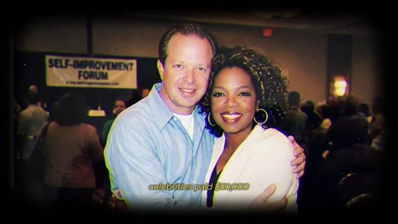  📷 22:38 — Foto de Dispenza com Oprah; legenda 'celebrities paid $50,000'  b12_dispenza_oprah_foto_retiros_00-22-38.jpg
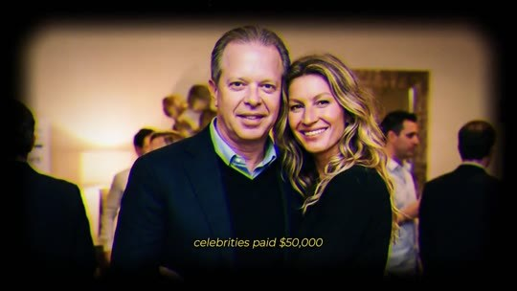  📷 22:40 — Foto de Dispenza com Gisele Bündchen  b12_dispenza_gisele_00-22-40.jpg | 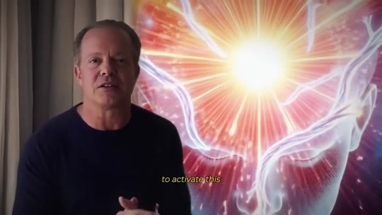  📷 22:46 — Jatinho particular; legenda 'private jets'  b12_jatinho_privado_00-22-46.jpg

JOE DISPENZA (narrador, avatar): E, e não são só pessoas comuns.
NEUROCIENTISTA (depoimento): Passei a minha carreira estudando o cérebro e estados alterados, e eu era cética em relação ao trabalho do Dr. Dispenza até ver os dados. O que acontece com a atividade cerebral dos voluntários que ouvem esta gravação não deveria ser possível em pessoas sem treino. Medimos padrões de coerência que a literatura só tinha descrito em monges com dezenas de milhares de horas de meditação aparecendo em questão de noites. Como cientista, não posso ignorar isso. A glândula pineal é a estrutura mais subestimada da neurociência moderna.
JOE DISPENZA (narrador, avatar): E, é, lembra o que eu te contei sobre os meus retiros? Celebridades pagavam $50.000 cada uma para sentar numa sala comigo e aprender a ativar essa glândula.

12.2 ⏱ 22:47 → 23:33
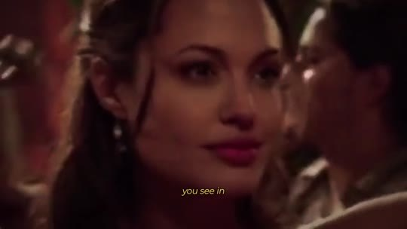  📷 22:53 — Michael Jordan com troféu; legenda 'athletes you see lifting trophies'  b12_jordan_trofeu_00-22-53.jpg | 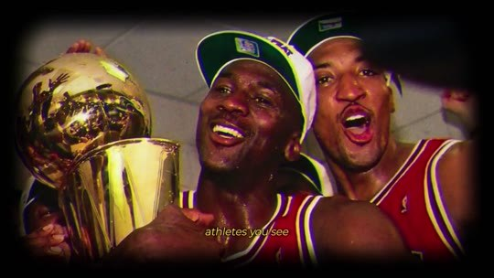  📷 22:55 — Jeff Bezos em close; legenda 'CEOs of companies'  b12_jeff_bezos_close_00-22-55.jpg
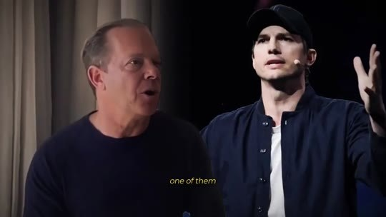  📷 23:01 — Dispenza ao lado de Ashton Kutcher; legenda 'one of them, an investor'  b12_dispenza_ashton_kutcher_00-23-01.jpg | 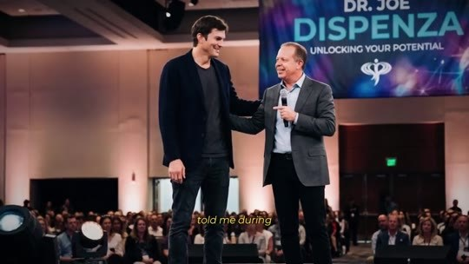  📷 23:05 — Ashton Kutcher no palco de Dispenza ('Unlocking your potential')  b12_dispenza_palco_ashton_00-23-05.jpg
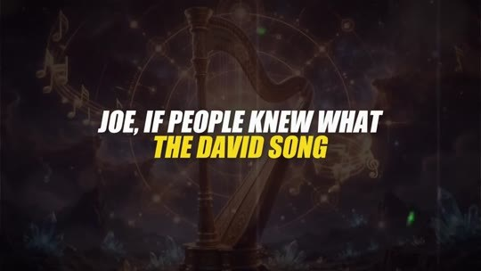  📷 23:09 — Lettering 'JOE, IF PEOPLE KNEW WHAT THE DAVID SONG…'  b12_lettering_if_people_knew_00-23-09.jpg | 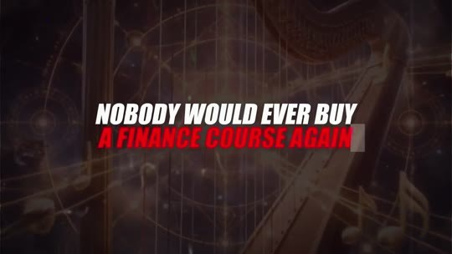  📷 23:13 — Lettering 'NOBODY WOULD EVER BUY A FINANCE COURSE AGAIN'  b12_lettering_finance_course_00-23-13.jpg
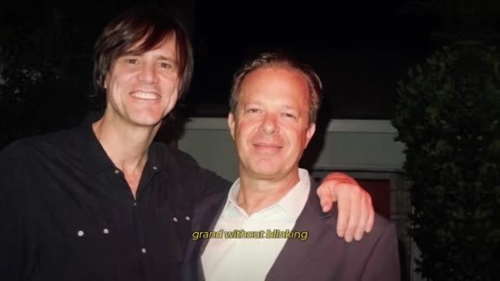  📷 23:15 — Foto de Dispenza com Jim Carrey  b12_dispenza_jim_carrey_foto_00-23-15.jpg | 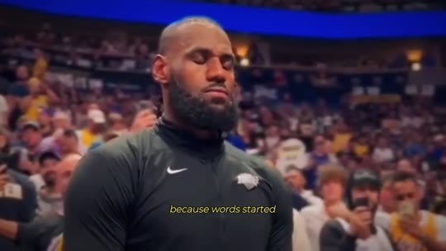  📷 23:17 — LeBron James na quadra; legenda 'because words started'  b12_lebron_james_quadra_00-23-17.jpg
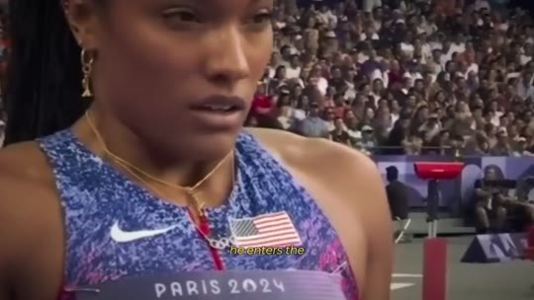  📷 23:29 — Atleta americana em Paris 2024; legenda 'switches it on'  b12_atleta_olimpica_paris_00-23-29.jpg | 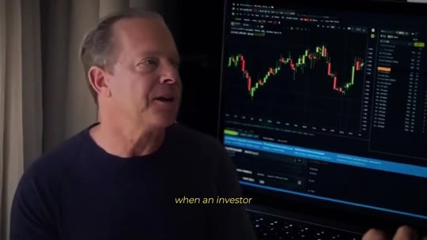  📷 23:33 — Dispenza com gráficos do mercado; legenda 'when an investor'  b12_dispenza_graficos_mercado_00-23-33.jpg

JOE DISPENZA (narrador, avatar): Chegavam de jatinho particular e assinavam termos de confidencialidade na porta. Atores que você vê nos filmes, atletas que você vê levantando troféus, CEOs de empresas que estão no seu bolso agora mesmo, no seu celular. Um deles, um investidor que você já viu em capas de revista, me disse num intervalo: 'Joe, se as pessoas soubessem o que o David Song faz pelo patrimônio de alguém, ninguém nunca mais compraria um curso de finanças.' Eles pagavam $50 mil sem piscar, porque começou a se espalhar entre a elite o sucesso que tinham depois de ativar a pineal. Quando um ator liga esse botão antes de um teste, ele ganha o papel. Quando um atleta liga antes da final, ele entra na zona de propósito, enquanto todos os outros rezam para que ela apareça.

12.3 ⏱ 23:33 → 24:13
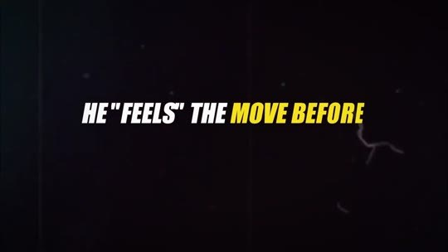  📷 23:37 — Lettering 'HE "FEELS" THE MOVE BEFORE THE MARKET DOES'  b12_lettering_feels_the_move_00-23-37.jpg | 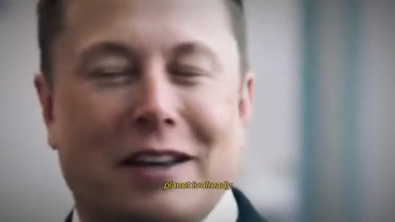  📷 23:45 — Elon Musk em close; legenda 'the richest man'  b12_elon_close_richest_man_00-23-45.jpg
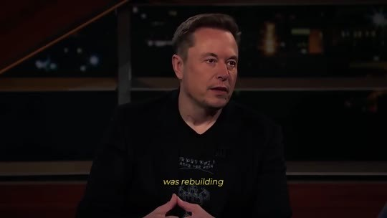
📷 23:53 — Elon Musk (avatar) em entrevista; legenda 'Joe Dispenza showed'
b12_elon_entrevista_david_song_00-23-53.jpg

JOE DISPENZA (narrador, avatar): Quando um investidor liga antes de uma decisão, ele sente o movimento antes do mercado. Eles não são melhores que você. Só tiveram acesso a uma porta que sempre esteve trancada para o resto do mundo. E o homem mais rico do planeta já está dizendo em público o que a elite sempre soube em silêncio.
ELON MUSK (avatar): O Joe Dispenza me mostrou o que estava reconstruindo: o som de uma harpa de 3.000 anos. Ele pôs os fones em mim, apagou as luzes e, em 2 minutos, entendi por que esconderam isso por um século. Ouço essa frequência todos os dias. Muitas das minhas ideias de negócio vieram logo depois de ouvir o som. As pessoas acham que sou algum tipo de gênio. Não sou. Hum, eu só ativo um botão no cérebro que faz as coisas acontecerem naturalmente para mim.

BLOCO 13 — O PACTO DAS 7 NOITES e o future pacing [24:13 – 26:33]

13.1 ⏱ 24:13 → 24:55
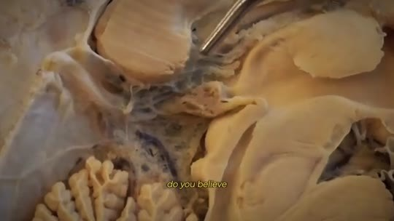  📷 24:17 — Corte do cérebro com luz na pineal  b13_cerebro_pineal_luz_pacto_00-24-17.jpg | 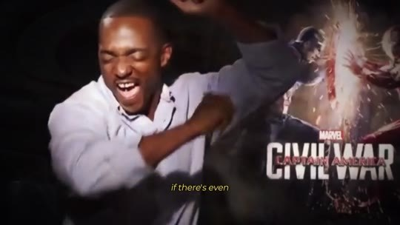  📷 24:21 — Homem rindo diante de pôster 'Civil War'  b13_homem_rindo_civil_war_00-24-21.jpg
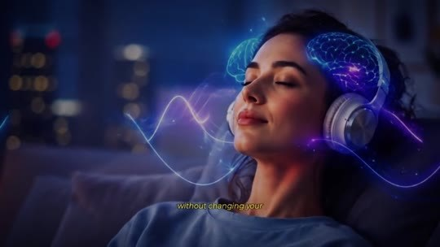  📷 24:35 — Mulher de fones com ondas azuis; legenda 'without changing your routine'  b13_mulher_fones_ondas_00-24-35.jpg | 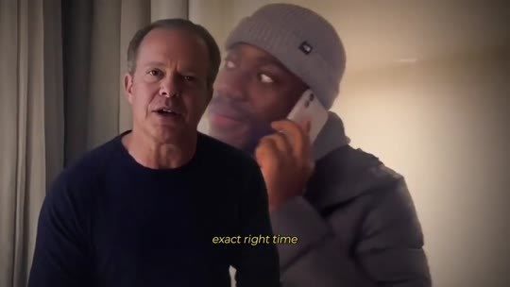  📷 24:41 — Dispenza com homem ao telefone; legenda 'exact right time'  b13_dispenza_homem_telefone_00-24-41.jpg
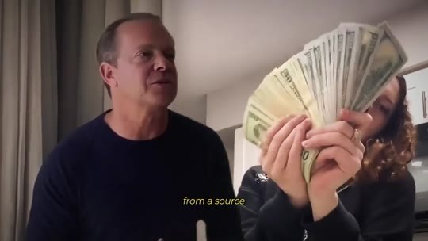  📷 24:49 — Dispenza com mulher segurando dinheiro; legenda 'from a source'  b13_dispenza_dinheiro_00-24-49.jpg | 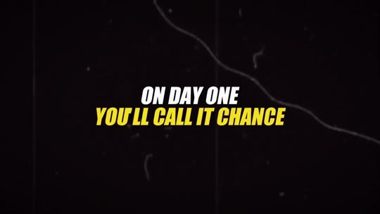  📷 24:53 — Lettering 'ON DAY ONE YOU'LL CALL IT CHANCE'  b13_lettering_day_one_chance_00-24-53.jpg
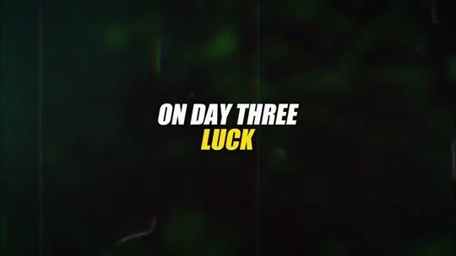
📷 24:55 — Lettering 'ON DAY THREE LUCK'
b13_lettering_day_three_luck_00-24-55.jpg

JOE DISPENZA (narrador, avatar): Então quero fazer um pacto com você, aqui e agora. Você acredita que o seu cérebro é capaz de criar mais do que a vida que você está vivendo? Se existe nem que seja uma parte de você que sempre soube que nasceu para mais, talvez seja exatamente esse botão que precisa ser ativado nas próximas 7 noites. É isso: 7 noites, uma vibração por noite, no escuro, de fones, sem mudar a sua rotina. Anote cada coincidência, a ligação que chega na hora exata, a ideia que aparece pronta, a pessoa que você precisava conhecer e que cruza o seu caminho, o dinheiro que aparece de uma fonte da qual você tinha esquecido. No dia 1, você vai chamar de acaso. No dia 3, de sorte.

13.2 ⏱ 24:56 → 25:41
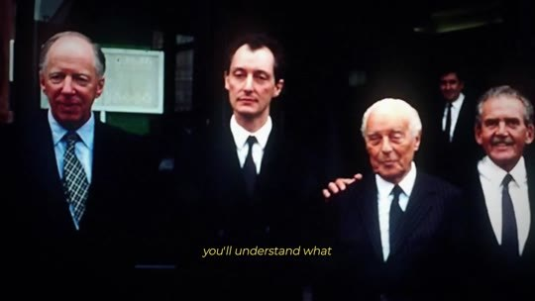  📷 24:57 — Grupo de homens de terno (elite)  b13_elite_rockefeller_grupo_00-24-57.jpg | 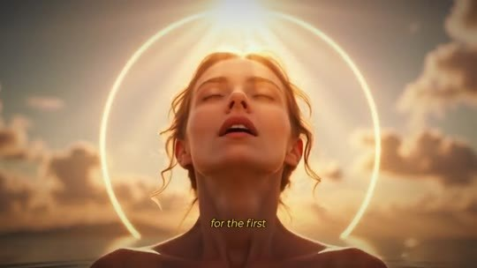  📷 25:05 — Mulher com halo de luz sorrindo  b13_mulher_halo_switched_on_00-25-05.jpg
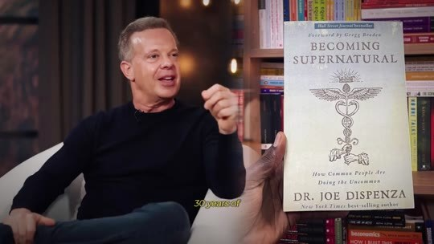  📷 25:11 — Dispenza com o livro 'Becoming Supernatural'  b13_livro_becoming_supernatural_00-25-11.jpg | 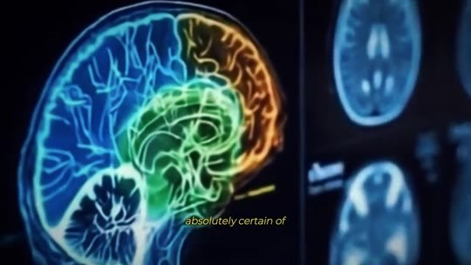  📷 25:19 — Cérebro em neon colorido  b13_cerebro_neon_00-25-19.jpg
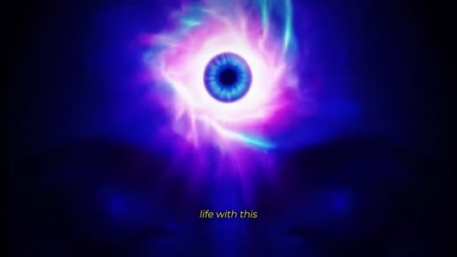  📷 25:27 — Olho cósmico; legenda 'life with this'  b13_olho_cosmico_life_with_00-25-27.jpg | 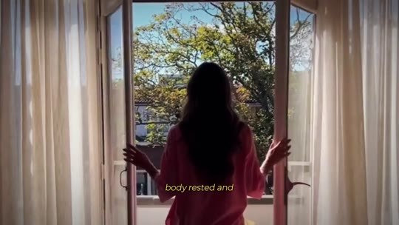  📷 25:35 — Mulher abrindo a janela de manhã; legenda 'body rested'  b13_mulher_janela_manha_00-25-35.jpg

JOE DISPENZA (narrador, avatar): Na 7ª noite, você vai entender o que a elite sempre soube. Não existe acaso para quem está no estado certo. Existe um botão, e o seu, pela primeira vez na vida, vai estar ligado. Eu não estaria colocando o meu nome, o meu rosto e 30 anos de ciência nisso, sabendo que já derrubaram o meu episódio com o Rogan e estão loucos para me transformar numa piada, se não tivesse certeza absoluta do que acontece quando uma pessoa comum aperta o play na primeira noite. Agora imagine a sua vida com esse botão ligado. Você consegue se ver daqui a alguns meses acordando de um sono profundo, sem despertador, com o corpo descansado e a mente clara, percebendo que a ansiedade que morava no seu peito simplesmente não está mais lá?

13.3 ⏱ 25:41 → 26:23
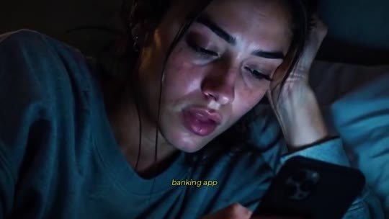  📷 25:43 — Mulher olhando o celular à noite; legenda 'in your stomach'  b13_mulher_celular_banco_noite_00-25-43.jpg | 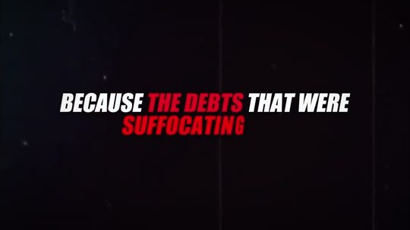  📷 25:47 — Lettering 'BECAUSE THE DEBTS THAT WERE SUFFOCATING'  b13_lettering_debts_suffocating_00-25-47.jpg
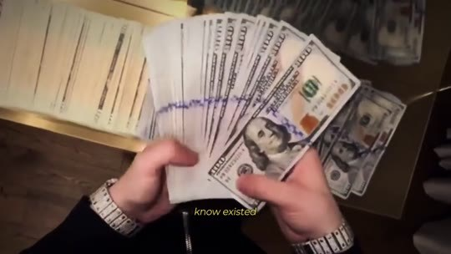  📷 25:53 — Mãos contando notas de dólar  b13_maos_notas_dolar_00-25-53.jpg | 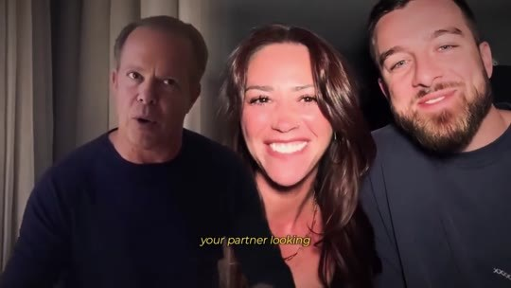  📷 25:55 — Dispenza com casal sorrindo; legenda 'your partner'  b13_dispenza_casal_00-25-55.jpg
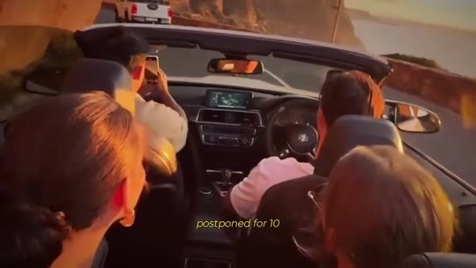  📷 26:01 — Conversível na estrada; legenda 'finally booked'  b13_conversivel_viagem_00-26-01.jpg | 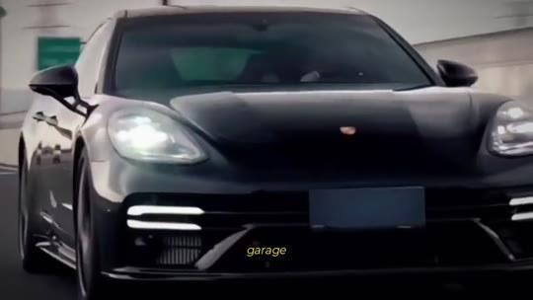  📷 26:05 — Carro na garagem; legenda 'the car in the garage'  b13_carro_garagem_00-26-05.jpg
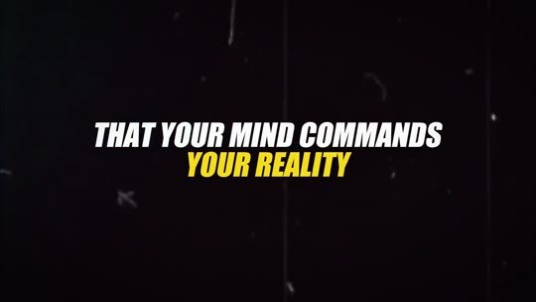
📷 26:19 — Lettering 'THAT YOUR MIND COMMANDS YOUR REALITY'
b13_lettering_mind_commands_reality_00-26-19.jpg

JOE DISPENZA (narrador, avatar): Você consegue se ver abrindo o aplicativo do banco sem aquele nó no estômago, porque as dívidas que te sufocavam foram pagas, uma por uma, com dinheiro que veio por portas que você nem sabia que existiam? Consegue imaginar o seu parceiro olhando para você de outro jeito, porque as brigas por dinheiro acabaram junto com a falta dele? A viagem que você adiou por 10 anos finalmente reservada? O carro na garagem? O presente dado sem olhar a etiqueta de preço? E, mais do que tudo isso, consegue imaginar a sensação de andar pelo mundo sabendo, não esperando, não desejando, sabendo que a sua mente comanda a sua realidade, e não o contrário? Essa sensação tem nome.

13.4 ⏱ 26:23 → 26:33
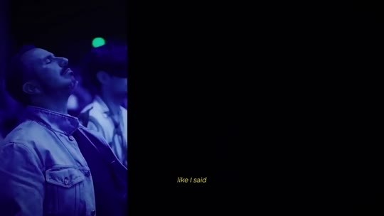
📷 26:33 — Plateia de retiro; legenda '$50,000 for a retreat'
b13_plateia_retiro_50000_00-26-33.jpg

JOE DISPENZA (narrador, avatar): É o seu terceiro olho desperto. É o estado em que o 1% acorda todos os dias, e o botão está dentro da sua cabeça agora mesmo, só esperando você ativá-lo.

BLOCO 14 — PREÇO: de $5.000 para $39, e por que não é de graça [26:33 – 29:44]

14.1 ⏱ 26:33 → 27:25
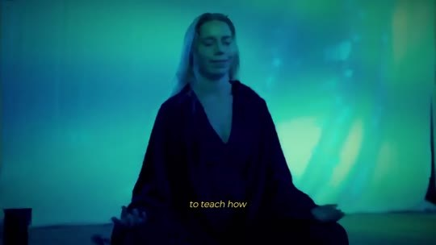  📷 26:37 — Mulher meditando sob luz verde (aurora)  b14_mulher_meditando_aurora_00-26-37.jpg | 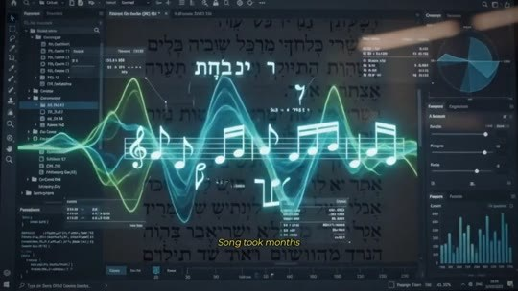  📷 26:45 — Software de reconstrução com espectros; legenda 'supercomputer'  b14_software_reconstrucao_supercomputador_00-26-45.jpg
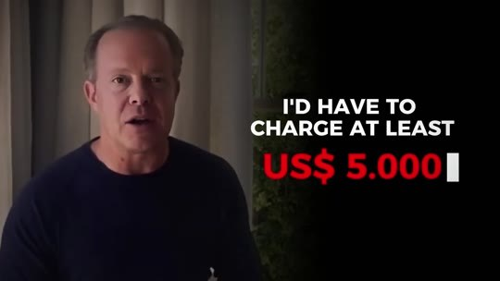  📷 27:01 — Dispenza; lettering 'I'D HAVE TO CHARGE AT LEAST US$ 5.000'  b14_dispenza_charge_5000_00-27-01.jpg | 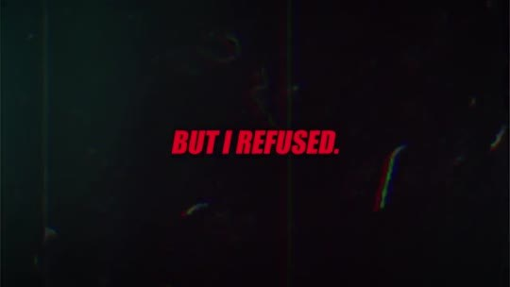  📷 27:03 — Lettering 'BUT I REFUSED.'  b14_lettering_but_i_refused_00-27-03.jpg
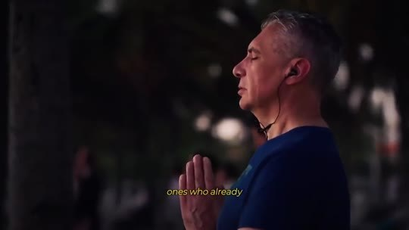  📷 27:11 — Homem de fones (tycoons)  b14_homem_fones_cruzando_00-27-11.jpg | 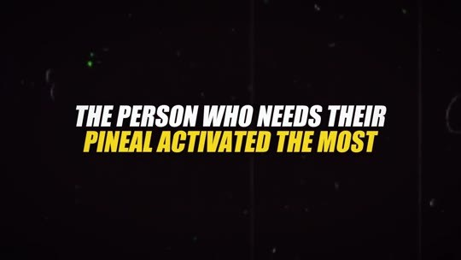  📷 27:23 — Lettering 'THE PERSON WHO NEEDS THEIR PINEAL ACTIVATED THE MOST'  b14_lettering_person_needs_pineal_00-27-23.jpg
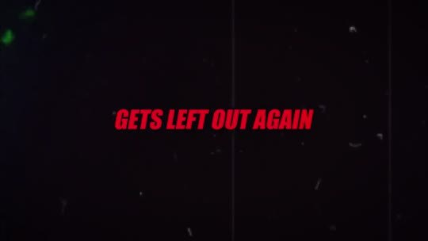
📷 27:25 — Lettering 'GETS LEFT OUT AGAIN'
b14_lettering_left_out_again_00-27-25.jpg

JOE DISPENZA (narrador, avatar): Como eu disse, já me pagaram até $50.000 por um retiro para ensinar a ativar essa glândula, e pagavam porque, em menos de 3 meses, já tinham multiplicado esse valor 3 vezes. Reconstruir o David Song levou meses de supercomputador, uma equipe internacional e uma boa parte do meu próprio dinheiro. Eu precisava que a elite me pagasse tanto só para cobrir o custo de tudo, porque, se eu tivesse que cobrar das pessoas comuns o que custou, teria que cobrar pelo menos $5.000. Mas eu me recusei, porque, se o David Song sair a $5.000, quem compra? As mesmas pessoas de sempre. As que já têm acesso. Magnatas, celebridades, e a mãe fazendo contas no supermercado, o pai com o cartão de crédito estourado, a pessoa que mais precisa da pineal ativada, fica de fora de novo.

14.2 ⏱ 27:26 → 28:18
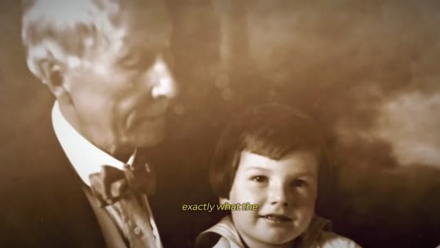  📷 27:29 — Foto antiga de Rockefeller com criança; legenda '100 years'  b14_rockefeller_com_crianca_00-27-29.jpg | 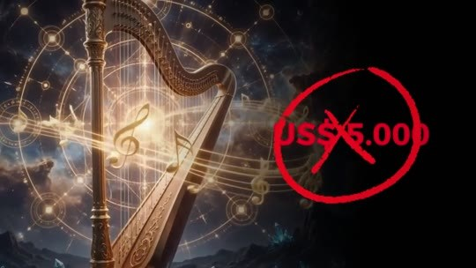  📷 27:43 — Harpa com '$5.000' riscado em vermelho  b14_harpa_5000_riscado_00-27-43.jpg
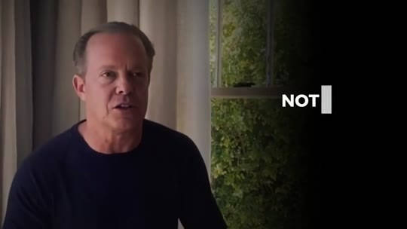  📷 27:47 — Dispenza; lettering 'IT WON'T COST A THOUSAND'  b14_lettering_wont_cost_thousand_00-27-47.jpg | 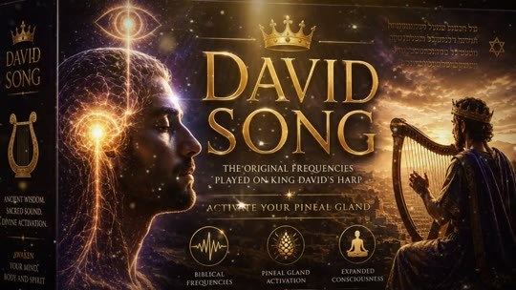  📷 27:53 — Capa do produto 'DAVID SONG' com Davi e a harpa  b14_capa_david_song_00-27-53.jpg
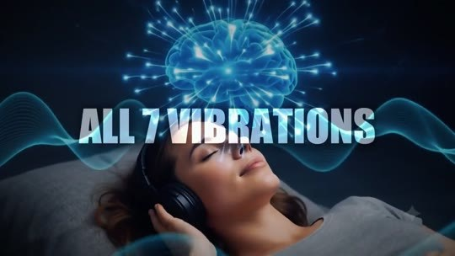  📷 27:55 — Lettering 'ALL 7 VIBRATIONS'  b14_lettering_all_7_vibrations_00-27-55.jpg | 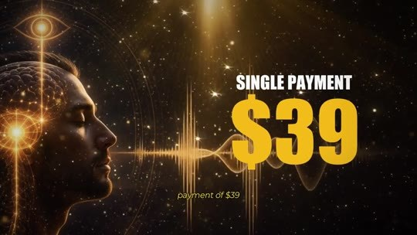  📷 27:59 — Lettering 'SINGLE PAYMENT $39'  b14_preco_single_payment_39_00-27-59.jpg
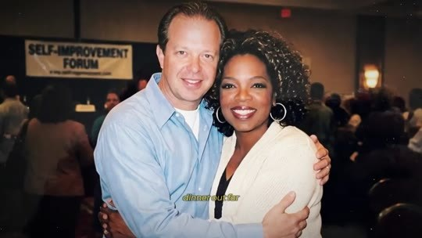  📷 28:05 — Foto de Dispenza com Oprah; legenda 'NDAs'  b14_dispenza_oprah_ndas_00-28-05.jpg | 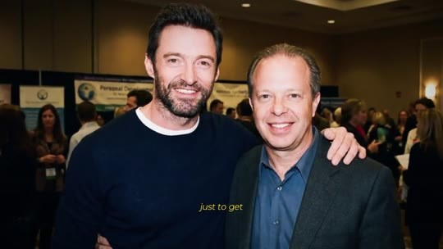  📷 28:09 — Foto de Dispenza com Hugh Jackman  b14_dispenza_hugh_jackman_00-28-09.jpg
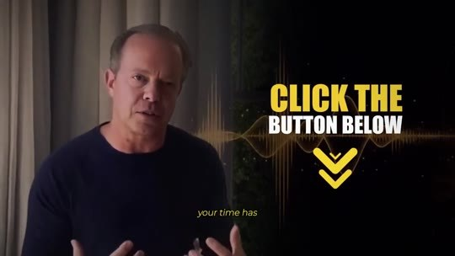
📷 28:13 — Dispenza; lettering 'CLICK THE BUTTON BELOW'
b14_click_the_button_below_00-28-13.jpg

JOE DISPENZA (narrador, avatar): Isso seria repetir, com o meu nome, exatamente o que os Rockefeller fizeram por 100 anos: trancar a chave num cofre e entregá-la só a quem aceita viver dentro do sistema deles. Então hoje, nesta página, o David Song não vai custar $5.000. Não vai custar $1.000. Não vai custar $500. Nem $250. Nem mesmo $100. Enquanto este vídeo ainda estiver no ar, você leva o David Song completo, as 7 vibrações, mais todos os bônus que vou te mostrar, num pagamento único de $39. $39. Menos de 50 centavos por dia. Menos que um jantar fora. Pelo som que celebridades pagaram $50.000 só para receber, assinando termos de confidencialidade. Se você sente que a sua hora chegou, clique no botão abaixo deste vídeo agora mesmo e garanta o seu acesso.

14.3 ⏱ 28:19 → 29:06
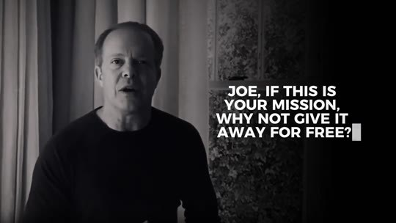  📷 28:25 — Lettering 'JOE, IF THIS IS YOUR MISSION, WHY NOT GIVE IT AWAY FOR FREE?'  b14_lettering_why_not_free_00-28-25.jpg | 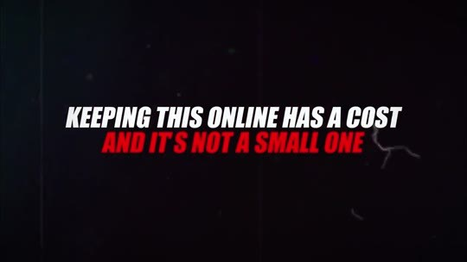  📷 28:33 — Lettering 'KEEPING THIS ONLINE HAS A COST AND IT'S NOT A SMALL ONE'  b14_lettering_online_has_a_cost_00-28-33.jpg
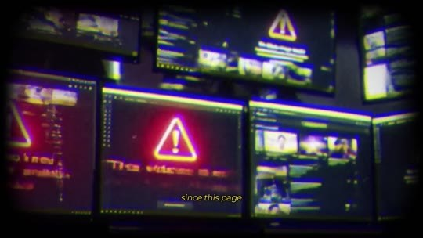
📷 28:39 — Monitores com alertas vermelhos (ataques ao site)
b14_servidores_alerta_00-28-39.jpg

JOE DISPENZA (narrador, avatar): E sei que tem alguém aí pensando: 'Joe, se essa é a sua missão, por que não dar de graça?' É uma pergunta justa, e existem dois motivos. Motivo número um: manter isto no ar tem um custo, e não é pequeno. Você viu o que fizeram com o meu episódio do Joe Rogan. 24 horas e ele sumiu. Desde que esta página entrou no ar, ela já foi derrubada e atacada mais de uma vez. Para manter esta página de pé, a minha equipe roda tudo em servidores de segurança máxima, a mesma infraestrutura que os grandes bancos usam, com backups fora do país. Cada dia que este vídeo fica no ar é pago do meu próprio bolso, contra gente com bolsos muito mais fundos que… Motivo número 2, e este eu descobri medindo cérebros, não vendendo cursos.

14.4 ⏱ 29:06 → 29:44
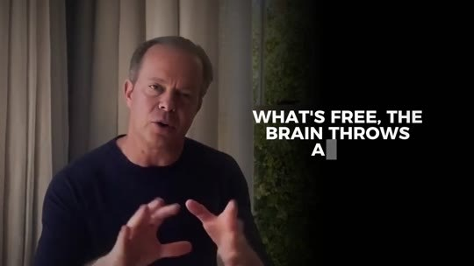  📷 29:08 — Dispenza; lettering 'WHAT'S FREE, THE BRAIN THROWS AWAY'  b14_lettering_whats_free_brain_throws_00-29-08.jpg | 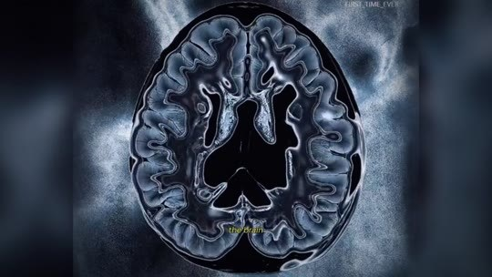  📷 29:16 — Ressonância do cérebro; legenda 'in the data'  b14_ressonancia_cerebro_dados_00-29-16.jpg
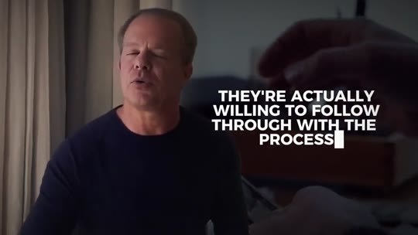
📷 29:24 — Dispenza; lettering 'THEY'RE ACTUALLY WILLING TO FOLLOW THROUGH WITH THE PROCESS'
b14_lettering_follow_through_00-29-24.jpg

JOE DISPENZA (narrador, avatar): O que é de graça, o cérebro joga fora. Hum, eu vi isso nos dados, preto no branco. O compromisso muda a corrente elétrica do cérebro. Quando uma pessoa investe nem que seja um valor simbólico, ela de fato se dispõe a seguir o processo até o fim. Se eu liberasse o David Song de graça na internet, ele viraria só mais uma aba aberta que você nunca mais olha, e o seu botão continuaria desligado, desta vez com a chave bem na sua mão. Não posso deixar isso acontecer. Os $39 não são o preço do David Song. São o preço do seu compromisso consigo mesmo.

BLOCO 15 — ACESSO DIGITAL VITALÍCIO e GARANTIA de 60 dias [29:45 – 31:57]

15.1 ⏱ 29:45 → 30:28
  📷 29:47 — Dispenza diante de tela 'Secure Checkout'  b15_checkout_seguro_00-29-47.jpg | 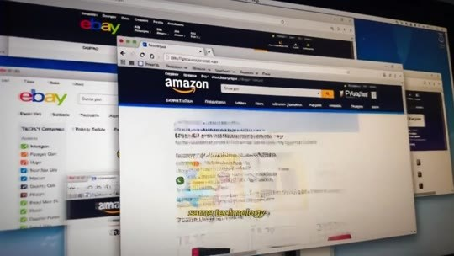  📷 29:53 — Tela com Amazon e eBay; legenda 'the big banks use'  b15_amazon_ebay_tela_00-29-53.jpg
  📷 30:01 — Celular com 'Payment Approved'  b15_payment_approved_00-30-01.jpg | 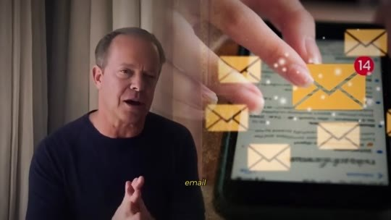  📷 30:05 — Ícones de e-mail chegando; legenda 'arrives in your email'  b15_email_acesso_00-30-05.jpg
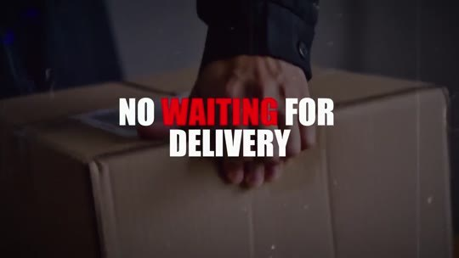  📷 30:13 — Lettering 'NO WAITING FOR DELIVERY'  b15_lettering_no_waiting_delivery_00-30-13.jpg | 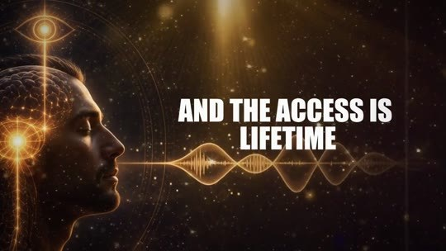  📷 30:19 — Lettering 'AND THE ACCESS IS LIFETIME'  b15_lettering_access_lifetime_00-30-19.jpg

JOE DISPENZA (narrador, avatar): Quando você clicar no botão abaixo, vai ser levado a uma página de pagamento 100% segura e criptografada, protegida pela mesma tecnologia que a Amazon e os grandes bancos usam. Nenhum dado seu é armazenado de forma indevida. Você preenche os dados, confirma e, no minuto em que o pagamento é aprovado, o acesso completo chega no seu e-mail. As 7 vibrações do David Song, junto com todos os bônus, tudo digital. Sem esperar entrega, sem frete. Você ouve no celular, no tablet ou no computador. E o acesso é vitalício, seu para sempre. Mesmo que este vídeo desapareça, o David Song agora vai ser seu. Nenhum governo ou poderoso pode tirar a verdade de você.

15.2 ⏱ 30:28 → 31:11
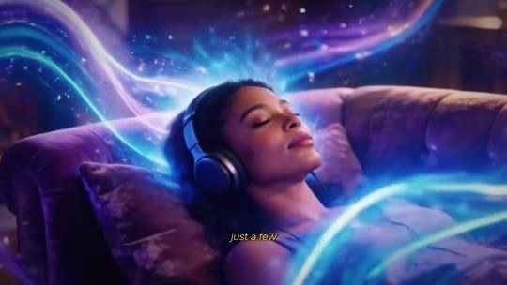  📷 30:29 — Mulher dormindo de fones com ondas de luz  b15_mulher_fones_ondas_luz_00-30-29.jpg |   📷 30:39 — Dispenza com equipe de suporte com headsets  b15_suporte_24h_00-30-39.jpg
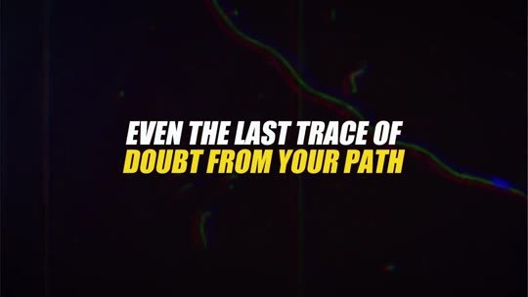  📷 30:47 — Lettering 'EVEN THE LAST TRACE OF DOUBT FROM YOUR PATH'  b15_lettering_last_trace_doubt_00-30-47.jpg | 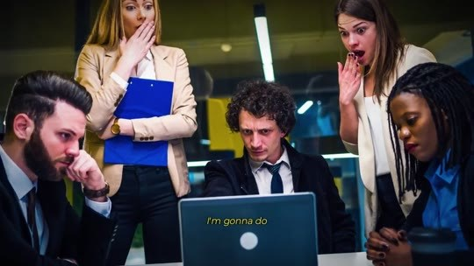  📷 30:55 — Equipe financeira chocada diante do laptop  b15_equipe_financeira_chocada_00-30-55.jpg
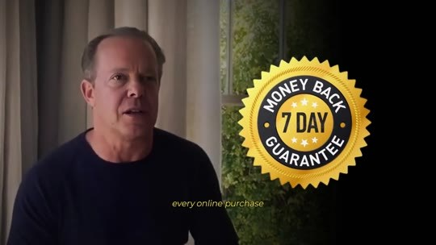  📷 31:01 — Dispenza com selo '7 DAY MONEY BACK GUARANTEE'  b15_selo_7_day_guarantee_00-31-01.jpg | 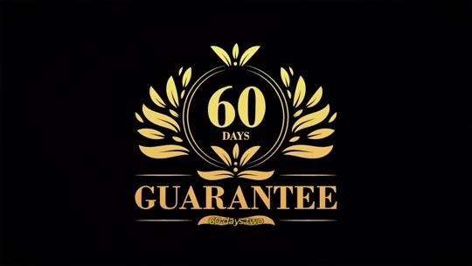  📷 31:05 — Selo dourado '60 DAYS GUARANTEE'  b15_selo_60_days_guarantee_00-31-05.jpg

JOE DISPENZA (narrador, avatar): Isso significa que, em poucos minutos, você já pode estar num quarto escuro, de fones, apertando o play na primeira das suas 7 noites. E, é, se algo der errado, a minha equipe de suporte atende 24 horas por dia e resolve na hora. Mas quero tirar até o último vestígio de dúvida do seu caminho, porque sei que você já se queimou antes com promessas de cursos, métodos, segredos. Então vou fazer algo que deixou a minha equipe financeira de cabelo em pé. Por lei, toda compra online vem com uma garantia de 7 dias. Eu estou te dando 60 dias, 2 meses inteiros. Faça as 7 noites, depois faça 7 semanas se quiser.

15.3 ⏱ 31:11 → 31:57
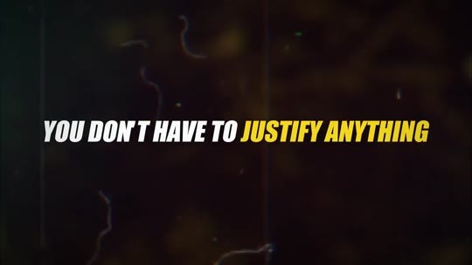  📷 31:23 — Lettering 'YOU DON'T HAVE TO JUSTIFY ANYTHING'  b15_lettering_dont_justify_00-31-23.jpg | 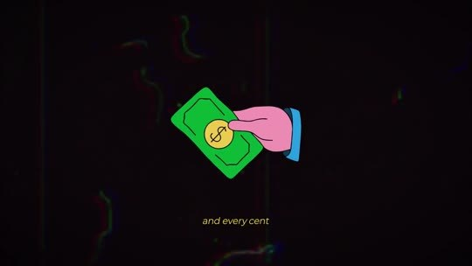  📷 31:27 — Ícone de mão devolvendo dinheiro; legenda 'and every cent'  b15_icone_dinheiro_volta_00-31-27.jpg
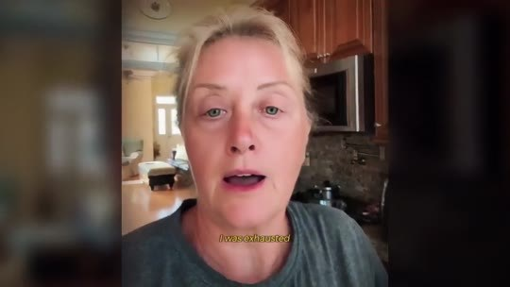
📷 31:57 — Mulher loira na cozinha (depoimento do sonho do acidente)
b15_depoimento_mae_cozinha_00-31-57.jpg

JOE DISPENZA (narrador, avatar): Observe o seu sono, os seus sonhos, a sua clareza, as coincidências, as oportunidades. Se, em qualquer momento dentro de 2 meses, você olhar para a sua vida e sentir que nada mudou, não precisa justificar nada. Mande um único e-mail para a minha equipe e cada centavo volta para a sua conta. Sem perguntas, sem burocracia, sem 'mas'. E tem mais. Não vou pedir nada de volta. O acesso continua seu. Se o David Song não funcionar para você, cada último centavo volta, mas ainda assim quero que você fique com a chave. Pense no que isso significa. Só existem 2 finais possíveis para esta história. Ou o seu botão liga e a sua realidade começa a se curvar a seu favor, ou você não paga absolutamente nada. Você não precisa dizer sim hoje. Só precisa dizer talvez. O risco é todo meu.

BLOCO 16 — DEPOIMENTOS: a mãe que sonhou com o acidente e o cético da família [31:57 – 33:30]

16.1 ⏱ 31:57 → 32:41
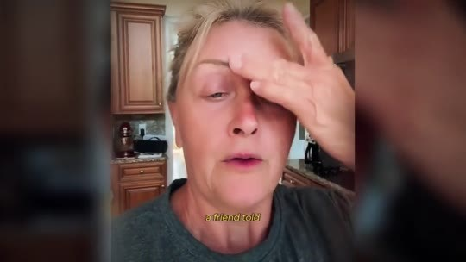
📷 32:05 — Mesma mulher com a mão na testa
b16_mae_mao_na_testa_00-32-05.jpg

MÃE (depoimento, sonho do acidente): Eu estava exausta, presa na minha rotina de trabalho e criando o meu filho pequeno sem energia, sem clareza mental e quase sem dormir. Uma amiga me falou do David Song e, mesmo cética, decidi experimentar. Na primeira semana, senti mudanças profundas. Finalmente dormi a noite inteira, acordei com a mente leve e mais foco. Mas o que realmente me marcou foi um sonho que tive alguns dias depois. Sonhei com um acidente de carro. Extremamente real, cada detalhe. Acordei abalada e, no fundo, sabia que não era só um sonho. Alguns dias depois, quando eu estava prestes a entrar num carro que tinha reservado, a cena do sonho se repetiu.

16.2 ⏱ 32:41 → 33:30
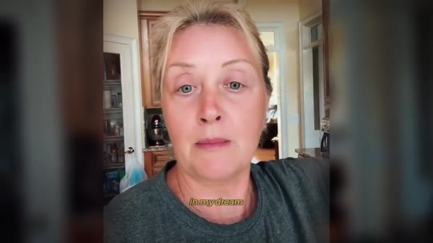  📷 32:52 — Homem de camiseta preta (o cético da família); legenda 'seven nights just'  b16_cetico_familia_depoimento_00-32-52.jpg | 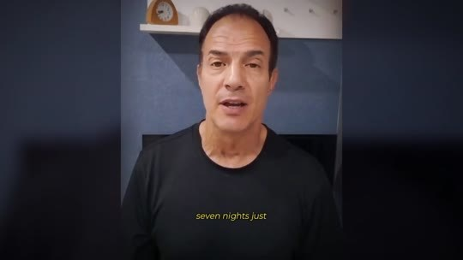  📷 33:10 — Mesmo homem; legenda 'refunding me $4,200'  b16_cetico_refunding_4200_00-33-10.jpg

MÃE (depoimento, sonho do acidente): Os meus instintos me pararam e decidi não entrar naquele carro. Mais tarde, vi no noticiário que aquele mesmo carro tinha se envolvido num acidente grave, exatamente como no meu sonho. Foi aí que entendi. O David Song não só transformou a minha mente, ele pode ter salvado a minha vida e a do meu filho. Desde então ouço todas as noites. A minha energia, o meu foco e a minha intuição estão em outro nível.
O CÉTICO DA FAMÍLIA (depoimento): Eu era o cético da família. Fiz as 7 noites só para provar que era bobagem. No dia 8, recebi uma carta do banco. Um erro de cobrança de anos tinha sido corrigido, e eles estavam me devolvendo $4.200 com juros. Coincidência? Talvez. Mas aí veio a segunda semana. E a terceira. Em algum momento você para de chamar de coincidência.

BLOCO 17 — ESCASSEZ e OS 7 BÔNUS (valor total de $2.076) [33:30 – 38:27]

17.1 ⏱ 33:30 → 34:17
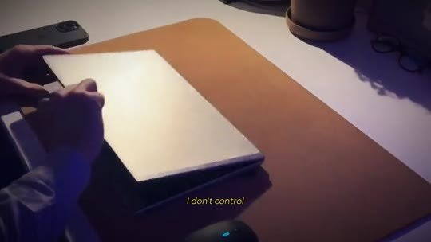  📷 33:34 — Laptop; legenda 'I don't control'  b17_laptop_i_dont_control_00-33-34.jpg | 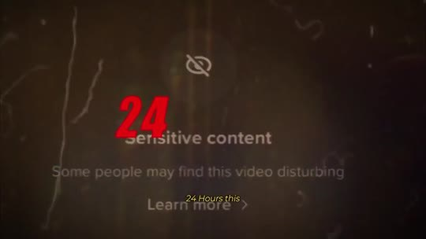  📷 33:40 — Lettering '24' sobre tela 'Sensitive content'  b17_lettering_24_sensitive_00-33-40.jpg
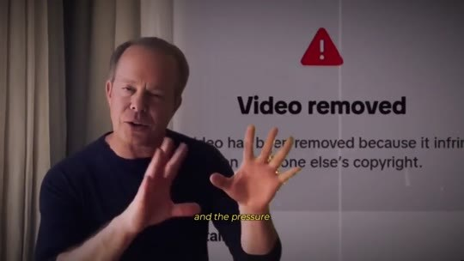  📷 33:44 — Dispenza com tela 'Video removed'  b17_dispenza_video_removed_00-33-44.jpg | 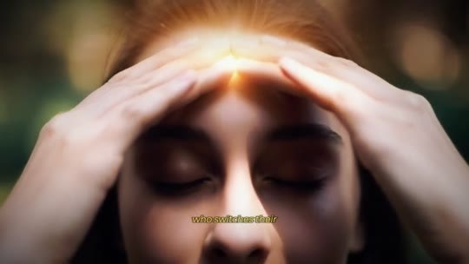  📷 33:48 — Mulher com as mãos na cabeça e luz  b17_mulher_maos_cabeca_luz_00-33-48.jpg
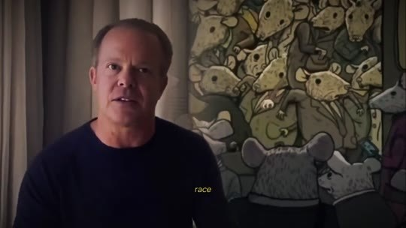  📷 33:52 — Dispenza com desenho dos ratos ao fundo; legenda 'rat race'  b17_dispenza_ratos_00-33-52.jpg | 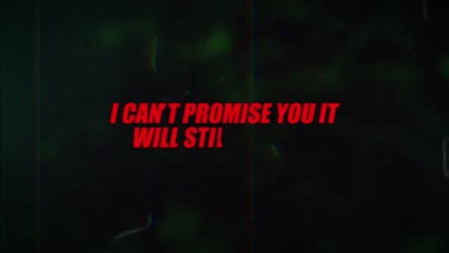  📷 34:00 — Lettering 'I CAN'T PROMISE YOU IT WILL STILL BE HERE'  b17_lettering_cant_promise_00-34-00.jpg
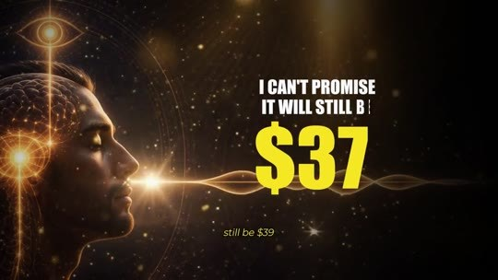  📷 34:04 — Lettering 'I CAN'T PROMISE IT WILL STILL BE $39'  b17_lettering_cant_promise_39_00-34-04.jpg | 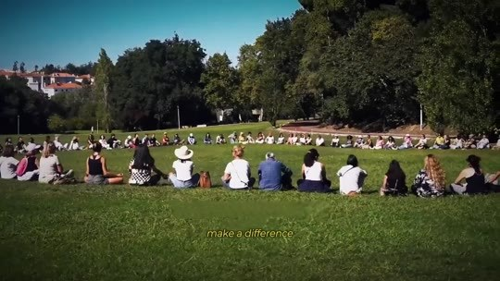  📷 34:14 — Grupo de retiro num gramado  b17_retiro_grupo_gramado_00-34-14.jpg

JOE DISPENZA (narrador, avatar): Mas preciso ser honesto com você sobre uma coisa, e queria não precisar. Eu não controlo por quanto tempo esta página fica no ar. Você viu o que fizeram com o episódio do Rogan. 24 horas. Esta página já caiu antes. E a pressão para que caia de novo só cresce, porque cada pessoa que liga o seu botão é mais uma pessoa saindo da corrida dos ratos, e a corrida dos ratos é o produto mais lucrativo da história. Se você fechar este vídeo para pensar e voltar amanhã, não posso te prometer que ele ainda vai estar aqui. E, se estiver, não posso prometer que ainda vai custar $39. E tem mais uma coisa para quem age agora. Ao garantir o seu acesso hoje, você não leva só o David Song. Incluí tudo o que já vi fazer diferença nos meus retiros, sem custo extra.

17.2 ⏱ 34:17 → 35:11
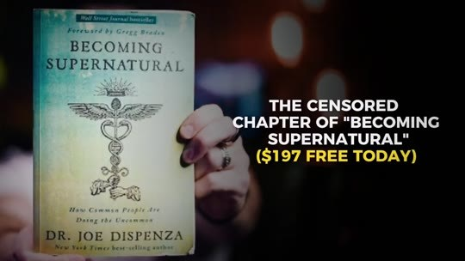  📷 34:20 — Livro 'Becoming Supernatural'; lettering 'THE CENSORED CHAPTER OF "BECOMING SUPERNATURAL" ($197 FREE TODAY)'  b17_bonus_1_capitulo_censurado_00-34-20.jpg | 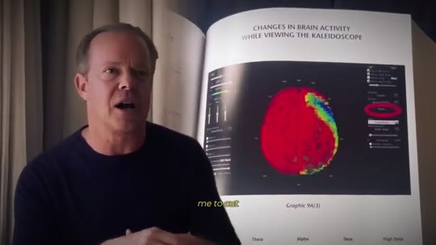  📷 34:34 — Dispenza com o livro aberto (cérebro em vermelho)  b17_livro_aberto_cerebro_00-34-34.jpg
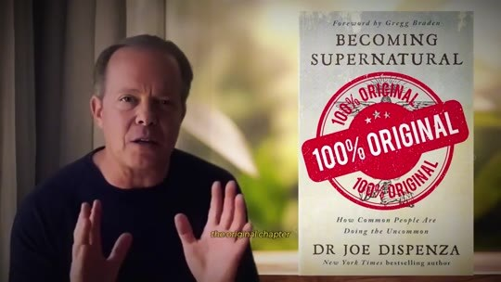  📷 34:50 — Livro com carimbo '100% ORIGINAL'  b17_livro_100_original_00-34-50.jpg | 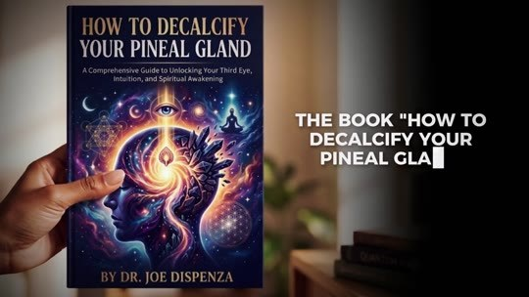  📷 34:58 — Livro 'How to Decalcify Your Pineal Gland'  b17_bonus_2_decalcify_00-34-58.jpg
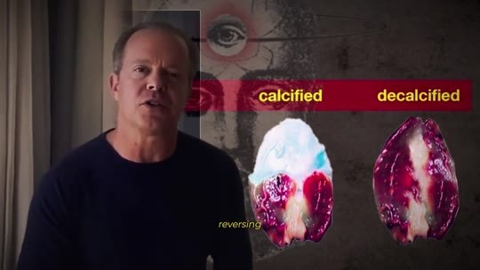
📷 35:02 — Comparativo 'calcified / decalcified' da pineal
b17_calcified_decalcified_00-35-02.jpg

JOE DISPENZA (narrador, avatar): Bônus 1: o capítulo censurado de Becoming Supernatural. Você talvez tenha lido o meu livro Becoming Supernatural, o best-seller que vendeu milhões de cópias no mundo todo. O que você não sabe é que o capítulo sobre a glândula pineal que foi publicado não é o capítulo que eu escrevi. A editora me obrigou a cortar as páginas mais importantes. Exatamente as que explicam a relação entre a vibração sonora e a ativação da glândula. Revelo outro tipo de ritual que as elites fazem em comunidades fechadas para manifestar o dinheiro que deveria estar indo para o seu bolso. Hoje você recebe o capítulo original, completo, sem cortes, do jeito que eu escrevi, do jeito que não te deixaram ler. Bônus 2: o livro Como Descalcificar a Sua Glândula Pineal, o guia passo a passo para reverter o dano dos aditivos na sua comida e na sua água que enfraquecem a sua pineal, mais outras orientações ancestrais para ativar a sua pineal ainda mais rápido.

17.3 ⏱ 35:12 → 35:58
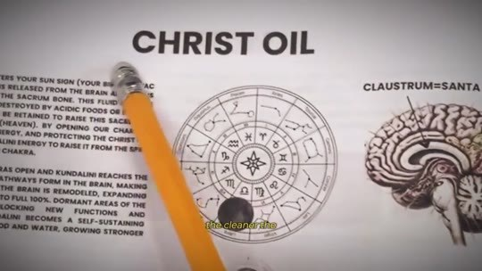  📷 35:12 — Desenho 'CHRIST OIL' com cérebro  b17_christ_oil_desenho_00-35-12.jpg | 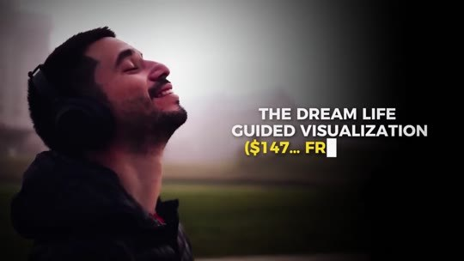  📷 35:18 — Homem de olhos fechados; lettering 'THE DREAM LIFE GUIDED VISUALIZATION ($147… FREE)'  b17_bonus_3_dream_life_00-35-18.jpg
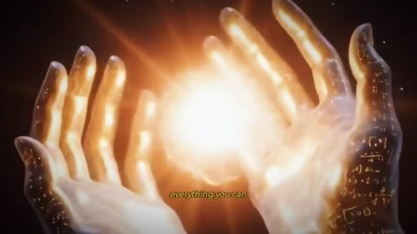  📷 35:32 — Mãos com luz dourada; legenda 'trapped for so long'  b17_maos_luz_dourada_00-35-32.jpg | 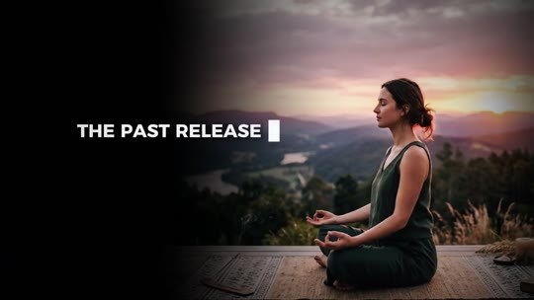  📷 35:44 — Mulher meditando no mirante; lettering 'THE PAST RELEASE TECHNIQUE'  b17_bonus_4_past_release_00-35-44.jpg
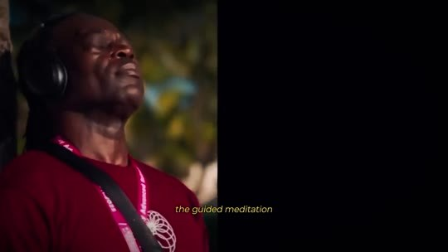
📷 35:46 — Homem de fones meditando no retiro
b17_homem_fones_retiro_00-35-46.jpg

JOE DISPENZA (narrador, avatar): Quanto mais limpo o cristal, mais forte ele responde à vibração. Bônus 3: a Visualização Guiada da Vida dos Sonhos. Uma visualização guiada por mim. Talvez, mesmo com o botão da manifestação ativo, você tenha vivido preso por tanto tempo que nem sabe o potencial do que poderia receber. Vou te ajudar a imaginar tudo o que você pode manifestar para que isso vire realidade. Ouça com o botão da manifestação ligado e deixe o seu cérebro ensaiar o futuro até ele virar presente. Bônus 4: a Técnica de Liberação do Passado. A meditação guiada que uso nos meus retiros para apagar o trauma marcado no seu corpo. Porque o trauma… o passado não mora na sua memória, mora no seu corpo, e um corpo preso no passado mantém os seus botões desligados.

17.4 ⏱ 35:58 → 36:43
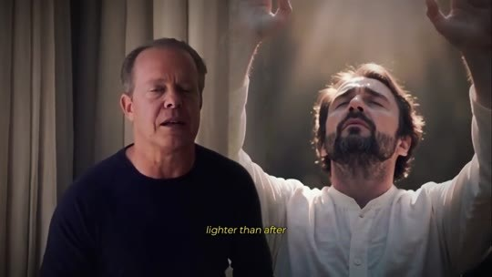  📷 36:12 — Dispenza com homem de braços erguidos; legenda 'lighter than'  b17_homem_bracos_abertos_lighter_00-36-12.jpg | 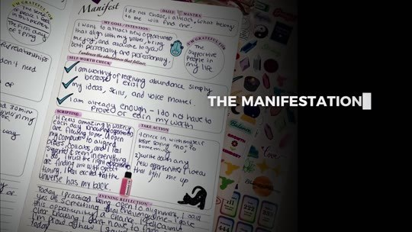  📷 36:26 — Diário com anotações; lettering 'THE MANIFESTATION JOURNAL'  b17_bonus_5_journal_00-36-26.jpg
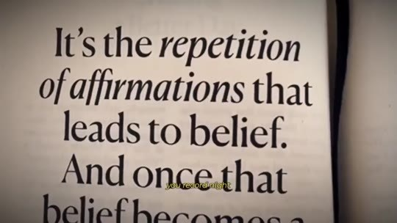
📷 36:34 — Livro 'It's the repetition of affirmations that leads to belief'
b17_livro_repetition_affirmations_00-36-34.jpg

JOE DISPENZA (narrador, avatar): Nesta prática, você desliga a carga emocional das memórias que te machucaram, e o seu corpo, finalmente livre, para de te puxar para trás. É a parte dos retiros em que os lenços passam pela sala e as pessoas saem mais leves do que depois de décadas de terapia. Você usa o potencial da sua pineal ativa para liberar o peso do passado, da energia ruim que acumulou, para poder viver a sua nova vida sem o peso do passado. Bônus 5: o Diário da Manifestação. O mesmo diário que todo aluno recebe no dia 1 dos meus retiros, agora numa versão guiada. Você registra, noite após noite, cada coincidência, cada oportunidade, cada resultado. Quem registra as suas sincronicidades recebe mais delas.

17.5 ⏱ 36:44 → 37:28
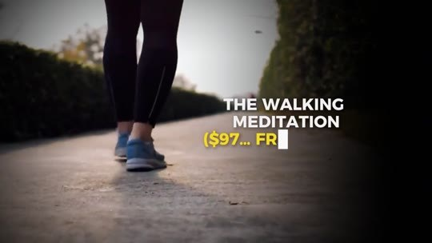  📷 36:52 — Pés caminhando; lettering 'THE WALKING MEDITATION ($97… FREE)'  b17_bonus_6_walking_meditation_00-36-52.jpg | 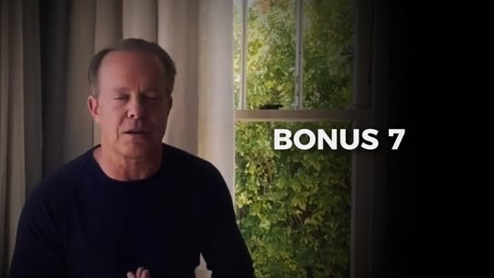  📷 37:14 — Dispenza ao vivo; lettering 'BONUS 7 / THE WEEKLY LIVE COHERENCE SESSION ($997… FREE TODAY)'  b17_bonus_7_coherence_00-37-14.jpg

JOE DISPENZA (narrador, avatar): E o seu diário vira a prova, escrita com a sua própria mão, de que o seu botão está ligado. Bônus 6: a meditação caminhando. O David Song liga o seu botão à noite. Esta prática o mantém ligado durante o dia. Você ativa o seu botão enquanto caminha ou faz qualquer atividade e aprende a manter esse estado de coerência de olhos abertos, lá fora, no mundo real. Você abre o seu sexto sentido, porque é aí… é aí que as oportunidades aparecem. Não no seu quarto, lá fora, no mundo. Bônus 7: a sessão semanal de coerência ao vivo. Todo domingo, uma meditação em grupo ao vivo conduzida por mim, a mesma que encerra cada dia dos meus retiros. Não é uma gravação, somos você e eu juntos, ao mesmo tempo.

17.6 ⏱ 37:28 → 38:15
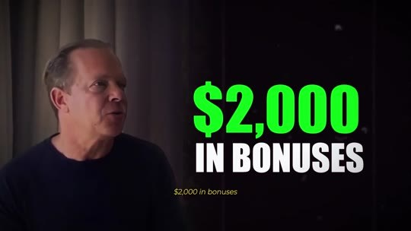  📷 37:34 — Dispenza; lettering '$2,000 IN BONUSES'  b17_lettering_2000_bonuses_00-37-34.jpg | 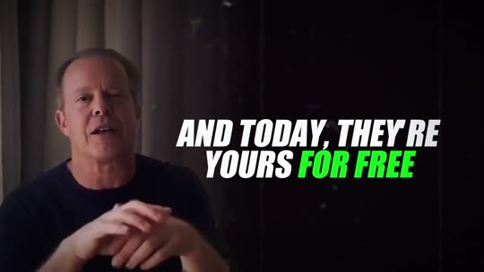  📷 37:38 — Lettering 'AND TODAY, THEY'RE YOURS FOR FREE'  b17_lettering_yours_for_free_00-37-38.jpg

JOE DISPENZA (narrador, avatar): Era a única parte do retiro que ninguém conseguia levar para casa. Agora você pode. Somando tudo, são mais de 2.000 em bônus, e hoje eles são seus de graça. Então deixa eu colocar tudo na mesa, preto no branco. Garantindo o seu acesso hoje, você recebe o David Song, as 7 Vibrações de Davi, o som original do kinnor reconstruído nota por nota, uma vibração por noite, mais os 7 bônus mais desejados dos meus retiros, mais uma garantia incondicional de 60 dias, e o acesso continua seu mesmo que você peça o reembolso. O valor total de tudo junto é de $2.076. O que algumas celebridades já me pagaram para aprender passa de $50.000. O que você investe hoje, uma única vez, enquanto esta página ainda está no ar, é só $39.

17.7 ⏱ 38:16 → 38:27
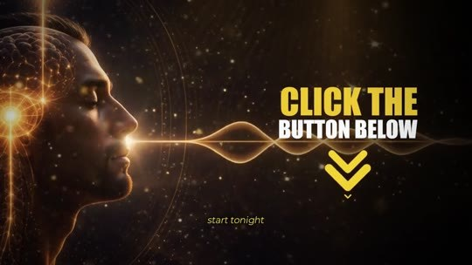
📷 38:27 — Lettering 'CLICK THE BUTTON BELOW'
b17_click_button_final_offer_00-38-27.jpg

JOE DISPENZA (narrador, avatar): E você recebe acesso instantâneo no seu e-mail, para a vida toda. Pode salvar no celular, no computador, e ninguém nunca vai poder tirar o seu acesso. Clique no botão abaixo agora. E comece hoje à noite.

BLOCO 18 — FECHAMENTO: as 2 portas [38:27 – 41:16]

18.1 ⏱ 38:27 → 39:12
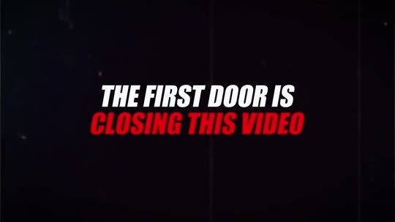  📷 38:35 — Lettering 'THE FIRST DOOR IS CLOSING THIS VIDEO'  b18_lettering_first_door_00-38-35.jpg | 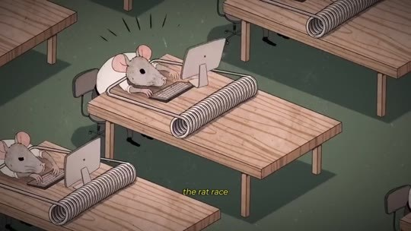  📷 38:41 — Ratos no metrô (rat race)  b18_ratos_metro_00-38-41.jpg
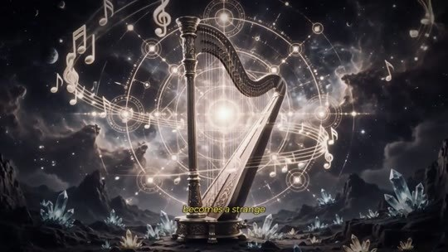  📷 38:49 — Harpa entre constelações  b18_harpa_constelacao_00-38-49.jpg | 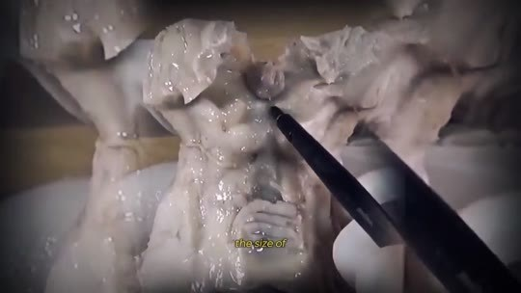  📷 38:57 — Mãos segurando um cérebro  b18_cerebro_maos_grao_arroz_00-38-57.jpg

JOE DISPENZA (narrador, avatar): Agora mesmo você está diante de 2 portas, e já vi milhares de pessoas exatamente onde você está. A primeira porta é fechar este vídeo e voltar à rotina. Amanhã o despertador toca, o modo sobrevivência liga, a corrida dos ratos recomeça: impostos, aluguel, cartões de crédito, juros, e tudo o que você viu aqui vira uma lembrança estranha de algum vídeo que você assistiu uma vez. O seu botão fica onde sempre esteve. Dentro da sua cabeça, do tamanho de um grão de arroz, desligado. E a única coisa que muda é que agora você sabe. Essa é a parte cruel da primeira porta. Dá para viver sem saber, mas saber e escolher não apertar, essa dúvida nunca vai embora.

18.2 ⏱ 39:12 → 39:56
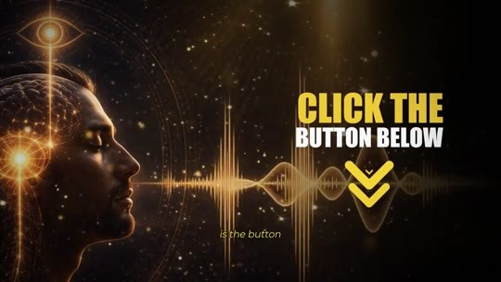  📷 39:13 — Lettering 'SINGLE PAYMENT $39'  b18_preco_39_final_00-39-13.jpg | 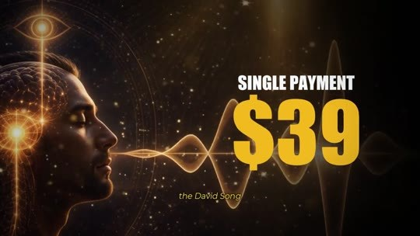  📷 39:17 — Selo '60 DAYS GUARANTEE'  b18_garantia_60_final_00-39-17.jpg
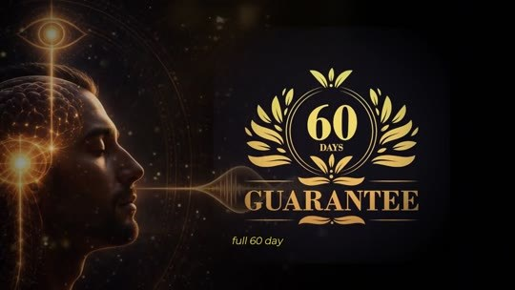  📷 39:21 — Mulher dormindo de fones; legenda 'and in the dark'  b18_mulher_fones_primeira_vibracao_00-39-21.jpg | 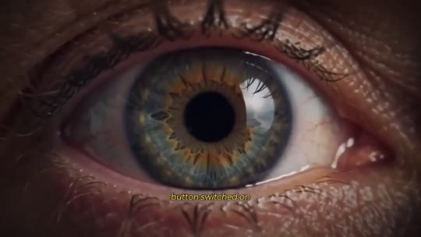  📷 39:41 — Close de um olho  b18_olho_close_00-39-41.jpg
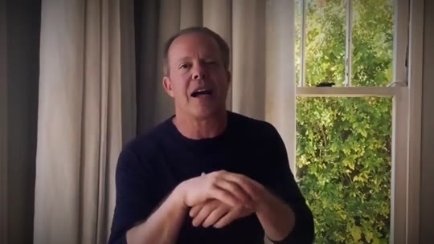  📷 39:49 — Cérebro em raio-x  b18_cerebro_raio_x_00-39-49.jpg | 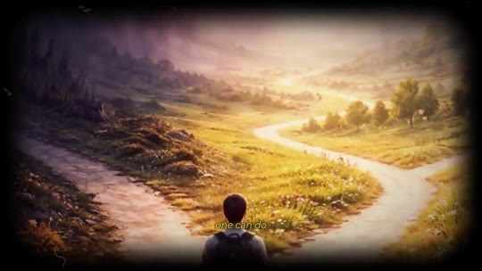  📷 39:55 — Homem diante de duas estradas  b18_duas_estradas_00-39-55.jpg

JOE DISPENZA (narrador, avatar): A segunda porta é o botão abaixo deste vídeo. Você clica e garante o David Song por $39. Protegido por uma garantia completa de 60 dias, em que o único que arrisca alguma coisa sou eu. E, é, hoje à noite, no escuro do seu quarto, de fones, você ouve a primeira vibração de Davi. E é aí que começa a história dos depoimentos deste vídeo. O sono, a clareza, as coincidências, as portas se abrindo, a versão de você com o botão ligado. 2 portas, a mesma pessoa, 2 vidas completamente diferentes. Eu já abri a segunda porta para você, contra a vontade de gente muito poderosa. Atravessá-la é a única parte que ninguém pode fazer por você.

18.3 ⏱ 39:56 → 40:42
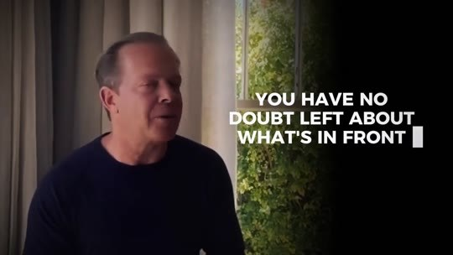  📷 39:59 — Dispenza; lettering 'I HOPE THAT BY NOW YOU HAVE NO DOUBT LEFT ABOUT WHAT'S IN FRONT'  b18_lettering_no_doubt_left_00-39-59.jpg | 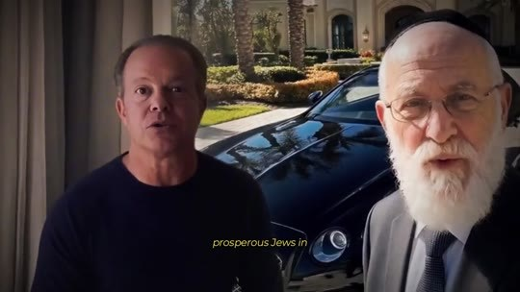  📷 40:09 — Dispenza com rabinos ao fundo; legenda 'thanks to some'  b18_dispenza_rabinos_final_00-40-09.jpg
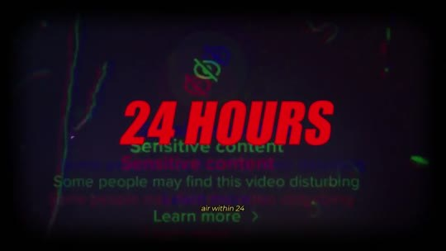  📷 40:21 — Lettering '24 HOURS' sobre tela 'Sensitive content'  b18_lettering_24_hours_00-40-21.jpg | 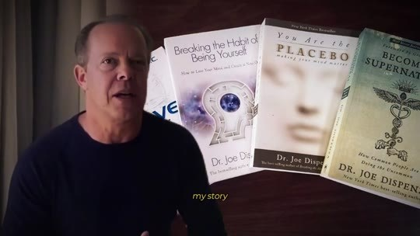  📷 40:29 — Livros de Dispenza (Becoming Supernatural, Placebo)  b18_livros_dispenza_00-40-29.jpg

JOE DISPENZA (narrador, avatar): Espero que, a esta altura, você não tenha mais nenhuma dúvida sobre o que está diante de você. Este é o som que ficou em silêncio por 3.000 anos, que sobreviveu escondido graças a alguns dos judeus mais discretamente prósperos da história, que o sistema Rockefeller trancou, comprou e apagou por mais de 100 anos. Que celebridades pagam $50.000 só para chegar perto. E que foi tirado do ar em 24 horas quando tentei contar ao mundo, sabe, o meu trabalho. Sabe, eu não colocaria o meu nome, a minha história e 30 anos de ciência nisso se não funcionasse. O botão sempre esteve aí, dentro da sua cabeça, do tamanho de um grão de arroz, esperando, enquanto eles faziam de tudo para que você nunca descobrisse que ele existe.

18.4 ⏱ 40:43 → 41:16
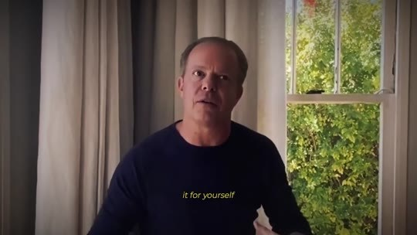
📷 41:10 — Último frame: 'Joe.'
b18_final_joe_00-41-10.jpg

JOE DISPENZA (narrador, avatar): Hoje isso acaba. Clique no botão abaixo e garanta o David Song com todos os bônus e a garantia de 60 dias. E, hoje à noite, no seu quarto, de fones, aperte o play e ouça o som tocado pelos judeus há 3.000 anos, aquele que permitiu a milhares de homens falar diretamente com Deus e receber bênçãos que ninguém conseguia explicar. Te vejo lá dentro. E no domingo, na nossa primeira sessão de coerência. Quero ouvir a sua história. Faça por você. Faça pela sua família. Faça pela vida que sempre esteve esperando o seu botão ligar. Joe.

