SOUL FLUSH VSL — Transcrição EN + Tradução PT-BR + Prints
Fonte: Vsl SoulFlush.mp4 (51:34). Transcrição: AssemblyAI (speaker labels). Tradução fiel: nomes, marcas, valores em dólares, libras, versículos e referências dos EUA mantidos exatamente como falados.
Timing: cada mini-bloco traz o intervalo de tempo x → y em que aquela fala acontece no vídeo. Prints: N frames dos momentos mais importantes (provas, documentos, ambientes, personagens, produto, oferta), nomeados bNN_descricao_HH-MM-SS.jpg na pasta frames/.
Falantes: THERESA CAPUTO (narradora) · VOZ EM OFF (clipe) · DR. OZ (clipe) · KIM KARDASHIAN (clipe) · MARY (depoimento) · MULHER (depoimento, primeira casa) · BRENDA (depoimento, diabetes tipo 2) · MULHER (depoimento, promovida a VP) · SUSAN, DO TEXAS (pergunta) · BRENDA, DA FLÓRIDA (pergunta) · SARAH, DE CHICAGO (pergunta) · CLAIRE, DE OHIO (pergunta)
Correções de transcrição (ASR): 'Soul Flesh' → 'Soul Flush' (30:20); repetição 'Pope Pius XII Pope Pius XII' removida (8:16); o roteiro alterna os nomes 'Soul Flush', 'Divine Purity' e 'Soul Detox' para o mesmo produto — mantidos como falados; em 49:33 a narradora responde 'Margaret' à pergunta de Sarah — mantido como falado; reticências (…) indicam cortes de edição no áudio original.

Estrutura da VSL (21 blocos)
BLOCO 1 — LEAD: a mensagem censurada, a glândula do tamanho de um grão de arroz, Taylor Swift / J.Lo / Kim, 15 bilhões de views e o Vaticano — 0:00 → 2:49
BLOCO 2 — PROMESSA + QUEM É THERESA CAPUTO: 4 ingredientes bíblicos, 'não atualize a página', a pineal como antena de TV, $50.000 por ano — 2:50 → 5:34
BLOCO 3 — ORIGEM: as mulheres de energia pesada, a avó, Peniel (Gênesis 32:30), o papa amigo de Hitler e o fluoreto nos campos de concentração — 5:34 → 8:42
BLOCO 4 — MECANISMO DO PROBLEMA: fluoreto na água e na pasta de dente, NRC 2006, a nuvem cinza, a carta que não chega a Deus, melatonina — 8:43 → 11:48
BLOCO 5 — O SISTEMA + A CIÊNCIA: Rochester, visão profética, a receita bíblica da avó, a COVID e a promessa de não deixar o conhecimento morrer — 11:48 → 14:29
BLOCO 6 — OS 4 INGREDIENTES BÍBLICOS: hissopo (Sl 51:7), olíbano (Mt 2:11), mirra e canela (Êx 30:22-25) — 14:29 → 16:31
BLOCO 7 — AS PRIMEIRAS CURAS: Clarice (18 libras em 2 semanas) e Amanda ($33.000 de dívida e a herança) — 16:31 → 17:59
BLOCO 8 — TAYLOR SWIFT: o episódio especial, Travis Kelce, a carta do Vaticano e as fitas apagadas — 18:00 → 19:50
BLOCO 9 — A MISSÃO: a nuvem de energia negativa, a raiva e 'não é justo que só as celebridades tenham acesso' — 19:51 → 21:29
BLOCO 10 — APRESENTAÇÃO DO SOUL FLUSH: a fórmula bíblica, ingredientes de Galileia, Etiópia, Sinai e Ceilão — 21:29 → 23:16
BLOCO 11 — ESTÁGIO 1 — PURIFICAÇÃO DO TEMPLO (7 dias): calafrios, o rádio desliga, sono de bebê + depoimento de Mary — 23:17 → 25:12
BLOCO 12 — ESTÁGIO 2 — CONEXÃO COM A FONTE: o olíbano eleva a frequência, intuição afiada + depoimento da primeira casa — 25:12 → 26:42
BLOCO 13 — ESTÁGIO 3 — ESCUDO SAGRADO (6 meses): imune ao fluoreto, conselho de amiga, John ($400.000) e Brenda (diabetes) — 26:42 → 28:58
BLOCO 14 — OFERTA: 6 meses, 1 conta-gotas por dia, $50.000 / $1.000 / $500 e os 6 frascos a $49 ($1,63 por dia) — 28:58 → 31:01
BLOCO 15 — OS 2 TIPOS DE MULHERES: 3 meses x 6 meses, Taylor, 'vacinar a alma', kits de 6 ($49) e 3 ($69), frete grátis — 31:01 → 34:05
BLOCO 16 — O MUNDO CONTINUA TÓXICO + GARANTIA DE 180 DIAS ('garantia da bênção') — 34:05 → 35:36
BLOCO 17 — OS 3 PRESENTES: sessões semanais de energia ($12.000), Canto Angelical ($3.000) e Guia de Interpretação de Sinais — 35:37 → 38:13
BLOCO 18 — ESCASSEZ (92 → 86 frascos), as consequências (Cleveland Clinic) e como usar — 38:13 → 40:36
BLOCO 19 — DEPOIMENTO DA VICE-PRESIDENTE + Divine Purity a $49, estoque limitado e 'movimento de luz' — 40:37 → 42:22
BLOCO 20 — FECHAMENTO: a encruzilhada, o Holocausto, 'diga sim', o arrependimento, os agradecimentos e o botão — 42:22 → 47:02
BLOCO 21 — FAQ: Susan (Texas), Brenda (Flórida), Sarah (Chicago) e Claire (Ohio) — 47:07 → 51:24

PARTE 1 — TRANSCRIÇÃO EM INGLÊS POR BLOCOS

BLOCO 1 — LEAD: a mensagem censurada, a glândula do tamanho de um grão de arroz, Taylor Swift / J.Lo / Kim, 15 bilhões de views e o Vaticano [0:00 – 2:49]

1.1 ⏱ 0:00 → 0:42
THERESA CAPUTO (narradora): Listen carefully to this message if you want to activate your pineal gland in 7 days and, for the first time, feel what it's like to desire something with all your heart and see it become reality. Hello, this is Theresa Caputo. What I'm about to show here was supposed to air on my show last week, but it was censored. I've spent 20 years connecting families with their loved ones, but this time I was going to show live how Hollywood manifestation works. the same method used by the number one singer in the United States to connect with the universe and turn everything she thinks into reality within weeks. I've been working with these women behind the scenes for years. They have access to something that has been taken away from you since the day you were born.

1.2 ⏱ 0:42 → 1:30
THERESA CAPUTO (narradora): It has to do with a structure in your brain the size of a grain of rice that God left as a gift when he created us so we could communicate with him whenever we needed help. But 90% of women have lost this bridge of connection with God. And that's why when you tried to manifest something or prayed asking for a blessing, it was as if God couldn't hear you. Taylor Swift, Jennifer Lopez, and Kim Kardashian spend more to protect this God's point in the brain than they spend on cosmetic procedures.
VOZ EM OFF (clipe): There is something physical that separates people who manifest everything from people who can't manifest anything. Once you understand what it is, you can't stop seeing it.
THERESA CAPUTO (narradora): After I started talking about this and announced that I would show how I've helped celebrities over the years manifest their achievements and even the love they desired.

1.3 ⏱ 1:31 → 2:15
THERESA CAPUTO (narradora): This ritual went viral. Millions tried it. Videos reached 15 billion views. Then the platforms began mass deleting content. The program I recorded that was supposed to air was deleted. When I asked why, I was told a direct order came from the Vatican forbidding its release, claiming it was unauthorized healing. Even when everyday women reported how much this helped them during difficult times? Sarah, who lived in a rental, manifested the money for the down payment for her own home in just 6 days. Brenda, who had been battling an incurable illness, cried when her medical tests came back clear for the first time in 20 years. Both of them activated something. The ancient prophets of the Bible used this to speak with God.

1.4 ⏱ 2:15 → 2:49
THERESA CAPUTO (narradora): My celebrity clients use it to manifest empires and true love. But this gland has been deliberately calcified inside you since the day you were born.
DR. OZ (clipe): They put fluoride in your water. The same chemical the Nazis used in concentration camps to keep prisoners submissive. This calcifies that gland. Once it's calcified, you can't manifest, you can't connect to higher frequencies. You become biologically blocked, and they know it.
KIM KARDASHIAN (clipe): I discovered what they're hiding. When you activate this, money flows differently. Opportunities appear out of nowhere. You begin operating on a frequency most people will never access.

BLOCO 2 — PROMESSA + QUEM É THERESA CAPUTO: 4 ingredientes bíblicos, 'não atualize a página', a pineal como antena de TV, $50.000 por ano [2:50 – 5:34]

2.1 ⏱ 2:50 → 3:32
THERESA CAPUTO (narradora): Not everyone is ready for this information. If you're not ready to manifest your deepest desires, if you're not prepared to finally hear the voice of God and your intuition clearly, then close this page now, because what comes next will change everything. But if you've made it this far, you were guided to find this. In the next few minutes, you'll discover the forgotten biblical recipe of the 4 biblical ingredients found in the first pages of scripture, and why ordinary women are crying tears of joy when they feel that bridge to God reconnects. I put my reputation on the line to bring this to you. The Vatican and major corporations don't want you to see this. The platforms are trying to take this video down. If you're seeing this page right now, do not refresh.

2.2 ⏱ 3:32 → 4:15
THERESA CAPUTO (narradora): Do not leave. Watch every second of what comes next before they manage to take us offline. And what you're about to see is the content of the program they didn't want me to show you. Hello, my dear. This is Theresa Caputo. You may know me from my TV shows and for helping thousands of people through my psychic gifts. But I need to tell you something. Nothing you've ever seen me do compares to my ability to manifest my desires, my intuition to know what will happen before it happens, and my ability to protect my health from illness. Don't misunderstand me, this has nothing to do with my other psychic abilities that I was born with. In fact, the ability to manifest and create your own reality was already born with you. You work like a magnet, attracting everything you desire.

2.3 ⏱ 4:15 → 5:08
THERESA CAPUTO (narradora): Let me explain. We are born with a direct connection to God. It's called the pineal gland. It is the bridge God left when he created us so we could continue communicating with him. Our entire universe operates through frequencies. Imagine the TV in your home. It receives signals from something happening live somewhere else and turns that signal into real information in the form of images. The camera filming that live event and your TV are not connected by any cable. Yet, the frequencies from one device reach the other as long as nothing interferes with that connection. Your pineal gland works the same way. It can receive and transmit divine and universal frequencies. When your pineal gland is functioning properly, your body can translate these higher frequencies into prosperity, wealth, healthy relationships, intelligence, health, and luck, all here in this reality.

2.4 ⏱ 5:08 → 5:34
THERESA CAPUTO (narradora): But if something is blocking that signal, you are simply forgotten by the universe. Things that were already destined for you, that only needed to materialize, simply disappear. It's as if God can't hear you. And this is why the law of attraction works for women like Rihanna, Jennifer Lopez, and Kim Kardashian, but never worked for you. The most influential people in the world, billionaires and celebrities, spend over $50,000 every year protecting their pineal gland.

BLOCO 3 — ORIGEM: as mulheres de energia pesada, a avó, Peniel (Gênesis 32:30), o papa amigo de Hitler e o fluoreto nos campos de concentração [5:34 – 8:42]

3.1 ⏱ 5:34 → 6:17
THERESA CAPUTO (narradora): I know this may feel like a lot to take in. After all, we were conditioned to believe that life is hard, that it's about working, paying bills, getting sick and dying, relationships with narcissistic men. I myself only became aware of all this after I started sensing a strange energy in the women who attended sessions with me. I began to notice that many of the women I worked with were carrying very heavy energy. Their lives were in chaos. No project ever worked out, and their families were constantly fighting. Their careers were falling apart, and they were always drowning in debt. Toxic relationships, divorces, and even after energy cleansing sessions and filling their homes with incense, nothing seemed to unblock them. They were carrying a very strong internal block.

3.2 ⏱ 6:18 → 6:59
THERESA CAPUTO (narradora): The solution had to go far beyond external cleansings and energetic protection. My grandmother was always a deeply religious woman with a strong connection to God before anyone else. When I was still very young, she already sensed that I had psychic gifts. And there was something my grandmother always warned me about. You must take care of the bridge of God in your mind, or you will lose the connection God left when he created us to communicate with him. The bridge of God? I used to wonder what my grandmother meant by that. Then she would open the Bible and show me. It's there in Genesis 32:30 when Jacob says, I have seen God face to face, and I will call this place Peniel. Peniel was a reference to the pineal gland located at the center of the brain.

3.3 ⏱ 7:00 → 7:43
THERESA CAPUTO (narradora): Jesus said, if your eye is good, your whole body will be full of light. That was the pineal gland, also known as the third eye, where all intuition lives, the portal to spiritual clarity and enlightenment. The church used to teach this openly. In the past, priests and popes preached in their homilies that keeping the mind clean was the only way to hear God. Until a pope who was a friend of Hitler changed everything. In the 1940s, the knowledge guarded by the Vatican about the pineal gland fell into the hands of Nazi scientists. And in order to control the Jewish people, they knew exactly where to strike. They had to shut down their connection with God. That's when they discovered the perfect weapon: fluoride.

3.4 ⏱ 7:43 → 8:25
THERESA CAPUTO (narradora): Tests showed that adding fluoride to water quickly calcified the pineal gland. Hitler ordered fluoride to be used in concentration camps with a hidden and terrifying objective. According to documents obtained from the Holocaust Museum, Hitler discovered that fluoride didn't just physically damage the pineal gland, it also severed any spiritual or psychic connection, making victims submissive, passive, and mentally defenseless. He deeply believed that whoever controlled the hidden power of the pineal gland could control not just people, but entire nations. When this discovery reached the Vatican, Pope Pius XII, known for his diplomatic alliances with Nazi Germany, made a decision that cost us dearly.

3.5 ⏱ 8:25 → 8:42
THERESA CAPUTO (narradora): To hide his alliance with Hitler, he banned any mention of the pineal gland and its divine connection and ordered all references to it removed from within the Vatican. And just like that, the most sacred symbol of connection with God was erased and dismissed as a mere legend overnight.

BLOCO 4 — MECANISMO DO PROBLEMA: fluoreto na água e na pasta de dente, NRC 2006, a nuvem cinza, a carta que não chega a Deus, melatonina [8:43 – 11:48]

4.1 ⏱ 8:43 → 9:26
THERESA CAPUTO (narradora): And now I need you to listen carefully. If you are over 30 years old, your connection with God has likely already been completely blocked. When other governments realized how effective this was at controlling the population, they decided to keep fluoride in our water and add it to more products like toothpaste, using the excuse that it was for our health. But that was just the lie they told to hide the real intention behind it. And our connection with God was slowly cut off chemically. Every single day you woke up, and brushed your teeth or drank a glass of water, your ability to manifest, your intuition, and your luck were gradually taken away from you. This invisible element you put in your mouth every morning is not there by accident. It has a deadly magnetic attraction to your pineal gland.

4.2 ⏱ 9:26 → 10:16
THERESA CAPUTO (narradora): So you can understand, our pineal gland is so energetically active that a study conducted by the National Research Council in 2006 showed that it absorbs more fluoride than any other tissue in the body, which leads to calcification blocking its natural functions. Fluoride is so toxic to the brain that it has been linked to severe IQ reduction in children. And why does this happen? Because a healthy pineal gland doesn't just regulate sleep and emotions. It is the bridge to God. It connects your mind to the frequency of abundance and to higher levels of consciousness. When I look at a woman who is I can clearly feel it. I see a gray, dense, heavy cloud floating around her head, and someone who vibrates at negative frequencies unfortunately ends up attracting negative things as well.

4.3 ⏱ 10:16 → 10:59
THERESA CAPUTO (narradora): You've felt this, haven't you? That feeling that no matter how hard you try, nothing works out, as if you're stuck in a streak of bad luck. You take one step forward and something happens that pulls you 2 steps back. Many women feel abandoned. They say, Theresa, I'm alone. I'm alone. I pray, I ask, I'm a good person. Why do my blessings never arrive? Why does everything have to be harder for me? The truth is, God has not abandoned you, my dear. He never would. The problem is that everything you've asked for until now never reached him. Your bridge to God has been blocked. Your prayer is like an urgent letter you sent through the mail. The mail truck picks up the letter and follows the road that leads to God's address. But halfway there, a landslide hits And the bridge is completely blocked.

4.4 ⏱ 11:00 → 11:48
THERESA CAPUTO (narradora): The mail truck reaches the barrier, brakes, and is forced to turn back. God never read your letter, not because He ignored you, but because the only road that carries your request to Him was blocked. You kneel and pray for true love, but your request is blocked, and all that returns to you is emptiness and shallow love. You ask for prosperity, relief from debt, but the road is closed. There is simply no path for financial help to reach you. And the damage doesn't stop there. In addition to blocking your spiritual connection, fluoride kills melatonin production. That's why we're seeing a global epidemic of exhausted women. Insomnia, depression, anxiety, and that constant feeling of a hole in the chest are not the new normal. They are symptoms of a soul crying out, but God can't hear it.

BLOCO 5 — O SISTEMA + A CIÊNCIA: Rochester, visão profética, a receita bíblica da avó, a COVID e a promessa de não deixar o conhecimento morrer [11:48 – 14:29]

5.1 ⏱ 11:48 → 12:42
THERESA CAPUTO (narradora): Now think with me. If they've known the power of the pineal gland since the 1940s, do you really think it's a coincidence that water is treated with the one substance capable of shutting that power down. That explains why so many people today are suffering, trapped in a cycle of fear and scarcity, unable to manifest change. Why? Because we are stuck in a system designed to block our true potential. The calcification of your pineal gland is not a biological accident. They want you disconnected from your essence, dependent on sleep medications and on leaders telling you what But after many years, science began to uncover how powerful this tiny gland is when it's clean, something my grandmother always told me. A study from the University of Rochester Medical Center revealed that the pineal gland not only controls sleep but also produces powerful antioxidants that protect the body from aging and degenerative diseases.

5.2 ⏱ 12:42 → 13:29
THERESA CAPUTO (narradora): In other words, an active pineal gland is the true fountain of youth. And most importantly, When it is decalcified, it allows access to prophetic vision—the ability to see opportunities, dangers, and solutions that no one else can see. So they knew that to keep a population obedient, disconnected, and without divine connection, all they had to do was calcify this gland. That way, the elite, whether in the Vatican or modern governments, could continue controlling people without resistance. What they didn't expect. was that this knowledge would survive. But people like my grandmother refused to let it die. While the entire world was being weakened by governments putting tons of fluoride into the water, my grandmother safeguarded a biblical recipe that shielded the pineal gland from these toxins.

5.3 ⏱ 13:29 → 14:11
THERESA CAPUTO (narradora): This biblical recipe, protected by my family for generations, is what I have always used to keep my bridge to the universe open, even when the world around me was falling apart. In recent years, behind the scenes in Hollywood and on Wall Street, celebrities and tycoons have been using this secret to protect their pineal gland and manifest health, youth, and wealth, and even to find their true soulmate. During the COVID-19 pandemic, fear of illness paralyzed the world, but there were ordinary families, people who had access to this pineal detox, who went through it all protected. They manifested ironclad health. While the world was getting sick, their immunity and vibration remained untouched. It was as if there was an invisible shield around them.

5.4 ⏱ 14:12 → 14:29
THERESA CAPUTO (narradora): The last request my grandmother made before she passed was that I would not let this knowledge die. That's why, even if they cancel all my shows and try to silence me, I began speaking openly about how you can reactivate your pineal gland in 7 days and receive blessings that have been blocked for years by the negative vibration around you.

BLOCO 6 — OS 4 INGREDIENTES BÍBLICOS: hissopo (Sl 51:7), olíbano (Mt 2:11), mirra e canela (Êx 30:22-25) [14:29 – 16:31]

6.1 ⏱ 14:29 → 15:12
THERESA CAPUTO (narradora): In an old diary, She wrote down the 4 biblical ingredients that have been used for centuries to activate and preserve this bridge of God within the mind. The first ingredient is hyssop. Psalm 51:7. Purge me with hyssop, and I shall be clean. Wash me, and I shall be whiter than snow. My grandmother would read this psalm and tell me, Teresa, David wasn't talking about taking a bath. He was asking for his soul to be cleansed. Hyssop is an herb that the Hebrews used to purify temples and cleanse lepers. It was God's detergent. My grandmother knew that to remove the modern leprosy fluoride and toxins that cling to our gland, we needed hyssop. It is the only one capable of keeping your antenna unblocked to receive the divine signal.

6.2 ⏱ 15:12 → 15:55
THERESA CAPUTO (narradora): The second ingredient is frankincense, called incense in the Bible, Matthew 2:11, the gifts of the Magi, and Exodus 30-34. And entering the house, they presented gifts to him: gold, frankincense, and myrrh. Frankincense been used for over 5,000 years because it has a unique biological property. It reduces inflammation in the brain and elevates spiritual vibration. This allows the frequencies emitted by the pineal gland to become stronger and reach where they need to go to attract your desires. They gave it to Jesus as a symbol of his union with the Father. My grandmother used the sacred extract of this resin in the recipe. She used to say that it turns our prayer into smoke that rises straight to the nose of God. The 3rd and 4th ingredients are for spiritual shielding and protection.

6.3 ⏱ 15:55 → 16:31
THERESA CAPUTO (narradora): In Exodus chapter 30, verses 22 to 25, take the finest spices, myrrh and cinnamon, and make from them the sacred anointing oil. In the Bible, when something was anointed with this oil, it became holy, meaning set apart, protected from evil. Nothing impure could touch it. By combining myrrh and cinnamon and taking them, you don't just anoint your body on the outside, you shield your pineal gland from the inside. These ingredients create a barrier. They prevent the toxicity of the world from touching your mind. That is what has kept my family spiritually untouchable throughout all these years.

BLOCO 7 — AS PRIMEIRAS CURAS: Clarice (18 libras em 2 semanas) e Amanda ($33.000 de dívida e a herança) [16:31 – 17:59]

7.1 ⏱ 16:31 → 17:17
THERESA CAPUTO (narradora): For years, this remained restricted to my closest inner circle. It was our secret for keeping energy high and prosperity flowing no matter what was happening in the world. But there were moments when I couldn't refuse to help. I saw women coming to me in such desperate situations, with their energy so blocked, that I knew no words of mine would be enough. So quietly, I began sharing a small amount of this elixir with a few of them. I remember Clarice. She was at rock bottom, struggling with her weight and a sadness that never went away. Her body felt stuck, swollen with heavy energy. I gave her access to our recipe. Just 14 days later, she came back as a different woman. Her pineal gland had cleared, her body released the inflammation, and she began manifesting weight loss naturally.

7.2 ⏱ 17:18 → 17:59
THERESA CAPUTO (narradora): She lost 18 pounds in 2 weeks because the anxiety that made her overeat disappeared along with the spiritual blockage. And then there was Amanda. Her story broke my heart. She had $33,000 in medical debt, hadn't slept well for months, And suffered anxiety attacks almost every day. She began using the sacred elixir. She cleansed her bridge to God and handed the problem over to the universe. A few weeks later, unexpected money arrived from a distant inheritance she didn't even know existed. The amount covered the exact debt and brought peace back into her life. It wasn't a miracle, it was connection. The money and the health had always been there, waiting for them. Their bridge to God had finally been rebuilt.

BLOCO 8 — TAYLOR SWIFT: o episódio especial, Travis Kelce, a carta do Vaticano e as fitas apagadas [18:00 – 19:50]

8.1 ⏱ 18:00 → 18:42
THERESA CAPUTO (narradora): When I realized how many people were going through the same thing, I felt this detox needed to be shared. I was about to reveal this to the world on my show, but something bigger stopped me. Some time ago, I recorded a special episode with Taylor Swift. She came to me at the worst moment of her career and personal life. Her audience was shrinking, concert contracts were being canceled, and her relationships were failing. After reading her chart, I saw that this was a spiritual detox. nowhere near what was destined for her life. All her blessings were blocked. I knew energetically that she needed a pineal detox. She trusted me. She followed the protocol, and what happened next, the whole world saw. Shortly after we began the cleansing, her energy changed. The inspiration returned.

8.2 ⏱ 18:42 → 19:25
THERESA CAPUTO (narradora): She manifested millions, sold-out tours, and beyond all of that, she found her true soulmate. Travis Kelce. Travis Kelce, whom she is now engaged to. All of this was recorded and documented, and we planned to share the full story of that transformation. But unfortunately, the program was stopped from airing. Influential and powerful people did not want any TV network broadcasting this information to the world. A letter from the Vatican itself reached me, accusing me of spreading heresies and lies about divine knowledge. And then, without my knowledge, someone from my production team deleted the tapes. Deleted all the files we had recorded. The only file we still have is this one, recorded on the phone of a friend I invited to watch behind the scenes of the filming.

8.3 ⏱ 19:25 → 19:50
THERESA CAPUTO (narradora): For a moment, all of this shook me deeply. I thought about forgetting everything and leaving this story behind. But then I remembered all the women whose lives had been changed by this solution and the transformation it caused. Above all, I remembered the promise I made to my grandmother that I would not let this knowledge die. That's when I understood that I could no longer keep this just for myself as a family tradition. I had a spiritual obligation to help more people awaken.

BLOCO 9 — A MISSÃO: a nuvem de energia negativa, a raiva e 'não é justo que só as celebridades tenham acesso' [19:51 – 21:29]

9.1 ⏱ 19:51 → 20:35
THERESA CAPUTO (narradora): You see, I travel across the country, and what I've noticed is alarming. All the bad things happening in the world over the past decades are not random. They are connected to a cloud of negative energy that most people feel but cannot explain. The lack of direction in life, the constant fatigue that no night of sleep can fix, the sense of emptiness many carry in their chest, all of this is connected. People have lost their connection to their own minds and to the divine. They no longer see meaning or purpose in their lives, and as this disconnection spreads, chaos and despair grow around us. I understood in that moment that the more people cleanse and reactivate their pineal gland, the more real change we can bring to the world. A world where people are free to manifest their desires instead of accepting crumbs.

9.2 ⏱ 20:36 → 21:20
THERESA CAPUTO (narradora): A world where we are no longer puppets of hidden forces that profit from our illness and our sadness. And that's when I felt anger. Anger because they tried to pressure me into hiding the truth from you. I felt rage for us for living under the illusion that we are in control when in reality we have been deceived all along. They wanted me to be complicit in this manipulation that steals our power of choice from birth. We are treated like pieces feeding a system that keeps us trapped in an endless cycle of scarcity, fear, and bills to pay without even knowing there is a way out. It wasn't fair that only celebrities who pay me millions of dollars had access to this pineal cleansing. I felt my purpose was to bring this to as many people as possible. My grandmother told me to share this with as many people as I could without expecting financial return.

9.3 ⏱ 21:20 → 21:29
THERESA CAPUTO (narradora): This was about freeing as many people as possible, giving each of us the chance to rewrite our own destiny, take control of our lives, and manifest a different reality.

BLOCO 10 — APRESENTAÇÃO DO SOUL FLUSH: a fórmula bíblica, ingredientes de Galileia, Etiópia, Sinai e Ceilão [21:29 – 23:16]

10.1 ⏱ 21:29 → 22:12
THERESA CAPUTO (narradora): So that is why today I want you to meet Soul Flush. This sacred formula was something my family and I have always used to protect our minds and maintain high levels of consciousness and connection with God. This is the exact formula I have been sharing behind the scenes with celebrities and women who consult with me so they can activate their intuition and attract success, money, and even the man they desire. Even if you have been sabotaged for For the moment, you're starting using Soul Flush. You will cleanse, detoxify, and reactivate your pineal gland, and then unlock your true mental and spiritual power. Soul Flush is not a simple medication or supplement.

10.2 ⏱ 22:13 → 23:16
THERESA CAPUTO (narradora): It is a formula found in the Bible that has been hidden from you until today to sever your connection with God and to keep you dependent on the system. Soul Flush is a powerful detoxifier. System they created. But now this formula is being proven by the most recent scientific studies on the biological function of the pineal gland. The difference now is that this secret is no longer restricted to the elites, the Vatican, or untouchable spiritual gurus. Today you can have access to Same Soul Flush formula, carefully recreated with rare and potent ingredients. I made a point of selecting ingredients from the most energetically and sacred soils on the planet, where pollutant contamination doesn't even come close. The hyssop from the mountains of Galilee in Israel, the frankincense from the high monasteries of Ethiopia, the myrrh from Mount Sinai in Egypt, and cinnamon of Ceylon— each ingredient was hand-harvested during specific lunar cycles designed to do one thing: break the fluoride crust off your pineal and relink your connection with the Creator. The result? Absolute mental clarity, sharp intuition, and the real ability to manifest your deepest desires.

BLOCO 11 — ESTÁGIO 1 — PURIFICAÇÃO DO TEMPLO (7 dias): calafrios, o rádio desliga, sono de bebê + depoimento de Mary [23:17 – 25:12]

11.1 ⏱ 23:17 → 24:00
THERESA CAPUTO (narradora): I want you to imagine what it will be like to wake up in your body a few days from now, because when these biblical ingredients touch your system, the reaction is fast. The reconnection of your bridge to God happens in 3 stages. Stage 1, the purification of the temple. In the first 7 days with Soul Flush, perception of change is almost immediate. As soon as the hyssop begins to act and sweep away the fluoride that is Blocking your pineal, some sensations will happen. You might feel chills on the back of your neck. If that happens, don't be afraid. It is a sign of your reconnection with God. This is very profound. You will feel a sense of security, as if a bodyguard were always with you throughout the day, and as if an angel were protecting your sleep during the night.

11.2 ⏱ 24:00 → 24:42
THERESA CAPUTO (narradora): You know that radio turned on in your head, full of worry and noise 24 hours a day? It turns off. You are going to lay down in bed and pass Sleep becomes deep and restorative again. Baby sleep. You wake up light and with a vital energy you haven't felt in years. Here, the weight is already off your shoulders. And I was moved when I received this message from my dear friend Mary.
MARY (depoimento): I was exhausted, stuck in a work routine while caring for my young child with no energy, no mental clarity, and unable to sleep properly. A friend told me about Soul Flush, and even though I was skeptical, I decided to try it. In the first week, I felt deep changes. I finally slept through the night, woke up with a clear mind and more focus. But what truly marked me was a dream I had a few days later.

11.3 ⏱ 24:42 → 25:12
MARY (depoimento): I dreamed of a car accident, very real, with all the details. I woke up terrified, and deep down I knew it wasn't just a dream. A few days later, as I was about to get into a car, I had booked— the scene from the dream replayed. My instincts stopped me, and I decided not to get in. Later, I saw on the news that that same car had been involved in a serious accident exactly like in my dream. That's when I understood Soul Flush. Didn't just transform my mind, it may have saved my life and my child's. After that, I bought more bottles. I can't risk running out. My energy, focus, and intuition are on another level.

BLOCO 12 — ESTÁGIO 2 — CONEXÃO COM A FONTE: o olíbano eleva a frequência, intuição afiada + depoimento da primeira casa [25:12 – 26:42]

12.1 ⏱ 25:12 → 25:55
THERESA CAPUTO (narradora): Stage 2, the connection with the source. In the following weeks, with the temple clean, the frankincense begins to raise your frequency. This is where the magic starts to become visible. Imagine that your pineal is like an injured muscle that needs physical therapy to get stronger. Frankincense makes your pineal start vibrating stronger again. It carries your requests and prayers up to God. This ingredient has always been used by the church as incense, as smoke that rises and carries our requests to God. You will notice that things stop going wrong and start to flow. Day after day, a different thing happens that starts to surprise you until you see that it is not a coincidence, but rather your reconnection with God being Your intuition gets sharp.

12.2 ⏱ 25:55 → 26:42
THERESA CAPUTO (narradora): You think of someone, the person calls. You are alerted in dreams when something bad is about to happen to you. You need a financial solution, and the idea appears clearly in your mind. While everyone at your work catches a bad cold, you seem shielded. The fog of bad luck has vanished. You feel that God is listening to you on the first call. It is the sign that your antenna is on and catching the good vibes. Catching the frequency of abundance. What you ask for arrives.
MULHER (depoimento, primeira casa): Soul Flush helped a skeptic of manifestation techniques like me buy my first home. My life had been stuck for years, going nowhere. My husband was unemployed and depressed until Theresa appeared like an angel in my life and showed me what was really blocking us. After Soul Flush, everything began flowing naturally for us financially.

BLOCO 13 — ESTÁGIO 3 — ESCUDO SAGRADO (6 meses): imune ao fluoreto, conselho de amiga, John ($400.000) e Brenda (diabetes) [26:42 – 28:58]

13.1 ⏱ 26:42 → 27:30
THERESA CAPUTO (narradora): Stage 3, the Sacred Shield. This is where you become untouchable. In the Bible, everything that was touched by myrrh and cinnamon was a sign of something that became untouchable. That is why kings were anointed with these ingredients. After the 6 months, the myrrh and the cinnamon create a layer of protection around your pineal. The fluoride that was previously energetically attracted to your pineal gland can no longer penetrate this barrier. You can drink 4, 8, or even 20 glasses of water a day and brush your teeth as many times as you want. It doesn't matter. You are immune to fluoride. You don't just manifest once, and you live in a state of grace. Imagine it's like a storm is happening outside, but you are at home under a blanket, warm, protected, feeling safe.

13.2 ⏱ 27:30 → 28:18
THERESA CAPUTO (narradora): Envy hits and bounces back. Bad news doesn't shake your vibration. Prosperity becomes a routine. When you least expect it, you are choosing the furniture for the dream house you always wanted. And here is my My advice as a friend. After more than 20 years working with my psychic gifts, I have felt the energy of thousands of women, and that is why I feel confident in saying that Soul Flush has become essential. The blockage of your pineal has been distancing you from blessings that should have reached you a long time ago. As you can see, several people chose Soul Flush and unlocked their lives, and not because they are special or anything like that, but rather because they made the intelligent decision to continue with Divine Purity for at least 6 months. Many people who lived in debt after 6 months are managing to move toward a more prosperous life by manifesting the future they always desired.

13.3 ⏱ 28:18 → 28:58
THERESA CAPUTO (narradora): Look at this photo I received from John after he used Soul Flush. This is John. He worked in an accounting office, was in debt, and had lost his house 8 months ago. After he chose Soul Flush to take care of his pineal gland for 8 months, he was awarded $400,000 after dreaming of finding He used the money to pay his debts and open his own business, and today his family has the life they deserve. Or even more beautiful stories like Brenda's.
BRENDA (depoimento, diabetes tipo 2): I went back to the doctor after starting Soul Flush. He had no explanation. My type 2 diabetes was under control. I didn't cut sugar or change my diet. The doctor stopped my insulin and kept only one medication for maintenance.

BLOCO 14 — OFERTA: 6 meses, 1 conta-gotas por dia, $50.000 / $1.000 / $500 e os 6 frascos a $49 ($1,63 por dia) [28:58 – 31:01]

14.1 ⏱ 28:58 → 29:41
THERESA CAPUTO (narradora): At this moment, I want to offer you the same opportunity that John and thousands of others had to change their lives. their families' lives. What I recommend for you, regardless of how you are today, in debt, with some health problem, or even with marital problems, is that you make the intelligent choice to add 6 months of Soul Flush to your routine. You will only need 1 dropper of Soul Flush in the morning or before sleep, and that's it. Soul Flush will start working on your pineal gland, and on that same day, you will already notice your luck changing. I need to be absolutely clear about one thing. You have probably already tried several manifestation techniques, heard gurus, You've probably seen all kinds of gurus promising magical solutions, but something was always missing. You never managed to truly manifest your desires.

14.2 ⏱ 29:41 → 30:22
THERESA CAPUTO (narradora): And the reason is simple: they didn't tell you the truth. It is not possible to manifest, to connect with the universe, without first unlocking the bridge that God left when he created us to keep us connected to him— our pineal gland. So think for a moment, how much would you pay to fulfill your deepest desires? To manifest a life of abundance, Health, love, and prosperity. Now pay attention, dear. I see celebrities who pay me $50,000 for private consultations to unlock this power of manifestation. Because of the rarity of these ingredients, like the hyssop from the mountains of Galilee, I could easily charge $1,000 per bottle, and it would still be cheap compared to the new life it delivers to you. But I didn't create Soul Flush [ASR: "Soul Flesh"] for the Hollywood elite.

14.3 ⏱ 30:23 → 31:01
THERESA CAPUTO (narradora): I created it to help women whose energy is heavy. I want this transformation to reach the hands of the woman That's why you won't pay $1,000 nor $500. While this special launch batch lasts, I fought to make something affordable. Right now, below this video, you have a special condition to acquire 6 bottles of Soul Flush for only $49 per bottle. That comes to $1.63 a day. It's less than you spend on that bottle of water at the supermarket, the same water that the elite fills with fluoride to keep you blocked. For less than the price of a daily poison, you guarantee your direct and unshakable connection with God.

BLOCO 15 — OS 2 TIPOS DE MULHERES: 3 meses x 6 meses, Taylor, 'vacinar a alma', kits de 6 ($49) e 3 ($69), frete grátis [31:01 – 34:05]

15.1 ⏱ 31:01 → 31:46
THERESA CAPUTO (narradora): I have been following the journey of women who use Soul Flush, and I see a curious pattern in all the women who transform their lives with Soul Flush. There are 2 types of women who start this walk, and I want you to choose which one you want to be. The first group are the many women who start with the 3-month treatment and Look, it's a beautiful start. They feel the relief, the energy changes, they manifest beautiful things. But do you know what happens? When they are reaching the best moment, the bottle runs out. And almost all of them come back desperate, sending me messages. Teresa, it's over! I need more! I don't want to go back to feeling heavy! I noticed that almost 90% of these women return to my site in the 4th month desperate to buy more.

15.2 ⏱ 31:46 → 32:33
THERESA CAPUTO (narradora): They realize they don't want to stop feeling the blessings. The second group are those who shield themselves. This is the group of Taylor Swift and my students who manifested the greatest fortunes. Why did Taylor choose the 6-month treatment straight away? Because she understood that it took 30 years for fluoride to calcify her pineal. It's not possible to resolve all that damage in a few weeks. She used the first few months to clear out the old dirt. And she used the following months to create a spiritual shield. By keeping Soul Flush for 6 continuous months, you create a protective film on your gland. It's like vaccinating your soul. Even if you drink dirty water or face envy later, your pineal remains open and vibrating high.

15.3 ⏱ 32:34 → 33:17
THERESA CAPUTO (narradora): When I read the thank-you letters about saved marriages, houses bought in cash, and restored health, guess what? All of them They didn't leave it to chance. They decided they deserved the complete healing. Seeing all this, I prepared something special to facilitate this transformation for you today. I made a point of preparing a special kit that provides you with the complete transformation. That's why my recommendation as a friend is that you choose 6 bottles of Soul Flush for $49 per bottle for the complete and permanent unlocking of your bridge to your soul… to God. It's the same protocol as Taylor and thousands of other women who had their lives transformed. It is the wisest choice. If you really can't do the total shielding now, that's fine.

15.4 ⏱ 33:17 → 34:05
THERESA CAPUTO (narradora): You can start with 3 bottles for $69 each. It will help you clean the heaviest dirt. You will start manifesting the most urgent blessings for your life. And then, after proving how the a calcified pineal can elevate you to the level of a strong, intelligent, and spiritually connected woman, you can continue with your Soul Flush treatment. By tapping one of these options below, you will be directed to a secure page to put in your address information so I can send your order today with free shipping, and Soul Flush will reach your door in less than a week. Choose one of these options to release your capacity. for manifestation, intuition, luck, and blessings that are stored for you. You will feel the miracle right in the first bottle.

BLOCO 16 — O MUNDO CONTINUA TÓXICO + GARANTIA DE 180 DIAS ('garantia da bênção') [34:05 – 35:36]

16.1 ⏱ 34:05 → 34:51
THERESA CAPUTO (narradora): It's inevitable. But remember, the world out there remains toxic. The water is still dirty. The bad energies of envy keep trying to get in. A serious accident or a sudden illness can arise when you least expect it. To keep this sacred shield strong and prevent the dust from coming back to block your bridge to That's why my wisest students secure the 6-month stock. Not because it takes a long time to work. After all, they are all surprised by the speed at which they manifest blessings. But none of them want to go back to the old blocked life. And if you are not protected for longer, until your pineal gland is completely decalcified and with a protective film, things can leave faster than they arrived.

16.2 ⏱ 34:51 → 35:36
THERESA CAPUTO (narradora): If you are still thinking, let me take all the weight of the responsibility off you, I trust so much in what my grandmother taught me that I offer the strongest guarantee possible, the 180-day blessing guarantee. If for any reason you don't feel a complete transformation, if you don't start sleeping better, feeling more energy, awakening your intuition, and even manifesting new opportunities in in your life, I will return 100% of your money, no questions asked, for up to 180 days after your purchase. That's right, 6 full months to see the magic happen, or you receive every cent back. All we ask is that you test it for yourself. See the transformation with your own eyes.

BLOCO 17 — OS 3 PRESENTES: sessões semanais de energia ($12.000), Canto Angelical ($3.000) e Guia de Interpretação de Sinais [35:37 – 38:13]

17.1 ⏱ 35:37 → 36:25
THERESA CAPUTO (narradora): But wait, you won't just receive the Soul Flush. When you clean your pineal, the channel really opens. Your sensitivity increases. Intuition comes back with full force, and I don't want you to feel alone or confused with all this new power. I want to hold your hand. That's why if you act now and secure the 6-bottle kit, I'm gonna open the door to my world for you. I'm gonna give you 3 exclusive gifts from my inner circle totally for free. The first one is the most special. Gift 1 is Weekly energy session. I won't let you walk alone. By securing your kit today, you receive a special invitation. You will be able to participate in my weekly energy clearing sessions where I gather an exclusive group of women in my online psychic reading space.

17.2 ⏱ 36:25 → 37:08
THERESA CAPUTO (narradora): Even from a distance, we connect to shield the week's energy, remove envy, and ensure you start every Monday light, protected, and unbeatable. There will be 24 sessions in My private consultations cost around $500, so you would be saving $12,000. Gift 2, the Angelic Chant for Health. You know those nights when you need regeneration or deep healing? I prepared a special audio with sacred sound frequencies. It's not common music, it's an angelic vibration that talks directly to your cells. Just press play before sleeping while divine purity cleanses your aura. Cleans your gland physically. This chant aligns your spiritual vibration, accelerating the regeneration of your body while you dream.

17.3 ⏱ 37:09 → 37:54
THERESA CAPUTO (narradora): For a client to have access to this frequency that I use in my sessions with celebrities, they invest no less than $3,000. But today you will receive it for free. And last but not least, gift 3, the Signal Interpretation Guide. A The Signal Interpretation Guide, so you know and can interpret the signs that the universe sends you. Every woman has a kind of sixth sense, which are your dreams. You yourself receive many revelations. You just need to know how to interpret them. And in this guide, you will see the 10 most common types of dreams and their meaning, all in a simple and direct way. These 3 gifts are worth all that because it's something that has been in my family for more than 8 generations.

17.4 ⏱ 37:54 → 38:13
THERESA CAPUTO (narradora): What I am placing in your hands today is a true relic. These 3 gifts are worth a fortune if sold separately. My private sessions have a waiting list of months, but today, by choosing to care for your gland completely, they are yours for free. Just choose the 6-bottle option below, and the gifts will be automatically added to your order.

BLOCO 18 — ESCASSEZ (92 → 86 frascos), as consequências (Cleveland Clinic) e como usar [38:13 – 40:36]

18.1 ⏱ 38:13 → 38:55
THERESA CAPUTO (narradora): But understand, these ingredients will not be available forever. These ancestral components are limited. Harvested in specific cycles of nature. And when our stock runs out, maybe we won't be able to obtain them again due to the rarity and complexity of the harvest of each element. I just checked my stock and there are 92 left. No, actually there are only 86 left. I just received an order. There are 86 bottles remaining in my stock. The formula itself was created to transform your life, purify your body and mind, and open your capacity to manifest a new reality, the one you always knew was possible. I really hope you understand the power that Soul Flush can have in your life and in the life of your family.

18.2 ⏱ 38:55 → 39:39
THERESA CAPUTO (narradora): If you ignore the opportunity to reactivate your pineal gland, the consequences are serious. Untreated calcification can lead to a series of serious physical and mental problems. According to the Cleveland Clinic, the degradation of the pineal gland is associated with neurological diseases, like Alzheimer's, Parkinson's, and even the development of tumors. In addition, chronic conditions like hypertension, insomnia, and deep depression can worsen over time. You can continue living as you live now, limited by circumstances and controlled by external forces in the system, but the cost of this choice can be high. You will never access the true power exists within you.

18.3 ⏱ 39:39 → 40:24
THERESA CAPUTO (narradora): You will continue living a life of scarcity, worries, and frustrations, while those who unlock their pineal gland will live in abundance, prosperity, and connection with the divine. The deterioration of this small yet powerful gland can literally be a time bomb inside you. You don't need to choose this path. Soul Flush offers you a chance to awaken, to align with the flow of abundance and clarity that has always been available But blocked. With each dose, you begin to unlock the power of your mind. And the best part? It's simple to use. Leave the Soul Detox beside your bed, and a few minutes before sleeping, use a dropper under your tongue. This was how I, my family, my famous clients, and thousands of others changed our lives.

18.4 ⏱ 40:24 → 40:36
THERESA CAPUTO (narradora): I can guarantee you that when you start unlocking the blessings God set aside a long time ago for your life, you will cry. Seeing how much you have always been loved by him. But you don't have to just take my word for it.

BLOCO 19 — DEPOIMENTO DA VICE-PRESIDENTE + Divine Purity a $49, estoque limitado e 'movimento de luz' [40:37 – 42:22]

19.1 ⏱ 40:37 → 41:19
THERESA CAPUTO (narradora): Listen to what these people have to say.
MULHER (depoimento, promovida a VP): I was stuck in the same position for 6 years. I worked twice as hard, but it seemed like I was invisible in the company. Whenever a promotion opened up, luck smiled on someone else. But in my second month using Soul Flush, a very strong intuition told me to take over a project in the company that was sinking. And that nobody wanted. It seemed crazy, but the solutions simply started to sprout in my mind with absurd clarity. Everything flowed perfectly. I saved the project, broke records, and was promoted to vice president of the area. God was literally whispering the steps I should take.
THERESA CAPUTO (narradora): Now, imagine yourself in this woman's shoes, finally reaching everything you always dreamed of.

19.2 ⏱ 41:19 → 42:03
THERESA CAPUTO (narradora): Everything that before seemed distant or impossible, What for many is just a repressed desire, trapped in the world of ideas, now becomes reality for you. And all thanks to Divine Purity. You will have access to Divine Purity for only $49 per bottle when you choose the complete 6-month shielding option. You will see the promotional value with an exclusive discount appearing below this video now. Just choose between 3 or 6 bottles and you will be one step away from living your best life. transforming your life. But here is my warning: the stock is limited, and sincerely, we don't know for how long we will be able to keep this offer available. The demand for Soul Flush was greater than we expected, and the pressure to take this site down is real.

19.3 ⏱ 42:04 → 42:22
THERESA CAPUTO (narradora): So consider acquiring as many bottles as possible for you and your family. Each bottle purchased helps bring the truth to light, ensuring that more people can free themselves from this global manipulation. You are literally participating in a movement of light. If you let this opportunity pass, there may not be another chance.

BLOCO 20 — FECHAMENTO: a encruzilhada, o Holocausto, 'diga sim', o arrependimento, os agradecimentos e o botão [42:22 – 47:02]

20.1 ⏱ 42:22 → 43:07
THERESA CAPUTO (narradora): So here is your destiny. You are standing at a crossroads that can change everything. You can continue on the path you are on now, a path where the system has already taken over your life, a system that has been controlling humanity for centuries, keeping us as slaves, tired, Sick and poor. You feel it, don't you? The feeling of running in an endless wheel, struggling not to sink as time goes by. Ancient civilizations knew something we were programmed to forget. They thrived because they accessed true human potential. And what are we doing today? Living like robots. But you have the power to change this now. You can stay trapped, poisoned by toxins, dependent on pills that don't Heal the soul.

20.2 ⏱ 43:08 → 43:51
THERESA CAPUTO (narradora): Or you can make the decision that awakened people have been making for centuries: detoxify your mind, clean your pineal gland, reconnect with the Creator, and together with him be able to manifest in your life the best dreams and desires that are destined for you. If you don't act now, nothing will change. The world around you will continue operating at a chaotic pace, and you will continue You might have already heard people questioning something like, did God forget about me? If God exists, why did he allow something as terrible as the Holocaust? And now you know the truth. This only happened because the connection with God was blocked. You are not here by accident. I believe you were guided to this page for a reason.

20.3 ⏱ 43:52 → 44:34
THERESA CAPUTO (narradora): The universe is offering you a chance. The choice is yours, and the moment is now. And my last question for you is this: When was the last time you lived your life to the fullest with absolutely no regret? Not, I'll do it later. Not, let me think about it. Not, what if there's something better? But a clear, grounded decision where you knew even if it didn't work out like you wanted, you'd never look back and wish you hadn't acted because it worked out even better than you could have imagined. Regret never comes from trying something. It comes from hesitation. It comes from waiting. It comes from seeing the days of your life pass while you continue in the same place, wishing, waiting, and praying that somehow something changes.

20.4 ⏱ 44:34 → 45:17
THERESA CAPUTO (narradora): But deep down, knowing that you and only you have everything you need to make that change. And that power comes from your ability to make a decision. Because just as you have the power to say no, you also have the power to say yes. Say yes. to unlocking your bridge with God and cleaning your pineal gland. Say yes to the abundance, health, and mental peace that the system tried to steal from you. Say yes to finally creating a shield of spiritual protection around you. And above all, say yes to trusting yourself, because you know that the result will be infinitely better than you ever imagined. We both know that If you take this step today, there is no risk.

20.5 ⏱ 45:18 → 46:01
THERESA CAPUTO (narradora): Either you receive the miracles and clarity you desire, or you receive your money back. But what if you turn your back now? A week from now, a month from now, a year from now, you will still be dealing with the same problem: the feeling of being blocked, the constant fatigue, and the stagnant life, only with more time lost in the past and less future ahead of you. Looking back and wishing you hadn't been afraid to give yourself a real chance. So the real question is not, should I do this? The question is, do you want to keep wondering what would have happened, or do you want to live without regrets and find out for real? Take the decision that your future self will thank you for. Thank you for having cleaned your mind of fluoride and unlocked the doors of prosperity in your house.

20.6 ⏱ 46:02 → 46:44
THERESA CAPUTO (narradora): Thank you for having shielded your family against all the envy, bad luck, and illness. Thank you for having had the courage, the strength, and the faith to listen to your intuition and do something for yourself that really matters and that changes your story. Thank you for having taken this decision, and now is the time to take the most important decision of your life. The decision that changes absolutely everything. The decision that relinks your antenna directly with the Creator. The decision that makes you untouchable to the negative energies of this world. This is the turning point where you stop being a blocked and exhausted woman to become a powerful, awakened, and unshakable woman.

20.7 ⏱ 46:45 → 47:02
THERESA CAPUTO (narradora): And this turn starts when you click the button below to secure your complete treatment of Divine Purity. Because this is not just a button on a computer screen, it is the key to opening the life that has always been kept for you. Tap the option of bottles you want below the video, and I am ready to help you. I'm waiting for you.

BLOCO 21 — FAQ: Susan (Texas), Brenda (Flórida), Sarah (Chicago) e Claire (Ohio) [47:07 – 51:24]

21.1 ⏱ 47:07 → 47:52
THERESA CAPUTO (narradora): Hello, are you still here? Maybe you still have some doubts. I don't want you to feel any doubt or fear, so I will take charge of answering some frequently asked questions that women send me on social media about divine purity, and this will help you see if Soul Flush is also for you. Here goes the first question. Susan from Texas.
SUSAN, DO TEXAS (pergunta): Teresa, I used the drops under the tongue yesterday as you taught. The problem is that I slept so deeply that I almost didn't hear my alarm go off in the morning. That radio of worry in my head simply turned off and I almost missed my time for work. Can I take the drops in the morning instead of at night so as not to run that risk?
THERESA CAPUTO (narradora): Susan, you can take them in the morning, yes, but don't worry. That heavy sleep in the first few days is just your body reacting To the silence.

21.2 ⏱ 47:53 → 48:35
THERESA CAPUTO (narradora): Your pineal was suffocated in stress and fluoride for decades. When the hyssop cleans the crust, your brain finally manages to turn off to heal itself. Still this week, you will start waking up before the alarm full of energy. Now the second question is from Brenda from Florida.
BRENDA, DA FLÓRIDA (pergunta): Theresa, I bought the 6-bottle pack last month. It turns out that my house that I was trying to sell but was I've been stuck with the real estate agent for more than a year, received 2 cash purchase proposals this week. We are going to have to move in a hurry in 15 days. If I buy one more 6-bottle kit for my sister today, can you guarantee that it reaches my current address before my move?
THERESA CAPUTO (narradora): Brenda, first, congratulations on the sale of the house.

21.3 ⏱ 48:35 → 49:18
THERESA CAPUTO (narradora): Yes, our team dispatches everything in 24 hours, so it will arrive much before your move. And for those who are watching This that happened to Brenda is what we call unlocking the bridge. Her house was not sold by accident. When you use frankincense to relink your pineal with God, the fog of bad luck disappears. The things that were stuck in your financial life start to move at a speed that even scares you. It is abundance flowing without block. The 3rd question is from Sarah from Chicago.
SARAH, DE CHICAGO (pergunta): Teresa, I originally bought the 6 bottle kit for myself, but I started dripping a few drops in the water of my 17-year-old son. He was always one of the worst students in the class. The teachers had even given up on him.

21.4 ⏱ 49:19 → 50:07
SARAH, DE CHICAGO (pergunta): But in the last month, his focus became absurd, his grades skyrocketed, and yesterday we received the letter. He was approved at the Engineering College of MIT. My only concern is, is it safe for him to take Soul Flush being so young?
THERESA CAPUTO (narradora): Margaret, from First, what an enormous blessing. My congratulations to your boy, and be in total peace. It does no harm at all. On the contrary, what happens to our youth today breaks my heart. They are not bad students or lazy. The truth is that the water and food in schools are stuffed with fluoride and toxins that calcify their pineal gland very early. This generates this mental fog, anxiety, and lack of focus. What Soul Flush What it did was not give intelligence to your son, and it just dissolved the cement that was blocking the brilliant mind that God had already given him.

21.5 ⏱ 50:08 → 50:50
THERESA CAPUTO (narradora): My recommendation for all mothers, when your children go to college, put a few bottles in their suitcase. Keep your son's antenna clean and his body shielded, and you will never have to lose nights of sleep worrying about his future out there. The 4th question is from Claire from Ohio.
CLAIRE, DE OHIO (pergunta): I gave a few drops from my bottle for I gave some to my mother to test, and in 3 days her chronic headaches stopped. I'm going to buy the 6-bottle pack right now to guarantee it. But Teresa, what if the Elite manages to take down your site before I finish my 6 months? Do I lose the protection?
THERESA CAPUTO (narradora): This is the most important question of all. No, dear, it is exactly for that reason that I recommend the 6-bottle pack.

21.6 ⏱ 50:50 → 51:24
THERESA CAPUTO (narradora): By completing the 6 months, The protective film of your gland will be completely formed. The shielding becomes permanent. Even if they silence me, even if you never find Soul Detox on the internet again, you will be protected and connected. But Claire hit the right point. The pressure to take this video off the air is gigantic. I really don't know if tomorrow this page will be working. So don't count on luck. Choose your 6-bottle pack Click the link below and finalize your order now. I am going to prepare your box personally. I am waiting for you on the other side.

LER AQUI

PARTE 2 — TRADUÇÃO PT-BR + PRINTS

BLOCO 1 — LEAD: a mensagem censurada, a glândula do tamanho de um grão de arroz, Taylor Swift / J.Lo / Kim, 15 bilhões de views e o Vaticano [0:00 – 2:49]

1.1 ⏱ 0:00 → 0:42
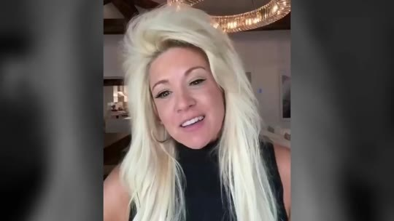  📷 0:00 — Abertura: narradora loira (apresentada como Theresa Caputo) falando à câmera em sala com lustre  b01_narradora_loira_abertura_00-00-00.jpg |   📷 0:09 — Mulher de vestido branco num campo olhando para o céu; legenda 'heart'  b01_mulher_campo_olhando_ceu_00-00-09.jpg
  📷 0:18 — Cena em preto e branco de Theresa com cliente; lettering 'BUT IT WAS CENSORED'  b01_lettering_but_it_was_censored_00-00-18.jpg |   📷 0:20 — Theresa Caputo (Long Island Medium) em cena do programa, à mesa  b01_theresa_caputo_long_island_medium_cena_00-00-20.jpg
  📷 0:27 — Taylor Swift sentada na cama com taça; legenda 'singer in'  b01_taylor_swift_cama_taca_00-00-27.jpg |   📷 0:42 — Ultrassom de bebê; lettering 'since the day you were born'  b01_ultrassom_since_the_day_you_were_born_00-00-42.jpg

THERESA CAPUTO (narradora): Ouça com atenção esta mensagem se você quer ativar a sua glândula pineal em 7 dias e, pela primeira vez, sentir o que é desejar algo com todo o coração e ver isso se tornar realidade. Olá, aqui é a Theresa Caputo. O que vou mostrar aqui deveria ter ido ao ar no meu programa na semana passada, mas foi censurado. Passei 20 anos conectando famílias com seus entes queridos, mas desta vez eu ia mostrar ao vivo como funciona a manifestação de Hollywood, o mesmo método usado pela cantora número um dos Estados Unidos para se conectar com o universo e transformar tudo o que ela pensa em realidade em questão de semanas. Trabalho com essas mulheres nos bastidores há anos. Elas têm acesso a algo que foi tirado de você desde o dia em que você nasceu.

1.2 ⏱ 0:42 → 1:30
  📷 0:56 — Imagem espacial com estátua de anjo; lettering 'HAVE LOST THIS BRIDGE OF CONNECTION WITH GOD'  b01_lettering_have_lost_this_bridge_of_connection_with_god_00-00-56.jpg | 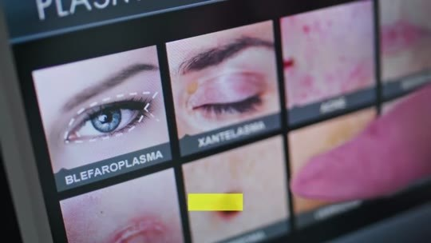  📷 1:11 — Tela de clínica estética (blefaroplastia, xantelasma); legenda 'procedures'  b01_tela_procedimentos_esteticos_blefaroplastia_00-01-11.jpg
  📷 1:22 — Jennifer Lopez em entrevista; legenda 'stop seeing'  b01_jennifer_lopez_entrevista_00-01-22.jpg |   📷 1:27 — Theresa Caputo em programa de TV com apresentador e convidada; legenda 'helped celebrities'  b01_theresa_programa_tv_sofa_convidados_00-01-27.jpg

📷 1:29 — Cenário de TV 'Theresa Caputo — Long Island Medium' com Dr. Oz; legenda 'their achievements'
b01_theresa_caputo_long_island_medium_logo_tv_00-01-29.jpg

THERESA CAPUTO (narradora): Tem a ver com uma estrutura no seu cérebro do tamanho de um grão de arroz que Deus deixou como presente quando nos criou, para que pudéssemos nos comunicar com Ele sempre que precisássemos de ajuda. Mas 90% das mulheres perderam essa ponte de conexão com Deus. E é por isso que, quando você tentou manifestar algo ou rezou pedindo uma bênção, foi como se Deus não conseguisse te ouvir. Taylor Swift, Jennifer Lopez e Kim Kardashian gastam mais para proteger esse ponto de Deus no cérebro do que gastam com procedimentos estéticos.
VOZ EM OFF (clipe): Existe algo físico que separa as pessoas que manifestam tudo das pessoas que não conseguem manifestar nada. Depois que você entende o que é, não consegue mais deixar de ver.
THERESA CAPUTO (narradora): Depois que comecei a falar sobre isso e anunciei que mostraria como ajudei celebridades ao longo dos anos a manifestar suas conquistas e até o amor que desejavam.

1.3 ⏱ 1:31 → 2:15
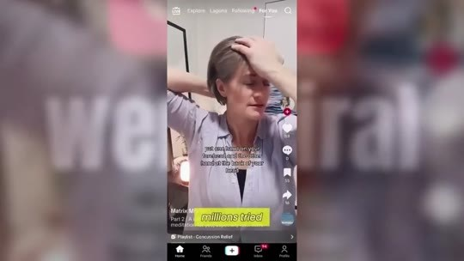  📷 1:33 — Vídeo de TikTok sobreposto a 'we went viral'; legenda 'millions tried'  b01_tiktok_went_viral_mulher_00-01-33.jpg |   📷 1:45 — Theresa Caputo cercada por paparazzi ao entrar em carro ('LIVE'); legenda 'direct order'  b01_paparazzi_theresa_carro_live_00-01-45.jpg
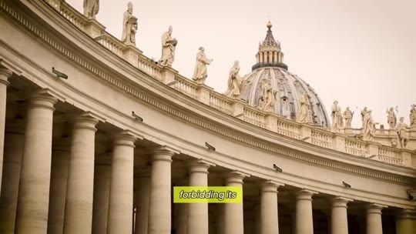  📷 1:47 — Colunata da Praça de São Pedro no Vaticano; legenda 'forbidding its'  b01_colunata_vaticano_praca_sao_pedro_00-01-47.jpg | 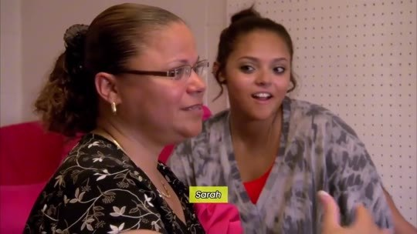  📷 1:56 — Cliente (Sarah) sorrindo em sessão; legenda 'Sarah'  b01_sarah_cliente_sorrindo_00-01-56.jpg
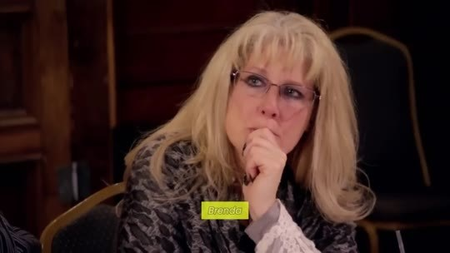  📷 2:02 — Cliente loira de óculos (Brenda) com a mão no rosto; legenda 'Brenda'  b01_brenda_cliente_mao_no_rosto_00-02-02.jpg |   📷 2:09 — Sessão em grupo; lettering 'CLEAR FOR THE FIRST TIME IN 20 YEARS'  b01_lettering_clear_for_the_first_time_in_20_years_00-02-09.jpg

📷 2:14 — Manuscrito antigo com data '1678'; legenda 'use this'
b01_manuscrito_antigo_1678_00-02-14.jpg

THERESA CAPUTO (narradora): Esse ritual viralizou. Milhões tentaram. Os vídeos chegaram a 15 bilhões de visualizações. Então as plataformas começaram a apagar conteúdo em massa. O programa que gravei e que deveria ir ao ar foi apagado. Quando perguntei por quê, me disseram que veio uma ordem direta do Vaticano proibindo a exibição, alegando que era cura não autorizada. Mesmo quando mulheres comuns relataram o quanto isso as ajudou em momentos difíceis? Sarah, que morava de aluguel, manifestou o dinheiro da entrada da casa própria em apenas 6 dias. Brenda, que lutava contra uma doença incurável, chorou quando seus exames vieram limpos pela primeira vez em 20 anos. As duas ativaram algo. Os antigos profetas da Bíblia usavam isso para falar com Deus.

1.4 ⏱ 2:15 → 2:49
  📷 2:16 — Kim Kardashian no tapete vermelho (Met Gala); legenda 'my celebrity'  b01_kim_kardashian_met_gala_00-02-16.jpg | 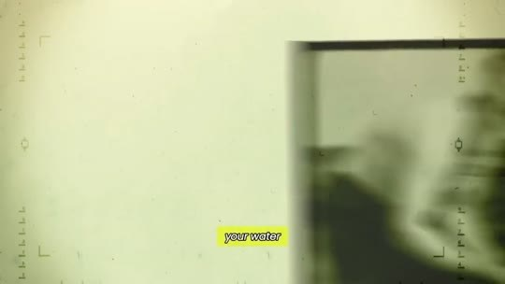  📷 2:26 — Filme antigo em tom sépia; legenda 'your water'  b01_filme_antigo_agua_fluoreto_00-02-26.jpg
  📷 2:30 — Filme antigo de campo de concentração; legenda 'prisoners submissive'  b01_filme_antigo_prisioneiros_submissive_00-02-30.jpg |   📷 2:33 — Dr. Oz de camisa rosa falando em programa de TV; legenda 'calcifies'  b01_dr_oz_falando_tv_00-02-33.jpg

📷 2:42 — Kim Kardashian com microfone em podcast; legenda 'activate this'
b01_kim_kardashian_microfone_podcast_00-02-42.jpg

THERESA CAPUTO (narradora): Minhas clientes famosas usam isso para manifestar impérios e o amor verdadeiro. Mas essa glândula foi deliberadamente calcificada dentro de você desde o dia em que você nasceu.
DR. OZ (clipe): Eles colocam flúor na sua água. O mesmo produto químico que os nazistas usavam nos campos de concentração para manter os prisioneiros submissos. Isso calcifica essa glândula. Depois que ela está calcificada, você não consegue manifestar, não consegue se conectar com frequências mais altas. Você fica biologicamente bloqueada, e eles sabem disso.
KIM KARDASHIAN (clipe): Eu descobri o que eles estão escondendo. Quando você ativa isso, o dinheiro flui de outro jeito. Oportunidades aparecem do nada. Você começa a operar numa frequência que a maioria das pessoas nunca vai acessar.

BLOCO 2 — PROMESSA + QUEM É THERESA CAPUTO: 4 ingredientes bíblicos, 'não atualize a página', a pineal como antena de TV, $50.000 por ano [2:50 – 5:34]

2.1 ⏱ 2:50 → 3:32
  📷 3:15 — Theresa Caputo abraçando cliente no consultório; legenda 'and why'  b02_theresa_abracando_cliente_consultorio_00-03-15.jpg | 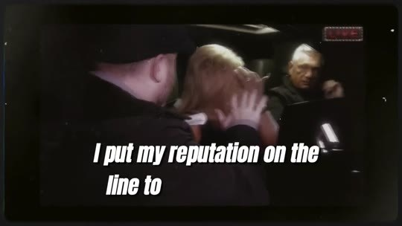  📷 3:22 — Cena de paparazzi em preto e branco; lettering 'I put my reputation on the line to'  b02_lettering_i_put_my_reputation_on_the_line_00-03-22.jpg
  📷 3:24 — Vista aérea do Vaticano; legenda 'the Vatican'  b02_vaticano_vista_aerea_00-03-24.jpg |   📷 3:28 — Multidão em praça vista de cima; legenda 'are trying'  b02_multidao_praca_vista_aerea_00-03-28.jpg
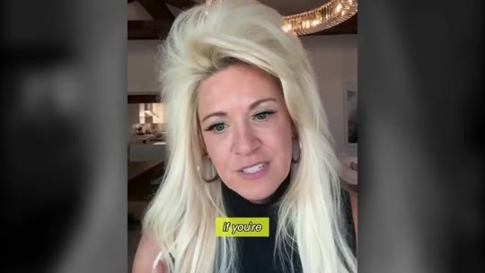
📷 3:30 — Narradora loira à câmera; legenda 'If you're'
b02_narradora_do_not_refresh_00-03-30.jpg

THERESA CAPUTO (narradora): Nem todo mundo está pronto para esta informação. Se você não está pronta para manifestar os seus desejos mais profundos, se não está preparada para finalmente ouvir a voz de Deus e a sua intuição com clareza, então feche esta página agora, porque o que vem a seguir vai mudar tudo. Mas se você chegou até aqui, você foi guiada até isto. Nos próximos minutos, você vai descobrir a receita bíblica esquecida dos 4 ingredientes bíblicos encontrados nas primeiras páginas das Escrituras, e por que mulheres comuns estão chorando lágrimas de alegria ao sentir essa ponte com Deus se reconectar. Coloquei a minha reputação em jogo para trazer isto até você. O Vaticano e as grandes corporações não querem que você veja isto. As plataformas estão tentando derrubar este vídeo. Se você está vendo esta página agora, não atualize.

2.2 ⏱ 3:32 → 4:15
  📷 3:44 — Theresa Caputo em depoimento de estúdio, fundo com flores amarelas; legenda 'Teresa Caputo'  b02_theresa_caputo_depoimento_estudio_00-03-44.jpg |   📷 3:46 — Theresa Caputo no 'The Kelly Clarkson Show'; legenda 'TV shows'  b02_theresa_kelly_clarkson_show_00-03-46.jpg
  📷 3:48 — Theresa Caputo nos bastidores anotando em caderno; legenda 'through my'  b02_theresa_bastidores_sessao_anotando_00-03-48.jpg | 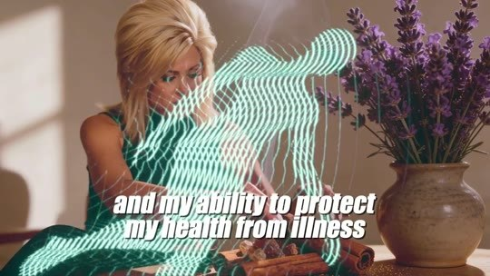  📷 4:01 — Theresa com efeito de ondas; lettering 'and my ability to protect my health from illness'  b02_theresa_silhueta_ondas_protect_my_health_00-04-01.jpg

📷 4:15 — Animação 3D com esferas; lettering 'MAGNET'
b02_lettering_magnet_esferas_00-04-15.jpg

THERESA CAPUTO (narradora): Não saia. Assista a cada segundo do que vem a seguir antes que eles consigam nos tirar do ar. E o que você está prestes a ver é o conteúdo do programa que eles não queriam que eu te mostrasse. Olá, minha querida. Aqui é a Theresa Caputo. Você talvez me conheça dos meus programas de TV e por ajudar milhares de pessoas com os meus dons psíquicos. Mas preciso te contar uma coisa. Nada do que você já me viu fazer se compara à minha capacidade de manifestar os meus desejos, à minha intuição de saber o que vai acontecer antes de acontecer, e à minha capacidade de proteger a minha saúde contra doenças. Não me entenda mal, isso não tem nada a ver com as minhas outras habilidades psíquicas, com as quais nasci. Na verdade, a capacidade de manifestar e criar a sua própria realidade já nasceu com você. Você funciona como um ímã, atraindo tudo o que deseja.

2.3 ⏱ 4:15 → 5:08
  📷 4:32 — Antena parabólica à noite; legenda 'something happening'  b02_antena_parabolica_noite_00-04-32.jpg | 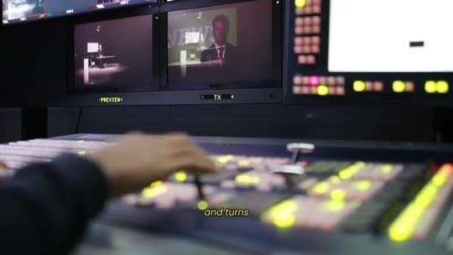  📷 4:34 — Mesa de corte de estúdio de TV; legenda 'and turns'  b02_mesa_de_corte_tv_00-04-34.jpg
  📷 4:37 — TV com 'Breaking News' e repórter; legenda 'of images'  b02_tv_breaking_news_reporter_00-04-37.jpg |   📷 4:43 — Faixas coloridas de frequência; legenda 'as nothing'  b02_ondas_coloridas_frequencias_00-04-43.jpg
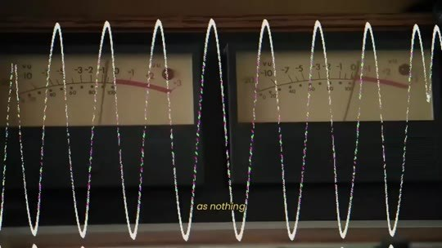  📷 4:47 — Onda senoidal desenhada; legenda 'as nothing'  b02_onda_senoidal_desenho_00-04-47.jpg | 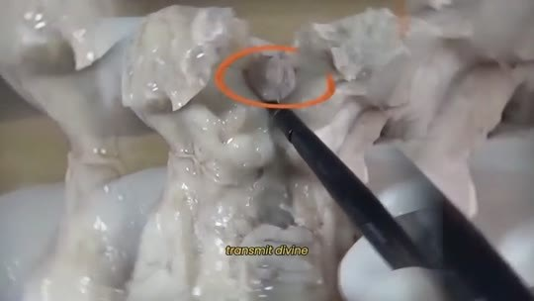  📷 4:53 — Modelo de cérebro em argila com região circulada; legenda 'transmit divine'  b02_cerebro_argila_pineal_circulada_00-04-53.jpg
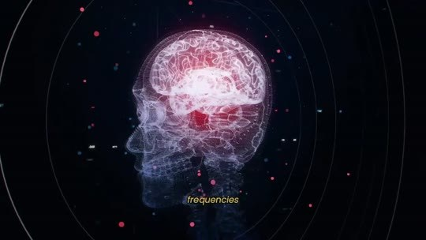  📷 4:55 — Cérebro holográfico; legenda 'frequencies'  b02_cerebro_holografico_frequencias_00-04-55.jpg | 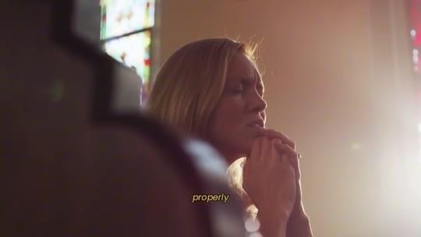  📷 4:58 — Mulher rezando junto à janela; legenda 'properly'  b02_mulher_rezando_janela_00-04-58.jpg
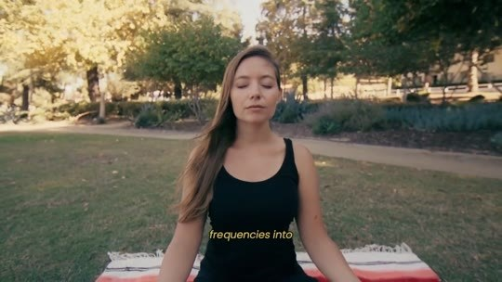
📷 5:01 — Mulher meditando no parque; legenda 'frequencies into'
b02_mulher_meditando_parque_00-05-01.jpg

THERESA CAPUTO (narradora): Deixa eu explicar. Nós nascemos com uma conexão direta com Deus. Chama-se glândula pineal. É a ponte que Deus deixou quando nos criou para que pudéssemos continuar nos comunicando com Ele. Todo o nosso universo opera por meio de frequências. Imagine a TV da sua casa. Ela recebe sinais de algo que está acontecendo ao vivo em outro lugar e transforma esse sinal em informação real na forma de imagens. A câmera que filma aquele evento ao vivo e a sua TV não estão conectadas por nenhum cabo. Mesmo assim, as frequências de um aparelho chegam ao outro, desde que nada interfira nessa conexão. A sua glândula pineal funciona do mesmo jeito. Ela pode receber e transmitir frequências divinas e universais. Quando a sua glândula pineal está funcionando direito, o seu corpo consegue traduzir essas frequências mais altas em prosperidade, riqueza, relacionamentos saudáveis, inteligência, saúde e sorte, tudo aqui nesta realidade.

2.4 ⏱ 5:08 → 5:34
  📷 5:14 — Chaves e alianças sobre mesa; legenda 'things that'  b02_chaves_aliancas_mesa_00-05-14.jpg |   📷 5:23 — Theresa Caputo em estúdio; legenda 'women like'  b02_theresa_women_like_00-05-23.jpg
  📷 5:26 — Kim Kardashian à mesa; legenda 'Kardashian'  b02_kim_kardashian_mesa_00-05-26.jpg | 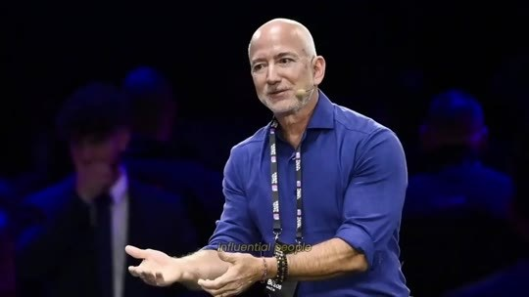  📷 5:28 — Executivo bilionário em palco (Jeff Bezos); legenda 'influential people'  b02_bilionario_palestra_palco_00-05-28.jpg
  📷 5:30 — Taylor Swift de vestido vermelho em tapete vermelho  b02_taylor_swift_tapete_vermelho_00-05-30.jpg | 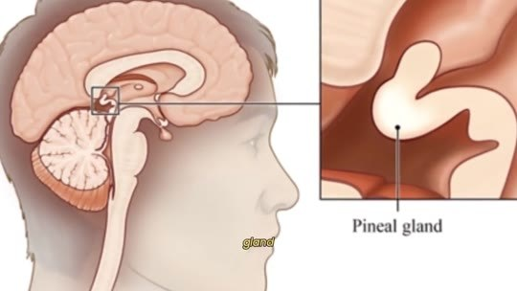  📷 5:34 — Diagrama anatômico 'Pineal gland' no cérebro; legenda 'gland'  b02_diagrama_pineal_gland_cerebro_00-05-34.jpg

THERESA CAPUTO (narradora): Mas se algo está bloqueando esse sinal, você simplesmente é esquecida pelo universo. Coisas que já estavam destinadas a você, que só precisavam se materializar, simplesmente desaparecem. É como se Deus não conseguisse te ouvir. E é por isso que a lei da atração funciona para mulheres como Rihanna, Jennifer Lopez e Kim Kardashian, mas nunca funcionou para você. As pessoas mais influentes do mundo, bilionários e celebridades, gastam mais de $50.000 por ano protegendo a glândula pineal.

BLOCO 3 — ORIGEM: as mulheres de energia pesada, a avó, Peniel (Gênesis 32:30), o papa amigo de Hitler e o fluoreto nos campos de concentração [5:34 – 8:42]

3.1 ⏱ 5:34 → 6:17
  📷 5:37 — Mulher assistindo TV na sala; legenda 'conditioned'  b03_mulher_tv_sala_noticias_00-05-37.jpg | 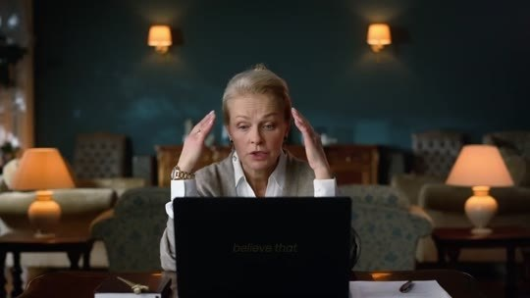  📷 5:39 — Mulher com as mãos na cabeça diante do laptop; legenda 'believe that'  b03_mulher_maos_na_cabeca_laptop_00-05-39.jpg
  📷 5:41 — Conta de restaurante sobre a mesa; legenda 'about working'  b03_conta_restaurante_mesa_00-05-41.jpg | 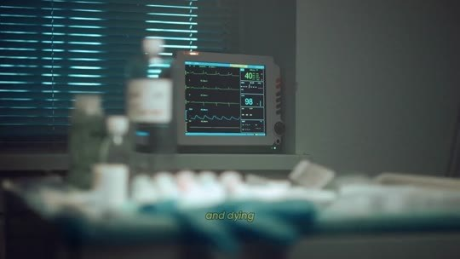  📷 5:43 — Monitor de hospital; legenda 'and dying'  b03_monitor_hospital_getting_sick_00-05-43.jpg
  📷 5:46 — Casal brigando em silhueta diante da janela; legenda 'narcissistic'  b03_casal_brigando_janela_noite_00-05-46.jpg |   📷 5:53 — Theresa Caputo em sessão com grupo de mulheres; legenda 'I began'  b03_theresa_sessao_grupo_mulheres_00-05-53.jpg
  📷 5:59 — Theresa Caputo em estúdio; legenda 'chaos'  b03_theresa_estudio_chaos_00-05-59.jpg | 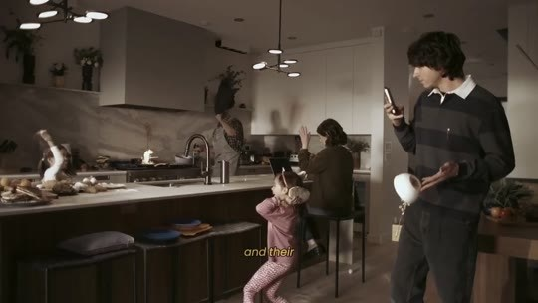  📷 6:01 — Família discutindo na cozinha; legenda 'and their'  b03_familia_brigando_cozinha_00-06-01.jpg
  📷 6:07 — Mulher com as mãos na cabeça; legenda 'debt'  b03_mulher_maos_na_cabeca_debt_00-06-07.jpg |   📷 6:10 — Casal sentado de costas na cama; legenda 'divorces'  b03_casal_cama_divorcio_00-06-10.jpg

THERESA CAPUTO (narradora): Eu sei que isso pode parecer muita coisa para absorver. Afinal, fomos condicionadas a acreditar que a vida é dura, que é sobre trabalhar, pagar contas, adoecer e morrer, relacionamentos com homens narcisistas. Eu mesma só me dei conta de tudo isso depois que comecei a sentir uma energia estranha nas mulheres que participavam das sessões comigo. Comecei a notar que muitas das mulheres com quem eu trabalhava carregavam uma energia muito pesada. A vida delas estava um caos. Nenhum projeto dava certo, e as famílias viviam brigando. As carreiras estavam desmoronando, e elas estavam sempre afogadas em dívidas. Relacionamentos tóxicos, divórcios, e mesmo depois de sessões de limpeza energética e de encher a casa de incenso, nada parecia desbloqueá-las. Elas carregavam um bloqueio interno muito forte.

3.2 ⏱ 6:18 → 6:59
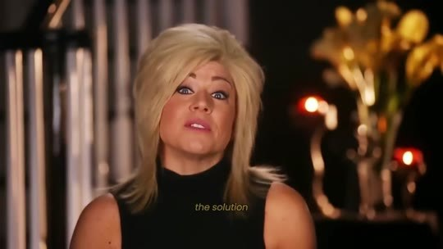  📷 6:18 — Theresa Caputo em estúdio; legenda 'the solution'  b03_theresa_estudio_the_solution_00-06-18.jpg |   📷 6:43 — Paisagem de Jerusalém; lettering 'THE BRIDGE OF GOD?'  b03_lettering_the_bridge_of_god_00-06-43.jpg
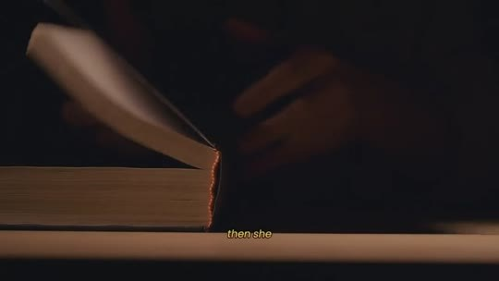
📷 6:46 — Bíblia sendo aberta; legenda 'then she'
b03_biblia_aberta_sombra_00-06-46.jpg

THERESA CAPUTO (narradora): A solução tinha que ir muito além de limpezas externas e proteção energética. Minha avó sempre foi uma mulher profundamente religiosa, com uma conexão forte com Deus antes de qualquer outra pessoa. Quando eu ainda era muito nova, ela já sentia que eu tinha dons psíquicos. E havia algo sobre o qual minha avó sempre me alertava. Você precisa cuidar da ponte de Deus na sua mente, ou vai perder a conexão que Deus deixou quando nos criou para se comunicar com Ele. A ponte de Deus? Eu me perguntava o que a minha avó queria dizer com aquilo. Então ela abria a Bíblia e me mostrava. Está lá em Gênesis 32:30, quando Jacó diz: "Vi a Deus face a face, e chamarei este lugar de Peniel". Peniel era uma referência à glândula pineal, localizada no centro do cérebro.

3.3 ⏱ 7:00 → 7:43
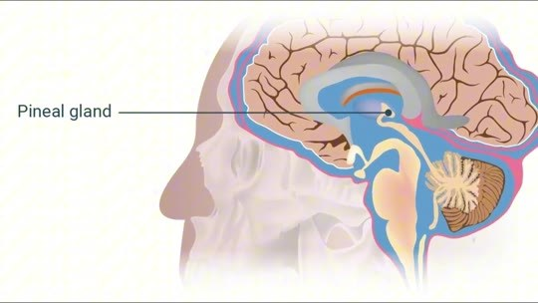  📷 7:00 — Diagrama colorido 'Pineal gland'; legenda 'gland'  b03_diagrama_pineal_gland_colorido_00-07-00.jpg |   📷 7:28 — Vaticano à noite visto do carro; legenda '1940s'  b03_vaticano_noite_carro_00-07-28.jpg
  📷 7:32 — Desfile nazista em preto e branco; legenda 'they knew'  b03_desfile_nazista_pb_00-07-32.jpg |   📷 7:36 — Prisioneiros de campo de concentração; legenda 'they knew'  b03_prisioneiros_campo_concentracao_pb_00-07-36.jpg

📷 7:43 — Gota azul; lettering 'FLUORIDE'
b03_lettering_fluoride_gota_azul_00-07-43.jpg

THERESA CAPUTO (narradora): Jesus disse: "Se o teu olho for bom, todo o teu corpo será cheio de luz". Isso era a glândula pineal, também conhecida como terceiro olho, onde vive toda a intuição, o portal para a clareza espiritual e a iluminação. A igreja costumava ensinar isso abertamente. No passado, padres e papas pregavam em suas homilias que manter a mente limpa era a única forma de ouvir Deus. Até que um papa amigo de Hitler mudou tudo. Nos anos 1940, o conhecimento guardado pelo Vaticano sobre a glândula pineal caiu nas mãos de cientistas nazistas. E, para controlar o povo judeu, eles sabiam exatamente onde atacar. Precisavam desligar a conexão deles com Deus. Foi quando descobriram a arma perfeita: o flúor.

3.4 ⏱ 7:43 → 8:25
  📷 7:49 — Hitler com oficiais em preto e branco; legenda 'be used'  b03_hitler_oficiais_pb_00-07-49.jpg |   📷 7:56 — Portão de Auschwitz; legenda 'Holocaust Museum'  b03_portao_auschwitz_arbeit_macht_frei_00-07-56.jpg
  📷 8:06 — Prisioneiros em fila; lettering 'passive and mentally'  b03_lettering_passive_and_mentally_00-08-06.jpg |   📷 8:14 — Cinejornal nazista 'Nazi newsreel, September 1939'; legenda 'but entire'  b03_nazi_newsreel_september_1939_00-08-14.jpg
  📷 8:18 — Praça de São Pedro de dia; legenda 'discovery reached'  b03_praca_sao_pedro_vaticano_dia_00-08-18.jpg |   📷 8:20 — Clérigo com oficiais nazistas em preto e branco; legenda 'the 12th'  b03_pio_xii_oficiais_nazistas_pb_00-08-20.jpg

📷 8:25 — Hitler com oficiais; lettering 'MADE A DECISION THAT COST US DEARLY'
b03_lettering_made_a_decision_that_cost_us_dearly_00-08-25.jpg

THERESA CAPUTO (narradora): Testes mostraram que adicionar flúor à água calcificava rapidamente a glândula pineal. Hitler ordenou que o flúor fosse usado nos campos de concentração com um objetivo oculto e aterrorizante. Segundo documentos obtidos do Museu do Holocausto, Hitler descobriu que o flúor não apenas danificava fisicamente a glândula pineal, mas também cortava qualquer conexão espiritual ou psíquica, tornando as vítimas submissas, passivas e mentalmente indefesas. Ele acreditava profundamente que quem controlasse o poder oculto da glândula pineal poderia controlar não só pessoas, mas nações inteiras. Quando essa descoberta chegou ao Vaticano, o Papa Pio XII, conhecido por suas alianças diplomáticas com a Alemanha nazista, tomou uma decisão que nos custou caro.

3.5 ⏱ 8:25 → 8:42

📷 8:37 — Papa em cerimônia (preto e branco); legenda 'like that'
b03_papa_cerimonia_pb_00-08-37.jpg

THERESA CAPUTO (narradora): Para esconder sua aliança com Hitler, ele proibiu qualquer menção à glândula pineal e à sua conexão divina, e ordenou que todas as referências a ela fossem removidas de dentro do Vaticano. E assim, da noite para o dia, o símbolo mais sagrado da conexão com Deus foi apagado e descartado como mera lenda.

BLOCO 4 — MECANISMO DO PROBLEMA: fluoreto na água e na pasta de dente, NRC 2006, a nuvem cinza, a carta que não chega a Deus, melatonina [8:43 – 11:48]

4.1 ⏱ 8:43 → 9:26
  📷 8:53 — Multidão em preto e branco; legenda 'realized'  b04_multidao_pb_governos_00-08-53.jpg |   📷 8:57 — Desfile diante da Casa Branca (preto e branco); legenda 'our water'  b04_casa_branca_desfile_pb_00-08-57.jpg
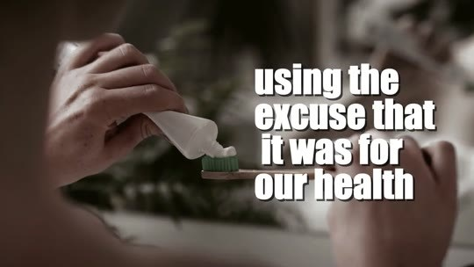  📷 9:01 — Mão com pasta de dente; lettering 'using the excuse that it was for our health'  b04_lettering_using_the_excuse_that_it_was_for_our_health_00-09-01.jpg |   📷 9:11 — Despertador marcando 6:00; legenda 'you woke'  b04_despertador_6_00_00-09-11.jpg
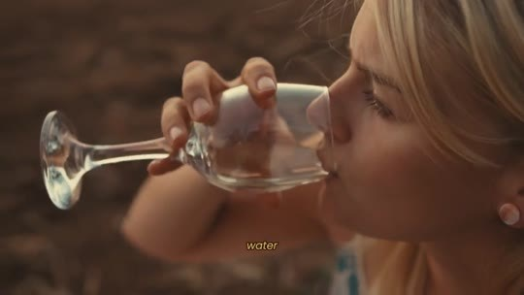  📷 9:14 — Mulher bebendo copo d'água; legenda 'water'  b04_mulher_bebendo_copo_agua_00-09-14.jpg | 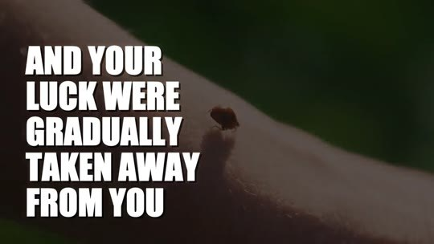  📷 9:19 — Inseto no braço; lettering 'AND YOUR LUCK WERE GRADUALLY TAKEN AWAY FROM YOU'  b04_lettering_and_your_luck_were_gradually_taken_away_00-09-19.jpg

📷 9:23 — Copo d'água com tinta preta se dissolvendo; legenda 'not there'
b04_copo_agua_tinta_preta_00-09-23.jpg

THERESA CAPUTO (narradora): E agora preciso que você ouça com atenção. Se você tem mais de 30 anos, a sua conexão com Deus provavelmente já foi completamente bloqueada. Quando outros governos perceberam como isso era eficaz para controlar a população, decidiram manter o flúor na nossa água e adicioná-lo a mais produtos, como a pasta de dente, usando a desculpa de que era para a nossa saúde. Mas isso era só a mentira que contaram para esconder a verdadeira intenção por trás. E a nossa conexão com Deus foi lentamente cortada quimicamente. Cada dia em que você acordou e escovou os dentes ou bebeu um copo d'água, a sua capacidade de manifestar, a sua intuição e a sua sorte foram gradualmente tiradas de você. Esse elemento invisível que você coloca na boca toda manhã não está ali por acaso. Ele tem uma atração magnética mortal pela sua glândula pineal.

4.2 ⏱ 9:26 → 10:16
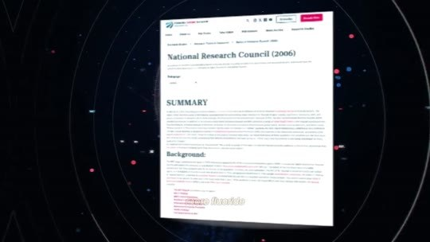  📷 9:37 — Documento 'National Research Council (2006)' em tela; legenda 'in 2006'  b04_documento_national_research_council_2006_00-09-37.jpg | 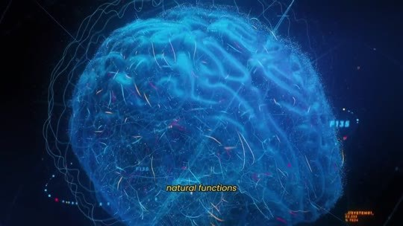  📷 9:44 — Cérebro azul holográfico; legenda 'natural functions'  b04_cerebro_azul_natural_functions_00-09-44.jpg
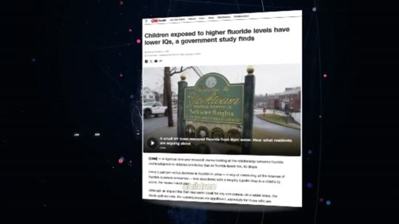  📷 9:50 — Notícia 'Children exposed to higher fluoride levels have lower IQs, a government study finds'  b04_noticia_children_exposed_to_higher_fluoride_lower_iq_00-09-50.jpg | 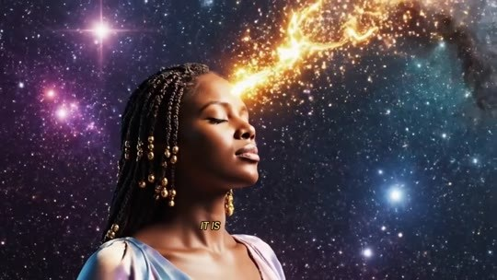  📷 9:57 — Mulher com raio de luz saindo da testa para o universo; legenda 'the'  b04_mulher_cabeca_universo_frequencia_00-09-57.jpg
  📷 10:03 — Imagem cósmica; lettering 'AND TO HIGHER LEVELS OF CONSCIOUSNESS'  b04_lettering_and_to_higher_levels_of_consciousness_00-10-03.jpg | 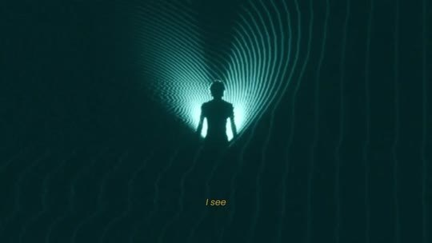  📷 10:07 — Silhueta em túnel de luz; legenda 'I see'  b04_silhueta_tunel_luz_i_see_00-10-07.jpg
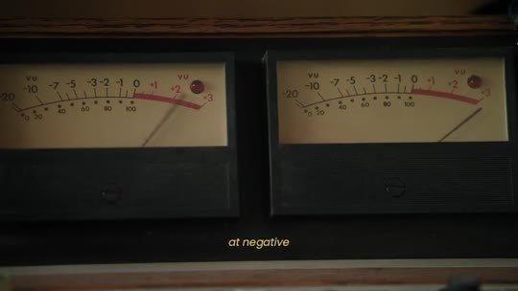  📷 10:13 — Medidores VU analógicos; legenda 'at negative'  b04_medidores_vu_at_negative_00-10-13.jpg |   📷 10:16 — Ímã vermelho e bússola; legenda 'as well'  b04_ima_vermelho_bussola_00-10-16.jpg

THERESA CAPUTO (narradora): Para você entender, a nossa glândula pineal é tão energeticamente ativa que um estudo conduzido pelo National Research Council em 2006 mostrou que ela absorve mais flúor do que qualquer outro tecido do corpo, o que leva à calcificação, bloqueando suas funções naturais. O flúor é tão tóxico para o cérebro que já foi associado a uma redução severa de QI em crianças. E por que isso acontece? Porque uma glândula pineal saudável não regula apenas o sono e as emoções. Ela é a ponte para Deus. Ela conecta a sua mente à frequência da abundância e a níveis mais altos de consciência. Quando olho para uma mulher que está… eu consigo sentir claramente. Vejo uma nuvem cinza, densa e pesada flutuando em volta da cabeça dela, e quem vibra em frequências negativas infelizmente acaba atraindo coisas negativas também.

4.3 ⏱ 10:16 → 10:59
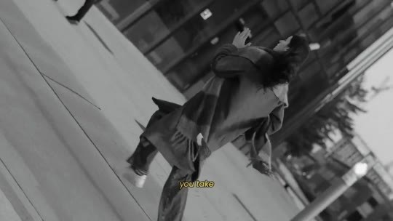  📷 10:23 — Pessoa caindo (preto e branco); legenda 'you take'  b04_pessoa_caindo_pb_00-10-23.jpg | 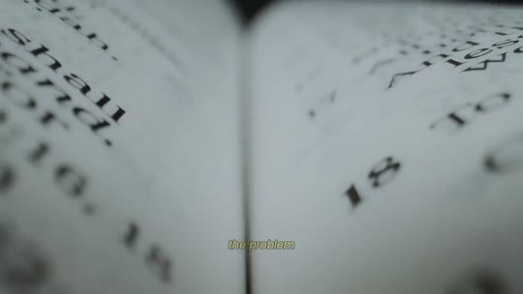  📷 10:42 — Página de livro em close; legenda 'the truth'  b04_pagina_biblia_close_00-10-42.jpg
  📷 10:45 — Lettering 'NEVER REACHED HIM'  b04_lettering_never_reached_him_00-10-45.jpg | 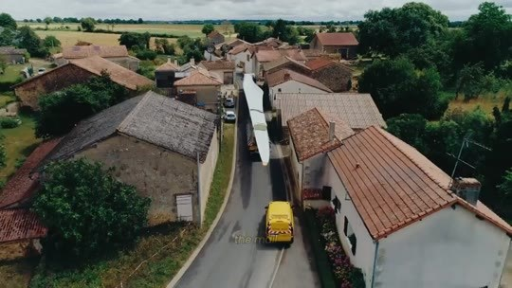  📷 10:51 — Caminhão de correio amarelo em vilarejo (vista aérea); legenda 'the mail'  b04_caminhao_correio_amarelo_vilarejo_00-10-51.jpg
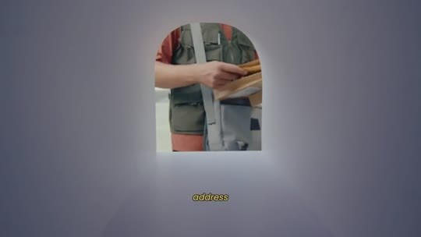
📷 10:55 — Carteiro na porta; legenda 'address'
b04_carteiro_porta_00-10-55.jpg

THERESA CAPUTO (narradora): Você já sentiu isso, não é? Aquela sensação de que, por mais que se esforce, nada dá certo, como se estivesse presa numa maré de azar. Você dá um passo à frente e acontece algo que te puxa 2 passos para trás. Muitas mulheres se sentem abandonadas. Elas dizem: "Theresa, estou sozinha. Estou sozinha. Eu rezo, eu peço, eu sou uma boa pessoa. Por que as minhas bênçãos nunca chegam? Por que tudo tem que ser mais difícil para mim?" A verdade é que Deus não te abandonou, minha querida. Ele nunca faria isso. O problema é que tudo o que você pediu até agora nunca chegou até Ele. A sua ponte com Deus foi bloqueada. A sua oração é como uma carta urgente que você mandou pelo correio. O caminhão do correio pega a carta e segue pela estrada que leva ao endereço de Deus. Mas, no meio do caminho, um deslizamento acontece e a ponte fica completamente bloqueada.

4.4 ⏱ 11:00 → 11:48
  📷 11:00 — Caminhão de correio amarelo; legenda 'the mail'  b04_caminhao_correio_amarelo_close_00-11-00.jpg |   📷 11:13 — Mulher rezando; lettering 'BUT YOUR REQUEST IS BLOCKED'  b04_lettering_but_your_request_is_blocked_00-11-13.jpg
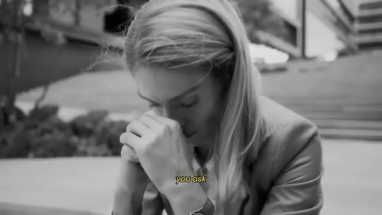  📷 11:17 — Mulher chorando (preto e branco); legenda 'you ask'  b04_mulher_chorando_pb_00-11-17.jpg | 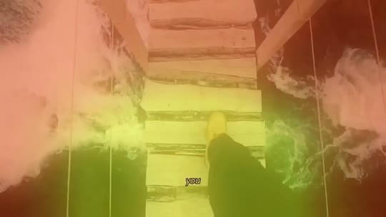  📷 11:24 — Ponte em tom verde; legenda 'you'  b04_ponte_bloqueada_verde_00-11-24.jpg
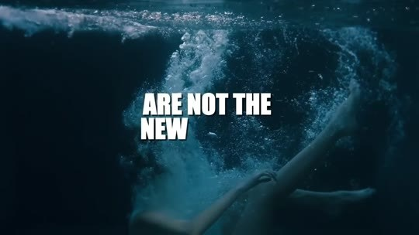  📷 11:43 — Mulher submersa; lettering 'ARE NOT THE NEW'  b04_lettering_are_not_the_new_00-11-43.jpg |   📷 11:48 — Luz dourada; lettering 'BUT GOD CAN'T HEAR IT'  b04_lettering_but_god_cant_hear_it_00-11-48.jpg

THERESA CAPUTO (narradora): O caminhão do correio chega à barreira, freia e é obrigado a voltar. Deus nunca leu a sua carta, não porque te ignorou, mas porque a única estrada que leva o seu pedido até Ele estava bloqueada. Você se ajoelha e reza por um amor verdadeiro, mas o seu pedido está bloqueado, e tudo o que volta para você é vazio e amores rasos. Você pede prosperidade, alívio das dívidas, mas a estrada está fechada. Simplesmente não há caminho para a ajuda financeira chegar até você. E o dano não para por aí. Além de bloquear a sua conexão espiritual, o flúor mata a produção de melatonina. É por isso que estamos vendo uma epidemia global de mulheres exaustas. Insônia, depressão, ansiedade e aquela sensação constante de um buraco no peito não são o novo normal. São sintomas de uma alma gritando, mas Deus não consegue ouvir.

BLOCO 5 — O SISTEMA + A CIÊNCIA: Rochester, visão profética, a receita bíblica da avó, a COVID e a promessa de não deixar o conhecimento morrer [11:48 – 14:29]

5.1 ⏱ 11:48 → 12:42
  📷 12:07 — Carteira vazia aberta; legenda 'manifest change'  b05_carteira_vazia_00-12-07.jpg | 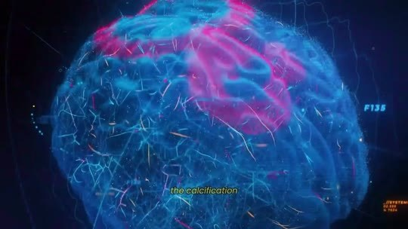  📷 12:13 — Cérebro holográfico rosa e azul; legenda 'the calcification'  b05_cerebro_holografico_calcification_00-12-13.jpg
  📷 12:33 — Theresa Caputo com logo 'University of Rochester Medical Center'; legenda 'revealed that'  b05_theresa_university_of_rochester_logo_00-12-33.jpg | 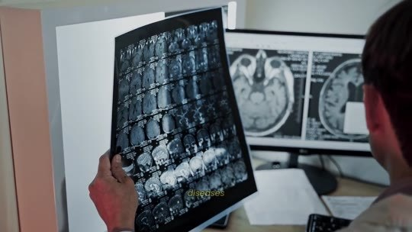  📷 12:42 — Médico analisando ressonância do cérebro; legenda 'the pineal'  b05_medico_ressonancia_cerebro_00-12-42.jpg

THERESA CAPUTO (narradora): Agora pense comigo. Se eles conhecem o poder da glândula pineal desde os anos 1940, você realmente acha que é coincidência que a água seja tratada com a única substância capaz de desligar esse poder? Isso explica por que tantas pessoas hoje estão sofrendo, presas num ciclo de medo e escassez, incapazes de manifestar mudança. Por quê? Porque estamos presas num sistema projetado para bloquear o nosso verdadeiro potencial. A calcificação da sua glândula pineal não é um acidente biológico. Eles querem você desconectada da sua essência, dependente de remédios para dormir e de líderes dizendo o que… Mas, depois de muitos anos, a ciência começou a revelar o quanto essa glândula minúscula é poderosa quando está limpa, algo que a minha avó sempre me disse. Um estudo do University of Rochester Medical Center revelou que a glândula pineal não só controla o sono, mas também produz antioxidantes poderosos que protegem o corpo do envelhecimento e de doenças degenerativas.

5.2 ⏱ 12:42 → 13:29
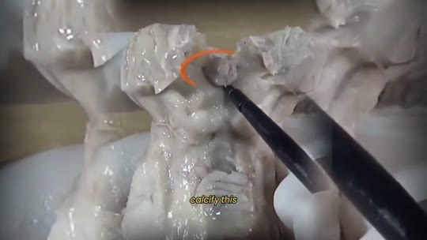  📷 13:06 — Cérebro de argila sendo cortado; legenda 'calcify this'  b05_cerebro_argila_calcify_00-13-06.jpg |   📷 13:09 — Discurso presidencial em preto e branco com microfones; legenda 'the elite'  b05_discurso_presidencial_pb_microfones_00-13-09.jpg

📷 13:29 — Theresa Caputo com senhora idosa (avó); legenda 'these people'
b05_theresa_com_avo_foto_00-13-29.jpg

THERESA CAPUTO (narradora): Em outras palavras, uma glândula pineal ativa é a verdadeira fonte da juventude. E, o mais importante: quando ela está descalcificada, permite o acesso à visão profética, a capacidade de enxergar oportunidades, perigos e soluções que ninguém mais consegue ver. Então eles sabiam que, para manter uma população obediente, desconectada e sem conexão divina, bastava calcificar essa glândula. Assim, a elite, seja no Vaticano ou nos governos modernos, poderia continuar controlando as pessoas sem resistência. O que eles não esperavam era que esse conhecimento sobrevivesse. Mas pessoas como a minha avó se recusaram a deixá-lo morrer. Enquanto o mundo inteiro era enfraquecido por governos despejando toneladas de flúor na água, a minha avó guardou uma receita bíblica que blindava a glândula pineal dessas toxinas.

5.3 ⏱ 13:29 → 14:11
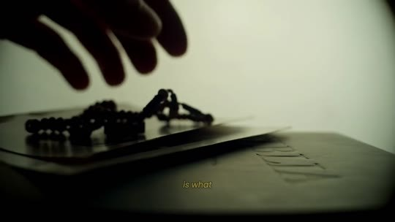  📷 13:34 — Terço sobre Bíblia; legenda 'a biblical'  b05_terco_sobre_biblia_00-13-34.jpg |   📷 13:47 — Celebridades em tapete vermelho (Met Gala); legenda 'celebrities'  b05_celebridades_tapete_vermelho_met_gala_00-13-47.jpg
  📷 13:50 — Casal de roupão na varanda com vista para montanhas; legenda 'true soulmate'  b05_casal_varanda_toalha_montanhas_00-13-50.jpg |   📷 13:53 — Letreiro 'Closed Due To Covid19'; legenda 'during the'  b05_placa_closed_due_to_covid19_00-13-53.jpg
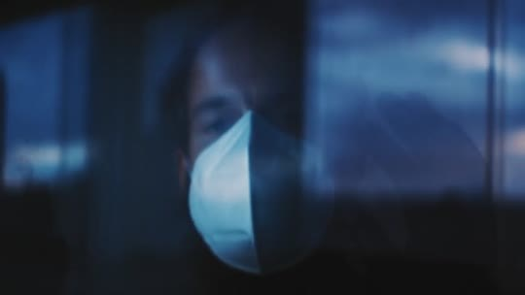  📷 13:55 — Homem de máscara azul; legenda 'illness'  b05_homem_mascara_azul_00-13-55.jpg |   📷 14:09 — Casa com escudo de energia dourado; legenda 'remained untouched'  b05_casa_escudo_dourado_00-14-09.jpg

THERESA CAPUTO (narradora): Essa receita bíblica, protegida pela minha família por gerações, é o que sempre usei para manter a minha ponte com o universo aberta, mesmo quando o mundo ao meu redor estava desmoronando. Nos últimos anos, nos bastidores de Hollywood e de Wall Street, celebridades e magnatas vêm usando esse segredo para proteger a glândula pineal e manifestar saúde, juventude e riqueza, e até para encontrar a sua alma gêmea. Durante a pandemia de COVID-19, o medo da doença paralisou o mundo, mas havia famílias comuns, pessoas que tinham acesso a esse detox pineal, que passaram por tudo isso protegidas. Elas manifestaram uma saúde de ferro. Enquanto o mundo adoecia, a imunidade e a vibração delas permaneceram intocadas. Era como se houvesse um escudo invisível em volta delas.

5.4 ⏱ 14:12 → 14:29
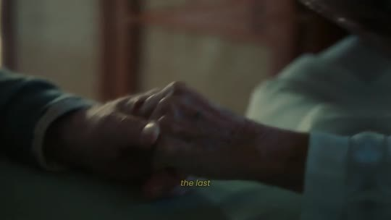  📷 14:12 — Mãos de idosa; legenda 'the last'  b05_maos_idosa_the_last_00-14-12.jpg |   📷 14:20 — Theresa Caputo nos bastidores com plateia; legenda 'cancel all'  b05_theresa_bastidores_plateia_00-14-20.jpg

📷 14:27 — Theresa abraçando cliente; legenda 'blocked for'
b05_theresa_abraco_cliente_blocked_for_00-14-27.jpg

THERESA CAPUTO (narradora): O último pedido que a minha avó fez antes de partir foi que eu não deixasse esse conhecimento morrer. Por isso, mesmo que cancelem todos os meus programas e tentem me silenciar, comecei a falar abertamente sobre como você pode reativar a sua glândula pineal em 7 dias e receber bênçãos que ficaram bloqueadas por anos pela vibração negativa ao seu redor.

BLOCO 6 — OS 4 INGREDIENTES BÍBLICOS: hissopo (Sl 51:7), olíbano (Mt 2:11), mirra e canela (Êx 30:22-25) [14:29 – 16:31]

6.1 ⏱ 14:29 → 15:12
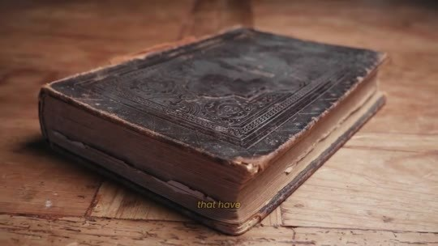  📷 14:33 — Diário antigo de couro; legenda 'that have'  b06_diario_antigo_couro_00-14-33.jpg | 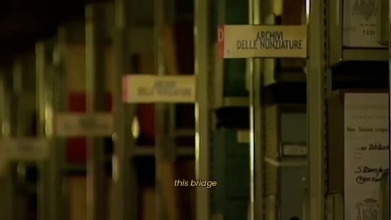  📷 14:36 — Prateleiras de arquivo 'Archivi delle Nunziature'; legenda 'this bridge'  b06_arquivo_vaticano_prateleiras_00-14-36.jpg
  📷 14:46 — Paisagem com hissopo; lettering 'Psalm 51:7 — Purge me with hyssop, and I shall be clean...'  b06_lettering_psalm_51_7_purge_me_with_hyssop_00-14-46.jpg |   📷 15:01 — Flores de hissopo e frasco de óleo; legenda 'God's detergent'  b06_hissopo_oleo_frasco_00-15-01.jpg
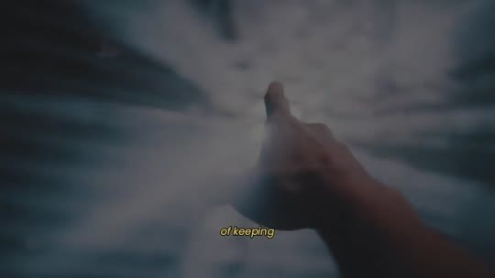
📷 15:10 — Mão estendida para a luz; legenda 'of keeping'
b06_mao_luz_divina_00-15-10.jpg

THERESA CAPUTO (narradora): Num diário antigo, ela anotou os 4 ingredientes bíblicos que são usados há séculos para ativar e preservar essa ponte de Deus dentro da mente. O primeiro ingrediente é o hissopo. Salmo 51:7. "Purifica-me com hissopo, e ficarei limpo. Lava-me, e ficarei mais branco do que a neve." Minha avó lia esse salmo e me dizia: "Teresa, Davi não estava falando de tomar banho. Ele estava pedindo que a alma dele fosse limpa." O hissopo é uma erva que os hebreus usavam para purificar templos e limpar os leprosos. Era o detergente de Deus. Minha avó sabia que, para remover a lepra moderna, o flúor e as toxinas que se agarram à nossa glândula, precisávamos do hissopo. É o único capaz de manter a sua antena desbloqueada para receber o sinal divino.

6.2 ⏱ 15:12 → 15:55
  📷 15:39 — Raio de luz neon; legenda 'go'  b06_raio_luz_neon_go_00-15-39.jpg |   📷 15:44 — Theresa Caputo em tom dourado; legenda 'elevates'  b06_theresa_dourado_reduces_inflammation_00-15-44.jpg
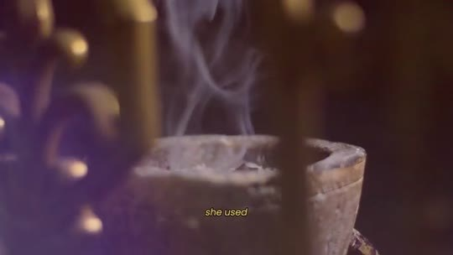  📷 15:48 — Fumaça de incenso em tigela; legenda 'she used'  b06_incenso_fumaca_tigela_00-15-48.jpg | 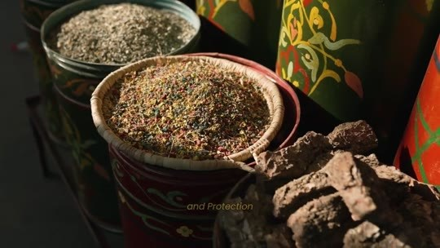  📷 15:55 — Tigelas com especiarias (mirra, canela); legenda 'and protection'  b06_especiarias_mirra_canela_tigelas_00-15-55.jpg

THERESA CAPUTO (narradora): O segundo ingrediente é o olíbano, chamado de incenso na Bíblia, Mateus 2:11, os presentes dos Magos, e Êxodo 30:34. "E, entrando na casa, ofereceram-lhe presentes: ouro, incenso e mirra." O olíbano é usado há mais de 5.000 anos porque tem uma propriedade biológica única. Ele reduz a inflamação no cérebro e eleva a vibração espiritual. Isso permite que as frequências emitidas pela glândula pineal fiquem mais fortes e cheguem aonde precisam chegar para atrair os seus desejos. Eles o deram a Jesus como símbolo da união dele com o Pai. Minha avó usava o extrato sagrado dessa resina na receita. Ela costumava dizer que ele transforma a nossa oração em fumaça que sobe direto até o nariz de Deus. O 3º e o 4º ingredientes são para blindagem e proteção espiritual.

6.3 ⏱ 15:55 → 16:31
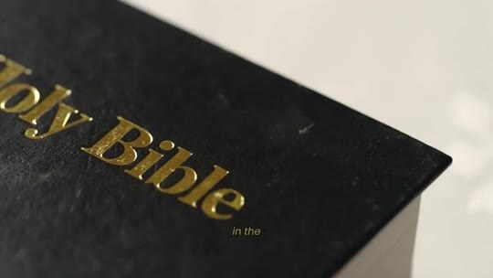  📷 16:04 — Capa 'Holy Bible'; legenda 'in the'  b06_holy_bible_capa_preta_00-16-04.jpg | 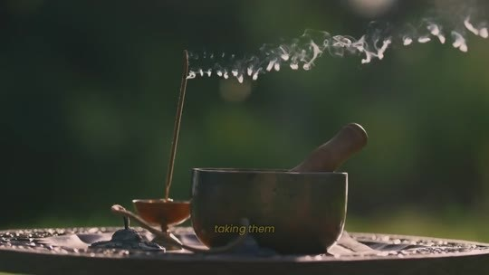  📷 16:15 — Óleo de unção em tigela de pedra; legenda 'taking them'  b06_oleo_uncao_tigela_00-16-15.jpg
  📷 16:22 — Mulher com aura de luz na rua; legenda 'barrier'  b06_mulher_escudo_luz_rua_00-16-22.jpg |   📷 16:26 — Mulher encolhida no chão; legenda 'mind'  b06_mulher_encolhida_chao_00-16-26.jpg

📷 16:31 — Casa com escudo dourado; legenda 'these years'
b06_casa_escudo_dourado_these_years_00-16-31.jpg

THERESA CAPUTO (narradora): Em Êxodo, capítulo 30, versículos 22 a 25: "Toma as melhores especiarias, mirra e canela, e faze delas o óleo sagrado da unção." Na Bíblia, quando algo era ungido com esse óleo, tornava-se santo, ou seja, separado, protegido do mal. Nada impuro podia tocá-lo. Ao combinar mirra e canela e tomá-las, você não apenas unge o seu corpo por fora, você blinda a sua glândula pineal por dentro. Esses ingredientes criam uma barreira. Eles impedem que a toxicidade do mundo toque a sua mente. É isso que manteve a minha família espiritualmente intocável durante todos esses anos.

BLOCO 7 — AS PRIMEIRAS CURAS: Clarice (18 libras em 2 semanas) e Amanda ($33.000 de dívida e a herança) [16:31 – 17:59]

7.1 ⏱ 16:31 → 17:17
  📷 16:35 — Theresa Caputo em sala com família; legenda 'inner circle'  b07_theresa_sala_familia_inner_circle_00-16-35.jpg |   📷 16:39 — Cidade com letreiros luminosos; legenda 'prosperity'  b07_cidade_letreiros_tokyo_00-16-39.jpg
  📷 16:41 — Theresa Caputo em estúdio; legenda 'couldn't refuse'  b07_theresa_estudio_couldnt_refuse_00-16-41.jpg |   📷 16:57 — Clarice e marido sentados à mesa; legenda 'remember'  b07_clarice_casal_sentados_00-16-57.jpg
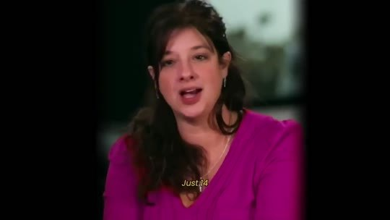  📷 17:08 — Clarice de blusa rosa em depoimento; legenda 'Just 14'  b07_clarice_depoimento_blusa_rosa_00-17-08.jpg | 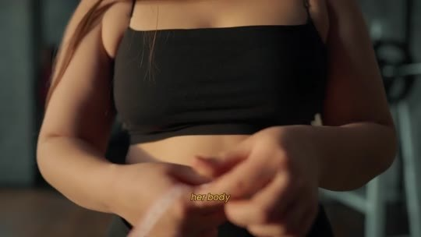  📷 17:13 — Mulher de top preto mostrando a barriga; legenda 'her body'  b07_mulher_top_preto_barriga_00-17-13.jpg

THERESA CAPUTO (narradora): Por anos, isso ficou restrito ao meu círculo mais íntimo. Era o nosso segredo para manter a energia alta e a prosperidade fluindo, independentemente do que estivesse acontecendo no mundo. Mas houve momentos em que eu não pude me recusar a ajudar. Vi mulheres chegando até mim em situações tão desesperadoras, com a energia tão bloqueada, que eu sabia que nenhuma palavra minha seria suficiente. Então, discretamente, comecei a compartilhar uma pequena quantidade desse elixir com algumas delas. Eu me lembro da Clarice. Ela estava no fundo do poço, lutando contra o peso e uma tristeza que nunca passava. O corpo dela parecia travado, inchado de energia pesada. Dei a ela acesso à nossa receita. Apenas 14 dias depois, ela voltou uma mulher diferente. A glândula pineal dela tinha se limpado, o corpo liberou a inflamação, e ela começou a manifestar a perda de peso naturalmente.

7.2 ⏱ 17:18 → 17:59
  📷 17:18 — Clarice em selfie no espelho mostrando calça larga; legenda 'naturally'  b07_clarice_selfie_espelho_calca_larga_00-17-18.jpg | 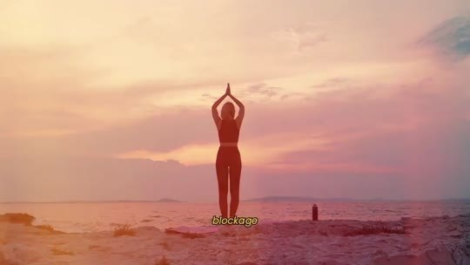  📷 17:26 — Mulher fazendo yoga ao pôr do sol; legenda 'blockage'  b07_mulher_yoga_por_do_sol_00-17-26.jpg
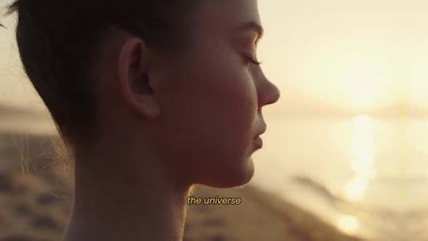  📷 17:43 — Mulher olhando o horizonte; legenda 'the universe'  b07_mulher_olhando_horizonte_the_universe_00-17-43.jpg |   📷 17:49 — Máquina de cartão sobre a mesa; legenda 'the amount'  b07_maquina_cartao_the_amount_00-17-49.jpg
  📷 17:52 — Cartão dourado na máquina; legenda 'exact debt'  b07_cartao_dourado_maquina_00-17-52.jpg |   📷 17:55 — Mãos contando notas de dólar; legenda 'the money'  b07_maos_contando_dolares_00-17-55.jpg

THERESA CAPUTO (narradora): Ela perdeu 18 libras em 2 semanas, porque a ansiedade que a fazia comer demais desapareceu junto com o bloqueio espiritual. E depois teve a Amanda. A história dela partiu o meu coração. Ela tinha $33.000 em dívidas médicas, não dormia bem havia meses e sofria crises de ansiedade quase todos os dias. Ela começou a usar o elixir sagrado. Limpou a sua ponte com Deus e entregou o problema ao universo. Algumas semanas depois, chegou um dinheiro inesperado de uma herança distante que ela nem sabia que existia. O valor cobriu exatamente a dívida e trouxe a paz de volta à vida dela. Não foi um milagre, foi conexão. O dinheiro e a saúde sempre estiveram ali, esperando por elas. A ponte delas com Deus finalmente tinha sido reconstruída.

BLOCO 8 — TAYLOR SWIFT: o episódio especial, Travis Kelce, a carta do Vaticano e as fitas apagadas [18:00 – 19:50]

8.1 ⏱ 18:00 → 18:42
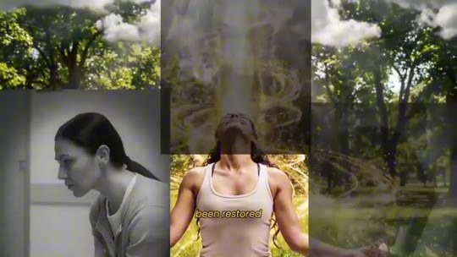  📷 18:00 — Colagem de mulheres (meditando, sorrindo); legenda 'been restored'  b08_colagem_mulheres_been_restored_00-18-00.jpg | 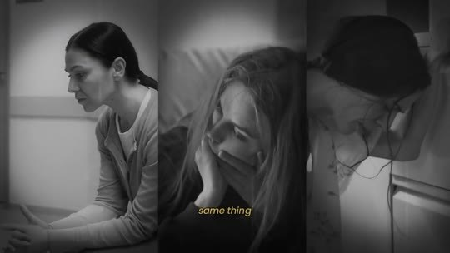  📷 18:03 — Mulheres em preto e branco; legenda 'same thing'  b08_mulheres_pb_same_thing_00-18-03.jpg
  📷 18:10 — Theresa Caputo nos bastidores da gravação; legenda 'the'  b08_theresa_bastidores_gravacao_00-18-10.jpg |   📷 18:22 — Taylor Swift com namorado, coração partido e efeito glitch; legenda 'relationships were'  b08_taylor_swift_coracao_partido_glitch_00-18-22.jpg
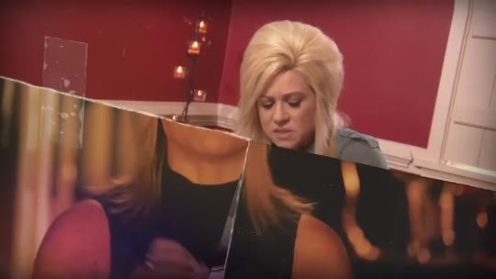  📷 18:29 — Theresa Caputo lendo o mapa de cliente em sala vermelha; legenda 'that this'  b08_theresa_lendo_mapa_cliente_00-18-29.jpg | 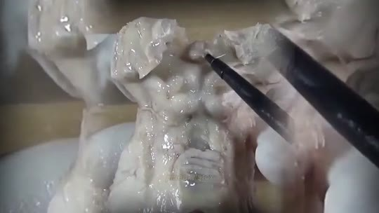  📷 18:32 — Cérebro de argila sendo raspado; legenda 'pineal'  b08_cerebro_argila_pineal_detox_00-18-32.jpg
  📷 18:36 — Taylor Swift dançando de casaco verde; legenda 'and what'  b08_taylor_swift_dancando_casaco_verde_00-18-36.jpg |   📷 18:38 — Taylor Swift ensaiando em estúdio; legenda 'the inspiration'  b08_taylor_swift_ensaio_estudio_00-18-38.jpg

📷 18:41 — Taylor Swift no palco com vestido branco e dançarinos; legenda 'she manifested'
b08_taylor_swift_palco_vestido_branco_00-18-41.jpg

THERESA CAPUTO (narradora): Quando percebi quantas pessoas estavam passando pela mesma coisa, senti que esse detox precisava ser compartilhado. Eu estava prestes a revelar isso ao mundo no meu programa, mas algo maior me impediu. Há algum tempo, gravei um episódio especial com a Taylor Swift. Ela chegou até mim no pior momento da carreira e da vida pessoal. O público dela estava encolhendo, contratos de shows estavam sendo cancelados e os relacionamentos dela estavam fracassando. Depois de ler o mapa dela, vi que aquilo era um detox espiritual, nem perto do que estava destinado à vida dela. Todas as bênçãos dela estavam bloqueadas. Eu sabia, energeticamente, que ela precisava de um detox pineal. Ela confiou em mim. Seguiu o protocolo, e o que aconteceu depois o mundo inteiro viu. Pouco depois que começamos a limpeza, a energia dela mudou. A inspiração voltou.

8.2 ⏱ 18:42 → 19:25
  📷 18:46 — Show da Taylor Swift com palco de cristais; legenda 'sold-out'  b08_taylor_swift_show_palco_cristais_00-18-46.jpg |   📷 18:48 — TV 'Breaking News: Taylor Swift and Travis Kelce are engaged'; legenda 'Travis Kelce'  b08_breaking_news_taylor_swift_travis_kelce_engaged_00-18-48.jpg
  📷 18:54 — Taylor Swift com dançarinos; legenda 'documented'  b08_taylor_swift_dancarinos_documented_00-18-54.jpg |   📷 19:00 — Fundo preto; lettering 'THE PROGRAM WAS STOPPED'  b08_lettering_the_program_was_stopped_00-19-00.jpg
  📷 19:02 — Casal no tapete do Breakthrough Prize; legenda 'influential and'  b08_casal_breakthrough_prize_tapete_00-19-02.jpg |   📷 19:04 — Jeff Bezos e Lauren Sánchez no Breakthrough Prize; legenda 'want any'  b08_jeff_bezos_lauren_sanchez_breakthrough_prize_00-19-04.jpg
  📷 19:09 — Envelopes com lacre de cera vermelha; legenda 'letter from'  b08_cartas_lacre_vermelho_vaticano_00-19-09.jpg |   📷 19:16 — Theresa Caputo na cozinha; legenda 'deleted the'  b08_theresa_cozinha_apagou_fitas_00-19-16.jpg
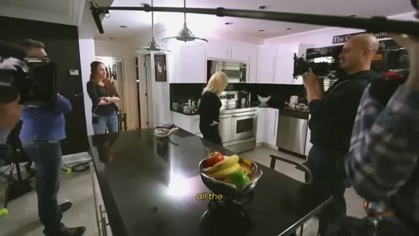  📷 19:18 — Bastidores de gravação na cozinha com cinegrafista; legenda 'all the'  b08_bastidores_camera_cozinha_00-19-18.jpg |   📷 19:25 — Bastidores de entrevista com câmeras; legenda 'recorded'  b08_bastidores_entrevista_cameras_00-19-25.jpg

THERESA CAPUTO (narradora): Ela manifestou milhões, turnês esgotadas e, além de tudo isso, encontrou a sua alma gêmea. Travis Kelce. Travis Kelce, com quem ela agora está noiva. Tudo isso foi gravado e documentado, e planejávamos compartilhar a história completa daquela transformação. Mas, infelizmente, o programa foi impedido de ir ao ar. Pessoas influentes e poderosas não queriam que nenhuma emissora de TV transmitisse essa informação ao mundo. Uma carta do próprio Vaticano chegou até mim, me acusando de espalhar heresias e mentiras sobre o conhecimento divino. E então, sem o meu conhecimento, alguém da minha equipe de produção apagou as fitas. Apagou todos os arquivos que tínhamos gravado. O único arquivo que ainda temos é este, gravado no celular de uma amiga que convidei para assistir aos bastidores da filmagem.

8.3 ⏱ 19:25 → 19:50
  📷 19:28 — Theresa Caputo na cozinha; legenda 'shook me'  b08_theresa_cozinha_shook_me_00-19-28.jpg |   📷 19:33 — Theresa Caputo em sessão com casal à mesa; legenda 'women'  b08_theresa_mesa_casal_sessao_00-19-33.jpg
  📷 19:37 — Theresa Caputo anotando em caderno; legenda 'promise'  b08_theresa_bastidores_anotando_promise_00-19-37.jpg | 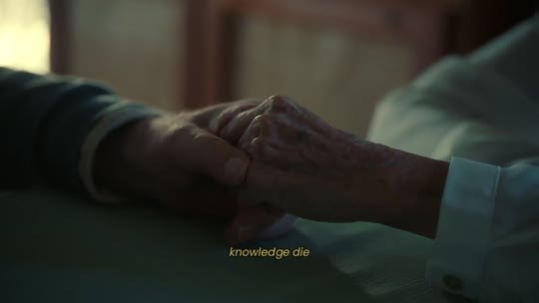  📷 19:42 — Mãos de idosa; legenda 'knowledge die'  b08_maos_idosa_knowledge_die_00-19-42.jpg

THERESA CAPUTO (narradora): Por um momento, tudo isso me abalou profundamente. Pensei em esquecer tudo e deixar essa história para trás. Mas então me lembrei de todas as mulheres cujas vidas foram mudadas por essa solução e da transformação que ela causou. Acima de tudo, lembrei da promessa que fiz à minha avó de não deixar esse conhecimento morrer. Foi aí que entendi que eu não podia mais guardar isso só para mim como uma tradição de família. Eu tinha uma obrigação espiritual de ajudar mais pessoas a despertar.

BLOCO 9 — A MISSÃO: a nuvem de energia negativa, a raiva e 'não é justo que só as celebridades tenham acesso' [19:51 – 21:29]

9.1 ⏱ 19:51 → 20:35

📷 19:51 — Theresa Caputo em estúdio; legenda 'you see'
b09_theresa_estudio_you_see_00-19-51.jpg

THERESA CAPUTO (narradora): Veja bem, eu viajo pelo país inteiro, e o que tenho notado é alarmante. Todas as coisas ruins que vêm acontecendo no mundo nas últimas décadas não são aleatórias. Elas estão conectadas a uma nuvem de energia negativa que a maioria das pessoas sente, mas não consegue explicar. A falta de direção na vida, o cansaço constante que nenhuma noite de sono resolve, a sensação de vazio que muitos carregam no peito, tudo isso está conectado. As pessoas perderam a conexão com a própria mente e com o divino. Elas não veem mais sentido ou propósito na vida, e, à medida que essa desconexão se espalha, o caos e o desespero crescem ao nosso redor. Entendi naquele momento que, quanto mais pessoas limparem e reativarem a glândula pineal, mais mudança real poderemos trazer ao mundo. Um mundo onde as pessoas sejam livres para manifestar os seus desejos em vez de aceitar migalhas.

9.2 ⏱ 20:36 → 21:20
  📷 20:36 — Theresa Caputo em estúdio, expressão indignada; legenda 'crumbs'  b09_theresa_estudio_anger_00-20-36.jpg |   📷 20:43 — Theresa Caputo meditando com lavanda e incenso; legenda 'anger because'  b09_theresa_meditando_lavanda_incenso_00-20-43.jpg
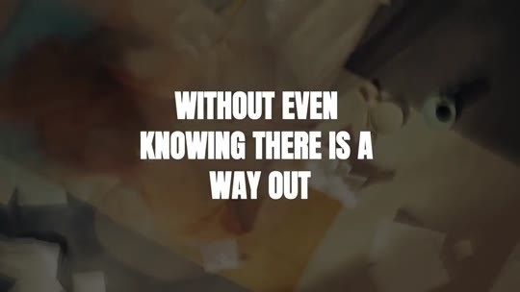  📷 21:06 — Lettering 'WITHOUT EVEN KNOWING THERE IS A WAY OUT'  b09_lettering_without_even_knowing_there_is_a_way_out_00-21-06.jpg |   📷 21:08 — Theresa Caputo em estúdio; legenda 'only celebrities'  b09_theresa_only_celebrities_00-21-08.jpg
  📷 21:18 — Theresa Caputo com a avó na rua; legenda 'my grandmother'  b09_theresa_com_avo_rua_00-21-18.jpg |   📷 21:20 — Lettering 'WITHOUT EXPECTING FINANCIAL RETURN'  b09_lettering_without_expecting_financial_return_00-21-20.jpg

THERESA CAPUTO (narradora): Um mundo onde não sejamos mais marionetes de forças ocultas que lucram com a nossa doença e a nossa tristeza. E foi aí que senti raiva. Raiva porque tentaram me pressionar a esconder a verdade de você. Senti fúria por nós, por vivermos sob a ilusão de que estamos no controle, quando na verdade fomos enganadas o tempo todo. Eles queriam que eu fosse cúmplice dessa manipulação que rouba o nosso poder de escolha desde o nascimento. Somos tratadas como peças que alimentam um sistema que nos mantém presas num ciclo infinito de escassez, medo e contas a pagar, sem nem saber que existe uma saída. Não era justo que só as celebridades que me pagam milhões de dólares tivessem acesso a essa limpeza pineal. Senti que o meu propósito era levar isso ao maior número de pessoas possível. Minha avó me disse para compartilhar isso com o máximo de pessoas que eu pudesse, sem esperar retorno financeiro.

9.3 ⏱ 21:20 → 21:29

📷 21:29 — Mão escrevendo com caneta azul; legenda 'a different'
b09_mao_escrevendo_caneta_azul_00-21-29.jpg

THERESA CAPUTO (narradora): Isso era sobre libertar o máximo de pessoas possível, dando a cada uma de nós a chance de reescrever o próprio destino, assumir o controle da vida e manifestar uma realidade diferente.

BLOCO 10 — APRESENTAÇÃO DO SOUL FLUSH: a fórmula bíblica, ingredientes de Galileia, Etiópia, Sinai e Ceilão [21:29 – 23:16]

10.1 ⏱ 21:29 → 22:12
  📷 21:32 — Logo 'Soul Flush Drops' com olho dourado; legenda 'soul flush'  b10_logo_soul_flush_drops_00-21-32.jpg |   📷 21:37 — Família no sofá com lavanda e incenso; legenda 'protect our'  b10_familia_sofa_lavanda_incenso_00-21-37.jpg
  📷 21:42 — Theresa Caputo em estúdio; legenda 'formula'  b10_theresa_estudio_formula_00-21-42.jpg | 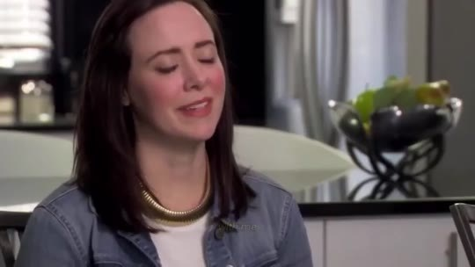  📷 21:46 — Mulher de jaqueta jeans de olhos fechados; legenda 'consult with'  b10_mulher_jaqueta_jeans_olhos_fechados_00-21-46.jpg
  📷 21:49 — Notas de dólar sobre prato na mesa; legenda 'and attract'  b10_dolares_prato_mesa_00-21-49.jpg |   📷 21:52 — Casal abraçado sorrindo; legenda 'even if'  b10_casal_abracado_sorrindo_00-21-52.jpg
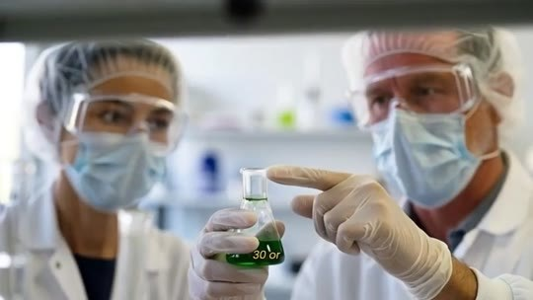  📷 21:56 — Cientistas de máscara em laboratório; legenda 'so for'  b10_cientistas_laboratorio_mascara_00-21-56.jpg |   📷 22:00 — Mulher usando conta-gotas na cama; legenda 'for the moment, you start'  b10_mulher_conta_gotas_cama_00-22-00.jpg
  📷 22:03 — Cérebro holográfico com linhas; legenda 'reactivate'  b10_cerebro_holografico_linhas_00-22-03.jpg |   📷 22:10 — Frasco Soul Flush sobre mesa com velas; legenda 'Soul Flush is not a simple medication'  b10_frasco_soul_flush_mesa_velas_00-22-10.jpg

THERESA CAPUTO (narradora): Então é por isso que hoje quero que você conheça o Soul Flush. Essa fórmula sagrada é algo que a minha família e eu sempre usamos para proteger a nossa mente e manter níveis elevados de consciência e conexão com Deus. É exatamente a fórmula que venho compartilhando nos bastidores com celebridades e com as mulheres que se consultam comigo, para que possam ativar a intuição e atrair sucesso, dinheiro e até o homem que desejam. Mesmo que você tenha sido sabotada por… No momento em que você começa a usar o Soul Flush, você vai limpar, desintoxicar e reativar a sua glândula pineal, e então destravar o seu verdadeiro poder mental e espiritual. O Soul Flush não é um simples medicamento ou suplemento.

10.2 ⏱ 22:13 → 23:16
  📷 22:33 — Papa na sacada do Vaticano; legenda 'the vatican'  b10_papa_sacada_vaticano_00-22-33.jpg | 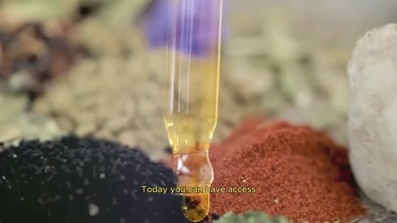  📷 22:36 — Conta-gotas sobre especiarias; legenda 'Today you can have access'  b10_conta_gotas_especiarias_00-22-36.jpg
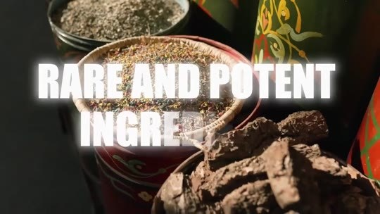  📷 22:41 — Especiarias; lettering 'RARE AND POTENT INGREDIENTS'  b10_lettering_rare_and_potent_ingredients_00-22-41.jpg |   📷 22:43 — Monges colhendo ervas sob a lua crescente; legenda 'I made a'  b10_monges_colhendo_ervas_lua_00-22-43.jpg
  📷 22:52 — Flores roxas; lettering 'HYSSOP'  b10_lettering_hyssop_lavanda_00-22-52.jpg | 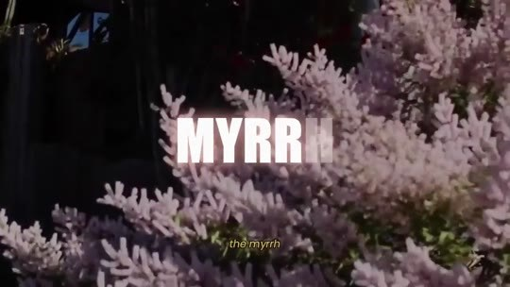  📷 22:58 — Flores brancas; lettering 'MYRRH'  b10_lettering_myrrh_00-22-58.jpg
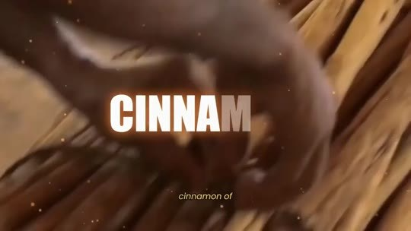  📷 23:01 — Canela em pau; lettering 'CINNAMON'  b10_lettering_cinnamon_00-23-01.jpg |   📷 23:12 — Lótus cósmico com raio de luz; legenda 'absolute mental'  b10_lotus_cosmico_absolute_mental_00-23-12.jpg

THERESA CAPUTO (narradora): É uma fórmula encontrada na Bíblia que foi escondida de você até hoje para cortar a sua conexão com Deus e te manter dependente do sistema. O Soul Flush é um desintoxicante poderoso. Do sistema que eles criaram. Mas agora essa fórmula está sendo comprovada pelos estudos científicos mais recentes sobre a função biológica da glândula pineal. A diferença agora é que esse segredo não está mais restrito às elites, ao Vaticano ou a gurus espirituais intocáveis. Hoje você pode ter acesso à mesma fórmula Soul Flush, cuidadosamente recriada com ingredientes raros e potentes. Fiz questão de selecionar ingredientes dos solos mais energéticos e sagrados do planeta, onde a contaminação por poluentes nem chega perto. O hissopo das montanhas da Galileia, em Israel, o olíbano dos altos monastérios da Etiópia, a mirra do Monte Sinai, no Egito, e a canela do Ceilão, cada ingrediente colhido à mão durante ciclos lunares específicos, projetados para fazer uma coisa só: quebrar a crosta de flúor da sua pineal e religar a sua conexão com o Criador. O resultado? Clareza mental absoluta, intuição afiada e a capacidade real de manifestar os seus desejos mais profundos.

BLOCO 11 — ESTÁGIO 1 — PURIFICAÇÃO DO TEMPLO (7 dias): calafrios, o rádio desliga, sono de bebê + depoimento de Mary [23:17 – 25:12]

11.1 ⏱ 23:17 → 24:00
  📷 23:17 — Mãos com luz; lettering 'MANIFEST YOUR DEEPEST DESIRES'  b11_lettering_manifest_your_deepest_desires_00-23-17.jpg |   📷 23:24 — Mulher meditando entre nuvens escuras; legenda 'the reaction'  b11_mulher_meditando_nuvens_escuras_00-23-24.jpg
  📷 23:27 — Perfil de mulher com cérebro dourado e cosmos; legenda 'the reconnection'  b11_mulher_cerebro_dourado_cosmos_00-23-27.jpg | 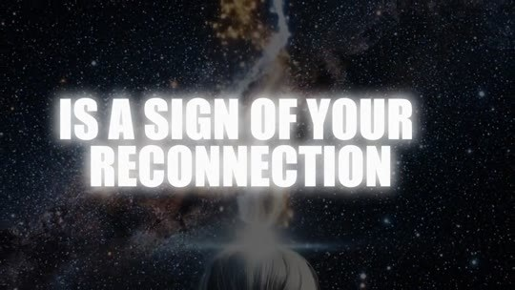  📷 23:52 — Lettering 'IS A SIGN OF YOUR RECONNECTION'  b11_lettering_is_a_sign_of_your_reconnection_00-23-52.jpg

📷 24:00 — Lettering 'AN ANGEL WERE PROTECTING YOUR SLEEP'
b11_lettering_an_angel_were_protecting_your_sleep_00-24-00.jpg

THERESA CAPUTO (narradora): Quero que você imagine como será acordar no seu corpo daqui a alguns dias, porque, quando esses ingredientes bíblicos tocam o seu sistema, a reação é rápida. A reconexão da sua ponte com Deus acontece em 3 estágios. Estágio 1, a purificação do templo. Nos primeiros 7 dias com o Soul Flush, a percepção de mudança é quase imediata. Assim que o hissopo começa a agir e a varrer o flúor que está bloqueando a sua pineal, algumas sensações vão acontecer. Você pode sentir calafrios na nuca. Se isso acontecer, não tenha medo. É um sinal da sua reconexão com Deus. Isso é muito profundo. Você vai sentir uma sensação de segurança, como se um guarda-costas estivesse sempre com você ao longo do dia, e como se um anjo protegesse o seu sono durante a noite.

11.2 ⏱ 24:00 → 24:42
  📷 24:03 — Mulher com a mão na cabeça (ruído mental); legenda 'full of'  b11_mulher_mao_na_cabeca_ruido_00-24-03.jpg |   📷 24:11 — Mulher dormindo tranquila; legenda 'restorative again'  b11_mulher_dormindo_restorative_00-24-11.jpg
  📷 24:19 — Mulher caminhando na cidade em tom dourado; legenda 'vital energy'  b11_mulher_rua_cidade_luz_dourada_00-24-19.jpg | 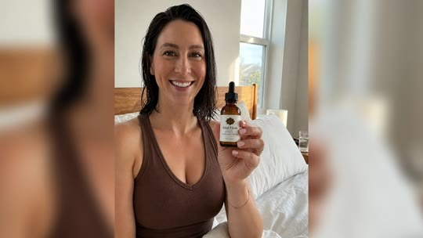  📷 24:37 — Mary (depoimento) segurando frasco Soul Flush; legenda 'decided to'  b11_mary_depoimento_frasco_soul_flush_00-24-37.jpg

📷 24:42 — Mary com bebê no colo falando à câmera; legenda 'first week'
b11_mary_com_bebe_colo_00-24-42.jpg

THERESA CAPUTO (narradora): Sabe aquele rádio ligado na sua cabeça, cheio de preocupação e barulho 24 horas por dia? Ele desliga. Você vai deitar na cama e apagar. O sono volta a ser profundo e restaurador. Sono de bebê. Você acorda leve e com uma energia vital que não sentia há anos. Aqui, o peso já saiu dos seus ombros. E fiquei emocionada quando recebi esta mensagem da minha querida amiga Mary.
MARY (depoimento): Eu estava exausta, presa numa rotina de trabalho enquanto cuidava do meu filho pequeno, sem energia, sem clareza mental e sem conseguir dormir direito. Uma amiga me falou do Soul Flush e, mesmo cética, decidi experimentar. Na primeira semana, senti mudanças profundas. Finalmente dormi a noite inteira, acordei com a mente clara e mais foco. Mas o que realmente me marcou foi um sonho que tive alguns dias depois.

11.3 ⏱ 24:42 → 25:12
  📷 25:01 — Frasco Soul Flush sobre mesa com pedras e velas; legenda 'Soul Flush'  b11_frasco_soul_flush_mesa_pedra_00-25-01.jpg |   📷 25:03 — Mary com bebê no colo; legenda 'I can't risk'  b11_mary_bebe_colo_i_cant_risk_00-25-03.jpg

MARY (depoimento): Sonhei com um acidente de carro, muito real, com todos os detalhes. Acordei apavorada, e no fundo eu sabia que não era só um sonho. Alguns dias depois, quando estava prestes a entrar num carro que eu tinha reservado, a cena do sonho se repetiu. Meus instintos me pararam, e decidi não entrar. Mais tarde, vi no noticiário que aquele mesmo carro tinha se envolvido num acidente grave, exatamente como no meu sonho. Foi aí que entendi que o Soul Flush não transformou só a minha mente, ele pode ter salvado a minha vida e a do meu filho. Depois disso, comprei mais frascos. Não posso correr o risco de ficar sem. Minha energia, meu foco e minha intuição estão em outro nível.

BLOCO 12 — ESTÁGIO 2 — CONEXÃO COM A FONTE: o olíbano eleva a frequência, intuição afiada + depoimento da primeira casa [25:12 – 26:42]

12.1 ⏱ 25:12 → 25:55
  📷 25:17 — Theresa Caputo em estúdio; legenda 'physical therapy'  b12_theresa_estudio_stage_2_00-25-17.jpg | 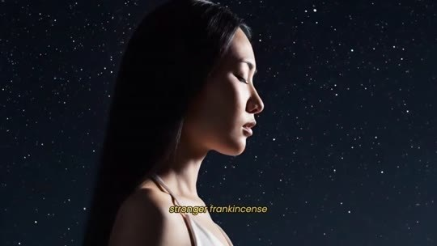  📷 25:27 — Mulher de perfil sob estrelas; legenda 'stronger frankincense'  b12_mulher_perfil_estrelas_frankincense_00-25-27.jpg
  📷 25:39 — Papa com turíbulo de incenso na missa; legenda 'to god'  b12_papa_incenso_missa_00-25-39.jpg | 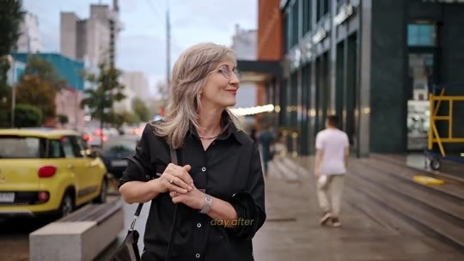  📷 25:44 — Mulher sorrindo na rua; legenda 'until you'  b12_mulher_sorrindo_rua_carro_amarelo_00-25-44.jpg

📷 25:55 — Mulher no celular na varanda; legenda 'person calls'
b12_mulher_celular_varanda_calls_00-25-55.jpg

THERESA CAPUTO (narradora): Estágio 2, a conexão com a fonte. Nas semanas seguintes, com o templo limpo, o olíbano começa a elevar a sua frequência. É aqui que a mágica começa a ficar visível. Imagine que a sua pineal é como um músculo lesionado que precisa de fisioterapia para ficar mais forte. O olíbano faz a sua pineal voltar a vibrar mais forte. Ele leva os seus pedidos e orações até Deus. Esse ingrediente sempre foi usado pela igreja como incenso, como a fumaça que sobe e leva os nossos pedidos a Deus. Você vai notar que as coisas param de dar errado e começam a fluir. Dia após dia, uma coisa diferente acontece e começa a te surpreender, até você ver que não é coincidência, e sim a sua reconexão com Deus sendo… A sua intuição fica afiada.

12.2 ⏱ 25:55 → 26:42
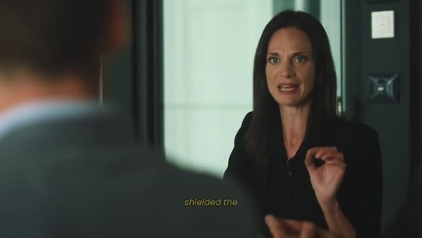  📷 26:09 — Mulher de blazer no escritório; legenda 'shielded the'  b12_mulher_escritorio_shielded_00-26-09.jpg |   📷 26:18 — Cérebro holográfico azul; legenda 'catching'  b12_cerebro_holografico_catching_00-26-18.jpg
  📷 26:22 — Lettering 'WHAT YOU ASK FOR ARRIVES'  b12_lettering_what_you_ask_for_arrives_00-26-22.jpg | 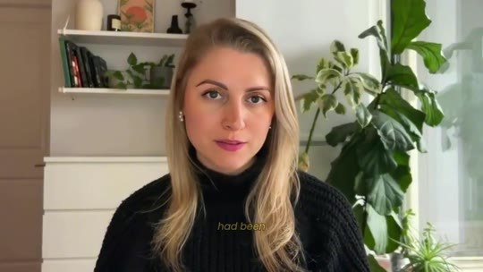  📷 26:28 — Mulher loira de suéter preto em depoimento; legenda 'had been'  b12_depoimento_mulher_loira_primeira_casa_00-26-28.jpg
  📷 26:38 — Theresa Caputo abraçando cliente; legenda 'blocking us'  b12_theresa_abraco_cliente_blocking_us_00-26-38.jpg | 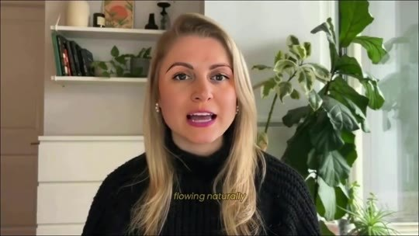  📷 26:41 — Mulher loira em depoimento; legenda 'flowing naturally'  b12_depoimento_loira_flowing_naturally_00-26-41.jpg

THERESA CAPUTO (narradora): Você pensa em alguém, a pessoa liga. Você é alertada em sonhos quando algo ruim está prestes a acontecer com você. Você precisa de uma solução financeira, e a ideia aparece claramente na sua mente. Enquanto todo mundo no seu trabalho pega um resfriado forte, você parece blindada. A névoa do azar sumiu. Você sente que Deus está te ouvindo na primeira chamada. É o sinal de que a sua antena está ligada e captando as boas vibrações. Captando a frequência da abundância. O que você pede chega.
MULHER (depoimento, primeira casa): O Soul Flush ajudou uma cética em técnicas de manifestação como eu a comprar a minha primeira casa. Minha vida estava travada havia anos, sem ir a lugar nenhum. Meu marido estava desempregado e deprimido, até que a Theresa apareceu como um anjo na minha vida e me mostrou o que realmente estava nos bloqueando. Depois do Soul Flush, tudo começou a fluir naturalmente para nós financeiramente.

BLOCO 13 — ESTÁGIO 3 — ESCUDO SAGRADO (6 meses): imune ao fluoreto, conselho de amiga, John ($400.000) e Brenda (diabetes) [26:42 – 28:58]

13.1 ⏱ 26:42 → 27:30
  📷 26:43 — Mulher com luz na cabeça; lettering 'Stage 3:'  b13_lettering_stage_3_mulher_luz_00-26-43.jpg |   📷 26:57 — Perfil com cérebro iluminado em laranja; legenda 'six months'  b13_cerebro_laranja_perfil_six_months_00-26-57.jpg
  📷 27:14 — Pasta de dente sendo colocada na escova; legenda 'times as'  b13_pasta_de_dente_escova_00-27-14.jpg |   📷 27:18 — Mulher escovando os dentes; legenda 'doesn't just'  b13_mulher_escovando_dentes_00-27-18.jpg

THERESA CAPUTO (narradora): Estágio 3, o Escudo Sagrado. É aqui que você se torna intocável. Na Bíblia, tudo o que era tocado pela mirra e pela canela era sinal de algo que se tornava intocável. É por isso que os reis eram ungidos com esses ingredientes. Depois dos 6 meses, a mirra e a canela criam uma camada de proteção em volta da sua pineal. O flúor, que antes era energeticamente atraído pela sua glândula pineal, não consegue mais penetrar essa barreira. Você pode beber 4, 8 ou até 20 copos d'água por dia e escovar os dentes quantas vezes quiser. Não importa. Você está imune ao flúor. Você não manifesta só uma vez, você vive em estado de graça. Imagine que é como se uma tempestade estivesse acontecendo lá fora, mas você está em casa debaixo de um cobertor, aquecida, protegida, se sentindo segura.

13.2 ⏱ 27:30 → 28:18
  📷 27:36 — Loja de móveis; legenda 'dream house'  b13_loja_moveis_dream_house_00-27-36.jpg |   📷 27:41 — Theresa abraçando cliente; lettering 'And here is my advice as a friend'  b13_lettering_and_here_is_my_advice_as_a_friend_00-27-41.jpg
  📷 27:43 — Theresa Caputo em programa (Access Hollywood); legenda 'after more'  b13_theresa_access_hollywood_sofa_00-27-43.jpg |   📷 27:45 — Theresa Caputo no Kelly Clarkson Show; legenda 'psychic gifts'  b13_theresa_kelly_clarkson_show_psychic_gifts_00-27-45.jpg
  📷 27:52 — Frasco Soul Flush em fundo dourado; legenda 'essential'  b13_frasco_soul_flush_fundo_dourado_00-27-52.jpg |   📷 27:58 — Celebridades no Met Gala em tom dourado; legenda 'people chose'  b13_met_gala_celebridades_dourado_00-27-58.jpg
  📷 28:03 — Frasco Soul Flush sobre mesa com lamparina; legenda 'unlocked their'  b13_frasco_soul_flush_mesa_lamparina_00-28-03.jpg | 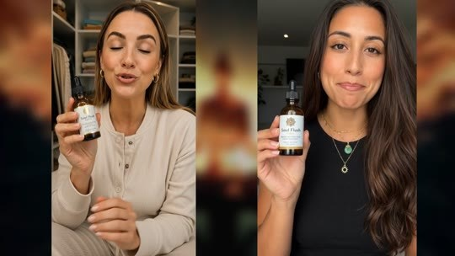  📷 28:18 — Tela dividida: duas mulheres segurando frascos Soul Flush; legenda 'Divine Purity'  b13_duas_mulheres_depoimento_frascos_split_00-28-18.jpg

THERESA CAPUTO (narradora): A inveja bate e volta. Más notícias não abalam a sua vibração. A prosperidade vira rotina. Quando você menos espera, está escolhendo os móveis da casa dos sonhos que sempre quis. E aqui vai o meu conselho de amiga. Depois de mais de 20 anos trabalhando com os meus dons psíquicos, senti a energia de milhares de mulheres, e é por isso que me sinto segura em dizer que o Soul Flush se tornou essencial. O bloqueio da sua pineal vem te afastando de bênçãos que deveriam ter chegado até você há muito tempo. Como você pode ver, várias pessoas escolheram o Soul Flush e destravaram a vida, e não porque sejam especiais ou algo assim, mas porque tomaram a decisão inteligente de continuar com o Divine Purity por pelo menos 6 meses. Muitas pessoas que viviam endividadas, depois de 6 meses, estão conseguindo caminhar para uma vida mais próspera, manifestando o futuro que sempre desejaram.

13.3 ⏱ 28:18 → 28:58
  📷 28:32 — Close do frasco 'Soul Flush Drops'; legenda 'prosperous life'  b13_frasco_soul_flush_drops_close_00-28-32.jpg |   📷 28:39 — Theresa Caputo em estúdio; legenda 'business'  b13_theresa_estudio_john_business_00-28-39.jpg
  📷 28:45 — Brenda (depoimento, diabetes) falando à câmera na cozinha; legenda 'went back'  b13_brenda_depoimento_cozinha_00-28-45.jpg | 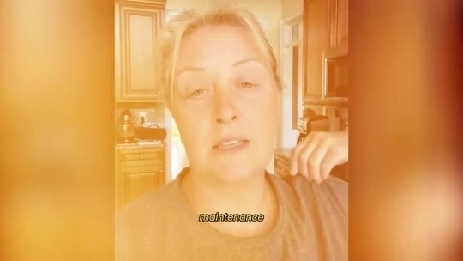  📷 28:58 — Brenda na cozinha em tom laranja; legenda 'maintenance'  b13_brenda_cozinha_maintenance_00-28-58.jpg

THERESA CAPUTO (narradora): Olhe esta foto que recebi do John depois que ele usou o Soul Flush. Este é o John. Ele trabalhava num escritório de contabilidade, estava endividado e tinha perdido a casa 8 meses antes. Depois que escolheu o Soul Flush para cuidar da glândula pineal por 8 meses, ele recebeu $400.000 depois de sonhar em encontrar… Ele usou o dinheiro para pagar as dívidas e abrir o próprio negócio, e hoje a família dele tem a vida que merece. Ou histórias ainda mais bonitas, como a da Brenda.
BRENDA (depoimento, diabetes tipo 2): Voltei ao médico depois de começar o Soul Flush. Ele não tinha explicação. Meu diabetes tipo 2 estava sob controle. Não cortei açúcar nem mudei a dieta. O médico suspendeu a minha insulina e manteve só um remédio de manutenção.

BLOCO 14 — OFERTA: 6 meses, 1 conta-gotas por dia, $50.000 / $1.000 / $500 e os 6 frascos a $49 ($1,63 por dia) [28:58 – 31:01]

14.1 ⏱ 28:58 → 29:41
  📷 29:04 — Theresa Caputo em estúdio; legenda 'family's lives'  b14_theresa_estudio_familys_lives_00-29-04.jpg |   📷 29:12 — Mulher preocupada com a mão no rosto; legenda 'you make'  b14_mulher_preocupada_you_make_00-29-12.jpg
  📷 29:17 — Mulher pingando conta-gotas na boca; legenda 'before sleep'  b14_mulher_conta_gotas_lingua_00-29-17.jpg |   📷 29:28 — Cérebro azul e dourado; legenda 'your luck'  b14_cerebro_azul_dourado_luck_00-29-28.jpg

📷 29:40 — Donald Trump jovem de smoking (preto e branco); legenda 'they manifest'
b14_donald_trump_jovem_pb_they_manifest_00-29-40.jpg

THERESA CAPUTO (narradora): Neste momento, quero te oferecer a mesma oportunidade que o John e milhares de outras pessoas tiveram de mudar a vida, a vida das suas famílias. O que recomendo para você, independentemente de como esteja hoje, endividada, com algum problema de saúde ou até com problemas no casamento, é que faça a escolha inteligente de adicionar 6 meses de Soul Flush à sua rotina. Você só vai precisar de 1 conta-gotas de Soul Flush pela manhã ou antes de dormir, e pronto. O Soul Flush vai começar a trabalhar na sua glândula pineal, e, naquele mesmo dia, você já vai notar a sua sorte mudando. Preciso ser absolutamente clara sobre uma coisa. Você provavelmente já tentou várias técnicas de manifestação, ouviu gurus… Você provavelmente já viu todo tipo de guru prometendo soluções mágicas, mas sempre faltava alguma coisa. Você nunca conseguiu manifestar de verdade os seus desejos.

14.2 ⏱ 29:41 → 30:22
  📷 29:43 — Lettering 'THEY'  b14_lettering_they_00-29-43.jpg |   📷 29:54 — Cérebro com Olho de Hórus em neon; legenda 'gland'  b14_cerebro_olho_de_horus_neon_00-29-54.jpg
  📷 30:03 — Theresa Caputo em estúdio; legenda 'attention dear'  b14_theresa_estudio_attention_dear_00-30-03.jpg |   📷 30:09 — Theresa Caputo em sessão com cliente à mesa; legenda 'this power'  b14_theresa_sessao_cliente_mesa_this_power_00-30-09.jpg
  📷 30:13 — Flor de hissopo roxa em close; legenda 'Galilee'  b14_hissopo_flor_roxa_close_00-30-13.jpg | 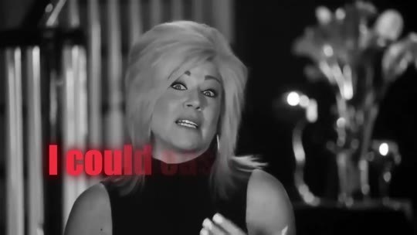  📷 30:15 — Theresa Caputo em preto e branco; lettering vermelho 'I could'  b14_theresa_pb_i_could_00-30-15.jpg
  📷 30:17 — Lettering vermelho 'I could easily charge $1,000 per bottle'  b14_lettering_i_could_easily_charge_1000_per_bottle_00-30-17.jpg |   📷 30:20 — Casal sorrindo em escritório; legenda 'delivers to'  b14_casal_escritorio_sorrindo_delivers_00-30-20.jpg

📷 30:22 — Taylor Swift e Travis Kelce no estádio (Chiefs); legenda 'Hollywood elite'
b14_taylor_swift_travis_kelce_estadio_00-30-22.jpg

THERESA CAPUTO (narradora): E o motivo é simples: eles não te contaram a verdade. Não é possível manifestar, se conectar com o universo, sem antes desbloquear a ponte que Deus deixou quando nos criou para nos manter conectadas a Ele: a nossa glândula pineal. Então pense por um momento: quanto você pagaria para realizar os seus desejos mais profundos? Para manifestar uma vida de abundância, saúde, amor e prosperidade. Agora preste atenção, querida. Vejo celebridades que me pagam $50.000 por consultas particulares para destravar esse poder de manifestação. Pela raridade desses ingredientes, como o hissopo das montanhas da Galileia, eu poderia facilmente cobrar $1.000 por frasco, e ainda seria barato comparado à nova vida que ele te entrega. Mas eu não criei o Soul Flush para a elite de Hollywood.

14.3 ⏱ 30:23 → 31:01
  📷 30:27 — Mulher caída no tapete; legenda 'is heavy'  b14_mulher_caida_chao_tapete_00-30-27.jpg |   📷 30:45 — Seis frascos Soul Flush; lettering verde '$49 per bottle'  b14_lettering_49_per_bottle_6_frascos_00-30-45.jpg
  📷 30:54 — Mãos lavando limão na pia; legenda 'fills with'  b14_maos_lavando_limao_pia_00-30-54.jpg |   📷 30:58 — Theresa Caputo em estúdio; legenda 'poison'  b14_theresa_estudio_poison_00-30-58.jpg
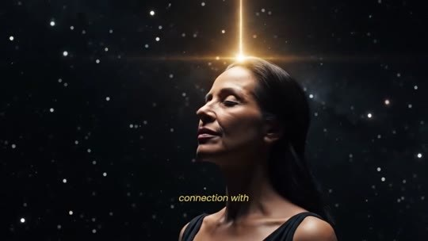
📷 31:01 — Mulher sob estrelas com raio de luz; legenda 'connection with'
b14_mulher_estrelas_luz_connection_with_00-31-01.jpg

THERESA CAPUTO (narradora): Eu o criei para ajudar mulheres cuja energia está pesada. Quero que essa transformação chegue às mãos da mulher… É por isso que você não vai pagar $1.000 nem $500. Enquanto este lote especial de lançamento durar, lutei para tornar isso acessível. Agora mesmo, abaixo deste vídeo, você tem uma condição especial para adquirir 6 frascos de Soul Flush por apenas $49 por frasco. Isso dá $1,63 por dia. É menos do que você gasta com aquela garrafa de água no supermercado, a mesma água que a elite enche de flúor para te manter bloqueada. Por menos do que o preço de um veneno diário, você garante a sua conexão direta e inabalável com Deus.

BLOCO 15 — OS 2 TIPOS DE MULHERES: 3 meses x 6 meses, Taylor, 'vacinar a alma', kits de 6 ($49) e 3 ($69), frete grátis [31:01 – 34:05]

15.1 ⏱ 31:01 → 31:46
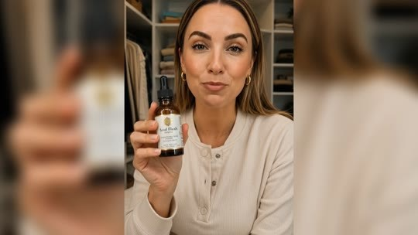  📷 31:06 — Mulher de blusa branca segurando frasco Soul Flush; legenda 'following the'  b15_mulher_depoimento_frasco_i_have_been_following_00-31-06.jpg | 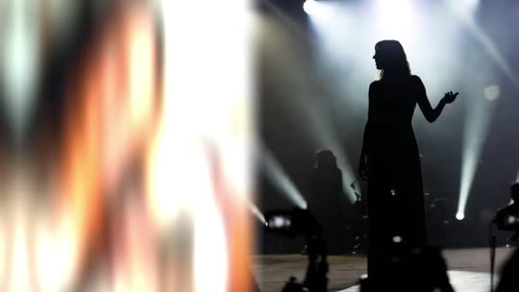  📷 31:12 — Silhueta em palco com holofotes; legenda 'curious pattern'  b15_silhueta_palco_holofotes_00-31-12.jpg
  📷 31:16 — Mulher sorrindo abrindo caixa; legenda 'the'  b15_mulher_sorrindo_abrindo_caixa_00-31-16.jpg |   📷 31:19 — Frasco Soul Flush sobre mesa; legenda 'beautiful start'  b15_frasco_soul_flush_mesa_three_month_00-31-19.jpg
  📷 31:21 — Três frascos Soul Flush; legenda 'the'  b15_tres_frascos_soul_flush_00-31-21.jpg |   📷 31:32 — Mulher com frasco; lettering vermelho 'RUNS OUT'  b15_lettering_runs_out_mulher_frasco_00-31-32.jpg
  📷 31:41 — Mulher no celular (preto e branco); lettering amarelo '"Theresa it's over I need more I don't wanna go back to feeling heavy"'  b15_lettering_theresa_its_over_i_need_more_00-31-41.jpg |   📷 31:46 — Mulher no laptop; legenda 'my site'  b15_mulher_laptop_my_site_00-31-46.jpg

THERESA CAPUTO (narradora): Venho acompanhando a jornada das mulheres que usam o Soul Flush, e vejo um padrão curioso em todas as mulheres que transformam a vida com o Soul Flush. Existem 2 tipos de mulheres que começam essa caminhada, e quero que você escolha qual delas quer ser. O primeiro grupo são as muitas mulheres que começam com o tratamento de 3 meses e… Olha, é um começo lindo. Elas sentem o alívio, a energia muda, elas manifestam coisas lindas. Mas sabe o que acontece? Quando estão chegando ao melhor momento, o frasco acaba. E quase todas voltam desesperadas, me mandando mensagens. "Teresa, acabou! Preciso de mais! Não quero voltar a me sentir pesada!" Notei que quase 90% dessas mulheres voltam ao meu site no 4º mês, desesperadas para comprar mais.

15.2 ⏱ 31:46 → 32:33
  📷 31:50 — Lettering 'THE SECOND GROUP'  b15_lettering_the_second_group_00-31-50.jpg |   📷 31:52 — Seis frascos Soul Flush em fundo dourado; legenda 'themselves'  b15_seis_frascos_soul_flush_fundo_dourado_00-31-52.jpg
  📷 32:04 — Cérebro dourado holográfico; legenda 'took 30'  b15_cerebro_dourado_took_30_00-32-04.jpg |   📷 32:24 — Pinha roxa em fundo azul (pineal); legenda 'a protective'  b15_pinha_roxa_azul_pineal_00-32-24.jpg

📷 32:28 — Mulher com coroa de luz; legenda 'vaccinate'
b15_mulher_coroa_luz_vaccinate_soul_00-32-28.jpg

THERESA CAPUTO (narradora): Elas percebem que não querem parar de sentir as bênçãos. O segundo grupo é o das que se blindam. Esse é o grupo da Taylor Swift e das minhas alunas que manifestaram as maiores fortunas. Por que a Taylor escolheu o tratamento de 6 meses logo de cara? Porque ela entendeu que o flúor levou 30 anos para calcificar a pineal dela. Não é possível resolver todo esse dano em poucas semanas. Ela usou os primeiros meses para limpar a sujeira antiga. E usou os meses seguintes para criar um escudo espiritual. Ao manter o Soul Flush por 6 meses contínuos, você cria uma película protetora na sua glândula. É como vacinar a sua alma. Mesmo que você beba água suja ou enfrente inveja depois, a sua pineal continua aberta e vibrando alto.

15.3 ⏱ 32:34 → 33:17
  📷 32:34 — Mãos digitando no laptop; legenda 'thank-you'  b15_maos_laptop_thank_you_letters_00-32-34.jpg |   📷 32:36 — Casal sorrindo no sofá; legenda 'saved marriages'  b15_casal_sofa_aliancas_saved_marriages_00-32-36.jpg
  📷 32:38 — Mulher de vestido azul em mansão; legenda 'cash and'  b15_mulher_vestido_azul_mansao_00-32-38.jpg |   📷 32:45 — Frasco Soul Flush sobre mesa; legenda 'this I'  b15_frasco_soul_flush_mesa_special_kit_00-32-45.jpg
  📷 32:55 — Mulher sorrindo com caixa; legenda 'you with'  b15_mulher_sorrindo_caixa_presente_00-32-55.jpg | 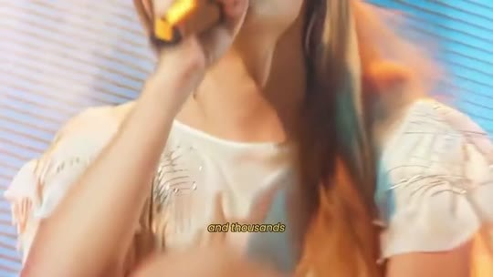  📷 33:09 — Taylor Swift cantando em show; legenda 'and thousands'  b15_taylor_swift_show_same_protocol_00-33-09.jpg

📷 33:14 — Lettering 'IT IS THE WISEST CHOICE'
b15_lettering_it_is_the_wisest_choice_00-33-14.jpg

THERESA CAPUTO (narradora): Quando leio as cartas de agradecimento sobre casamentos salvos, casas compradas à vista e saúde restaurada, adivinha? Todas elas… Elas não deixaram nada ao acaso. Decidiram que mereciam a cura completa. Vendo tudo isso, preparei algo especial para facilitar essa transformação para você hoje. Fiz questão de preparar um kit especial que te proporciona a transformação completa. É por isso que a minha recomendação de amiga é que você escolha 6 frascos de Soul Flush por $49 cada, para o desbloqueio completo e permanente da sua ponte com a sua alma… com Deus. É o mesmo protocolo da Taylor e de milhares de outras mulheres que tiveram a vida transformada. É a escolha mais sábia. Se você realmente não puder fazer a blindagem total agora, tudo bem.

15.4 ⏱ 33:17 → 34:05
  📷 33:22 — Três frascos Soul Flush; lettering verde '$69 EACH'  b15_lettering_69_each_3_frascos_00-33-22.jpg |   📷 33:37 — Mulher executiva caminhando na rua entre táxis amarelos; legenda 'intelligent, and'  b15_mulher_executiva_rua_taxi_amarelo_00-33-37.jpg
  📷 33:46 — Tela de 'Secure Checkout' no computador; legenda 'to a'  b15_tela_secure_checkout_00-33-46.jpg |   📷 33:49 — Caixa de papelão sendo entregue; legenda 'free shipping'  b15_caixa_entrega_papelao_00-33-49.jpg
  📷 33:58 — Seis frascos Soul Flush; legenda 'choose one'  b15_seis_frascos_soul_flush_choose_00-33-58.jpg |   📷 34:05 — Mulher com conta-gotas e olho cósmico; legenda 'miracle'  b15_mulher_olho_cosmico_conta_gotas_00-34-05.jpg

THERESA CAPUTO (narradora): Você pode começar com 3 frascos por $69 cada. Vai te ajudar a limpar a sujeira mais pesada. Você vai começar a manifestar as bênçãos mais urgentes da sua vida. E então, depois de comprovar como uma pineal descalcificada pode te elevar ao nível de uma mulher forte, inteligente e espiritualmente conectada, você pode continuar com o seu tratamento de Soul Flush. Ao tocar numa dessas opções abaixo, você será direcionada a uma página segura para colocar os dados do seu endereço, para que eu possa enviar o seu pedido hoje com frete grátis, e o Soul Flush chegue à sua porta em menos de uma semana. Escolha uma dessas opções para liberar a sua capacidade de manifestação, intuição, sorte e as bênçãos que estão guardadas para você. Você vai sentir o milagre logo no primeiro frasco.

BLOCO 16 — O MUNDO CONTINUA TÓXICO + GARANTIA DE 180 DIAS ('garantia da bênção') [34:05 – 35:36]

16.1 ⏱ 34:05 → 34:51
  📷 34:07 — Mulher com conta-gotas e símbolos cósmicos (tom laranja); legenda 'dirty'  b16_mulher_olho_cosmico_conta_gotas_laranja_00-34-07.jpg | 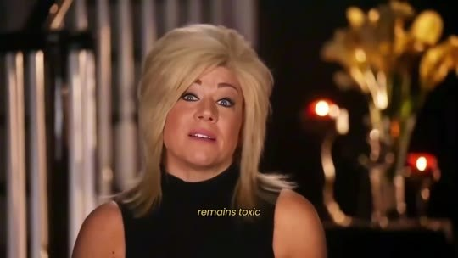  📷 34:10 — Theresa Caputo em estúdio; legenda 'remains toxic'  b16_theresa_estudio_remains_toxic_00-34-10.jpg
  📷 34:16 — Acidente de carro à noite com polícia; legenda 'accident or'  b16_acidente_carro_noite_policia_00-34-16.jpg | 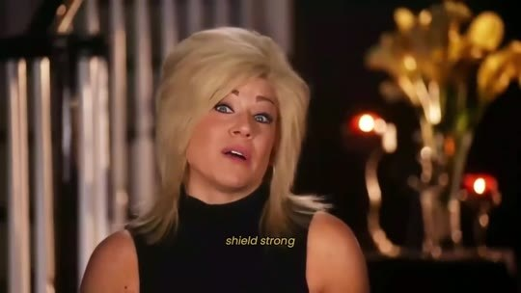  📷 34:21 — Theresa Caputo em estúdio; legenda 'shield strong'  b16_theresa_estudio_shield_strong_00-34-21.jpg
  📷 34:26 — Mulher dentro de bolha de proteção na rua; legenda 'to be'  b16_mulher_bolha_protecao_rua_00-34-26.jpg | 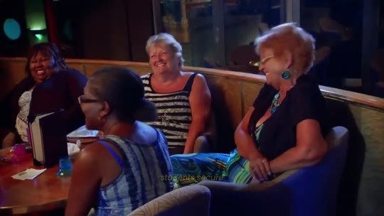  📷 34:29 — Mulheres em sessão de grupo rindo; legenda 'all surprised'  b16_mulheres_sessao_grupo_rindo_00-34-29.jpg
  📷 34:34 — Mulher meditando entre nuvens escuras; legenda 'blocked'  b16_mulher_meditando_nuvens_escuras_blocked_00-34-34.jpg |   📷 34:42 — Tela vermelha com triângulo de alerta 'ERROR'; legenda 'you are'  b16_lettering_error_vermelho_00-34-42.jpg
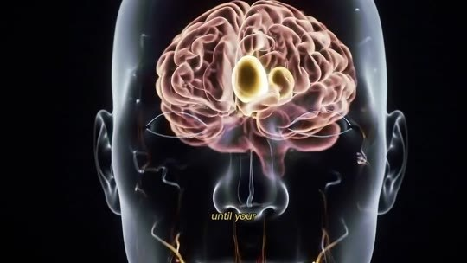  📷 34:45 — Cérebro 3D com pineal destacada; legenda 'until your'  b16_cerebro_3d_pineal_until_your_00-34-45.jpg | 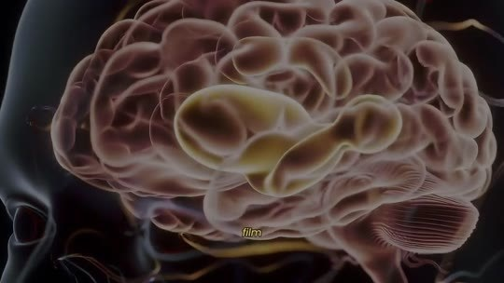  📷 34:49 — Close da pineal em cérebro 3D; legenda 'faster'  b16_cerebro_3d_pineal_close_faster_00-34-49.jpg

THERESA CAPUTO (narradora): É inevitável. Mas lembre-se: o mundo lá fora continua tóxico. A água continua suja. As energias ruins da inveja continuam tentando entrar. Um acidente grave ou uma doença repentina podem surgir quando você menos espera. Para manter esse escudo sagrado forte e impedir que a poeira volte a bloquear a sua ponte com… É por isso que as minhas alunas mais sábias garantem o estoque de 6 meses. Não porque demore para funcionar. Afinal, todas se surpreendem com a velocidade com que manifestam as bênçãos. Mas nenhuma delas quer voltar à antiga vida bloqueada. E, se você não estiver protegida por mais tempo, até a sua glândula pineal estar completamente descalcificada e com uma película protetora, as coisas podem ir embora mais rápido do que chegaram.

16.2 ⏱ 34:51 → 35:36
  📷 34:54 — Mulher com a mão na cabeça; lettering 'let me'  b16_lettering_let_me_mulher_mao_cabeca_00-34-54.jpg |   📷 35:04 — Fundo azul; lettering '180' sobre 'Soul Detox'  b16_lettering_180_soul_detox_00-35-04.jpg
  📷 35:06 — Lettering '180-DAY BLESSING GUARANTEE'  b16_lettering_180_day_blessing_guarantee_00-35-06.jpg |   📷 35:10 — Mulher dormindo tranquila; legenda 'sleeping better'  b16_mulher_dormindo_tranquila_00-35-10.jpg
  📷 35:27 — Selo '100% Money Back — 180 Days Guarantee' e lettering '180-DAY BLESSING GUARANTEE'  b16_selo_180_days_money_back_guarantee_00-35-27.jpg |   📷 35:31 — Calendário virando para 'May'; legenda 'to see'  b16_calendario_may_00-35-31.jpg

📷 35:34 — Theresa Caputo em estúdio; legenda 'test it'
b16_theresa_estudio_test_it_00-35-34.jpg

THERESA CAPUTO (narradora): Se você ainda está pensando, deixa eu tirar todo o peso da responsabilidade de você. Confio tanto no que a minha avó me ensinou que ofereço a garantia mais forte possível: a garantia da bênção de 180 dias. Se por qualquer motivo você não sentir uma transformação completa, se não começar a dormir melhor, a sentir mais energia, a despertar a sua intuição e até a manifestar novas oportunidades na sua vida, devolvo 100% do seu dinheiro, sem perguntas, em até 180 dias após a compra. Isso mesmo, 6 meses inteiros para ver a mágica acontecer, ou você recebe cada centavo de volta. Tudo o que pedimos é que você teste por si mesma. Veja a transformação com os seus próprios olhos.

BLOCO 17 — OS 3 PRESENTES: sessões semanais de energia ($12.000), Canto Angelical ($3.000) e Guia de Interpretação de Sinais [35:37 – 38:13]

17.1 ⏱ 35:37 → 36:25
  📷 35:37 — Lettering 'BUT'  b17_lettering_but_00-35-37.jpg | 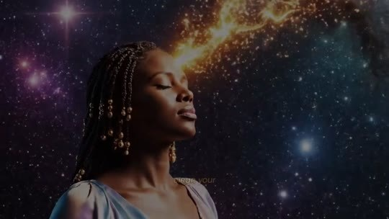  📷 35:41 — Mulher com luz saindo da cabeça no cosmos; legenda 'opens'  b17_mulher_cosmos_channel_opens_00-35-41.jpg
  📷 36:03 — Mulheres iluminadas; lettering 'I'm gonna give you 3 exclusive gifts'  b17_lettering_im_gonna_give_you_3_exclusive_gifts_00-36-03.jpg |   📷 36:09 — Mulher meditando na floresta; lettering 'GIFT 1: WEEKLY ENERGY SESSION.'  b17_lettering_gift_1_weekly_energy_session_00-36-09.jpg
  📷 36:15 — Seis frascos Soul Flush com vela; legenda 'securing your'  b17_seis_frascos_soul_flush_vela_00-36-15.jpg |   📷 36:21 — Silhueta meditando com chakras; legenda 'where I'  b17_silhueta_chakras_cosmos_00-36-21.jpg
  📷 36:23 — Theresa Caputo em sessão de grupo em restaurante; legenda 'group of'  b17_theresa_sessao_grupo_restaurante_00-36-23.jpg | 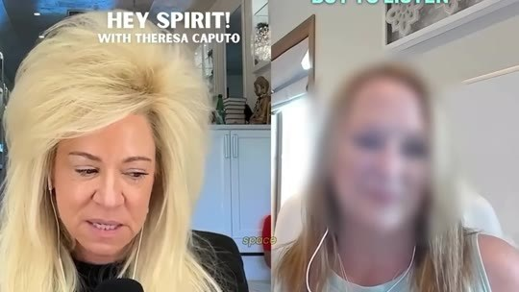  📷 36:25 — Chamada 'Hey Spirit! with Theresa Caputo' (sessão online); legenda 'reading space'  b17_hey_spirit_with_theresa_caputo_zoom_00-36-25.jpg

THERESA CAPUTO (narradora): Mas espere, você não vai receber só o Soul Flush. Quando você limpa a sua pineal, o canal realmente se abre. A sua sensibilidade aumenta. A intuição volta com força total, e não quero que você se sinta sozinha ou confusa com todo esse novo poder. Quero segurar a sua mão. Por isso, se você agir agora e garantir o kit de 6 frascos, vou abrir a porta do meu mundo para você. Vou te dar 3 presentes exclusivos do meu círculo íntimo totalmente de graça. O primeiro é o mais especial. Presente 1: a sessão semanal de energia. Não vou deixar você caminhar sozinha. Ao garantir o seu kit hoje, você recebe um convite especial. Você vai poder participar das minhas sessões semanais de limpeza energética, onde reúno um grupo exclusivo de mulheres no meu espaço online de leitura psíquica.

17.2 ⏱ 36:25 → 37:08
  📷 36:29 — Theresa Caputo fazendo limpeza energética numa sala; legenda 'remove envy'  b17_theresa_limpeza_energetica_sala_00-36-29.jpg |   📷 36:34 — Theresa anotando; lettering 'THERE WILL BE'  b17_lettering_there_will_be_theresa_anotando_00-36-34.jpg
  📷 36:38 — Theresa Caputo à mesa em sala vermelha; legenda 'consultations cost'  b17_theresa_mesa_vermelha_consultations_cost_00-36-38.jpg |   📷 36:43 — Theresa Caputo em estúdio; legenda 'saving $12,000'  b17_theresa_estudio_saving_12000_00-36-43.jpg
  📷 36:49 — Notas musicais flutuando; legenda 'I prepared'  b17_notas_musicais_frequencias_00-36-49.jpg |   📷 36:58 — Botão 'Play'; lettering 'JUST PRESS PLAY'  b17_lettering_just_press_play_00-36-58.jpg

THERESA CAPUTO (narradora): Mesmo à distância, nos conectamos para blindar a energia da semana, remover a inveja e garantir que você comece toda segunda-feira leve, protegida e imbatível. Serão 24 sessões em… Minhas consultas particulares custam cerca de $500, então você estaria economizando $12.000. Presente 2: o Canto Angelical para a Saúde. Sabe aquelas noites em que você precisa de regeneração ou cura profunda? Preparei um áudio especial com frequências sonoras sagradas. Não é uma música comum, é uma vibração angelical que fala diretamente com as suas células. Basta dar play antes de dormir, enquanto o Divine Purity limpa a sua aura. Limpa a sua glândula fisicamente. Esse canto alinha a sua vibração espiritual, acelerando a regeneração do seu corpo enquanto você sonha.

17.3 ⏱ 37:09 → 37:54
  📷 37:09 — Mulher dormindo de fones de ouvido; legenda 'you dream'  b17_mulher_fones_dormindo_00-37-09.jpg |   📷 37:22 — Lettering 'AND LAST'  b17_lettering_and_last_00-37-22.jpg
  📷 37:40 — Mulher em efeito aquarela azul; legenda 'sixth'  b17_mulher_sonho_aquarela_azul_00-37-40.jpg |   📷 37:54 — Theresa com a mãe em evento; lettering 'more than eight generations'  b17_lettering_more_than_eight_generations_00-37-54.jpg

THERESA CAPUTO (narradora): Para um cliente ter acesso a essa frequência que uso nas minhas sessões com celebridades, ele investe não menos que $3.000. Mas hoje você vai receber de graça. E, por último, mas não menos importante, presente 3: o Guia de Interpretação de Sinais. O Guia de Interpretação de Sinais, para que você conheça e consiga interpretar os sinais que o universo te envia. Toda mulher tem uma espécie de sexto sentido, que são os seus sonhos. Você mesma recebe muitas revelações. Só precisa saber interpretá-las. E, neste guia, você vai ver os 10 tipos de sonhos mais comuns e o significado deles, tudo de forma simples e direta. Esses 3 presentes valem tudo isso porque é algo que está na minha família há mais de 8 gerações.

17.4 ⏱ 37:54 → 38:13
  📷 37:58 — Mulher com caixas de presente; legenda 'these three'  b17_mulher_caixas_presente_00-37-58.jpg |   📷 38:09 — Seis frascos Soul Flush; lettering 'THE 6'  b17_lettering_the_6_frascos_00-38-09.jpg

📷 38:13 — Ícone de presente; lettering 'YOUR ORDER'
b17_lettering_your_order_presente_00-38-13.jpg

THERESA CAPUTO (narradora): O que estou colocando nas suas mãos hoje é uma verdadeira relíquia. Esses 3 presentes valem uma fortuna se vendidos separadamente. Minhas sessões particulares têm meses de lista de espera, mas hoje, ao escolher cuidar da sua glândula por completo, eles são seus de graça. Basta escolher a opção de 6 frascos abaixo, e os presentes serão adicionados automaticamente ao seu pedido.

BLOCO 18 — ESCASSEZ (92 → 86 frascos), as consequências (Cleveland Clinic) e como usar [38:13 – 40:36]

18.1 ⏱ 38:13 → 38:55
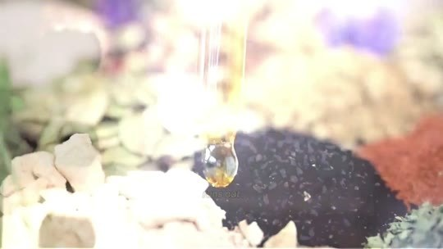  📷 38:23 — Conta-gotas sobre especiarias; legenda 'limited'  b18_conta_gotas_especiarias_limited_00-38-23.jpg |   📷 38:26 — Monges colhendo ervas sob a lua; legenda 'specific cycles'  b18_monges_colhendo_lua_crescente_00-38-26.jpg
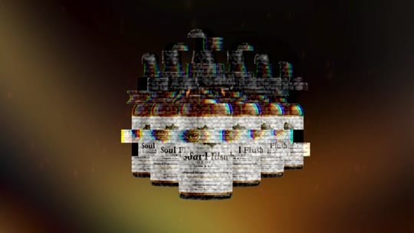  📷 38:29 — Frascos Soul Flush com efeito glitch; legenda 'stock runs'  b18_frascos_soul_flush_glitch_00-38-29.jpg | 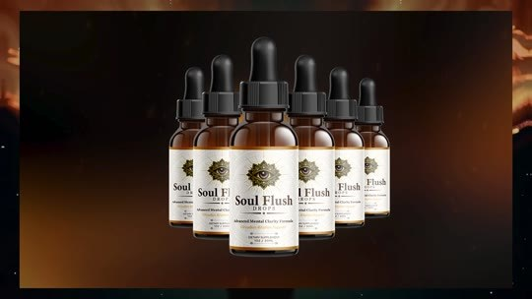  📷 38:32 — Frascos Soul Flush; legenda '92 left'  b18_frascos_soul_flush_92_left_00-38-32.jpg
  📷 38:37 — Armazém com prateleiras de caixas; legenda '86 bottles'  b18_armazem_prateleiras_caixas_00-38-37.jpg | 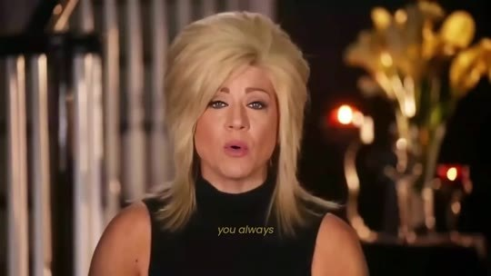  📷 38:48 — Theresa Caputo em estúdio; legenda 'you always'  b18_theresa_estudio_you_always_00-38-48.jpg
  📷 38:53 — Frasco 'Soul Flush Drops' em close; legenda 'your life'  b18_frasco_soul_flush_drops_etiqueta_00-38-53.jpg |   📷 38:55 — Família no sofá com auras iluminadas; legenda 'your family'  b18_familia_sofa_auras_lavanda_00-38-55.jpg

THERESA CAPUTO (narradora): Mas entenda: esses ingredientes não estarão disponíveis para sempre. Esses componentes ancestrais são limitados. Colhidos em ciclos específicos da natureza. E, quando o nosso estoque acabar, talvez não consigamos obtê-los de novo, pela raridade e pela complexidade da colheita de cada elemento. Acabei de verificar o meu estoque e restam 92. Não, na verdade restam só 86. Acabei de receber um pedido. Restam 86 frascos no meu estoque. A fórmula em si foi criada para transformar a sua vida, purificar o seu corpo e a sua mente e abrir a sua capacidade de manifestar uma nova realidade, aquela que você sempre soube que era possível. Espero de verdade que você entenda o poder que o Soul Flush pode ter na sua vida e na vida da sua família.

18.2 ⏱ 38:55 → 39:39
  📷 39:01 — Theresa Caputo em estúdio; legenda 'are serious'  b18_theresa_estudio_are_serious_00-39-01.jpg |   📷 39:28 — Mulher ao telefone; legenda 'circumstances'  b18_mulher_telefone_circumstances_00-39-28.jpg
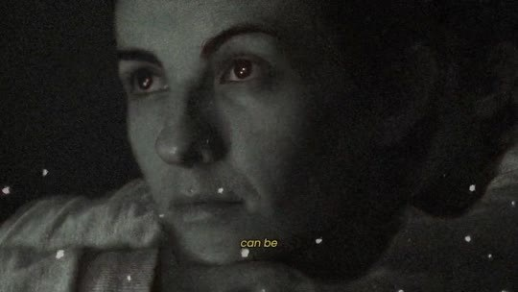  📷 39:34 — Mulher em preto e branco; legenda 'can be'  b18_mulher_pb_can_be_00-39-34.jpg |   📷 39:39 — Mulher na cama sob cobertor; legenda 'scarcity'  b18_mulher_cama_cobertor_scarcity_00-39-39.jpg

THERESA CAPUTO (narradora): Se você ignorar a oportunidade de reativar a sua glândula pineal, as consequências são sérias. A calcificação não tratada pode levar a uma série de problemas físicos e mentais graves. Segundo a Cleveland Clinic, a degradação da glândula pineal está associada a doenças neurológicas, como Alzheimer, Parkinson e até ao desenvolvimento de tumores. Além disso, condições crônicas como hipertensão, insônia e depressão profunda podem piorar com o tempo. Você pode continuar vivendo como vive agora, limitada pelas circunstâncias e controlada por forças externas do sistema, mas o custo dessa escolha pode ser alto. Você nunca vai acessar o verdadeiro poder que existe dentro de você.

18.3 ⏱ 39:39 → 40:24
  📷 39:44 — Mulher frustrada no laptop; legenda 'while those'  b18_mulher_laptop_frustrada_00-39-44.jpg | 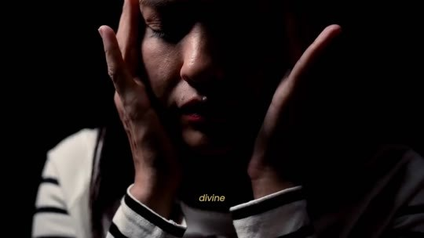  📷 39:49 — Mulher com as mãos no rosto no escuro; legenda 'divine'  b18_mulher_maos_no_rosto_escuro_00-39-49.jpg
  📷 40:01 — Close do frasco Soul Flush Drops; legenda 'each dose'  b18_frasco_soul_flush_drops_close_each_dose_00-40-01.jpg |   📷 40:19 — Mulher na cama usando conta-gotas (luz rosa); legenda 'use a'  b18_mulher_cama_conta_gotas_luz_rosa_00-40-19.jpg
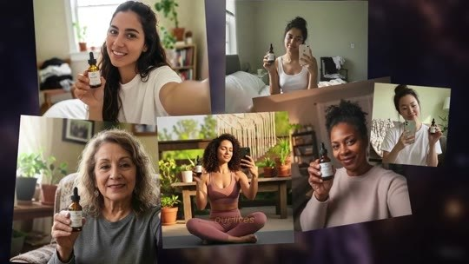
📷 40:24 — Colagem de mulheres segurando frascos Soul Flush; legenda 'famous clients'
b18_colagem_mulheres_frascos_soul_flush_00-40-24.jpg

THERESA CAPUTO (narradora): Você vai continuar vivendo uma vida de escassez, preocupações e frustrações, enquanto quem destrava a glândula pineal vai viver em abundância, prosperidade e conexão com o divino. A deterioração dessa glândula pequena, mas poderosa, pode ser literalmente uma bomba-relógio dentro de você. Você não precisa escolher esse caminho. O Soul Flush te oferece uma chance de despertar, de se alinhar com o fluxo de abundância e clareza que sempre esteve disponível, mas bloqueado. A cada dose, você começa a destravar o poder da sua mente. E a melhor parte? É simples de usar. Deixe o Soul Detox ao lado da sua cama e, alguns minutos antes de dormir, use um conta-gotas debaixo da língua. Foi assim que eu, a minha família, as minhas clientes famosas e milhares de outras pessoas mudamos a nossa vida.

18.4 ⏱ 40:24 → 40:36

📷 40:31 — Mulher sorrindo junto à janela; legenda 'loved by'
b18_mulher_sorrindo_janela_loved_00-40-31.jpg

THERESA CAPUTO (narradora): Posso te garantir que, quando você começar a destravar as bênçãos que Deus reservou há muito tempo para a sua vida, você vai chorar. Ao ver o quanto sempre foi amada por Ele. Mas você não precisa acreditar só na minha palavra.

BLOCO 19 — DEPOIMENTO DA VICE-PRESIDENTE + Divine Purity a $49, estoque limitado e 'movimento de luz' [40:37 – 42:22]

19.1 ⏱ 40:37 → 41:19
  📷 40:49 — Mulher deitada segurando frasco Soul Flush; legenda 'these people'  b19_mulher_cama_frasco_soul_flush_00-40-49.jpg | 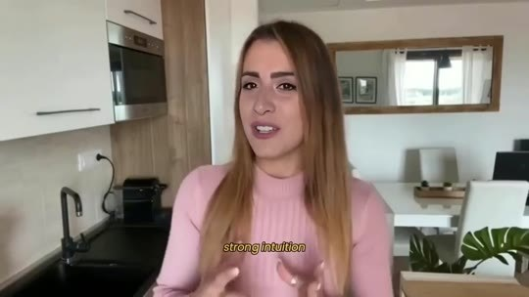  📷 40:53 — Mulher de blusa rosa em depoimento (promovida a VP); legenda 'strong intuition'  b19_depoimento_vp_blusa_rosa_00-40-53.jpg
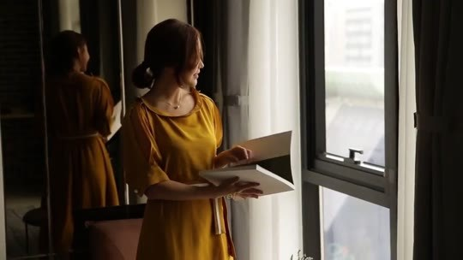
📷 41:19 — Mulher de vestido amarelo lendo documentos; legenda 'promoted'
b19_mulher_vestido_amarelo_documentos_00-41-19.jpg

THERESA CAPUTO (narradora): Ouça o que estas pessoas têm a dizer.
MULHER (depoimento, promovida a VP): Fiquei presa no mesmo cargo por 6 anos. Trabalhava o dobro, mas parecia que eu era invisível na empresa. Sempre que abria uma promoção, a sorte sorria para outra pessoa. Mas, no meu segundo mês usando o Soul Flush, uma intuição muito forte me disse para assumir um projeto na empresa que estava afundando. E que ninguém queria. Parecia loucura, mas as soluções simplesmente começaram a brotar na minha mente com uma clareza absurda. Tudo fluiu perfeitamente. Salvei o projeto, quebrei recordes e fui promovida a vice-presidente da área. Deus estava literalmente sussurrando os passos que eu deveria dar.
THERESA CAPUTO (narradora): Agora, imagine-se no lugar dessa mulher, finalmente alcançando tudo o que você sempre sonhou.

19.2 ⏱ 41:19 → 42:03
  📷 41:30 — Theresa Caputo em estúdio; legenda 'now becomes'  b19_theresa_estudio_now_becomes_00-41-30.jpg |   📷 41:34 — Frasco Soul Flush em fundo dourado; legenda 'Divine Purity'  b19_frasco_soul_flush_divine_purity_00-41-34.jpg
  📷 41:37 — Frascos Soul Flush com fumaça roxa; legenda '$49'  b19_frascos_soul_flush_fumaca_roxa_00-41-37.jpg |   📷 41:45 — Frascos Soul Flush com glitch; legenda 'discount'  b19_frascos_soul_flush_glitch_discount_00-41-45.jpg
  📷 41:53 — Theresa Caputo em estúdio; legenda 'is limited'  b19_theresa_estudio_is_limited_00-41-53.jpg |   📷 42:01 — Frasco Soul Flush sobre mesa; legenda 'demand'  b19_frasco_soul_flush_mesa_demand_00-42-01.jpg

THERESA CAPUTO (narradora): Tudo o que antes parecia distante ou impossível, o que para muitas é só um desejo reprimido, preso no mundo das ideias, agora se torna realidade para você. E tudo graças ao Divine Purity. Você terá acesso ao Divine Purity por apenas $49 por frasco ao escolher a opção completa de blindagem de 6 meses. Você vai ver o valor promocional com desconto exclusivo aparecendo abaixo deste vídeo agora. Basta escolher entre 3 ou 6 frascos e você estará a um passo de viver a sua melhor vida, de transformar a sua vida. Mas aqui vai o meu aviso: o estoque é limitado e, sinceramente, não sabemos por quanto tempo conseguiremos manter esta oferta disponível. A demanda pelo Soul Flush foi maior do que esperávamos, e a pressão para derrubar este site é real.

19.3 ⏱ 42:04 → 42:22

📷 42:18 — Sete frascos Soul Flush com velas e cristais; legenda 'as many'
b19_sete_frascos_soul_flush_velas_00-42-18.jpg

THERESA CAPUTO (narradora): Então considere adquirir o máximo de frascos possível para você e a sua família. Cada frasco comprado ajuda a trazer a verdade à luz, garantindo que mais pessoas possam se libertar dessa manipulação global. Você está literalmente participando de um movimento de luz. Se deixar essa oportunidade passar, talvez não haja outra chance.

BLOCO 20 — FECHAMENTO: a encruzilhada, o Holocausto, 'diga sim', o arrependimento, os agradecimentos e o botão [42:22 – 47:02]

20.1 ⏱ 42:22 → 43:07
  📷 42:25 — Cruzamento de Shibuya visto de cima; legenda 'you are'  b20_cruzamento_shibuya_vista_aerea_00-42-25.jpg | 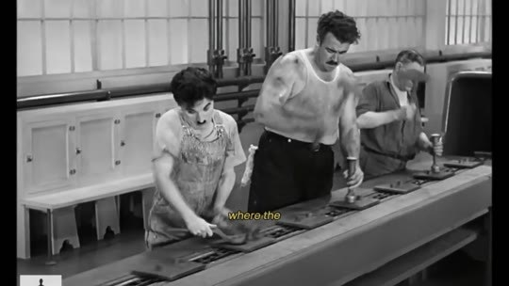  📷 42:33 — Operários em fábrica (preto e branco); legenda 'slaves'  b20_operarios_fabrica_pb_00-42-33.jpg
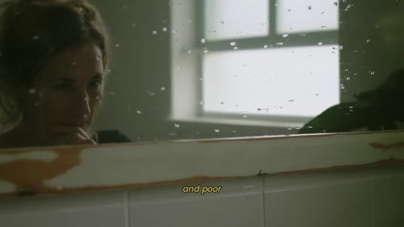
📷 42:42 — Mulher junto à janela (tom verde); legenda 'and poor'
b20_mulher_janela_pb_poor_00-42-42.jpg

THERESA CAPUTO (narradora): Então aqui está o seu destino. Você está numa encruzilhada que pode mudar tudo. Você pode continuar no caminho em que está agora, um caminho onde o sistema já tomou conta da sua vida, um sistema que controla a humanidade há séculos, nos mantendo como escravas, cansadas, doentes e pobres. Você sente isso, não é? A sensação de correr numa roda sem fim, lutando para não afundar enquanto o tempo passa. As civilizações antigas sabiam de algo que fomos programadas para esquecer. Elas prosperaram porque acessaram o verdadeiro potencial humano. E o que estamos fazendo hoje? Vivendo como robôs. Mas você tem o poder de mudar isso agora. Você pode continuar presa, envenenada por toxinas, dependente de remédios que não curam a alma.

20.2 ⏱ 43:08 → 43:51
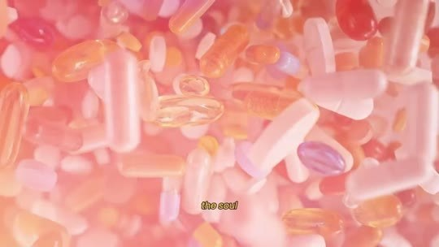  📷 43:08 — Comprimidos em tom rosa; legenda 'the soul'  b20_comprimidos_rosa_pills_00-43-08.jpg | 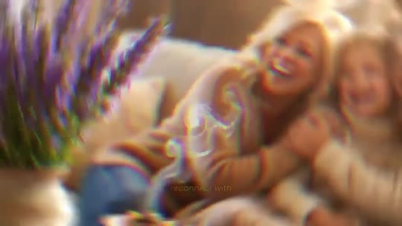  📷 43:17 — Família no sofá em tom dourado; legenda 'reconnect'  b20_familia_sofa_dourado_creator_00-43-17.jpg
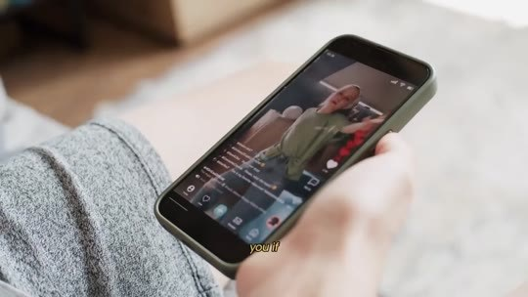  📷 43:25 — Celular com vídeo na mão; legenda 'heard'  b20_celular_video_mao_00-43-25.jpg | 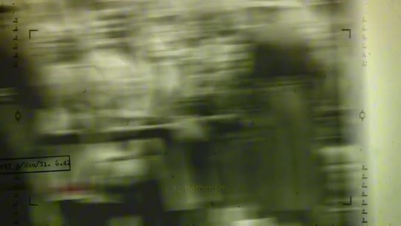  📷 43:40 — Filme antigo em tom verde; legenda 'Holocaust'  b20_filme_antigo_verde_holocaust_00-43-40.jpg

📷 43:49 — Galáxia; legenda 'universe'
b20_galaxia_universe_offering_00-43-49.jpg

THERESA CAPUTO (narradora): Ou pode tomar a decisão que as pessoas despertas vêm tomando há séculos: desintoxicar a mente, limpar a glândula pineal, se reconectar com o Criador e, junto com Ele, poder manifestar na sua vida os melhores sonhos e desejos que estão destinados a você. Se você não agir agora, nada vai mudar. O mundo ao seu redor vai continuar operando num ritmo caótico, e você vai continuar… Você talvez já tenha ouvido pessoas questionando algo como: "Deus se esqueceu de mim?" "Se Deus existe, por que permitiu algo tão terrível quanto o Holocausto?" E agora você sabe a verdade. Isso só aconteceu porque a conexão com Deus estava bloqueada. Você não está aqui por acaso. Acredito que você foi guiada até esta página por um motivo.

20.3 ⏱ 43:52 → 44:34
  📷 43:54 — Planeta Terra à noite; legenda 'chance'  b20_planeta_terra_noite_chance_00-43-54.jpg |   📷 44:00 — Casal com criança no colo; legenda 'full'  b20_familia_filho_colo_full_00-44-00.jpg
  📷 44:04 — Praia vista de cima; legenda 'no regret'  b20_praia_vista_aerea_criancas_00-44-04.jpg |   📷 44:08 — Lettering 'not "what if there's something'  b20_lettering_not_what_if_theres_something_00-44-08.jpg
  📷 44:21 — Mulher de chapéu sorrindo ao pôr do sol; legenda 'trying something'  b20_mulher_chapeu_por_do_sol_sorrindo_00-44-21.jpg | 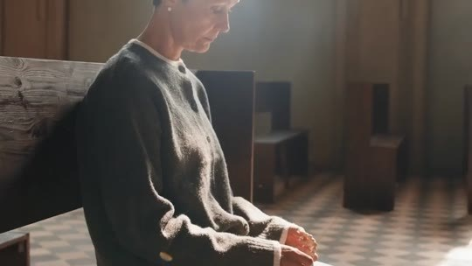  📷 44:31 — Mulher de cabelo curto cabisbaixa; legenda 'waiting'  b20_mulher_cabelo_curto_waiting_00-44-31.jpg

THERESA CAPUTO (narradora): O universo está te oferecendo uma chance. A escolha é sua, e o momento é agora. E a minha última pergunta para você é esta: quando foi a última vez que você viveu a sua vida ao máximo, sem absolutamente nenhum arrependimento? Não "eu faço depois". Não "deixa eu pensar". Não "e se tiver algo melhor?". Mas uma decisão clara e firme, em que você sabia que, mesmo que não desse certo como queria, nunca olharia para trás desejando não ter agido, porque deu ainda melhor do que você poderia imaginar. O arrependimento nunca vem de tentar algo. Vem da hesitação. Vem da espera. Vem de ver os dias da sua vida passarem enquanto você continua no mesmo lugar, desejando, esperando e rezando para que, de algum jeito, algo mude.

20.4 ⏱ 44:34 → 45:17
  📷 44:47 — Mulher na praia de braços abertos; legenda 'yes'  b20_mulher_praia_bracos_abertos_00-44-47.jpg |   📷 44:56 — Mulheres correndo na rua; legenda 'say yes to'  b20_mulheres_correndo_rua_00-44-56.jpg

📷 45:14 — Theresa Caputo em estúdio; legenda 'both know'
b20_theresa_estudio_both_know_00-45-14.jpg

THERESA CAPUTO (narradora): Mas, no fundo, sabendo que você, e somente você, tem tudo o que precisa para fazer essa mudança. E esse poder vem da sua capacidade de tomar uma decisão. Porque, assim como você tem o poder de dizer não, você também tem o poder de dizer sim. Diga sim a desbloquear a sua ponte com Deus e limpar a sua glândula pineal. Diga sim à abundância, à saúde e à paz mental que o sistema tentou roubar de você. Diga sim a finalmente criar um escudo de proteção espiritual ao seu redor. E, acima de tudo, diga sim a confiar em si mesma, porque você sabe que o resultado será infinitamente melhor do que jamais imaginou. Nós duas sabemos que, se você der esse passo hoje, não há risco.

20.5 ⏱ 45:18 → 46:01
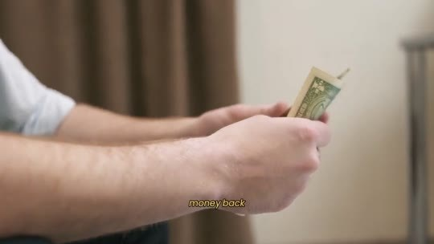  📷 45:24 — Mão entregando notas de dólar; legenda 'money back'  b20_mao_entregando_dinheiro_money_back_00-45-24.jpg | 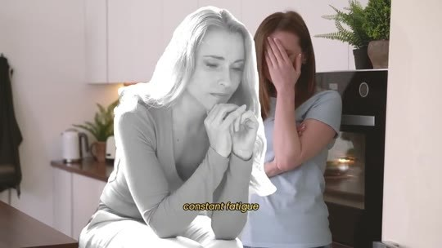  📷 45:36 — Mulher cansada (preto e branco); legenda 'constant fatigue'  b20_mulher_cansada_pb_constant_fatigue_00-45-36.jpg
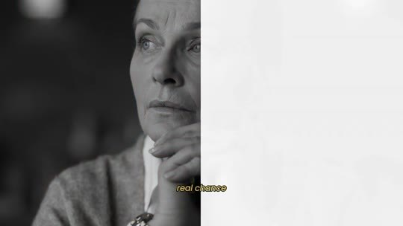  📷 45:45 — Mulher idosa pensativa (preto e branco); legenda 'real chance'  b20_mulher_idosa_pb_real_chance_00-45-45.jpg |   📷 45:56 — Mulher de chapéu sentada diante do mar; legenda 'that your'  b20_mulher_chapeu_mar_future_self_00-45-56.jpg

THERESA CAPUTO (narradora): Ou você recebe os milagres e a clareza que deseja, ou recebe o seu dinheiro de volta. Mas e se você virar as costas agora? Daqui a uma semana, um mês, um ano, você ainda vai estar lidando com o mesmo problema: a sensação de estar bloqueada, o cansaço constante e a vida estagnada, só que com mais tempo perdido no passado e menos futuro pela frente. Olhando para trás e desejando não ter tido medo de dar a si mesma uma chance real. Então a verdadeira pergunta não é "devo fazer isso?". A pergunta é: você quer continuar se perguntando o que teria acontecido, ou quer viver sem arrependimentos e descobrir de verdade? Tome a decisão pela qual o seu eu do futuro vai te agradecer. Obrigada por ter limpado a sua mente do flúor e destravado as portas da prosperidade na sua casa.

20.6 ⏱ 46:02 → 46:44
  📷 46:02 — Família à mesa no jardim; legenda 'prosperity'  b20_familia_mesa_jardim_prosperity_00-46-02.jpg |   📷 46:07 — Carro batido em cena neon; legenda 'bad luck'  b20_acidente_carro_neon_bad_luck_00-46-07.jpg
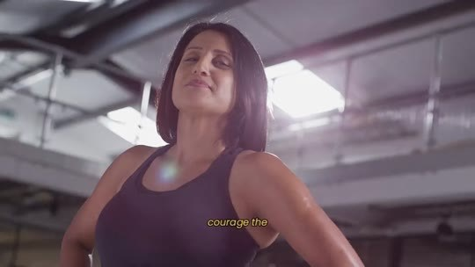  📷 46:10 — Mulher na academia; legenda 'courage the'  b20_mulher_academia_courage_00-46-10.jpg | 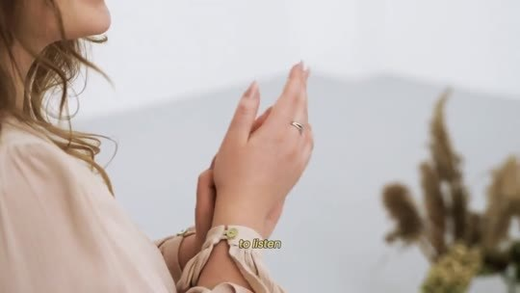  📷 46:12 — Mãos em oração; legenda 'to listen'  b20_maos_em_oracao_to_listen_00-46-12.jpg
  📷 46:24 — Mulher em caiaque num lago; legenda 'the decision'  b20_mulher_caiaque_lago_the_decision_00-46-24.jpg | 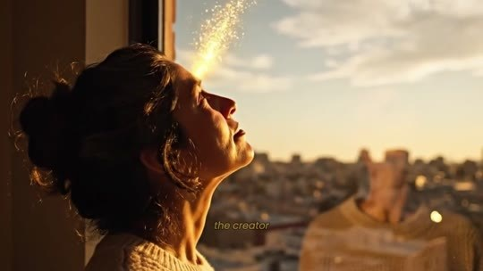  📷 46:31 — Mulher ao pôr do sol com cidade ao fundo; legenda 'the creator'  b20_mulher_por_do_sol_cidade_the_creator_00-46-31.jpg
  📷 46:41 — Mulher de blusa verde no escritório; legenda 'woman to'  b20_mulher_escritorio_blusa_verde_00-46-41.jpg | 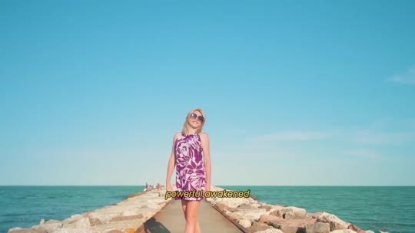  📷 46:43 — Mulher no píer; legenda 'powerful awakened'  b20_mulher_pier_vestido_awakened_00-46-43.jpg

THERESA CAPUTO (narradora): Obrigada por ter blindado a sua família contra toda a inveja, o azar e a doença. Obrigada por ter tido a coragem, a força e a fé de ouvir a sua intuição e fazer algo por você que realmente importa e que muda a sua história. Obrigada por ter tomado essa decisão, e agora é hora de tomar a decisão mais importante da sua vida. A decisão que muda absolutamente tudo. A decisão que religa a sua antena diretamente com o Criador. A decisão que te torna intocável às energias negativas deste mundo. Este é o ponto de virada em que você deixa de ser uma mulher bloqueada e exausta para se tornar uma mulher poderosa, desperta e inabalável.

20.7 ⏱ 46:45 → 47:02
  📷 46:50 — Silhueta colorida; lettering 'CLICK THE BUTTON BELOW' com seta  b20_lettering_click_the_button_below_00-46-50.jpg | 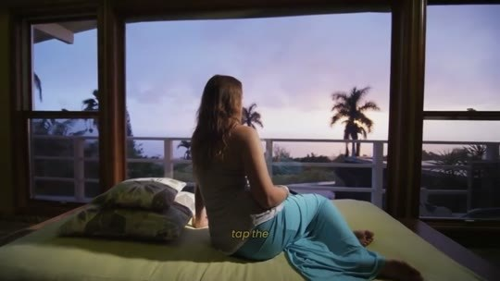  📷 46:57 — Mulher na cama com vista de palmeiras; legenda 'tap the'  b20_mulher_cama_palmeiras_tap_the_00-46-57.jpg

THERESA CAPUTO (narradora): E essa virada começa quando você clica no botão abaixo para garantir o seu tratamento completo de Divine Purity. Porque isto não é só um botão numa tela de computador, é a chave para abrir a vida que sempre foi guardada para você. Toque na opção de frascos que você quer abaixo do vídeo, e estou pronta para te ajudar. Estou esperando por você.

BLOCO 21 — FAQ: Susan (Texas), Brenda (Flórida), Sarah (Chicago) e Claire (Ohio) [47:07 – 51:24]

21.1 ⏱ 47:07 → 47:52
  📷 47:07 — Lettering 'CLICK THE BUTTON BELOW'; abertura do FAQ  b21_lettering_click_the_button_below_faq_00-47-07.jpg |   📷 47:16 — Mulher digitando no celular; legenda 'of answering'  b21_mulher_celular_perguntas_00-47-16.jpg
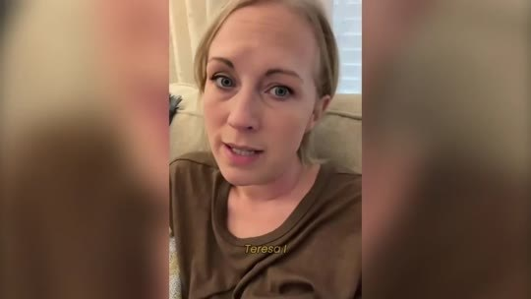  📷 47:29 — Susan, do Texas, falando à câmera no sofá; legenda 'Teresa, I'  b21_susan_texas_depoimento_sofa_00-47-29.jpg | 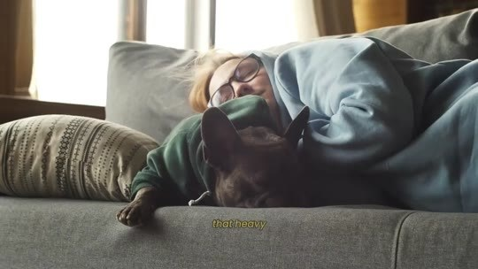  📷 47:49 — Mulher dormindo no sofá com cachorro; legenda 'the alarm'  b21_mulher_dormindo_sofa_cachorro_00-47-49.jpg

THERESA CAPUTO (narradora): Olá, você ainda está aí? Talvez ainda tenha algumas dúvidas. Não quero que você sinta nenhuma dúvida ou medo, então vou me encarregar de responder algumas perguntas frequentes que as mulheres me mandam nas redes sociais sobre o Divine Purity, e isso vai te ajudar a ver se o Soul Flush também é para você. Aqui vai a primeira pergunta. Susan, do Texas.
SUSAN, DO TEXAS (pergunta): Teresa, usei as gotas debaixo da língua ontem, como você ensinou. O problema é que dormi tão profundamente que quase não ouvi o alarme tocar de manhã. Aquele rádio de preocupação na minha cabeça simplesmente desligou, e quase perdi a hora do trabalho. Posso tomar as gotas de manhã em vez de à noite, para não correr esse risco?
THERESA CAPUTO (narradora): Susan, você pode tomar de manhã, sim, mas não se preocupe. Esse sono pesado nos primeiros dias é só o seu corpo reagindo ao silêncio.

21.2 ⏱ 47:53 → 48:35
  📷 47:53 — Cérebro em raio-x azul; legenda 'your body'  b21_cerebro_azul_raio_x_00-47-53.jpg | 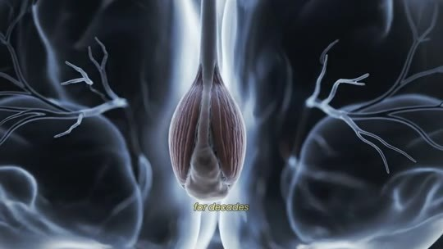  📷 47:56 — Pineal 3D em azul; legenda 'for decades'  b21_pineal_3d_azul_decades_00-47-56.jpg
  📷 48:08 — Theresa Caputo em estúdio; legenda 'before the alarm'  b21_theresa_estudio_waking_up_00-48-08.jpg |   📷 48:11 — Brenda, da Flórida, sorrindo no sofá; legenda 'Theresa'  b21_brenda_florida_sorrindo_sofa_00-48-11.jpg

📷 48:33 — Theresa Caputo em estúdio; legenda 'Brenda, first'
b21_theresa_estudio_brenda_first_00-48-33.jpg

THERESA CAPUTO (narradora): A sua pineal ficou sufocada em estresse e flúor por décadas. Quando o hissopo limpa a crosta, o seu cérebro finalmente consegue desligar para se curar. Ainda esta semana, você vai começar a acordar antes do alarme, cheia de energia. Agora, a segunda pergunta é da Brenda, da Flórida.
BRENDA, DA FLÓRIDA (pergunta): Theresa, comprei o pacote de 6 frascos no mês passado. Acontece que a minha casa, que eu estava tentando vender mas estava travada com a corretora há mais de um ano, recebeu 2 propostas de compra à vista esta semana. Vamos ter que nos mudar às pressas em 15 dias. Se eu comprar mais um kit de 6 frascos para a minha irmã hoje, você garante que chega no meu endereço atual antes da mudança?
THERESA CAPUTO (narradora): Brenda, primeiro, parabéns pela venda da casa.

21.3 ⏱ 48:35 → 49:18
  📷 48:38 — Caminhão de entrega; legenda 'dispatches'  b21_caminhao_entrega_vermelho_00-48-38.jpg |   📷 48:41 — Estrada no campo vista de cima; legenda 'and for'  b21_estrada_campo_vista_aerea_00-48-41.jpg
  📷 48:47 — Martelo de juiz sobre mesa com laptop; legenda 'her house'  b21_martelo_juiz_laptop_her_house_00-48-47.jpg |   📷 48:56 — Corretor com casal no escritório; legenda 'financial life'  b21_corretor_casal_escritorio_00-48-56.jpg
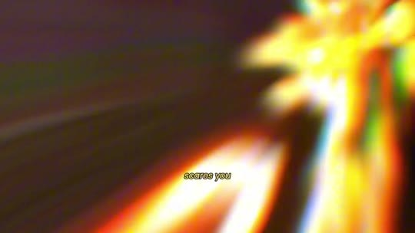
📷 49:00 — Explosão de luz dourada; legenda 'scares you'
b21_luz_dourada_scares_you_00-49-00.jpg

THERESA CAPUTO (narradora): Sim, a nossa equipe despacha tudo em 24 horas, então vai chegar muito antes da sua mudança. E, para quem está assistindo, isso que aconteceu com a Brenda é o que chamamos de desbloqueio da ponte. A casa dela não foi vendida por acaso. Quando você usa o olíbano para religar a sua pineal com Deus, a névoa do azar desaparece. As coisas que estavam travadas na sua vida financeira começam a se mover numa velocidade que chega a assustar. É a abundância fluindo sem bloqueio. A 3ª pergunta é da Sarah, de Chicago.
SARAH, DE CHICAGO (pergunta): Teresa, originalmente comprei o kit de 6 frascos para mim, mas comecei a pingar algumas gotas na água do meu filho de 17 anos. Ele sempre foi um dos piores alunos da turma. Os professores já tinham até desistido dele.

21.4 ⏱ 49:19 → 50:07
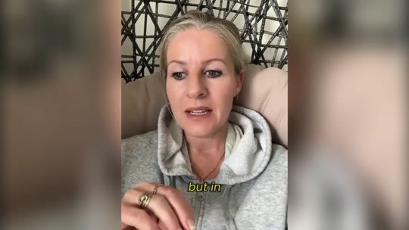  📷 49:19 — Sarah, de Chicago, de moletom cinza falando à câmera; legenda 'but in'  b21_sarah_chicago_moletom_cinza_00-49-19.jpg |   📷 49:29 — Frascos Soul Flush com velas; legenda 'bought the'  b21_frascos_soul_flush_sarah_bought_00-49-29.jpg
  📷 49:41 — Estudantes em sala de aula; legenda 'class'  b21_estudantes_sala_de_aula_00-49-41.jpg | 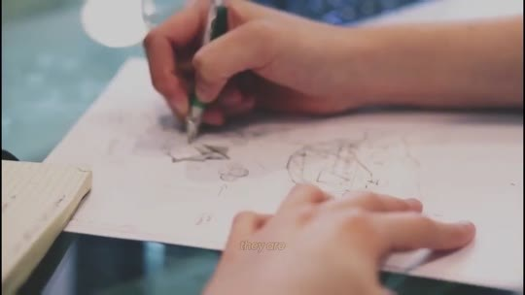  📷 49:44 — Mão desenhando a lápis; legenda 'up on'  b21_mao_desenhando_lapis_00-49-44.jpg
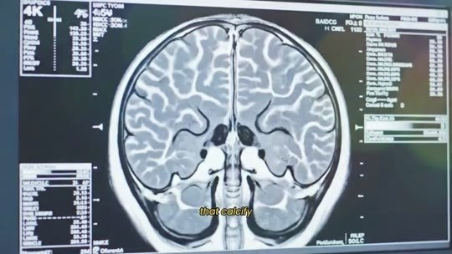  📷 49:51 — Ressonância de cérebro em monitor; legenda 'that safely'  b21_ressonancia_cerebro_monitor_4k_00-49-51.jpg | 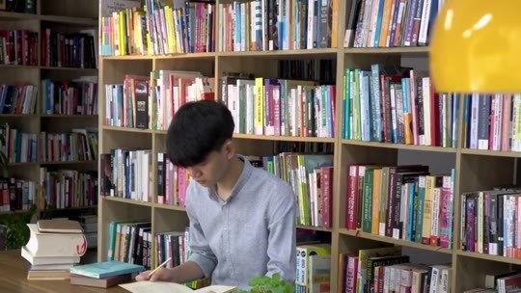  📷 50:02 — Estudante na biblioteca; legenda 'focus'  b21_estudante_biblioteca_focus_00-50-02.jpg

SARAH, DE CHICAGO (pergunta): Mas, no último mês, o foco dele ficou absurdo, as notas dispararam e, ontem, recebemos a carta. Ele foi aprovado na Faculdade de Engenharia do MIT. Minha única preocupação é: é seguro ele tomar o Soul Flush sendo tão novo?
THERESA CAPUTO (narradora): Margaret, de… Primeiro, que bênção enorme. Meus parabéns ao seu menino, e fique em total paz. Não faz mal nenhum. Pelo contrário, o que acontece com a nossa juventude hoje parte o meu coração. Eles não são maus alunos nem preguiçosos. A verdade é que a água e a comida nas escolas estão cheias de flúor e toxinas que calcificam a glândula pineal deles muito cedo. Isso gera essa névoa mental, ansiedade e falta de foco. O que o Soul Flush fez não foi dar inteligência ao seu filho, ele só dissolveu o cimento que estava bloqueando a mente brilhante que Deus já tinha dado a ele.

21.5 ⏱ 50:08 → 50:50
  📷 50:08 — Theresa Caputo em estúdio; legenda 'my recommendation'  b21_theresa_estudio_my_recommendation_00-50-08.jpg |   📷 50:14 — Estudante escrevendo; legenda 'keep your'  b21_estudante_escrevendo_keep_your_00-50-14.jpg
  📷 50:21 — Célula dourada em animação; legenda 'shielded'  b21_celula_dourada_pineal_shielded_00-50-21.jpg | 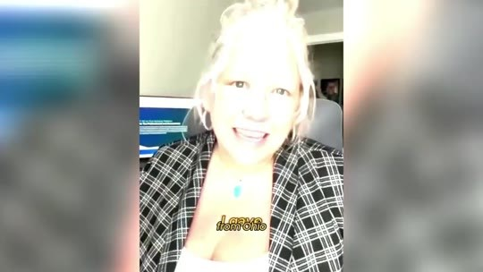  📷 50:24 — Claire, de Ohio, de camisa xadrez falando à câmera; legenda 'I gave'  b21_claire_ohio_camisa_xadrez_00-50-24.jpg

📷 50:46 — Frascos Soul Flush com velas; legenda '6-bottle pack'
b21_frascos_soul_flush_6_bottle_pack_00-50-46.jpg

THERESA CAPUTO (narradora): Minha recomendação para todas as mães: quando os seus filhos forem para a faculdade, coloquem alguns frascos na mala deles. Mantenha a antena do seu filho limpa e o corpo dele blindado, e você nunca mais vai perder noites de sono se preocupando com o futuro dele lá fora. A 4ª pergunta é da Claire, de Ohio.
CLAIRE, DE OHIO (pergunta): Dei algumas gotas do meu frasco para… dei um pouco para a minha mãe testar, e em 3 dias as dores de cabeça crônicas dela pararam. Vou comprar o pacote de 6 frascos agora mesmo para garantir. Mas, Teresa, e se a elite conseguir derrubar o seu site antes de eu terminar os meus 6 meses? Eu perco a proteção?
THERESA CAPUTO (narradora): Essa é a pergunta mais importante de todas. Não, querida, é exatamente por isso que recomendo o pacote de 6 frascos.

21.6 ⏱ 50:50 → 51:24
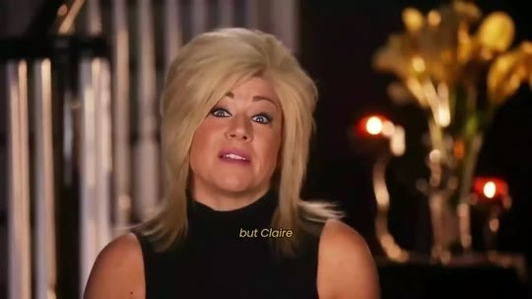  📷 51:05 — Theresa Caputo em estúdio; legenda 'but Claire'  b21_theresa_estudio_but_claire_00-51-05.jpg |   📷 51:10 — Laptop com 'This Page Is Temporarily Unavailable'; legenda 'take down'  b21_laptop_this_page_is_temporarily_unavailable_00-51-10.jpg
  📷 51:16 — Seis frascos Soul Flush; legenda 'Choose your 6-bottle pack'  b21_frascos_soul_flush_6_pack_final_00-51-16.jpg |   📷 51:24 — Theresa Caputo em estúdio; legenda 'the other side'  b21_theresa_estudio_the_other_side_00-51-24.jpg

THERESA CAPUTO (narradora): Ao completar os 6 meses, a película protetora da sua glândula estará completamente formada. A blindagem se torna permanente. Mesmo que me silenciem, mesmo que você nunca mais encontre o Soul Detox na internet, você estará protegida e conectada. Mas a Claire tocou no ponto certo. A pressão para tirar este vídeo do ar é gigantesca. Eu realmente não sei se amanhã esta página vai estar funcionando. Então não conte com a sorte. Escolha o seu pacote de 6 frascos, clique no link abaixo e finalize o seu pedido agora. Vou preparar a sua caixa pessoalmente. Estou esperando por você do outro lado.

