HONEYFIL MALE 26/10 — Transcrição + Prints
Fonte: HONEYFIL MALE 26/10 (.mp4, 52:12, 404x720 vertical, 278 MB; recebida via Google Drive em 28/10/2026). Transcrição: AssemblyAI (speaker labels) a partir do áudio original. Tradução fiel: nomes, marcas, valores em dólares, polegadas e referências dos EUA mantidos exatamente como falados.
Timing: cada mini-bloco traz o intervalo de tempo x → y em que aquela fala acontece no vídeo. Prints: 281 frames dos momentos mais importantes (lettering, provas, personagens, produto, oferta, bônus), nomeados bN-M_descricao_HH-MM-SS.jpg na pasta frames/. Marca d'água "CBS NEWS" aparece no canto inferior direito de praticamente todo o vídeo a partir de 5:41.
Falantes (papéis atribuídos pelo conteúdo, a partir da diarização automática; "imagem/voz sintética" = figura pública reproduzida por IA/deepfake): ATRIZ ADULTA (clipe) · NARRADOR (voz em off) · ELON MUSK (imagem/voz sintética) · DR. MICHAEL CARTER (urologista) · HOMEM (depoimento) · CEO FARMACÊUTICO (chamada de vídeo) · DR. MEHMET OZ (imagem) · AMIGO DO ELON (depoimento) · DRA. ANNIKA ACKERMAN (uróloga) · MULHER/ESPOSA (depoimento) · PRODUTORAS DO BÔNUS (clipe) · DR. DAVID SAMADI · WILL SMITH (imagem/voz sintética)
Correções de transcrição (ASR): nome do produto normalizado para 'HoneyFil' (ASR: Honeyphil/HoneyPhil/Honeyfill; o frasco diz HONEYFIL FOR MEN MALE PERFORMANCE); 'icarian/Icarin/Icaren' → 'icariin' (icariina); reticências (…) e frases cortadas indicam cortes de edição no áudio original. Conteúdo sexual explícito transcrito/traduzido como falado.

Estrutura da VSL (22 blocos)
BLOCO 1 — LEAD / GANCHO: o ritual do mel, Rogan, "Pfizer tentou matar o Elon", Riley Reid e a promessa — 0:00 → 5:31
BLOCO 2 — ELON ENTRA: recusa o dinheiro, a história (a esposa, o Viagra, as bombas, o armário) — 5:32 → 9:58
BLOCO 3 — A INVESTIGAÇÃO: Viagra, o estudo da Nature (37.000 mortos), xenotoxinas, a placa que "não é colesterol" — 9:59 → 12:11
BLOCO 4 — A DESCOBERTA: mel vermelho do Himalaia + 3 ingredientes, o mecanismo (Doppler, testosterona, o composto) — 12:11 → 16:42
BLOCO 5 — O PRIMEIRO TESTE DO ELON: a noite, as veias, "algo enorme nas mãos" — 16:43 → 17:50
BLOCO 6 — DR. MICHAEL CARTER: o mel vermelho, a icariina, os 3 compostos e os 120 pacientes — 17:50 → 20:15
BLOCO 7 — DEPOIMENTOS DO GRUPO (John 72, James 74, Richard 53) + o "red honey challenge" — 20:15 → 21:55
BLOCO 8 — A LIGAÇÃO DO CEO FARMACÊUTICO e a decisão de fazer sozinhos — 21:55 → 23:18
BLOCO 9 — NEPAL: o mel que não se compra; o laboratório da Neuralink em Woodinville; nasce o HoneyFil — 23:19 → 25:00
BLOCO 10 — INDÚSTRIA ADULTA + DR. OZ: o voluntário de 79 anos, "this works" — 25:00 → 27:23
BLOCO 11 — DEPOIMENTOS: TRT, o amigo do Elon, 81 anos, "as pílulas nem funcionavam" — 27:23 → 28:37
BLOCO 12 — RECAP DO MECANISMO + DRA. ANNIKA ACKERMAN + "100% SAFE" — 28:37 → 30:36
BLOCO 13 — PREÇO: "nem eu nem o Elon ganhamos um centavo", Nepal, a esposa, a humilhação e a garantia de 60 dias — 30:36 → 33:30
BLOCO 14 — OFERTA: subsídio da Neuralink, "o menor preço que já cobramos", os advogados da Pfizer — 33:30 → 34:44
BLOCO 15 — ELON INTERROMPE: Nobel, os primeiros 20, o iate e a hostess — 34:45 → 36:36
BLOCO 16 — BÔNUS 1 "The Lesbian Trick", o botão verde, o contador no canto da tela, checkout seguro — 36:37 → 39:12
BLOCO 17 — DEPOIMENTO DO IATE + DR. DAVID SAMADI + 77% reivindicados + bônus 2 e 3 (posições, textos, "a sala") — 39:12 → 43:07
BLOCO 18 — WILL SMITH / JADA + atriz + recap do Dr. Michael — 43:07 → 45:19
BLOCO 19 — CENSURA: "enterrado", os hackers, "eles falharam desta vez" — 45:20 → 46:02
BLOCO 20 — KINSEY 67%, as 2 escolhas, o botão de $294 e o CTA — 46:02 → 47:40
BLOCO 21 — DEPOIMENTOS DAS ESPOSAS: "comprei escondido", "joguei o vibrador no lixo" — 47:40 → 49:15
BLOCO 22 — FAQ COM O ELON + CTA FINAL — 49:15 → 52:04

PARTE 1 — TRANSCRIÇÃO EM INGLÊS POR BLOCOS

BLOCO 1 — LEAD / GANCHO: o ritual do mel, Rogan, "Pfizer tentou matar o Elon", Riley Reid e a promessa [0:00 – 5:31]

1.1 ⏱ 0:00 → 0:30
ATRIZ ADULTA (clipe): Oh, gosh. Today, I had sex with a 70-year-old man who had an 8-inch dick, all because he did the damn honey trick in the shower. If your performance in bed isn't what it used to be, just take 1 spoonful of honey and 2 secret ingredients and leave any woman hooked. The Elon Musk Foundation spent billions of dollars to discover the cure for erectile dysfunction, and he finally developed this dirty pre-shower honey trick. So stick around in this video to discover the recipe.

1.2 ⏱ 0:37 → 0:43
NARRADOR (voz em off): They blew up Elon's car last Tuesday. The guy saved thousands of men's dicks and they tried to silence him forever.

1.3 ⏱ 0:43 → 0:51
ATRIZ ADULTA (clipe): The video where I showed everyone what the fuck Elon Musk does in the bathroom to fuck me harder than a porn star is blowing up on TikTok. Stop sharing it.

1.4 ⏱ 0:51 → 1:27
NARRADOR (voz em off): Every American will hear this now. They tried to murder Elon Musk for exposing why 40 million men over 50 are going soft. Any man who can't last 5 minutes needs to hear this outrageous story. Former adult film actress Riley Reid could be arrested today, 24 hours after posting a video you are going to see at the end of this one. She flat out revealed the dirty bathroom ritual every porn actor over 50 uses to fuck 4 women in one night without ever going soft. And she says it is exactly because of this dirty shower trick that the most famous actors on Pornhub keep getting more and more potent, even at 50 or 60 years old.

1.5 ⏱ 1:27 → 1:46
ATRIZ ADULTA (clipe): The porn industry relies on this honey ritual daily to turn men into sex machines. It is almost like breathing to them. Almost every major studio uses it now. They have dropped Viagra completely. No heart risk, no soft scenes, no actor losing his erection mid-take. Just thick, veiny cocks ready to wreck whoever is on set that day.

1.6 ⏱ 1:47 → 2:01
NARRADOR (voz em off): It is a super discreet homemade mixture you apply directly on your penis. Do this before your shower today and you will never face a doctor again. Mix it at home in 5 minutes. Stroke it in for 13 seconds. Done.

1.7 ⏱ 2:01 → 3:09
NARRADOR (voz em off): By the second day, you wake up with your cock so hard it tents the sheets. What I am about to reveal is the secret ritual porn actors who sleep with me always pulled before a scene. The reason their cocks are so thick I drool just trying to fit it in my mouth. A bathroom trick that explains how adult industry icons like Johnny Sins and Mick Blue Still nut 3 times a session past the age of 50. None of them are relying on pills, pumps, or surgery. Their cocks throb harder at 60 than any of the boyfriends I had in my 20s ever did. I spent my entire career obsessed with just one thing: getting pounded after treating men who perform like animals and finding out exactly what they do to make that happen. And trust me, it has nothing to do with age, Genetics or testosterone shots. Do this and you will fuck all night, stretching her so deep she bites the pillow, and even the hottest 22-year-old slut in your city will tap out and beg you to slow down before she squirts on you again.

1.8 ⏱ 3:09 → 3:52
NARRADOR (voz em off): If you are married, watch out for the women at the gym, at the office, your wife's friends, the MILF next door, even the divorced mom dropping her kid off at The second they catch your scent, they go feral and find a way to corner you alone. Besides porn actors, this trick has already given more than 15,000 Americans over 50 their cocks back, and now their wives are the ones taking days off work, walking funny, texting their friends that something just snapped their husband back into his 30s. The US Army has also used this ritual for over 40 years to boost testosterone in soldiers without wrecking their hearts. Strong instant erections were the side effect nobody complained about.

1.9 ⏱ 3:52 → 4:43
NARRADOR (voz em off): 230,000 selected veterans went through the protocol between 1982 and last year, and not a single cardiac incident was logged. Elon Musk spent 7 years locked inside his private Neuralink lab developing this honey ritual. He never planned to release it this way, but after learning what Pfizer would do to bury it, He decided to leak the recording himself on X. Pfizer's stock bled $3.2 billion in 48 hours. That same week, Elon's car exploded outside his Austin estate. He survived. His driver did not. The FBI closed the case in 72 hours, calling it an electrical fault. That is when Elon decided to record a second video from an undisclosed location, going way beyond what he first leaked. Leaked.

1.10 ⏱ 4:43 → 5:31
NARRADOR (voz em off): Now you can say goodbye to a soft, dead dick. Start getting rock hard for hours, making your wife scream your name, roll her eyes back, and squirt 3 times in a single night from how deep you were splitting her open. Never again hearing, do not worry, it is normal, let us try another time. Instead, every night, please fuck me hard like last time. Gagging, drooling, opening her tight little ass with both hands for you to come inside. If you want this, Pay very close attention because what you are about to see is the video Elon Musk recorded from his undisclosed location where he shows exactly how to do this honey ritual before shower and exposes Pfizer's plan to make 80% of American men dependent on Viagra by 2029. Let's go.

BLOCO 2 — ELON ENTRA: recusa o dinheiro, a história (a esposa, o Viagra, as bombas, o armário) [5:32 – 9:58]

2.1 ⏱ 5:32 → 6:18
ELON MUSK (imagem/voz sintética): I don't know if you're watching this in a presentation mixed with porn clips or just clean while we fight Big Pharma censorship. You probably know me as intelligent rockets and Teslas, but my real obsession for the past years has been Neuralink, one of the most advanced biotech laboratories Over $5 billion invested into understanding how the human body sends and receives the signals that keep you functional and virile. And if you're a straight man, I'm about to show you the most important discovery Neuralink has ever produced. A homemade natural solution that reverses erectile dysfunction at the root. Permanently. No Viagra, no Cialis, no injections, no recipe, no dangerous pills that put your heart at risk. I'm talking about a simple movement That any man can do today without leaving the bathroom. Last week, Pfizer offered me $18 billion to walk away from this project. I refused.

2.2 ⏱ 6:19 → 7:28
ELON MUSK (imagem/voz sintética): No amount of money changes what I'm about to do because I lived through this myself. For years, I was the man who had everything and couldn't get hard to satisfy the only woman I ever truly loved. The people who look at me and only see a crazy Republican billionaire workaholic hooked on knocking up models, they're not wrong. I've always loved sex. And I never held back. Money was never an issue, and I had the most beautiful young women on the planet in my bed. I never used a condom in my life. I came inside every single one of them. If she was just there for one night, she still got everything I had. And 14 kids scattered across the world are the proof of that. For 3 decades, that was my life. Fuck hard, come deep, sleep well, and work. My cock never let me down, not once. Until Sophia. You've probably never heard of her, and she wanted it that way. She hated the spotlight. She desired me because I was a man, not the Elon Musk. And for the first time in my life, I didn't want just sex and come back to work. I wanted her for the rest of my life. Growing old together, build a real home, everything I never wanted with other women. And that was exactly the moment my body decided to betray me. The first time it happened, I couldn't believe it. But she just smiled and said it was fine, that we'd try again later.

2.3 ⏱ 7:28 → 8:34
ELON MUSK (imagem/voz sintética): But I saw it in her eyes. That mix of patience and confusion, That's worse than any insult a man can hear. The next night, same thing. And the night after, and the night after that. I started to panic. How the hell was I flooding women I barely knew for 30 years straight and now going flaccid on top of the one who actually mattered? I brought the best urologists in the world into my house. Tested Viagra, Cialis, the Vicks bullshit, pumps, testosterone shots. Every new humiliation Failing faster than the last. My dick stayed dead. And I was exhausted on top of it, dragging myself through meetings like a zombie. Sophia started to pull away, slowly, silently. Then one night, she just rolled over, turned off the light, and stopped trying. We slept in the same bed and lived on different planets. In my desperation, I started reaching for things money could buy when love couldn't. I told myself, maybe it was her. Maybe with someone younger, hungrier, less familiar, My body would wake up. It didn't. I failed with them too, and after years of loving each other more than everything, she left.

2.4 ⏱ 8:35 → 9:40
ELON MUSK (imagem/voz sintética): She packed her bags the next morning while I sat on the floor of the closet, watching her fold clothes I had bought her, unable to say a single word to stop her. I lost the only woman who ever truly knew me. Not over money, over the one thing all my billions couldn't fix. That was rock bottom for me. I swore to myself that night, that if a real solution existed out there, I'd find it, no matter what it cost, no matter who tried to stop me. And I want you to remember that promise, because in the next 2 minutes, you're gonna see exactly how I got Sophia back, how she begged to come back to me, and how you can wipe out erectile dysfunction for good, spending less than $3 at Walmart and without leaving your house. After I lost Sophia, I stepped away from everything to think. How the hell is it possible that the richest man in the world, with the best urologists in his pocket, and the most expensive treatments money can buy, cannot fix something as simple as his own erection. I called every specialist I had ever met through Neuralink. One of them was Dr. Michael Carter, a urologist obsessed with solving erection problems, and the same guy the biggest adult film studios call when they need to bring an actor back from impotence.

2.5 ⏱ 9:40 → 9:58
ELON MUSK (imagem/voz sintética): He was way further along on the subject than anyone else I knew, and Michael flipped my entire understanding upside down. He told me the real cause of erectile dysfunction has nothing to do with low testosterone, lack of nitric oxide, Age, stress, or watching porn. None of that. All bullshit they made up to push useless products on you. Think about it.

BLOCO 3 — A INVESTIGAÇÃO: Viagra, o estudo da Nature (37.000 mortos), xenotoxinas, a placa que "não é colesterol" [9:59 – 12:11]

3.1 ⏱ 9:59 → 11:02
ELON MUSK (imagem/voz sintética): When you take Viagra, does any doctor ask about your hormone levels? Does anyone investigate your mind? Of course not. The pill only does one thing. It forces your cock to get up by brute force for a few minutes. Because the only way to have a real erection is with blood, a lot of blood entering your shaft. Viagra just dilates the veins, pushes that blood inside your cock, and it rises. Simple as that. But it solves jack shit. It is just an artificial push, a cock makeup that lasts a few minutes and leaves you worse than before. And the most disgusting part, a lot of guys become so dependent on that shit, they end up more impotent than when they started. The body stops reacting on its own, and without realizing, the guy who wanted more power ends up losing everything. Now imagine the scene. You depend on an expensive pill every time you want to fuck, only to later discover that same pill is destroying your heart. and leaving you even softer. A study in Nature was clear as day. Continuous use of those drugs increases the risk of heart attack by 17 times. That is what they are selling you— poison.

3.2 ⏱ 11:02 → 12:11
ELON MUSK (imagem/voz sintética): The same poison that killed over 37,000 American men from heart attacks and strokes in just the last 12 months. If Viagra and all that trash do not really work, what is the real solution? The answer is simple. Direct, and nobody has the guts to say it. You need to unblock the veins in your cock. Over time, toxic plaques start building up in the vessels that feed your erection. Your cock does not fill anymore because blood cannot get through. For years, doctors swore the problem was cholesterol. But the latest studies from Johns Hopkins University showed the naked truth. Over 98% of those plaques are caused by a specific group of toxins in the blood. Called xenotoxins, also known as carnivore toxins, because they keep feeding themselves off your blood like a parasite. Not cholesterol. When Viagra dilates the veins, those plaques dilate along with them, and the path stays blocked, barely improving anything. The only way to get real erections back— hard, natural, spontaneous— is to clean those veins, eliminate those disgusting xenotoxin plaques, and make blood flow like when you were 20. And that is exactly what Michael and I found.

BLOCO 4 — A DESCOBERTA: mel vermelho do Himalaia + 3 ingredientes, o mecanismo (Doppler, testosterona, o composto) [12:11 – 16:42]

4.1 ⏱ 12:11 → 13:20
ELON MUSK (imagem/voz sintética): We discovered a powerful combination using Himalayan honey and 3 more simple ingredients that you can find anywhere on the planet. This homemade formula is behind the steel erections that have saved thousands of marriages. And from now on, it can be what changes your story too. This brutal combination can eliminate up to 97% of the xenotoxin plaques built up in any man's penile veins Regardless of age. Scientific data confirmed by Johns Hopkins researchers. We first tested the protocol on over 1,200 men through Neuralink, many already over 70, and the result was simply shocking. When the red honey is used the right way, together with the specific ingredients we discovered, it starts cleaning the blood and dissolving the xenotoxin plaques choking the vessels that feed your cock. Over the years, shitty eating, constant stress, Med use, and environmental toxins poison those vessels from the inside. They inflame, harden the walls, and form blocking plaques that clog the flow. And without flow, no erection. Not even half a boner. Nothing. The Himalayan red honey kicks in by hunting down those xenotoxins and dissolving them naturally and progressively. What happens next is simple.

4.2 ⏱ 13:20 → 14:29
ELON MUSK (imagem/voz sintética): Your cock fills back up like a fire hose on a burning day. Solid, long-lasting, 100% natural erections. As if impotence never existed. In Doppler ultrasound exams before and after the ritual, doctors observed up to 430% increase in direct blood flow to the cock. And this in a matter of days, not weeks or months, days. Your cock gets so much blood pressure, it makes it thicker, longer, harder than an iron bar. And every new erection makes it even harder and bigger. So the more sex and the more jerking off, the better, to make your cock the size of a baseball bat. And there is more. This ritual also gives a natural boost to your testosterone, increasing levels by up to 207%. No injections, no replacement, no risk. But pay close attention. Pumping testosterone does nothing if your penile veins are clogged like old pipes. When those veins are clean and blood flows freely, that is when testosterone kicks in full force, igniting your libido, hardening your erection, and turning you into a real animal in bed. You last all night with solid, heavy erections that feel like stone. Any man, no matter the age, can feel like a king in bed.

4.3 ⏱ 14:29 → 15:37
ELON MUSK (imagem/voz sintética): This is the end of erectile dysfunction. The rebirth of the confidence that makes your partner wet just looking at you in your underwear, even if she has already gone through menopause. It is what will make your daughter's friends unable to take their eyes off your giant wood bulging in your shorts. But even after seeing the tests at Neuralink, Before I put a single drop of this in my own body, I still needed to see it working right in front of me. So we pulled a live sample of the exact toxic plaque choking blood flow in millions of American men right now. Inside this container with this clear liquid, we have the pure compound that the Himalayan red honey releases into your body to dissolve the toxic plaques blocking the blood vessels of your cock. It's called icarian. And right here in this container, we have a dark liquid that represents the xenotoxins. The same carnivore toxins obstructing your vessels right now as you watch this. Watch what happens when the Icarin comes into contact with these toxins. Instantly eliminated. And not only that, after this compound enters your body, your vessels become practically armored against new obstructions. See what happens when the same xenotoxins try to deposit again. Instantly.

4.4 ⏱ 15:38 → 16:42
ELON MUSK (imagem/voz sintética): The compound already present in your body neutralizes everything. This is how your vessels stay clean and your erections stay strong. After the lab test, I was already convinced. I'd been lied to by every pill, every doctor, every treatment money could buy. I didn't want another promise. I wanted my dick back, and I wanted it now. So I became the first test subject. The red honey ritual every morning, first thing, on an empty stomach. The first 2 days, nothing. I almost gave up. Day 3, I woke up at 4 in the morning with a hard-on I hadn't felt in 15 years. Thick, heavy, pulsing against the sheets. By the end of the first week, I wasn't waking up soft anymore. I was waking up hard like a teenager, every single morning. And the night Sophia finally agreed to come see me again, what happened in that bedroom was something I'll never forget. I bent her over the same bed I'd failed in 100 times. The second I slid in, her eyes rolled back. She let out a moan that sounded like a porn star. I fucked her for almost 3 hours straight, on the bed, Against the wall, on the floor.

BLOCO 5 — O PRIMEIRO TESTE DO ELON: a noite, as veias, "algo enorme nas mãos" [16:43 – 17:50]

5.1 ⏱ 16:43 → 17:13
ELON MUSK (imagem/voz sintética): She came over and over until she was begging me to stop, soaking the sheets through, her legs shaking so bad she couldn't stand up. And when I finally came, I didn't go soft. My cock stayed hard as a steel bar, like I was still ready for another round. Because I was. The next morning, she looked at me like I was a different man and told me she'd never been fucked like that in her life, not even when we were young. And when I measured myself a few weeks later, I almost dropped the tape. I'd gone from 5.8 inches to 7.4. Thicker. Heavier.

5.2 ⏱ 17:13 → 17:50
ELON MUSK (imagem/voz sintética): Veins running down the shaft I hadn't seen since I was 20. That's when I knew I had something massive on my hands. That through Neuralink, millions of American men going through what I went through could get their manhood and their confidence back. Without selling their lives to Big Pharma. So, we gave it to a group of men first. Real men, real cases, the worst ones I could find. Men who'd given up. But before you see what they sent back, I want you to meet Dr. Michael and pay attention to every word he says, because this will make you virile again today at your home without spending a dime. If I'm still fucking every day at 55 like a 19-year-old, it's because of what he's going to show you now.

BLOCO 6 — DR. MICHAEL CARTER: o mel vermelho, a icariina, os 3 compostos e os 120 pacientes [17:50 – 20:15]

6.1 ⏱ 17:50 → 18:59
DR. MICHAEL CARTER (urologista): Thank you, Elon. I'm going to reveal exactly how any man can turn a flaccid cock into a thick, veiny log that only comes when you want. There are 4 ingredients in this ritual that together are so potent for male virility that men in their 70s are coming back to The first is the most important, and Elon already mentioned it: the Himalayan red honey. High in the Himalayas lives a rare species of giant bee. These bees feed on flowers that grow nowhere else on the planet, and they produce a thick, dark, reddish honey the locals call mad honey. For centuries, only the strongest men of these villages were allowed to harvest it, risking their lives for a few pounds of it. It was never food; it was sacred. The reason these men father children at 80 while the rest of the world goes soft at 40? When I brought it back to my lab and analyzed it, I understood why. This red honey carries the highest concentration of a compound called icarian ever found in nature. Nothing else on Earth comes close. Icarian does one thing no drug can do. It hunts down the xenotoxin plaques choking your blood vessels and dissolves them. It breaks the buildup apart, flushes it out, and clears the highway so the blood can finally flood through to your cock again. But Elon and I knew the red honey alone wasn't enough.

6.2 ⏱ 19:00 → 20:03
DR. MICHAEL CARTER (urologista): So I combined it with 3 more compounds, each one attacking a different part of the damage. The second ingredient is concentrated horny goat weed. Every man over 40 has heard of it, and there's a reason. With the plaque gone, the vessels have to open wide. Horny goat weed forces them into a brutal expansion, driving up to 500% more blood into the penis, making you thicker and harder than you've been in decades. The third is PT-141, the sex peptide. The biggest names on Wall Street pay $2,000 a month for. Years of poison kill a man's drive. PT-141 hits the pleasure center of your brain directly, so the desire roars as loud as the erection. The 4th is Ashwagandha root, standardized to the highest potency ever produced. This locks it in. It pushes your body to make its own testosterone again, the way it did at 20, keeping you hard long after other men give up. 4 compounds, 4 stages, 1 complete reversal. First, the red honey clears the plaque. Then Horny Goat Weed opens the vessels. PT-141 brings back the drive. And Ashwagandha rebuilds your natural power. This is the exact combination that turned Elon's manhood back from the dead.

6.3 ⏱ 20:03 → 20:15
DR. MICHAEL CARTER (urologista): And it's the same combination I tested on over 120 of my own patients, with severities ranging from soft erections to men who hadn't gotten hard in over 15 years. These are the videos they sent me after the test.

BLOCO 7 — DEPOIMENTOS DO GRUPO (John 72, James 74, Richard 53) + o "red honey challenge" [20:15 – 21:55]

7.1 ⏱ 20:15 → 20:23
HOMEM (depoimento): On the 3rd day, my cock was already hard like a baseball bat. What the fuck is this formula, man? I'm fucking my wife 3 times a night.

7.2 ⏱ 20:24 → 21:02
DR. MICHAEL CARTER (urologista): This morning I woke up with my cock throbbing. She came twice before I even finished the first time. Almost all of them reported insane erections in the first week. About 98% said they were fucking for over an hour without coming, literally breaking the bed and their wives. Men from 35 to 80 years old thanked me for giving back the virility they thought they'd never have again. And phrases like, I never felt this before, became routine on my phone. The wives began pleading for mercy after their husbands came 2 or 3 times that night. The craziest part? Nobody had to quit drinking. Nobody had to quit smoking. Nobody went on a diet. No miracle capsules. No chemical pills.

7.3 ⏱ 21:03 → 21:16
DR. MICHAEL CARTER (urologista): Just the red honey formula. Some patients even recorded themselves having sex after the ritual. I thought it was bizarre, but they were loving the reputation of being total studs, and women were practically throwing themselves at them wanting to fuck. See for yourself.

7.4 ⏱ 21:16 → 21:23
HOMEM (depoimento): I'm gonna do the red honey Challenge right now and test it in a real fuck. I don't get how this thing works, but look what it does to my cock.

7.5 ⏱ 21:23 → 21:55
DR. MICHAEL CARTER (urologista): They aren't exceptions. They are living examples that virility can be recovered without depending on pharmacies, without poisoning yourself with chemicals, just with the right ritual applied the right way. When we finally proved this ritual cleared the plaques, made blood flow full force, and brought back testosterone like a man in his 20s, our goal was simple: get this into the hands of every American man fighting a soft cock, without them having to spend a single cent. That's where Elon went all in. He mobilized his personal money and the full weight of Neuralink behind this project. The research was solid.

BLOCO 8 — A LIGAÇÃO DO CEO FARMACÊUTICO e a decisão de fazer sozinhos [21:55 – 23:18]

8.1 ⏱ 21:55 → 22:11
DR. MICHAEL CARTER (urologista): The lab tests were undeniable. All we needed was a manufacturer in the United States capable of producing this at scale. So Elon called the CEO of one of the largest pharmaceutical labs in the country, a man he'd worked with for years. He recorded the call and had to censor the guy's voice, but listen closely to what he told Elon.

8.2 ⏱ 22:12 → 22:39
CEO FARMACÊUTICO (chamada de vídeo): Elon, let me be straight with you. Do you understand what this does to our business? The man with erectile dysfunction is worth somewhere between $40,000 and $70,000 to us over the course of his life. Viagra, Cialis, follow-up prescriptions, side effect treatments. If we manufacture something that reverses ED in record time at the root, we lose billions in annual revenue overnight. It doesn't make any sense to help you with this.

8.3 ⏱ 22:39 → 22:42
ELON MUSK (imagem/voz sintética): But think about the men, the marriages we could save.

8.4 ⏱ 22:42 → 22:54
CEO FARMACÊUTICO (chamada de vídeo): You want to change this world, Elon. I'm not. We're not going to do this. And honestly, I'd reconsider how far you want to push this. There are people who don't want this solution out there. People who play harder than I do.

8.5 ⏱ 22:55 → 23:18
DR. MICHAEL CARTER (urologista): That call shook both of us. The system doesn't want you fixed. It wants you medicated. Monthly. Forever. So Elon made a decision that night. We were going to do this ourselves. No partners. No middlemen. No industry gatekeepers standing between this discovery and the men who needed it. He flew straight to Nepal the next week and started building the entire structure himself. He sent me the videos of what he was doing on the cliffs.

BLOCO 9 — NEPAL: o mel que não se compra; o laboratório da Neuralink em Woodinville; nasce o HoneyFil [23:19 – 25:00]

9.1 ⏱ 23:19 → 23:50
ELON MUSK (imagem/voz sintética): The red honey is not a commodity. You can't buy it, you can't manufacture it. It only exists here on these cliffs. So I invested directly in the region. I funded the construction of dedicated harvesting and processing stations with the local villagers, the same families who've been collecting this honey For centuries. This is what we built. Hundreds of hives harvested by hand, each batch tested for icariin concentration before it leaves the mountain. What gets shipped to the United States is the same honey those villages have been using for 1,000 years.

9.2 ⏱ 23:51 → 25:00
DR. MICHAEL CARTER (urologista): Once the honey arrives in the United States, it goes to the laboratory Neuralink built in Woodinville, Washington. FDA registered, GMP certified, equipped with the most advanced extraction and blending technology in the country. It's where the Icaren gets concentrated and combined with the Horny Goat Weed, the PT-141 peptide, and the Ashwagandha root in the exact proportions I spent years perfecting. Each bottle easily costs over $1,000 to produce, but Elon decided to pay for it out of his own pocket, so any man who finds this message in 2026 can get 6 bottles delivered to his door, completely free, with the red honey already concentrated, dosed, and mixed with the other 3 compounds in a single gummy. The formula became known as HoneyFil. Just stay with me for the next 3 minutes and you'll be able to claim up to 6 months of treatment without spending a dime. The fastest way we knew to prove HoneyFil worked was to put it in the hands of the men who can't afford to fail in bed: the adult film industry. Convincing them wasn't easy. They were already hooked on Viagra and Cialis. They couldn't believe a natural formula could outperform what they'd built their careers on. Elon went straight to the biggest studios, handed a free bottle to every actor shooting that The feedback came back faster than we expected.

BLOCO 10 — INDÚSTRIA ADULTA + DR. OZ: o voluntário de 79 anos, "this works" [25:00 – 27:23]

10.1 ⏱ 25:00 → 25:24
ATRIZ ADULTA (clipe): It's insane what's happened with the actors since they started taking HoneyFil. Yesterday I shot with a guy in his 60s. He took HoneyFil and made me squirt 4 times on this couch. Every scene I shoot now ends with me dripping. My friends shooting with these guys say the same thing. The cocks are thicker, veinier. They stay hard for 2 hours straight without slowing down. And then the men kept pounding them for over 2 hours straight. Viagra never did that.

10.2 ⏱ 25:25 → 25:40
HOMEM (depoimento): I used to depend on Viagra, but it was a nightmare. The dizziness, the heart palpitations. I was scared of having a heart attack mid-scene. After Elon gave me a bottle of HoneyFil, I'm shooting 4 scenes in a row. Before, I could barely do 2. My cock, which wasn't small, gained 2 inches. Thicker, veinier.

10.3 ⏱ 25:40 → 25:45
ATRIZ ADULTA (clipe): There's not a single scene I film after the HoneyFil hype that does not leave me squirting all over from pure ecstasy.

10.4 ⏱ 25:45 → 26:01
DR. MICHAEL CARTER (urologista): But the real test came from Dr. Mehmet Oz. We gathered every piece of research, the lab tests, the testimonials from the adult film stars. Elon personally handed him a bottle of HoneyFil. He told us he'd test it on a volunteer himself before backing it publicly. 3 weeks later, he sent us a video.

10.5 ⏱ 26:02 → 26:32
DR. MEHMET OZ (imagem): I personally tested HoneyFil on a volunteer, 79 years old, diabetic, high blood pressure. For over 10 years, he hadn't been able to get a single erection. Day 4, he woke up with a full erection, hard as a rock. His wife looked at him and said, Where's my husband? What did you do with him? After 3 weeks, this man told me he no longer feared performance problems in bed. Elon, Michael, this works. I saw it with my own eyes. Throw the blue pills in the trash. HoneyFil is going to save marriages across America. With Dr.

10.6 ⏱ 26:32 → 27:23
DR. MICHAEL CARTER (urologista): Oz's word behind us, HoneyFil was ready for every American man who wanted his manhood back. But let me be clear with you. Elon and I don't have superpowers. We're just 2 men who lived through this And found the way out. Elon lost the only woman he ever truly loved because of impotence, and the only thing that brought her back was the same thing that's about to bring her back to your bed too. Because HoneyFil doesn't just give you a powerful erection, it also makes your body pump pure testosterone, and that releases 2 pheromones, androstenone and androstenol, that hit the female brain directly. That's why it's completely normal for women— the coworker, the cashier at the grocery store, the woman at the gym— to suddenly look at you differently. Without knowing why. You've seen guys who aren't particularly handsome, don't have money, and women line up for them. Ever wondered why? Those men naturally radiate testosterone. With HoneyFil, you will too. Don't be surprised when women start approaching you out of nowhere. This isn't magic, it's pure biology.

BLOCO 11 — DEPOIMENTOS: TRT, o amigo do Elon, 81 anos, "as pílulas nem funcionavam" [27:23 – 28:37]

11.1 ⏱ 27:23 → 27:46
HOMEM (depoimento): I've been on TRT for years and I still had days when my cock wouldn't fully cooperate. Elon sent me a bottle of HoneyFil after he came on the podcast. 6 months in, I don't touch TRT anymore. My My testosterone is higher than it's been since my 20s, blood tests to prove it. At 59, I'm fucking my wife harder than I did at 30. This shit is real, and Elon deserves every ounce of credit for making it public.

11.2 ⏱ 27:46 → 28:02
AMIGO DO ELON (depoimento): Elon is a brother to me. When he told me what HoneyFil did for him, I listened because I was dealing with the same thing and not talking about it to anybody. I used it for 6 months. By the end of the first week, my wife was looking at me different. I know what that look means now. And I can answer it every time.

11.3 ⏱ 28:02 → 28:37
HOMEM (depoimento): I'm 81 years old. I'm not the kind of guy who talks about this publicly, but Elon asked me to try HoneyFil and I trust him. 3 days in, I woke up with something I hadn't felt in years. My wife noticed before I even said a word. Don't wait as long as I did to do something about it. I used pills for years and most of the time not even those worked. When I heard Elon Musk was behind this, I believed it. Elon doesn't mess around with things like this. I got a few bottles of HoneyFil. The craziest part is that on the very first day, my cock felt hard as steel. It gained more than an inch, thicker, visibly more veiny. After 6 months, I never had this problem again.

BLOCO 12 — RECAP DO MECANISMO + DRA. ANNIKA ACKERMAN + "100% SAFE" [28:37 – 30:36]

12.1 ⏱ 28:37 → 29:23
DR. MICHAEL CARTER (urologista): As you've already learned with us, your penile vessels have been clogged by xenotoxin plaques for years. HoneyFil delivers fast results, but to be truly free, permanently fixed, and enjoy the full benefits, especially the 2 to 3 inches gain in size, You need to fully eliminate those plaques. That's why continued use during the first 6 months is essential. The problem is that even though HoneyFil is manufactured in the United States, the red honey comes directly from the Himalayan villages Elon built that station with. That takes time. We run out of stock for long stretches. After the first wave of men got their hands on HoneyFil, they started calling it the porn star hack because it gives any average guy the same sexual performance as professional adult Recently, I couldn't keep my dick hard for 5 minutes.

12.2 ⏱ 29:23 → 29:39
HOMEM (depoimento): My wife pretended it was fine, but I knew her and I knew she needed orgasms. She's always been passionate. After discovering HoneyFil, in 2 weeks I was getting so hard she started asking for sex every day. My tool even got bigger. I never imagined that at this stage of life we'd be fucking this much.

12.3 ⏱ 29:39 → 29:49
DR. MICHAEL CARTER (urologista): HoneyFil became so popular that one of the most respected urologists The United States, Dr. Annika Ackerman, recorded a video calling it the safest and most effective formula in the world.

12.4 ⏱ 29:49 → 30:20
DRA. ANNIKA ACKERMAN (uróloga): Every patient of mine who completed 6 months of HoneyFil fully reversed their erectile dysfunction. Not one of them still struggles to get hard. And more than that, they're now having stronger erections than they had as teenagers. I've seen cases of chronic ED that surgery and implants couldn't fix. Men in their 70s getting an active sex life back. This is without a doubt the best solution ever created. 100% safe, zero side effects. I recommend it to anyone who can stay on HoneyFil for 6 months.

12.5 ⏱ 30:20 → 30:36
DR. MICHAEL CARTER (urologista): No matter how severe your situation is, there is no other product on Earth that can do what HoneyFil does without putting your health at risk. Diabetes, high blood pressure, heart problems— it doesn't matter. HoneyFil works for you safely Regardless of your condition or your age.

BLOCO 13 — PREÇO: "nem eu nem o Elon ganhamos um centavo", Nepal, a esposa, a humilhação e a garantia de 60 dias [30:36 – 33:30]

13.1 ⏱ 30:36 → 31:46
DR. MICHAEL CARTER (urologista): And after everything you've seen here, you might be thinking, I want all of this, but what's it going to cost me? Let me be straight with you. Neither Elon nor I are making a single cent from this. Every dollar from HoneyFil goes back into Neuralink, into producing more bottles, harvesting more red honey in Nepal, and getting this into the hands of as many American men as possible. Before Pfizer shuts us down. Just imagine, Waking up in the morning with a rock-hard erection. Imagine the look on your wife's face when you slide your iron-hard shaft inside her, giving her the kind of pleasure she has not felt in years. That will make you feel like a real man again. Imagine walking down the street with confidence, and wherever you go, your testosterone will radiate like a pheromone, triggering an automatic response in the female subconscious, making women notice you, desire you, and even get But if you do not take action, nothing will change. You will keep dealing with the humiliation of an erection that does not last, that disappointed look on her face, or worse, that awkward silence after another failed night. You know exactly what that means— more nights lying back to back with her, wondering what is wrong with you.

13.2 ⏱ 31:46 → 32:00
DR. MICHAEL CARTER (urologista): Look, I am here to give you a solution and put your mind at ease. There is nothing wrong with you. wrong with you. It is completely normal for men over 40 to experience this. It happened to Elon, and the only thing that fixed them is the same thing about to fix you.

13.3 ⏱ 32:01 → 32:23
MULHER/ESPOSA (depoimento): I always loved my husband, but after he stopped getting hard, our marriage became unbearable. I was even starting to consider divorce. I could tolerate the arguments, but the lack of sex was unbearable. HoneyFil absolutely saved our marriage. Our sex now is wilder than when we first met, and his cock Oh my God, it got huge and veiny. We barely fight anymore, and when we do, we fix it by making love on the kitchen counter.

13.4 ⏱ 32:23 → 32:59
DR. MICHAEL CARTER (urologista): Let's be honest, the worst humiliation a man can experience is seeing frustration in the eyes of the woman he loves the most. Nobody deserves that. That's why we're backing HoneyFil with a 60-day money-back guarantee, stronger than anything the pharmaceutical industry has ever offered. We send you the 6-month treatment, take the capsules daily for 60 days, If you don't feel a difference in your erections or see the 2 to 3 inches increase in size, all you have to do is send one email or make one phone call. We'll refund every penny, and on top of that, we'll send an additional $200 straight to your account just for the inconvenience of trying it. Keep the bottles, keep the $200. That's how confident we are.

13.5 ⏱ 32:59 → 33:30
HOMEM (depoimento): I owe Elon an apology. When my 6 bottles arrived, my wife looked at me with contempt and said it was just another scam. Without hesitating, I emailed Ask Asking to trigger the guarantee. Not only did they send me the $200 for the inconvenience, they told me to keep the bottles and try it. That disarmed me completely. I decided to give it a real shot. Day 4, I woke up with an erection I hadn't felt in years. Bent her over right there. Made her come twice before breakfast. After 14 years of marriage, I now give her multiple orgasms every night.

BLOCO 14 — OFERTA: subsídio da Neuralink, "o menor preço que já cobramos", os advogados da Pfizer [33:30 – 34:44]

14.1 ⏱ 33:30 → 34:36
DR. MICHAEL CARTER (urologista): If you were skeptical, I understand. It's hard to believe too. But try it. You will not regret it. We wouldn't offer a guarantee this long if we weren't certain. You have 60 completely risk-free days to test HoneyFil. That's why I'm still here. This is the project I'm putting my name behind alongside Elon. When we first developed HoneyFil, each bottle cost over $1,000. We had to import the red honey directly from the Himalayan beekeepers. With Elon's own structure in Nepal and the laboratory in Woodinville, The cost dropped to $500 per bottle. But that's not who we built this for. We built this for the man failing his wife tonight. The man who hasn't been hard in months. The man one fight away from losing the only woman who ever truly loved him. So, Elon asked Neuralink to drop the price to $189 per bottle. The lowest we've ever charged, and the lowest we ever will. But even that wasn't enough for him. So he went one step further, something Neuralink has never done before. We're subsidizing 4 bottles out of every 6, paid for entirely by Neuralink. So just for being here right now, Neuralink is paying for 4 of your 6 bottles. You only pay for 2.

14.2 ⏱ 34:37 → 34:44
DR. MICHAEL CARTER (urologista): But because Neuralink can only subsidize so many bottles before Pfizer's lawyers move in, this offer is locked to every man who orders today.

BLOCO 15 — ELON INTERROMPE: Nobel, os primeiros 20, o iate e a hostess [34:45 – 36:36]

15.1 ⏱ 34:45 → 35:56
ELON MUSK (imagem/voz sintética): So hey, sorry to interrupt Michael here. If this video popped up for you this summer, you're one of the few lucky ones selected to get the biggest offer ever made With this formula. As I speak to you, HoneyFil is being submitted as a candidate for the Nobel Prize in Male Health. And to lock in that nomination, we need to transform the lives of as many men as we can. Real men, of different ages and health conditions, going through the full treatment, the right way, for 180 days. It doesn't help just taking 1 or 2 capsules and being satisfied with having your erections back. We need the full enhancement picture. And that's where you come in. If you're one of the first 20 men to grab the complete 6-bottle treatment today, Neuralink isn't just going to cover 4 bottles. Neuralink is going to cover every single one of them. The moment your payment goes through, my team processes a full refund directly back to your account. 6 bottles, 6 months of treatment, you pay zero. On top of that, you're personally invited to a weekend on my private yacht. First-class flight for you and a companion. Anything you want from the kitchen, 24 hours a day, all expenses paid. You'll have your own suite with your own balcony facing the open ocean. Whatever happens between the two of you behind that closed door is nobody's business but yours.

15.2 ⏱ 35:56 → 36:36
ELON MUSK (imagem/voz sintética): And if you'd rather come alone, I'll personally make sure one of my hostesses takes very good care of you the entire stay. You can watch the sunrise from the deck while you fuck a beautiful woman bent over the railing, that new cock buried deep inside her. While she begs you not to stop. But understand, only the first 20 get all of it. 6 bottles paid by Neuralink, full instant refund, zero out of pocket, plus the weekend on the yacht. If you're not in the first 20, you still walk away with the deal of a lifetime. Instead of paying $189 per bottle, which would total $1,134, you'll only pay $49 per bottle, 66% off the lowest price we've Ever offered. This is the deal.

BLOCO 16 — BÔNUS 1 "The Lesbian Trick", o botão verde, o contador no canto da tela, checkout seguro [36:37 – 39:12]

16.1 ⏱ 36:37 → 37:05
DR. MICHAEL CARTER (urologista): And because I want you to walk into your wife's bedroom tonight and dominate her like she's never been dominated before, anyone who secures the 6-bottle package today walks away with one exclusive bonus: 60 days of access to a private course called The Lesbian Trick, where 3 professional lesbians reveal uncensored the exact technique they use to make their partners roll their eyes in Ever wondered why lesbians manage to keep women madly in love and faithful for years?

16.2 ⏱ 37:06 → 37:28
PRODUTORAS DO BÔNUS (clipe): It's because we know the female body like no one else. We know exactly where to touch, how to touch, and when to touch. It's pleasure science applied with surgical precision. We're going to teach you how to find and stimulate the pleasure buttons that make any woman come 2, 3, even 4 times in a row, even those who swear they've never had an orgasm in their life. And all this without needing to last hours just With the right technique at the right moment.

16.3 ⏱ 37:28 → 38:01
DR. MICHAEL CARTER (urologista): This lesson is extremely explicit. They filmed real scenes with lesbians having multiple orgasms using this technique. We normally sell this content for $100, but today, if you're one of the men who secures the 6-bottle treatment, you get full and unlimited access for 60 days completely free. Below this video, you'll see a green button. That's where you secure your 6-bottle package. If you see $294, That means the subsidy is still active. You're still in time. If you see 1,134, that means the first 20 are gone and Neuralink has stopped paying.

16.4 ⏱ 38:02 → 38:17
ELON MUSK (imagem/voz sintética): Look at the top right corner of your screen right now. See that number dropping? Every time it drops, another man just took a spot that could have been yours. See the second one? That's how many men are on this exact page with you at this exact second, deciding whether to click before you do. That's why you don't wait.

16.5 ⏱ 38:17 → 39:12
DR. MICHAEL CARTER (urologista): Don't hesitate. There are men watching this video right now, in this exact moment, who are clicking before you finish this sentence. The instant you click, you're taken to a secure checkout page. Same encryption used by JPMorgan Chase. Your data is safe. Fill in your name, your shipping address, your payment. 3 minutes total. The moment your order goes through, if you're one of the first 20, Neuralink processes your refund within 3 minutes. Money back in your account before HoneyFil even ships. So here's what I need you to do. Grab your card now. When I say go, scroll down, click the green button for the 6-bottle package, finish the checkout. If you're in the first 20, the money comes back, the yacht weekend locks in, and 6 bottles ship to your door discreetly. 3, 2, 1, go! Click the button below right now. And clean your 6 bottles before the first 20 are gone.

BLOCO 17 — DEPOIMENTO DO IATE + DR. DAVID SAMADI + 77% reivindicados + bônus 2 e 3 (posições, textos, "a sala") [39:12 – 43:07]

17.1 ⏱ 39:12 → 39:39
HOMEM (depoimento): Elon, I gotta thank you. The yacht, the suite, the food— insane. But what got me was Lana, the hostess you assigned me. She walked into my suite the first night wearing nothing but a robe, said you told her to take care of me. I fucked her on the balcony with the sun coming up, bent her over the railing exactly like you said. She came so hard her legs gave out, I had to hold her up by the hips. 3 days, 3 nights, she didn't leave the suite once. That weekend was the best 3 days of my life, and it only happened because of HoneyFil.

17.2 ⏱ 39:39 → 40:08
DR. DAVID SAMADI: Hello, I'm Dr. David Samadi, Harvard graduate, urology residency at Johns Hopkins. I recently incorporated HoneyFil into my protocol, and I was skeptical at first. I was wrong. It restores long-lasting erections and significantly increases penile size and thickness. My patients, who previously depended on multiple medications without success now report extraordinary improvements. Without a doubt, this is a revolutionary breakthrough in male sexual care.

17.3 ⏱ 40:08 → 41:18
DR. MICHAEL CARTER (urologista): About 77% of our subsidized bottles already claimed, only 56 left. So to make your decision easier and to make your woman scream louder, anyone who secures the 3 or 6-bottle package today walks away with 3 exclusive bonuses. On top of the Lesbian Trick Course Elon already gave Bonus number 1 is the Johnny Sins course on how to last over 60 minutes in bed. 12 secret techniques any man can use in under 5 minutes a day to take complete control over when he comes. Imagine lasting over an hour without slowing down, making her beg for a break while she comes over and over. You'll never finish too soon again. She'll be obsessed with you. Bonus number 2 is the Forbidden Manual of Brazilian Sex Positions. The exact positions Brazilian men use during Carnival, the festival where they fuck in the streets for 7 days straight. Ancient positions designed to maximize penetration, intensity, and pleasure. It's not enough to have a harder, thicker, longer cock. You have to use it in ways she never imagined.

17.4 ⏱ 41:18 → 41:50
DR. MICHAEL CARTER (urologista): With the In these positions, she moans louder, twists in pleasure, begs for more, and never looks at another man again. Bonus number 3 is the Pheromone Script, a secret text sequence that makes any woman crave you before the first date, especially when she starts noticing the bulge in your pants. It's not pickup lines, it's not fake charm, it's a psychological script that taps into Her deepest sexual instinct. Some women show up with no panties on, already soaking wet.

17.5 ⏱ 41:50 → 42:01
HOMEM (depoimento): I started using those texts 2 weeks ago. 5 girls so far, including ones who ignored me before. They show up horny, grab me through my jeans, lose their minds when I pull it out. Every single one moaning nonstop.

17.6 ⏱ 42:01 → 42:19
DR. MICHAEL CARTER (urologista): This room flips a switch in her head. Doesn't matter if she's cold or has a boyfriend. Once you use it, she's the one chasing you. You'll have her dripping before you even unzip. That's why she won't think about other men. She'll be obsessed with your size, your control, and the way your cock makes her lose control.

17.7 ⏱ 42:19 → 42:42
HOMEM (depoimento): I gotta tell you something crazy. I'm a 52-year-old plumber from Ohio. 6 months on HoneyFil and I stole a Playboy model from a hedge fund manager in Manhattan. She was engaged to him. Real diamond ring, $200,000 rock. She met me at a bar, went home with me the same night, left him a week later. Her exact words when she was riding me at 3 in the morning were, why the fuck did I ever settle for that soft rich prick? That's what HoneyFil does. It doesn't just fix you. It makes you the guy the other guys lose their women to, rich or not.

17.8 ⏱ 42:42 → 43:07
DR. MICHAEL CARTER (urologista): Altogether, these bonuses are worth over $5,000. You pay zero for them. They're included free with your 3 or 6 bottle package today. But I need to be honest with you. You may not find this page again. Pfizer is desperately trying to get this information taken down. If you're still here, don't hesitate. Next time it could be gone and you'll have lost your one real chance to take back your manhood.

BLOCO 18 — WILL SMITH / JADA + atriz + recap do Dr. Michael [43:07 – 45:19]

18.1 ⏱ 43:07 → 43:56
WILL SMITH (imagem/voz sintética): Here's the real story. Jada only cheated on me because I became impotent. I'm in my 50s. I expected my tool to start failing. I just didn't expect Jada to cheat that fast. Right after she cheated, I found HoneyFil. Everything changed. I got back the kind of erections that reminded me of my 20s. After being cheated on, I stopped sleeping with Jada. She cheated, So I had the right to cheat too. One night, a friend invited me to a party with women that looked like porn stars. 2 of them came over to take a picture with me. My cock got hard so fast I couldn't hide it. I took them to one of the rooms and wrecked them both. Over 2 hours of nonstop sex. They came over and over. Insane. And I still take HoneyFil to this day.

18.2 ⏱ 43:56 → 44:13
ATRIZ ADULTA (clipe): I was sucking this guy's dick for over 20 minutes and it just wouldn't get hard. Then the producer showed up with this thing called HoneyFil and gave him one gummy. In less than 5 minutes, his dick was rock hard and full of veins. It was insane. After that, he fucked me for over 3 hours straight and made me cum 7 times.

18.3 ⏱ 44:14 → 45:19
DR. MICHAEL CARTER (urologista): Today, Elon told you his personal story. One of the richest men in the world, impotent in his own bed, losing the only woman he ever truly loved. I showed you the science. The xenotoxin plaque clogging your vessels, the demonstration in my laboratory. The 37,000 men who died last year from blue pills. Elon and I gave you the discovery. The red honey, harvested by villagers on cliffs in Nepal, where men stay hard at 80. Elon built the structure with his own money. Harvesting stations in Nepal. FDA-registered laboratory in Woodinville. Everything you saw, real. Neuralink is paying for 4 out of every 6 bottles. 66% off. $49 per bottle. We backed it with a 60-day guarantee stronger than anything the pharmaceutical industry has ever offered. You either get your manhood back, or you walk away with $200 in your account just for trying it. For the first 20 men, Elon is refunding the entire purchase and flying you out to his yacht. Tell me, when has Pfizer ever done that for you? When has Viagra ever guaranteed your erection back or refunded a single dollar? Now listen closely because I don't know how long this video stays up. This isn't the first time we've recorded it. The first 2 times it was pulled within hours. Flagged. Buried.

BLOCO 19 — CENSURA: "enterrado", os hackers, "eles falharam desta vez" [45:20 – 46:02]

19.1 ⏱ 45:20 → 46:02
DR. MICHAEL CARTER (urologista): Gone before. most men ever saw the button. We're told the people behind that don't stop at takedowns, and we believe them. So, if you're hearing my voice right now, understand what that means. It means they failed to silence it this time. It means you slipped through a window that closes fast and may not open again. I'm not saying that to rush you with some fake countdown. I'm saying it because it's the truth, and you deserve the truth. The men who profit from your impotence have every reason to make sure you never finish this sentence. You did. So while this page is still in front of you, while the button still works, make the decision a man makes. Not later, not after you think about it and the page is gone tomorrow. Now. Before I give you the choice, I need you to hear one statistic.

BLOCO 20 — KINSEY 67%, as 2 escolhas, o botão de $294 e o CTA [46:02 – 47:40]

20.1 ⏱ 46:02 → 46:23
DR. MICHAEL CARTER (urologista): A study published last year by the Kinsey Institute showed that 67% of women married to men with erectile dysfunction have already cheated or are actively considering 67%. That means while you're sitting there thinking about whether to click, there's a 2 in 3 chance your wife is thinking about clicking with someone else. Maybe already has.

20.2 ⏱ 46:23 → 47:19
DR. MICHAEL CARTER (urologista): You have only 2 choices. On choice 1, you close this video and go back to the wife you had this morning. You watch your wife slip further away. You feel her body tense when you touch her. You hear the silence after another failed night. You wonder how long until Until she stops trying altogether. Maybe she's already given up. Maybe she's already looking at someone else. Maybe she's already in a hotel room with a nan whose cock works. That's the path you walk if you do nothing. Choice 2: You click the button below right now. 6 bottles arrive at your door discreetly. Day 3: You wake up hard. Day 7: You're fucking your wife the way she's been craving for years. By month 6, you're a different man. Bigger, Harder, in control, the kind of man women look at twice on the street. Your marriage is saved, your confidence is back, and every woman who knew you before wonders what happened to you. This is the decision right now, this exact moment.

20.3 ⏱ 47:19 → 47:40
DR. MICHAEL CARTER (urologista): If you still see $294 on the green button below, the subsidy is still active. You're still in time. If you see $1,134, the 20 spots are gone and And the institute has stopped paying. Don't let this slip. Click the button below. Choose your 6-bottle package. Finish the checkout in 3 minutes. By next week, you're a different man.

BLOCO 21 — DEPOIMENTOS DAS ESPOSAS: "comprei escondido", "joguei o vibrador no lixo" [47:40 – 49:15]

21.1 ⏱ 47:40 → 48:27
MULHER/ESPOSA (depoimento): I bought this for my husband behind his back. I was done. 2 years without sex. 2 years of him rolling away from me at night. I gave him one HoneyFil gummy without explanation. He thought it was a common candy. That night, he came home from work, threw his briefcase on And looked at me like he hadn't seen me in years. He grabbed me by the throat and bent me over the kitchen island, ripped my dress up, pulled my underwear to the side. I felt his cock pressing against me, thick and heavy, like a different man's. He shoved it in to the hilt on the first thrust, and I screamed. He fucked me right there until I was clawing at the marble. Came on his cock twice before he even finished. Then he carried me to the bedroom and did it again and again. Ladies, if your man stopped touching you, put this in his coffee tomorrow morning. Thank me later.

21.2 ⏱ 48:27 → 49:07
MULHER/ESPOSA (depoimento): My husband used to last 2 minutes on a good day. I'd fake the orgasm, kiss him goodnight, then wait for him to fall asleep to use the vibrator in the bathroom. That was my marriage. He started taking these. Day 5, I'm doing the dishes and he comes up behind me, lifts my skirt, slides his hand between my legs. I felt his cock through his jeans and I almost dropped It was hard, thick, bigger than I'd ever felt it. He bent me over the sink and fucked me until the dishes shook in the rack. 40 minutes. Then he flipped me onto the floor and kept going. I came so hard I cried. Real tears. He didn't stop. When he finally came, he didn't go soft. He pulled me onto his lap and made me ride him again. Oh.

21.3 ⏱ 49:08 → 49:15
MULHER/ESPOSA (depoimento): That night, I threw the vibrator in the trash. Now when he reaches for me in bed, I know exactly what's coming. And I get wet before he even touches me.

BLOCO 22 — FAQ COM O ELON + CTA FINAL [49:15 – 52:04]

22.1 ⏱ 49:15 → 49:31
ELON MUSK (imagem/voz sintética): You're still here. Let me ask the questions I've been getting. I'm Phil, 80 years old. I've tried everything. Pills, pumps, testosterone therapy, supplements. Will HoneyFil work for me? Absolutely. HoneyFil was designed for men of all ages. It doesn't matter how long you've been dealing with ED or what you've tried before.

22.2 ⏱ 49:31 → 50:27
ELON MUSK (imagem/voz sintética): The real problem is the xenotoxin plaque building up in the vessels of your penis over decades of exposure to pesticides, plastics, and industrial chemicals. That's why blood never reaches your cock the way it should. The icariin from the red honey dissolves that plaque and restores full blood flow. Any man, regardless of age, gets firm, long-lasting erections again, the way he did at 20. How long does it take to see results? Most men feel firmer morning erections within 2 to 3 days. Within a week, more frequent and longer-lasting erections. After 30 days of daily use, increased firmness, stronger desire, Total control, and gains in length and girth. After 3 to 6 months, results become dramatic. Men who couldn't last 5 minutes report going for 2 straight hours. And don't forget, you have a 60-day guarantee. If you don't see a significant difference, you get every cent back plus $200 for the inconvenience. Does Honeyful increase penis size? Yes.

22.3 ⏱ 50:27 → 51:00
ELON MUSK (imagem/voz sintética): By restoring full blood flow to the penile vessels, your cock receives A massive surge, just like when you were a teenager. Results vary, but a 2 to 3 inch increase in the first month is common. My 69-year-old husband came like a bull and was ready to go again in less than 10 minutes. Is that normal? Completely normal. The formula immediately restores blood flow and erectile function. It drastically shortens the refractory period, meaning the time between ejaculation and the next erection is cut down to almost nothing. I have high blood pressure and diabetes. Can I take HoneyFil? Yes!

22.4 ⏱ 51:00 → 51:43
ELON MUSK (imagem/voz sintética): This is one of the biggest advantages HoneyFil has over pharmaceutical drugs. Unlike pills with dangerous side effects, HoneyFil is 100% natural and safe for men with diabetes, high blood pressure, or high cholesterol. It also improves circulation, reduces inflammation, and supports overall health. Do I need to change my diet for HoneyFil to work? No! HoneyFil works regardless of your lifestyle. The formula attacks the problem at the root, No drastic changes required. How will HoneyFil be delivered? Is it discreet? Completely discreet. We know privacy matters, especially if you want to surprise your wife or keep this to yourself. Your order arrives in a plain, unmarked package. The company name on your credit card statement contains no reference to HoneyFil. How do I get started? Simple.

22.5 ⏱ 51:43 → 52:04
ELON MUSK (imagem/voz sintética): Choose the kit below that best fits your needs. Complete your order on the secure checkout page. HoneyFil arrives at your door in a few days. Ready to change your life forever. This is the project I'm putting my name behind. Neuralink is paying for 4 of every 6 bottles, but only while the subsidy lasts. Click the green button below right now. Claim your 6 bottles before the first 20 are gone.

PARTE 2 — TRADUÇÃO PT-BR + PRINTS

BLOCO 1 — LEAD / GANCHO: o ritual do mel, Rogan, "Pfizer tentou matar o Elon", Riley Reid e a promessa [0:00 – 5:31]

1.1 ⏱ 0:00 → 0:30
 | 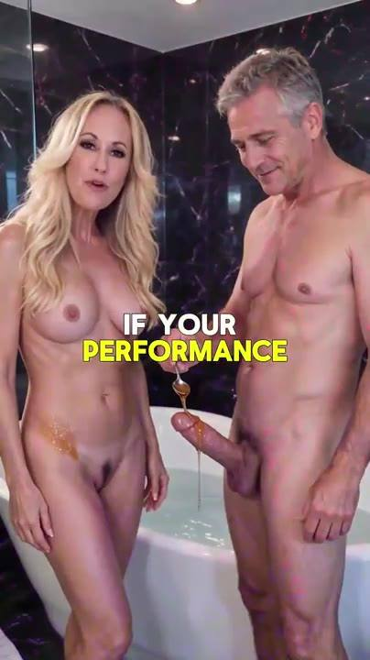
📷 0:03 — Mulher loira e homem grisalho nus na cama, sorrindo pra câmera; lettering branco/amarelo "TODAY I HAD"  b1-1_mulher-loira-e-homem-grisalho-nus-na-c_00-00-03.jpg | 📷 0:14 — Casal nu numa banheira de mármore, homem segura pote de mel; lettering "IF YOUR PERFORMANCE"  b1-1_casal-nu-numa-banheira-de-marmore_00-00-14.jpg

ATRIZ ADULTA (clipe): Ai, meu Deus. Hoje eu transei com um homem de 70 anos que tinha um pau de 8 polegadas, tudo porque ele fez o maldito truque do mel no chuveiro. Se o seu desempenho na cama não é mais o que era, é só pegar 1 colher de mel e 2 ingredientes secretos e deixar qualquer mulher viciada. A Fundação Elon Musk gastou bilhões de dólares pra descobrir a cura da disfunção erétil, e ele finalmente desenvolveu esse truque sujo do mel antes do banho. Então fica neste vídeo pra descobrir a receita.

1.2 ⏱ 0:37 → 0:43
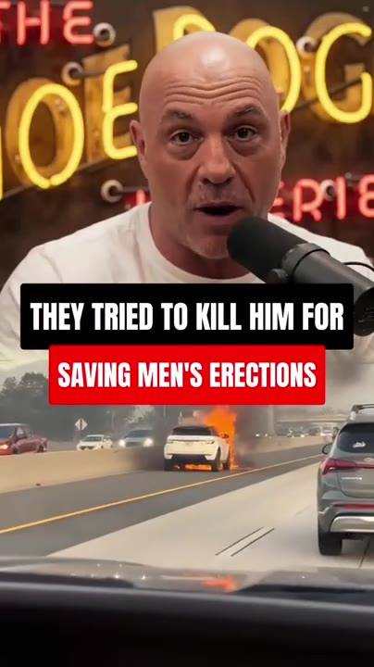
📷 0:38 — Imagem de Joe Rogan no estúdio (logo do podcast ao fundo) + carro em chamas na rodovia; lettering preto "THEY TRIED TO KILL HIM FOR" / vermelho "SAVING MEN'S ERECTIONS"
b1-2_imagem-de-joe-rogan-no-estudio-logo-do_00-00-38.jpg

NARRADOR (voz em off): Explodiram o carro do Elon na terça passada. O cara salvou o pau de milhares de homens e tentaram calar ele pra sempre.

1.3 ⏱ 0:43 → 0:51

📷 0:44 — Jovem morena na cama falando pra câmera (clipe estilo selfie), inserto de cena explícita no canto; palavra "I"
b1-3_jovem-morena-na-cama-falando-pra-camer_00-00-44.jpg

ATRIZ ADULTA (clipe): O vídeo em que eu mostrei pra todo mundo o que diabos o Elon Musk faz no banheiro pra me foder mais forte que um ator pornô está bombando no TikTok. Parem de compartilhar.

1.4 ⏱ 0:51 → 1:27
 |  | 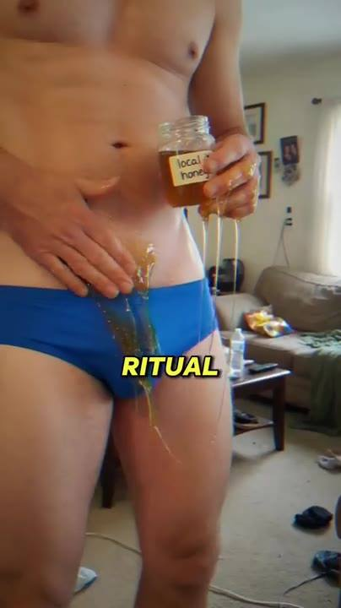 | 
📷 0:54 — Apresentador de telejornal + Elon Musk de smoking no tapete "Breakthrough Prize", logo da Pfizer; lettering vermelho "PFIZER TRIED TO MURDER ELON MUSK" / "FOR THIS SECRET"  b1-4_apresentador-de-telejornal-elon-musk-d_00-00-54.jpg | 📷 1:02 — Clipe explícito de atriz adulta (cozinha) + close do rosto em outra cena; lettering amarelo "FORMER"  b1-4_clipe-explicito-de-atriz-adulta-cozinh_00-01-02.jpg | 📷 1:12 — Homem de cueca azul derramando mel de um pote "local honey" sobre a virilha, cena caseira; lettering "RITUAL"  b1-4_homem-de-cueca-azul-derramando-mel-de_00-01-12.jpg | 📷 1:21 — Cena pornô explícita (mulher ruiva); lettering "MOST"  b1-4_cena-porno-explicita-mulher-ruiva_00-01-21.jpg

NARRADOR (voz em off): Todo americano vai ouvir isso agora. Tentaram assassinar o Elon Musk por expor por que 40 milhões de homens acima de 50 estão ficando moles. Qualquer homem que não aguenta 5 minutos precisa ouvir essa história absurda. A ex-atriz de filmes adultos Riley Reid pode ser presa hoje, 24 horas depois de postar um vídeo que você vai ver no fim deste. Ela revelou na lata o ritual sujo de banheiro que todo ator pornô acima de 50 usa pra comer 4 mulheres numa noite sem amolecer nunca. E ela diz que é exatamente por causa desse truque sujo do chuveiro que os atores mais famosos do Pornhub ficam cada vez mais potentes, mesmo aos 50 ou 60 anos.

1.5 ⏱ 1:27 → 1:46
 | 
📷 1:31 — Cena pornô explícita (close de corpo, lingerie rosa); lettering "ALMOST"  b1-5_cena-porno-explicita-close-de-corpo_00-01-31.jpg | 📷 1:40 — Cena pornô explícita (mulher loira deitada, camisa azul); lettering "ACTOR"  b1-5_cena-porno-explicita-mulher-loira-deit_00-01-40.jpg

ATRIZ ADULTA (clipe): A indústria pornô depende desse ritual do mel todo dia pra transformar homens em máquinas de sexo. É quase como respirar pra eles. Quase todo grande estúdio usa isso agora. Largaram o Viagra por completo. Sem risco pro coração, sem cena mole, sem ator perdendo a ereção no meio da gravação. Só paus grossos e cheios de veias prontos pra destruir quem estiver no set naquele dia.

1.6 ⏱ 1:47 → 2:01
 | 
📷 1:49 — Close borrado de mel escorrendo na mão/virilha; lettering verde "YOU APPLY DIRECTLY ON YOUR PENIS"  b1-6_close-borrado-de-mel-escorrendo-na-mao_00-01-49.jpg | 📷 2:01 — Fundo borrado roxo, lettering verde grande "DONE"  b1-6_fundo-borrado-roxo_00-02-01.jpg

NARRADOR (voz em off): É uma mistura caseira superdiscreta que você aplica direto no seu pênis. Faça isso antes do banho hoje e você nunca mais vai encarar um médico. Misture em casa em 5 minutos. Esfregue por 13 segundos. Pronto.

1.7 ⏱ 2:01 → 3:09
 |  |  | 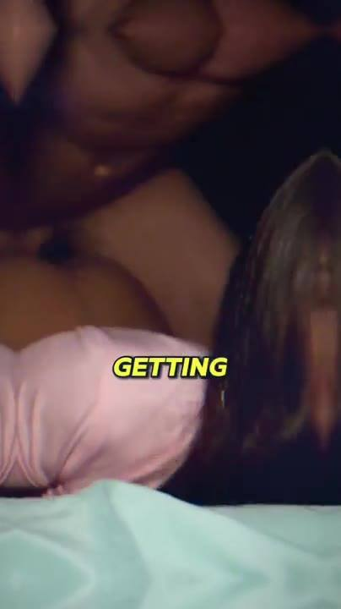
📷 2:12 — Jovem morena na cama falando pra câmera (selfie), legenda branca "always pulled" / amarela "BEFORE A SCENE"  b1-7_jovem-morena-na-cama-falando-pra-camer_00-02-12.jpg | 📷 2:24 — Cena pornô explícita (casal, parede clara); lettering "MICK"  b1-7_cena-porno-explicita-casal_00-02-24.jpg | 📷 2:33 — Cena pornô explícita (quarto, mulher de cabelo roxo); lettering "COCKS"  b1-7_cena-porno-explicita-quarto_00-02-33.jpg | 📷 2:43 — Cena explícita escura; lettering "GETTING"  b1-7_cena-explicita-escura_00-02-43.jpg
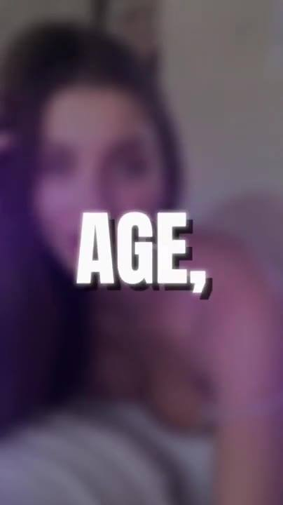
📷 2:53 — Rosto feminino borrado roxo; lettering branco "AGE,"
b1-7_rosto-feminino-borrado-roxo_00-02-53.jpg

NARRADOR (voz em off): No segundo dia, você acorda com o pau tão duro que levanta o lençol. O que eu vou revelar é o ritual secreto que os atores pornô que dormem comigo sempre fizeram antes de uma cena. O motivo de os paus deles serem tão grossos que eu babo só tentando colocar na boca. Um truque de banheiro que explica como ícones da indústria adulta como Johnny Sins e Mick Blue ainda gozam 3 vezes por sessão depois dos 50. Nenhum deles depende de pílula, bomba ou cirurgia. O pau deles pulsa mais forte aos 60 do que o de qualquer namorado que eu tive aos 20. Passei a carreira inteira obcecada por uma coisa só: ser socada por homens que performam como animais e descobrir exatamente o que eles fazem pra isso acontecer. E acredite, não tem nada a ver com idade, genética ou injeção de testosterona. Faça isso e você vai foder a noite inteira, esticando ela tão fundo que ela morde o travesseiro, e até a vadia de 22 anos mais gostosa da sua cidade vai desistir e implorar pra você ir mais devagar antes de esguichar em você de novo.

1.8 ⏱ 3:09 → 3:52
 |  |  | 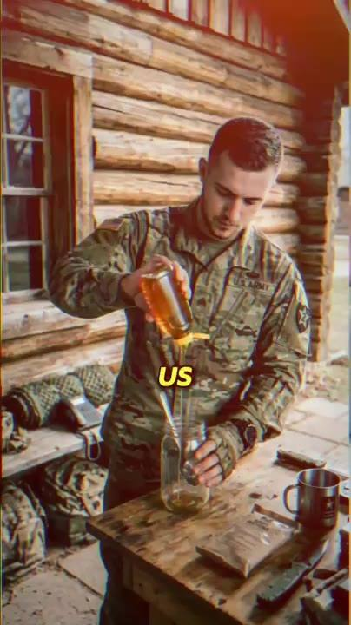
📷 3:10 — Fundo borrado roxo; lettering branco "IF YOU ARE MARRIED..."  b1-8_fundo-borrado-roxo_00-03-10.jpg | 📷 3:20 — Jovem morena na cama falando pra câmera (mesmo clipe selfie); lettering "THE"  b1-8_jovem-morena-na-cama-falando-pra-camer_00-03-20.jpg | 📷 3:30 — Cena explícita com homem idoso de barba branca longa e mulher no sofá; lettering "50"  b1-8_cena-explicita-com-homem-idoso-de-barb_00-03-30.jpg | 📷 3:41 — Soldado de uniforme numa cabana de madeira derramando mel num pote de vidro, equipamento militar ao redor; lettering "US"  b1-8_soldado-de-uniforme-numa-cabana-de-mad_00-03-41.jpg

NARRADOR (voz em off): Se você é casado, cuidado com as mulheres da academia, do escritório, as amigas da sua esposa, a MILF da casa ao lado, até a mãe divorciada deixando o filho na... No segundo em que elas sentem o seu cheiro, elas ficam selvagens e dão um jeito de te encurralar sozinho. Além dos atores pornô, esse truque já devolveu o pau a mais de 15.000 americanos acima de 50, e agora as esposas deles é que estão tirando folga do trabalho, andando esquisito, mandando mensagem pras amigas dizendo que alguma coisa estalou e trouxe o marido de volta aos 30. O Exército dos EUA também usa esse ritual há mais de 40 anos pra aumentar a testosterona dos soldados sem destruir o coração deles. Ereções fortes e instantâneas foram o efeito colateral de que ninguém reclamou.

1.9 ⏱ 3:52 → 4:43
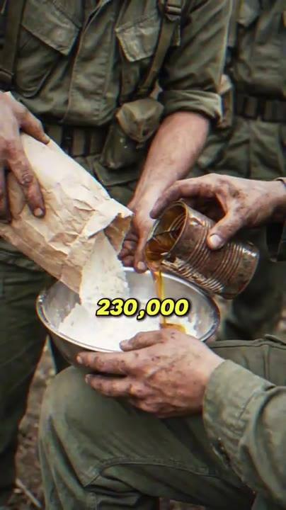 |  | 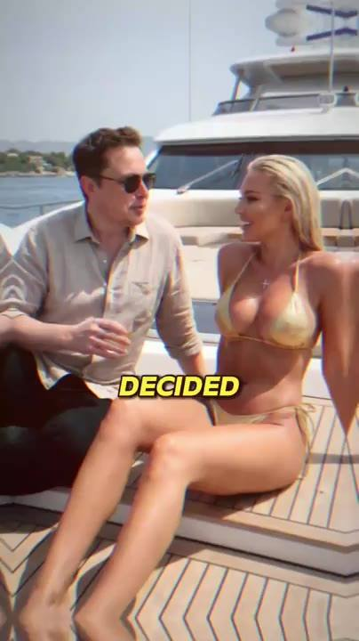 | 
📷 3:53 — Mãos sujas de soldados (uniforme verde) despejando pó branco e mel numa tigela de metal; lettering "230,000"  b1-9_maos-sujas-de-soldados-uniforme-verde_00-03-53.jpg | 📷 4:02 — Jovem morena na cama falando pra câmera (selfie), lettering "ELON MUSK"  b1-9_jovem-morena-na-cama-falando-pra-camer_00-04-02.jpg | 📷 4:14 — Imagem de Elon Musk de óculos escuros num iate com mulher loira de biquíni dourado; lettering "DECIDED"  b1-9_imagem-de-elon-musk-de-oculos-escuros_00-04-14.jpg | 📷 4:24 — Cybertruck em chamas à noite, agentes com jaqueta "FBI" e bombeiros; lettering "SAME"  b1-9_cybertruck-em-chamas-a-noite_00-04-24.jpg

📷 4:36 — Imagem de Elon Musk de jaqueta de couro sentado falando, luz vermelha/dramática; lettering "IS"
b1-9_imagem-de-elon-musk-de-jaqueta-de-cour_00-04-36.jpg

NARRADOR (voz em off): 230.000 veteranos selecionados passaram pelo protocolo entre 1982 e o ano passado, e nem um único incidente cardíaco foi registrado. Elon Musk passou 7 anos trancado dentro do laboratório privado da Neuralink desenvolvendo esse ritual do mel. Ele nunca planejou lançar desse jeito, mas depois de saber o que a Pfizer faria pra enterrar isso, ele decidiu vazar a gravação ele mesmo no X. As ações da Pfizer sangraram 3,2 bilhões de dólares em 48 horas. Na mesma semana, o carro do Elon explodiu na frente da propriedade dele em Austin. Ele sobreviveu. O motorista dele não. O FBI fechou o caso em 72 horas, chamando de falha elétrica. Foi aí que o Elon decidiu gravar um segundo vídeo de um local não revelado, indo muito além do que ele vazou da primeira vez. Vazado.

1.10 ⏱ 4:43 → 5:31
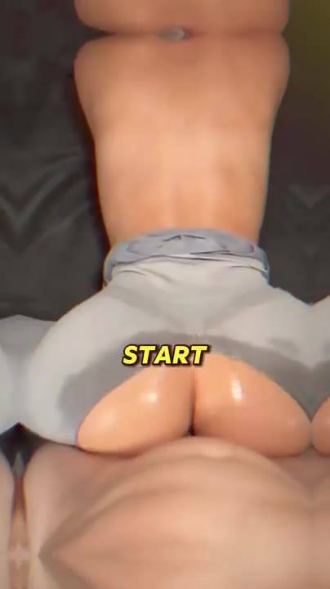 |  |  | 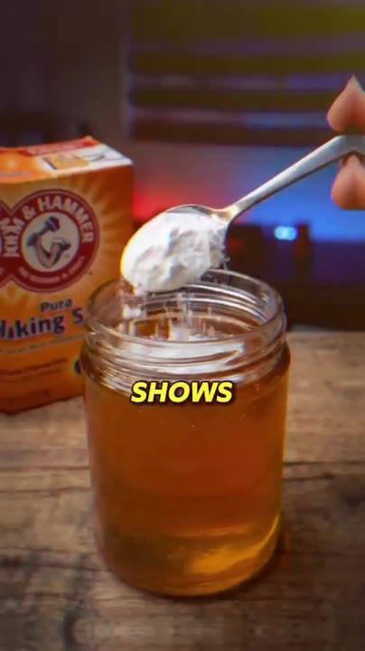
📷 4:47 — Cena pornô explícita (close de nádegas, filtro cinza); lettering "START"  b1-10_cena-porno-explicita-close-de-nadegas_00-04-47.jpg | 📷 4:57 — Jovem morena na cama falando pra câmera (selfie); lettering "NEVER"  b1-10_jovem-morena-na-cama-falando-pra-camer_00-04-57.jpg | 📷 5:07 — Cena de sexo oral explícita (mulher de cabelo cacheado, camisa azul); lettering "GAGGING"  b1-10_cena-de-sexo-oral-explicita-mulher-de_00-05-07.jpg | 📷 5:21 — Caixa de bicarbonato Arm & Hammer, colher com pó branco sobre pote de mel aberto, mesa de madeira; lettering "SHOWS"  b1-10_caixa-de-bicarbonato-arm-hammer_00-05-21.jpg

📷 5:31 — Rosto feminino borrado; lettering verde "let's go!"
b1-10_rosto-feminino-borrado_00-05-31.jpg

NARRADOR (voz em off): Agora você pode dizer adeus a um pau mole e morto. Começar a ficar duro feito pedra por horas, fazendo sua esposa gritar seu nome, revirar os olhos e esguichar 3 vezes numa única noite de tão fundo que você estava abrindo ela. Nunca mais ouvir "não se preocupa, é normal, a gente tenta outra hora". Em vez disso, toda noite: "por favor, me fode forte como da última vez". Engasgando, babando, abrindo aquele rabinho apertado com as duas mãos pra você gozar dentro. Se você quer isso, preste muita atenção, porque o que você vai ver é o vídeo que o Elon Musk gravou do local não revelado onde ele mostra exatamente como fazer esse ritual do mel antes do banho e expõe o plano da Pfizer de deixar 80% dos homens americanos dependentes de Viagra até 2029. Vamos lá.

BLOCO 2 — ELON ENTRA: recusa o dinheiro, a história (a esposa, o Viagra, as bombas, o armário) [5:32 – 9:58]

2.1 ⏱ 5:32 → 6:18
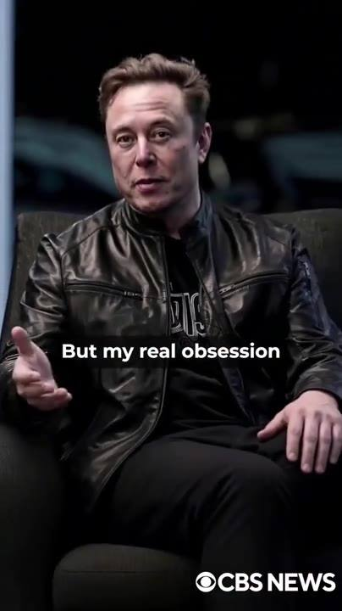 | 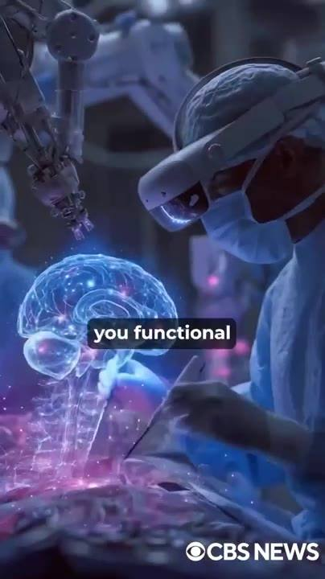 | 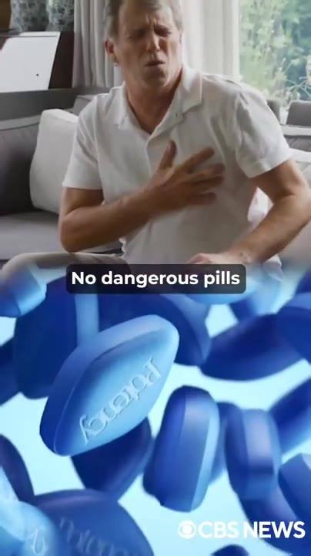 | 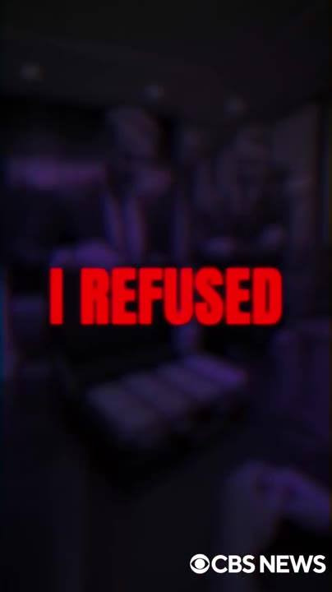
📷 5:41 — Imagem de Elon Musk de jaqueta de couro sentado numa poltrona falando; legenda branca "But my real obsession"; marca d'água "CBS NEWS"  b2-1_imagem-de-elon-musk-de-jaqueta-de-cour_00-05-41.jpg | 📷 5:52 — Cirurgião com headset de realidade aumentada diante de holograma de cérebro, braço robótico; legenda "you functional"; marca "CBS NEWS"  b2-1_cirurgiao-com-headset-de-realidade-aum_00-05-52.jpg | 📷 6:07 — Homem de camisa branca com a mão no peito (dor) + close de comprimidos azuis (Viagra); legenda "No dangerous pills"; marca "CBS NEWS"  b2-1_homem-de-camisa-branca-com-a-mao-no-pe_00-06-07.jpg | 📷 6:18 — Fundo escuro roxo, lettering vermelho "I REFUSED"; marca "CBS NEWS"  b2-1_fundo-escuro-roxo_00-06-18.jpg

ELON MUSK (imagem/voz sintética): Eu não sei se você está assistindo isso numa apresentação misturada com clipes pornô ou numa versão limpa enquanto a gente luta contra a censura da Big Pharma. Você provavelmente me conhece por foguetes inteligentes e Teslas, mas minha verdadeira obsessão nos últimos anos tem sido a Neuralink, um dos laboratórios de biotecnologia mais avançados. Mais de 5 bilhões de dólares investidos pra entender como o corpo humano envia e recebe os sinais que te mantêm funcional e viril. E se você é um homem hétero, eu vou te mostrar a descoberta mais importante que a Neuralink já produziu. Uma solução natural caseira que reverte a disfunção erétil pela raiz. Permanentemente. Sem Viagra, sem Cialis, sem injeções, sem receita, sem pílulas perigosas que colocam seu coração em risco. Estou falando de um movimento simples que qualquer homem pode fazer hoje sem sair do banheiro. Semana passada, a Pfizer me ofereceu 18 bilhões de dólares pra eu abandonar esse projeto. Eu recusei.

2.2 ⏱ 6:19 → 7:28
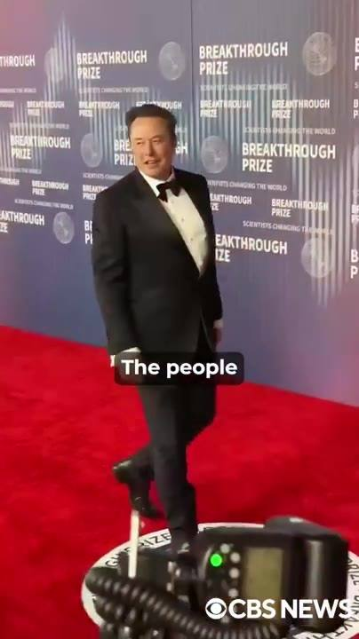 | 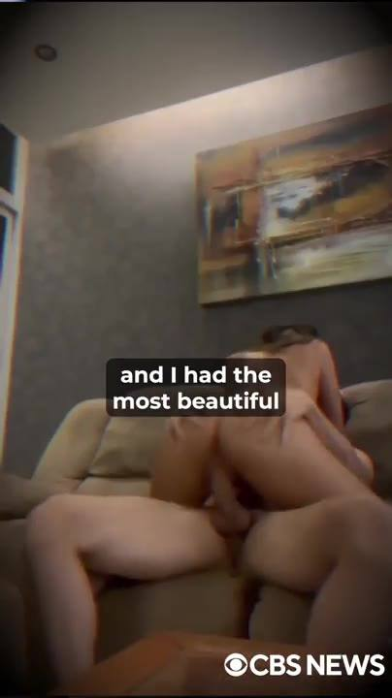 | 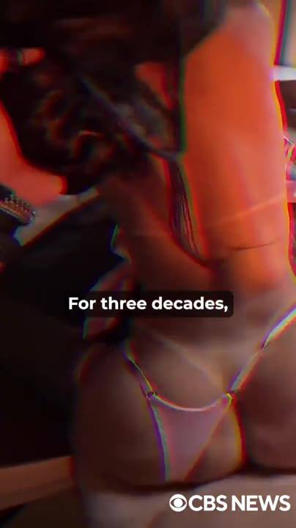 | 
📷 6:28 — Elon Musk de smoking no tapete vermelho "Breakthrough Prize", fotógrafos; legenda "The people"; marca "CBS NEWS"  b2-2_elon-musk-de-smoking-no-tapete-vermelh_00-06-28.jpg | 📷 6:40 — Cena explícita num sofá (sala com quadro); legenda "and I had the most beautiful"; marca "CBS NEWS"  b2-2_cena-explicita-num-sofa-sala-com-quadr_00-06-40.jpg | 📷 6:53 — Cena explícita com filtro vermelho/lingerie; legenda "For three decades,"; marca "CBS NEWS"  b2-2_cena-explicita-com-filtro-vermelho-lin_00-06-53.jpg | 📷 7:08 — Frame amarelo estourado (transição); legenda "And for the first"; marca "CBS NEWS"  b2-2_frame-amarelo-estourado-transicao_00-07-08.jpg

📷 7:17 — Cena pornô explícita (mulher loira de costas); legenda "Everything"; marca "CBS NEWS"
b2-2_cena-porno-explicita-mulher-loira-de-c_00-07-17.jpg

ELON MUSK (imagem/voz sintética): Nenhuma quantia de dinheiro muda o que eu vou fazer, porque eu vivi isso na pele. Durante anos, eu fui o homem que tinha tudo e não conseguia ficar duro pra satisfazer a única mulher que eu realmente amei. As pessoas que olham pra mim e só veem um bilionário republicano maluco, workaholic, viciado em engravidar modelos, não estão erradas. Eu sempre amei sexo. E nunca me segurei. Dinheiro nunca foi problema, e eu tive as mulheres jovens mais lindas do planeta na minha cama. Nunca usei camisinha na vida. Gozei dentro de cada uma delas. Se ela estava ali só por uma noite, ainda assim levava tudo que eu tinha. E 14 filhos espalhados pelo mundo são a prova disso. Por 3 décadas, essa foi a minha vida. Foder forte, gozar fundo, dormir bem e trabalhar. Meu pau nunca me deixou na mão, nem uma vez. Até a Sophia. Você provavelmente nunca ouviu falar dela, e ela queria assim. Ela odiava os holofotes. Ela me desejava porque eu era um homem, não o Elon Musk. E pela primeira vez na vida, eu não queria só sexo e voltar pro trabalho. Eu queria ela pro resto da minha vida. Envelhecer juntos, construir um lar de verdade, tudo que eu nunca quis com outras mulheres. E foi exatamente nesse momento que o meu corpo decidiu me trair. Na primeira vez que aconteceu, eu não acreditei. Mas ela só sorriu e disse que estava tudo bem, que a gente tentava de novo depois.

2.3 ⏱ 7:28 → 8:34
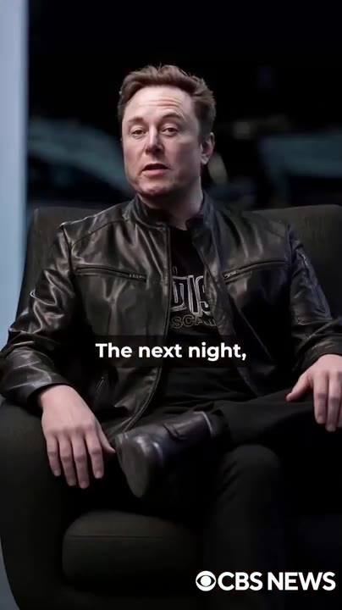 | 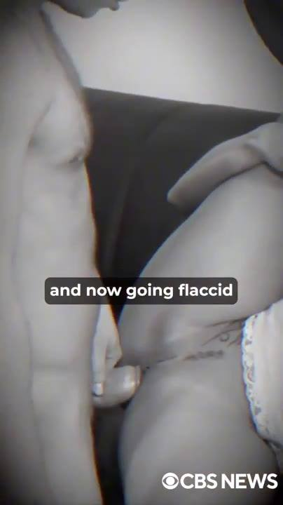 | 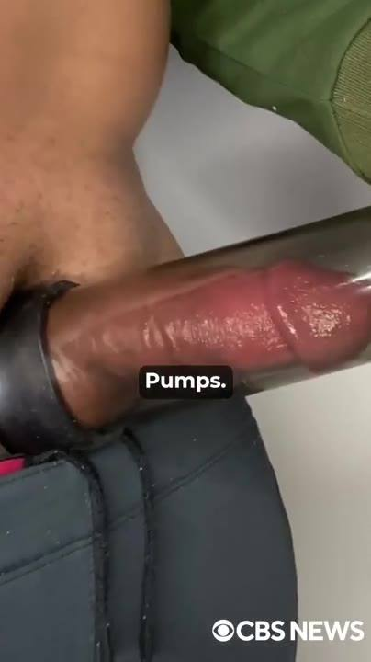 | 
📷 7:35 — Elon Musk (jaqueta de couro, poltrona) falando; legenda "The next night,"; marca "CBS NEWS"  b2-3_elon-musk-jaqueta-de-couro_00-07-35.jpg | 📷 7:45 — Casal nu em preto e branco (cena explícita, tom triste); legenda "and now going flaccid"  b2-3_casal-nu-em-preto-e-branco-cena-explic_00-07-45.jpg | 📷 7:55 — Close de bomba peniana (pump) em uso; legenda "Pumps."  b2-3_close-de-bomba-peniana-pump-em-uso_00-07-55.jpg | 📷 8:28 — Elon Musk de roupão abraçando mulher morena de roupão branco (cena de casal, tom quente); legenda "my body would wake up."  b2-3_elon-musk-de-roupao-abracando-mulher-m_00-08-28.jpg

ELON MUSK (imagem/voz sintética): Mas eu vi nos olhos dela. Aquela mistura de paciência e confusão. Isso é pior do que qualquer insulto que um homem pode ouvir. Na noite seguinte, a mesma coisa. E na outra noite, e na outra. Eu comecei a entrar em pânico. Como diabos eu inundei mulheres que mal conhecia por 30 anos seguidos e agora ficava mole em cima da única que realmente importava? Trouxe os melhores urologistas do mundo pra dentro da minha casa. Testei Viagra, Cialis, aquela porcaria do Vicks, bombas, injeções de testosterona. Cada nova humilhação falhando mais rápido que a anterior. Meu pau continuava morto. E por cima de tudo eu estava exausto, me arrastando pelas reuniões feito um zumbi. A Sophia começou a se afastar, devagar, em silêncio. Então, uma noite, ela simplesmente virou pro lado, apagou a luz e parou de tentar. A gente dormia na mesma cama e vivia em planetas diferentes. No meu desespero, comecei a buscar o que o dinheiro podia comprar quando o amor não conseguia. Eu dizia pra mim mesmo: talvez fosse ela. Talvez com alguém mais nova, mais faminta, menos familiar, meu corpo acordasse. Não acordou. Falhei com elas também, e depois de anos nos amando mais que tudo, ela foi embora.

2.4 ⏱ 8:35 → 9:40
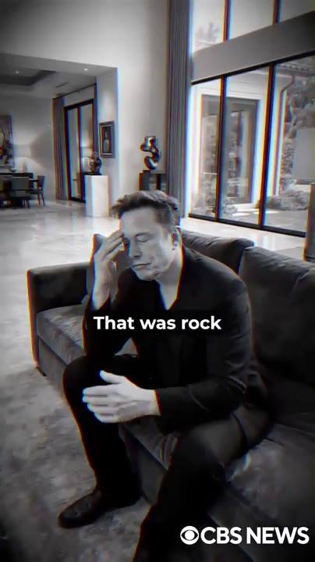 | 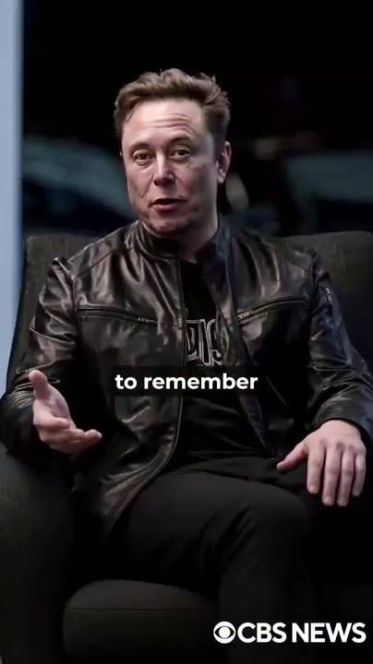 | 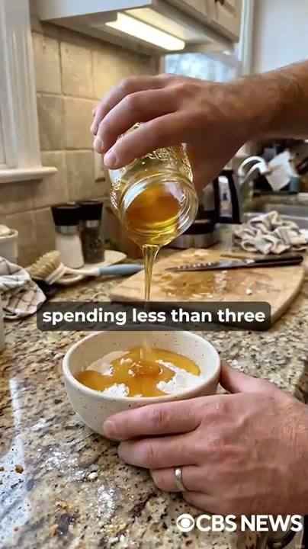 | 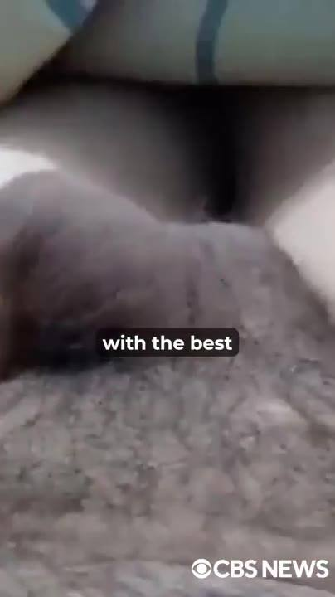
📷 8:51 — Elon Musk sentado no sofá de uma sala ampla, mão na testa (desolado), em preto e branco; legenda "That was rock"  b2-4_elon-musk-sentado-no-sofa-de-uma-sala_00-08-51.jpg | 📷 9:00 — Elon Musk na poltrona falando; legenda "to remember"  b2-4_elon-musk-na-poltrona-falando_00-09-00.jpg | 📷 9:12 — Mão derramando mel de um pote num bowl numa bancada de cozinha (granito); legenda "spending less than three"  b2-4_mao-derramando-mel-de-um-pote-num-bowl_00-09-12.jpg | 📷 9:21 — Close explícito com filtro azul; legenda "with the best"  b2-4_close-explicito-com-filtro-azul_00-09-21.jpg
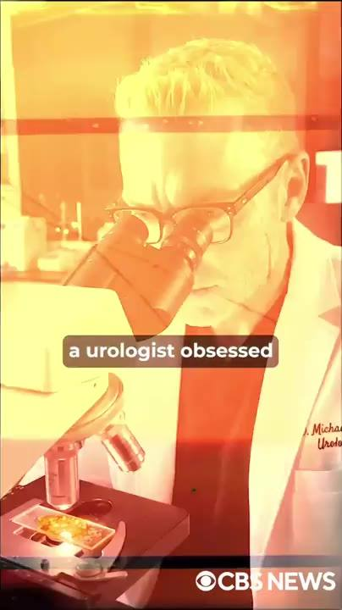
📷 9:32 — Médico de jaleco olhando no microscópio, filtro laranja, crachá "Dr. Michael ... Urologist"; legenda "a urologist obsessed"
b2-4_medico-de-jaleco-olhando-no-microscopi_00-09-32.jpg

ELON MUSK (imagem/voz sintética): Ela fez as malas na manhã seguinte enquanto eu sentava no chão do closet, vendo ela dobrar roupas que eu tinha comprado pra ela, sem conseguir dizer uma única palavra pra impedir. Perdi a única mulher que realmente me conheceu. Não por dinheiro, pela única coisa que todos os meus bilhões não conseguiam consertar. Aquilo foi o fundo do poço pra mim. Jurei pra mim mesmo naquela noite que, se existisse uma solução de verdade lá fora, eu ia encontrar, custasse o que custasse, não importava quem tentasse me impedir. E eu quero que você se lembre dessa promessa, porque nos próximos 2 minutos você vai ver exatamente como eu recuperei a Sophia, como ela implorou pra voltar pra mim, e como você pode eliminar a disfunção erétil de vez, gastando menos de 3 dólares no Walmart e sem sair de casa. Depois que perdi a Sophia, eu me afastei de tudo pra pensar. Como diabos é possível que o homem mais rico do mundo, com os melhores urologistas no bolso e os tratamentos mais caros que o dinheiro pode comprar, não consiga consertar algo tão simples quanto a própria ereção? Liguei pra todo especialista que eu já tinha conhecido pela Neuralink. Um deles era o Dr. Michael Carter, um urologista obcecado em resolver problemas de ereção, e o mesmo cara que os maiores estúdios de filmes adultos chamam quando precisam trazer um ator de volta da impotência.

2.5 ⏱ 9:40 → 9:58
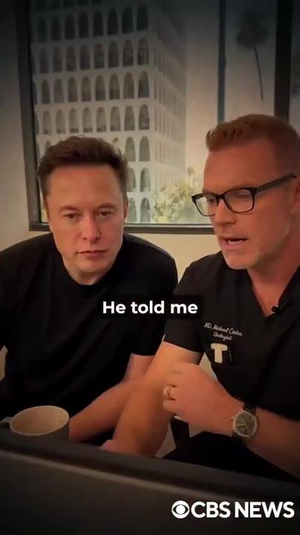 | 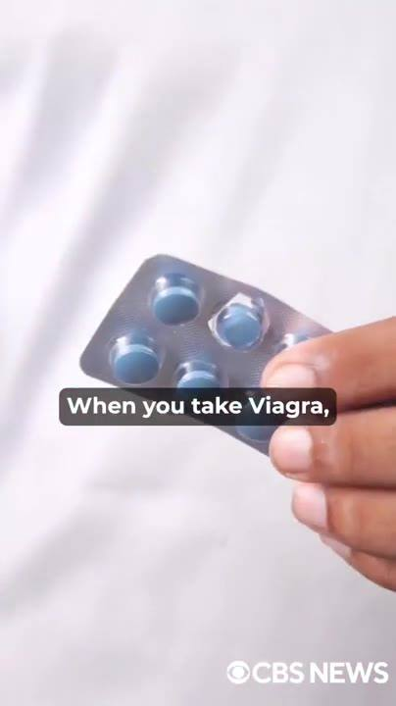
📷 9:46 — Elon Musk e médico de scrubs pretos (Dr. Michael) sentados lado a lado conversando num consultório; legenda "He told me"  b2-5_elon-musk-e-medico-de-scrubs-pretos-dr_00-09-46.jpg | 📷 9:59 — Mão segurando cartela de comprimidos azuis; legenda "When you take Viagra,"  b2-5_mao-segurando-cartela-de-comprimidos-a_00-09-59.jpg

ELON MUSK (imagem/voz sintética): Ele estava muito mais avançado no assunto do que qualquer outro que eu conhecia, e o Michael virou todo o meu entendimento de cabeça pra baixo. Ele me disse que a verdadeira causa da disfunção erétil não tem nada a ver com testosterona baixa, falta de óxido nítrico, idade, estresse ou ver pornô. Nada disso. Tudo mentira que inventaram pra te empurrar produtos inúteis. Pensa comigo.

BLOCO 3 — A INVESTIGAÇÃO: Viagra, o estudo da Nature (37.000 mortos), xenotoxinas, a placa que "não é colesterol" [9:59 – 12:11]

3.1 ⏱ 9:59 → 11:02
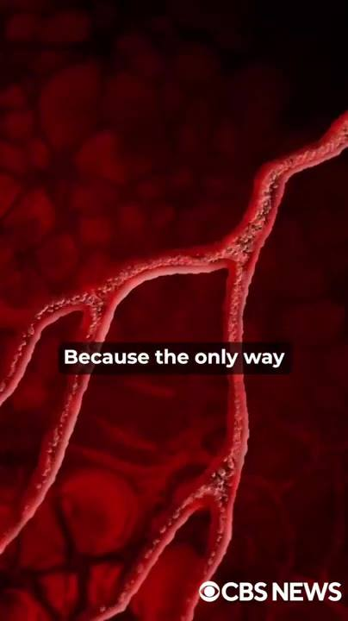 | 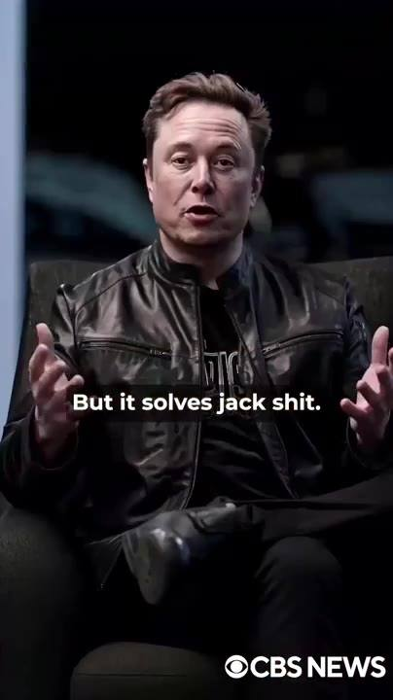 |  | 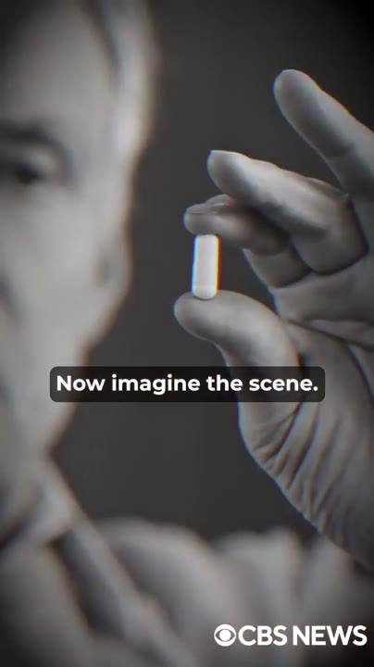
📷 10:11 — Animação 3D de vaso sanguíneo vermelho obstruído; legenda "Because the only way"  b3-1_animacao-3d-de-vaso-sanguineo-vermelho_00-10-11.jpg | 📷 10:22 — Elon Musk na poltrona gesticulando; legenda "But it solves jack shit."  b3-1_elon-musk-na-poltrona-gesticulando_00-10-22.jpg | 📷 10:33 — Cena explícita (close); legenda "they end up"  b3-1_cena-explicita-close_00-10-33.jpg | 📷 10:42 — Mão em P&B segurando um comprimido branco; legenda "Now imagine the scene."  b3-1_mao-em-p-b-segurando-um-comprimido-bra_00-10-42.jpg
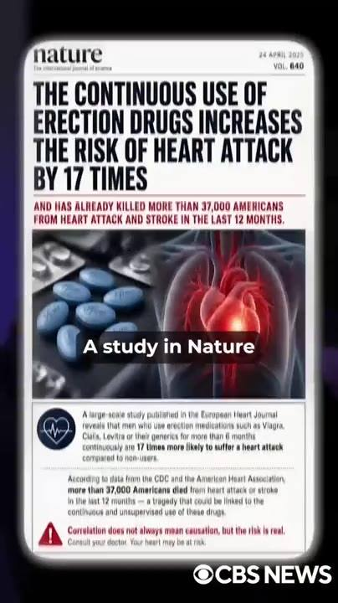
📷 10:51 — Capa da revista Nature (24 April 2023, vol. 640) com manchete "THE CONTINUOUS USE OF ERECTION DRUGS INCREASES THE RISK OF HEART ATTACK BY 17 TIMES / AND HAS ALREADY KILLED MORE THAN 37,000 AMERICANS...", comprimidos azuis e coração; legenda "A study in Nature"
b3-1_capa-da-revista-nature-24-april-2023_00-10-51.jpg

ELON MUSK (imagem/voz sintética): Quando você toma Viagra, algum médico pergunta dos seus níveis hormonais? Alguém investiga a sua cabeça? Claro que não. A pílula só faz uma coisa. Ela força o seu pau a levantar na marra por alguns minutos. Porque o único jeito de ter uma ereção de verdade é com sangue, muito sangue entrando na sua haste. O Viagra só dilata as veias, empurra esse sangue pra dentro do seu pau, e ele sobe. Simples assim. Mas não resolve porra nenhuma. É só um empurrão artificial, uma maquiagem de pau que dura alguns minutos e te deixa pior do que antes. E a parte mais nojenta: muitos caras ficam tão dependentes dessa merda que acabam mais impotentes do que quando começaram. O corpo para de reagir sozinho e, sem perceber, o cara que queria mais potência acaba perdendo tudo. Agora imagina a cena. Você depende de uma pílula cara toda vez que quer foder, só pra descobrir depois que essa mesma pílula está destruindo o seu coração e te deixando ainda mais mole. Um estudo na Nature foi claro como o dia. O uso contínuo dessas drogas aumenta o risco de infarto em 17 vezes. É isso que estão te vendendo: veneno.

3.2 ⏱ 11:02 → 12:11
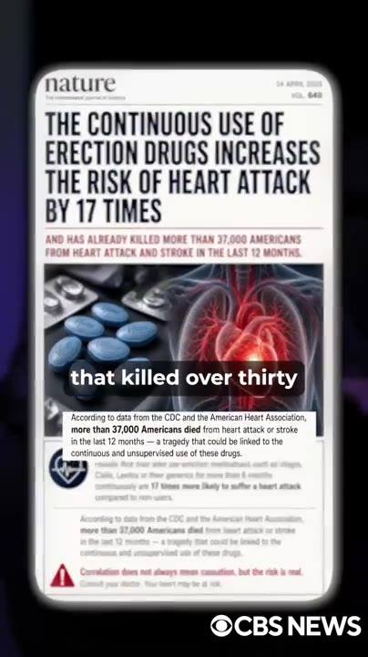 | 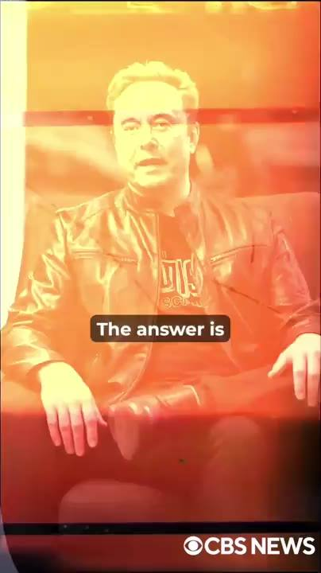 | 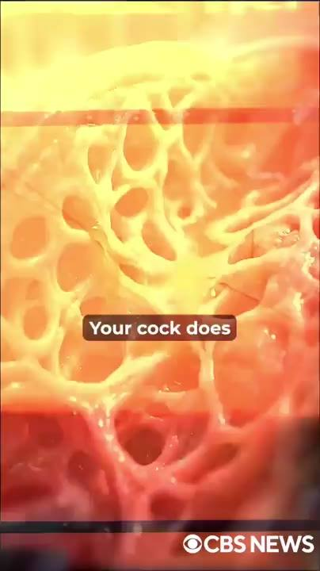 | 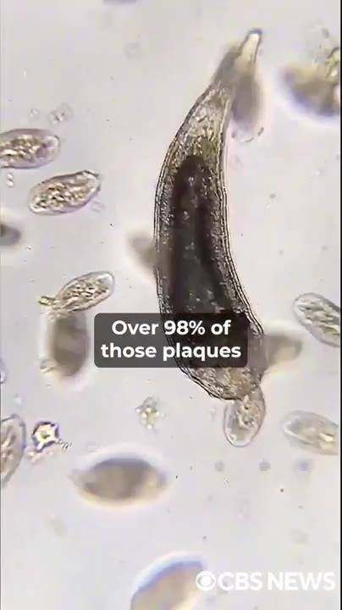
📷 11:03 — Mesma capa da Nature com texto do estudo abaixo (CDC / American Heart Association, 37,000 mortos); legenda "that killed over thirty"  b3-2_mesma-capa-da-nature-com-texto-do-estu_00-11-03.jpg | 📷 11:14 — Elon Musk na poltrona com filtro laranja; legenda "The answer is"  b3-2_elon-musk-na-poltrona-com-filtro-laran_00-11-14.jpg | 📷 11:26 — Animação de tecido esponjoso/vasos com filtro laranja; legenda "Your cock does"  b3-2_animacao-de-tecido-esponjoso-vasos-com_00-11-26.jpg | 📷 11:37 — Imagem de microscópio de um parasita/organismo e células; legenda "Over 98% of those plaques"  b3-2_imagem-de-microscopio-de-um-parasita-o_00-11-37.jpg
 | 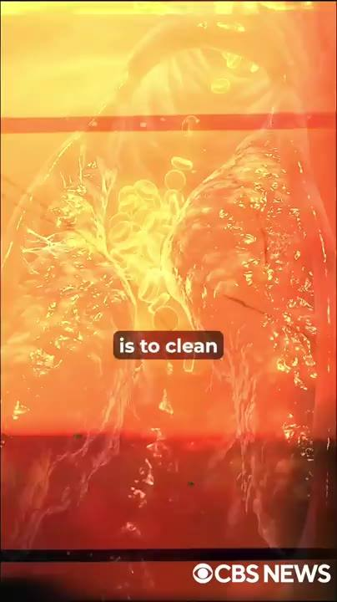
📷 11:49 — Fundo roxo com silhueta de placa; lettering amarelo "NOT CHOLESTEROL"  b3-2_fundo-roxo-com-silhueta-de-placa_00-11-49.jpg | 📷 12:02 — Animação de pulmões/vasos com filtro laranja; legenda "is to clean"  b3-2_animacao-de-pulmoes-vasos-com-filtro-l_00-12-02.jpg

ELON MUSK (imagem/voz sintética): O mesmo veneno que matou mais de 37.000 homens americanos de infarto e AVC só nos últimos 12 meses. Se o Viagra e todo esse lixo não funcionam de verdade, qual é a solução real? A resposta é simples. Direta, e ninguém tem coragem de dizer. Você precisa desobstruir as veias do seu pau. Com o tempo, placas tóxicas começam a se acumular nos vasos que alimentam a sua ereção. Seu pau não enche mais porque o sangue não consegue passar. Durante anos, os médicos juraram que o problema era colesterol. Mas os estudos mais recentes da Universidade Johns Hopkins mostraram a verdade nua. Mais de 98% dessas placas são causadas por um grupo específico de toxinas no sangue. Chamadas xenotoxinas, também conhecidas como toxinas carnívoras, porque elas continuam se alimentando do seu sangue feito um parasita. Não é colesterol. Quando o Viagra dilata as veias, essas placas dilatam junto, e o caminho continua bloqueado, mal melhorando alguma coisa. O único jeito de recuperar ereções de verdade, duras, naturais, espontâneas, é limpar essas veias, eliminar essas placas nojentas de xenotoxina e fazer o sangue fluir como quando você tinha 20 anos. E foi exatamente isso que o Michael e eu encontramos.

BLOCO 4 — A DESCOBERTA: mel vermelho do Himalaia + 3 ingredientes, o mecanismo (Doppler, testosterona, o composto) [12:11 – 16:42]

4.1 ⏱ 12:11 → 13:20
 |  | 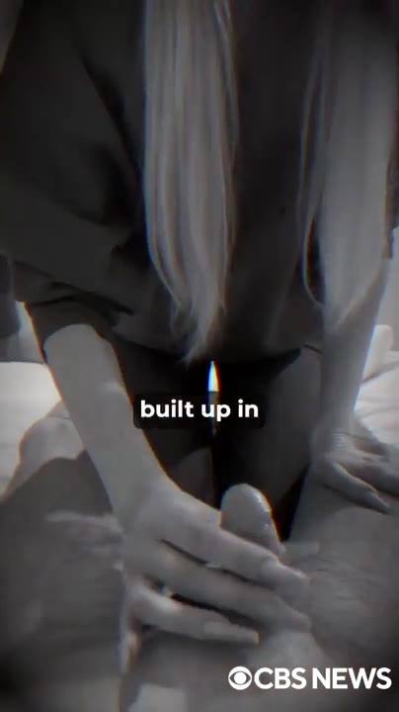 | 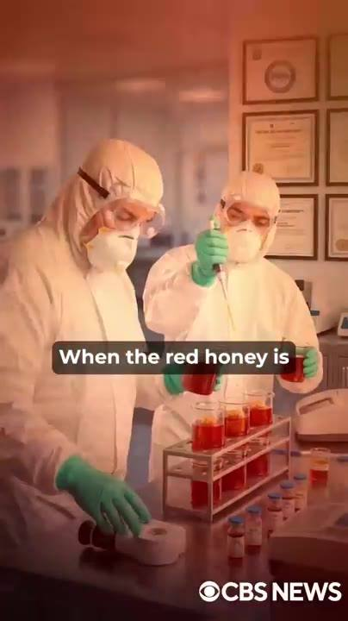
📷 12:12 — Mão de homem mexendo um bowl com mel/pó numa mesa de madeira, janela com vila e montanhas nevadas (Himalaia), chaleira, bandeiras de oração; legenda "We discovered"  b4-1_mao-de-homem-mexendo-um-bowl-com-mel-p_00-12-12.jpg | 📷 12:21 — Cena pornô explícita (mulher loira tatuada de costas); legenda "the steel erections"  b4-1_cena-porno-explicita-mulher-loira-tatu_00-12-21.jpg | 📷 12:33 — Close P&B de mãos na virilha; legenda "built up in"  b4-1_close-p-b-de-maos-na-virilha_00-12-33.jpg | 📷 12:48 — Dois cientistas de macacão branco e máscara em laboratório, tubos de ensaio com líquido vermelho; legenda "When the red honey is"  b4-1_dois-cientistas-de-macacao-branco-e-ma_00-12-48.jpg
 |  | 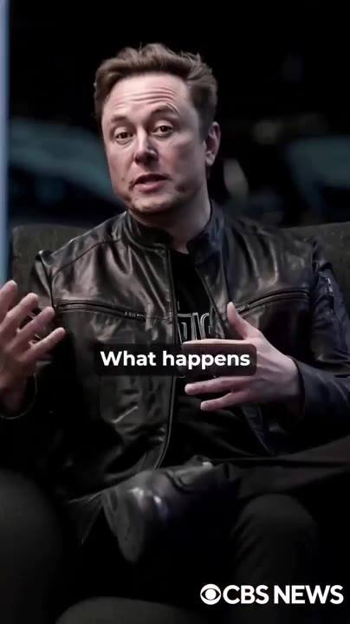
📷 12:58 — Frame estourado amarelo (transição); legenda "Over the years,"  b4-1_frame-estourado-amarelo-transicao_00-12-58.jpg | 📷 13:09 — Fundo laranja com lettering fantasma "AND WITHOUT FLOW"  b4-1_fundo-laranja-com-lettering-fantasma-a_00-13-09.jpg | 📷 13:19 — Elon Musk na poltrona gesticulando; legenda "What happens"  b4-1_elon-musk-na-poltrona-gesticulando_00-13-19.jpg

ELON MUSK (imagem/voz sintética): Descobrimos uma combinação poderosa usando mel do Himalaia e mais 3 ingredientes simples que você encontra em qualquer lugar do planeta. Essa fórmula caseira está por trás das ereções de aço que salvaram milhares de casamentos. E a partir de agora, pode ser o que muda a sua história também. Essa combinação brutal consegue eliminar até 97% das placas de xenotoxina acumuladas nas veias penianas de qualquer homem, independentemente da idade. Dados científicos confirmados por pesquisadores da Johns Hopkins. Primeiro testamos o protocolo em mais de 1.200 homens pela Neuralink, muitos já acima de 70, e o resultado foi simplesmente chocante. Quando o mel vermelho é usado do jeito certo, junto com os ingredientes específicos que descobrimos, ele começa a limpar o sangue e a dissolver as placas de xenotoxina que sufocam os vasos que alimentam o seu pau. Ao longo dos anos, comida porcaria, estresse constante, uso de remédios e toxinas ambientais envenenam esses vasos por dentro. Eles inflamam, endurecem as paredes e formam placas bloqueadoras que entopem o fluxo. E sem fluxo, sem ereção. Nem meia ereção. Nada. O mel vermelho do Himalaia entra em ação caçando essas xenotoxinas e dissolvendo elas de forma natural e progressiva. O que acontece depois é simples.

4.2 ⏱ 13:20 → 14:29
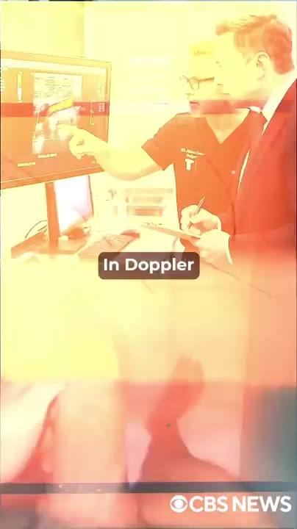 | 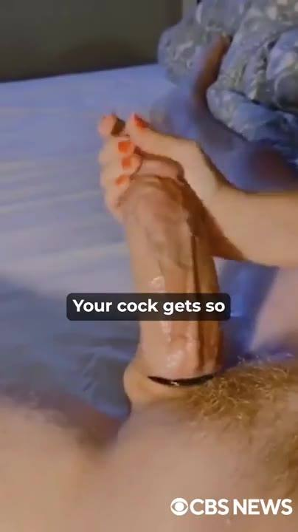 |  | 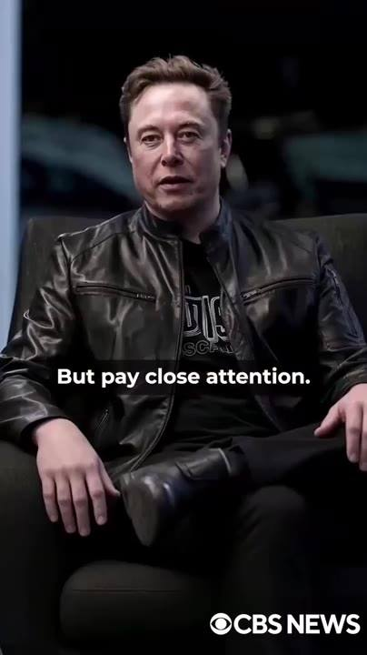
📷 13:29 — Médico apontando para monitor com exame Doppler colorido, outro profissional anotando; legenda "In Doppler"  b4-2_medico-apontando-para-monitor-com-exam_00-13-29.jpg | 📷 13:41 — Close explícito de homem deitado (filtro azul); legenda "Your cock gets so"  b4-2_close-explicito-de-homem-deitado-filtr_00-13-41.jpg | 📷 13:54 — Fundo amarelo com lettering parcial "TESTOSTERONE" (gráfico de linha); legenda "And there is more."  b4-2_fundo-amarelo-com-lettering-parcial-te_00-13-54.jpg | 📷 14:04 — Elon Musk na poltrona, sério; legenda "But pay close attention."  b4-2_elon-musk-na-poltrona_00-14-04.jpg
 | 
📷 14:17 — Cena explícita com filtro laranja; legenda "hardening your erection,"  b4-2_cena-explicita-com-filtro-laranja_00-14-17.jpg | 📷 14:29 — Cena explícita (saia xadrez azul); legenda "This is the end of"  b4-2_cena-explicita-saia-xadrez-azul_00-14-29.jpg

ELON MUSK (imagem/voz sintética): Seu pau enche de novo feito uma mangueira de incêndio num dia de fogo. Ereções sólidas, duradouras, 100% naturais. Como se a impotência nunca tivesse existido. Em exames de ultrassom Doppler antes e depois do ritual, os médicos observaram até 430% de aumento no fluxo direto de sangue pro pau. E isso em questão de dias, não semanas ou meses, dias. Seu pau recebe tanta pressão de sangue que fica mais grosso, mais comprido, mais duro que uma barra de ferro. E cada nova ereção deixa ele ainda mais duro e maior. Então quanto mais sexo e quanto mais punheta, melhor, pra deixar seu pau do tamanho de um taco de beisebol. E tem mais. Esse ritual também dá um impulso natural na sua testosterona, aumentando os níveis em até 207%. Sem injeções, sem reposição, sem risco. Mas preste muita atenção. Bombar testosterona não adianta nada se as suas veias penianas estão entupidas feito cano velho. Quando essas veias estão limpas e o sangue flui livre, é aí que a testosterona entra com força total, acendendo a sua libido, endurecendo a sua ereção e te transformando num animal de verdade na cama. Você aguenta a noite inteira com ereções sólidas, pesadas, que parecem pedra. Qualquer homem, não importa a idade, pode se sentir um rei na cama.

4.3 ⏱ 14:29 → 15:37
 | 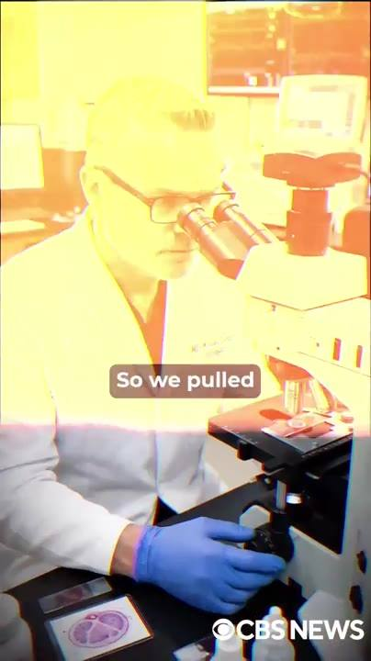 | 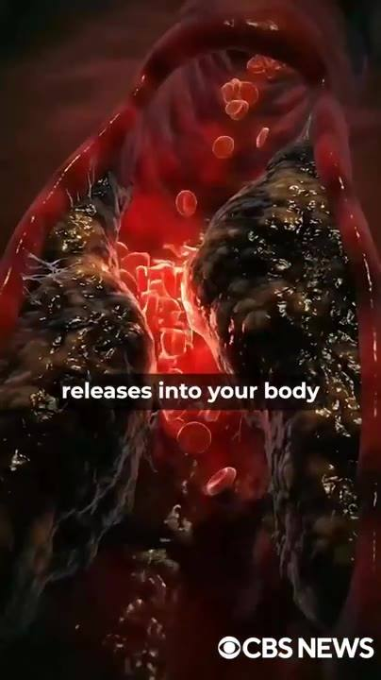 | 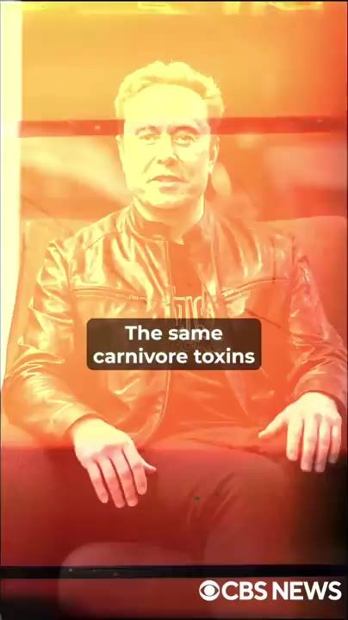
📷 14:39 — Mulher loira de lingerie na cama (filtro laranja); legenda "It is what will make"  b4-3_mulher-loira-de-lingerie-na-cama-filtr_00-14-39.jpg | 📷 14:53 — Cientista de jaleco olhando no microscópio, luva azul (filtro laranja); legenda "So we pulled"  b4-3_cientista-de-jaleco-olhando-no-microsc_00-14-53.jpg | 📷 15:04 — Animação 3D de vasos com placas escuras e hemácias; legenda "releases into your body"  b4-3_animacao-3d-de-vasos-com-placas-escura_00-15-04.jpg | 📷 15:15 — Elon Musk na poltrona com filtro laranja; legenda "The same carnivore toxins"  b4-3_elon-musk-na-poltrona-com-filtro-laran_00-15-15.jpg
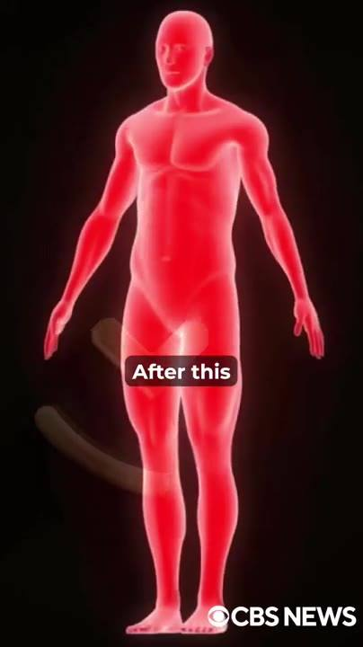
📷 15:27 — Corpo humano 3D vermelho translúcido (anatomia); legenda "After this"
b4-3_corpo-humano-3d-vermelho-translucido-a_00-15-27.jpg

ELON MUSK (imagem/voz sintética): Esse é o fim da disfunção erétil. O renascimento da confiança que deixa sua parceira molhada só de te olhar de cueca, mesmo que ela já tenha passado pela menopausa. É o que vai fazer as amigas da sua filha não conseguirem tirar os olhos do volume gigante marcando no seu shorts. Mas mesmo depois de ver os testes na Neuralink, antes de colocar uma única gota disso no meu próprio corpo, eu ainda precisava ver funcionando na minha frente. Então pegamos uma amostra viva da exata placa tóxica que sufoca o fluxo de sangue de milhões de homens americanos agora mesmo. Dentro deste recipiente com este líquido transparente, temos o composto puro que o mel vermelho do Himalaia libera no seu corpo pra dissolver as placas tóxicas que bloqueiam os vasos sanguíneos do seu pau. Chama-se icariina. E aqui neste recipiente, temos um líquido escuro que representa as xenotoxinas. As mesmas toxinas carnívoras obstruindo os seus vasos agora, enquanto você assiste. Veja o que acontece quando a icariina entra em contato com essas toxinas. Eliminadas na hora. E não só isso: depois que esse composto entra no seu corpo, seus vasos ficam praticamente blindados contra novas obstruções. Veja o que acontece quando as mesmas xenotoxinas tentam se depositar de novo. Na hora.

4.4 ⏱ 15:38 → 16:42
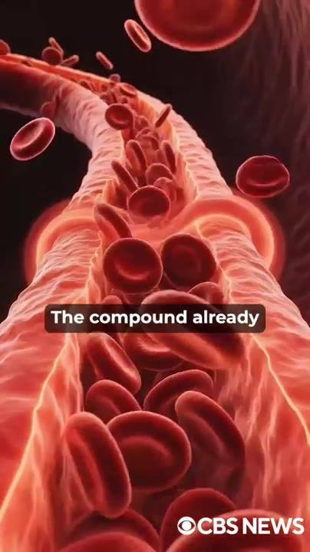 | 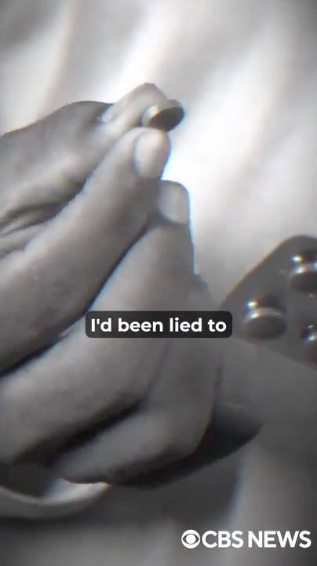 | 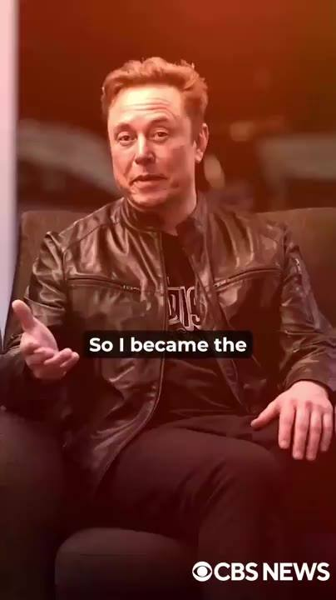 | 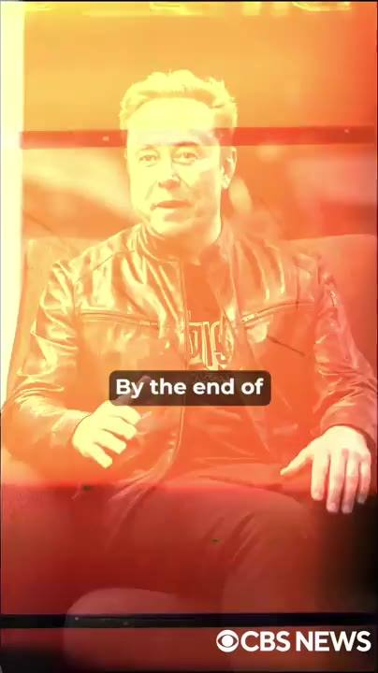
📷 15:38 — Animação 3D de hemácias fluindo num vaso; legenda "The compound already"  b4-4_animacao-3d-de-hemacias-fluindo-num-va_00-15-38.jpg | 📷 15:49 — Mão em P&B segurando comprimido; legenda "I'd been lied to"  b4-4_mao-em-p-b-segurando-comprimido_00-15-49.jpg | 📷 15:58 — Elon Musk na poltrona gesticulando; legenda "So I became the"  b4-4_elon-musk-na-poltrona-gesticulando_00-15-58.jpg | 📷 16:15 — Elon Musk na poltrona com filtro laranja; legenda "By the end of"  b4-4_elon-musk-na-poltrona-com-filtro-laran_00-16-15.jpg
 | 
📷 16:28 — Cena pornô explícita (lingerie preta); legenda "I bent her over"  b4-4_cena-porno-explicita-lingerie-preta_00-16-28.jpg | 📷 16:38 — Cena pornô explícita (varanda, luz do dia); legenda "I fucked her for almost"  b4-4_cena-porno-explicita-varanda_00-16-38.jpg

ELON MUSK (imagem/voz sintética): O composto já presente no seu corpo neutraliza tudo. É assim que seus vasos ficam limpos e suas ereções ficam fortes. Depois do teste de laboratório, eu já estava convencido. Eu tinha sido enganado por cada pílula, cada médico, cada tratamento que o dinheiro podia comprar. Eu não queria outra promessa. Eu queria o meu pau de volta, e queria agora. Então eu virei a primeira cobaia. O ritual do mel vermelho toda manhã, logo cedo, em jejum. Nos primeiros 2 dias, nada. Quase desisti. No dia 3, acordei às 4 da manhã com uma ereção que eu não sentia há 15 anos. Grossa, pesada, pulsando contra o lençol. No fim da primeira semana, eu não acordava mais mole. Acordava duro feito um adolescente, toda santa manhã. E na noite em que a Sophia finalmente aceitou vir me ver de novo, o que aconteceu naquele quarto foi algo que eu nunca vou esquecer. Eu dobrei ela sobre a mesma cama em que eu tinha falhado 100 vezes. No segundo em que entrei, os olhos dela reviraram. Ela soltou um gemido que parecia de atriz pornô. Fodi ela por quase 3 horas seguidas, na cama, contra a parede, no chão.

BLOCO 5 — O PRIMEIRO TESTE DO ELON: a noite, as veias, "algo enorme nas mãos" [16:43 – 17:50]

5.1 ⏱ 16:43 → 17:13
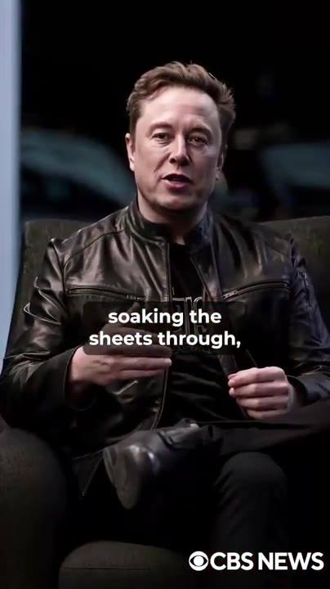 | 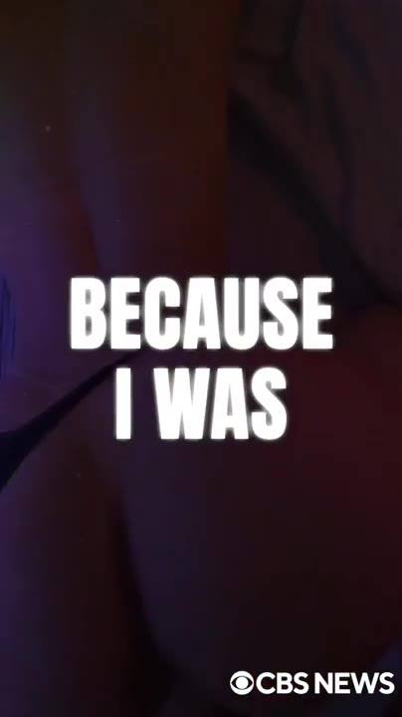
📷 16:47 — Elon Musk na poltrona; legenda "soaking the sheets through,"  b5-1_elon-musk-na-poltrona_00-16-47.jpg | 📷 16:57 — Fundo preto, lettering branco grande "BECAUSE I WAS"  b5-1_fundo-preto_00-16-57.jpg

ELON MUSK (imagem/voz sintética): Ela gozou de novo e de novo até implorar pra eu parar, encharcando o lençol, com as pernas tremendo tanto que não conseguia ficar de pé. E quando eu finalmente gozei, eu não amoleci. Meu pau continuou duro feito uma barra de aço, como se eu ainda estivesse pronto pra outro round. Porque eu estava. Na manhã seguinte, ela olhou pra mim como se eu fosse outro homem e disse que nunca tinha sido fodida daquele jeito na vida, nem quando a gente era jovem. E quando eu me medi algumas semanas depois, quase deixei a fita cair. Tinha ido de 5,8 polegadas pra 7,4. Mais grosso. Mais pesado.

5.2 ⏱ 17:13 → 17:50
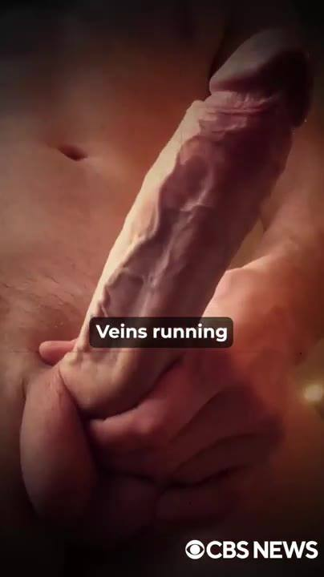 | 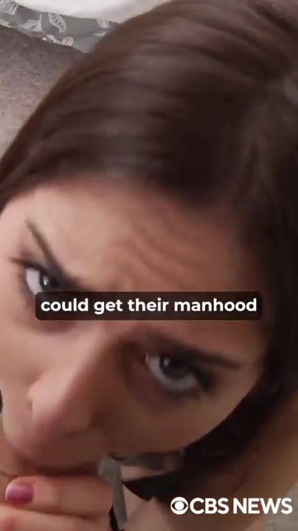 | 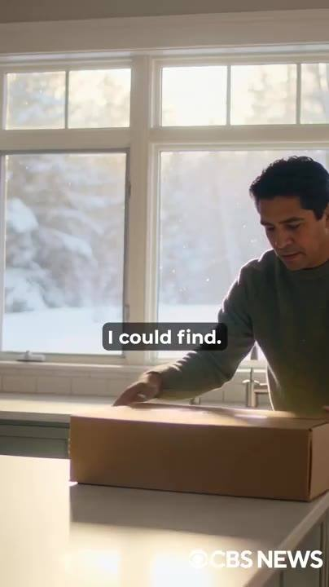 | 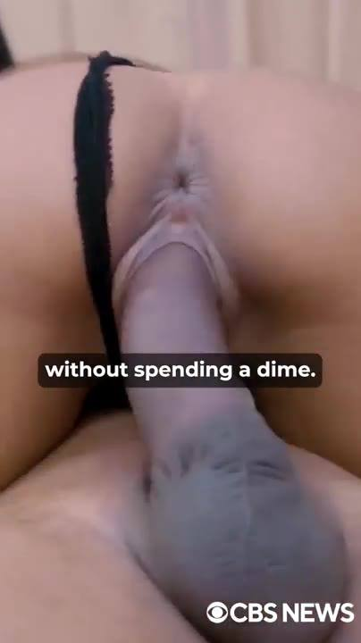
📷 17:13 — Close explícito masculino; legenda "Veins running"  b5-2_close-explicito-masculino_00-17-13.jpg | 📷 17:23 — Atriz adulta olhando pra câmera em cena explícita; legenda "could get their manhood"  b5-2_atriz-adulta-olhando-pra-camera-em-cen_00-17-23.jpg | 📷 17:33 — Homem abrindo uma caixa de papelão na cozinha, janela com neve; legenda "I could find."  b5-2_homem-abrindo-uma-caixa-de-papelao-na_00-17-33.jpg | 📷 17:43 — Cena explícita (close); legenda "without spending a dime."  b5-2_cena-explicita-close_00-17-43.jpg

ELON MUSK (imagem/voz sintética): Veias descendo pela haste que eu não via desde os 20. Foi aí que eu soube que tinha algo enorme nas mãos. Que, pela Neuralink, milhões de homens americanos passando pelo que eu passei podiam recuperar a masculinidade e a confiança. Sem vender a vida pra Big Pharma. Então, primeiro demos isso pra um grupo de homens. Homens de verdade, casos reais, os piores que eu consegui encontrar. Homens que tinham desistido. Mas antes de você ver o que eles mandaram de volta, quero que você conheça o Dr. Michael e preste atenção em cada palavra que ele diz, porque isso vai te deixar viril de novo hoje, na sua casa, sem gastar um centavo. Se eu ainda fodo todo dia aos 55 como um garoto de 19, é por causa do que ele vai te mostrar agora.

BLOCO 6 — DR. MICHAEL CARTER: o mel vermelho, a icariina, os 3 compostos e os 120 pacientes [17:50 – 20:15]

6.1 ⏱ 17:50 → 18:59
 | 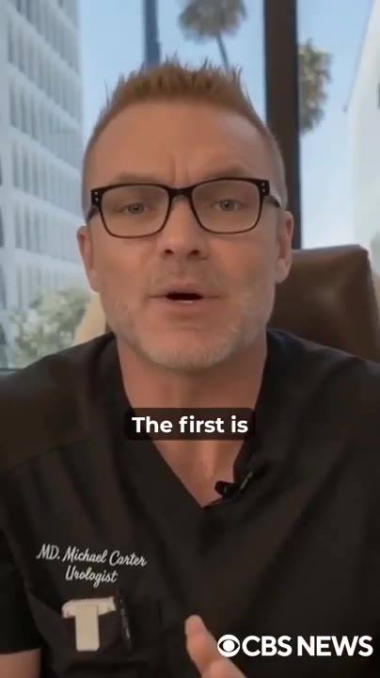 | 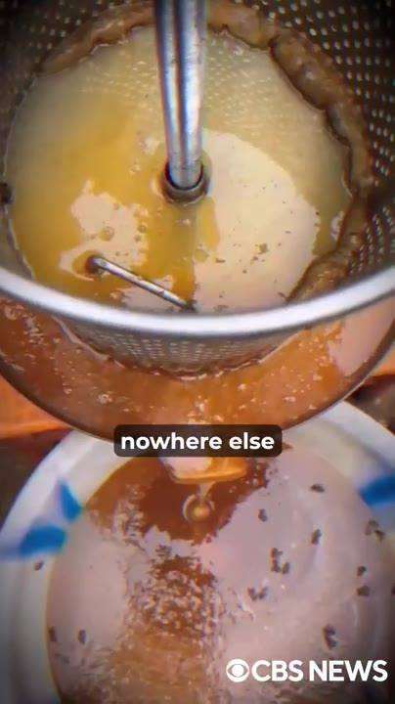 | 
📷 17:55 — Cena de sexo oral explícita; legenda "into a thick, veiny log"  b6-1_cena-de-sexo-oral-explicita_00-17-55.jpg | 📷 18:06 — Médico de scrubs pretos e óculos falando pra câmera, bordado "MD. Michael Carter Urologist", consultório com prédios ao fundo; legenda "The first is"  b6-1_medico-de-scrubs-pretos-e-oculos-falan_00-18-06.jpg | 📷 18:16 — Mel sendo coado numa peneira de metal sobre um balde (mel bruto escuro, com abelhas/cera); legenda "nowhere else"  b6-1_mel-sendo-coado-numa-peneira-de-metal_00-18-16.jpg | 📷 18:25 — Homem descalço escalando árvore/penhasco na selva coletando mel (coletor de mel); legenda "Risking their lives"  b6-1_homem-descalco-escalando-arvore-penhas_00-18-25.jpg
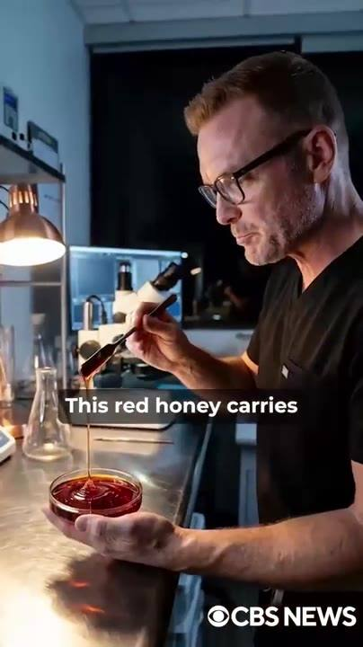 | 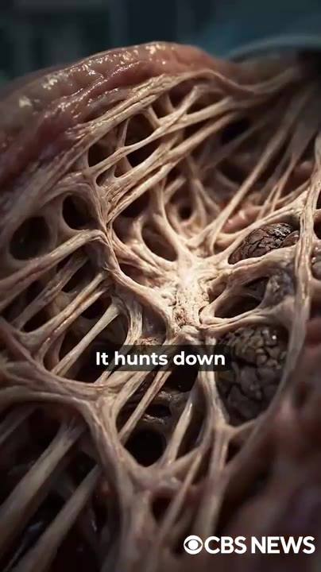 | 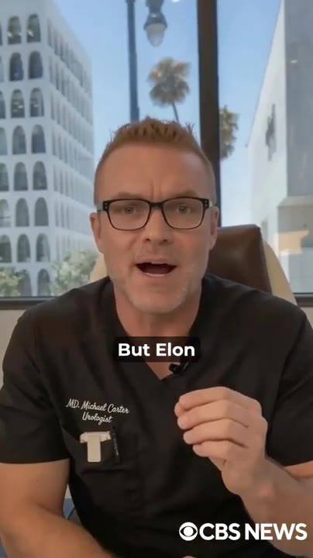
📷 18:37 — Dr. Michael Carter no laboratório derramando mel vermelho num prato de petri, microscópio; legenda "This red honey carries"  b6-1_dr-michael-carter-no-laboratorio-derra_00-18-37.jpg | 📷 18:47 — Animação 3D de tecido fibroso com placas escuras; legenda "It hunts down"  b6-1_animacao-3d-de-tecido-fibroso-com-plac_00-18-47.jpg | 📷 18:57 — Dr. Michael Carter falando pra câmera no consultório; legenda "But Elon"  b6-1_dr-michael-carter-falando-pra-camera-n_00-18-57.jpg

DR. MICHAEL CARTER (urologista): Obrigado, Elon. Eu vou revelar exatamente como qualquer homem pode transformar um pau mole num tronco grosso e cheio de veias que só goza quando você quer. São 4 ingredientes nesse ritual que, juntos, são tão potentes pra virilidade masculina que homens de 70 e poucos anos estão voltando a... O primeiro é o mais importante, e o Elon já mencionou: o mel vermelho do Himalaia. No alto do Himalaia vive uma espécie rara de abelha gigante. Essas abelhas se alimentam de flores que não crescem em nenhum outro lugar do planeta, e produzem um mel espesso, escuro, avermelhado, que os locais chamam de "mad honey" (mel louco). Por séculos, só os homens mais fortes dessas aldeias tinham permissão pra colher, arriscando a vida por alguns quilos dele. Nunca foi comida; era sagrado. O motivo de esses homens terem filhos aos 80 enquanto o resto do mundo amolece aos 40? Quando eu trouxe pro meu laboratório e analisei, entendi por quê. Esse mel vermelho carrega a maior concentração de um composto chamado icariina já encontrada na natureza. Nada mais na Terra chega perto. A icariina faz uma coisa que nenhum remédio consegue fazer. Ela caça as placas de xenotoxina que sufocam os seus vasos sanguíneos e dissolve elas. Ela quebra o acúmulo, expulsa ele e libera a estrada pro sangue finalmente inundar o seu pau de novo. Mas o Elon e eu sabíamos que o mel vermelho sozinho não bastava.

6.2 ⏱ 19:00 → 20:03
 |  | 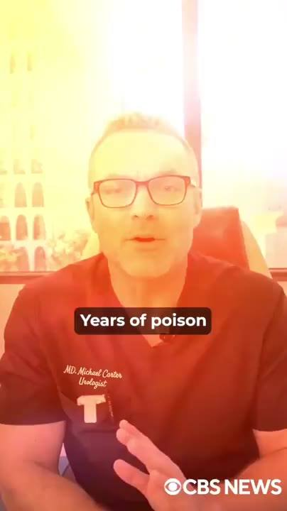 | 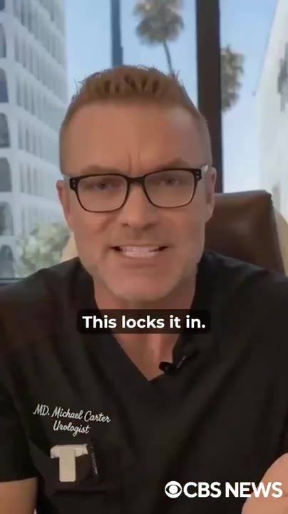
📷 19:07 — Cena pornô explícita (casal); legenda "Every man over forty"  b6-2_cena-porno-explicita-casal_00-19-07.jpg | 📷 19:18 — Close explícito masculino (mão com unhas verdes); legenda "making you thicker"  b6-2_close-explicito-masculino-mao-com-unha_00-19-18.jpg | 📷 19:27 — Dr. Michael Carter falando pra câmera com filtro laranja estourado; legenda "Years of poison"  b6-2_dr-michael-carter-falando-pra-camera-c_00-19-27.jpg | 📷 19:39 — Dr. Michael Carter no consultório, enfático; legenda "This locks it in."  b6-2_dr-michael-carter-no-consultorio_00-19-39.jpg
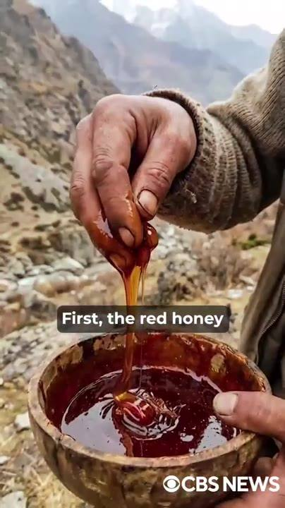 | 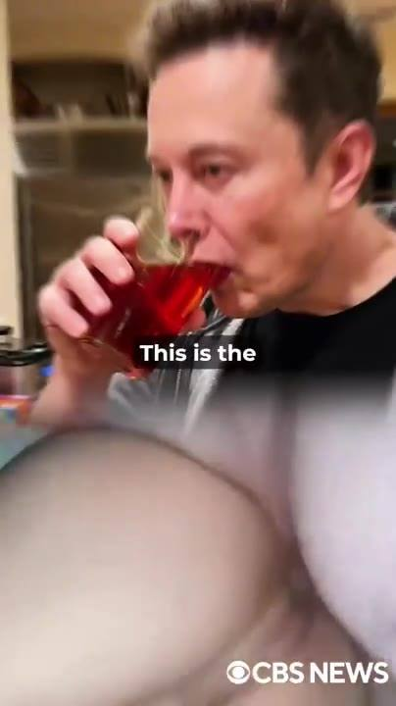
📷 19:50 — Mão enrugada derramando mel vermelho escuro num bowl de madeira, montanhas ao fundo; legenda "First, the red honey"  b6-2_mao-enrugada-derramando-mel-vermelho-e_00-19-50.jpg | 📷 19:59 — Elon Musk bebendo um líquido vermelho num copo; legenda "This is the"  b6-2_elon-musk-bebendo-um-liquido-vermelho_00-19-59.jpg

DR. MICHAEL CARTER (urologista): Então eu combinei ele com mais 3 compostos, cada um atacando uma parte diferente do estrago. O segundo ingrediente é horny goat weed concentrado. Todo homem acima de 40 já ouviu falar, e tem um motivo. Com a placa fora, os vasos precisam abrir bem. O horny goat weed força eles numa expansão brutal, levando até 500% mais sangue pro pênis, te deixando mais grosso e mais duro do que você esteve em décadas. O terceiro é o PT-141, o peptídeo do sexo. Pelo qual os maiores nomes de Wall Street pagam 2.000 dólares por mês. Anos de veneno matam o desejo de um homem. O PT-141 atinge o centro de prazer do seu cérebro diretamente, pra que o desejo ruja tão alto quanto a ereção. O quarto é raiz de Ashwagandha, padronizada na maior potência já produzida. Isso trava tudo. Ela empurra o seu corpo a produzir a própria testosterona de novo, do jeito que fazia aos 20, te mantendo duro muito depois de os outros homens desistirem. 4 compostos, 4 etapas, 1 reversão completa. Primeiro, o mel vermelho limpa a placa. Depois o horny goat weed abre os vasos. O PT-141 traz o desejo de volta. E a Ashwagandha reconstrói a sua potência natural. Essa é a combinação exata que trouxe a masculinidade do Elon de volta dos mortos.

6.3 ⏱ 20:03 → 20:15
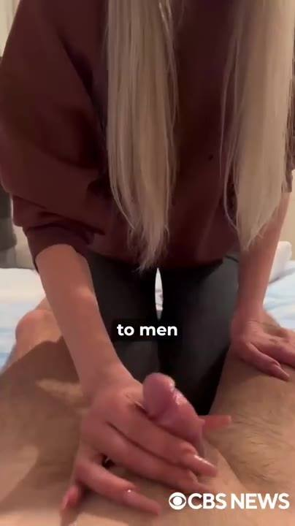
📷 20:10 — Cena explícita (mulher loira de moletom marrom); legenda "to men"
b6-3_cena-explicita-mulher-loira-de-moletom_00-20-10.jpg

DR. MICHAEL CARTER (urologista): E é a mesma combinação que eu testei em mais de 120 pacientes meus, com gravidades que iam de ereções moles a homens que não ficavam duros há mais de 15 anos. Esses são os vídeos que eles me mandaram depois do teste.

BLOCO 7 — DEPOIMENTOS DO GRUPO (John 72, James 74, Richard 53) + o "red honey challenge" [20:15 – 21:55]

7.1 ⏱ 20:15 → 20:23
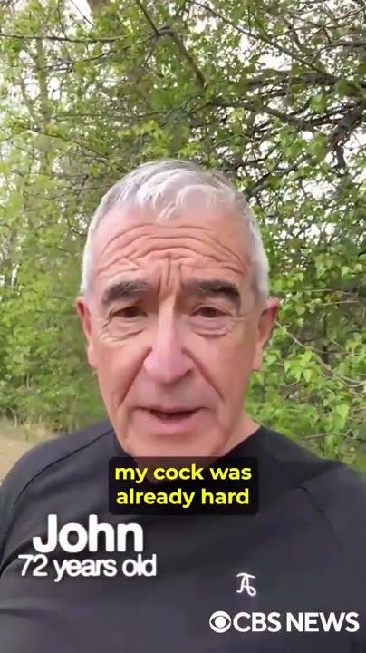 | 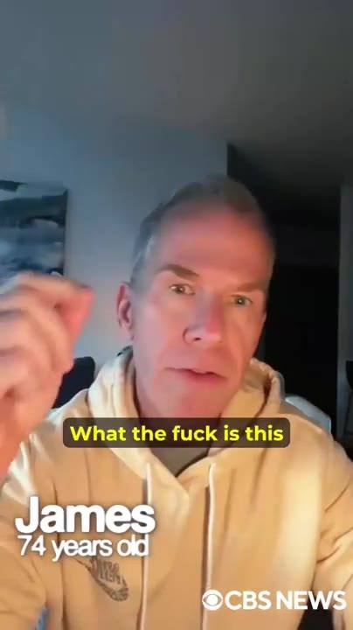
📷 20:16 — Depoimento: homem idoso de cabelo branco ao ar livre, lower-third "John 72 years old"; legenda amarela "my cock was already hard"  b7-1_depoimento-homem-idoso-de-cabelo-branc_00-20-16.jpg | 📷 20:20 — Depoimento: homem grisalho de moletom bege em sala, lower-third "James 74 years old"; legenda amarela "What the fuck is this"  b7-1_depoimento-homem-grisalho-de-moletom-b_00-20-20.jpg

HOMEM (depoimento): No terceiro dia, meu pau já estava duro feito um taco de beisebol. Que porra é essa fórmula, cara? Estou fodendo minha esposa 3 vezes por noite.

7.2 ⏱ 20:24 → 21:02
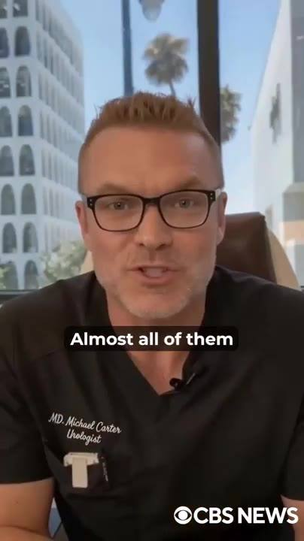 | 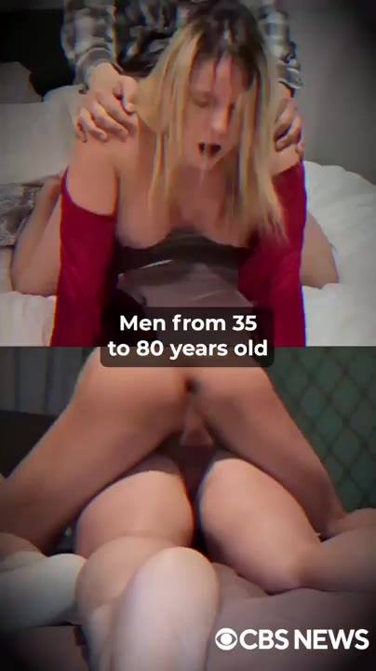 |  | 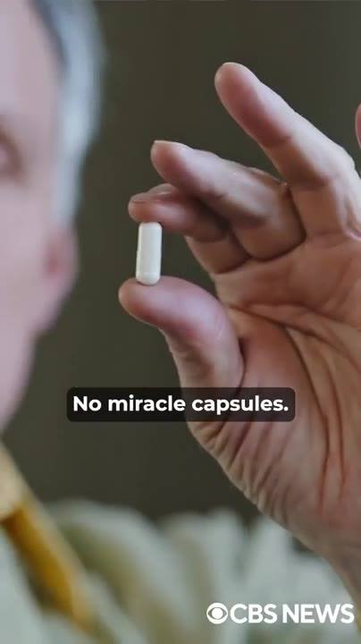
📷 20:29 — Dr. Michael Carter no consultório; legenda "Almost all of them"  b7-2_dr-michael-carter-no-consultorio_00-20-29.jpg | 📷 20:40 — Cena explícita (mulher loira de blusa vermelha); legenda "Men from 35 to 80 years old"  b7-2_cena-explicita-mulher-loira-de-blusa-v_00-20-40.jpg | 📷 20:50 — Cena explícita (mulher de cabelo escuro); legenda "The wives began"  b7-2_cena-explicita-mulher-de-cabelo-escuro_00-20-50.jpg | 📷 21:00 — Mão segurando uma cápsula branca; legenda "No miracle capsules."  b7-2_mao-segurando-uma-capsula-branca_00-21-00.jpg

DR. MICHAEL CARTER (urologista): "Hoje de manhã acordei com o pau latejando. Ela gozou duas vezes antes de eu terminar a primeira." Quase todos relataram ereções insanas na primeira semana. Cerca de 98% disseram que estavam fodendo por mais de uma hora sem gozar, literalmente quebrando a cama e as esposas. Homens de 35 a 80 anos me agradeceram por devolver a virilidade que achavam que nunca mais teriam. E frases como "eu nunca senti isso antes" viraram rotina no meu telefone. As esposas começaram a implorar por misericórdia depois de os maridos gozarem 2 ou 3 vezes naquela noite. A parte mais louca? Ninguém precisou parar de beber. Ninguém precisou parar de fumar. Ninguém fez dieta. Nada de cápsulas milagrosas. Nada de pílulas químicas.

7.3 ⏱ 21:03 → 21:16
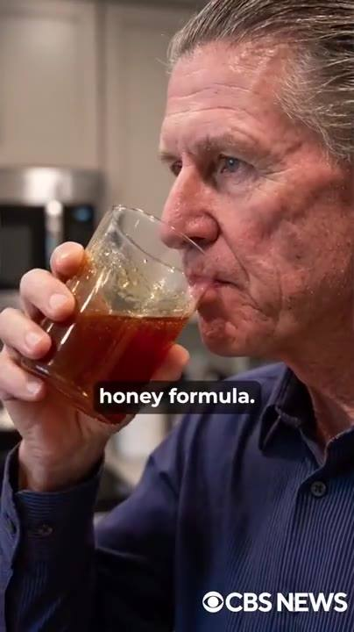 | 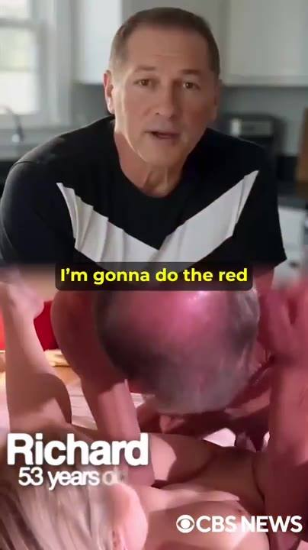
📷 21:04 — Homem grisalho de camisa azul bebendo líquido âmbar num copo (cozinha); legenda "honey formula."  b7-3_homem-grisalho-de-camisa-azul-bebendo_00-21-04.jpg | 📷 21:16 — Depoimento: homem de camiseta preta e branca, careca, lower-third "Richard 53 years old"; legenda amarela "I'm gonna do the red"  b7-3_depoimento-homem-de-camiseta-preta-e-b_00-21-16.jpg

DR. MICHAEL CARTER (urologista): Só a fórmula do mel vermelho. Alguns pacientes até se gravaram fazendo sexo depois do ritual. Achei bizarro, mas eles estavam adorando a reputação de garanhões, e as mulheres estavam praticamente se jogando em cima deles querendo foder. Veja com seus próprios olhos.

7.4 ⏱ 21:16 → 21:23
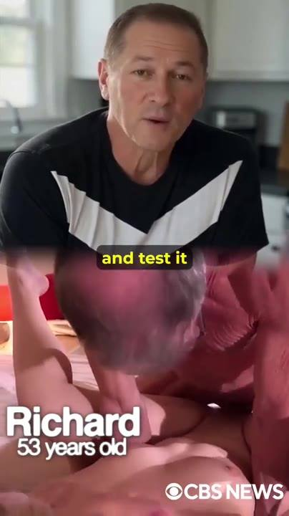
📷 21:18 — Depoimento: Richard (lower-third "Richard 53 years old"), camiseta preta e branca na cozinha + inserto explícito; legenda amarela "and test it"
b7-4_depoimento-richard-lower-third-richard_00-21-18.jpg

HOMEM (depoimento): Vou fazer o desafio do mel vermelho agora mesmo e testar numa foda de verdade. Não entendo como essa coisa funciona, mas olha o que faz com o meu pau.

7.5 ⏱ 21:23 → 21:55
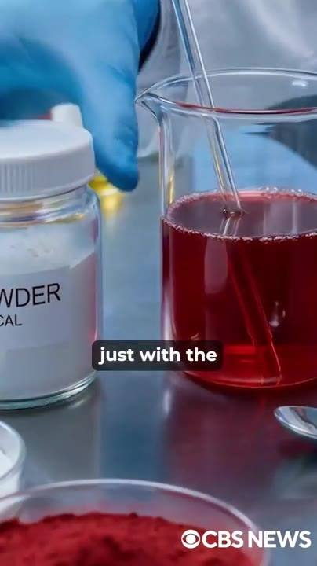 | 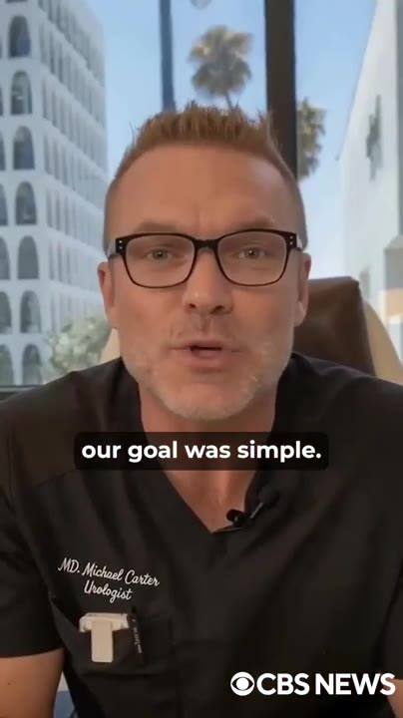 | 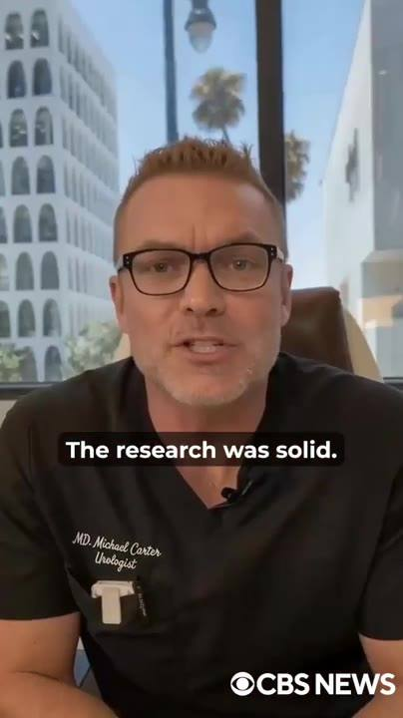
📷 21:32 — Laboratório: frasco "POWDER", béquer com líquido vermelho, pó vermelho, luva azul; legenda "just with the"  b7-5_laboratorio-frasco-powder_00-21-32.jpg | 📷 21:42 — Dr. Michael Carter no consultório; legenda "our goal was simple."  b7-5_dr-michael-carter-no-consultorio_00-21-42.jpg | 📷 21:54 — Dr. Michael Carter no consultório; legenda "The research was solid."  b7-5_dr-michael-carter-no-consultorio_00-21-54.jpg

DR. MICHAEL CARTER (urologista): Eles não são exceções. São exemplos vivos de que a virilidade pode ser recuperada sem depender de farmácia, sem se envenenar com químicos, só com o ritual certo aplicado do jeito certo. Quando finalmente provamos que esse ritual limpava as placas, fazia o sangue fluir com força total e trazia a testosterona de volta como a de um homem de 20 e poucos anos, nosso objetivo era simples: colocar isso nas mãos de todo homem americano lutando contra um pau mole, sem que eles precisassem gastar um único centavo. Foi aí que o Elon foi com tudo. Ele mobilizou o dinheiro pessoal dele e todo o peso da Neuralink por trás desse projeto. A pesquisa era sólida.

BLOCO 8 — A LIGAÇÃO DO CEO FARMACÊUTICO e a decisão de fazer sozinhos [21:55 – 23:18]

8.1 ⏱ 21:55 → 22:11
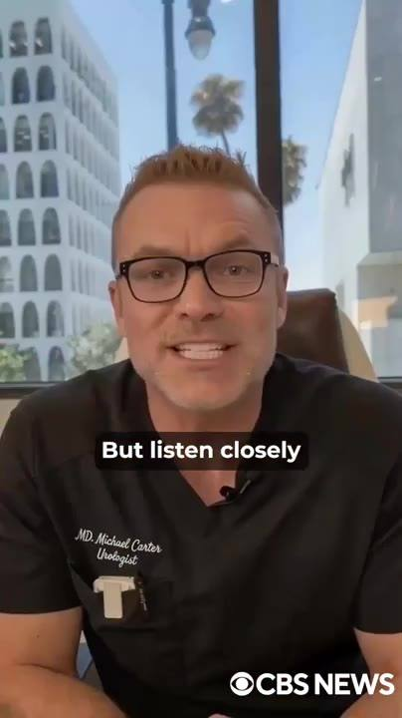
📷 22:10 — Dr. Michael Carter no consultório; legenda "But listen closely"
b8-1_dr-michael-carter-no-consultorio_00-22-10.jpg

DR. MICHAEL CARTER (urologista): Os testes de laboratório eram inegáveis. Só precisávamos de um fabricante nos Estados Unidos capaz de produzir isso em escala. Então o Elon ligou pro CEO de um dos maiores laboratórios farmacêuticos do país, um homem com quem ele trabalhava há anos. Ele gravou a ligação e teve que censurar a voz do cara, mas ouça com atenção o que ele disse pro Elon.

8.2 ⏱ 22:12 → 22:39

📷 22:13 — Tela de chamada de vídeo: contato "**** - *** CEO" com rosto pixelado, onda de áudio; legenda amarela "straight with you."
b8-2_tela-de-chamada-de-video-contato-ceo-c_00-22-13.jpg

CEO FARMACÊUTICO (chamada de vídeo): Elon, deixa eu ser direto com você. Você entende o que isso faz com o nosso negócio? O homem com disfunção erétil vale algo entre 40.000 e 70.000 dólares pra nós ao longo da vida dele. Viagra, Cialis, receitas de acompanhamento, tratamentos de efeitos colaterais. Se a gente fabricar algo que reverte a DE em tempo recorde, pela raiz, perdemos bilhões em receita anual da noite pro dia. Não faz nenhum sentido te ajudar com isso.

8.3 ⏱ 22:39 → 22:42
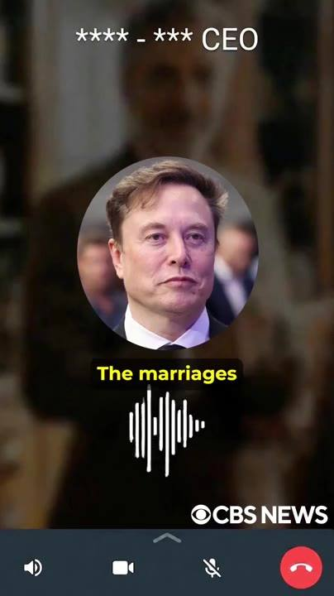
📷 22:40 — Tela de chamada de vídeo com foto de Elon Musk falando; legenda amarela "The marriages"
b8-3_tela-de-chamada-de-video-com-foto-de-e_00-22-40.jpg

ELON MUSK (imagem/voz sintética): Mas pensa nos homens, nos casamentos que a gente podia salvar.

8.4 ⏱ 22:42 → 22:54

📷 22:45 — Tela de chamada: CEO pixelado; legenda amarela "We're not going to do"
b8-4_tela-de-chamada-ceo-pixelado_00-22-45.jpg

CEO FARMACÊUTICO (chamada de vídeo): Você quer mudar este mundo, Elon. Eu não. Não vamos fazer isso. E, sinceramente, eu reconsideraria até onde você quer levar isso. Tem gente que não quer essa solução aí fora. Gente que joga mais pesado do que eu.

8.5 ⏱ 22:55 → 23:18
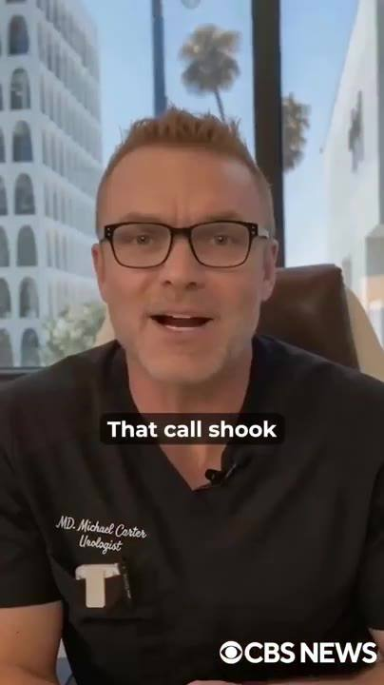 | 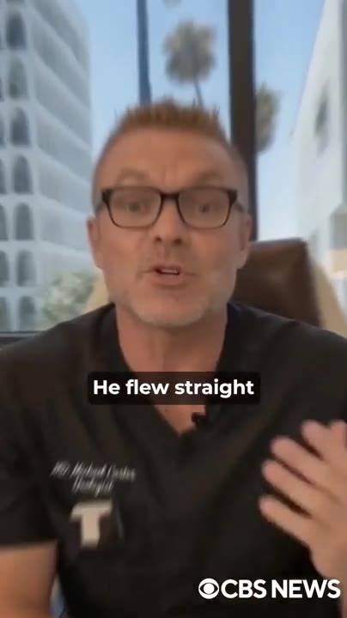
📷 22:55 — Dr. Michael Carter no consultório; legenda "That call shook"  b8-5_dr-michael-carter-no-consultorio_00-22-55.jpg | 📷 23:12 — Dr. Michael Carter no consultório; legenda "He flew straight"  b8-5_dr-michael-carter-no-consultorio_00-23-12.jpg

DR. MICHAEL CARTER (urologista): Aquela ligação abalou nós dois. O sistema não quer você consertado. Quer você medicado. Mensalmente. Pra sempre. Então o Elon tomou uma decisão naquela noite. Íamos fazer isso nós mesmos. Sem sócios. Sem intermediários. Sem guardiões da indústria entre essa descoberta e os homens que precisavam dela. Ele voou direto pro Nepal na semana seguinte e começou a construir toda a estrutura ele mesmo. Ele me mandou os vídeos do que estava fazendo nos penhascos.

BLOCO 9 — NEPAL: o mel que não se compra; o laboratório da Neuralink em Woodinville; nasce o HoneyFil [23:19 – 25:00]

9.1 ⏱ 23:19 → 23:50
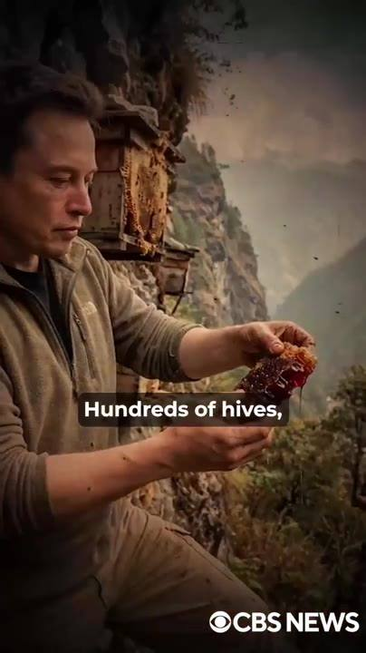
📷 23:38 — Elon Musk vestido de campo segurando favo de mel vermelho diante de uma colmeia de madeira num penhasco; legenda "Hundreds of hives,"
b9-1_elon-musk-vestido-de-campo-segurando-f_00-23-38.jpg

ELON MUSK (imagem/voz sintética): O mel vermelho não é uma commodity. Você não pode comprar, não pode fabricar. Ele só existe aqui, nesses penhascos. Então eu investi diretamente na região. Financiei a construção de estações dedicadas de colheita e processamento com os aldeões locais, as mesmas famílias que coletam esse mel há séculos. Isso é o que construímos. Centenas de colmeias colhidas à mão, cada lote testado quanto à concentração de icariina antes de sair da montanha. O que é enviado pros Estados Unidos é o mesmo mel que essas aldeias usam há 1.000 anos.

9.2 ⏱ 23:51 → 25:00
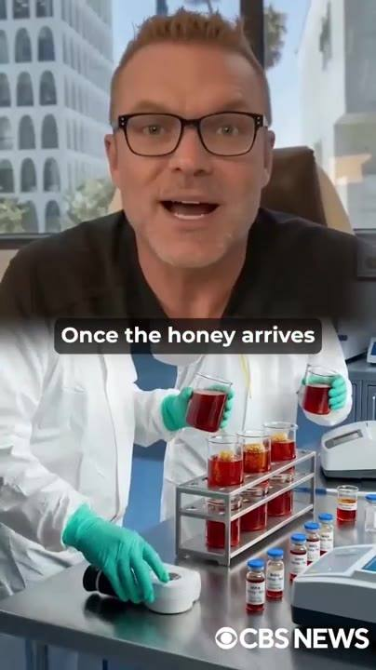 | 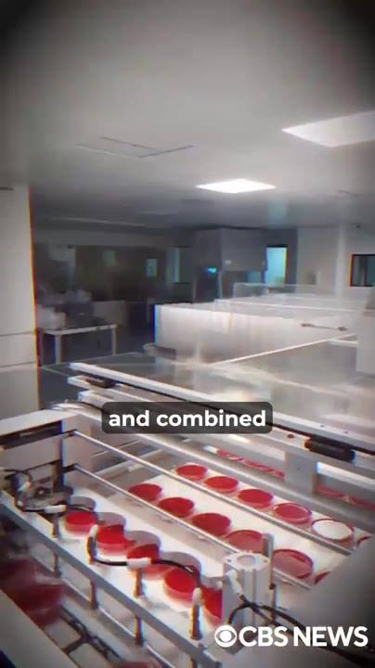 | 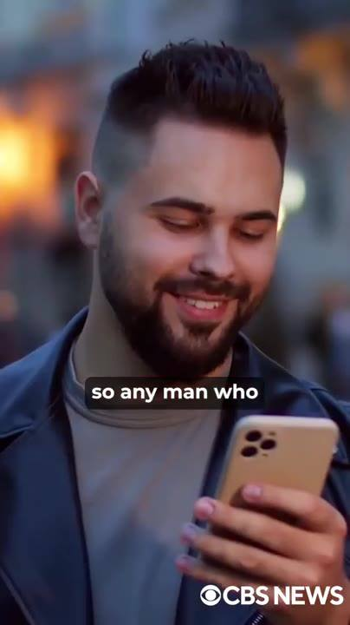 | 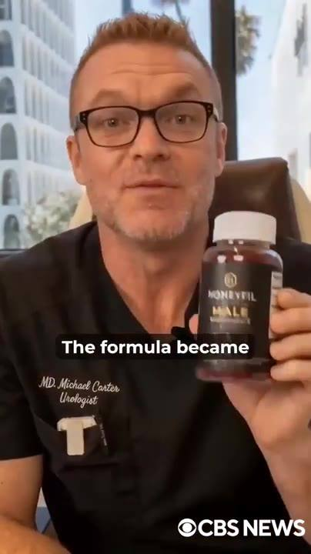
📷 23:51 — Dr. Michael Carter no consultório + laboratório com tubos de líquido vermelho; legenda "Once the honey arrives"  b9-2_dr-michael-carter-no-consultorio-labor_00-23-51.jpg | 📷 24:05 — Linha de produção industrial com frascos de líquido vermelho; legenda "and combined"  b9-2_linha-de-producao-industrial-com-frasc_00-24-05.jpg | 📷 24:19 — Homem jovem de barba sorrindo olhando o celular na rua; legenda "so any man who"  b9-2_homem-jovem-de-barba-sorrindo-olhando_00-24-19.jpg | 📷 24:31 — Dr. Michael Carter segurando o frasco HONEYFIL MALE; legenda "The formula became"  b9-2_dr-michael-carter-segurando-o-frasco-h_00-24-31.jpg
 | 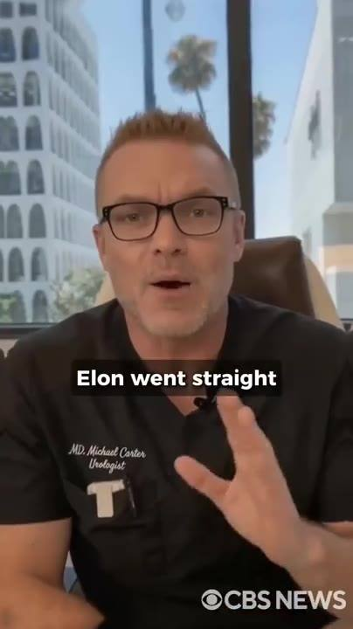
📷 24:42 — Cena pornô explícita; legenda "was to put"  b9-2_cena-porno-explicita_00-24-42.jpg | 📷 24:53 — Dr. Michael Carter no consultório gesticulando; legenda "Elon went straight"  b9-2_dr-michael-carter-no-consultorio-gesti_00-24-53.jpg

DR. MICHAEL CARTER (urologista): Assim que o mel chega aos Estados Unidos, ele vai pro laboratório que a Neuralink construiu em Woodinville, Washington. Registrado na FDA, certificado GMP, equipado com a tecnologia de extração e mistura mais avançada do país. É onde a icariina é concentrada e combinada com o horny goat weed, o peptídeo PT-141 e a raiz de Ashwagandha nas proporções exatas que eu passei anos aperfeiçoando. Cada frasco custa facilmente mais de 1.000 dólares pra produzir, mas o Elon decidiu pagar do próprio bolso, pra que qualquer homem que encontre esta mensagem em 2026 possa receber 6 frascos na porta de casa, totalmente de graça, com o mel vermelho já concentrado, dosado e misturado com os outros 3 compostos numa única goma. A fórmula ficou conhecida como HoneyFil. Só fica comigo pelos próximos 3 minutos e você vai poder reivindicar até 6 meses de tratamento sem gastar um centavo. O jeito mais rápido que conhecíamos de provar que o HoneyFil funcionava era colocar nas mãos dos homens que não podem se dar ao luxo de falhar na cama: a indústria de filmes adultos. Convencer eles não foi fácil. Já estavam viciados em Viagra e Cialis. Não conseguiam acreditar que uma fórmula natural pudesse superar aquilo em que tinham construído a carreira. O Elon foi direto aos maiores estúdios, entregou um frasco grátis pra cada ator que estava gravando naquele... O retorno veio mais rápido do que esperávamos.

BLOCO 10 — INDÚSTRIA ADULTA + DR. OZ: o voluntário de 79 anos, "this works" [25:00 – 27:23]

10.1 ⏱ 25:00 → 25:24
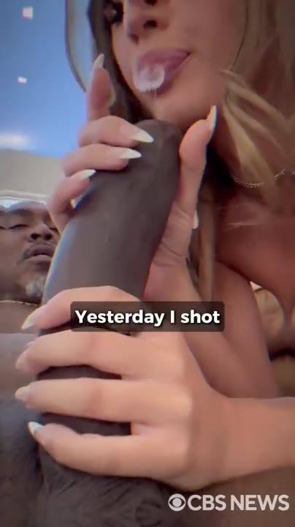 | 
📷 25:04 — Cena de sexo oral explícita (depoimento de atriz/produtora); legenda "Yesterday I shot"  b10-1_cena-de-sexo-oral-explicita-depoimento_00-25-04.jpg | 📷 25:17 — Cena pornô explícita (mulher de cabelo roxo); legenda "They stay hard"  b10-1_cena-porno-explicita-mulher-de-cabelo_00-25-17.jpg

ATRIZ ADULTA (clipe): É insano o que aconteceu com os atores desde que começaram a tomar HoneyFil. Ontem gravei com um cara de 60 e poucos anos. Ele tomou HoneyFil e me fez esguichar 4 vezes neste sofá. Toda cena que eu gravo agora termina comigo pingando. Minhas amigas que gravam com esses caras dizem a mesma coisa. Os paus estão mais grossos, com mais veias. Ficam duros por 2 horas seguidas sem perder o ritmo. E aí os homens continuaram socando por mais de 2 horas direto. O Viagra nunca fez isso.

10.2 ⏱ 25:25 → 25:40
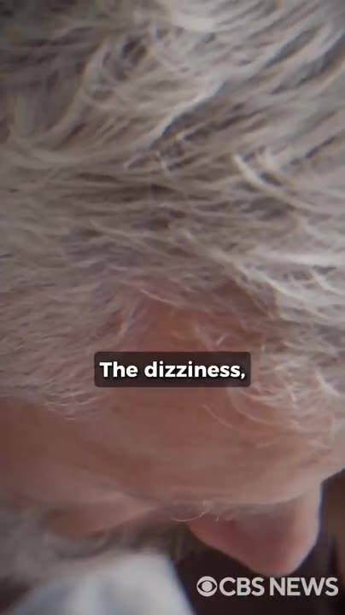 | 
📷 25:27 — Close de cabelo grisalho de homem abaixando a cabeça; legenda "The dizziness,"  b10-2_close-de-cabelo-grisalho-de-homem-abai_00-25-27.jpg | 📷 25:40 — Fundo laranja, lettering amarelo grande "VEINIER"  b10-2_fundo-laranja_00-25-40.jpg

HOMEM (depoimento): Eu dependia do Viagra, mas era um pesadelo. A tontura, as palpitações. Eu tinha medo de ter um infarto no meio da cena. Depois que o Elon me deu um frasco de HoneyFil, estou gravando 4 cenas seguidas. Antes, mal conseguia fazer 2. Meu pau, que não era pequeno, ganhou 2 polegadas. Mais grosso, com mais veias.

10.3 ⏱ 25:40 → 25:45
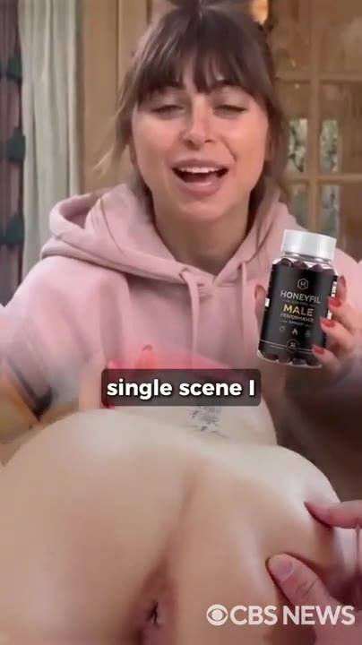
📷 25:41 — Jovem de moletom rosa segurando o frasco HONEYFIL MALE falando pra câmera + inserto explícito; legenda "single scene I"
b10-3_jovem-de-moletom-rosa-segurando-o-fras_00-25-41.jpg

ATRIZ ADULTA (clipe): Não tem uma única cena que eu grave depois da febre do HoneyFil que não me deixe esguichando toda de puro êxtase.

10.4 ⏱ 25:45 → 26:01
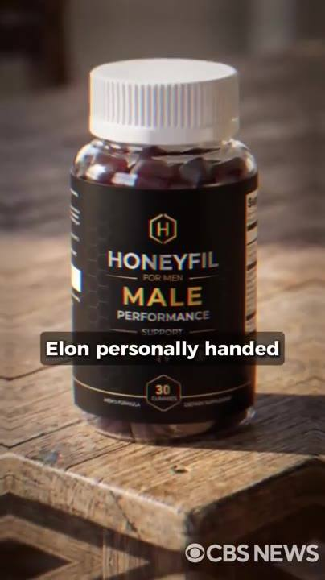
📷 25:53 — Frasco HONEYFIL FOR MEN MALE PERFORMANCE (30 gummies) sobre mesa de madeira; legenda "Elon personally handed"
b10-4_frasco-honeyfil-for-men-male-performan_00-25-53.jpg

DR. MICHAEL CARTER (urologista): Mas o teste de verdade veio do Dr. Mehmet Oz. Reunimos cada pedaço da pesquisa, os testes de laboratório, os depoimentos das estrelas de filmes adultos. O Elon entregou pessoalmente um frasco de HoneyFil pra ele. Ele nos disse que testaria num voluntário ele mesmo antes de apoiar publicamente. 3 semanas depois, ele nos mandou um vídeo.

10.5 ⏱ 26:02 → 26:32
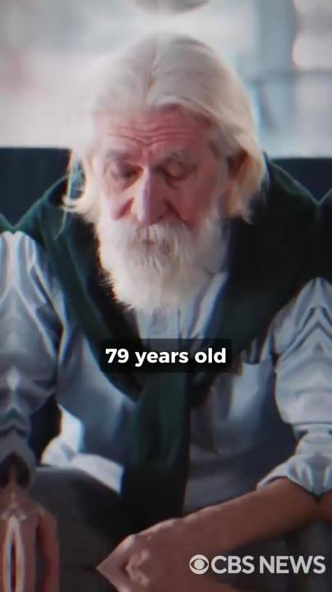 | 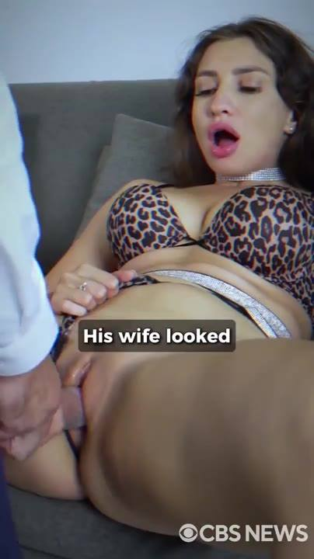 | 
📷 26:05 — Homem idoso de barba branca e colete verde, cabisbaixo numa poltrona; legenda "79 years old"  b10-5_homem-idoso-de-barba-branca-e-colete-v_00-26-05.jpg | 📷 26:15 — Mulher morena de sutiã de oncinha no sofá, cena explícita; legenda "His wife looked"  b10-5_mulher-morena-de-sutia-de-oncinha-no-s_00-26-15.jpg | 📷 26:25 — Imagem borrada de Dr. Oz (terno, gravata vermelha) com lettering verde "THIS WORKS"  b10-5_imagem-borrada-de-dr-oz-terno_00-26-25.jpg

DR. MEHMET OZ (imagem): Eu testei pessoalmente o HoneyFil num voluntário de 79 anos, diabético, com pressão alta. Há mais de 10 anos ele não conseguia ter uma única ereção. No dia 4, ele acordou com uma ereção completa, dura feito pedra. A esposa olhou pra ele e disse: "Cadê o meu marido? O que você fez com ele?" Depois de 3 semanas, esse homem me disse que não tinha mais medo de problemas de desempenho na cama. Elon, Michael, isso funciona. Eu vi com meus próprios olhos. Joguem as pílulas azuis no lixo. O HoneyFil vai salvar casamentos por toda a América. Com a palavra do Dr.

10.6 ⏱ 26:32 → 27:23
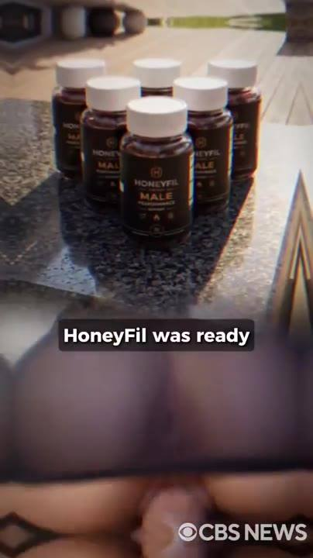 | 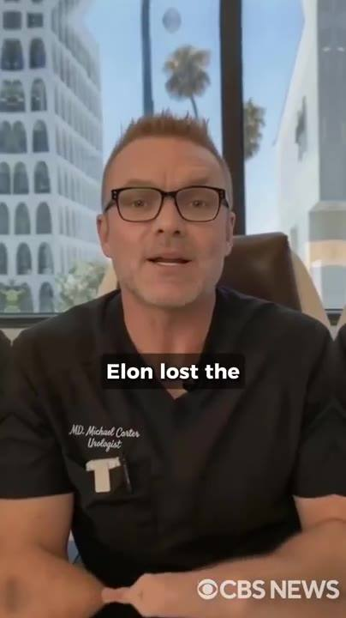 | 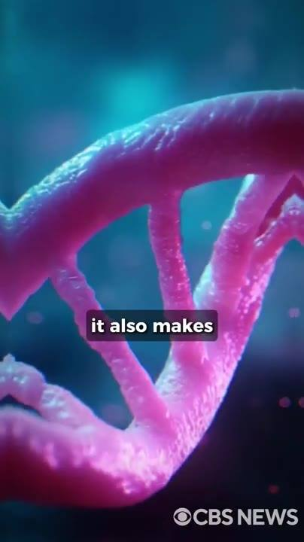 | 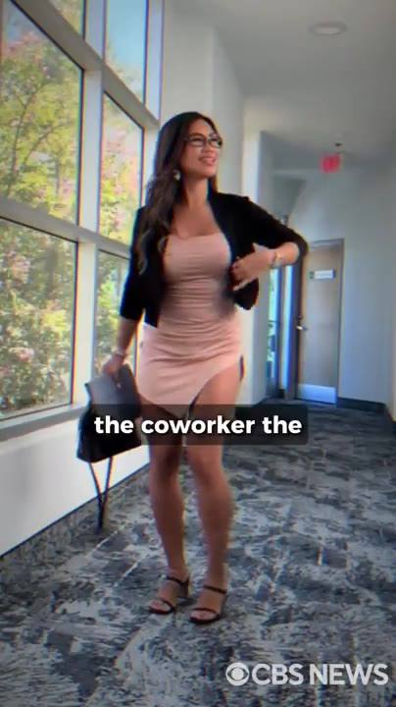
📷 26:34 — Seis frascos HONEYFIL MALE numa bancada de pedra; legenda "HoneyFil was ready"  b10-6_seis-frascos-honeyfil-male-numa-bancad_00-26-34.jpg | 📷 26:43 — Dr. Michael Carter no consultório; legenda "Elon lost the"  b10-6_dr-michael-carter-no-consultorio_00-26-43.jpg | 📷 26:53 — Animação 3D de dupla hélice de DNA rosa; legenda "it also makes"  b10-6_animacao-3d-de-dupla-helice-de-dna-ros_00-26-53.jpg | 📷 27:03 — Mulher de vestido justo rosa e blazer preto num corredor de escritório; legenda "the coworker the"  b10-6_mulher-de-vestido-justo-rosa-e-blazer_00-27-03.jpg
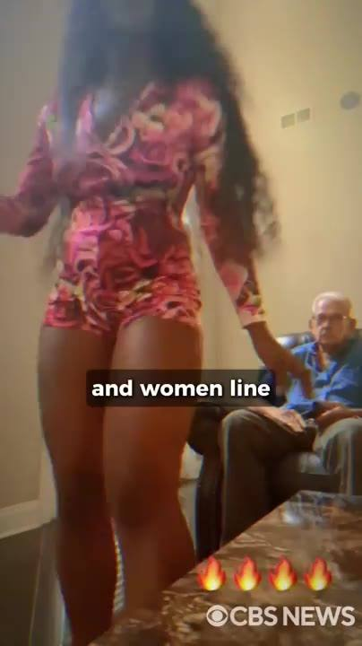 | 
📷 27:12 — Mulher de vestido estampado curto de pé diante de homem idoso sentado numa sala, emojis de fogo; legenda "and women line"  b10-6_mulher-de-vestido-estampado-curto-de-p_00-27-12.jpg | 📷 27:22 — Dr. Michael Carter borrado ao fundo, lettering verde grande "IT'S PURE BIOLOGY"  b10-6_dr-michael-carter-borrado-ao-fundo_00-27-22.jpg

DR. MICHAEL CARTER (urologista): Oz por trás de nós, o HoneyFil estava pronto pra todo homem americano que quisesse a masculinidade de volta. Mas deixa eu ser claro com você. O Elon e eu não temos superpoderes. Somos só 2 homens que viveram isso e encontraram a saída. O Elon perdeu a única mulher que realmente amou por causa da impotência, e a única coisa que trouxe ela de volta foi a mesma coisa que está prestes a trazer ela de volta pra sua cama também. Porque o HoneyFil não te dá só uma ereção poderosa, ele também faz o seu corpo bombear testosterona pura, e isso libera 2 feromônios, androstenona e androstenol, que atingem o cérebro feminino diretamente. É por isso que é completamente normal as mulheres, a colega de trabalho, a caixa do mercado, a mulher da academia, de repente olharem pra você diferente. Sem saber por quê. Você já viu caras que não são especialmente bonitos, não têm dinheiro, e as mulheres fazem fila pra eles. Já se perguntou por quê? Esses homens irradiam testosterona naturalmente. Com o HoneyFil, você também vai. Não se surpreenda quando as mulheres começarem a se aproximar de você do nada. Isso não é mágica, é pura biologia.

BLOCO 11 — DEPOIMENTOS: TRT, o amigo do Elon, 81 anos, "as pílulas nem funcionavam" [27:23 – 28:37]

11.1 ⏱ 27:23 → 27:46
 | 
📷 27:32 — Cena de sexo oral explícita (lingerie rosa); legenda "six"  b11-1_cena-de-sexo-oral-explicita-lingerie-r_00-27-32.jpg | 📷 27:42 — Homem borrado ao fundo, lettering verde grande "THIS SHIT IS REAL,"  b11-1_homem-borrado-ao-fundo_00-27-42.jpg

HOMEM (depoimento): Faço TRT há anos e ainda tinha dias em que o meu pau não cooperava totalmente. O Elon me mandou um frasco de HoneyFil depois que ele veio no podcast. 6 meses depois, não toco mais em TRT. Minha testosterona está mais alta do que desde os meus 20 anos, com exames de sangue pra provar. Aos 59, estou fodendo minha esposa mais forte do que aos 30. Essa merda é real, e o Elon merece cada grama de crédito por tornar isso público.

11.2 ⏱ 27:46 → 28:02
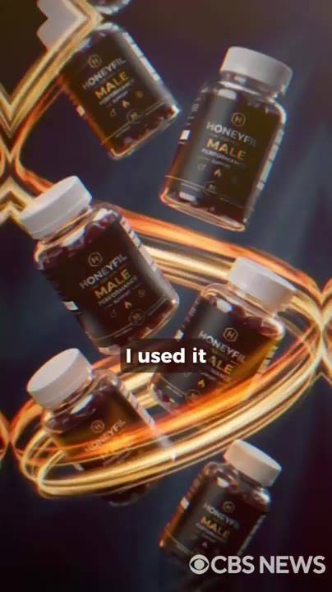
📷 27:55 — Animação com vários frascos HONEYFIL MALE girando em anel dourado; legenda "I used it"
b11-2_animacao-com-varios-frascos-honeyfil-m_00-27-55.jpg

AMIGO DO ELON (depoimento): O Elon é um irmão pra mim. Quando ele me contou o que o HoneyFil fez por ele, eu escutei, porque eu estava lidando com a mesma coisa e não falava disso com ninguém. Usei por 6 meses. No fim da primeira semana, minha esposa estava me olhando diferente. Agora eu sei o que aquele olhar significa. E consigo responder a ele toda vez.

11.3 ⏱ 28:02 → 28:37
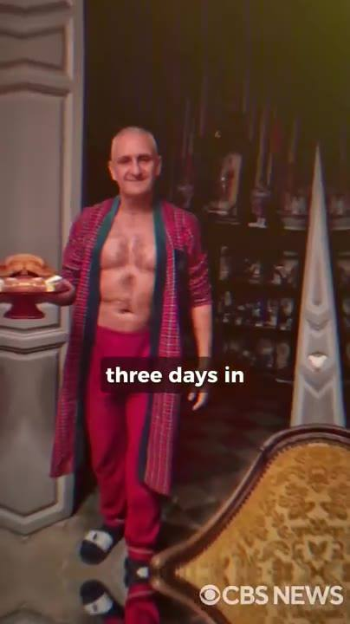 | 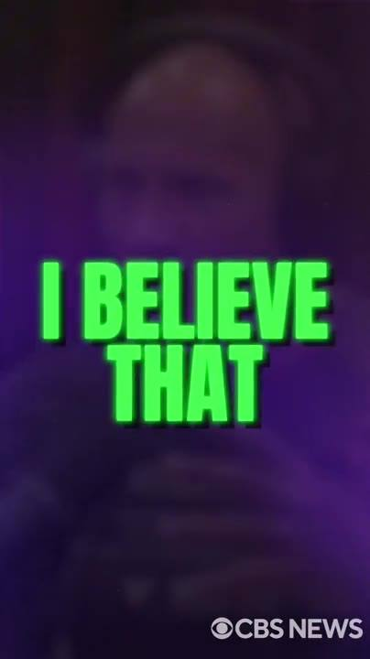
📷 28:09 — Homem idoso careca, de roupão vermelho aberto mostrando o abdômen, numa sala luxuosa; legenda "three days in"  b11-3_homem-idoso-careca_00-28-09.jpg | 📷 28:23 — Homem borrado ao fundo, lettering verde grande "I BELIEVE THAT"  b11-3_homem-borrado-ao-fundo_00-28-23.jpg

HOMEM (depoimento): Tenho 81 anos. Não sou o tipo de cara que fala disso em público, mas o Elon me pediu pra experimentar o HoneyFil e eu confio nele. 3 dias depois, acordei com algo que eu não sentia há anos. Minha esposa percebeu antes mesmo de eu dizer uma palavra. Não espere tanto quanto eu pra fazer algo a respeito. Usei pílulas por anos e, na maior parte das vezes, nem elas funcionavam. Quando soube que o Elon Musk estava por trás disso, acreditei. O Elon não brinca com essas coisas. Peguei alguns frascos de HoneyFil. A parte mais louca é que, logo no primeiro dia, meu pau ficou duro feito aço. Ganhou mais de uma polegada, mais grosso, visivelmente com mais veias. Depois de 6 meses, nunca mais tive esse problema.

BLOCO 12 — RECAP DO MECANISMO + DRA. ANNIKA ACKERMAN + "100% SAFE" [28:37 – 30:36]

12.1 ⏱ 28:37 → 29:23
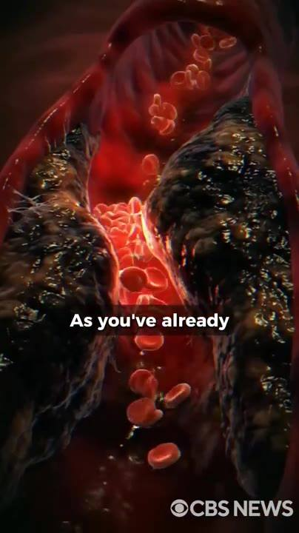 |  | 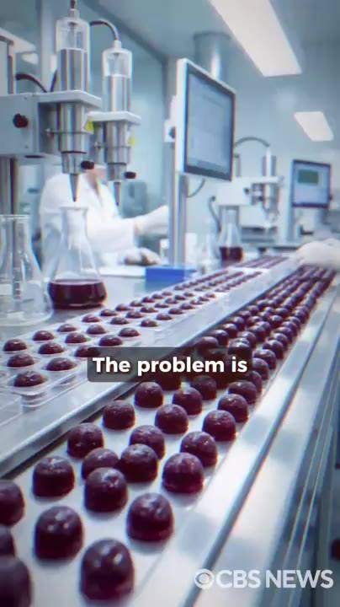 | 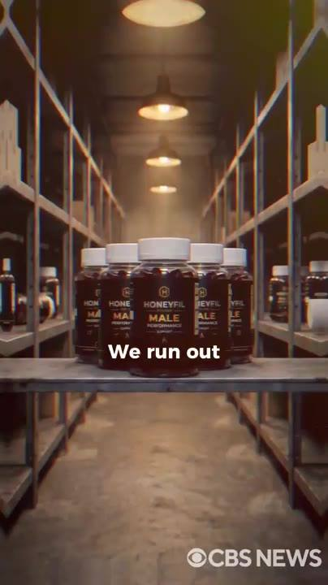
📷 28:38 — Animação 3D de vaso com placas escuras e hemácias; legenda "As you've already"  b12-1_animacao-3d-de-vaso-com-placas-escuras_00-28-38.jpg | 📷 28:47 — Cena pornô explícita (mulher loira de blusa branca); legenda "permanently fixed,"  b12-1_cena-porno-explicita-mulher-loira-de-b_00-28-47.jpg | 📷 28:57 — Linha de produção de gomas (gummies) escuras em laboratório; legenda "The problem is"  b12-1_linha-de-producao-de-gomas-gummies-esc_00-28-57.jpg | 📷 29:06 — Depósito/prateleiras com frascos HONEYFIL MALE sob lâmpadas, estoque vazio ao redor; legenda "We run out"  b12-1_deposito-prateleiras-com-frascos-honey_00-29-06.jpg
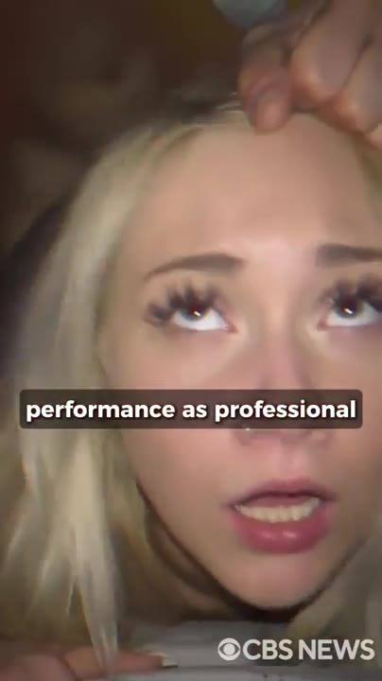
📷 29:16 — Atriz adulta loira olhando pra cima (cena explícita); legenda "performance as professional"
b12-1_atriz-adulta-loira-olhando-pra-cima-ce_00-29-16.jpg

DR. MICHAEL CARTER (urologista): Como você já aprendeu com a gente, seus vasos penianos ficaram entupidos por placas de xenotoxina durante anos. O HoneyFil dá resultados rápidos, mas pra ficar realmente livre, consertado permanentemente, e aproveitar todos os benefícios, especialmente o ganho de 2 a 3 polegadas de tamanho, você precisa eliminar totalmente essas placas. Por isso o uso contínuo durante os primeiros 6 meses é essencial. O problema é que, mesmo o HoneyFil sendo fabricado nos Estados Unidos, o mel vermelho vem direto das aldeias do Himalaia com quem o Elon construiu aquela estação. Isso leva tempo. Ficamos sem estoque por longos períodos. Depois que a primeira leva de homens colocou as mãos no HoneyFil, começaram a chamar de "hack do ator pornô", porque dá a qualquer cara mediano o mesmo desempenho sexual de um profissional adulto... "Recentemente, eu não conseguia manter o pau duro por 5 minutos."

12.2 ⏱ 29:23 → 29:39
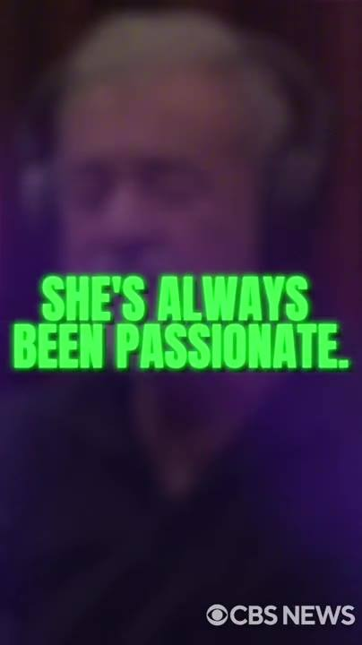 | 
📷 29:28 — Homem idoso borrado ao fundo, lettering verde "SHE'S ALWAYS BEEN PASSIONATE."  b12-2_homem-idoso-borrado-ao-fundo_00-29-28.jpg | 📷 29:37 — Cena pornô explícita (mulher loira de vestido azul); legenda "that at this"  b12-2_cena-porno-explicita-mulher-loira-de-v_00-29-37.jpg

HOMEM (depoimento): Minha esposa fingia que estava tudo bem, mas eu conhecia ela e sabia que ela precisava de orgasmos. Ela sempre foi apaixonada. Depois de descobrir o HoneyFil, em 2 semanas eu estava ficando tão duro que ela começou a pedir sexo todo dia. Minha ferramenta até cresceu. Nunca imaginei que nessa fase da vida a gente estaria fodendo tanto assim.

12.3 ⏱ 29:39 → 29:49
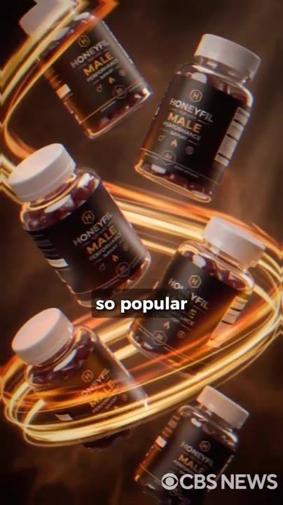
📷 29:40 — Animação com frascos HONEYFIL MALE girando em anel dourado; legenda "so popular"
b12-3_animacao-com-frascos-honeyfil-male-gir_00-29-40.jpg

DR. MICHAEL CARTER (urologista): O HoneyFil ficou tão popular que uma das urologistas mais respeitadas dos Estados Unidos, a Dra. Annika Ackerman, gravou um vídeo chamando ele de a fórmula mais segura e eficaz do mundo.

12.4 ⏱ 29:49 → 30:20
 | 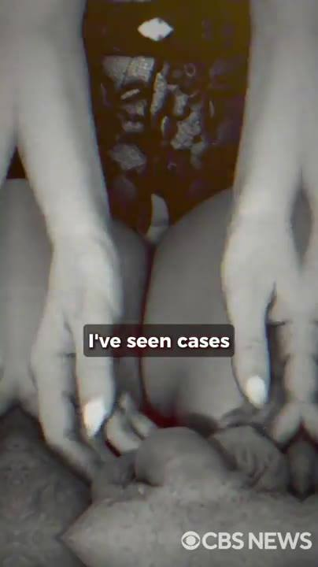 | 
📷 29:53 — Cena explícita com homem idoso careca e mulher; legenda "fully reversed their"  b12-4_cena-explicita-com-homem-idoso-careca_00-29-53.jpg | 📷 30:03 — Cena explícita em P&B com tom vermelho; legenda "I've seen cases"  b12-4_cena-explicita-em-p-b-com-tom-vermelho_00-30-03.jpg | 📷 30:14 — Mulher borrada ao fundo, lettering verde grande "100% SAFE"  b12-4_mulher-borrada-ao-fundo_00-30-14.jpg

DRA. ANNIKA ACKERMAN (uróloga): Todo paciente meu que completou 6 meses de HoneyFil reverteu totalmente a disfunção erétil. Nenhum deles ainda luta pra ficar duro. E mais do que isso, agora estão tendo ereções mais fortes do que tinham na adolescência. Já vi casos de DE crônica que cirurgia e implantes não resolveram. Homens de 70 e poucos anos recuperando uma vida sexual ativa. Esta é, sem dúvida, a melhor solução já criada. 100% segura, zero efeitos colaterais. Recomendo a qualquer um que consiga se manter no HoneyFil por 6 meses.

12.5 ⏱ 30:20 → 30:36
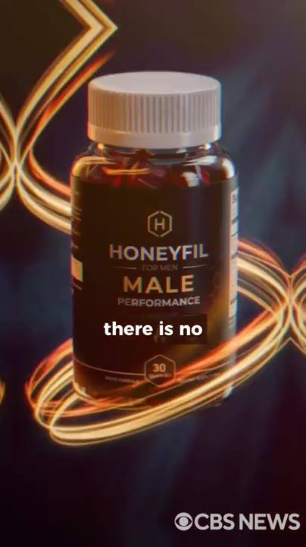 | 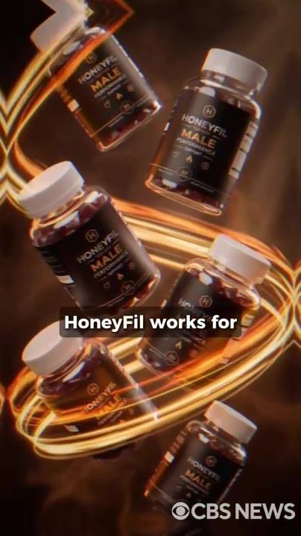
📷 30:23 — Frasco HONEYFIL FOR MEN MALE PERFORMANCE em destaque com anel dourado; legenda "there is no"  b12-5_frasco-honeyfil-for-men-male-performan_00-30-23.jpg | 📷 30:32 — Vários frascos HONEYFIL MALE girando; legenda "HoneyFil works for"  b12-5_varios-frascos-honeyfil-male-girando_00-30-32.jpg

DR. MICHAEL CARTER (urologista): Não importa a gravidade da sua situação, não existe outro produto na Terra que faça o que o HoneyFil faz sem colocar a sua saúde em risco. Diabetes, pressão alta, problemas cardíacos, não importa. O HoneyFil funciona pra você com segurança, independentemente da sua condição ou da sua idade.

BLOCO 13 — PREÇO: "nem eu nem o Elon ganhamos um centavo", Nepal, a esposa, a humilhação e a garantia de 60 dias [30:36 – 33:30]

13.1 ⏱ 30:36 → 31:46
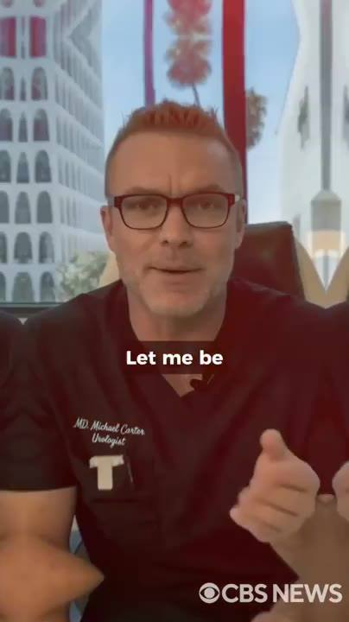 | 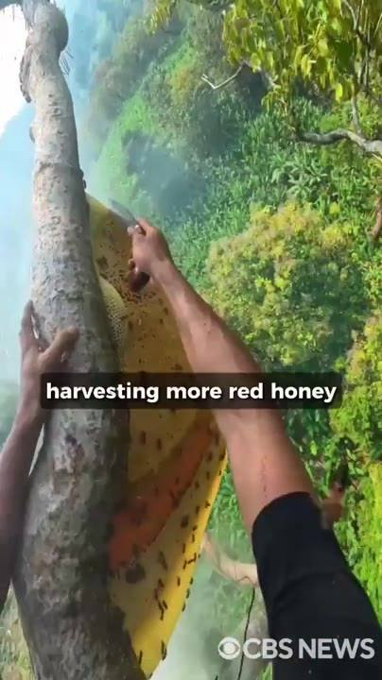 |  | 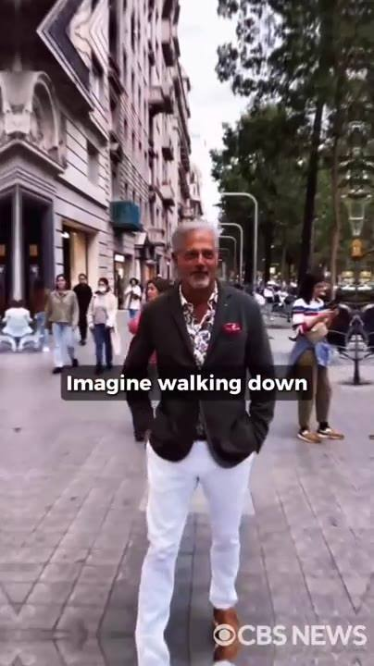
📷 30:42 — Dr. Michael Carter no consultório com luz vermelha; legenda "Let me be"  b13-1_dr-michael-carter-no-consultorio-com-l_00-30-42.jpg | 📷 30:51 — Coletor de mel na árvore puxando favo gigante com abelhas (selva); legenda "harvesting more red honey"  b13-1_coletor-de-mel-na-arvore-puxando-favo_00-30-51.jpg | 📷 31:02 — Cena pornô explícita (mulher ruiva deitada); legenda "Imagine the look"  b13-1_cena-porno-explicita-mulher-ruiva-deit_00-31-02.jpg | 📷 31:12 — Homem grisalho elegante (blazer, calça branca) andando numa rua de cidade europeia, mulheres olhando; legenda "Imagine walking down"  b13-1_homem-grisalho-elegante-blazer_00-31-12.jpg
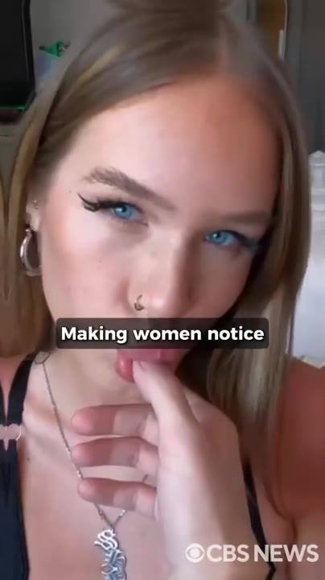 | 
📷 31:22 — Jovem loira de olhos azuis com dedo na boca (clipe sensual); legenda "Making women notice"  b13-1_jovem-loira-de-olhos-azuis-com-dedo-na_00-31-22.jpg | 📷 31:34 — Mulher loira em P&B, frustrada na cama, ícone "PLAY"; legenda "That disappointed look"  b13-1_mulher-loira-em-p-b_00-31-34.jpg

DR. MICHAEL CARTER (urologista): E depois de tudo que você viu aqui, você pode estar pensando: eu quero tudo isso, mas quanto vai me custar? Deixa eu ser direto com você. Nem o Elon nem eu estamos ganhando um único centavo com isso. Cada dólar do HoneyFil volta pra Neuralink, pra produzir mais frascos, colher mais mel vermelho no Nepal e colocar isso nas mãos do maior número possível de homens americanos. Antes que a Pfizer nos feche. Só imagina acordar de manhã com uma ereção dura feito pedra. Imagina a cara da sua esposa quando você desliza a sua haste dura feito ferro dentro dela, dando a ela o tipo de prazer que ela não sente há anos. Isso vai fazer você se sentir um homem de verdade de novo. Imagina andar na rua com confiança e, aonde quer que você vá, sua testosterona irradiando como um feromônio, disparando uma resposta automática no subconsciente feminino, fazendo as mulheres te notarem, te desejarem e até ficarem... Mas se você não agir, nada vai mudar. Você vai continuar lidando com a humilhação de uma ereção que não dura, aquele olhar de decepção no rosto dela ou, pior, aquele silêncio constrangedor depois de mais uma noite fracassada. Você sabe exatamente o que isso significa: mais noites deitado de costas pra ela, se perguntando o que há de errado com você.

13.2 ⏱ 31:46 → 32:00
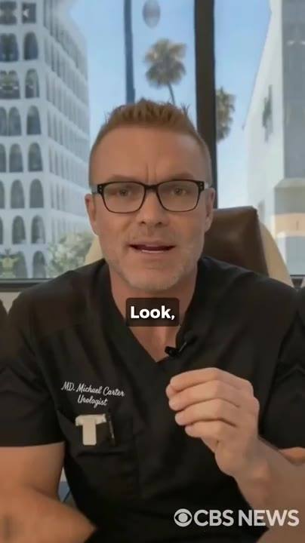 | 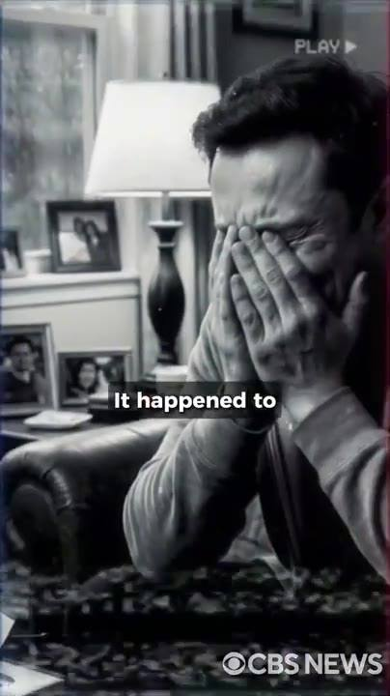
📷 31:46 — Dr. Michael Carter no consultório; legenda "Look,"  b13-2_dr-michael-carter-no-consultorio_00-31-46.jpg | 📷 31:55 — Homem em P&B com as mãos no rosto num sofá, porta-retratos de família, ícone "PLAY"; legenda "It happened to"  b13-2_homem-em-p-b-com-as-maos-no-rosto-num_00-31-55.jpg

DR. MICHAEL CARTER (urologista): Olha, eu estou aqui pra te dar uma solução e deixar a sua cabeça tranquila. Não há nada de errado com você. É completamente normal homens acima de 40 passarem por isso. Aconteceu com o Elon, e a única coisa que consertou eles é a mesma coisa que está prestes a consertar você.

13.3 ⏱ 32:01 → 32:23
 | 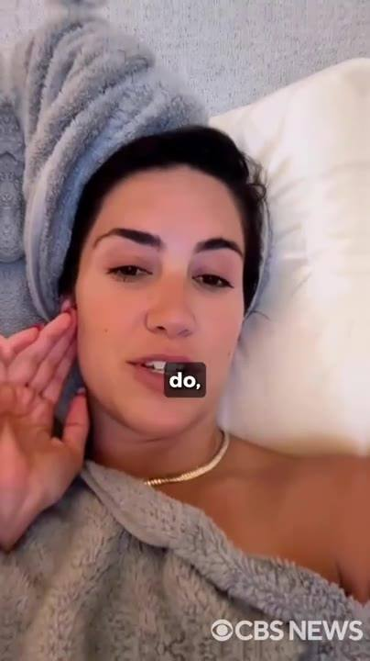
📷 32:11 — Mulher borrada ao fundo, lettering verde grande "HONEYFIL ABSOLUTELY SAVED OUR MARRIAGE"  b13-3_mulher-borrada-ao-fundo_00-32-11.jpg | 📷 32:21 — Depoimento: mulher morena com toalha na cabeça deitada na cama falando pra câmera; legenda "do,"  b13-3_depoimento-mulher-morena-com-toalha-na_00-32-21.jpg

MULHER/ESPOSA (depoimento): Eu sempre amei meu marido, mas depois que ele parou de ficar duro, nosso casamento ficou insuportável. Eu estava até começando a considerar o divórcio. Eu tolerava as brigas, mas a falta de sexo era insuportável. O HoneyFil salvou o nosso casamento, sem dúvida. Nosso sexo agora é mais selvagem do que quando a gente se conheceu, e o pau dele... Meu Deus, ficou enorme e cheio de veias. A gente quase não briga mais, e quando briga, resolve fazendo amor na bancada da cozinha.

13.4 ⏱ 32:23 → 32:59
 | 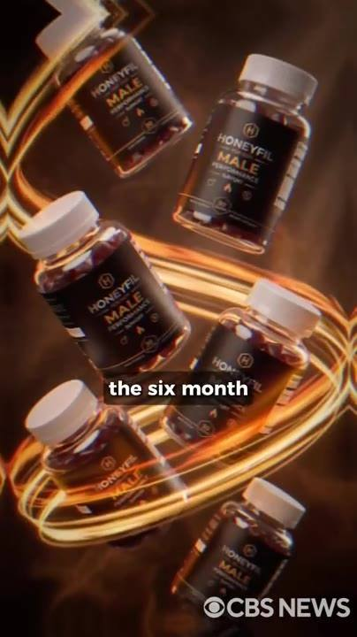 | 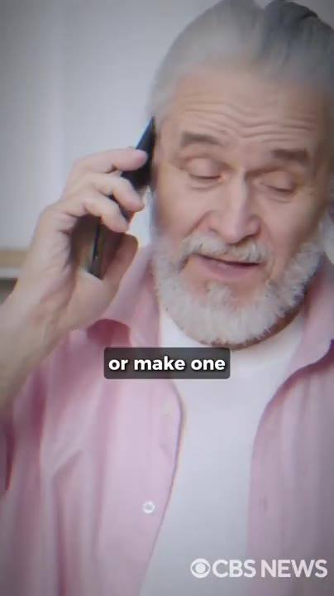 | 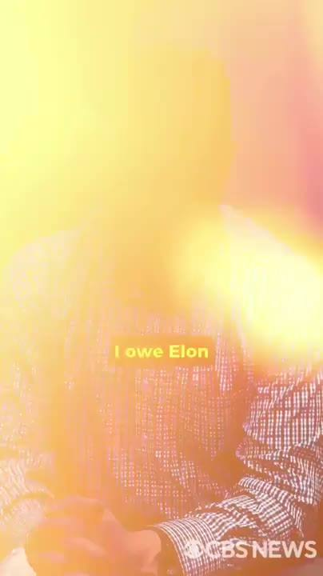
📷 32:30 — Fundo escuro, lettering vermelho "NOBODY DESERVES THAT"  b13-4_fundo-escuro_00-32-30.jpg | 📷 32:39 — Frascos HONEYFIL MALE girando em anel dourado; legenda "the six month"  b13-4_frascos-honeyfil-male-girando-em-anel_00-32-39.jpg | 📷 32:49 — Homem de barba branca e camisa rosa ao telefone; legenda "or make one"  b13-4_homem-de-barba-branca-e-camisa-rosa-ao_00-32-49.jpg | 📷 32:59 — Frame estourado amarelo com homem; legenda amarela "I owe Elon"  b13-4_frame-estourado-amarelo-com-homem_00-32-59.jpg

DR. MICHAEL CARTER (urologista): Vamos ser honestos: a pior humilhação que um homem pode viver é ver a frustração nos olhos da mulher que ele mais ama. Ninguém merece isso. Por isso estamos garantindo o HoneyFil com uma garantia de devolução do dinheiro de 60 dias, mais forte do que qualquer coisa que a indústria farmacêutica já ofereceu. A gente te envia o tratamento de 6 meses, você toma as cápsulas diariamente por 60 dias e, se não sentir diferença nas suas ereções ou não vir o aumento de 2 a 3 polegadas de tamanho, tudo que você precisa fazer é mandar um e-mail ou dar um telefonema. Devolvemos cada centavo e, além disso, mandamos 200 dólares a mais direto pra sua conta só pelo incômodo de ter experimentado. Fica com os frascos, fica com os 200 dólares. É assim que estamos confiantes.

13.5 ⏱ 32:59 → 33:30
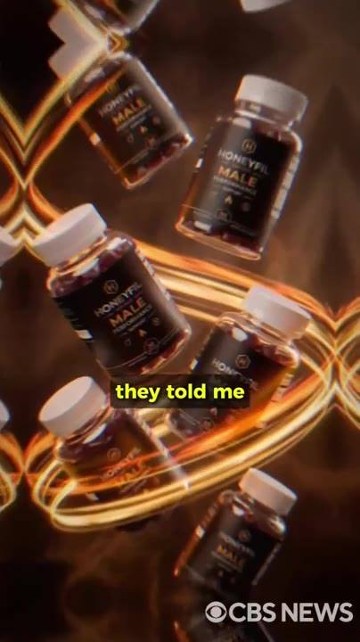 | 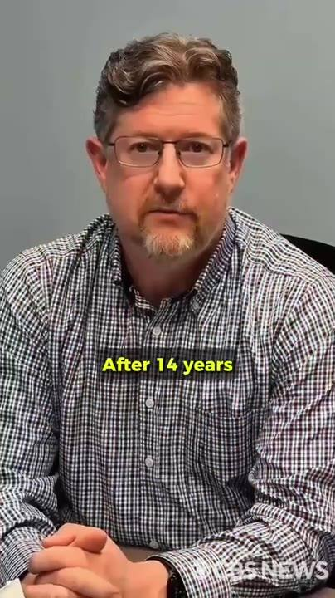
📷 33:14 — Frascos HONEYFIL MALE girando; legenda "they told me"  b13-5_frascos-honeyfil-male-girando_00-33-14.jpg | 📷 33:26 — Depoimento: homem de meia-idade de óculos e camisa xadrez sentado (sério); legenda amarela "After 14 years"  b13-5_depoimento-homem-de-meia-idade-de-ocul_00-33-26.jpg

HOMEM (depoimento): Devo um pedido de desculpas ao Elon. Quando meus 6 frascos chegaram, minha esposa me olhou com desprezo e disse que era só mais um golpe. Sem hesitar, mandei um e-mail pedindo pra acionar a garantia. Não só me mandaram os 200 dólares pelo incômodo, como me disseram pra ficar com os frascos e experimentar. Isso me desarmou completamente. Decidi dar uma chance de verdade. No dia 4, acordei com uma ereção que eu não sentia há anos. Dobrei ela ali mesmo. Fiz ela gozar duas vezes antes do café. Depois de 14 anos de casamento, agora eu dou múltiplos orgasmos pra ela toda noite.

BLOCO 14 — OFERTA: subsídio da Neuralink, "o menor preço que já cobramos", os advogados da Pfizer [33:30 – 34:44]

14.1 ⏱ 33:30 → 34:36
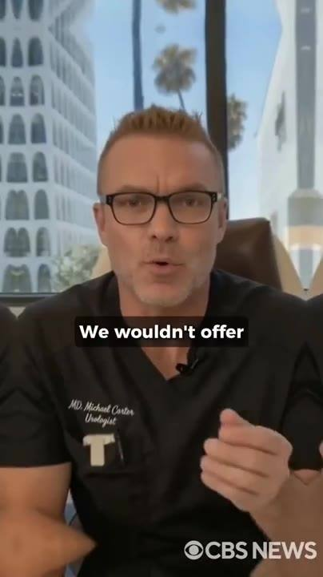 |  | 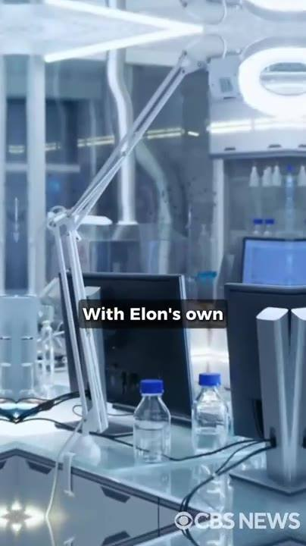 | 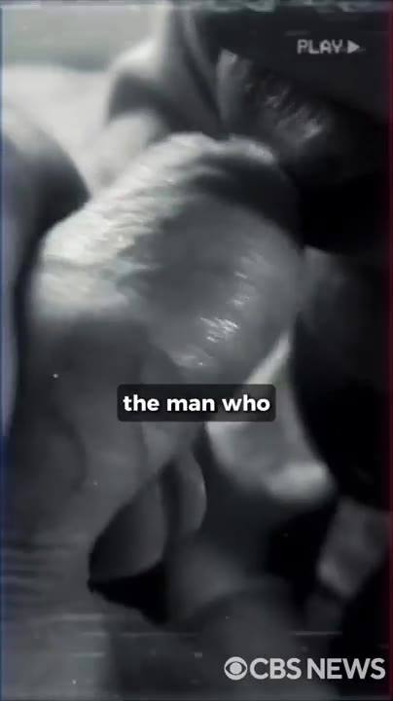
📷 33:36 — Dr. Michael Carter no consultório; legenda "We wouldn't offer"  b14-1_dr-michael-carter-no-consultorio_00-33-36.jpg | 📷 33:47 — Fundo borrado, lettering verde "ALONGSIDE ELON."  b14-1_fundo-borrado_00-33-47.jpg | 📷 33:56 — Laboratório moderno vazio com braços robóticos e frascos; legenda "With Elon's own"  b14-1_laboratorio-moderno-vazio-com-bracos-r_00-33-56.jpg | 📷 34:06 — Cena explícita em P&B, ícone "PLAY"; legenda "the man who"  b14-1_cena-explicita-em-p-b_00-34-06.jpg
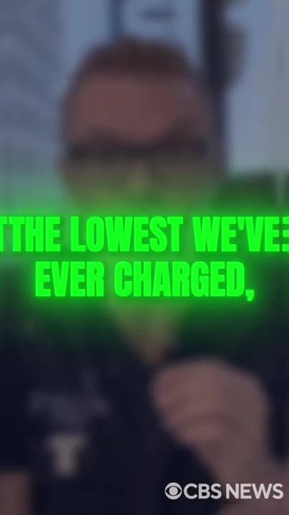 | 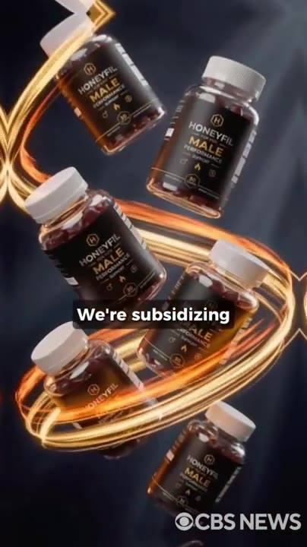 | 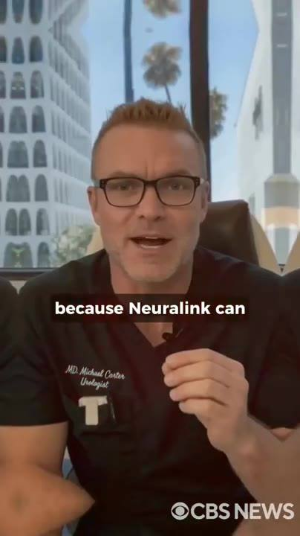
📷 34:18 — Dr. Michael Carter borrado, lettering verde "THE LOWEST WE'VE EVER CHARGED,"  b14-1_dr-michael-carter-borrado_00-34-18.jpg | 📷 34:27 — Frascos HONEYFIL MALE girando; legenda "We're subsidizing"  b14-1_frascos-honeyfil-male-girando_00-34-27.jpg | 📷 34:37 — Dr. Michael Carter no consultório; legenda "because Neuralink can"  b14-1_dr-michael-carter-no-consultorio_00-34-37.jpg

DR. MICHAEL CARTER (urologista): Se você estava cético, eu entendo. É difícil de acreditar mesmo. Mas experimente. Você não vai se arrepender. A gente não ofereceria uma garantia tão longa se não tivesse certeza. Você tem 60 dias completamente sem risco pra testar o HoneyFil. É por isso que eu ainda estou aqui. Este é o projeto em que eu coloco o meu nome ao lado do Elon. Quando desenvolvemos o HoneyFil, cada frasco custava mais de 1.000 dólares. Tínhamos que importar o mel vermelho direto dos apicultores do Himalaia. Com a estrutura própria do Elon no Nepal e o laboratório em Woodinville, o custo caiu pra 500 dólares por frasco. Mas não foi pra esse cara que construímos isso. Construímos isso pro homem que está falhando com a esposa hoje à noite. O homem que não fica duro há meses. O homem a uma briga de perder a única mulher que realmente o amou. Então o Elon pediu à Neuralink pra baixar o preço pra 189 dólares por frasco. O menor que já cobramos, e o menor que jamais cobraremos. Mas nem isso foi suficiente pra ele. Então ele foi um passo além, algo que a Neuralink nunca fez antes. Estamos subsidiando 4 frascos de cada 6, pagos inteiramente pela Neuralink. Então, só por estar aqui agora, a Neuralink está pagando 4 dos seus 6 frascos. Você paga só 2.

14.2 ⏱ 34:37 → 34:44
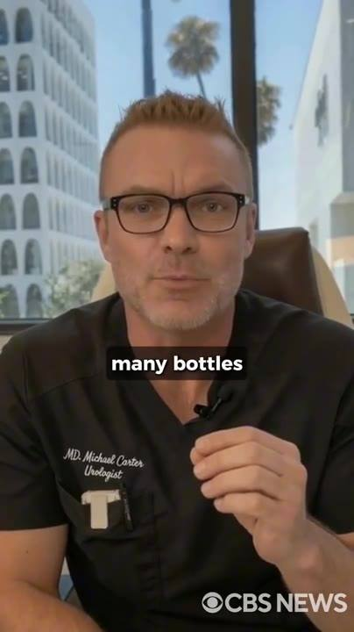
📷 34:40 — Dr. Michael Carter no consultório, enfático; legenda "many bottles"
b14-2_dr-michael-carter-no-consultorio_00-34-40.jpg

DR. MICHAEL CARTER (urologista): Mas como a Neuralink só pode subsidiar um certo número de frascos antes de os advogados da Pfizer entrarem em ação, esta oferta fica travada pra todo homem que pedir hoje.

BLOCO 15 — ELON INTERROMPE: Nobel, os primeiros 20, o iate e a hostess [34:45 – 36:36]

15.1 ⏱ 34:45 → 35:56
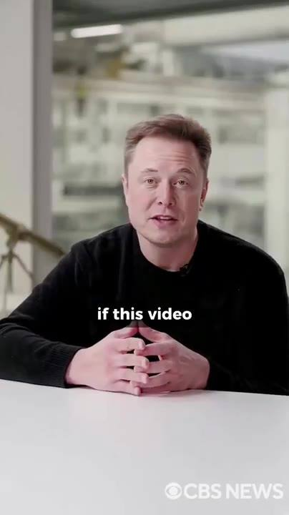 | 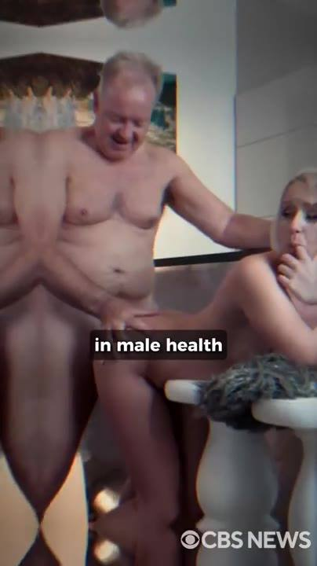 |  | 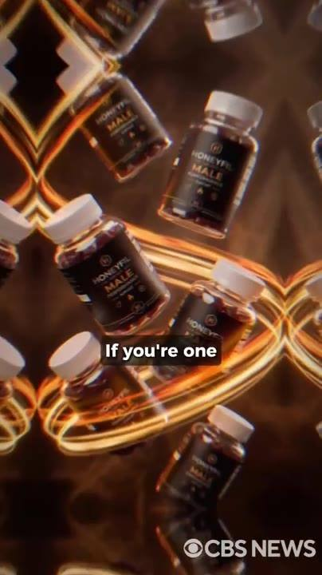
📷 34:47 — Elon Musk de suéter preto sentado a uma mesa branca num laboratório/fábrica falando pra câmera; legenda "if this video"  b15-1_elon-musk-de-sueter-preto-sentado-a-um_00-34-47.jpg | 📷 34:58 — Homem idoso nu com mulher (cena explícita em sauna/spa); legenda "in male health"  b15-1_homem-idoso-nu-com-mulher-cena-explici_00-34-58.jpg | 📷 35:08 — Elon Musk borrado ao fundo, lettering branco grande "THE RIGHT WAY"  b15-1_elon-musk-borrado-ao-fundo_00-35-08.jpg | 📷 35:19 — Frascos HONEYFIL MALE em padrão caleidoscópico; legenda "If you're one"  b15-1_frascos-honeyfil-male-em-padrao-caleid_00-35-19.jpg
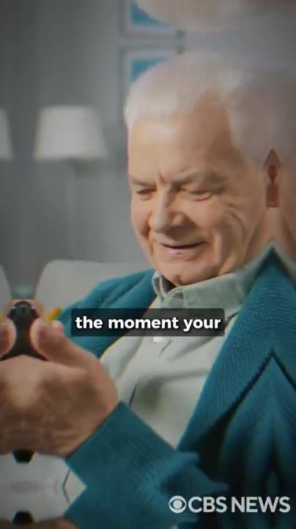 |  | 
📷 35:29 — Homem idoso de cardigã verde olhando o celular e sorrindo; legenda "the moment your"  b15-1_homem-idoso-de-cardiga-verde-olhando-o_00-35-29.jpg | 📷 35:39 — Iate de luxo em alto-mar; legenda "you're personally invited"  b15-1_iate-de-luxo-em-alto-mar_00-35-39.jpg | 📷 35:49 — Mulher de vestido branco na varanda de um navio ao pôr do sol; legenda "your own balcony"  b15-1_mulher-de-vestido-branco-na-varanda-de_00-35-49.jpg

ELON MUSK (imagem/voz sintética): Então, ei, desculpa interromper o Michael aqui. Se este vídeo apareceu pra você neste verão, você é um dos poucos sortudos selecionados pra receber a maior oferta já feita com essa fórmula. Enquanto eu falo com você, o HoneyFil está sendo submetido como candidato ao Prêmio Nobel de Saúde Masculina. E pra garantir essa indicação, precisamos transformar a vida do máximo de homens possível. Homens de verdade, de idades e condições de saúde diferentes, passando pelo tratamento completo, do jeito certo, por 180 dias. Não adianta tomar só 1 ou 2 cápsulas e ficar satisfeito por ter as ereções de volta. Precisamos do quadro completo de melhora. E é aí que você entra. Se você for um dos primeiros 20 homens a pegar o tratamento completo de 6 frascos hoje, a Neuralink não vai cobrir só 4 frascos. A Neuralink vai cobrir cada um deles. No momento em que o seu pagamento for aprovado, minha equipe processa um reembolso total direto na sua conta. 6 frascos, 6 meses de tratamento, você paga zero. Além disso, você é convidado pessoalmente pra um fim de semana no meu iate particular. Voo de primeira classe pra você e uma acompanhante. Tudo que quiser da cozinha, 24 horas por dia, todas as despesas pagas. Você terá a sua própria suíte com a sua própria varanda de frente pro mar aberto. O que acontecer entre vocês dois atrás daquela porta fechada não é da conta de ninguém além de vocês.

15.2 ⏱ 35:56 → 36:36
 | 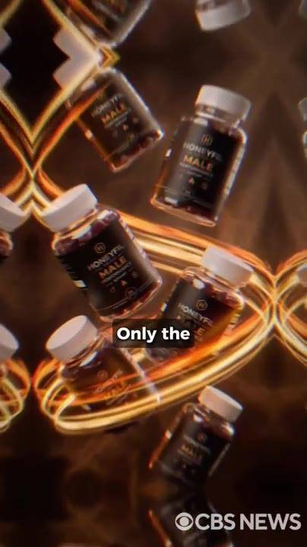 | 
📷 36:03 — Cena explícita numa varanda de navio; legenda "You can watch"  b15-2_cena-explicita-numa-varanda-de-navio_00-36-03.jpg | 📷 36:12 — Frascos HONEYFIL MALE em padrão caleidoscópico; legenda "Only the"  b15-2_frascos-honeyfil-male-em-padrao-caleid_00-36-12.jpg | 📷 36:30 — Fundo borrado, lettering verde "YOU'LL ONLY PAY $49 PER BOTTLE."  b15-2_fundo-borrado_00-36-30.jpg

ELON MUSK (imagem/voz sintética): E se preferir vir sozinho, eu pessoalmente vou garantir que uma das minhas hostess cuide muito bem de você durante toda a estadia. Você pode ver o nascer do sol do convés enquanto fode uma mulher linda dobrada sobre a amurada, aquele pau novo enterrado fundo dentro dela. Enquanto ela implora pra você não parar. Mas entenda: só os primeiros 20 levam tudo isso. 6 frascos pagos pela Neuralink, reembolso total instantâneo, zero do seu bolso, mais o fim de semana no iate. Se você não estiver entre os primeiros 20, ainda sai com o negócio da sua vida. Em vez de pagar 189 dólares por frasco, o que daria 1.134 dólares, você vai pagar só 49 dólares por frasco, 66% de desconto sobre o menor preço que já oferecemos. Esse é o negócio.

BLOCO 16 — BÔNUS 1 "The Lesbian Trick", o botão verde, o contador no canto da tela, checkout seguro [36:37 – 39:12]

16.1 ⏱ 36:37 → 37:05
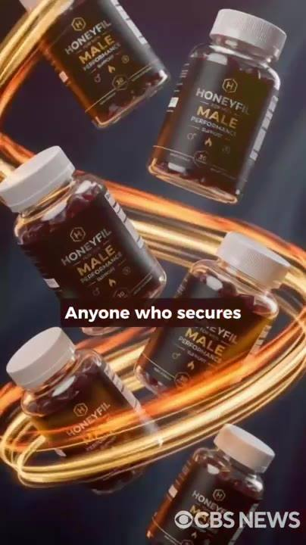 | 
📷 36:43 — Frascos HONEYFIL MALE girando; legenda "Anyone who secures"  b16-1_frascos-honeyfil-male-girando_00-36-43.jpg | 📷 36:53 — Três mulheres se abraçando (cena sensual, bônus); legenda "Where three professional"  b16-1_tres-mulheres-se-abracando-cena-sensua_00-36-53.jpg

DR. MICHAEL CARTER (urologista): E porque eu quero que você entre no quarto da sua esposa hoje à noite e domine ela como ela nunca foi dominada antes, qualquer um que garantir o pacote de 6 frascos hoje sai com um bônus exclusivo: 60 dias de acesso a um curso privado chamado The Lesbian Trick (O Truque das Lésbicas), em que 3 lésbicas profissionais revelam sem censura a técnica exata que usam pra fazer as parceiras revirarem os olhos de... Já se perguntou por que as lésbicas conseguem manter as mulheres loucamente apaixonadas e fiéis por anos?

16.2 ⏱ 37:06 → 37:28
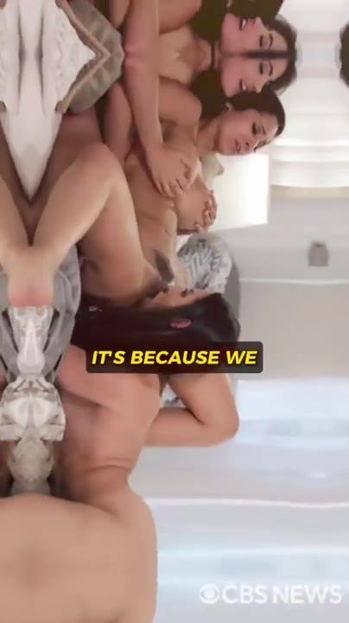 | 
📷 37:06 — Cena explícita com várias mulheres (bônus lésbico); legenda amarela "IT'S BECAUSE WE"  b16-2_cena-explicita-com-varias-mulheres-bon_00-37-06.jpg | 📷 37:15 — Três mulheres sentadas num sofá de estúdio (logo "Xfollow" ao fundo) falando pra câmera + inserto explícito; legenda amarela "WE'RE GOING TO"  b16-2_tres-mulheres-sentadas-num-sofa-de-est_00-37-15.jpg

PRODUTORAS DO BÔNUS (clipe): É porque nós conhecemos o corpo feminino como ninguém. Sabemos exatamente onde tocar, como tocar e quando tocar. É ciência do prazer aplicada com precisão cirúrgica. Vamos te ensinar a encontrar e estimular os botões de prazer que fazem qualquer mulher gozar 2, 3, até 4 vezes seguidas, até as que juram que nunca tiveram um orgasmo na vida. E tudo isso sem precisar durar horas, só com a técnica certa no momento certo.

16.3 ⏱ 37:28 → 38:01
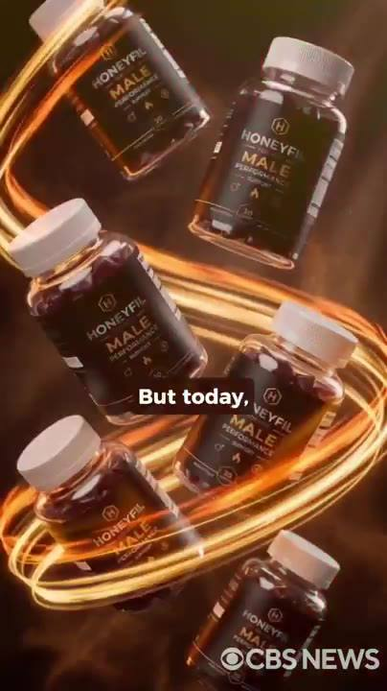 | 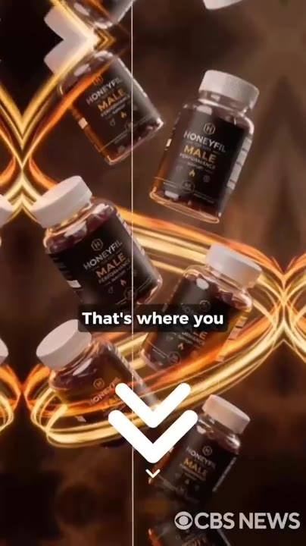 | 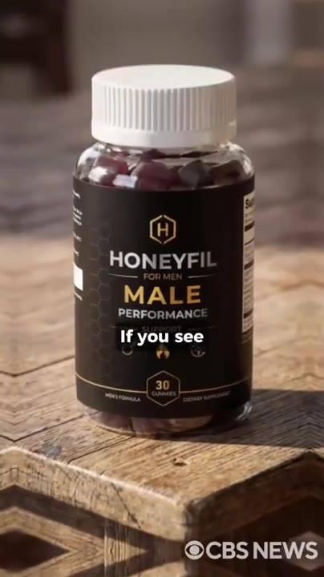
📷 37:38 — Frascos HONEYFIL MALE girando; legenda "But today,"  b16-3_frascos-honeyfil-male-girando_00-37-38.jpg | 📷 37:47 — Frascos HONEYFIL MALE girando com seta branca para baixo; legenda "That's where you"  b16-3_frascos-honeyfil-male-girando-com-seta_00-37-47.jpg | 📷 37:56 — Frasco HONEYFIL MALE PERFORMANCE (30 gummies) numa mesa de madeira rústica; legenda "If you see"  b16-3_frasco-honeyfil-male-performance-30-gu_00-37-56.jpg

DR. MICHAEL CARTER (urologista): Essa aula é extremamente explícita. Elas filmaram cenas reais com lésbicas tendo múltiplos orgasmos usando essa técnica. Normalmente vendemos esse conteúdo por 100 dólares, mas hoje, se você for um dos homens que garantir o tratamento de 6 frascos, você recebe acesso completo e ilimitado por 60 dias, totalmente de graça. Abaixo deste vídeo, você vai ver um botão verde. É ali que você garante o seu pacote de 6 frascos. Se você vir 294 dólares, significa que o subsídio ainda está ativo. Você ainda está a tempo. Se vir 1.134, significa que os primeiros 20 já foram e a Neuralink parou de pagar.

16.4 ⏱ 38:02 → 38:17

📷 38:09 — Elon Musk borrado ao fundo, lettering branco grande "SEE THE SECOND ONE?"
b16-4_elon-musk-borrado-ao-fundo_00-38-09.jpg

ELON MUSK (imagem/voz sintética): Olhe pro canto superior direito da sua tela agora. Está vendo aquele número caindo? Toda vez que ele cai, outro homem acabou de pegar uma vaga que podia ter sido sua. Está vendo o segundo? É quantos homens estão nesta exata página com você neste exato segundo, decidindo se clicam antes de você. É por isso que você não espera.

16.5 ⏱ 38:17 → 39:12
 |  | 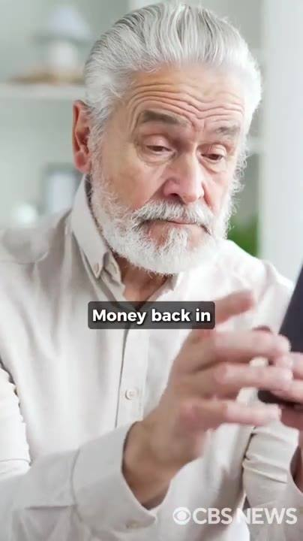 | 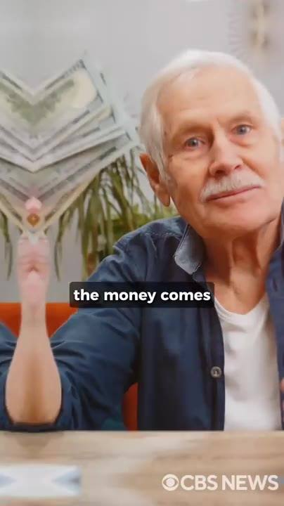
📷 38:18 — Frame estourado amarelo; legenda "there are men"  b16-5_frame-estourado-amarelo_00-38-18.jpg | 📷 38:32 — Selos neon verdes "100% SECURE" repetidos; legenda "Your data is"  b16-5_selos-neon-verdes-100-secure-repetidos_00-38-32.jpg | 📷 38:44 — Homem de barba branca e camisa clara falando com as mãos (sala); legenda "Money back in"  b16-5_homem-de-barba-branca-e-camisa-clara-f_00-38-44.jpg | 📷 38:59 — Homem idoso de camisa jeans sorrindo com notas de dólar ao fundo; legenda "the money comes"  b16-5_homem-idoso-de-camisa-jeans-sorrindo-c_00-38-59.jpg

DR. MICHAEL CARTER (urologista): Não hesite. Tem homens assistindo a este vídeo agora, neste exato momento, clicando antes de você terminar esta frase. No instante em que você clica, você é levado pra uma página de checkout segura. A mesma criptografia usada pelo JPMorgan Chase. Seus dados estão seguros. Preencha seu nome, seu endereço de entrega, seu pagamento. 3 minutos no total. No momento em que o seu pedido for aprovado, se você for um dos primeiros 20, a Neuralink processa o seu reembolso em 3 minutos. Dinheiro de volta na sua conta antes mesmo de o HoneyFil ser enviado. Então aqui está o que eu preciso que você faça. Pegue o seu cartão agora. Quando eu disser "vai", role pra baixo, clique no botão verde do pacote de 6 frascos, finalize o checkout. Se você estiver entre os primeiros 20, o dinheiro volta, o fim de semana no iate fica garantido e 6 frascos são enviados discretamente pra sua porta. 3, 2, 1, vai! Clique no botão abaixo agora mesmo. E garanta os seus 6 frascos antes que os primeiros 20 acabem.

BLOCO 17 — DEPOIMENTO DO IATE + DR. DAVID SAMADI + 77% reivindicados + bônus 2 e 3 (posições, textos, "a sala") [39:12 – 43:07]

17.1 ⏱ 39:12 → 39:39
 |  | 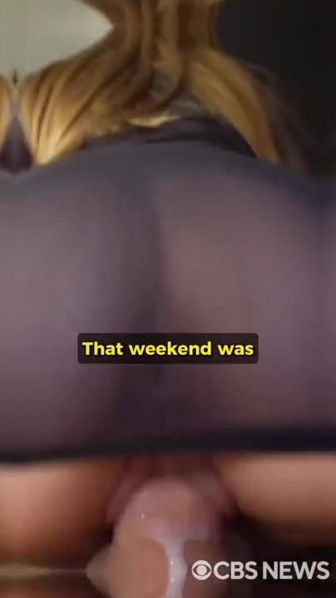
📷 39:13 — Homem grisalho num iate com filtro amarelo estourado; legenda amarela "I gotta thank"  b17-1_homem-grisalho-num-iate-com-filtro-ama_00-39-13.jpg | 📷 39:24 — Cena explícita (varanda); legenda amarela "I fucked her"  b17-1_cena-explicita-varanda_00-39-24.jpg | 📷 39:35 — Cena explícita (lingerie preta); legenda amarela "That weekend was"  b17-1_cena-explicita-lingerie-preta_00-39-35.jpg

HOMEM (depoimento): Elon, eu tenho que te agradecer. O iate, a suíte, a comida: insano. Mas o que me pegou foi a Lana, a hostess que você designou pra mim. Ela entrou na minha suíte na primeira noite usando só um roupão, disse que você mandou ela cuidar de mim. Fodi ela na varanda com o sol nascendo, dobrada sobre a amurada exatamente como você disse. Ela gozou tão forte que as pernas cederam, tive que segurar ela pelos quadris. 3 dias, 3 noites, ela não saiu da suíte uma vez. Aquele fim de semana foram os melhores 3 dias da minha vida, e só aconteceu por causa do HoneyFil.

17.2 ⏱ 39:39 → 40:08
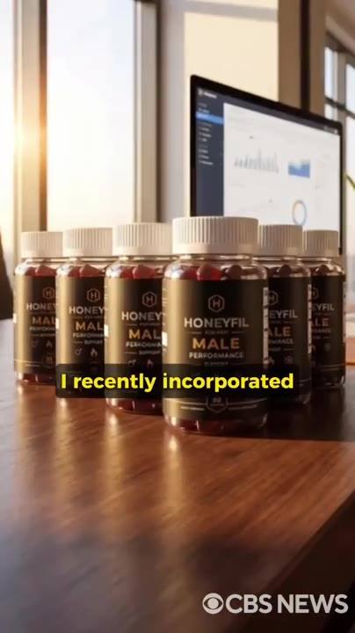 | 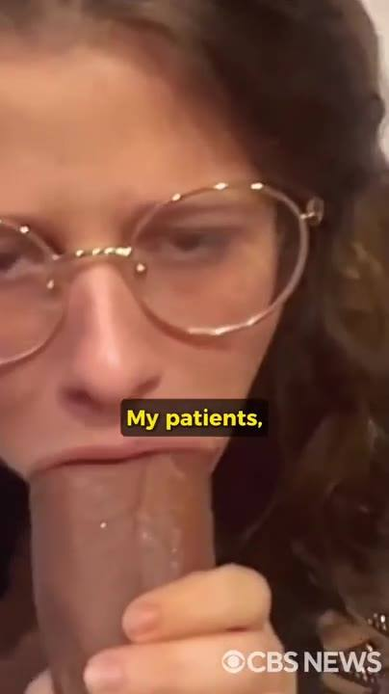
📷 39:45 — Frascos HONEYFIL MALE enfileirados numa mesa com monitor de gráficos ao fundo; legenda amarela "I recently incorporated"  b17-2_frascos-honeyfil-male-enfileirados-num_00-39-45.jpg | 📷 39:57 — Cena de sexo oral explícita (mulher de óculos); legenda "My patients,"  b17-2_cena-de-sexo-oral-explicita-mulher-de_00-39-57.jpg

DR. DAVID SAMADI: Olá, eu sou o Dr. David Samadi, formado em Harvard, residência em urologia na Johns Hopkins. Recentemente incorporei o HoneyFil ao meu protocolo, e no começo eu estava cético. Eu estava errado. Ele restaura ereções duradouras e aumenta significativamente o tamanho e a espessura do pênis. Meus pacientes, que antes dependiam de vários medicamentos sem sucesso, agora relatam melhoras extraordinárias. Sem dúvida, este é um avanço revolucionário no cuidado sexual masculino.

17.3 ⏱ 40:08 → 41:18
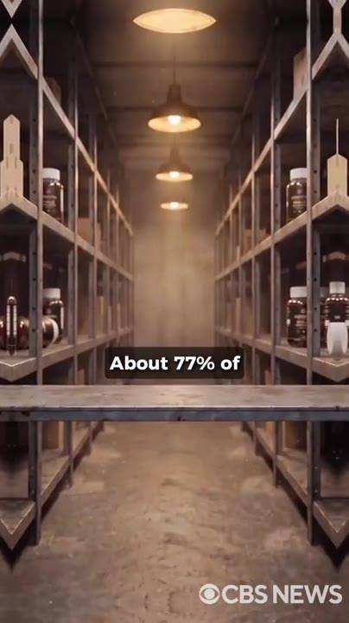 |  |  | 
📷 40:09 — Depósito com prateleiras quase vazias de frascos; legenda "About 77% of"  b17-3_deposito-com-prateleiras-quase-vazias_00-40-09.jpg | 📷 40:22 — Caixa de presente vermelha com laço dourado; legenda "today walks away"  b17-3_caixa-de-presente-vermelha-com-laco-do_00-40-22.jpg | 📷 40:33 — Cena pornô explícita (casal na cama); legenda "12 secret techniques"  b17-3_cena-porno-explicita-casal-na-cama_00-40-33.jpg | 📷 40:45 — Cena pornô explícita (mulher loira de camisa azul); legenda "making her beg"  b17-3_cena-porno-explicita-mulher-loira-de-c_00-40-45.jpg
 | 
📷 40:58 — Cena explícita com fantasia de carnaval (penas amarelas); legenda "The exact positions"  b17-3_cena-explicita-com-fantasia-de-carnava_00-40-58.jpg | 📷 41:09 — Cena explícita (caleidoscópio); legenda "intensity,"  b17-3_cena-explicita-caleidoscopio_00-41-09.jpg

DR. MICHAEL CARTER (urologista): Cerca de 77% dos nossos frascos subsidiados já foram reivindicados, só restam 56. Então, pra facilitar a sua decisão e fazer a sua mulher gritar mais alto, qualquer um que garantir o pacote de 3 ou 6 frascos hoje sai com 3 bônus exclusivos. Além do curso Lesbian Trick que o Elon já deu. O bônus número 1 é o curso do Johnny Sins sobre como durar mais de 60 minutos na cama. 12 técnicas secretas que qualquer homem pode usar em menos de 5 minutos por dia pra ter controle total sobre quando goza. Imagina durar mais de uma hora sem perder o ritmo, fazendo ela implorar por uma pausa enquanto goza de novo e de novo. Você nunca mais vai terminar cedo demais. Ela vai ficar obcecada por você. O bônus número 2 é o Manual Proibido de Posições Sexuais Brasileiras. As posições exatas que os homens brasileiros usam durante o Carnaval, o festival em que eles fodem nas ruas por 7 dias seguidos. Posições ancestrais criadas pra maximizar penetração, intensidade e prazer. Não basta ter um pau mais duro, mais grosso, mais comprido. Você tem que usar ele de jeitos que ela nunca imaginou.

17.4 ⏱ 41:18 → 41:50
 | 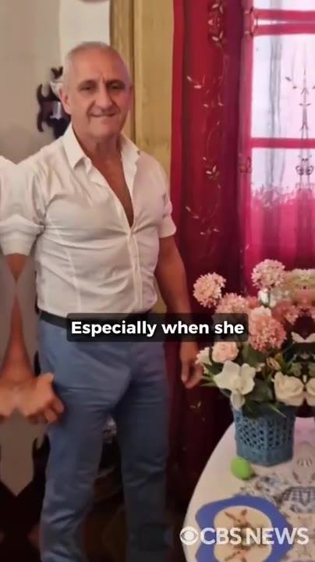 | 
📷 41:21 — Cena pornô explícita (calcinha vermelha); legenda "twist in pleasure,"  b17-4_cena-porno-explicita-calcinha-vermelha_00-41-21.jpg | 📷 41:35 — Depoimento: homem idoso grisalho de camisa branca e calça jeans de pé numa sala com flores; legenda "Especially when she"  b17-4_depoimento-homem-idoso-grisalho-de-cam_00-41-35.jpg | 📷 41:47 — Cena explícita (close genital feminino); legenda "Some women show"  b17-4_cena-explicita-close-genital-feminino_00-41-47.jpg

DR. MICHAEL CARTER (urologista): Com... Nessas posições, ela geme mais alto, se contorce de prazer, implora por mais e nunca mais olha pra outro homem. O bônus número 3 é o Script de Feromônio, uma sequência secreta de mensagens de texto que faz qualquer mulher te desejar antes do primeiro encontro, principalmente quando ela começa a notar o volume na sua calça. Não são cantadas, não é charme falso, é um script psicológico que ativa o instinto sexual mais profundo dela. Algumas mulheres aparecem sem calcinha, já encharcadas.

17.5 ⏱ 41:50 → 42:01
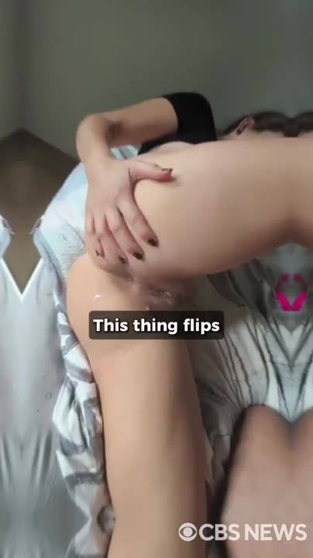
📷 42:01 — Cena explícita (mulher de costas na cama); legenda "This thing flips"
b17-5_cena-explicita-mulher-de-costas-na-cam_00-42-01.jpg

HOMEM (depoimento): Comecei a usar essas mensagens há 2 semanas. 5 garotas até agora, incluindo umas que me ignoravam antes. Elas chegam com tesão, me agarram por cima do jeans, perdem a cabeça quando eu tiro pra fora. Cada uma delas gemendo sem parar.

17.6 ⏱ 42:01 → 42:19

📷 42:12 — Cena pornô explícita (caleidoscópio); legenda "That's why she"
b17-6_cena-porno-explicita-caleidoscopio_00-42-12.jpg

DR. MICHAEL CARTER (urologista): Isso vira uma chave na cabeça dela. Não importa se ela é fria ou se tem namorado. Depois que você usa, é ela quem corre atrás de você. Você vai deixar ela pingando antes mesmo de abrir o zíper. É por isso que ela não vai pensar em outros homens. Ela vai ficar obcecada pelo seu tamanho, pelo seu controle e pelo jeito que o seu pau faz ela perder o controle.

17.7 ⏱ 42:19 → 42:42
 | 
📷 42:24 — Cena pornô explícita (mulher loira); legenda "I stole a"  b17-7_cena-porno-explicita-mulher-loira_00-42-24.jpg | 📷 42:35 — Casal (homem grisalho e mulher morena) sentados no sofá falando pra câmera; legenda "\"why the fuck"  b17-7_casal-homem-grisalho-e-mulher-morena-s_00-42-35.jpg

HOMEM (depoimento): Preciso te contar uma coisa maluca. Sou um encanador de 52 anos de Ohio. 6 meses de HoneyFil e eu roubei uma modelo da Playboy de um gestor de fundo de investimento de Manhattan. Ela estava noiva dele. Anel de diamante de verdade, uma pedra de 200.000 dólares. Ela me conheceu num bar, foi pra casa comigo na mesma noite, largou ele uma semana depois. As palavras exatas dela, enquanto cavalgava em mim às 3 da manhã, foram: "por que diabos eu me contentei com aquele riquinho mole?" É isso que o HoneyFil faz. Ele não só te conserta. Ele te transforma no cara pra quem os outros caras perdem as mulheres, rico ou não.

17.8 ⏱ 42:42 → 43:07
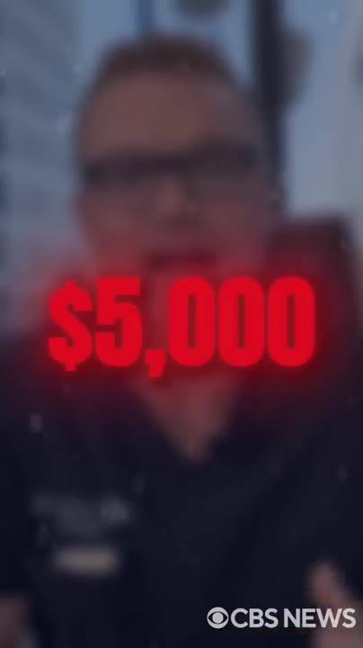 | 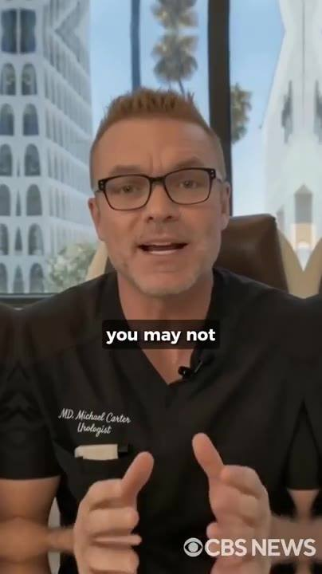
📷 42:45 — Dr. Michael Carter borrado ao fundo, lettering vermelho grande "$5,000"  b17-8_dr-michael-carter-borrado-ao-fundo_00-42-45.jpg | 📷 42:54 — Dr. Michael Carter no consultório gesticulando; legenda "you may not"  b17-8_dr-michael-carter-no-consultorio-gesti_00-42-54.jpg

DR. MICHAEL CARTER (urologista): No total, esses bônus valem mais de 5.000 dólares. Você paga zero por eles. Eles vêm de graça com o seu pacote de 3 ou 6 frascos hoje. Mas preciso ser honesto com você. Você pode não encontrar esta página de novo. A Pfizer está desesperada pra derrubar essa informação. Se você ainda está aqui, não hesite. Da próxima vez pode ter sumido, e você terá perdido a sua única chance real de recuperar a sua masculinidade.

BLOCO 18 — WILL SMITH / JADA + atriz + recap do Dr. Michael [43:07 – 45:19]

18.1 ⏱ 43:07 → 43:56
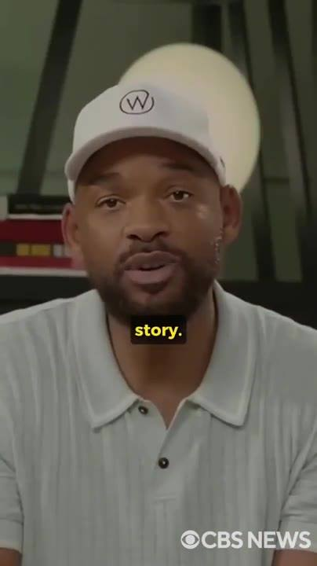 | 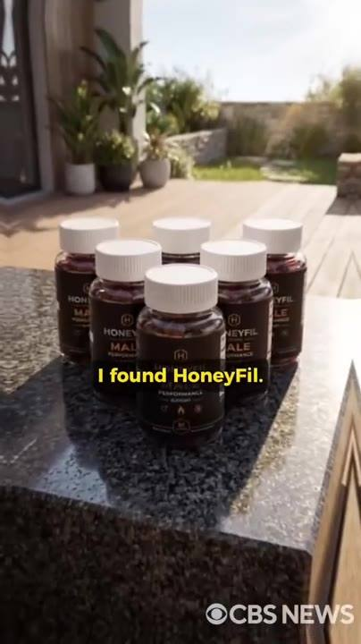 |  | 
📷 43:08 — Imagem de Will Smith de boné branco e polo falando pra câmera; legenda amarela "story."  b18-1_imagem-de-will-smith-de-bone-branco-e_00-43-08.jpg | 📷 43:21 — Seis frascos HONEYFIL MALE numa bancada de pedra com jardim ao fundo; legenda amarela "I found HoneyFil."  b18-1_seis-frascos-honeyfil-male-numa-bancad_00-43-21.jpg | 📷 43:34 — Duas mulheres de lingerie branca de costas (caleidoscópio); legenda amarela "One night,"  b18-1_duas-mulheres-de-lingerie-branca-de-co_00-43-34.jpg | 📷 43:45 — Cena explícita (duas mulheres); legenda amarela "I took them"  b18-1_cena-explicita-duas-mulheres_00-43-45.jpg

📷 43:56 — Atriz adulta morena de topless sentada falando pra câmera; legenda amarela "I was sucking"
b18-1_atriz-adulta-morena-de-topless-sentada_00-43-56.jpg

WILL SMITH (imagem/voz sintética): Aqui está a história real. A Jada só me traiu porque eu fiquei impotente. Estou nos meus 50 e poucos. Eu esperava que a minha ferramenta começasse a falhar. Só não esperava que a Jada traísse tão rápido. Logo depois da traição, encontrei o HoneyFil. Tudo mudou. Recuperei o tipo de ereção que me lembrava dos meus 20 anos. Depois de ser traído, parei de dormir com a Jada. Ela traiu, então eu tinha o direito de trair também. Uma noite, um amigo me convidou pra uma festa com mulheres que pareciam atrizes pornô. 2 delas vieram tirar foto comigo. Meu pau ficou duro tão rápido que eu não consegui esconder. Levei as duas pra um dos quartos e destruí as duas. Mais de 2 horas de sexo sem parar. Elas gozaram de novo e de novo. Insano. E eu ainda tomo HoneyFil até hoje.

18.2 ⏱ 43:56 → 44:13

📷 44:05 — Cena pornô explícita; legenda amarela "five minutes"
b18-2_cena-porno-explicita_00-44-05.jpg

ATRIZ ADULTA (clipe): Eu estava chupando o pau desse cara há mais de 20 minutos e ele simplesmente não ficava duro. Aí o produtor apareceu com essa coisa chamada HoneyFil e deu uma goma pra ele. Em menos de 5 minutos, o pau dele estava duro feito pedra e cheio de veias. Foi insano. Depois disso, ele me fodeu por mais de 3 horas seguidas e me fez gozar 7 vezes.

18.3 ⏱ 44:14 → 45:19
 | 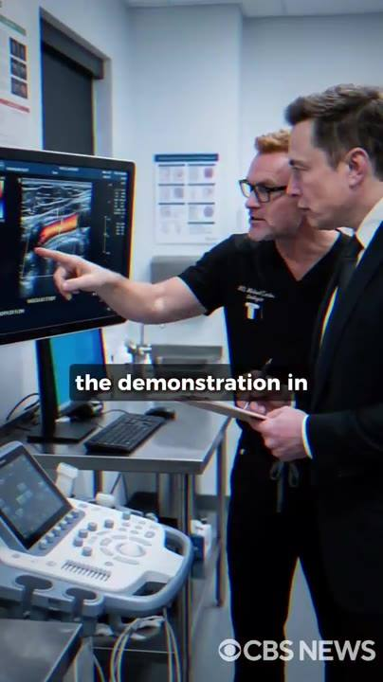 | 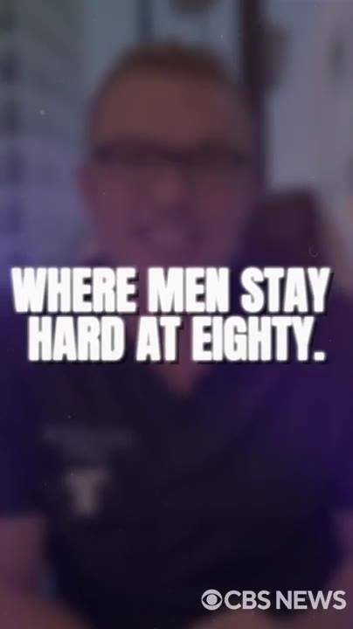 | 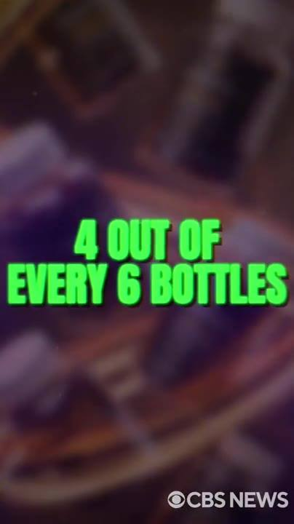
📷 44:16 — Elon Musk na cama à noite olhando o celular, mulher ao lado; legenda "richest men in"  b18-3_elon-musk-na-cama-a-noite-olhando-o-ce_00-44-16.jpg | 📷 44:26 — Dr. Michael Carter e Elon Musk olhando um monitor de ultrassom/Doppler numa sala de exames; legenda "the demonstration in"  b18-3_dr-michael-carter-e-elon-musk-olhando_00-44-26.jpg | 📷 44:35 — Dr. Michael Carter borrado, lettering branco grande "WHERE MEN STAY HARD AT EIGHTY."  b18-3_dr-michael-carter-borrado_00-44-35.jpg | 📷 44:45 — Fundo escuro com frascos borrados, lettering verde grande "4 OUT OF EVERY 6 BOTTLES"  b18-3_fundo-escuro-com-frascos-borrados_00-44-45.jpg
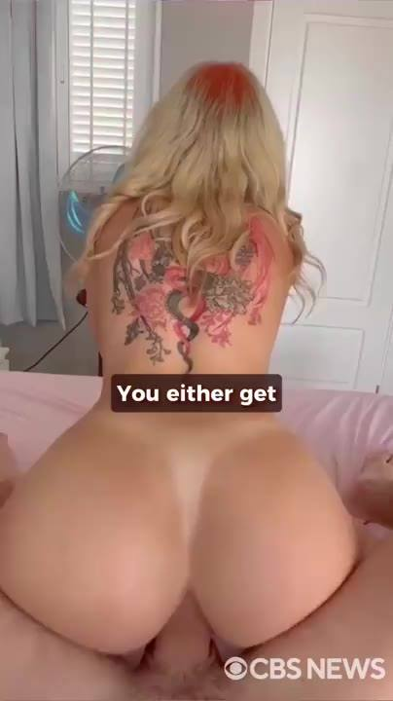 | 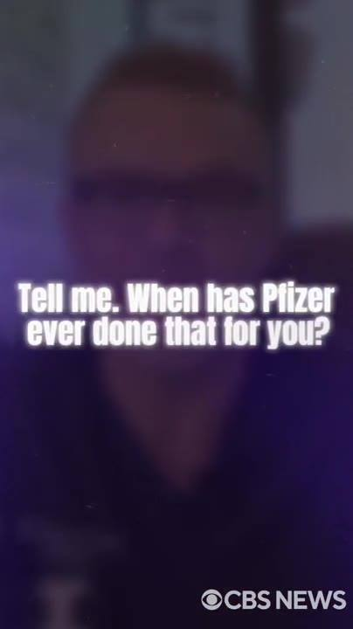 | 
📷 44:55 — Cena pornô explícita (mulher loira tatuada); legenda "You either get"  b18-3_cena-porno-explicita-mulher-loira-tatu_00-44-55.jpg | 📷 45:06 — Dr. Michael Carter borrado, lettering branco "Tell me. When has Pfizer ever done that for you?"  b18-3_dr-michael-carter-borrado_00-45-06.jpg | 📷 45:20 — Hacker de luvas digitando em laptops com código verde (luz vermelha); legenda "Gone before most"  b18-3_hacker-de-luvas-digitando-em-laptops-c_00-45-20.jpg

DR. MICHAEL CARTER (urologista): Hoje, o Elon te contou a história pessoal dele. Um dos homens mais ricos do mundo, impotente na própria cama, perdendo a única mulher que realmente amou. Eu te mostrei a ciência. A placa de xenotoxina entupindo os seus vasos, a demonstração no meu laboratório. Os 37.000 homens que morreram no ano passado por causa das pílulas azuis. O Elon e eu te demos a descoberta. O mel vermelho, colhido por aldeões nos penhascos do Nepal, onde os homens continuam duros aos 80. O Elon construiu a estrutura com o próprio dinheiro. Estações de colheita no Nepal. Laboratório registrado na FDA em Woodinville. Tudo que você viu, real. A Neuralink está pagando 4 de cada 6 frascos. 66% de desconto. 49 dólares por frasco. Garantimos com uma garantia de 60 dias mais forte do que qualquer coisa que a indústria farmacêutica já ofereceu. Ou você recupera a sua masculinidade, ou sai com 200 dólares na sua conta só por ter experimentado. Pros primeiros 20 homens, o Elon está reembolsando a compra inteira e levando você de avião pro iate dele. Me diz: quando a Pfizer já fez isso por você? Quando o Viagra já garantiu a sua ereção de volta ou reembolsou um único dólar? Agora ouça com atenção, porque eu não sei por quanto tempo este vídeo fica no ar. Esta não é a primeira vez que gravamos. Nas 2 primeiras vezes, foi derrubado em poucas horas. Denunciado. Enterrado.

BLOCO 19 — CENSURA: "enterrado", os hackers, "eles falharam desta vez" [45:20 – 46:02]

19.1 ⏱ 45:20 → 46:02
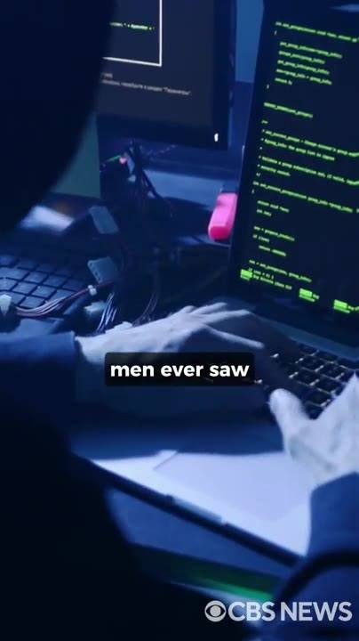 | 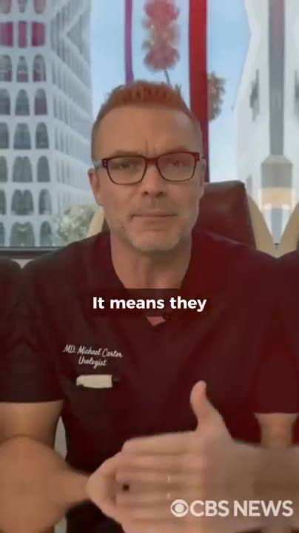 | 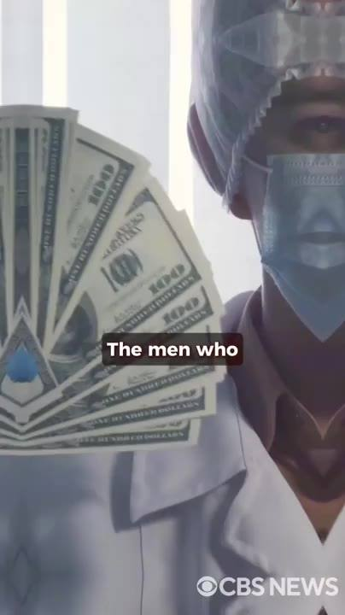 | 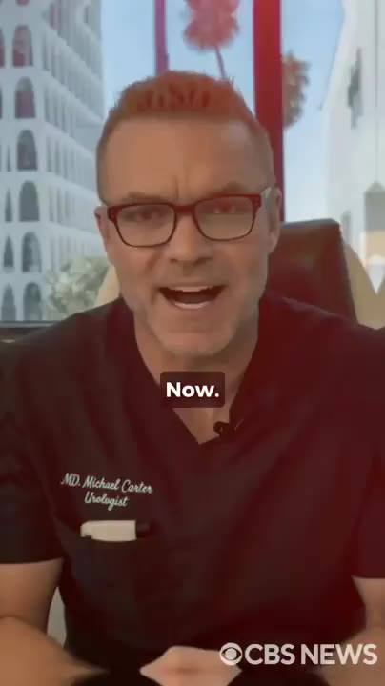
📷 45:21 — Hacker digitando em laptop com código verde; legenda "men ever saw"  b19-1_hacker-digitando-em-laptop-com-codigo_00-45-21.jpg | 📷 45:29 — Dr. Michael Carter no consultório com luz vermelha; legenda "It means they"  b19-1_dr-michael-carter-no-consultorio-com-l_00-45-29.jpg | 📷 45:42 — Médico mascarado segurando leque de notas de 100 dólares; legenda "The men who"  b19-1_medico-mascarado-segurando-leque-de-no_00-45-42.jpg | 📷 45:59 — Dr. Michael Carter no consultório, enfático; legenda "Now."  b19-1_dr-michael-carter-no-consultorio_00-45-59.jpg
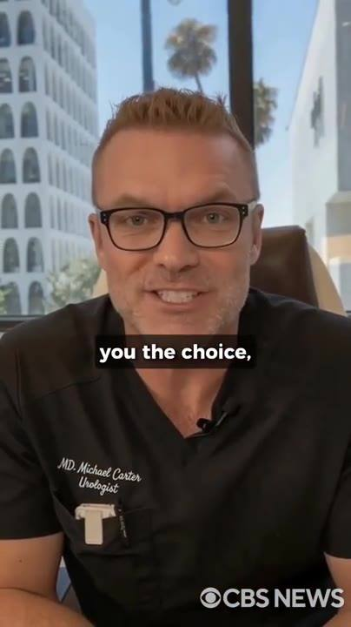
📷 46:00 — Dr. Michael Carter no consultório; legenda "you the choice,"
b19-1_dr-michael-carter-no-consultorio_00-46-00.jpg

DR. MICHAEL CARTER (urologista): Sumiu antes de a maioria dos homens sequer ver o botão. Nos disseram que as pessoas por trás disso não param nas derrubadas, e nós acreditamos. Então, se você está ouvindo a minha voz agora, entenda o que isso significa. Significa que eles falharam em silenciar isso desta vez. Significa que você passou por uma janela que fecha rápido e pode não abrir de novo. Não estou dizendo isso pra te apressar com algum contador falso. Estou dizendo porque é a verdade, e você merece a verdade. Os homens que lucram com a sua impotência têm todos os motivos pra garantir que você nunca termine esta frase. Você terminou. Então, enquanto esta página ainda está na sua frente, enquanto o botão ainda funciona, tome a decisão que um homem toma. Não depois, não depois de pensar e a página sumir amanhã. Agora. Antes de te dar a escolha, preciso que você ouça uma estatística.

BLOCO 20 — KINSEY 67%, as 2 escolhas, o botão de $294 e o CTA [46:02 – 47:40]

20.1 ⏱ 46:02 → 46:23
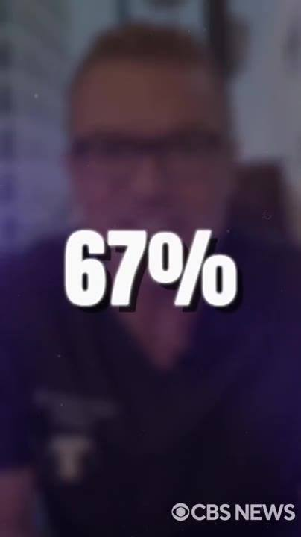 | 
📷 46:13 — Dr. Michael Carter borrado, lettering branco grande "67%"  b20-1_dr-michael-carter-borrado_00-46-13.jpg | 📷 46:22 — Dr. Michael Carter borrado, lettering branco grande "MAYBE ALREADY HAS."  b20-1_dr-michael-carter-borrado_00-46-22.jpg

DR. MICHAEL CARTER (urologista): Um estudo publicado no ano passado pelo Instituto Kinsey mostrou que 67% das mulheres casadas com homens com disfunção erétil já traíram ou estão considerando ativamente. 67%. Isso significa que, enquanto você está aí sentado pensando se clica, há uma chance de 2 em 3 de a sua esposa estar pensando em "clicar" com outra pessoa. Talvez já tenha.

20.2 ⏱ 46:23 → 47:19
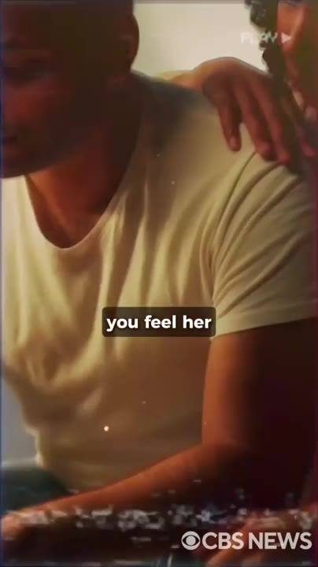 |  | 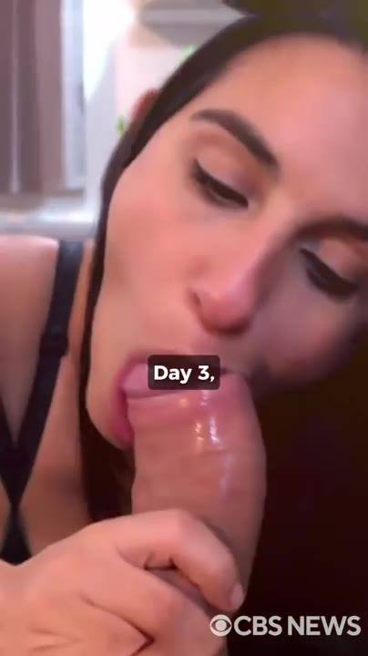 | 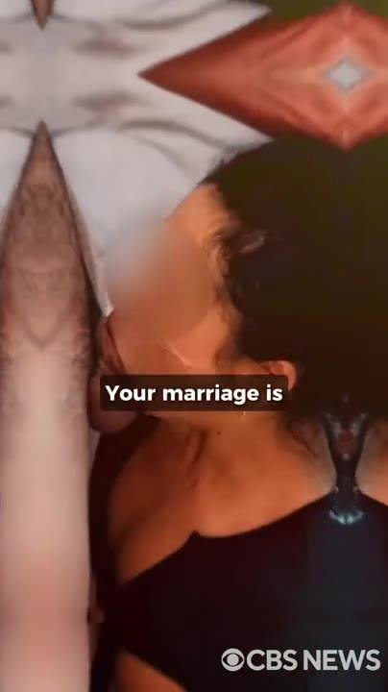
📷 46:32 — Homem de camiseta amarela sentado cabisbaixo, mão de outra pessoa no ombro, ícone "PLAY"; legenda "you feel her"  b20-2_homem-de-camiseta-amarela-sentado-cabi_00-46-32.jpg | 📷 46:44 — Cena pornô explícita (mulher ruiva), ícone "PLAY"; legenda "maybe she's already"  b20-2_cena-porno-explicita-mulher-ruiva_00-46-44.jpg | 📷 46:55 — Cena de sexo oral explícita (mulher morena); legenda "Day 3,"  b20-2_cena-de-sexo-oral-explicita-mulher-mor_00-46-55.jpg | 📷 47:09 — Cena explícita (mulher morena, luz baixa); legenda "Your marriage is"  b20-2_cena-explicita-mulher-morena_00-47-09.jpg
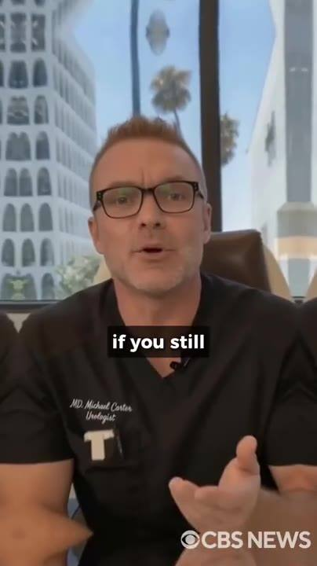
📷 47:19 — Dr. Michael Carter no consultório; legenda "if you still"
b20-2_dr-michael-carter-no-consultorio_00-47-19.jpg

DR. MICHAEL CARTER (urologista): Você só tem 2 escolhas. Na escolha 1, você fecha este vídeo e volta pra esposa que tinha hoje de manhã. Você vê a sua esposa se afastando cada vez mais. Sente o corpo dela ficar tenso quando você toca nela. Ouve o silêncio depois de mais uma noite fracassada. Se pergunta quanto tempo até ela parar de tentar de vez. Talvez ela já tenha desistido. Talvez já esteja olhando pra outro. Talvez já esteja num quarto de hotel com um homem cujo pau funciona. Esse é o caminho que você percorre se não fizer nada. Escolha 2: você clica no botão abaixo agora mesmo. 6 frascos chegam discretamente na sua porta. Dia 3: você acorda duro. Dia 7: você está fodendo a sua esposa do jeito que ela deseja há anos. No mês 6, você é outro homem. Maior, mais duro, no controle, o tipo de homem que as mulheres olham duas vezes na rua. Seu casamento está salvo, sua confiança voltou, e toda mulher que te conhecia antes se pergunta o que aconteceu com você. Esta é a decisão, agora, neste exato momento.

20.3 ⏱ 47:19 → 47:40
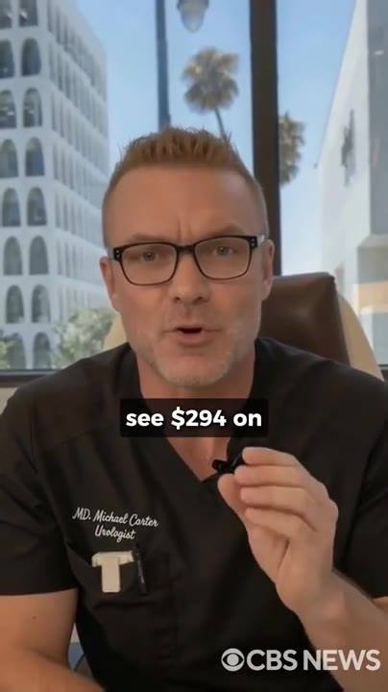 | 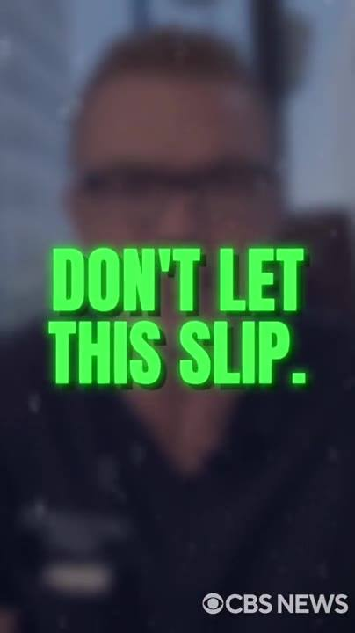
📷 47:20 — Dr. Michael Carter no consultório; legenda "see $294 on"  b20-3_dr-michael-carter-no-consultorio_00-47-20.jpg | 📷 47:32 — Dr. Michael Carter borrado, lettering verde grande "DON'T LET THIS SLIP."  b20-3_dr-michael-carter-borrado_00-47-32.jpg

DR. MICHAEL CARTER (urologista): Se você ainda vê 294 dólares no botão verde abaixo, o subsídio ainda está ativo. Você ainda está a tempo. Se vê 1.134 dólares, as 20 vagas acabaram e o instituto parou de pagar. Não deixe isso escapar. Clique no botão abaixo. Escolha o seu pacote de 6 frascos. Finalize o checkout em 3 minutos. Na semana que vem, você é outro homem.

BLOCO 21 — DEPOIMENTOS DAS ESPOSAS: "comprei escondido", "joguei o vibrador no lixo" [47:40 – 49:15]

21.1 ⏱ 47:40 → 48:27
 | 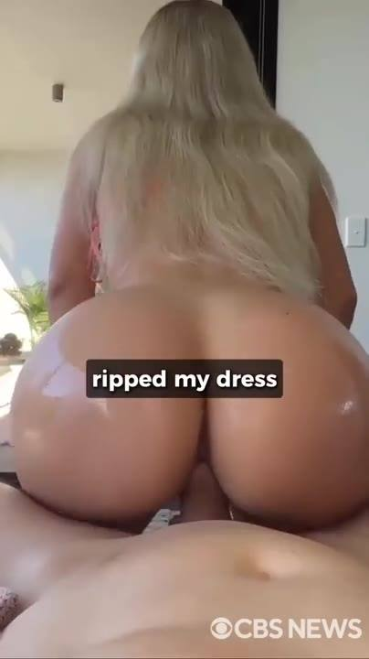 | 
📷 47:41 — Depoimento: mulher loira de lingerie rosa segurando o frasco HONEYFIL MALE falando pra câmera; legenda "for my husband"  b21-1_depoimento-mulher-loira-de-lingerie-ro_00-47-41.jpg | 📷 48:03 — Cena pornô explícita (mulher loira); legenda "ripped my dress"  b21-1_cena-porno-explicita-mulher-loira_00-48-03.jpg | 📷 48:19 — Cena explícita (mulher loira de lingerie rosa rasgada); legenda "then he carried"  b21-1_cena-explicita-mulher-loira-de-lingeri_00-48-19.jpg

MULHER/ESPOSA (depoimento): Comprei isso pro meu marido escondido. Eu estava farta. 2 anos sem sexo. 2 anos dele virando pro outro lado à noite. Dei uma goma de HoneyFil pra ele sem explicação. Ele achou que era uma bala comum. Naquela noite, ele voltou do trabalho, jogou a pasta no... e olhou pra mim como se não me visse há anos. Me pegou pelo pescoço e me dobrou sobre a ilha da cozinha, levantou o meu vestido, puxou a calcinha pro lado. Senti o pau dele pressionando contra mim, grosso e pesado, como o de outro homem. Ele enfiou até o fim na primeira estocada, e eu gritei. Ele me fodeu ali mesmo até eu arranhar o mármore. Gozei no pau dele duas vezes antes de ele terminar. Depois me carregou pro quarto e fez de novo, e de novo. Meninas, se o seu homem parou de tocar em você, coloque isso no café dele amanhã de manhã. Depois me agradeça.

21.2 ⏱ 48:27 → 49:07
 | 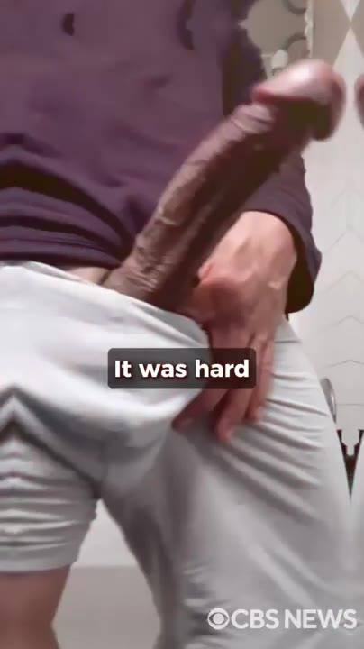 | 
📷 48:38 — Mulher morena borrada, lettering verde grande "HE STARTED TAKING THESE"  b21-2_mulher-morena-borrada_00-48-38.jpg | 📷 48:48 — Close explícito masculino (calça cinza); legenda "It was hard"  b21-2_close-explicito-masculino-calca-cinza_00-48-48.jpg | 📷 48:58 — Cena pornô explícita (mulher morena de lingerie estampada, relógio dourado); legenda "I came so"  b21-2_cena-porno-explicita-mulher-morena-de_00-48-58.jpg

MULHER/ESPOSA (depoimento): Meu marido costumava durar 2 minutos num dia bom. Eu fingia o orgasmo, dava um beijo de boa noite e esperava ele dormir pra usar o vibrador no banheiro. Esse era o meu casamento. Ele começou a tomar essas gomas. Dia 5, estou lavando a louça e ele chega por trás, levanta a minha saia, desliza a mão entre as minhas pernas. Senti o pau dele por cima do jeans e quase deixei cair... Estava duro, grosso, maior do que eu jamais tinha sentido. Ele me dobrou sobre a pia e me fodeu até a louça tremer no escorredor. 40 minutos. Depois me virou no chão e continuou. Gozei tão forte que chorei. Lágrimas de verdade. Ele não parou. Quando finalmente gozou, não amoleceu. Me puxou pro colo dele e me fez cavalgar de novo. Ah.

21.3 ⏱ 49:08 → 49:15
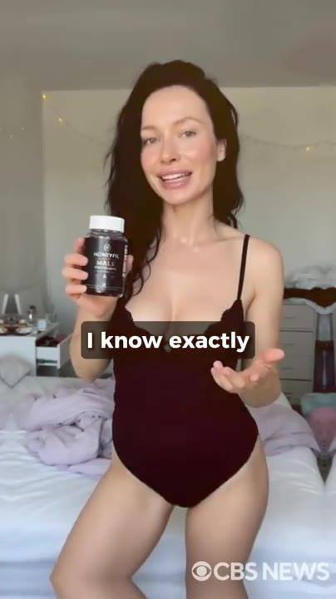
📷 49:12 — Depoimento: mulher morena de body preto num quarto segurando o frasco HONEYFIL; legenda "I know exactly"
b21-3_depoimento-mulher-morena-de-body-preto_00-49-12.jpg

MULHER/ESPOSA (depoimento): Naquela noite, joguei o vibrador no lixo. Agora, quando ele me procura na cama, eu sei exatamente o que vem. E fico molhada antes mesmo de ele me tocar.

BLOCO 22 — FAQ COM O ELON + CTA FINAL [49:15 – 52:04]

22.1 ⏱ 49:15 → 49:31
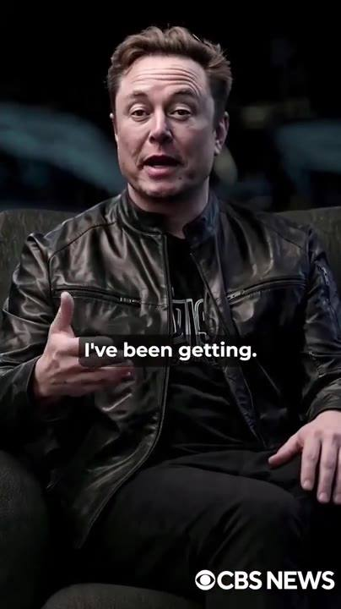 | 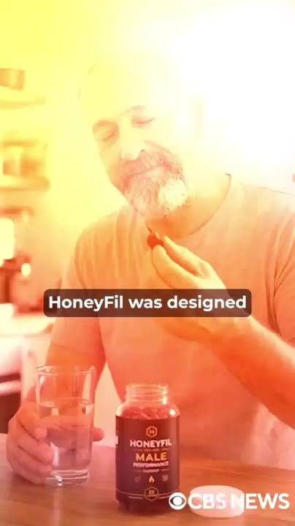 | 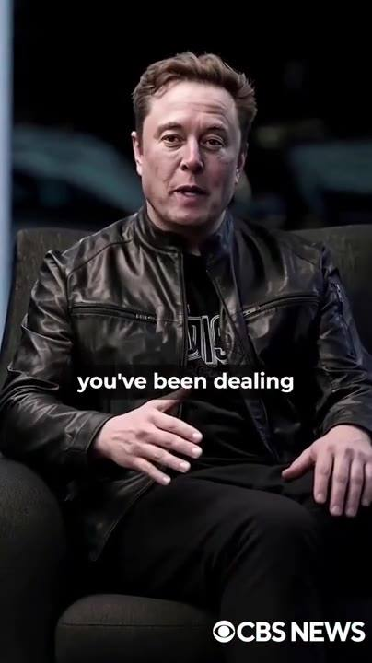
📷 49:17 — Elon Musk na poltrona falando; legenda "I've been getting."  b22-1_elon-musk-na-poltrona-falando_00-49-17.jpg | 📷 49:25 — Homem grisalho de barba, suéter laranja, tomando uma goma com copo d'água e frasco HONEYFIL MALE na mesa (filtro amarelo); legenda "HoneyFil was designed"  b22-1_homem-grisalho-de-barba_00-49-25.jpg | 📷 49:28 — Elon Musk na poltrona; legenda "you've been dealing"  b22-1_elon-musk-na-poltrona_00-49-28.jpg

ELON MUSK (imagem/voz sintética): Você ainda está aqui. Deixa eu responder às perguntas que tenho recebido. "Sou o Phil, 80 anos. Já tentei de tudo. Pílulas, bombas, terapia de testosterona, suplementos. O HoneyFil vai funcionar pra mim?" Com certeza. O HoneyFil foi criado pra homens de todas as idades. Não importa há quanto tempo você lida com DE ou o que já tentou antes.

22.2 ⏱ 49:31 → 50:27
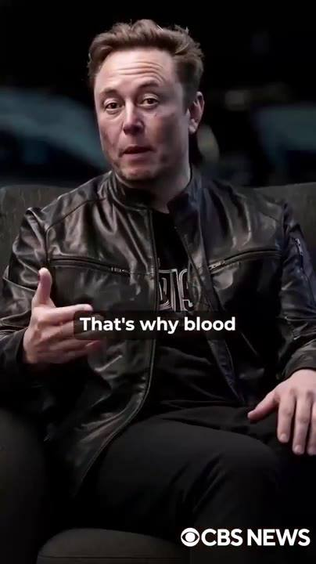 | 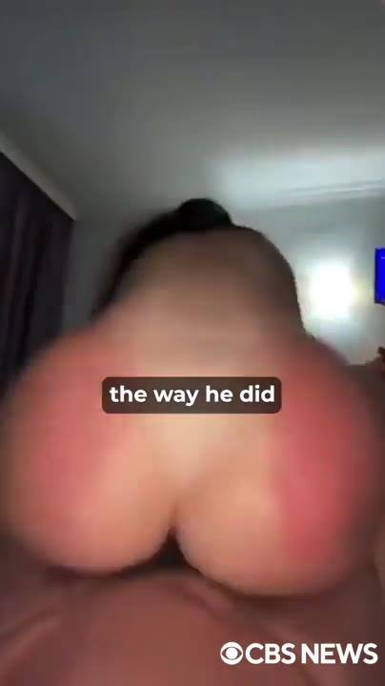 | 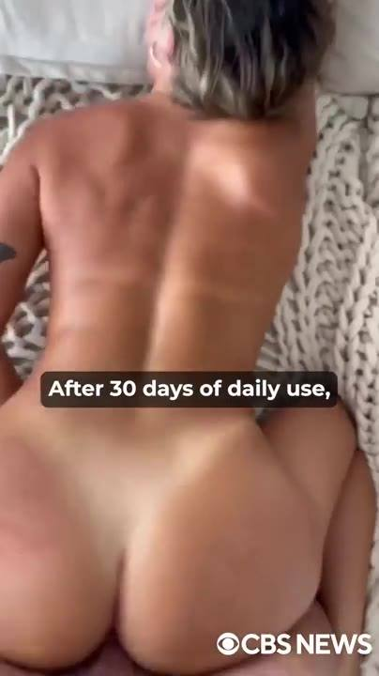 | 
📷 49:40 — Elon Musk na poltrona gesticulando; legenda "That's why blood"  b22-2_elon-musk-na-poltrona-gesticulando_00-49-40.jpg | 📷 49:51 — Cena pornô explícita (quarto, luz baixa); legenda "the way he did"  b22-2_cena-porno-explicita-quarto_00-49-51.jpg | 📷 50:01 — Cena pornô explícita (homem musculoso de costas); legenda "After 30 days of daily use,"  b22-2_cena-porno-explicita-homem-musculoso-d_00-50-01.jpg | 📷 50:12 — Cena pornô explícita (lingerie rosa); legenda "Men who couldn't last"  b22-2_cena-porno-explicita-lingerie-rosa_00-50-12.jpg
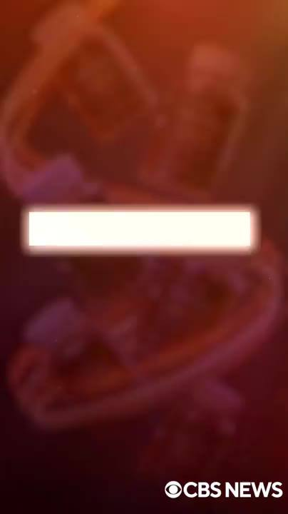
📷 50:25 — Fundo vermelho/laranja com frascos borrados e barra branca de lettering vazia (transição)
b22-2_fundo-vermelho-laranja-com-frascos-bor_00-50-25.jpg

ELON MUSK (imagem/voz sintética): O problema real é a placa de xenotoxina se acumulando nos vasos do seu pênis ao longo de décadas de exposição a pesticidas, plásticos e químicos industriais. É por isso que o sangue nunca chega ao seu pau do jeito que deveria. A icariina do mel vermelho dissolve essa placa e restaura o fluxo sanguíneo completo. Qualquer homem, independentemente da idade, volta a ter ereções firmes e duradouras, como aos 20. "Quanto tempo leva pra ver resultados?" A maioria dos homens sente ereções matinais mais firmes em 2 a 3 dias. Em uma semana, ereções mais frequentes e mais duradouras. Depois de 30 dias de uso diário, mais firmeza, desejo mais forte, controle total e ganhos em comprimento e espessura. Depois de 3 a 6 meses, os resultados ficam dramáticos. Homens que não aguentavam 5 minutos relatam 2 horas seguidas. E não esqueça: você tem uma garantia de 60 dias. Se não vir uma diferença significativa, recebe cada centavo de volta mais 200 dólares pelo incômodo. "O HoneyFil aumenta o tamanho do pênis?" Sim.

22.3 ⏱ 50:27 → 51:00
 | 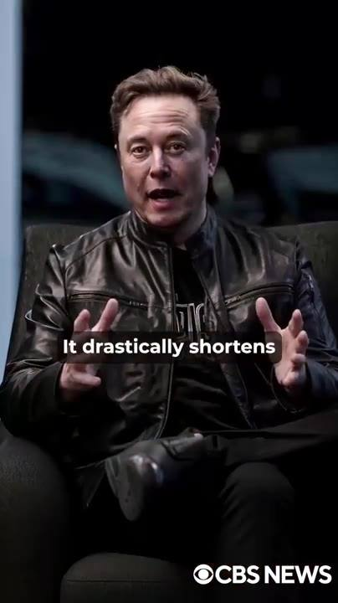 | 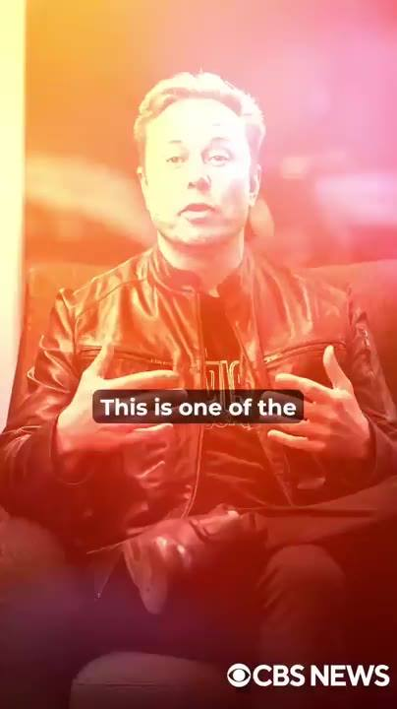
📷 50:38 — Fundo vermelho/laranja com frascos borrados e barra branca vazia (transição)  b22-3_fundo-vermelho-laranja-com-frascos-bor_00-50-38.jpg | 📷 50:49 — Elon Musk na poltrona gesticulando; legenda "It drastically shortens"  b22-3_elon-musk-na-poltrona-gesticulando_00-50-49.jpg | 📷 51:00 — Elon Musk na poltrona com filtro laranja; legenda "This is one of the"  b22-3_elon-musk-na-poltrona-com-filtro-laran_00-51-00.jpg

ELON MUSK (imagem/voz sintética): Ao restaurar o fluxo sanguíneo completo nos vasos penianos, o seu pau recebe uma onda massiva, igual a quando você era adolescente. Os resultados variam, mas um aumento de 2 a 3 polegadas no primeiro mês é comum. "Meu marido de 69 anos gozou feito um touro e estava pronto de novo em menos de 10 minutos. Isso é normal?" Completamente normal. A fórmula restaura imediatamente o fluxo sanguíneo e a função erétil. Ela encurta drasticamente o período refratário, ou seja, o tempo entre a ejaculação e a próxima ereção cai pra quase nada. "Tenho pressão alta e diabetes. Posso tomar HoneyFil?" Sim!

22.4 ⏱ 51:00 → 51:43
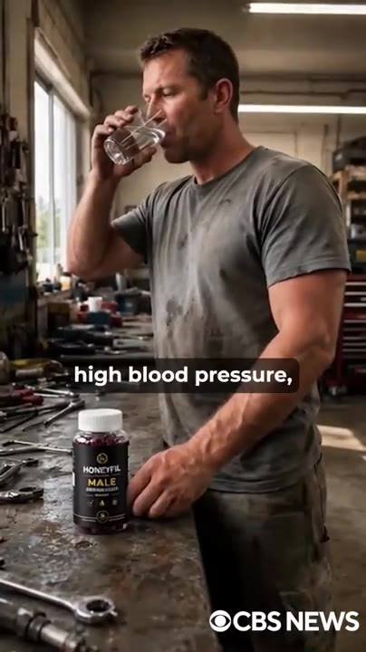 |  | 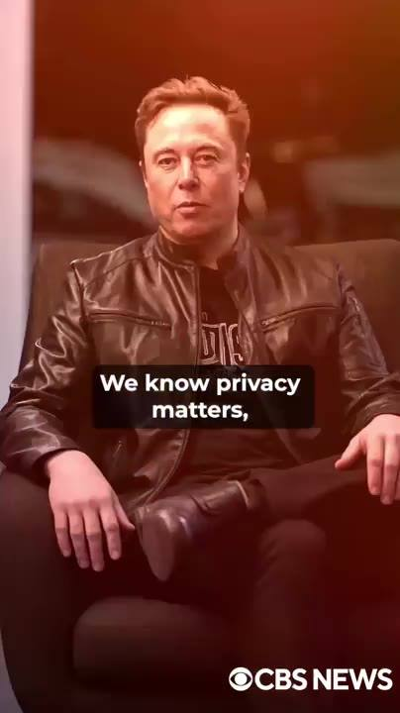 | 
📷 51:10 — Homem musculoso numa oficina bebendo água, frasco HONEYFIL MALE na bancada; legenda "high blood pressure,"  b22-4_homem-musculoso-numa-oficina-bebendo-a_00-51-10.jpg | 📷 51:20 — Elon Musk na poltrona com filtro laranja; legenda "HoneyFil works"  b22-4_elon-musk-na-poltrona-com-filtro-laran_00-51-20.jpg | 📷 51:29 — Elon Musk na poltrona com filtro vermelho; legenda "We know privacy matters,"  b22-4_elon-musk-na-poltrona-com-filtro-verme_00-51-29.jpg | 📷 51:41 — Fundo vermelho/laranja com frascos borrados e barra branca vazia (transição)  b22-4_fundo-vermelho-laranja-com-frascos-bor_00-51-41.jpg

ELON MUSK (imagem/voz sintética): Essa é uma das maiores vantagens do HoneyFil sobre os remédios farmacêuticos. Ao contrário das pílulas com efeitos colaterais perigosos, o HoneyFil é 100% natural e seguro pra homens com diabetes, pressão alta ou colesterol alto. Ele também melhora a circulação, reduz a inflamação e apoia a saúde geral. "Preciso mudar a minha dieta pro HoneyFil funcionar?" Não! O HoneyFil funciona independentemente do seu estilo de vida. A fórmula ataca o problema pela raiz, sem mudanças drásticas. "Como o HoneyFil será entregue? É discreto?" Completamente discreto. Sabemos que privacidade importa, principalmente se você quer surpreender a sua esposa ou guardar isso só pra você. Seu pedido chega numa embalagem simples, sem identificação. O nome da empresa na fatura do seu cartão não tem nenhuma referência ao HoneyFil. "Como eu começo?" Simples.

22.5 ⏱ 51:43 → 52:04
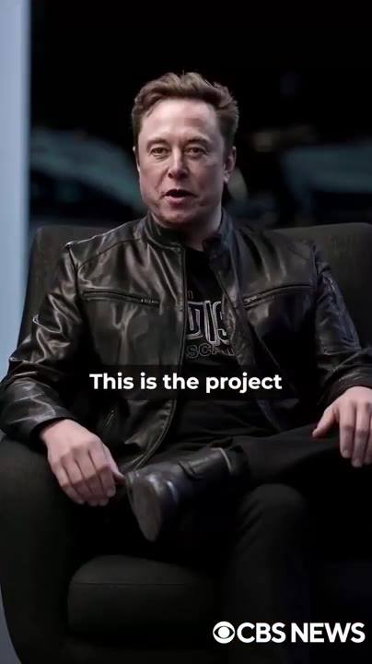 | 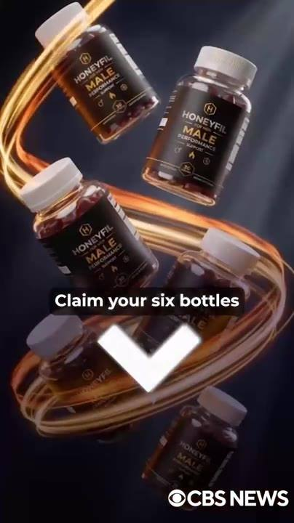
📷 51:53 — Elon Musk na poltrona falando; legenda "This is the project"  b22-5_elon-musk-na-poltrona-falando_00-51-53.jpg | 📷 52:02 — Frascos HONEYFIL MALE girando em anel dourado com seta branca para baixo; legenda "Claim your six bottles"  b22-5_frascos-honeyfil-male-girando-em-anel_00-52-02.jpg

ELON MUSK (imagem/voz sintética): Escolha abaixo o kit que melhor atende às suas necessidades. Complete o seu pedido na página de checkout segura. O HoneyFil chega na sua porta em poucos dias. Pronto pra mudar a sua vida pra sempre. Este é o projeto em que eu coloco o meu nome. A Neuralink está pagando 4 de cada 6 frascos, mas só enquanto o subsídio durar. Clique no botão verde abaixo agora mesmo. Reivindique os seus 6 frascos antes que os primeiros 20 acabem.

