<https://tecnotitan.herokuapp.com/panel>

Use the link above to create a user and login.

Click sign up button and you will see a page to create a new company user.

Fill up username, email and password field and click on Payment method and choose 1 Plan and click Register.

PS. The payment method to process credit/debit card is not working yet.

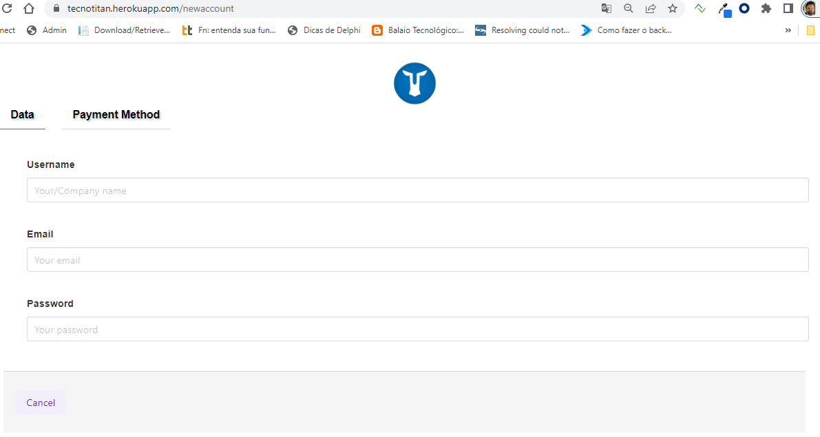

After you create the user, go back to <https://tecnotitan.herokuapp.com/panel>

and fill up email and password field and click login.

You will see:

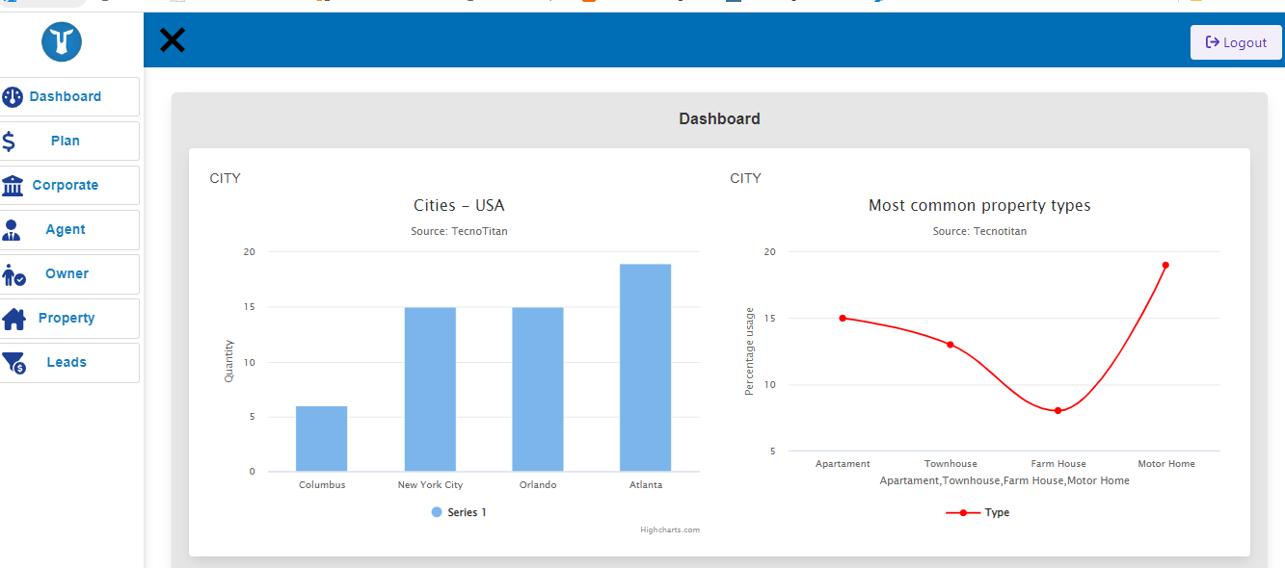

This a Fake Dashboard. We are still working on it.

Plan option – It´s not done yet.

**Click Corporate**

Fill Up the fields before you continue. (YOU MUST to do that)

Corporate Menu option is only available for Company user login.

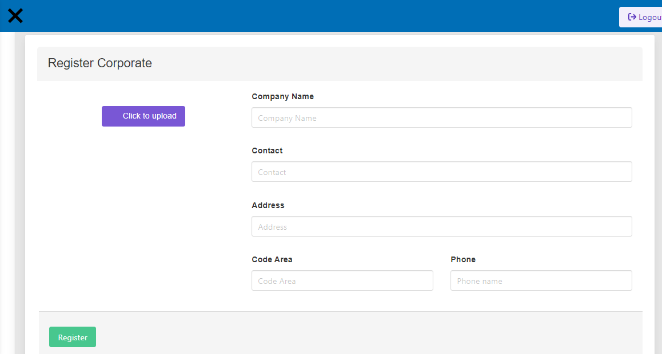

**Click Agent**

You will create new login broker so they can use the system. You can create user as many as you want.

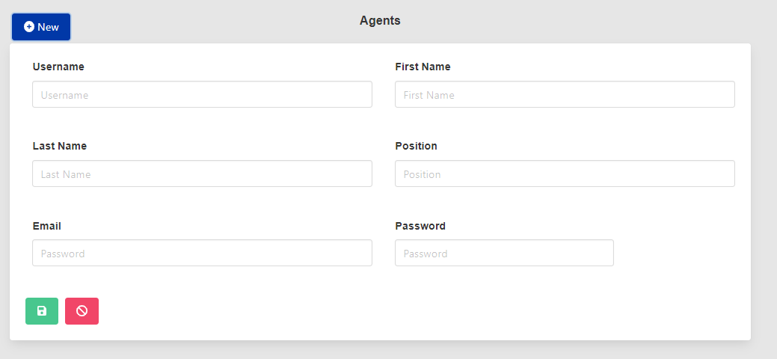

**Click Owner**

You will create property´s owners. You can create as many as you want.

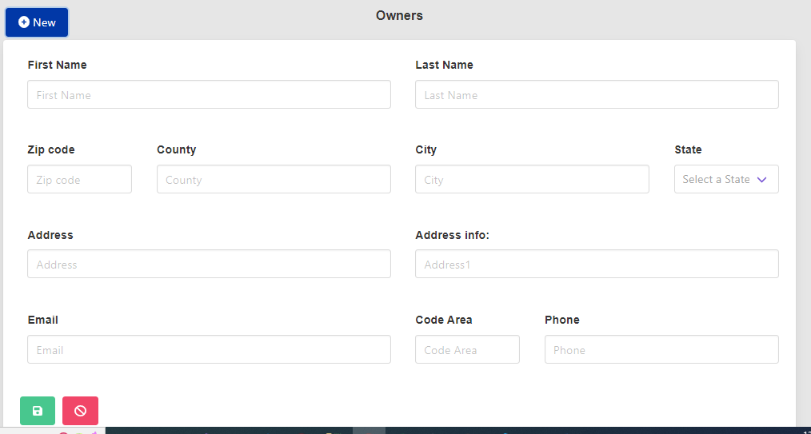

**Click Property**

You can create as many as you want

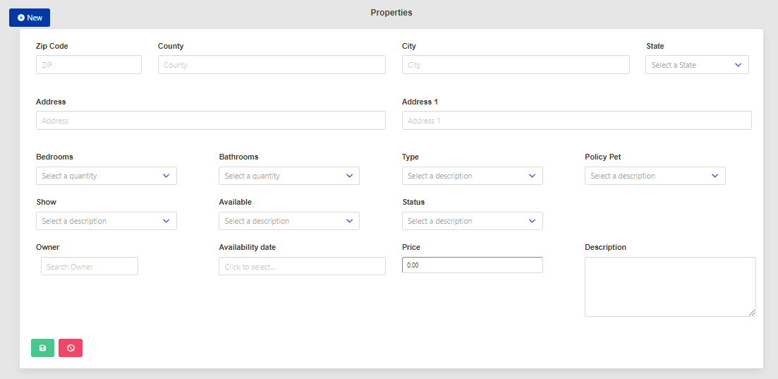

**Click Leads**

You will see the leads that clicked on the main page and selected one property to buy or to rent.

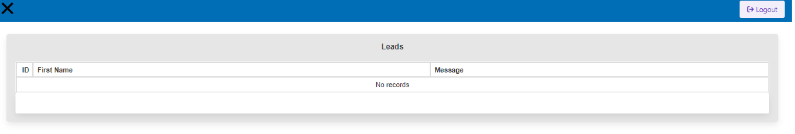

<https://tecnotitan.herokuapp.com/>

Below is the main page.

The filters is not working yet.

But you can create a property using the backend and the property will be displayed at the main page.

The Request info button is working.

You can click and fill up all the fields and save. The property´s broker that input the property into the system will receive an email.

You will see the lead at the lead screen by the link <https://tecnotitan.herokuapp.com/panel>

