**Instrucctions and stimuli configuration for the visual illusion task (https://github.com/marcosrosetti/visual_illusion_task)**

**Péter Szenczi, Marcos Rosettiand Oxána Bánszegi**

**Probe trials:**

These trials were built in at the beginning of the program to familiarize participants with the test and to check that they understood the instructions. First, they had to select the longer line out of seven, random direction and position. It was repeated three times. Second, they had to click on a green circle. which appeared in a random position on the screen. The circle gradually shrank after every click (10 repeats)

The third type of probe trial was built in just before the Kanizsa illusion trials. Four pictures appeared simultaneously on the screen: a Kanizsa square in which all Pac-man-shaped inducers were in the right position to form a square, a Kanizsa square in which one of the Pac-man-shaped inducers were turned out forward, a Kanizsa square in which two of the Pac-man-shaped inducers were turned out forward, and a Kanizsa triangle (Figure 1.). The participant had to choose the picture with the square. The program did not let to continue until the choice was correct. This was repeated two times.

*Figure 1. Probe trial for the Kanizsa illusion. Participant are asked to click on the white square.*

**Geometrical [Ebbinghaus and Müller-Lyer] illusions:** In these illusions the geometric properties of a stimulus – e.g., size, angle, area, or form – are affected and systematically altered by the presence of other elements in the visual field (Figure 2.)

*Figure 2. The Ebbinghaus illusion (left): The orange circles are the same size; and the Müller-Lyer illusion (right): The horizontal lines are the same length.*

*Ebbinghaus illusion:* It consists of an inner circle surrounded by an annulus of either larger or smaller circles. The central circle is perceived as smaller when surrounded by larger circles than when surrounded by smaller circles.

Control conditions: Different-sized target circles are surrounded by identically sized (small or large) outer circles on both sides (Small and Large controls; see Figure 3 *The Ebbinghaus illusion (left); The orange circles are the same size, and the Müller-Lyer illusion (right): The horizontal lines are the same length.*). The two target circles always differ in size—by 1%, 5%, 10%, 15%, 20%, or 30%—and this difference varies across trials.

Illusory conditions: Different-sized target circles are surrounded by different-sized (small or large) outer circles. The outer circles are arranged so that the context either supports (Helpful trials) or opposes (Misleading trials) accurate discrimination (see Figure 4). In the Helpful trials, the larger inner circle is surrounded by smaller outer circles, and the smaller inner circle is surrounded by larger outer circles. Illusion perception leads to increased performance in the Helpful trials because the smaller target circle appears even smaller than it actually is, whereas the larger target circle with the small outer circles appears even larger than its true size. In the Misleading trials, the larger inner circle is surrounded by larger outer circles, and the smaller inner circle is surrounded by smaller outer circles. In the Misleading trials, illusion perception leads to a decrease in performance due to the overestimation of the smaller target circle and the underestimation of the larger circle. The task for the participants is to decide whether the larger center circle was on the left or the right.

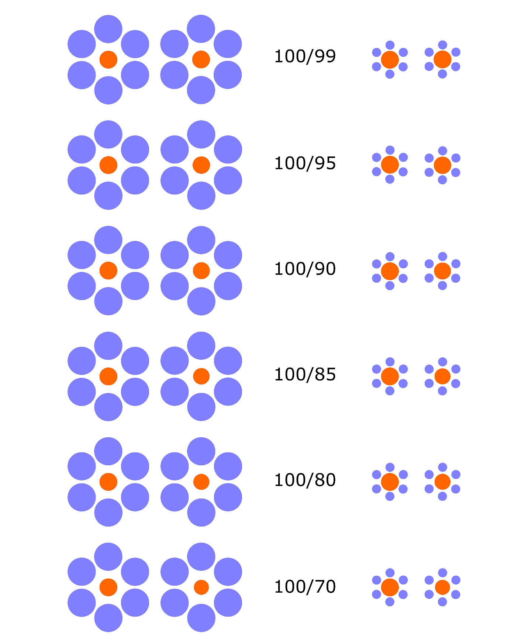

Figure 3. Large (left) and small (right) controls for the Ebbinghaus illusion. The central circles have different sizes, while their outer circles are the same size. The pairs of numbers show the surface area ratio of the target circles.

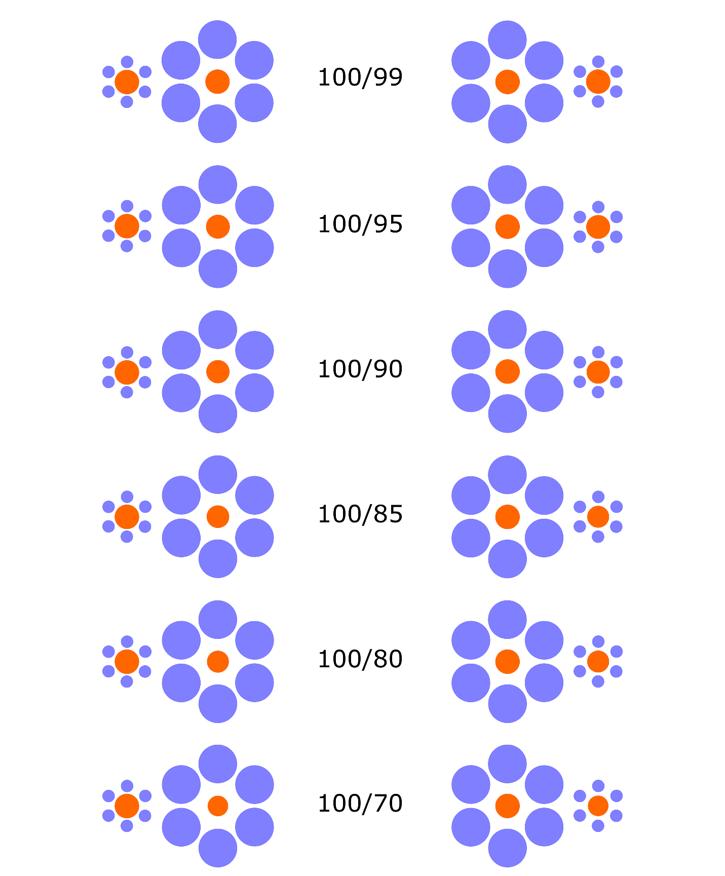

*Figure 4. Helpful (left) and Misleading (right) illusory trials for the Ebbinghaus illusion. The central circles have different sizes, while the surrounding circles also differ. The pairs of numbers show the surface area ratio of the target circles.*

*Müller-Lyer illusion:* It consists of horizontal lines that have inward- or outward-pointing fins on both ends. The length of a line is perceptually overestimated if bounded by outward-pointing fins and perceptually underestimated if bounded by inward-pointing fins.

Control conditions: Different-length target lines are bounded by fins pointing inward or outward on both sides (Inward and Outward controls, Figure 5). The two target lines always differ in size—by 1%, 5%, 10%, 15%, 20%, or 30%—and this difference varies across trials.

Illusory conditions: The fins of the different length lines are arranged so that the context would either support (Helpful trials) or oppose (Misleadingtrials) accurate discrimination similar to the Ebbinghaus illusion but here the orientation of the fins is responsible for the illusory effect (Figure 6). The task for the participants is to decide whether the longer line was on the left or on the right.

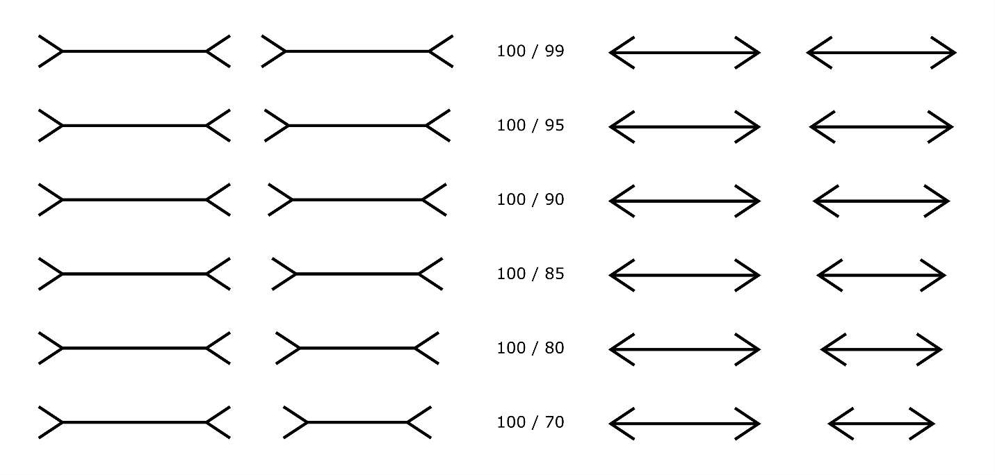

Figure 5. Control trials for the Müller-Lyer illusion. The target lines have different sizes and both are bounded by inward (left) or outward (right) pointing fins. The pairs of numbers indicate the length ratio between the target lines.

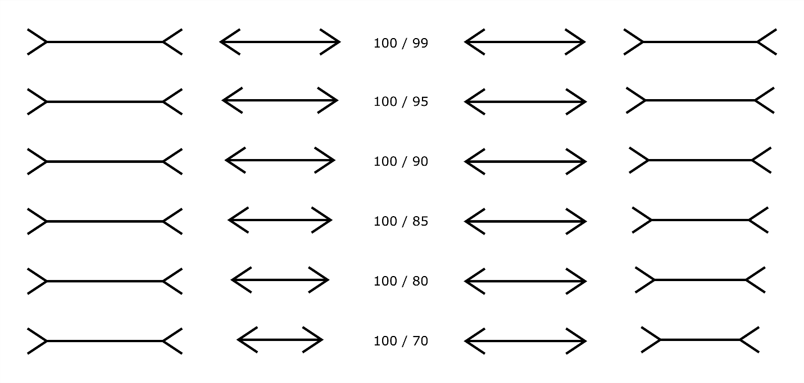

*Figure 6. Helpful* *(left) and Misleading (right) illusory trials for the Müller-Lyer illusion. In the Misleading trials the longer line is bounded by the inward pointing fins and the shorter line is bounded by the outward pointing fins, which perceptually magnify the illusion perception.*

Every comparison in both geometric illusions (6 Small or Inward control, 6 Large or Outward control, 6 Helpful and 6 Misleading) is presented one time, which makes a total of 24 trials for each of the geometrical illusions.

**Simultaneous Contrast illusion:** This illusion exploits the mechanisms underlying lightness constancy. The perception of the luminance of a stimulus – how dark or light – is affected by the immediate surroundings. Two target object which are the same shade of grey are perceived different depending on the shade of their surroundings (Figure 7).

*Figure 7. Contrast illusion. The two circles within the rectangle are the same shade of grey.*

Control conditions: Target circles of different shades of gray are exhibited in front of rectangles that have the same luminance (both darker or both lighter than the target circles; Figure 8). The difference in the target circles’ luminance is 1, 2, 4, 6 and 10 units on a gray scale where 0 is black and 100 is white. Half of the control trials are presented on darker, the other half are presented on lighter backgrounds.

Illusory conditions: Different-shade target circles are exhibited in front of different-shade (darker or lighter) rectangles. The rectangles are arranged so that the context either supports (Helpful trials) or opposes (Misleading trials) accurate discrimination (see Figure 9). In the Helpful trials, the darker inner circle has the lighter rectangle, while the lighter inner circle has darker rectangle as background. Illusion perception leads to increased performance in the Helpful trials because the lighter target circle appears even lighter than it actually is, whereas the darker target circle in front of the lighter rectangle appears even darker than its true shade. In the Misleading trials, the darker inner circle has the daker rectangle, while the lighter target circle has the light rectangle as background. In the Misleading trials, illusion perception leads to a decrease in performance. The task for the participants is to decide whether the darker center circle was on the left or the right. In total 20 Contrast illusion trials are presented to the children: ten different control (Five light and five dark control) and 10 different illusory (Five Helpful and five Misleading) trials.

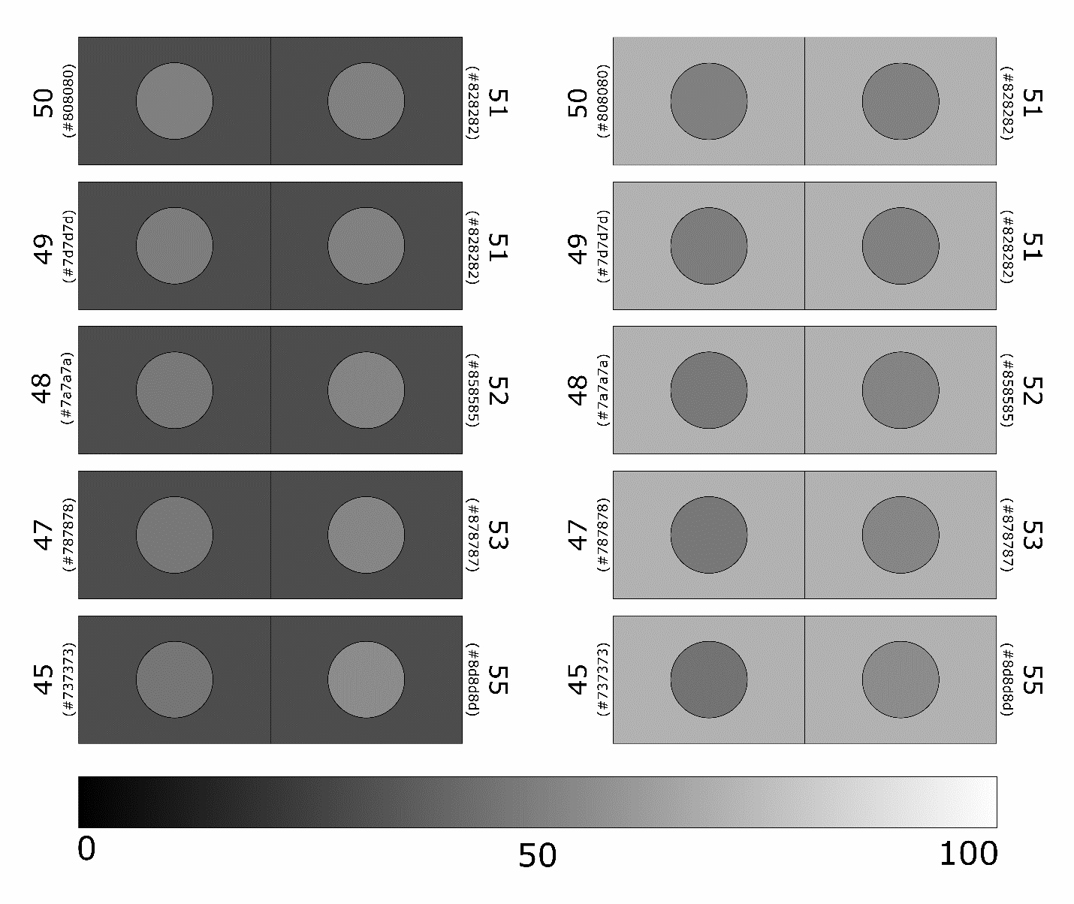

*Figure 8. Control trials for the Simultaneous Contrast illusion. The two circles (target object) in the rectangles have different shade of achromatic grey, while both have the same shade of surroundings. The bigger numbers next to the rectangles show the relative luminance of the target objects (where 0 is black and 100 is white, see palette at the bottom) and hence their difference from each other. The smaller numbers in brackets represent the hexadecimal RGBA values for that shade of grey.*

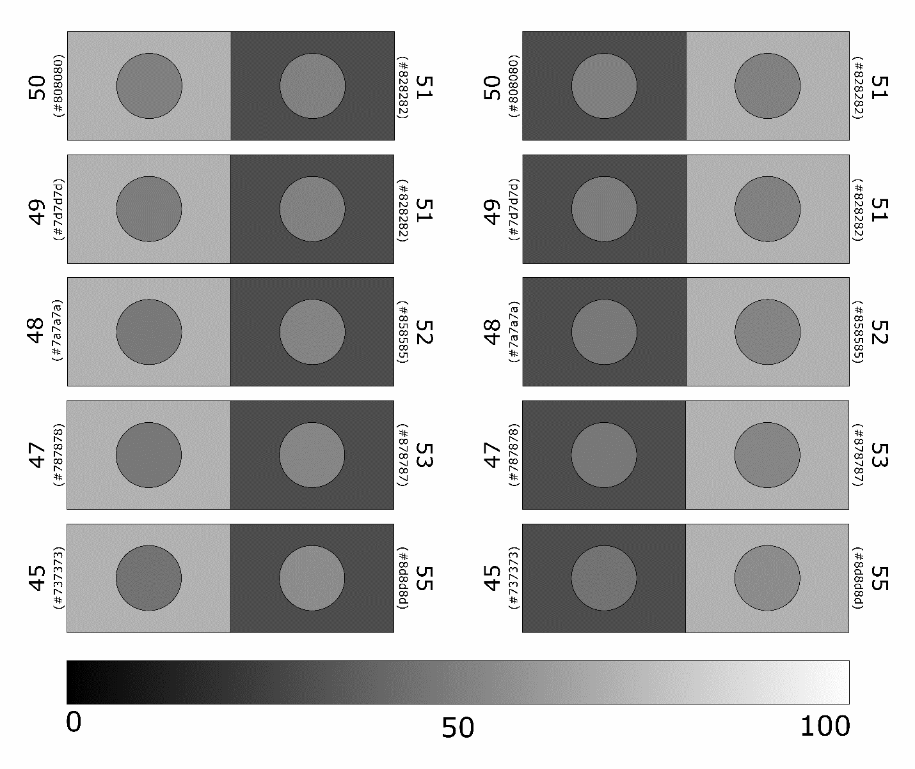

*Figure 9. Misleading (left) and Helpful (right) illusory trials for the Contrast illusion. The bigger numbers next to the rectangles show the relative luminance of the target objects (where 0 is black and 100 is white, see palette at the bottom) and hence their difference from each other. The smaller numbers in brackets represent the hexadecimal RGBA values for that shade of grey.*

**Moving Snake illusion**: A type of peripheral drift illusion, the "snakes" consist of periodical arrangement of regions with different alternating luminance in several bands which resemble coiled serpents. Although the image is static, certain luminance sequence produces illusory motion perception and the snakes appear to be moving in circles.

Five different version of the Moving snake (Figure 10) illusion are created where the patches of the snake have different illuminance. Contrast was gradually reduced between the two shades of gray in five equal steps. More contrast between of the patches separated by the white or black line results stronger illusion magnitude. Participants are asked to select from the simultaneously presented pair of pictures the one which they perceive as faster or more moving. We presented the pairs in a full factorial design (10 pairs) which resulted in 10 trials.

**e)**

**d)**

**c)**

**b)**

**a)**

*Figure 10. Five versions of the Moving snakes motion illusion. The concentric circles are constructed from parts of two shades of achromatic gray separated by alternating black and white segments. On picture a) the luminance difference between the two grey parts is the greatest so as the illusion of movement for those who perceive this type of illusion. As the contrast between the two shades of grey decrease on b), c), d) panels, the perception of motions is less and less strong and seem to slow down. On panel e) the two shades of grey are identical thus the motion perception completely ceases.*

# Kanizsa Illusory Contour illusions (or subjective contours): These illusions evoke the perception of an edge without a luminance or color change across that edge. We chose the Kanizsa square for our tests.

We prepared pictures of a grid of Pac-man shaped inducers (7 x 7) where the orientation of the mouth of the Pac-men was randomized. We created two different versions, one where four Pac-man shapes next to each other created a Kanizsa square somewhere in the grid and one where no contour illusion appeared. Then these two pictures were placed next to each other (Figure 9). Participants were asked to choose the pair of images presented at the same time in which they saw a square. Since the size of the Pac-Man-shaped inducers can influence the magnitude of the illusion perception (larger the Pac-man, stronger the illusion), we created 5 types of pictures where the size of the Pac-man shapes were altered (Figure 11). Since the Kanizsa square appeared randomly which might influence the performance (e.g. easier to spot the square if it is in the middle of the screen) we tested five times with each size thus we run 25 trials in total.

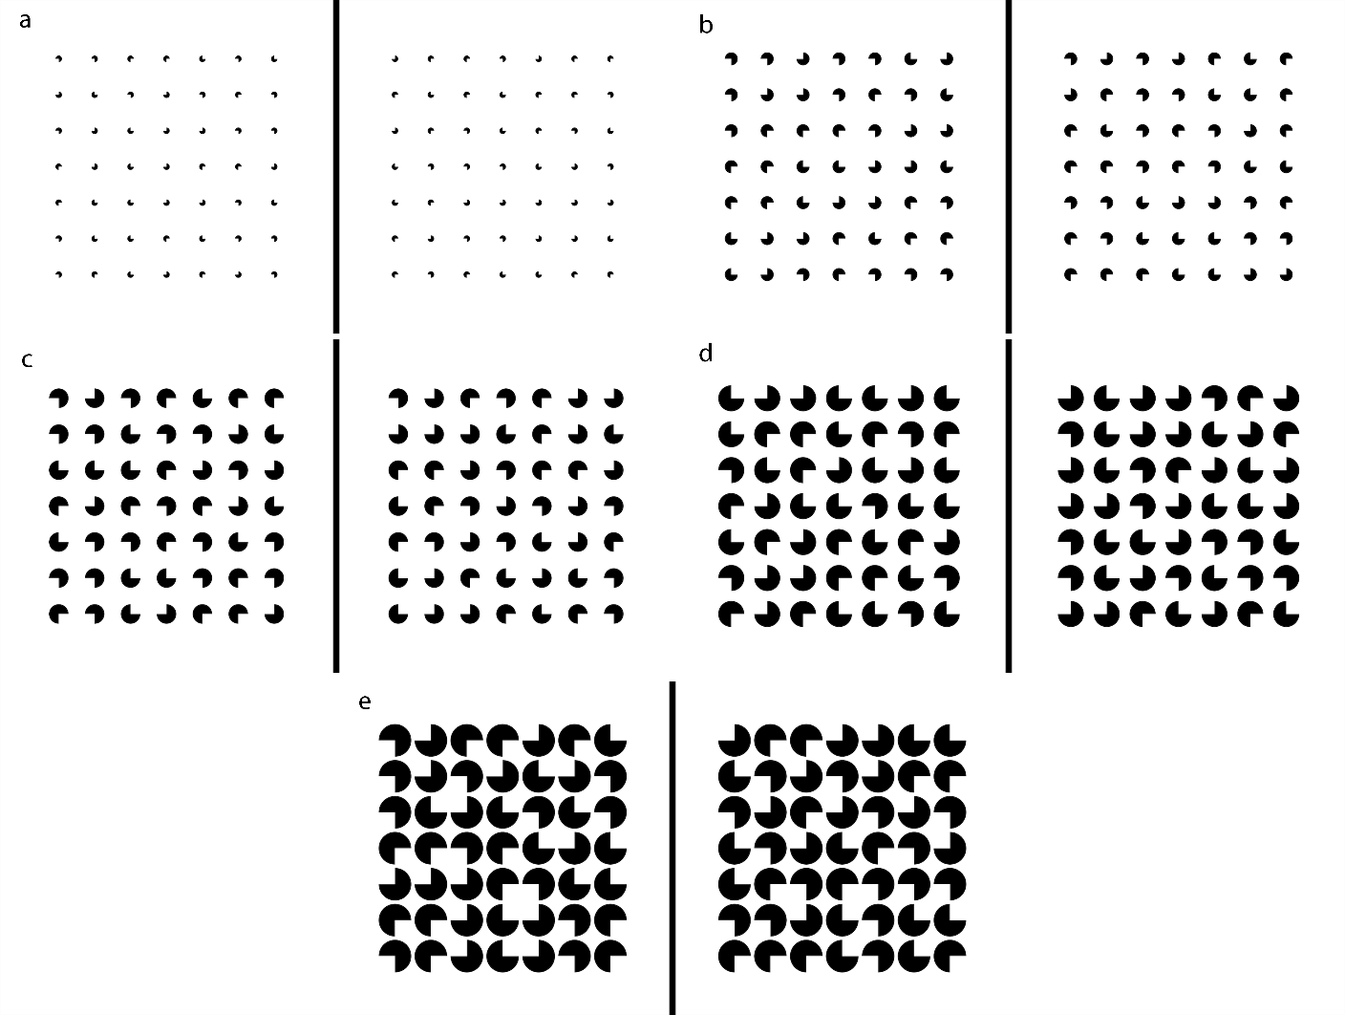*Figure 11. Five versions of the Kanizsa square contour illusion. Four Pac-man shaped inducers can evoke the perception of an edge of a square. On picture a) the size of the Pac-man shaped inducers is the smallest so the illusion perception to those who perceive at all this type of illusion. As the size of the inducers are increased b) twice, c) three times, d) four times or e) five times the illusion magnitude increases and the susceptibility with it.*