|  |
| --- |
| **A study of fire on Boeing 747 overhead cargo compartment: Experiments and Fire Dynamics Simulator validation** |
| **Marcos Vanella, Randall McDermott**  *Fire Research Division, National Institute of Standards and Technology, Gaithersburg, MD, USA*  *100 Bureau Drive, Building 224 B266, Gaithersburg, MD 20899, USA*  *[marcos.vanella@nist.gov](mailto:marcos.vanella@nist.gov), Ph: +1 301 975 6577*  **Haiqing Guo, Richard Lyon**  *Fire Safety Branch, William J. Hughes Technical Center, Federal Aviation Administration, Atlantic City International Airport, NJ USA* |

**Keywords:** Fire modeling; aircraft fires; compartment fire experiments; heat transfer; smoke transport; fluid dynamics; CFD Validation.

**Abstract**

The Federal Aviation Administration (FAA) Advisory Circular (AC) 120-80A [1] defines hidden fires as those that are not readily accessible, may be difficult to locate, and challenging to extinguish. In-flight fire in the hidden areas can be catastrophic and therefore it must be detected at its earliest stage. For example, the Ethiopian airline experienced a battery-initiated fire that happened in the overhead space of a Boeing-787 and spread along the fuselage for a considerable distance [2]. Hidden areas in aircraft overhead cabins involve complex geometry, a densely cluttered, highly curved fuselage, and present a great challenge for timely fire detection and suppression. In order to provide better guidance to the placement of fire detectors in overhead hidden areas, costly full-scale studies are needed to reveal the heat and smoke transfer behaviour under these conditions.

In recent years, fire models based on computational fluid dynamics (CFD) have been developed, allowing for simulation of complex fire scenarios. One of said fire models is FDS [3], used in design of fire protection systems within civil, aviation and transport industries, as well as in forensic research and modeling outdoor flows and fires. FDS uses cartesian meshes and a finite volume method for discretization of the governing fluid flow, heat and mass transport equations. Recently, substantial work has been performed in adding to FDS the capability of representing curved surfaces, which do not need to conform to the fluid grid. Some target applications of this functionality are fires in aircraft and transport vehicle cabins, curved roofs and atria. The key components of this new capability are a cut-cell method [4] for species transport and thermodynamic divergence next to the geometry, and an immersed boundary method [5] coupled with dynamic boundary layer modelling for velocity and thermal boundary layer reconstruction. Parallel computations can be performed using hundreds of cores by means of the MPI standard [6].

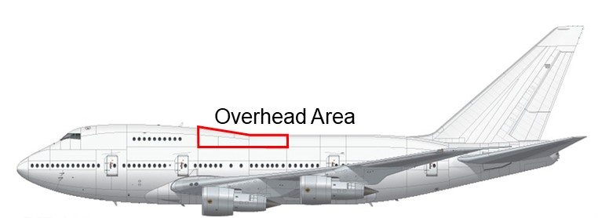

Figure 1: Boeing B747-SP overhead compartment.

Figure 2: Sample temperature slice showing unstructured geometry model for B747-SP overhead area and FDS simulation instance.

In this effort, an experimental campaign was conducted at the FAA Hughes Technical Center, on different fire scenarios for the Boeing747-SP overhead cargo compartment located at the aft of the upper deck (Figure [1]) to advance knowledge on this phenomenon and provide critical validation data for FDS. A gas burner was used to provide the fire source and located on two positions within the compartment. To map out the hot gas movement and temperature distribution at the fuselage, the overhead area is equipped with fifty Type-K thermocouples. These thermocouples were laid on the ribs and placed 5 cm below the insulated ceiling. Also, to reconstruct the interior geometry for CFD modeling, Light detection and ranging (LIDAR) technology was implemented to generate a high resolution point cloud and was then converted to a three-dimensional model. The CAD model was imported in FDS (Figure [2]) and simulation of the experimental fires was performed for the cases studied.

We will discuss some technical details on the numerics and implementation of FDS unstructured geometry solver. We will describe the fire scenarios chosen for the experiments, as well as simulation parameters and input information for these. Also, we will analyse and present results in our validation comparison of experiments and FDS simulations in terms of flow visualization and the thermocouple signals obtained. Finally, concluding remarks will be presented.

**References**

[1] O. AFS-200, “*Advisory Circular 120-80A, In-Flight fires*”, Tech. rep., Federal Aviation Administration, December 2014.

[2] K. Conradi, *“Report on the serious incident to Boeing B787-8, ET-AOP London Heathrow Airport on 12 July 2013”*, Tech. rep., Air Accidents Investigation Branch, February 2015.

[3] K. McGrattan, S. Hostikka, R. McDermott, J. Floyd, C. Weinschenk, K. Overholt, “*Fire Dynamics Simulator, Technical Reference Guide”*, National Institute of Standards and Technology, Gaithersburg, Maryland, USA, and VTT Technical Research Centre of Finland, Espoo, Finland, sixth Edition, September 2013.

[4] M. Berger, *“Cut cells: Meshes and solvers”*, Handbook of Numerical Analysis-doi:10.1016/bs.hna.2016.10.008.

[5] E. Fadlun, R. Verzicco, P. Orlandi, J. Mohd-Yusof, *“Combined Immersed-Boundary Finite-Difference Methods for Three-Dimensional Complex Flow Simulations”*, J. Comp. Phys. 161, 35–60, 2000.

[6] W. Gropp, E. Lusk, A. Skjellum, *“Using MPI – Portable Parallel Programming with the Message-Passing Interface”*, 2nd Edition, MIT Press, Cambridge, Massachusetts, 1999.