Step 1: create an application in: http://applications.mercadolibre.com
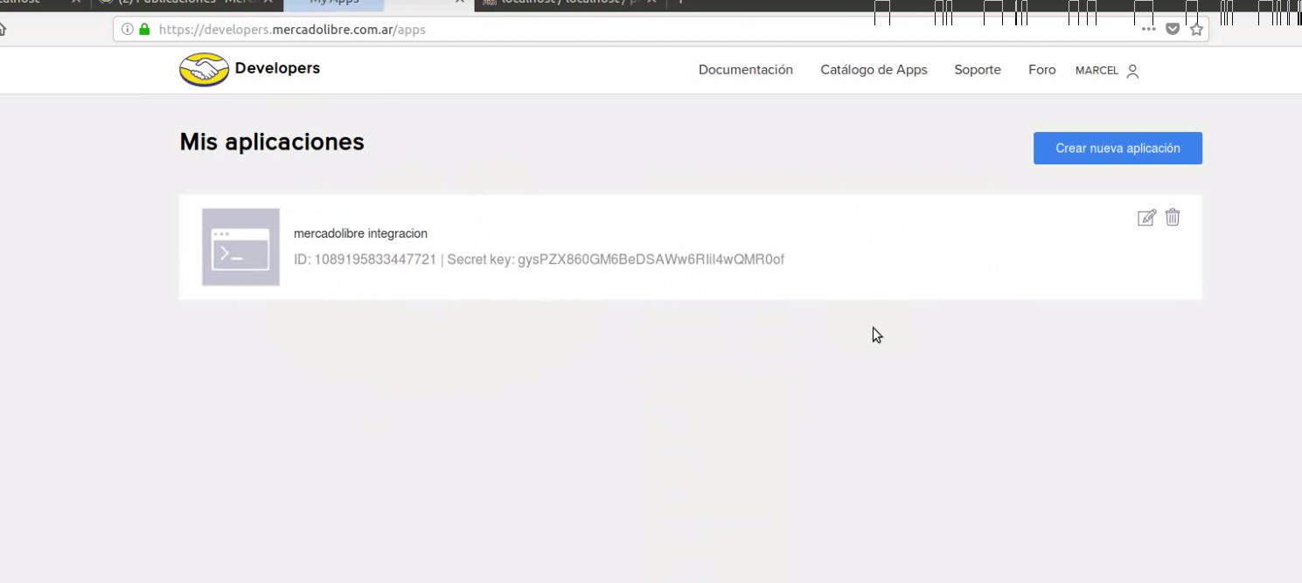
Step 2: install the module and complete the configuration
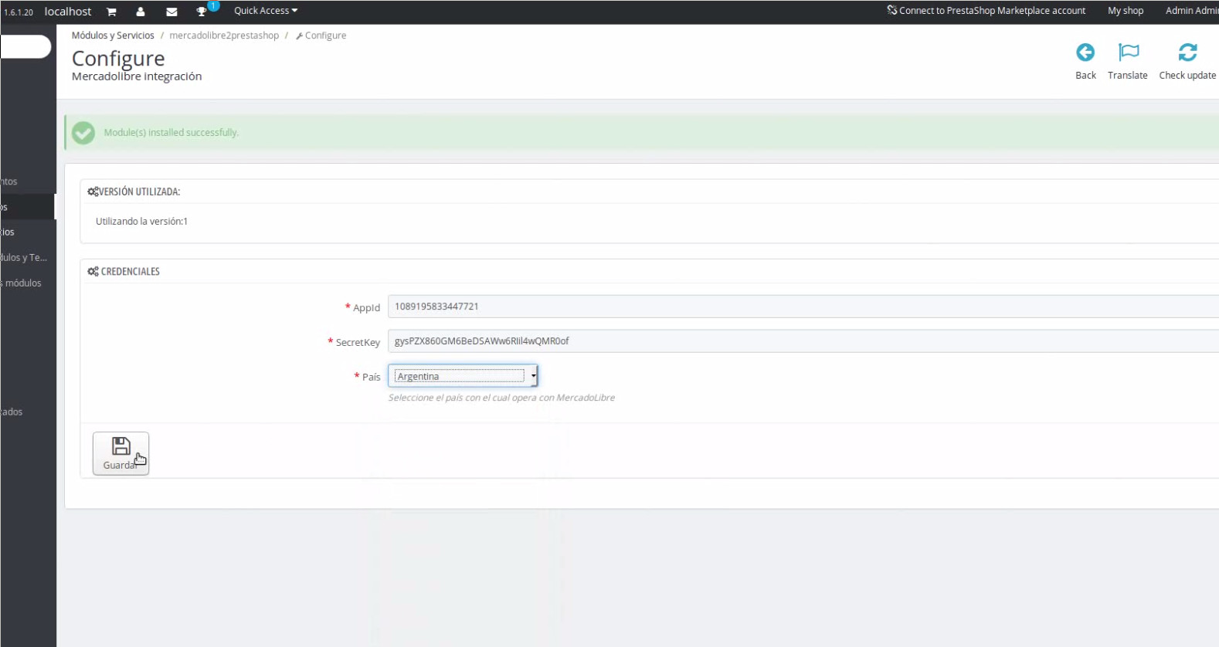

Step 3: go to products administration and clik on “Login with Mercado Libre”
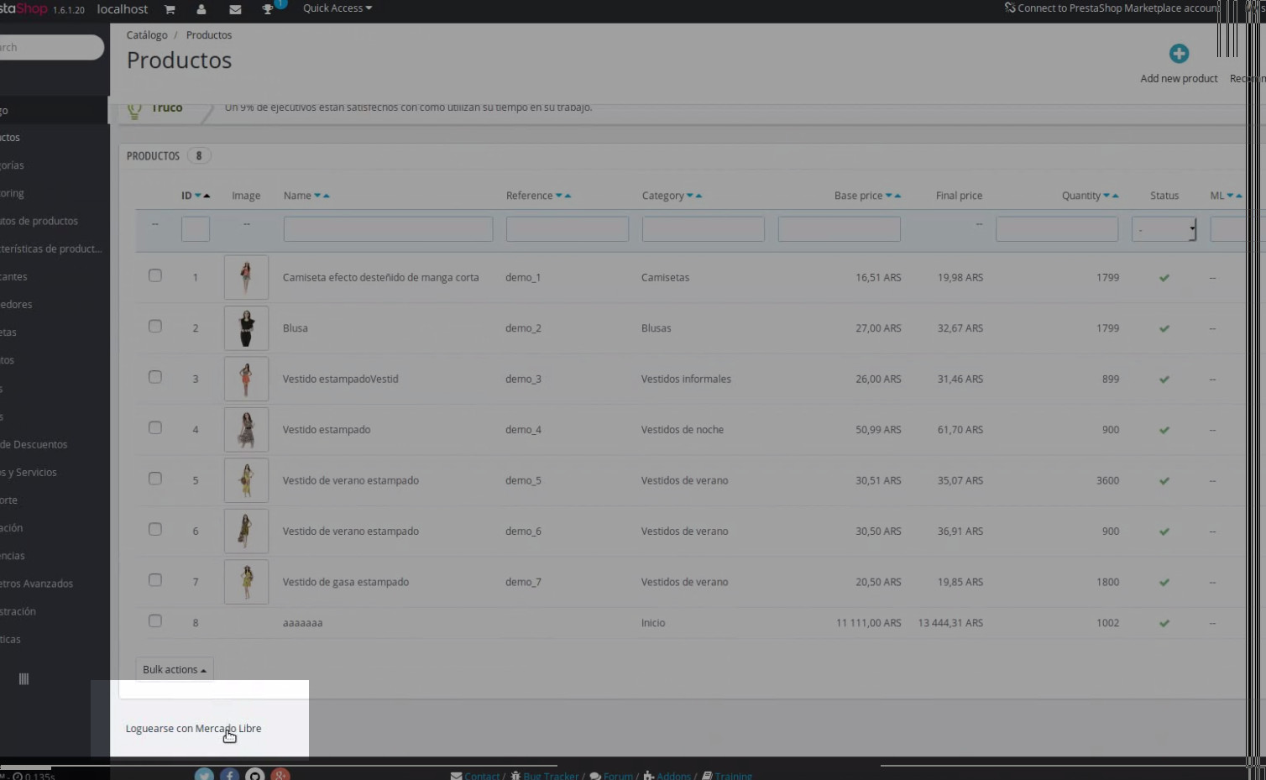
Step 4: now you can exports your producs. First you need to set te category and select each product in the table
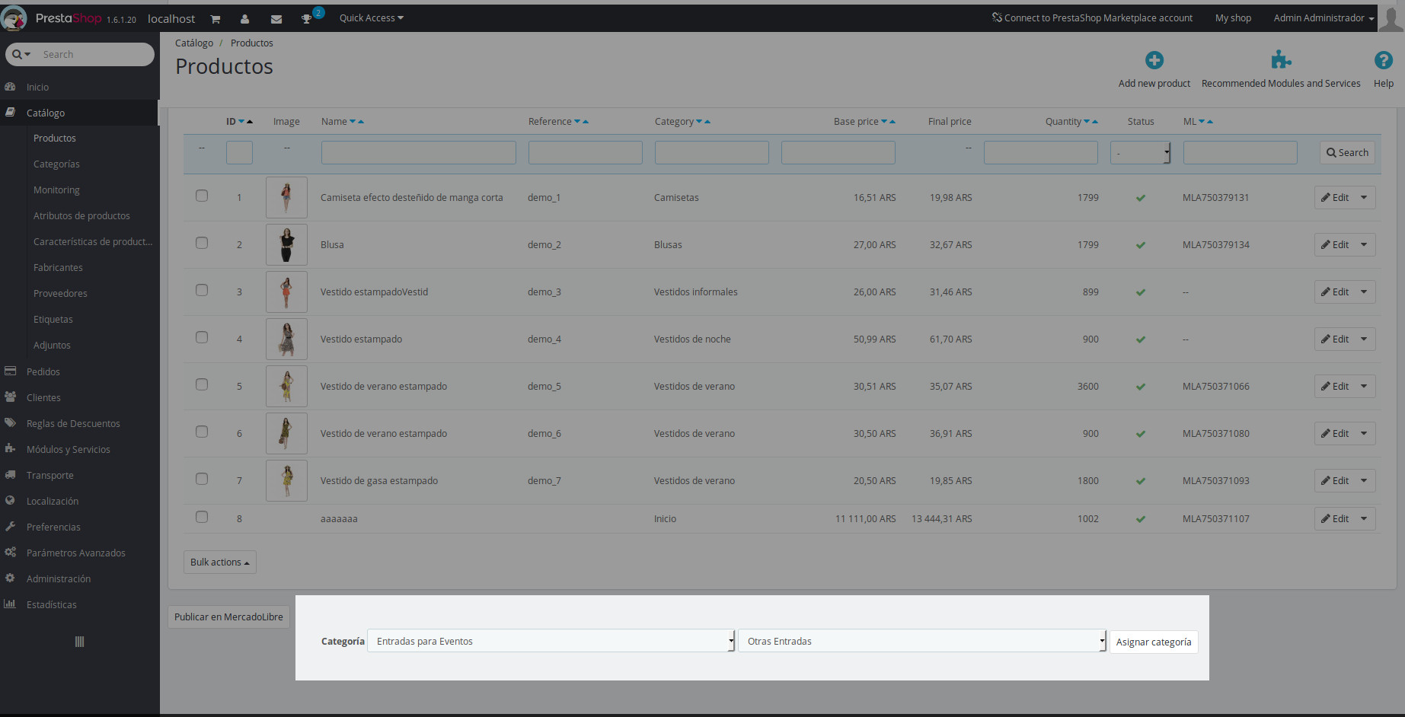

Step 5: now you can use the option for export the producs to Mercado Libre
