

Final Degree Project

**Biomedical Engineering Degree**

**“Predictive modelling of Loss Of Consciousness under general anaesthesia“**

Barcelona, 15th of January of 2022

Author: Marc Palomer Cadenas

Director: Pedro L. Gambús

**Abstract**

The abstract is a very brief summary (up to 250 words) of the TFG contents. It should provide sufficient detail that someone unfamiliar with the project is able to understand the general content on the basis of the abstract alone and should therefore be written for a general audience.

Table of Contents

2. Introduction 3

2.1 Objectives 4

2.2 Methodology and Structure 4

2.3 Scope of the project 5

3. Background 5

3.1 Background 5

3.1.1 General Anaesthesia 6

3.1.2 Anaesthesia monitoring 7

3.1.3 Prediction modelling 7

3.2 Situation 9

3.2.1 State of the art 9

3.2.2 Sources 9

4. Solution implementation 9

4.1 Concept engineering 9

4.1.1 Different solutions 9

4.1.2 Proposed Solution 9

4.2 Detail engineering 9

4.2.1 Data processing 10

4.2.2 Exploratory analysis 10

4.2.3 Model training 10

4.2.4 Model Validation 10

5. Technical 10

5.1 Specifications and technical characteristics 10

5.2 DAFO 10

6. Economic viability 10

7. Chronogram and execution 10

8. Results 10

9. Discussion and Future Prospects 10

10. Bibliography 10

Table 1 Systemic effects of i.v. agents. SVR, systemic vascular resistance; MAP, mean arterial pressure; CBF, cerebral blood flow (Khurram Saleem Khan, Sept. 2013, págs. 100-105) 7

# Introduction

This project is implemented within the Systems Pharmacology Effect Control-Modelling (SPEC-M) Reserch Group from the Department of Anaesthesiology and reanimation of the Hospital Clinic of Barcelona. The Surgery Theatre number 4 of the Major Ambulatory Surgery department of the Hospital is the place where the field work has taken place, the data has been collected and familiarisation with the anaesthesia and surgical processes has taken place.

## Objectives

The objectives mentioned below have been conceived around the expressed necessity of the anaesthesiology team to acknowledge the state of arousal of a patient rapidly and beforehand before the initiation of a surgical procedure. Even though anaesthesiologists have great knowledge in this matter, no predicted parameter is now a days used to directly approach this event.

Therefore, the principal aims of this project is **to generate, train and validate a model in order to predict the level of Loss of Consciousness (LoC) of a newly given patient undergoing Propophol and Remiphentanil mediated general anaesthesia**.

In order to achieve the main goals of the project, several sub-goals are defined:

Firstly, it is **crucial to get deeply familiarized with the surgical environment, anaesthetic procedures, and recorded biological parameters**, which will be done through practical sessions in gynaecological surgical room 4 throughout of two whole months.

Last but not least, it is necessary **to properly use a control version software**, generating a commit every time an improvement has been made on the code until the final application is done, and correctly handling possible errors.

## Methodology and Structure

The structure of the project is divided in three differentiated temporal sections; practical sessions in the operating room and, later, working from home on the data and documents and finally document submission and personal presentation. (buscar algun gràfic rollo data rangling i tot això o ferlo jo...).

Firstly, practical sessions in surgical room take place, where data is collected from the surgical procedures in the operating room number four of the Major ambulatory Surgery department on Tuesdays and Thursdays from September until November. In this section Dr. Pedro Gambús guides the gathering of the intraoperatory data and gives explanations around the activity done in the operating room.

Secondly, work from home takes place. In this section procedures like data analysis and document preparation are performed. Data preparation and model building, training and validation are performed using python language and Visual Studio Code user interphase. The packages used in the data analysis are a wide range, with special mention to scikit-learn. This package is a python package specifically designed for ML programming. In this section PhD undergraduate Joan Altés guides the programming process.

Finally, documents submission and presentation take place.

## Scope of the project and limitations

Limitacions:

1. Perdua de resposta verbal i no de LoC, que es un concepte vago.
2. Limitacions amb les dades, no son les que vam recollir nosaltres.
3. Buscar limitacions generiques de models de ML

# Background

## Background

In interventions under general anaesthesia some methods are used by the anaesthesiologists in order to determine the state of consciousness of the patient. Typical examples of undertaken actions to determine LoC are palpebral reflex, corneal reflex, and verbal response. If the three of them are negative, the patient is considered to be unconscious, thus permitting further actions such as intubation. [podria haverhi referencia]

This clinical assessment has been frequently endorsed by the introduction of indexes, mostly extracted from EEG signal processing, that try to indicate the depth of unconsciousness of the patients. Bispectral Index (BIS) is an example of this approach, which gives a value between 0-100, being 0 completely unconscious and 100 completely conscious. Typical values of BIS under general anaesthesia go from 40-60 (Mathur S, 2021 Jan-. Available).

In the approach proposed, we pretend to generate an index not dependent on EEG but trained to identify at every second the state of consciousness of the patient through training with previous patients’ data.

### General Anaesthesia

General anaesthesia is a medically induced reversible loss of consciousness, with loss of both protective reflexes and the ability to acknowledge painful stimuli (Smith G, 2021). Depending on the anaesthetics administered and their effects in the brain and muscles the effects of the anaesthesia are discerned in four different parts: unconsciousness or hypnosis, amnesia, analgesia, skeletal muscle relaxation, and akinesia. (Siddiqui BA, 2021)

That general anaesthesia is a reversible coma state of the patient is a widely accepted statement in the clinical environment. Although the patterns of EEG activity observed in comatose patients depend on the extent of the brain injury, they frequently resemble the high–amplitude, low-frequency activity seen in patients under general anaesthesia, therefore supporting this analogy (Emery N. Brown, 2010). This comparative rises an immediate question: How much anaesthetics are enough for an intervention under general anaesthesia? The desired effects upon CNS does not remain isolated: when anaesthetic drugs are administered a wide range of other parameters such as HR, Contractility, SVM, MAP and respiratory functions are modulated. Once the desired therapeutic effect is achieved, further increasing concentrations of anaesthetics generally enhance these undesired effects of the drugs both within the surgical procedure and less drastically throughout the recuperation process. It is therefore accepted that the optimal concentrations of anaesthetics in a surgical procedure is the one that achieves the desired therapeutic effects and not more than that (Khurram Saleem Khan, Sept. 2013, págs. 100-105)[3].

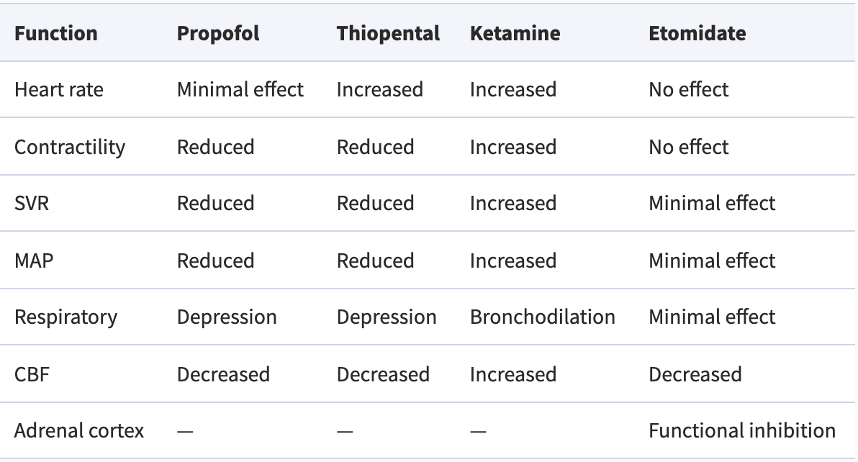

Table 1 Systemic effects of i.v. agents. SVR, systemic vascular resistance; MAP, mean arterial pressure; CBF, cerebral blood flow (Khurram Saleem Khan, Sept. 2013, págs. 100-105)

Several pharmacological models and approaches such as Target Controlled infusion (TCI), EEG suppression analysis and BIS analysis have been implemented to achieve this goal (Guarracino F, 2005) and will be further discussed in the Anaesthetics and Anaesthesia monitoring chapters respectively.

The final desired effect when performing general anaesthesia is to achieve the LoC state of the patient, where the effect of the anaesthetics is strong enough to start with the surgical procedure, but avoiding the undesired effect of administering too much anaesthetics.

Indicacions i contraindicacions

#### Anaesthetic drugs

Anaesthesic drugs can either be inhalational or intravenous. Total intravenous anaesthetics (TIVA) refers to the administration of anaesthetic agents via intravenous route. Compared to inhalational anesthesia, TIVA shows several benefits including better hemodynamic stability and reduced post-operative incidence of nausea and vomiting (Total Intravenous Anesthesia (Tiva)- A Brief Review., 2018).

The infusion of TIVA can either be administered manually through an initial bolus injection, or through the usage of algorithm-mediated infusion pumps, such as TCI.

**TCI**

Progress in computing technology has allowed the development of target controlled infusion devices, with drugs delivered to achieve specific predicted target blood drug concentrations. Target controlled infusion (TCI) system has been developed as a standardised infusion system for the administration of opioids, propofol and other anaesthetics by target controlled infusion. A set of pharmacokinetic parameters has been selected using computer simulation of a known infusion scheme. The selected model is incorporated into a computer-compatible infusion pump. Clinical trials with such systems have provided appropriate target concentrations for the administration of TCI of anaesthetic drugs (Guarracino F, Target controlled infusion: TCI., 2005).

Anaesthetics drugs are divided depending on their effect first and later on their type. Most common drug types used in TIVA are hypnotic and analgesic drugs, sometimes combined with other drugs if necessary, such as Rocuronium for muscle relaxation. In the Hospital Clinic a mixture of propofol and Remifentanil is used, as this hypnotic and analgesic altogether have demonstrated to create a synergic effect, achieving the desired effect with less concentration of both drugs (Mertens MJ, 2003).

#### States of anaesthesia

Hipnosis and unconsciousness

The state of hypnosis, which is analogous to unconsciousness, is induced by hypnotic agents such as propofol, the molecular pathways involved in this process have not yet been determined accurately, this is why it can be said that the way consciousness arises in the brain remains unknown. Yet, for nearly two centuries our ignorance has not hampered the use of general anaesthesia for routinely extinguishing consciousness during surgery. Unfortunately, once in every 1000–2000 operations a patient may temporarily regain consciousness or even remain conscious during surgery (Sebel PS, Anesth Analg. 2004). Such intraoperative awareness arises in part because our ability to evaluate levels of consciousness remains limited. Nevertheless, progress is being made in identifying general principles that underlie how anaesthetics bring about unconsciousness [] and how, occasionally, they may fail to do so.

Analgesia

Amnesia

Akinesia

### Anaesthesia monitoring

### Prediction modelling

Aquí caldria parlar de:

* Que és un model?
* i de predicció?
* Correlació vs causalitat (que es un model predictiu?)
* Perquè son útils?
* Quin tipus n’hi ha?

Generally, a system can be defined as a box, with a process happening inside of it, which takes some input arguments and delivers some output results. Depending on the processes inside the system and the type of inputs and outputs the system can be classified in several ways. If the given system is particularly a mathematical model, which is our case of study, it can be classified in several ways that will be in the next paragraphs.

Grafic de systema

As a matter of fact, any type of modelling is intrinsically a representation, numerical or not, of the world surrounding us. Or more concretely of the system we wish to study. When models are developed, some input variables or characteristics are used, and some others are excluded; it is therefore straightforward that a models can be good enough to be useful or not but will never pretend to explain a real process in its whole complexity. Otherwise, they will try to simplify the studied system in a way the results have significance.

As stated before, mathematical models can be classified in several ways;

* deterministic vs stochastic (probabilistic): Where the model’s output is the same always for a given set of input values, or otherwise it has an intrinsic randomness which makes the output values vary even for the same set of input values. In this last case we usually see that state variables of the system are not described by unique values, but for probabilistic equations.
* Static vs. dynamic:
* Discrete vs. continuous:
* Linear vs. nonlinear:
* Etc.

When talking about predictive modelling, the adjective predictive stands for its finality to obtain information about what is going to happen in the future based on information of the past.

For instance, sophisticated predictive models are used to predict health events in patients and to screen high risk individuals, such as for predicting cardiovascular disease, breast cancer or anaesthetic complications and events. Predictive modelling does not inherently belong to any of the classifications stated above but takes different forms depending on its characteristics and those of the algorithms inside it.

Correlation vs causation?

Therefore, a model is predictive if it uses information from the past, e.g., past examples, in order to achieve a future prediction or output result. Even though the term Machine Learning model is frequently used, what we are handling is a predictive model, which inside it we are using a ML algorithm. Also, methods and algorithms used inside the model can be of several types and origins: basic statistics, time-dependant causal equations, AI algorithms such as ML and DL, and a long etcetera.

But what is exactly ML and what has in common with AI? AI is a set of algorithms and techniques which pretend to mimic or assemble human like mental processes to accomplish tasks which usually require of human intelligence. ML is a subset of the AI paradigm, which is characterised by being capable of learning without being explicitly programmed. Finally, DL is a subset of ML characterised by a brain-like net of artificial neural networks (NN) which the DL algorithm uses to learn, also without being explicitly programmed. [8]

Figure 1Visualization of algorithms vs. artificial intelligence vs. machine learning vs. deep learning (Author: Johannes Vrana, Vrana GmbH, Licenses: CC BY-ND 4.0) [8]

Estatistics vs ML vs DL (?)

IA? Que és? Tipus?

Aqui ja parlar dels diferents models de ML

## Situation

### State of the art

### Sources

# Solution implementation

## Concept engineering

Ingeniería de concepción (funcional) de la solución. Esquemas de principio, balances y predimensionados

### Different solutions

Aqui hauriem de tractar les diferents solucions possibles al problema (estadistica, ML, DL...)

### Proposed Solution

Justificar la solucio triada sobre les altres

## Detail engineering

En la ingenieria de detalle pondriamos todos los planes, especificaciones, condiciones que se empezaron a describir en la ingenieria de concepcion

### Data processing

### Exploratory analysis

### Model training

### Model Validation

# Technical

## Specifications and technical characteristics

## DAFO

Debilidades y fortalezas. Resistencias. Puntos criticos

Mantenibilidad, fiabilidad, disponibilidad y calidad

Seguridad

Suministros y repuestos

Asistencia tecnica

# Economic viability

Estudio de costes y presupuestos

Planificación económica

Estudios de costes

Estudios de financiación

Análisis de rentabilidad: Payback, VAN, TRI

Análisis de sensibilidad

# Chronogram and execution

Definición de tareas, tiempos y asignación de

responsabilidades. Establecimiento de fases e

hitos. Análisis de caminos: camino critico

Diagramas de PERT, GANT

Cronograma. Penalizaciones

EDT, Análisis de precedencias, CPM/PERT y

GANTT

# Results

# Discussion and Future Prospects

# Bibliography

[1] Mathur S, P. J. (2021 Jan-. Available). *Bispectral Index.* StatPearls [Internet]. Treasure Island (FL): StatPearls Publishing; .

[2] Siddiqui BA, K. P. (2021, January). *Anesthesia Stages.* Retrieved from NCBI: https://www.ncbi.nlm.nih.gov/books/NBK557596/

[3] Emery N. Brown, M. P. (2010). *General Anesthesia, Sleep, and Coma.* NIH. Retrieved from NCBI: https://www.ncbi.nlm.nih.gov/pmc/articles/PMC3162622/#R10

[3] Khurram Saleem Khan, F. F. (Sept. 2013). Pharmacology of anaesthetic agents I: intravenous anaesthetic agents. In *Continuing Education in Anaesthesia Critical Care & Pain* (pp. 100-105).

[4] Guarracino F, L. F. (2005). Target controlled infusion: TCI. *EDIZIONI MINERVA MEDICA*.

[5] Sebel PS, B. T. (Anesth Analg. 2004). *The incidence of awareness during anesthesia: a multicenter United States study*. Retrieved from PubMed: https://pubmed.ncbi.nlm.nih.gov/15333419/

Validació prospectiva d’un model de supervivència, que preten donar una probabilitat de que el pacient romangui conscient en funció de la dosi de propofol (Hipnotic) administrada.

Loss of consciousness refers to a state in which an individual lacks normal awareness of self and the surrounding environment. The patient is not responsive and will not react to any activity or stimulation. Syncope is the medical term for temporary loss of consciousness.