Activity 1 - IPL ticket booking website
Name: Marc Raymond Pedrin
Roll no: R25EF140
Github: https://github.com/marcpedrin/COLLEGE-WAD
Aim:
to create html structure of ipl ticket booking website
Tools:
vs code, live server
Steps:
1. made index.html file in vs code and added navbar with matches, book ticket, my bookings and guidelines links
2. added banner section with tagline and 2 buttons view schedule and book ticket
3. added about ipl 2026 section with teams list and venues list
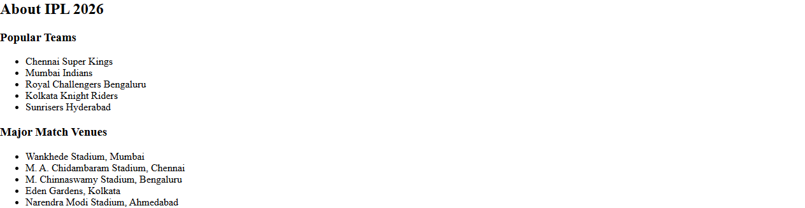
4. made match schedule table with match no, teams, date time, venue and ticket prices (general premium vip). added team filter above table and book button in every row
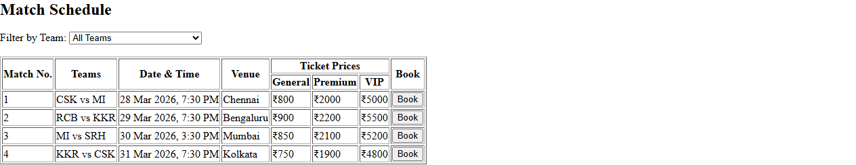
5. made booking form with match, stand, no of tickets, name, email, phone and booking summary card next to it
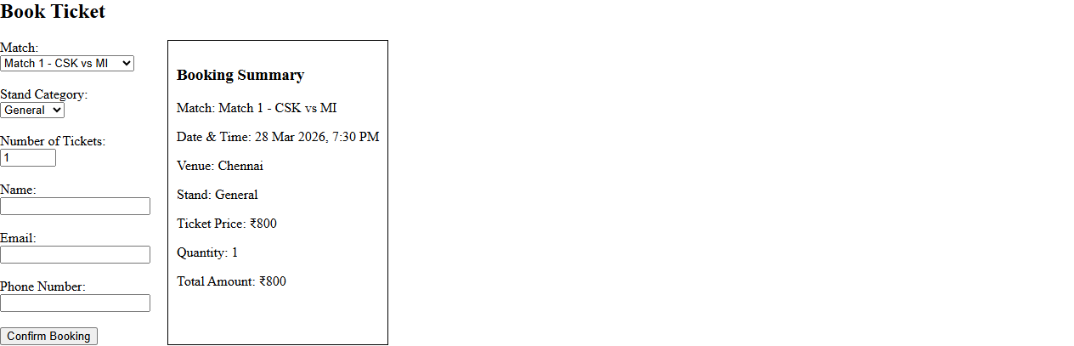
6. my ticket bookings section with empty table
7. guidelines section with 3 cards - ticket verification, id proof, prohibited items
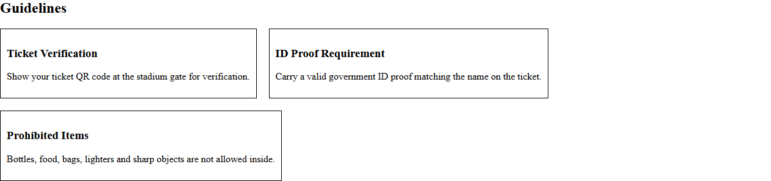
8. footer with copyright
Output:
opened it with live server, all nav links go to there sections
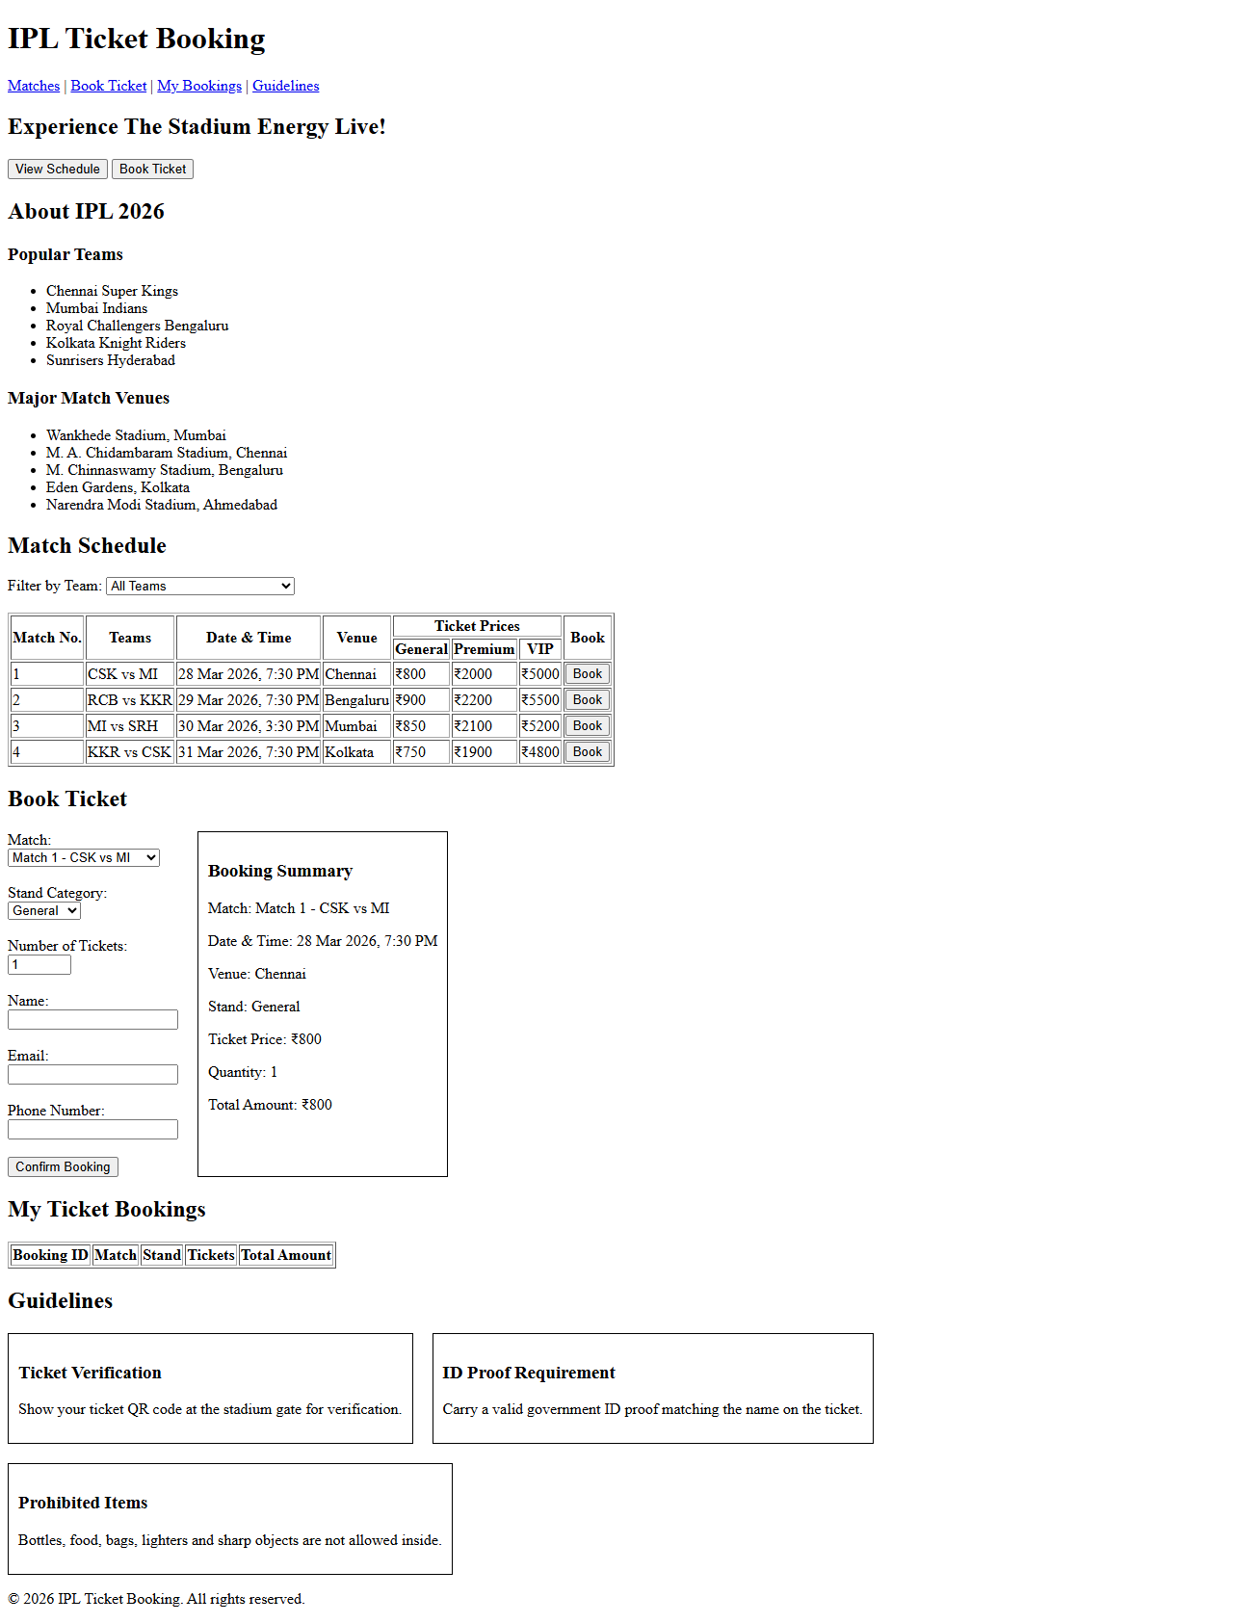
Result:
html structure of ipl ticket booking website is created successfully and pushed to github

