Header: gratis en la web

https://tailwindui.com/components/ecommerce/components/store-navigation

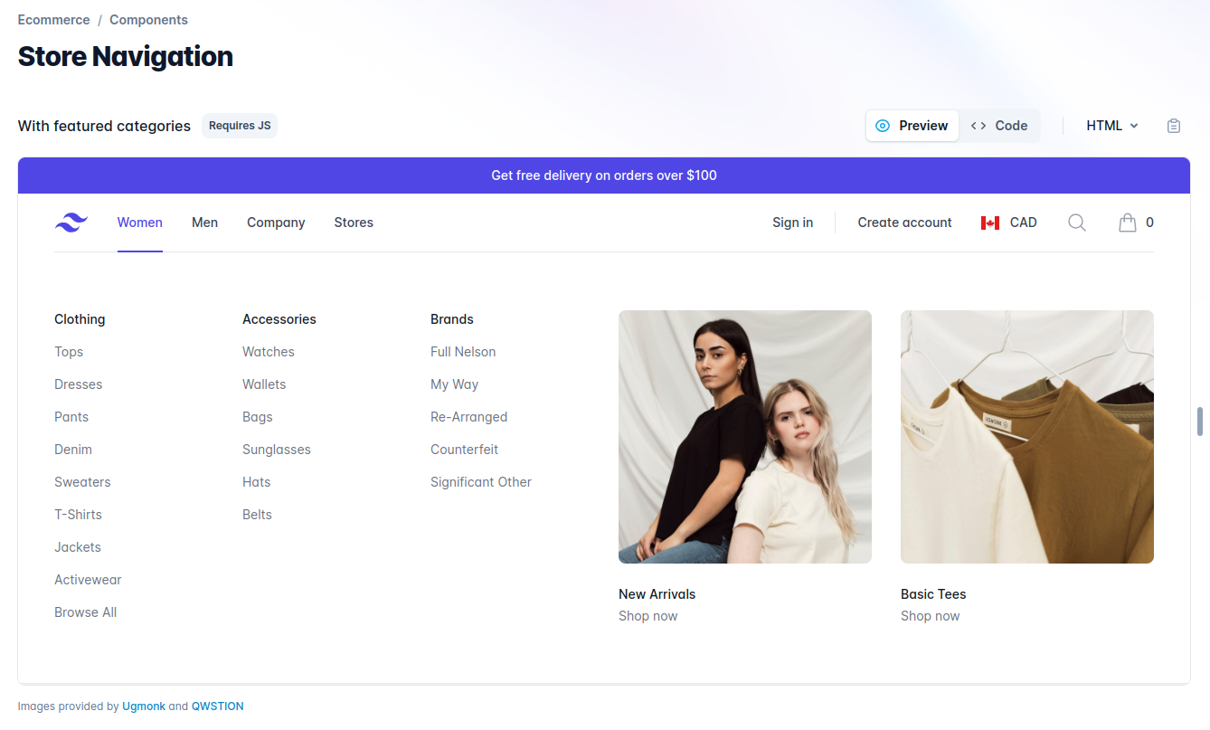

Shopping Carts

https://tailwindui.com/components/ecommerce/components/shopping-carts

