REPORT FOR LAB 1
The N Queens Problem

1. A visual representation of the solution on a chessboard. You are free to use any program to
generate the visual representation and it may be in text format if required. No extra marks
will be given for a good representation.
This is the applet we have used to generate the visual representation:
https://www.cs.usfca.edu/~galles/visualization/RecQueens.html
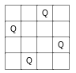

As we can observe, the output of the SAT-Solver it’s the same as in the visual representation.

2. Time to solve problem for n=10, 30, 50.

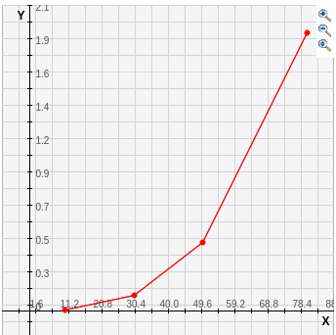
for n = 10

for n = 30

for n = 50

for n = 80

So as far as we can see, the temporal computational cost seems to follow an exponential distribution throughout time.

3. What is the largest n that can be solved in a few minutes?

For example, for an n equal to 300 the solution is returned after aproximately two minutes, so this is one of the largest n’s that can be solved in a few minutes.

4. What is the number of propositional symbols required for 3?
The required number of propositional symbols for 3 is 9, because we have a board of 3x3 variables.

5. What is the number of clauses in 3?
The number of clauses in 3 are 34:
- 12 combinations in rows
- 12 combinations in columns
- 6 combinations in larger diagonals
- 4 combinations in shorter diagonals
- 34 clauses
