Marc Gian Reantaso  
1CS-D 50% WEB BASE DESIGN WITH

SOURCE CODE.

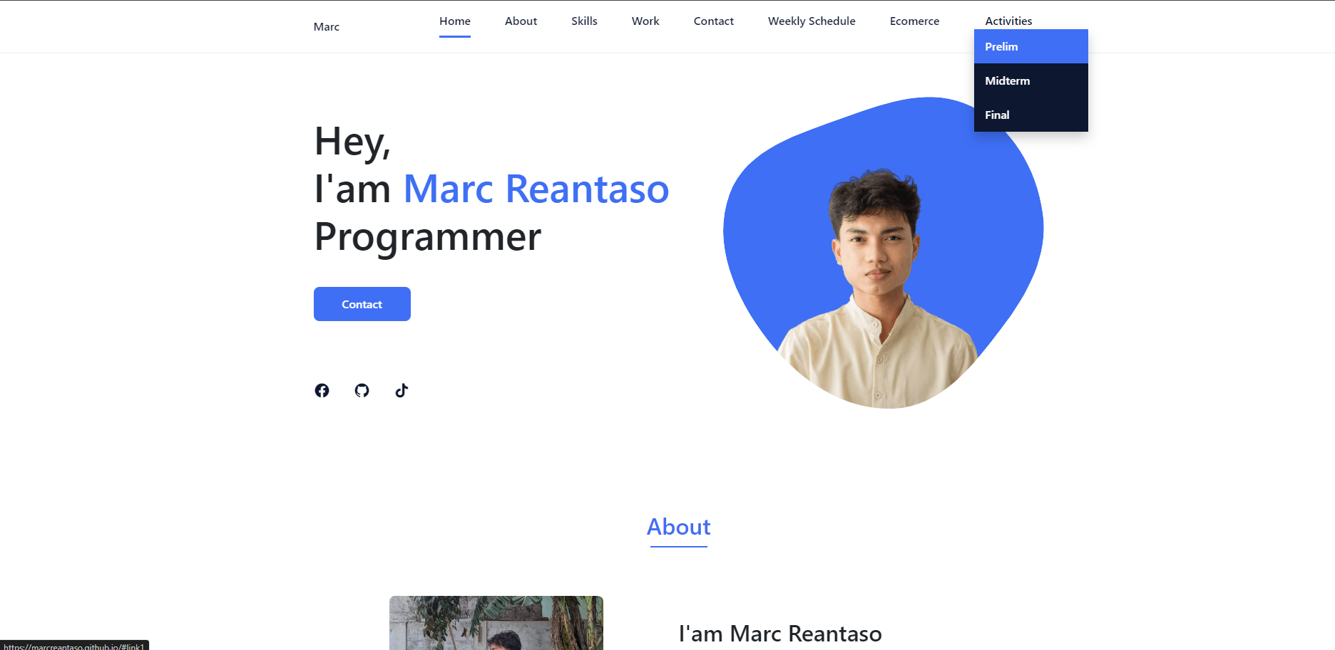OUTPUT:

<!DOCTYPE html>

<html lang="en">

<head>

<meta charset="UTF-8">

<meta name="viewport" content="width=device-width, initial-scale=1.0">

<link rel="stylesheet" href="Portfolio-Marc/Untitled-2.css">

<!-- =====BOX ICONS===== -->

<link href='https://cdn.jsdelivr.net/npm/boxicons@2.0.5/css/boxicons.min.css' rel='stylesheet'>

<link href='https://unpkg.com/boxicons@2.1.4/css/boxicons.min.css' rel='stylesheet'>

<link href="https://getbootstrap.com/docs/5.3/assets/css/docs.css" rel="stylesheet">

<link href="https://cdn.jsdelivr.net/npm/bootstrap@5.3.3/dist/css/bootstrap.min.css" rel="stylesheet">

<title>Marc Reantaso</title>

</head>

<body>

<!--===== HEADER =====-->

<header class="l-header">

<nav class="nav bd-grid">

<div>

<a href="#" class="nav__logo">Marc</a>

</div>

<div class="nav__menu" id="nav-menu">

<ul class="nav__list">

<li class="nav__item"><a href="#home" class="nav__link active-link">Home</a></li>

<li class="nav__item"><a href="#about" class="nav__link">About</a></li>

<li class="nav__item"><a href="#skills" class="nav__link">Skills</a></li>

<li class="nav__item"><a href="#work" class="nav__link">Work</a></li>

<li class="nav__item"><a href="#contact" class="nav__link">Contact</a></li>

<li class="nav__item"><a href="Portfolio-Marc/schedule.html" class="nav__link">Weekly Schedule</a></li>

<li class="nav__item"><a href="ekomerzz/loginfrom.html" class="nav__link">Ecomerce</a></li>

<li class="nav__item dropdown">

<a href="javascript:void(0)" class="nav__link dropdown__btn">Activities</a>

<div class="dropdown__content">

<a href="#link1" class="dropdown__link">Prelim</a>

<a href="#link2" class="dropdown__link">Midterm</a>

<a href="#link3" class="dropdown__link">Final</a>

</div>

</li>

</ul>

</div>

<div class="nav__toggle" id="nav-toggle">

<i class='bx bx-menu'></i>

</div>

</nav>

</header>

<main class="l-main">

<!--===== HOME =====-->

<section class="home bd-grid" id="home">

<div class="home__data">

<h1 class="home__title">Hey,<br>I'am <span class="home__title-color">Marc Reantaso</span><br>Programmer</h1>

<a href="#" class="button">Contact</a>

</div>

<div class="home__social">

<a href="https://www.facebook.com/MarcccX" class="home__social-icon"><i class='bx bxl-facebook-circle'></i></a>

<a href="" class="home__social-icon"><i class='bx bxl-github' ></i></a>

<a href="https://www.tiktok.com/@tsr.marccc" class="home__social-icon"><i class='bx bxl-tiktok'></i></a>

</div>

<div class="home__img">

<svg class="home__blob" viewBox="0 0 479 467" xmlns="http://www.w3.org/2000/svg" xmlns:xlink="http://www.w3.org/1999/xlink">

<mask id="mask0" mask-type="alpha">

<path d="M9.19024 145.964C34.0253 76.5814 114.865 54.7299 184.111 29.4823C245.804 6.98884 311.86 -14.9503 370.735 14.143C431.207 44.026 467.948 107.508 477.191 174.311C485.897 237.229 454.931 294.377 416.506 344.954C373.74 401.245 326.068 462.801 255.442 466.189C179.416 469.835 111.552 422.137 65.1576 361.805C17.4835 299.81 -17.1617 219.583 9.19024 145.964Z"/>

</mask>

<g mask="url(#mask0)">

<path d="M9.19024 145.964C34.0253 76.5814 114.865 54.7299 184.111 29.4823C245.804 6.98884 311.86 -14.9503 370.735 14.143C431.207 44.026 467.948 107.508 477.191 174.311C485.897 237.229 454.931 294.377 416.506 344.954C373.74 401.245 326.068 462.801 255.442 466.189C179.416 469.835 111.552 422.137 65.1576 361.805C17.4835 299.81 -17.1617 219.583 9.19024 145.964Z"/>

<image class="home__blob-img" x="50" y="70" href="Portfolio-Marc/img/jiyan1.png.png"/>

</g>

</svg>

</div>

</section>

OUTPUT:

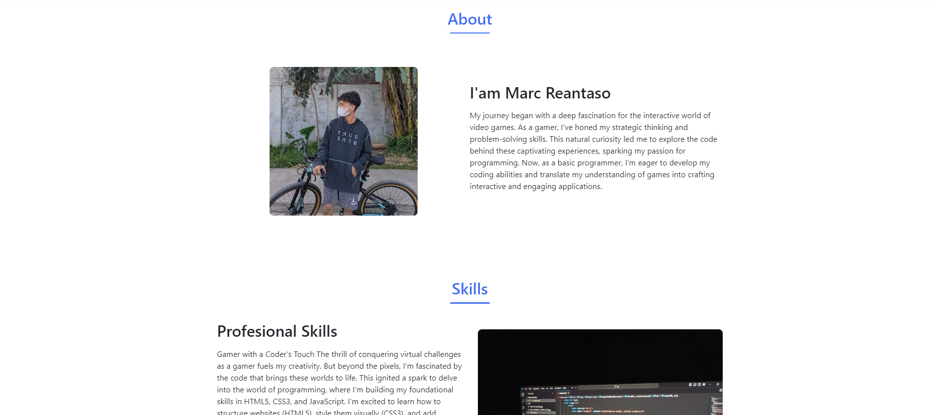 <!--===== ABOUT =====-->

<section class="about section " id="about">

<h2 class="section-title">About</h2>

<div class="about__container bd-grid">

<div class="about__img">

<img src="Portfolio-Marc/img/jiyan.png.jpg" alt="">

</div>

<div>

<h2 class="about__subtitle">I'am Marc Reantaso</h2>

<p class="about__text">My journey began with a deep fascination for the interactive world of video games. As a gamer, I've honed my strategic thinking and problem-solving skills. This natural curiosity led me to explore the code behind these captivating experiences, sparking my passion for programming. Now, as a basic programmer, I'm eager to develop my coding abilities and translate my understanding of games into crafting interactive and engaging applications.</p>

</div>

</div>

</section>

OUTPUT:

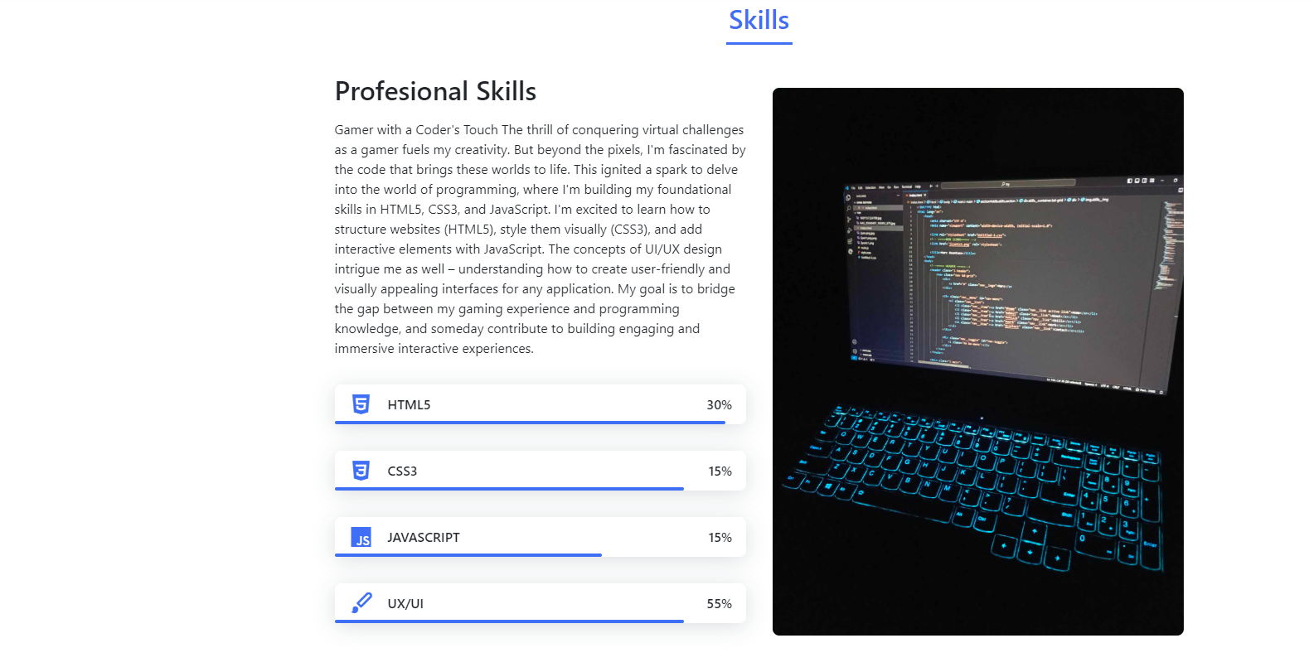 <!--===== SKILLS =====-->

<section class="skills section" id="skills">

<h2 class="section-title">Skills</h2>

<div class="skills__container bd-grid">

<div>

<h2 class="skills__subtitle">Profesional Skills</h2>

<p class="skills__text">Gamer with a Coder's Touch

The thrill of conquering virtual challenges as a gamer fuels my creativity. But beyond the pixels, I'm fascinated by the code that brings these worlds to life. This ignited a spark to delve into the world of programming, where I'm building my foundational skills in HTML5, CSS3, and JavaScript.

I'm excited to learn how to structure websites (HTML5), style them visually (CSS3), and add interactive elements with JavaScript. The concepts of UI/UX design intrigue me as well – understanding how to create user-friendly and visually appealing interfaces for any application. My goal is to bridge the gap between my gaming experience and programming knowledge, and someday contribute to building engaging and immersive interactive experiences.</p>

<div class="skills__data">

<div class="skills__names">

<i class='bx bxl-html5 skills__icon'></i>

<span class="skills__name">HTML5</span>

</div>

<div class="skills__bar skills__html">

</div>

<div>

<span class="skills__percentage">30%</span>

</div>

</div>

<div class="skills__data">

<div class="skills__names">

<i class='bx bxl-css3 skills__icon'></i>

<span class="skills__name">CSS3</span>

</div>

<div class="skills__bar skills__css">

</div>

<div>

<span class="skills__percentage">15%</span>

</div>

</div>

<div class="skills__data">

<div class="skills__names">

<i class='bx bxl-javascript skills__icon' ></i>

<span class="skills__name">JAVASCRIPT</span>

</div>

<div class="skills__bar skills__js">

</div>

<div>

<span class="skills__percentage">15%</span>

</div>

</div>

<div class="skills__data">

<div class="skills__names">

<i class='bx bxs-paint skills__icon'></i>

<span class="skills__name">UX/UI</span>

</div>

<div class="skills__bar skills__ux">

</div>

<div>

<span class="skills__percentage">55%</span>

</div>

</div>

</div>

<div>

<img src="Portfolio-Marc/img/skills1.jpg" alt="" class="skills__img">

</div>

</div>

</section>

OUTPUT:

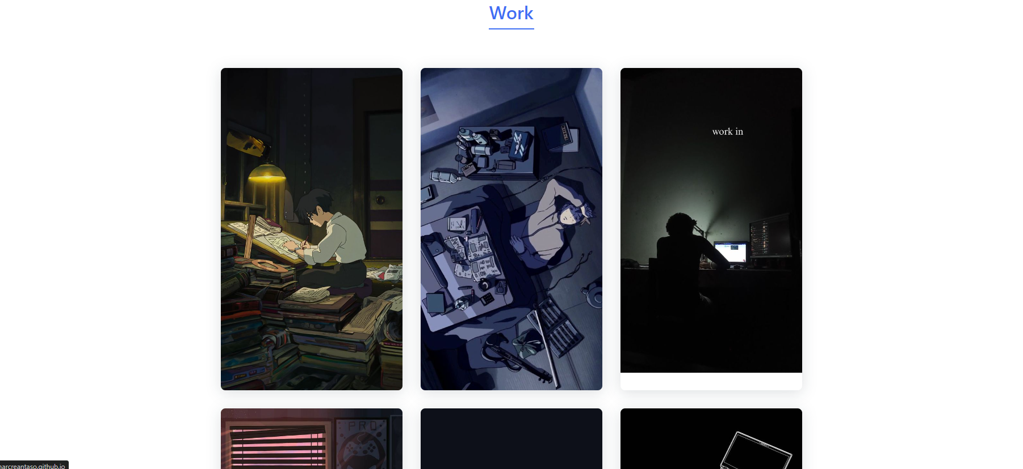 <!--===== WORK =====-->

<section class="work section" id="work">

<h2 class="section-title">Work</h2>

<div class="work__container bd-grid">

<a href="" class="work__img">

<img src="Portfolio-Marc/img/marc100.jpg" alt="">

</a>

<a href="" class="work__img">

<img src="Portfolio-Marc/img/marc20.jpg" alt="">

</a>

<a href="" class="work__img">

<img src="Portfolio-Marc/img/marc30.jpg" alt="">

</a>

<a href="" class="work__img">

<img src="Portfolio-Marc/img/marc40.jpg" alt="">

</a>

<a href="" class="work__img">

<img src="Portfolio-Marc/img/marc50.jpg" alt="">

</a>

<a href="" class="work__img">

<img src="Portfolio-Marc/img/marc60.jpg" alt="">

</a>

</div>

</section>

OUTPUT:

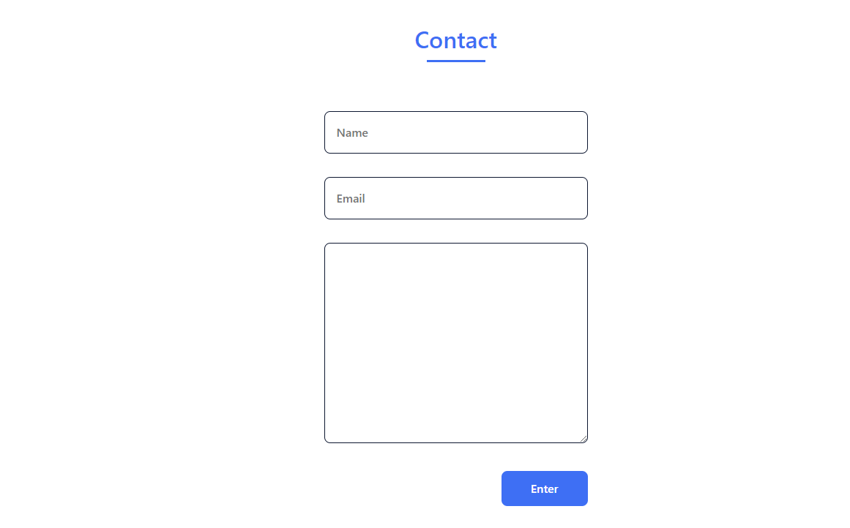 <!--===== CONTACT =====-->

<section class="contact section" id="contact">

<h2 class="section-title">Contact</h2>

<div class="contact__container bd-grid">

<form action="" class="contact__form">

<input type="text" placeholder="Name" class="contact__input">

<input type="mail" placeholder="Email" class="contact__input">

<textarea name="" id="" cols="0" rows="10" class="contact__input"></textarea>

<input type="button" value="Enter" class="contact__button button">

</form>

</div>

</section>

OUTPUT:

 <!--===== FOOTER =====-->

<footer class="footer">

<p class="footer__title">Marc Reantaso</p>

<div class="footer__social">

<a href="#" class="footer__icon"><i class='bx bxl-facebook' ></i></a>

<a href="#" class="footer__icon"><i class='bx bxl-instagram' ></i></a>

<a href="#" class="footer__icon"><i class='bx bxl-twitter' ></i></a>

</div>

<p class="footer__copy">&#169; MarcReantaso. All rigths reserved</p>

</footer>