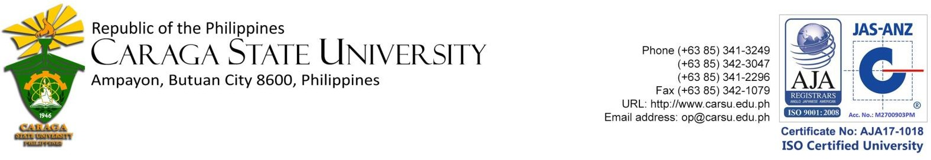

**Center for Robotics Automation and Fabrication Technologies (CRAFT)**

C E R T I F I C A T I O N

This certifies that the students from Father Saturnino Urios University namely: Anthony Carl Jose O. Asuncion, Adrian Gil A. Urag, and Francis Eugene K. Young conducted their Science Research Project entitled: **Automated Drainage Cleaning Robot** in the Center for Robotics, Automation and Fabrication Technology (CRAFT) last August 1 to October 01, 2019. The design, fabrication, and testing of their project were supervised and assisted by the center staff and consultants. Furthermore, the concept and design are from the students, and the center disclaims the ownership of the project.

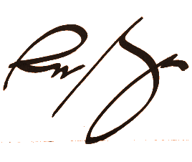Issued this 1st day of October 2019 at the Center for Robotics, Automation and Fabrication Technology, Caraga State University, Ampayon, Butuan City.

**ENGR. RONIETO N. MENDOZA**

Center Consultant