**\*\*\*\*\*\* INLAB \*\*\*\*\*\*\***

· Objectives (See Lab guide).

Examples:

1. Discuss the program and class diagram

2. Use Anaconda and Linux terminal in running python statements.

3. Use Visual Studio Code for program tracing

· Tools Used

o Visual Studio Code

o Git Terminal

o Umlet

**Figure 1: Student Class**

Figure 1 shows the student class and all the objects and methods in it. The initialize method will start the program by initializing the values to default. Then the different variables needed will be inputted by the student such as their name, scores, and the different parameters related to their scores. The last method str will return all values as a string for the class.

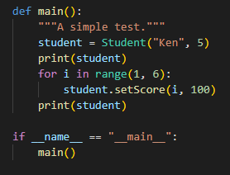

**Figure 2: Main**

The main function runs the program and calls the student class.

**Figure 3: Student Class Diagram**

The class diagram shows the different components of the student class diagram. Since the only purpose of the program is to make a class showing the scores of a student, the needed objects are only the string variable for the student’s name and the int variable for the score parameters. The methods shown are for getting the student’s name and scores and returning them as the needed variable type.