Escola:_________________________________________________________________________________________

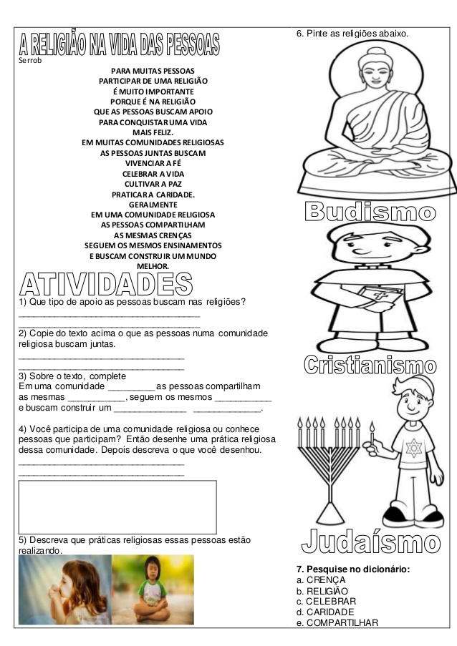Nome:__________________________________________________________________________________________

Data: ____/_____/________ 6° ano_____ Turno:________________