CobGDB - The GnuCOBOL TUI DEBUGGER / ANIMATOR
HOW TO USE CobGDB


Table of Contents
1. Introduction 2
1.1. Installing the debugger CobGDB on Windows 3
1.2. Compile and Debug GnuCOBOL programs 4
1.3. Main Commands 5
2. Tutorial - Sample Debugging Session 6
2.1. ? - Help Command 8
2.2. R - Run Command 9
2.3. S - Step Command 11
2.4. G - Go Command 13
2.5. D - Display Variables Command 14
2.6. H - Show Command 15
2.6.1. E - Edit subCommand 16
2.7. V - Variables Command 17
2.7.1. Enter - subCommand 18
2.7.2. E - Edit subCommand 19
2.7.3. R - Return subCommand 20
2.8. S - Step Command 21
2.9. O - Focus Command 23
2.10. Pop-up Variable windows 25
2.11. F - File Command 26
2.12. R - Run Command 29
2.13. W - Window Size command 30
2.14. Q - Quit Command 33
2.15. A - Attach Command 34
3.Other Commands 36
3.1.CTRL-F - Find command 36
3.2. Change the Current Line background color 36
3.3. Display Variable content by hover the mouse 37
3.4. CTRL-S and CTRL-B - Save and Load Breakpoints 38
3.5. Debugging a pre-compiled Program 39
3.6. Debugging sub programs 40
3.7. CobGDB Version 43
4. Document Change Log 44
- Introduction

CobGDB is a TUI (Text User Interface) application, programmed in C, designed to assist in animate and debugging GnuCOBOL programs using GDB (the GNU Debugger at https://www.gnu.org/software/gdb/).

The CobGDB project is hosted at https://github.com/marcsosduma/cobgdb

Very important: you don't need to know how to use the GDB product and its many commands (https://www.sourceware.org/gdb/).
CobGDB has its own user interface (described in this document) that is very simple to use
and is responsible for interfacing the underlying GDB which is the real debug and animate engine
but operates practically in a transparent way to the GnuCOBOL developer.

The CobGDB application is based on the extension for Visual Studio Code (VSCode) created by Oleg Kunitsyn, which can be found on GitHub: https://github.com/OlegKunitsyn/gnucobol-debug.

At https://github.com/marcsosduma/cobgdb in the Windows subdirectory,
the executable program cobgdb.exe for this operating system is available and ready to use.

To compile CobGDB from C source code on Windows, you can use MinGW.
The Makefile is configured to generate the program cobgdb.exe for both Windows and Linux.

  - Installing the debugger CobGDB on Windows

On Windows, just download cobgdb.exe from following folder: https://github.com/marcsosduma/cobgdb/tree/main/windows .

As an example you can put cobgdb.exe into the "bin" folder of your GnuCOBOL installation (the same folder where the GnuCOBOL compiler cobc.exe is located)

or

first install MinGW (Minimalist GNU for Windows).
Then execute the make ('mingw32-make' for Windows) command to compile the code from C source.

Note: if you have security problems downloading an .exe file then you can try download the entire repository with the following github button < > Code▼ --> Download ZIP

Then unzip the file and copy cobgdb.exe to the "bin" folder of your GnuCOBOL installation (the same folder where the GnuCOBOL compiler cobc.exe is located)

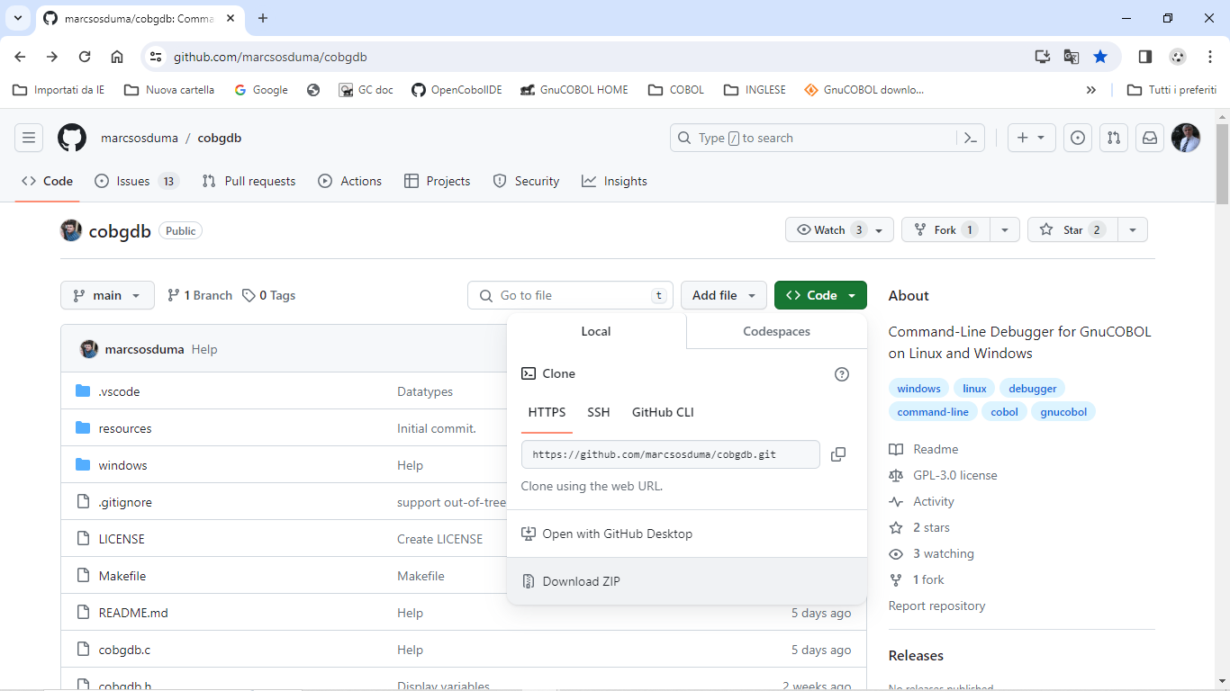

  - Compile and Debug GnuCOBOL programs

Compile and run a debugging session of the sample program using the following command:
cobgdb customer.cob -x

Source code of customer.cob sample program used also for following tutorial is at: https://github.com/marcsosduma/cobgdb/tree/main/windows

or, other example for cobc parameters , use :
cobgdb customer.cob -x -Tcustomer.txt

where '-Tcustomer.txt' is an argument that can be indirectly passed to 'cobc' by 'cobgdb,' even if it is not used by 'cobgdb' itself. (-T just creates a compilation list output into the customer.txt file )

CobGDB takes one or more programs with COB or CBL extension as parameters and runs the GnuCOBOL compiler with the following format:
cobc -g -fsource-location -ftraceall -v -free -O0 -x prog.cob prog2.cob ...

note:
-g as we know, it is used to add “debug symbols” (variable names, variable types, correspondence between assembler binary instructions and source code lines) inside the executable code (inside the .exe or .dll file).
-O0 is used to tell the compiler not to optimize, for example it must also compile parts of the source code that would never be executed, otherwise the debugger will not find an exact correspondence between the executable and the source lines.

To debug multiple programs, use COBGDB with the following syntax :
cobgdb prog.cob subprog1.cob subprog2.cob ...

This will create a single prog.exe executable to debug.
To debug sub programs separately , see also "Debugging sub Programs" chapter in this document.

You can also run GDB/GDBSERVER remotely using the "A" (Attach) key.
CobGDB will prompt you to provide the server and port in the format server: port or the PID of the application.
Example:
- localhost: 5555
- 9112

  - Main Commands

Command | Short | Description
? | Help | Show the HELP window
R | Run | Start the program and Run until a breakpoint is encountered, also when, by default, the first Breakpoint is at first program statement.  Always use this command to start a debugging session.  If the debugger is already active re-start the program from the beginning.
B | Breakpoint | Set or Unset a Breakpoint at current line of the Procedure Division code.
S | Step  (Step Into) | Runs the program until the next line.  If needed it goes into a subroutine executed by PERFORM or CALL.
N | Next  (Step Over) | Runs the program until the next line but does not enter a subroutine executed by PERFORM or CALL.
G | Go  (Step Out) | Executes the remaining statements of the current subroutine and returns to the calling point. Continues the program execution until return from a subroutine (PERFORM or CALL = Step Out) or encounters a stopping point: a Breakpoint or the end of the program.
C | Cursor | Runs the program until it reaches the selected line at Cursor location.
J | Jump | Ask for a line number and runs the program until it reaches that line.
V | Variables | Displays a window with a list of all variables and their content for the running program. From this window you can also change the content of variables.
H | sHow | Displays a window with a list of variables and its content from the cursor selected line. From this window you can also edit / change the content of variables from the selected line. Right-click on a source line is same as command "H".
D | Display | Settle to OFF or ON the automatic Display of variables of current and previous statement in execution during a debugging session. At program start it is OFF.
O | fOcus | When program encounters an ACCEPT verb, this command switch the focus from the debugging screen to the application screen to accept the user input and then automatic go back to the debugging screen.
F | File | When CobGDB is executed with more than one program, allows selecting one of those source file to manage debugging commands (es. Setting new Breakpoints).
A | Attach | Attach to GDBSERVER or to an Application PID.
W | Window | Switch between two window size: 24 rows x 80 cols or 34 rows x 132 cols.
CTRL-F | Find text | Ask for some text and search in the source code.
CTRL-G | Go to line | Ask for a line number and move the current/cursor line in the source code.
CTRL-S | Save breakpoints | Save all Breakpoints from the current debugging session.
CTRL-B | Load breakpoints | Load all saved Breakpoints from a previous debugging session.
+ or - |  | Change the background color of the current line / cursor line
Q | Quit | Quits (ends) the debugger and the program (or programs).

- Tutorial - Sample Debugging Session

This tutorial is on a Windows 10 or Windows 11 platform using following version of GnuCOBOL:

cobc (GnuCOBOL) 3.2.0
Copyright (C) 2023 Free Software Foundation, Inc.
License GPLv3+: GNU GPL version 3 or later <https://gnu.org/licenses/gpl.html>
This is free software; see the source for copying conditions. There is NO
warranty; not even for MERCHANTABILITY or FITNESS FOR A PARTICULAR PURPOSE.
Written by Keisuke Nishida, Roger While, Ron Norman, Simon Sobisch, Edward Hart
Built Jul 28 2023 16:07:38
Packaged Jul 28 2023 16:58:47 UTC
C version (MinGW) "13.1.0"

Downloaded from https://www.arnoldtrembley.com/GnuCOBOL.htm

====== Version 3.2 ======
GnuCOBOL 3.2 (28Jul2023) MSYS2 64-bit GC32M-BDB-x64.7z -- MSYS2 64-bit GnuCOBOL 3.2 Final release with full debugging support. (95.4 Megabytes).
GnuCOBOL 3.2 (28Jul2023) MSYS2 32-bit GC32M-BDB-x32.7z -- MSYS2 32-bit GnuCOBOL 3.2 Final release with full debugging support. (96.1 Megabytes).

After executing cobgdb customer.cob -x the application automatically inserts a Breakpoint at first executable program statement of PROCEDURE DIVISON.
See the B symbol at left of line 103 in this sample, and displays following screen:

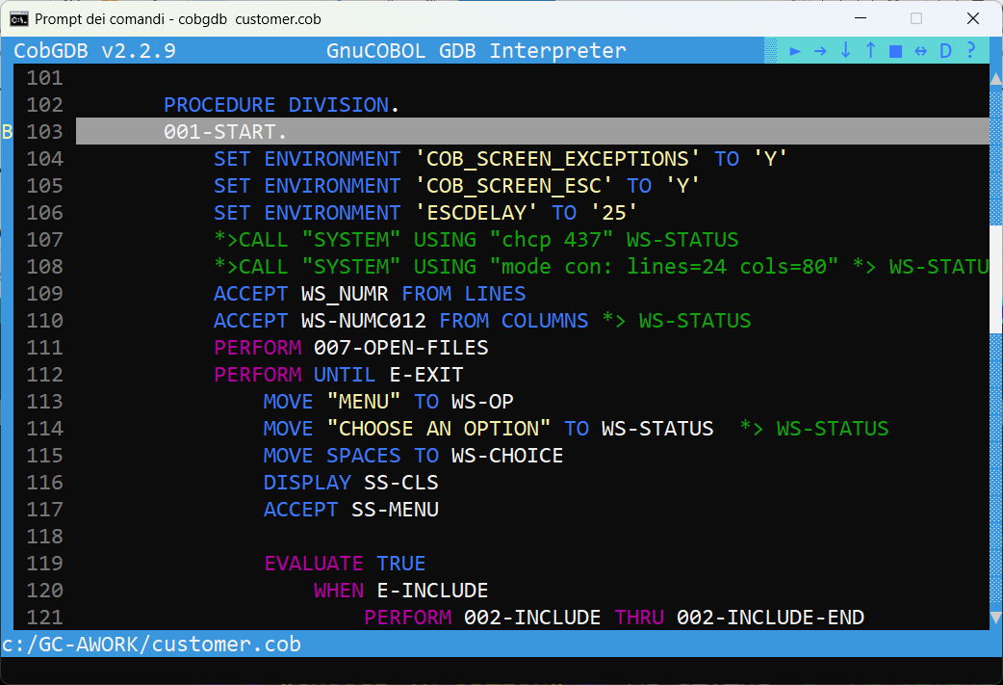

You can scroll the source code window with keys UP and DOWN, with keys PG UP and PG DOWN, with mouse left click on the ▲ and ▼ symbols or on the scroll bar, dragging the slide bar present in the scroll bar.or using the mouse wheel Use key RIGHT and key LEFT to scroll horizontally.

In the upper right window corner there is a "Symbol bar" where you can find following symbols:

► ➡ ⬇ ⬆ ■ ↔ D ?

 | Symbol | Command
 | ► | Run | Start (or Re-Start) the debugging session
 | ➡ | Next | Run until next statement and do not enter Call or Perform routine (“Step Over” )
 | ⬇ | Step | Run until next statement and enter Call or Perform routine (“Step Into”)
 | ⬆ | Go | Run until next stopping point, (es. exit from Call or Perform routine or “Step Out”)
 | ■ | Quit | Ends the debugging session
 | ↔ | Focus | Switch the focus to the application window and back
 | D | Display | Toggle on / off the automatic variable display during animation
 | ? | Help | Displays the Help window

when you hover over one of these symbol, you get the corresponding command description (like a tooltip) displayed at the bottom left of the screen.

  - ? - Help Command

Type ? (key) HELP command or left click with mouse on the ? symbol:
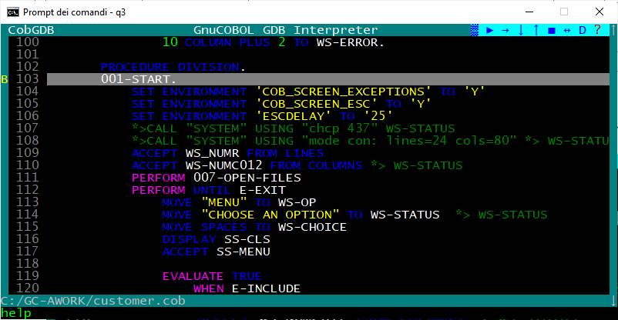

the HELP window is displayed
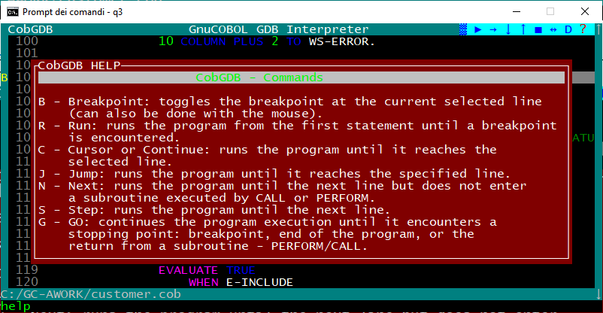

scroll the Help window with cursor keys UP and DOWN or mouse wheel.
Use ESC or Enter or left click to exit from this HELP window and return to debugging session.

  - R - Run Command

To start executing the program and the debugging session from first program statement you always must use the
"R" command (key) or left click with mouse on the ► Run symbol

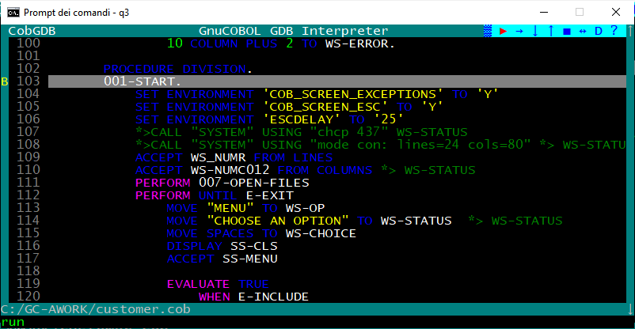

CobGDB opens the program terminal window (the application will run in this separate window. ).

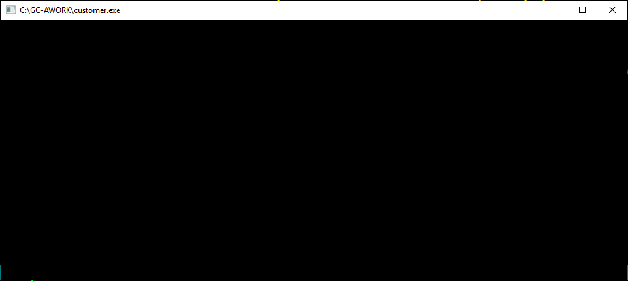

go back to the CobGDB screen, and you see a > green symbol on the left of statement where initial B (Breakpoint) is present (in our example is at line 103 B>103 ):

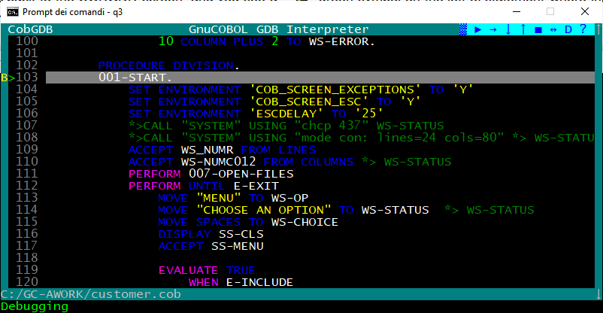

From that moment on, you can use all the commands (keys) or corresponding buttons to "animate" and debug the application, example: "S" Step (a Step Into), "N" Next (a Step Over), "G" Go (a Step Out) and so on.

After the D command or pressing D symbol and during the source code animation, the debugger automatically shows some pop-up windows with variables content from the line in execution.

In order not to slow down the debugging / animation of the program unnecessarily, the automatic display of all variables of the statement in execution is disabled by default at program startup.
To activate the Automatic Display of all variables of the statement in execution use the "D" command or click the "D" symbol on the Symbol bar..

  - S - Step Command

Proceed with S (Step into) command or left click with mouse the ⬇ symbol on the Symbol bar.

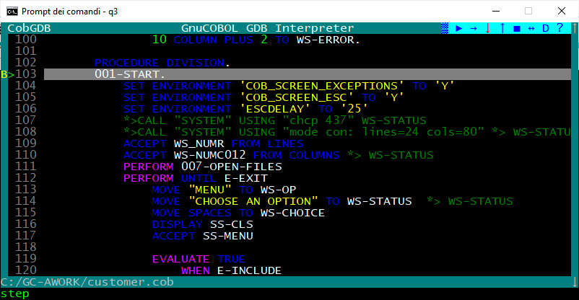

the >104 green symbol now is on the following line 104:

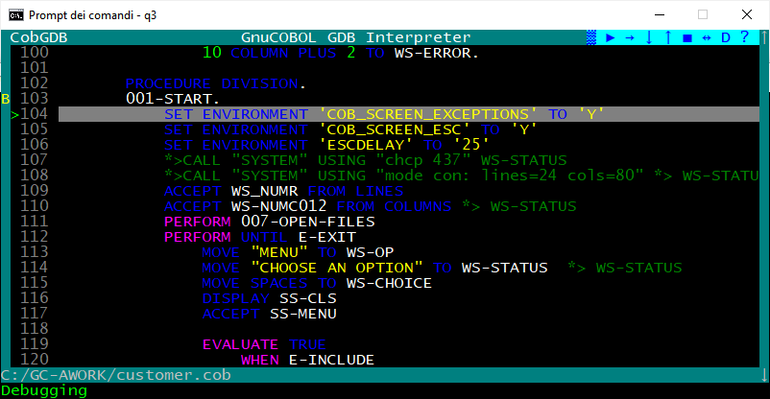

Now you can proceed with S command or N command or as an example:

- Scroll with cursor down to select line 116 of Procedure Division and type "B" (to set a Breakpoint), (you also can simply click with mouse left button on the 116 row number)

- The application displays a "B" on the left of the line (type B again - or re-click - when you want to delete the Breakpoint, not do that at this moment)

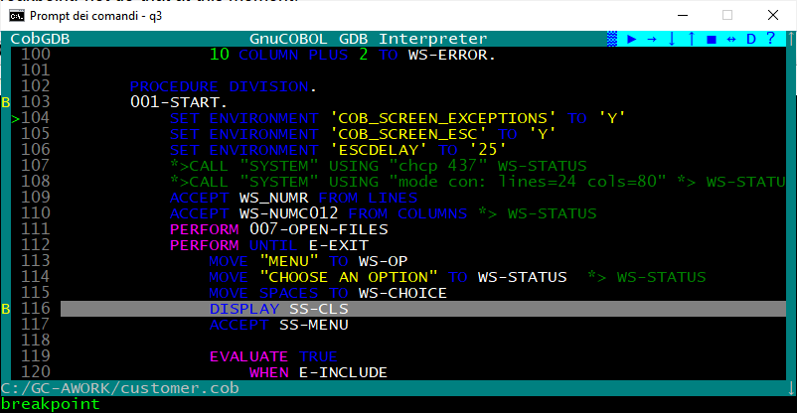

  - G - Go Command

Type G (Go) or left click with mouse the ⬆ symbol on the toolbar to execute the program until exit from a PERFORM or a CALL routine (Step Out) or until a stopping point (es. a new Breakpoint) is detected:

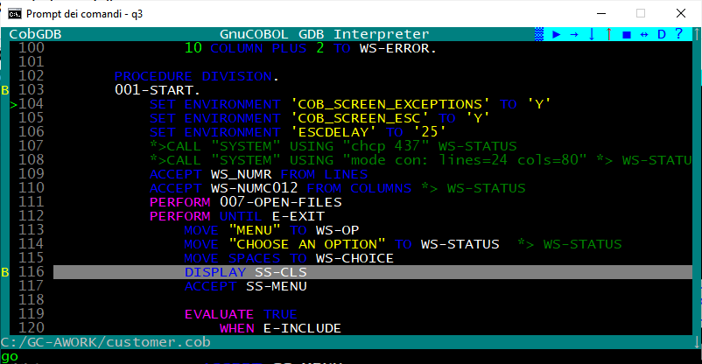

the system reach the second breakpoint at line 116 and displays a green > symbol to the left of the line to be executed, see following screen:

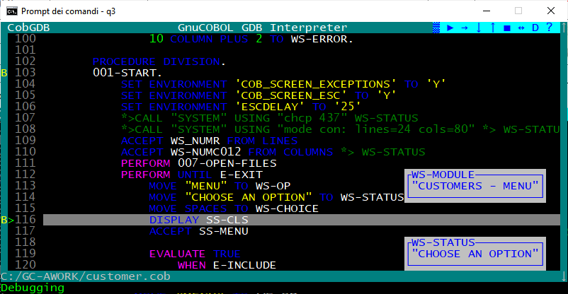

  - D - Display Variables Command

The debugger / animator can do an automatic display of all variables content from the statement executed and from the previous statement.
This can slow down the animation / execution and it may not be useful to have it activated everywhere.
Type D (Display Variables) command or left click with mouse the D symbol on the Symbol bar to enable or disable this display at your convenience.
By moving the mouse over the "D" symbol in the Symbol bar you will see a message with the current status of this option displayed at the bottom left of screen: Display of Variables: ON or Display of Variables: OFF.
At the beginning of the program this option is always set to OFF to speed up the animation.
When you have reached the point of the program that interests you, you can click on "D", or type the command "D", to activate the automatic display of all the variables of the statement in execution (black frame pop-up windows) and of the previous statement (blue frame pop-up windows).

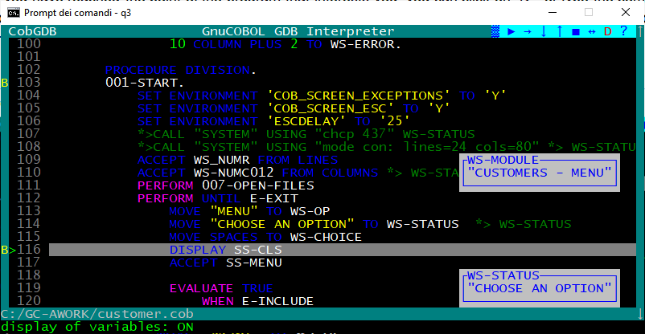

  - H - Show Command

typing the 'H' command (key) allows you to view the variables on the cursor selected (highlighted) line.

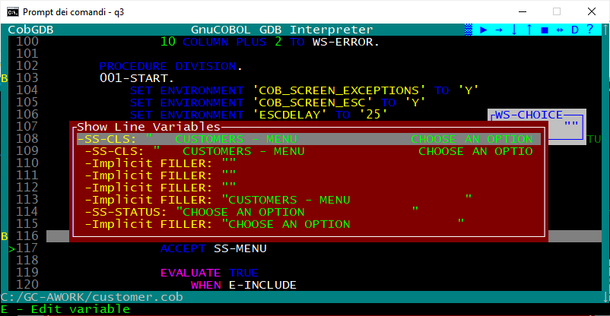

Display the content of variables also clicking right mouse button on a source line, example click right mouse button on line 114 will execute the H command on that line and give you:
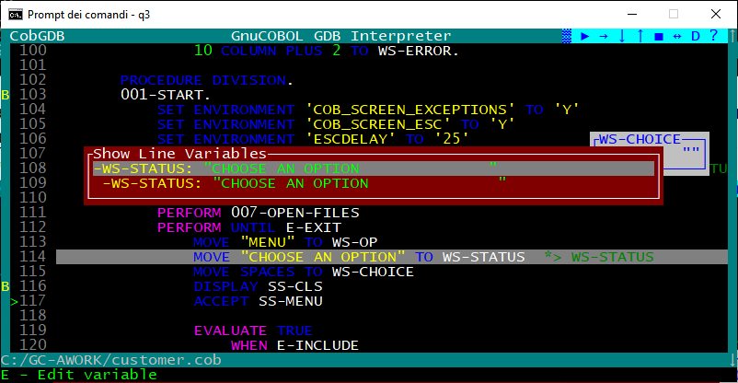

Now at lower left line on screen is a message: E = Edit (change) the variable value.

    - E - Edit subCommand

Scroll with cursor key UP and DOWN (or with mouse wheel). to select one of the variable.
The key E (or clicking again right mouse button) can be used to edit the content of the variable.
Change the value and type Enter to confirm changes or use ESC to exit without changes :

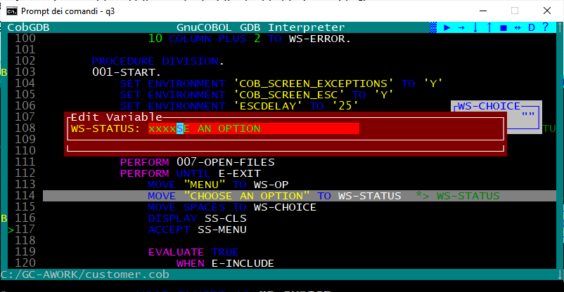

Resulting:
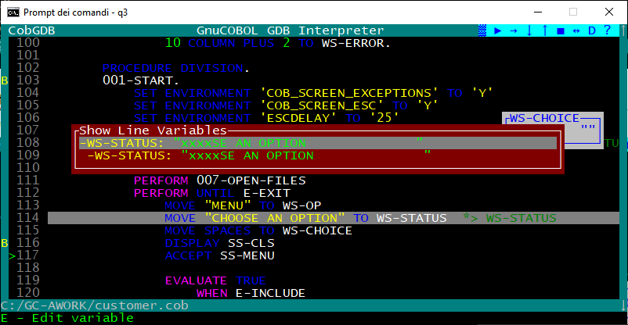

  - V - Variables Command

Type the V command (key) to display the list of all program variables:
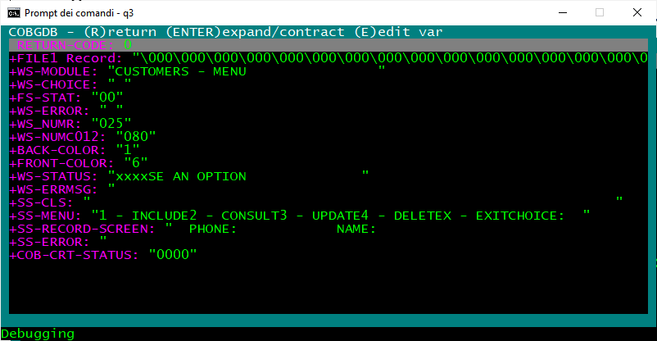

    - Enter - subCommand

Scroll with cursor key UP and DOWN (or with mouse wheel) in this list to the variable WS-MODULE and type
Enter: the application opens and displays its subfields WS-MODULE and WS-OP
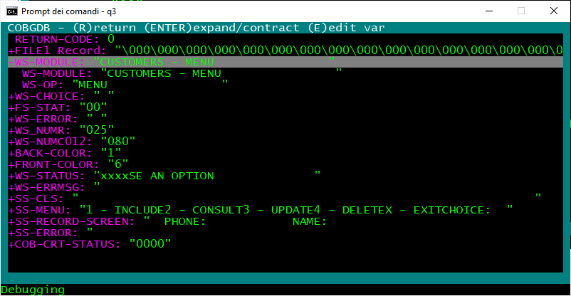

select WS-MODULE subfield

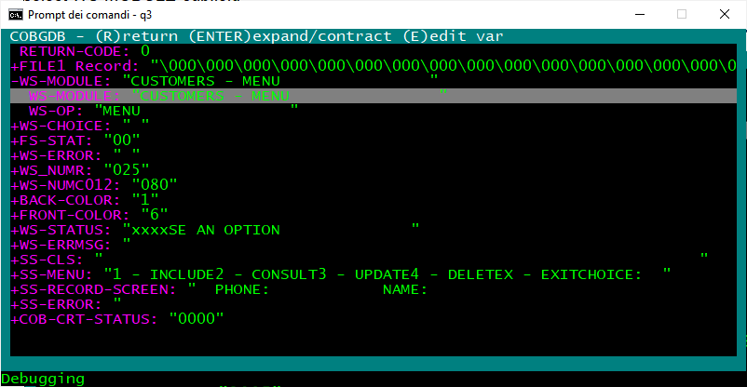

    - E - Edit subCommand

Now you can select WS-MODULE subfield whit cursor DOWN or mouse wheel and type "E" (Edit)
CobGDB shows a Edit Variable window:

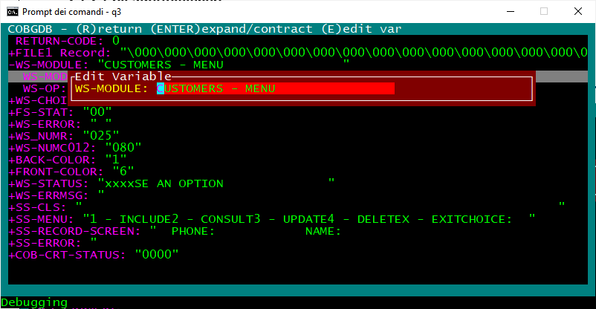

Change "CUSTOMERS" to "TEST" and type Enter to change the value (use ESC to exit without changes) :
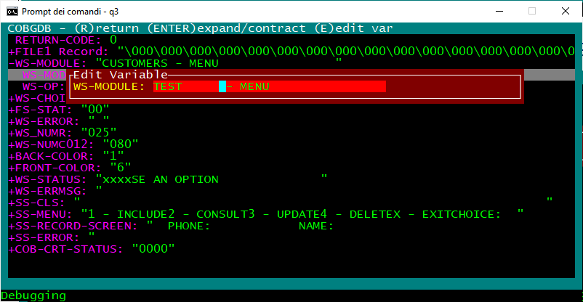

    - R - Return subCommand

WS-Module has new value.

Now type "R" (Return) to go back to the debugging session:
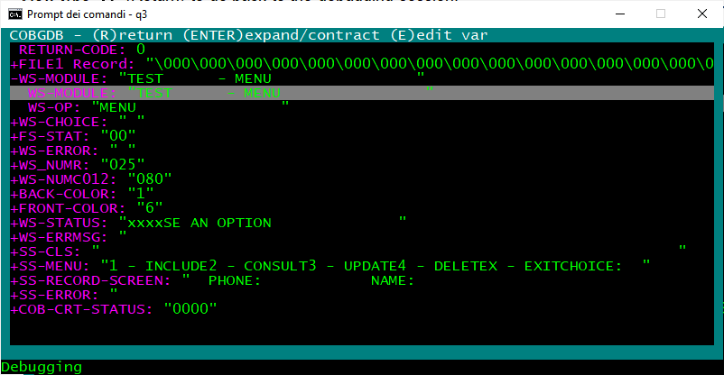

  - S - Step Command

now you are back in the main debugging window: type S (Step into) command or left click with mouse the ⬇ symbol to execute the DISPLAY statement at line 116

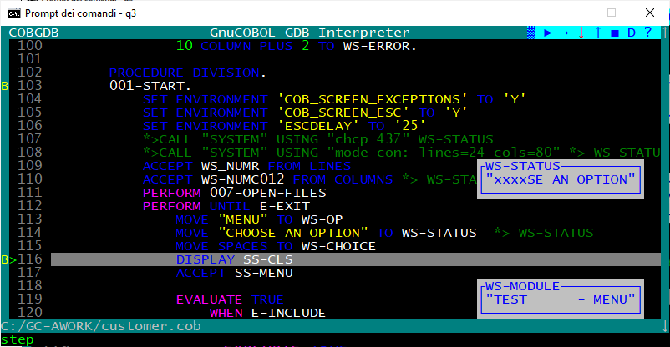

in the other application window you can see the result of DISPLAY statement

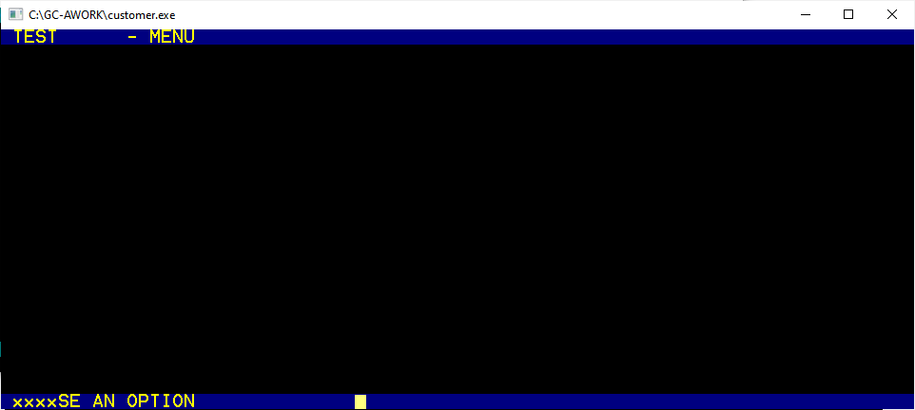

go back to debugging window and now the ACCEPT statement will be executed with S command

Type S (Step into) command or leftclick with mouse the ⬇ symbol again to execute ACCEPT statement at line 117:

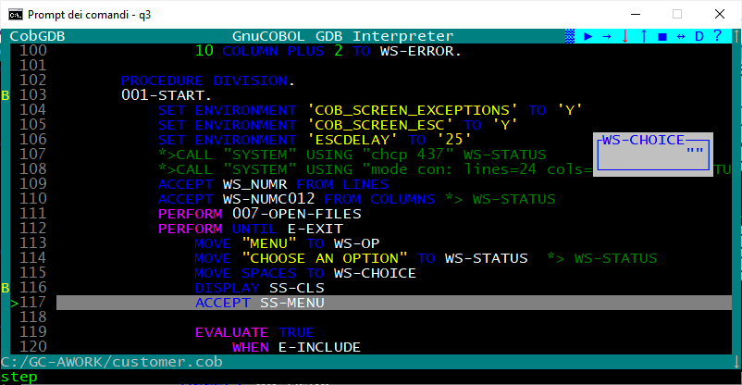

A red ! exclamation mark appears on the line !117 .
This means that the application is running and a user action is required at application window.

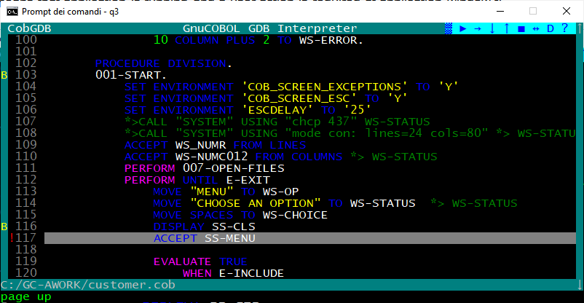

  - O - Focus Command

The application is running in a separate window.
The 'O = Focus' command switches the focus from debugging / animation window to the application window.
Instead of using the "O" command you can left-click on the ↔ symbol on the Symbol bar.

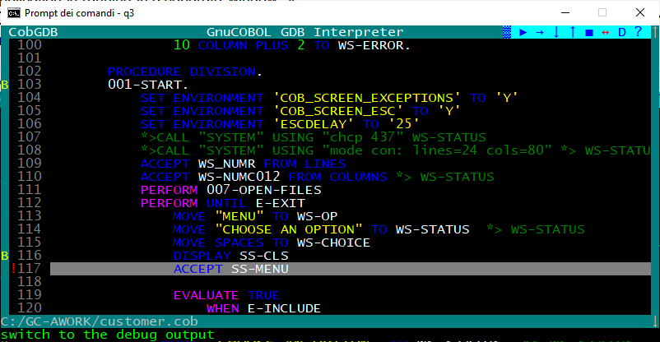

The focus now is on the application window where a user action is needed.
In our sample, we type the "X" choice and Enter:

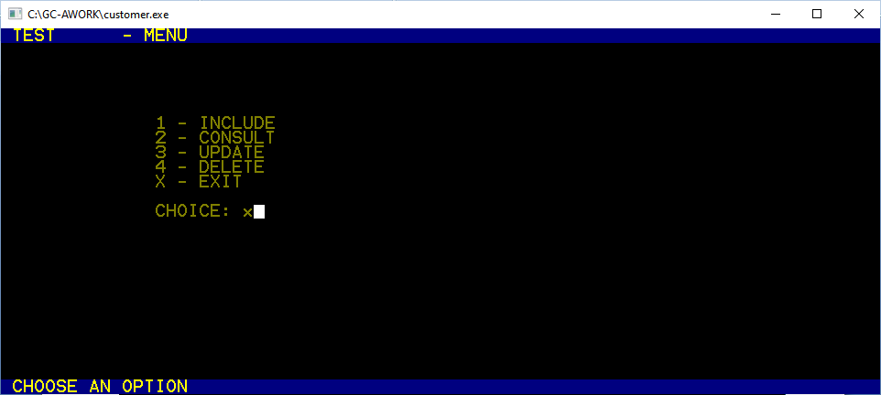

Now the system automatic switch back to the debugger / animation window to continue debugging.
You can see that the ACCEPT statement has been executed, now you are on line >119 :

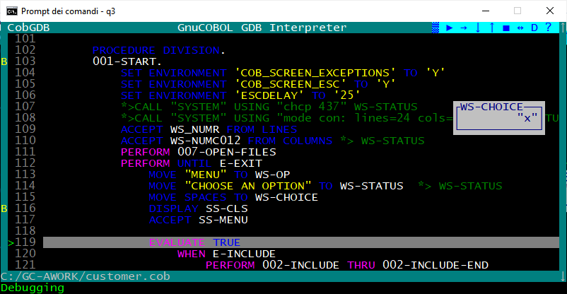

  - Pop-up Variable windows

During a debugging session CobGDB shows variable content.
Blue frame and values ........... : variables of executing cobol statement
Black frame and values ......... : variables of last executed cobol statement.

Sample:

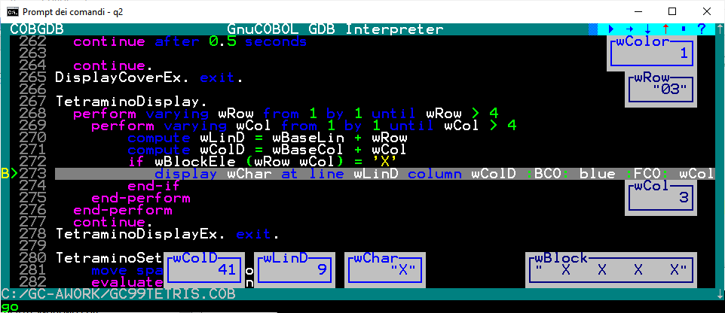

See also the “D” command to enable or disable these pop-up windows.

  - F - File Command

To show this command we use following sample:

cobgdb sample.cbl subsample.cbl subsubsample.cbl -x -lpdcurses

where sample.cbl is the main program; it calls
--> subsample.cbl; it calls
--> subsubsample.cbl

Source code is at https://github.com/marcsosduma/cobgdb/tree/main/resources.
This will create a single sample.exe executable.

This example shows that when you need to debug only subsample.cbl or only subsubsample.cbl you need to execute CobGDB with all three programs.

CobGDB sets the B breakpoint at first executable statement of first program "sample.cbl".
here use the R Run command to start the debugging session.

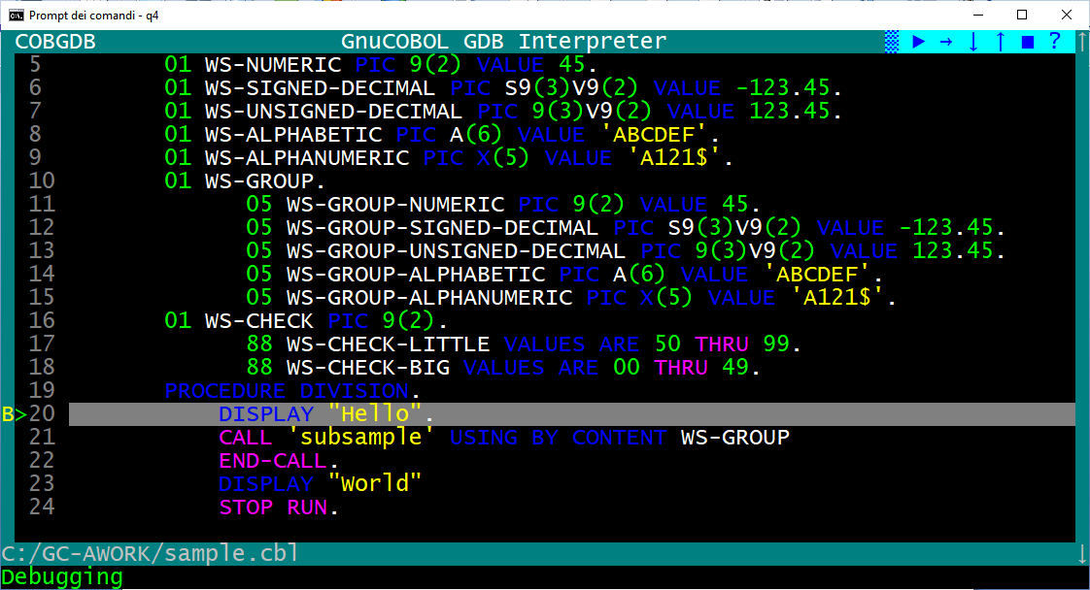

Now you can type the F File command and you will have the "Source Files" window.
In this sample we select the second program in the list (subsample.cbl) and type Enter.

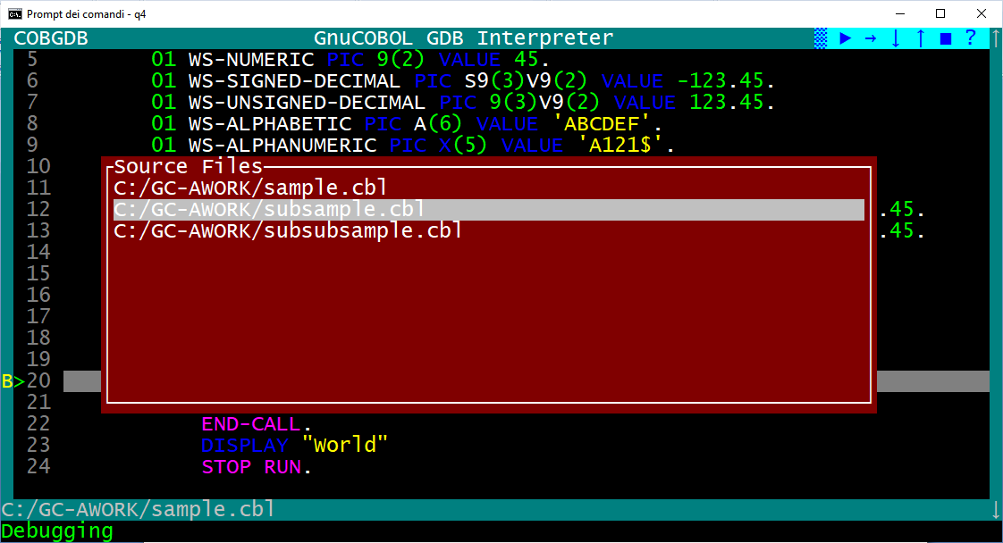

CobGDB shows the selected program source code where in this sample we type a B command at line 14.

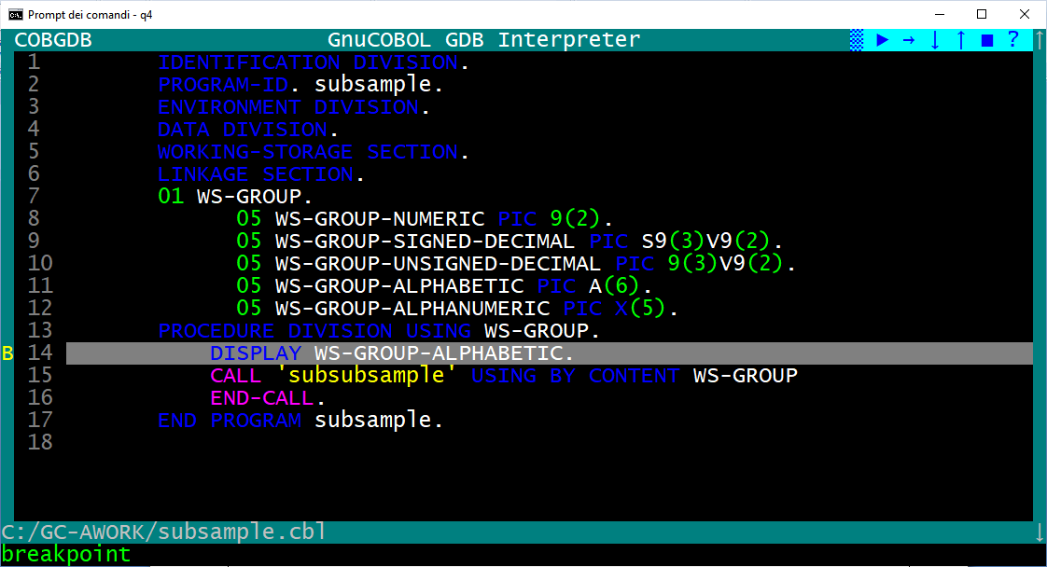

now we type the F command again, then select the "sample.cbl" program and press Enter

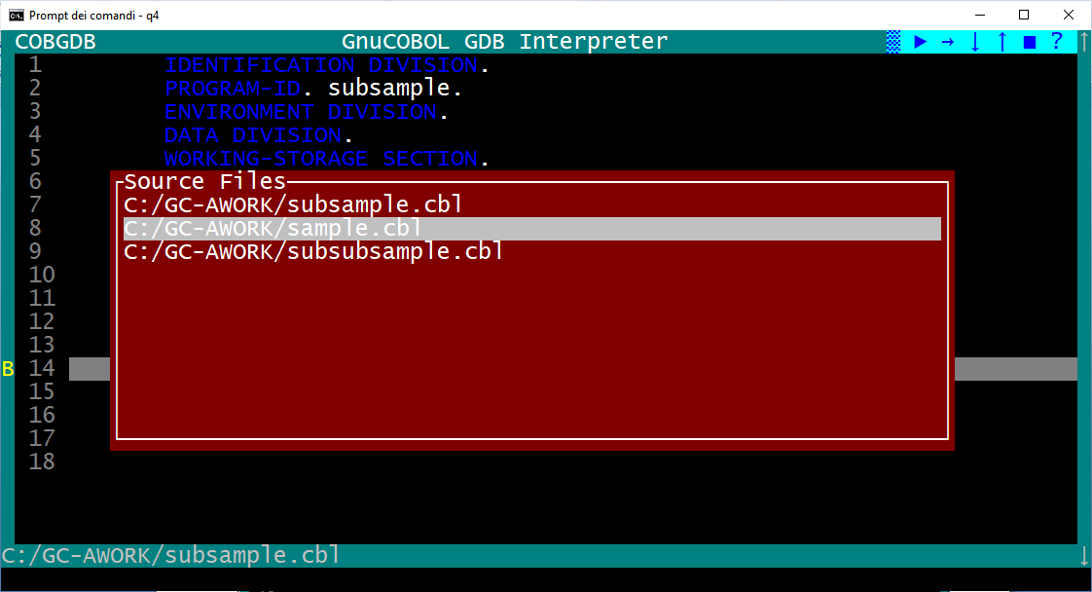

now we are back to the sample.cbl program to continue the debugging session as we need.

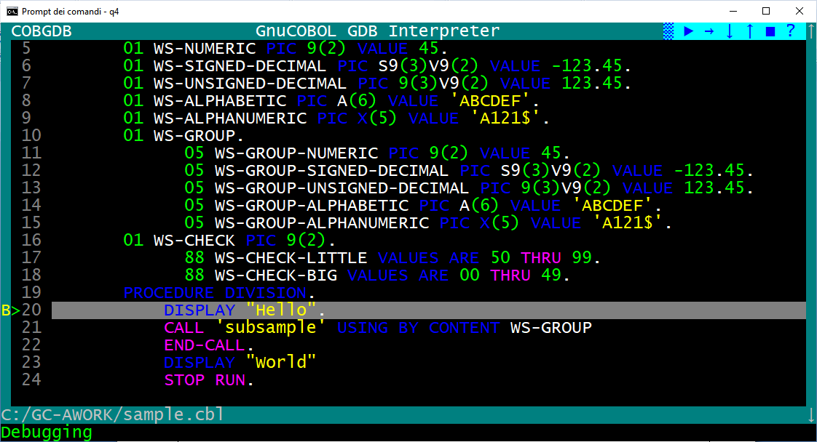

  - R - Run Command

If you click the Run command during a debug session you will receive a confirmation request,
because Yes will restart a new the debugging session from first Procedure Division executable statement:

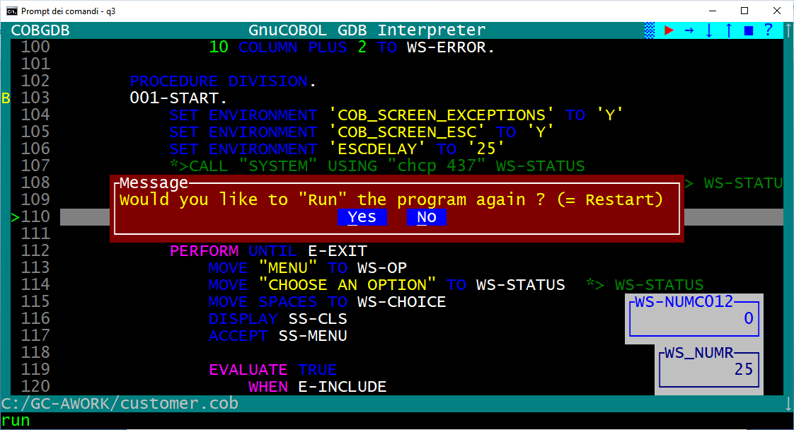

Note: if program has DECLARATIVES then the first automatic B Breakpoint will be settled at first executable PROCEDURE DIVISION statement that is the one after END DECLARATIVES, see following sample:

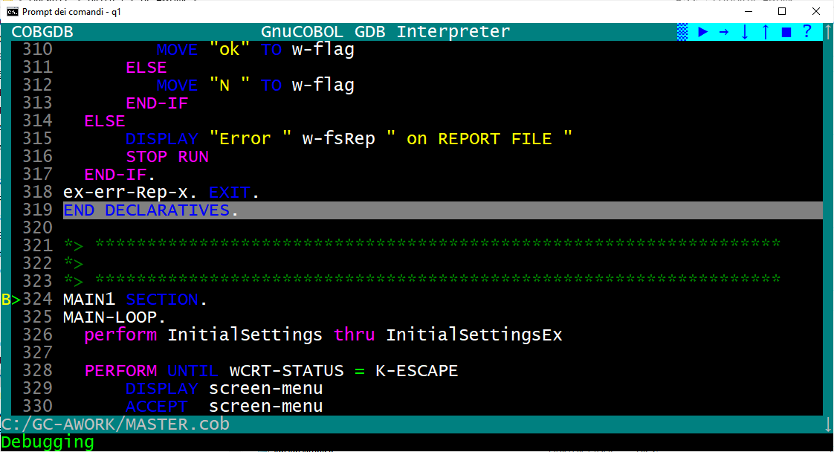

  - W - Window Size command

When you start a debugging session, the screen size is 24 rows x 80 columns.

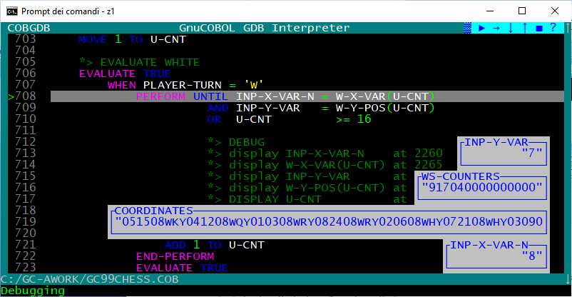

Type W (Window Size) command to switch between two window size of the debugger : 24 x 80 or 34 x 132.

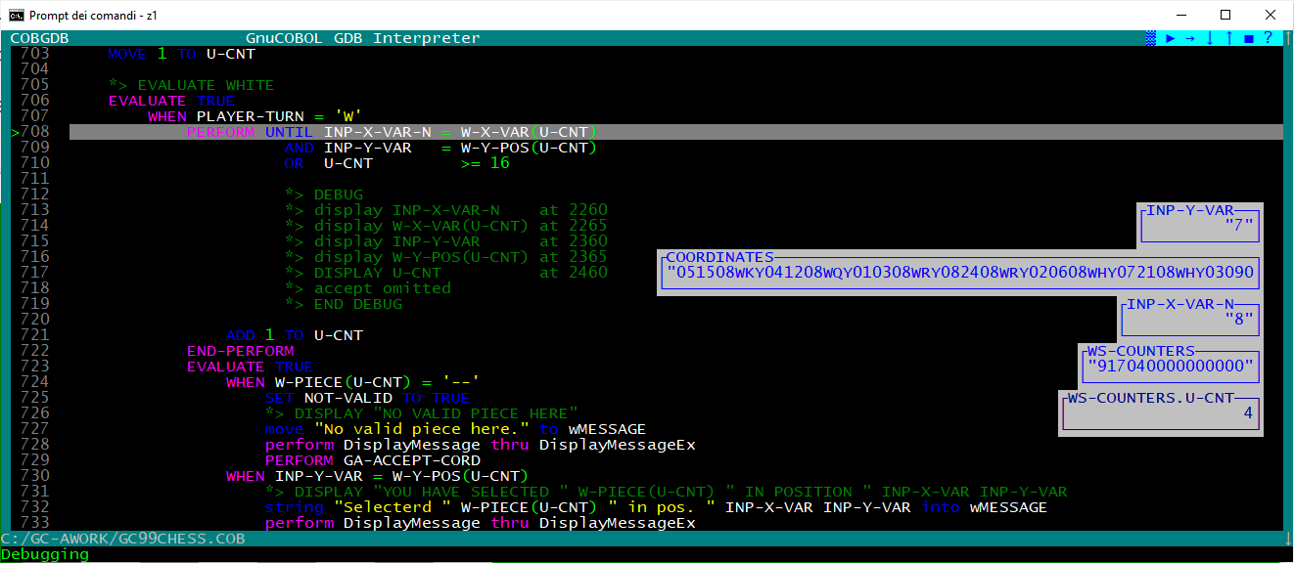

This can be very useful when you write GnuCOBOL code with the GnuCOBOL FREE FORMAT source option where each line of code can be longer than the classic 80 characters of GnuCOBOL FIXED FORMAT.

Warning 1.
Make sure the system font size is not too large otherwise the W command cannot display the 132 columns (your screen will "blink"). For a Windows environment use "Property" menu item to chek or change the Font size:

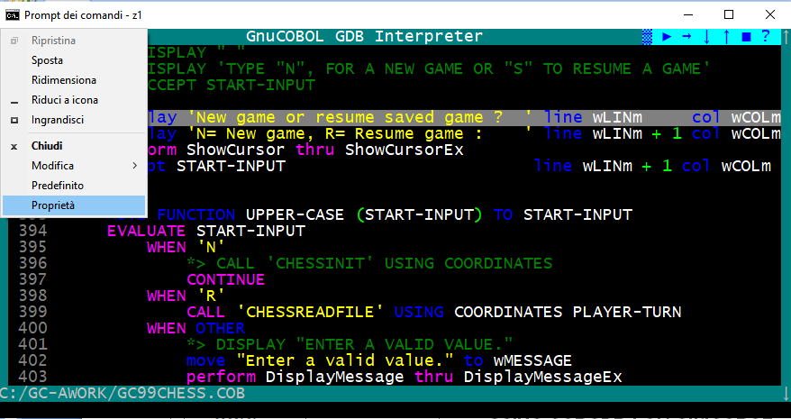

and then select a suitable font, for example Lucida Console of 16 might be adequate.

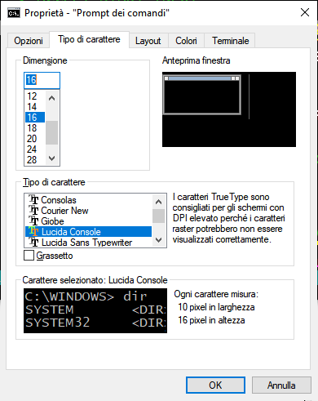

Warning 2.
If you are running on Windows 11, it’s mandatory to switch the “default terminal” back to “Windows Console Host”.
The new “Windows Terminal”, which is the default on Windows 11, does not allow changing the console window size in CobGDB.

The W command in CobGDB will not work properly unless this change is made:
- Open Windows Terminal (using the cmd command)
- Click the down arrow V next to the tab bar and select Settings
- In the left-hand menu, go to Startup.
- Under Default terminal application, select Windows Console Host.
- Click Save.

  - Q - Quit Command

To close the debug session use the Q Quit command or left click with mouse the ■ symbol on the Symbol bar.

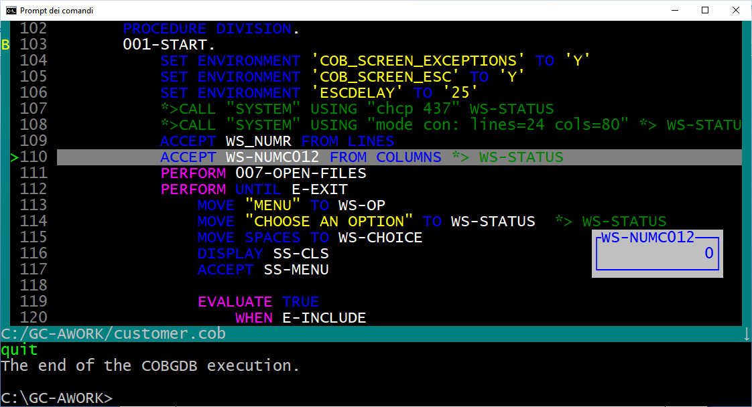

  - A - Attach Command

You may debug your COBOL program attaching to a running Local process or running Remote Debugger (GDBServer).

Prerequiste: your programs are all compiled for debug (use the -g, a cobc compiler option), because you just compile everything for debug because that's no big overhead and you can attach and use system corefiles at any time. CobGDB needs the .cob, .c, .c.h, and .c.l.h files in order to perform debugging.

- Scenario 1. Start a program from the command line.
You are "somewhere in the application" and find the current state to be strange or can reproduce the bug by something you do. Now you just open the debugger from a different terminal, Attach to the program, debug normally, then either kill or detach.

- Scenario 2. The program has no terminal at all (like with [web]services, Java/C/HTML frontends, runs in the background, is started by other COBOL programs, ...) it is just "somehow started". Now you just open the debugger from a different terminal, Attach to the program, debug normally, then either kill or detach.

- Scenario 3. You can run GDB/GDBSERVER remotely using the Attach command. CobGDB will prompt you to provide the server and port in the format server:port or the PID of the application.
Example:
- server:port = localhost:5555
- PID = 9112
Command line:
- cobgdb --connect localhost:5555 prog.cob

Just to note how debug CGI programs: Start gdbserver cgiexecutable and just get its PID after starting (possibly have it waiting inside a loop) and ensuring the setup provides rights to ptrace (debug) that process, then use the following cobgdb with its "A"ttach option to attach to that.

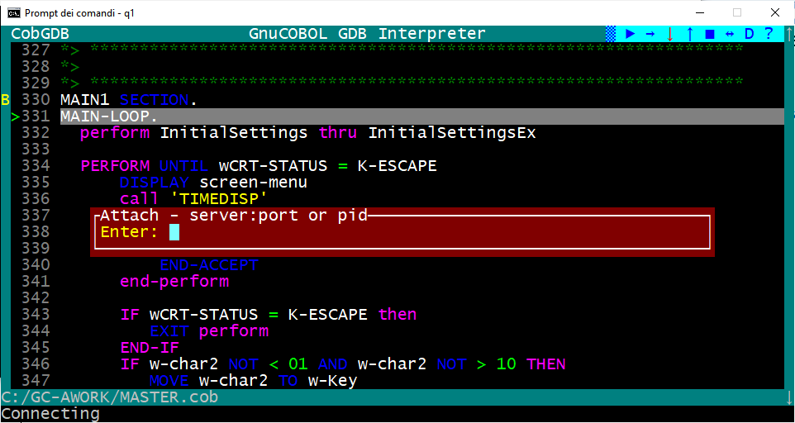

- Other Commands

  - CTRL-F - Find command

Press CTRL-F to display the “Search pop-up”. Type the text and press Enter to start the search foreword.
The system performs the search and keeps the pop-up on the screen with the text already filled in, whether the string was found or not. Press Enter again to repeat the search for the same string.
Press ESC when you want to exit the search.

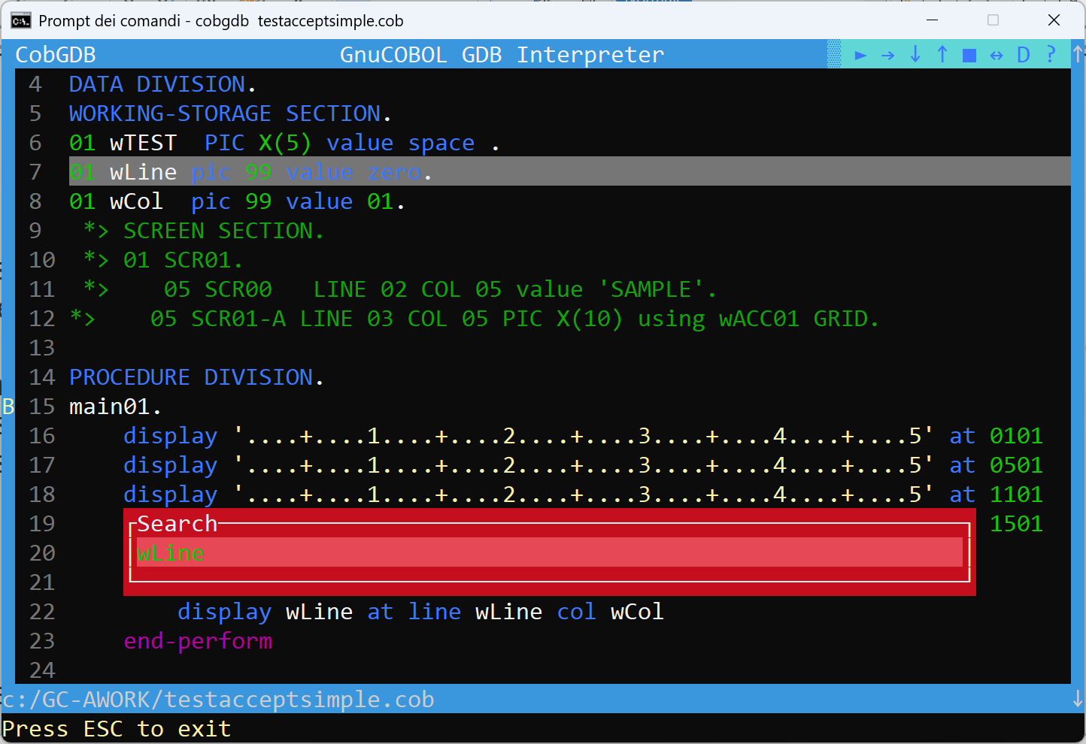

  - Change the Current Line background color

Use the + or - keys to change the background color of the “current line” to have a better visibility.
There are 256 available background colors. See also at:
https://jakob-bagterp.github.io/colorist-for-python/ansi-escape-codes/extended-256-colors/#sequence-parts
This new background color will be automatically saved at the end of the debugging session in a dedicated file in the C:\USERS\username\cobgbd.cfg file.
In subsequent debugging sessions, this color will be used for the background of the “current line”.
To restore the default background color simply delete o rename this file.

  - Display Variable content by hover the mouse

Hover your mouse over the name of a variable (either in Procedure Division or Data Division) and hold it for 2 seconds. A pop-up will appear with the contents of that variable. Move the mouse and the pop-up disappear

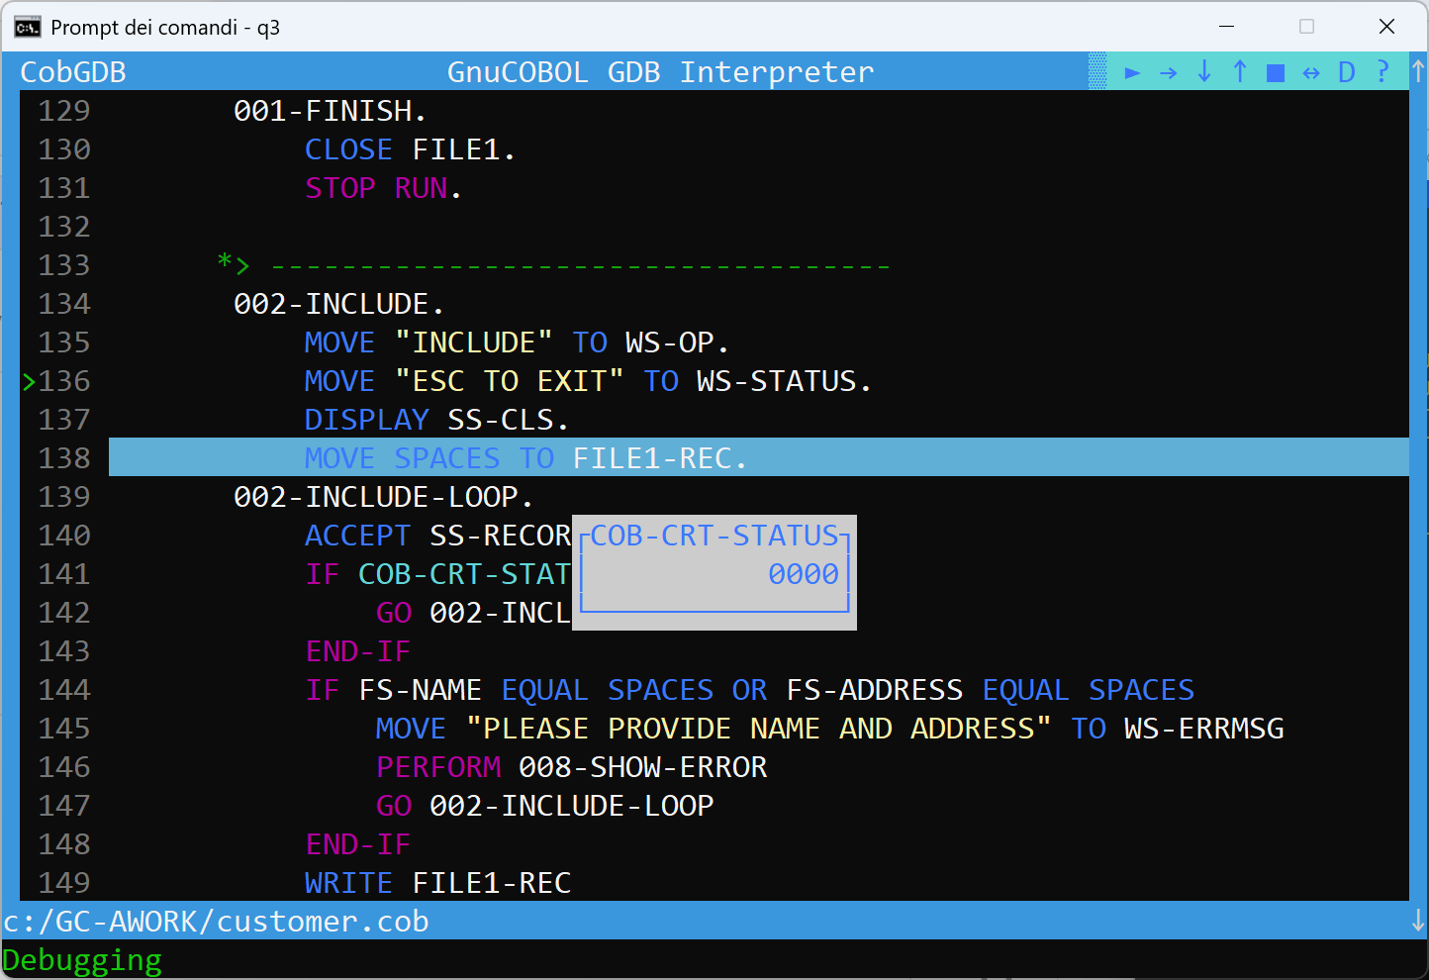

  - CTRL-S and CTRL-B - Save and Load Breakpoints

Type CTRL-S to save Breakpoints from current session.
CobGDB will create the file programname.bkp es. customer.bkp with following records content:
c:/GC-AWORK/customer.cob 102
c:/GC-AWORK/customer.cob 111

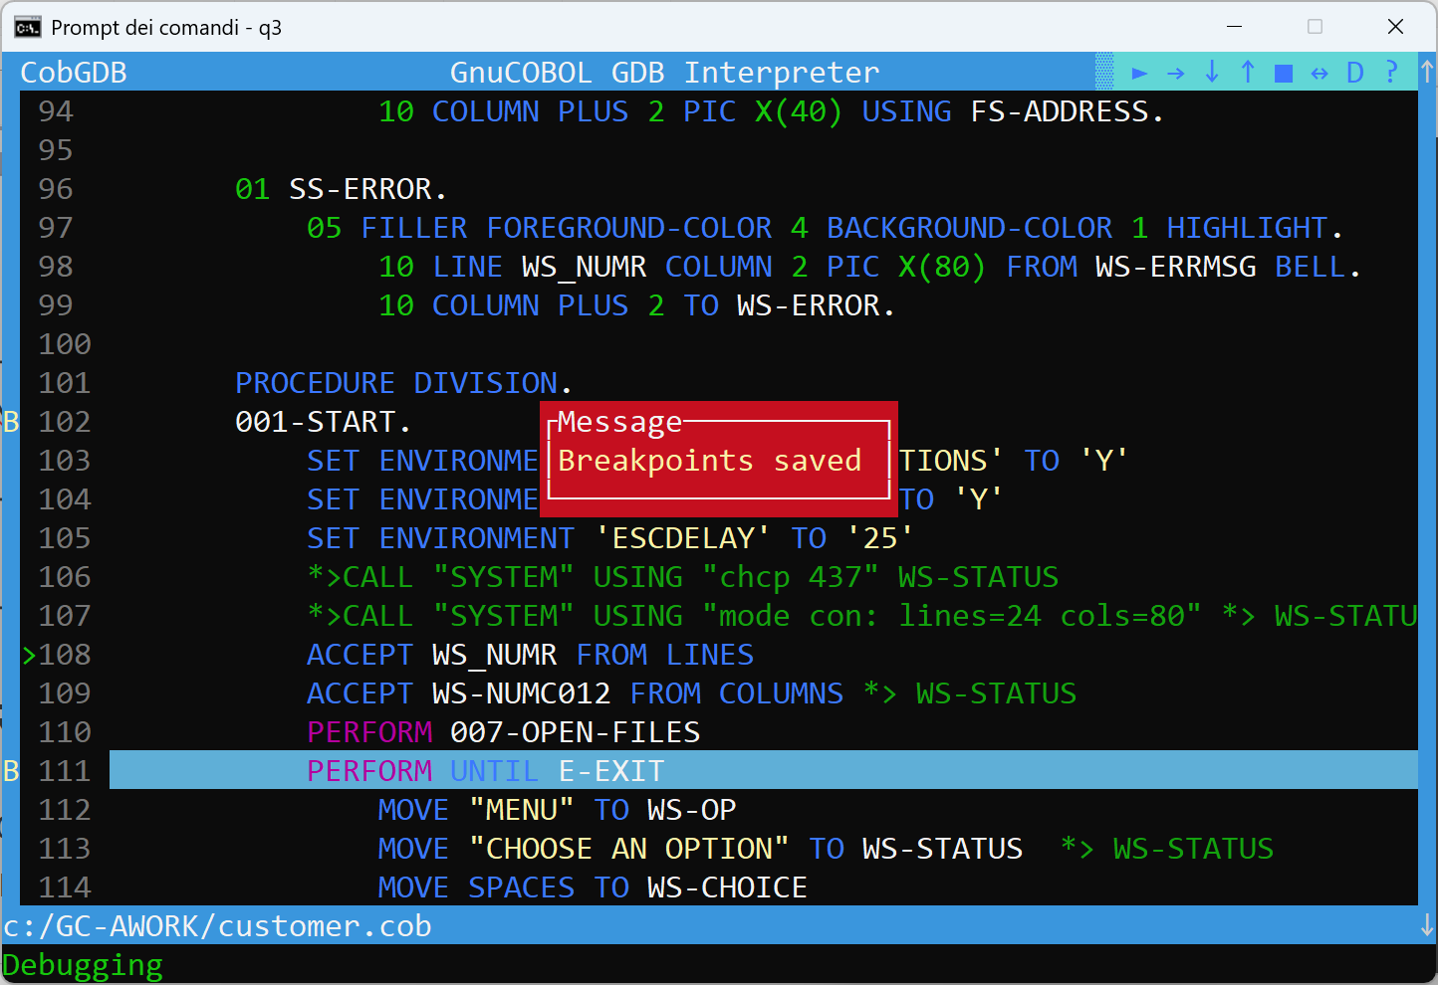

Type CTRL-B to load Breakpoints saved from the previous debugging session:

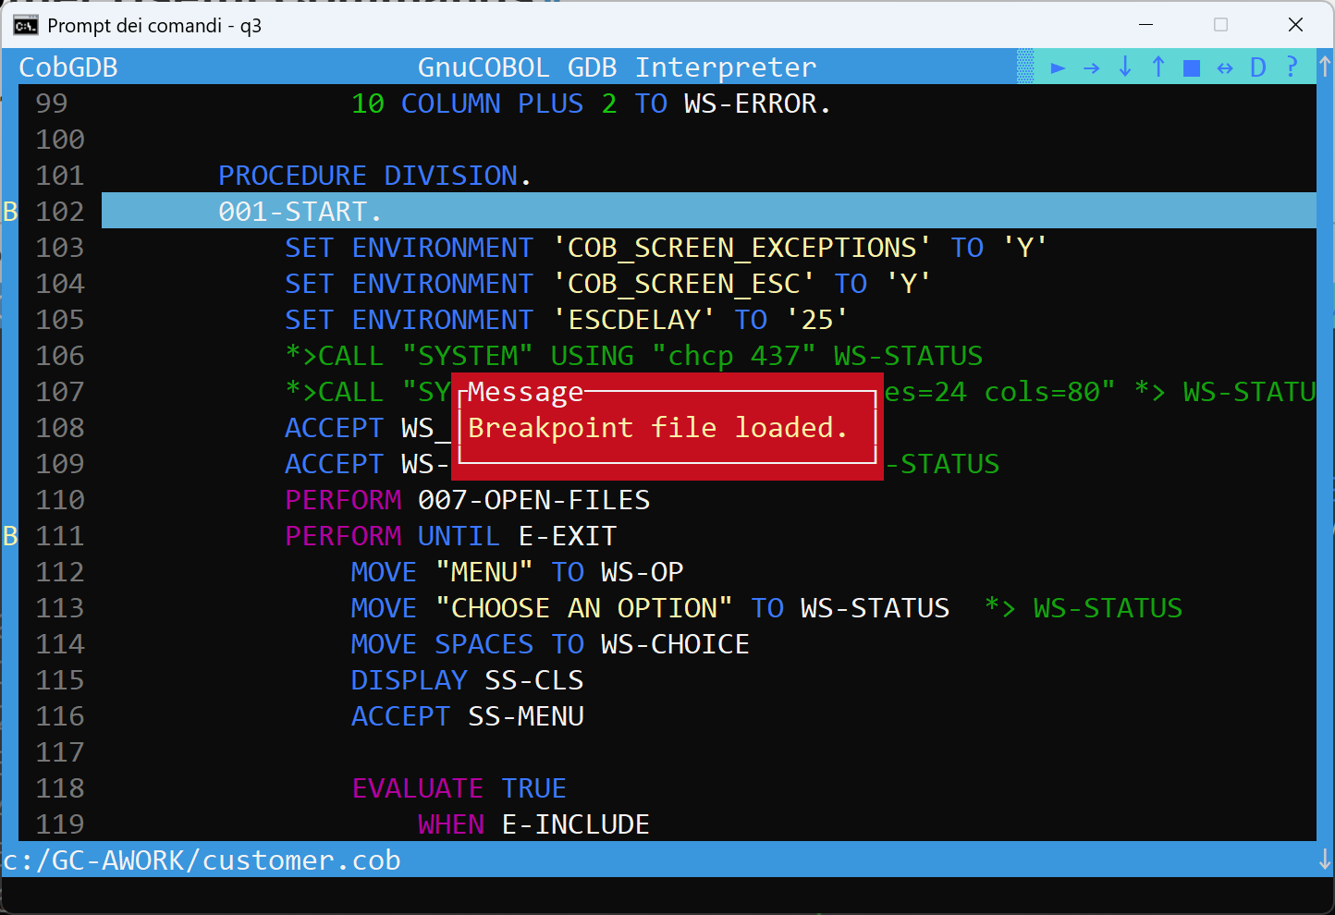

  - Debugging a pre-compiled Program

You can use CobGDB to debug a previously generated executable file ex. prog.exe.
To do this, you must first compile the GnuCOBOL program prog.cob with these options:

cobc -g -fsource-location -ftraceall -v -O0 -x prog.cob prog2.cob ...

To start debugging without recompile the program, run cobgdb using the --exe directive as follows:

Windows: cobgdb --exe prog.exe
Linux: cobgdb --exe prog

  - Debugging sub programs

We use following sample programs p0.cob and p1.cob to show this feature:

>>SOURCE FORMAT IS FREE
IDENTIFICATION DIVISION.
PROGRAM-ID. p0.
DATA DIVISION.
WORKING-STORAGE SECTION.
01 WS-NUMERIC PIC 9(2) VALUE 45.
01 WS-SIGNED-DECIMAL PIC S9(3)V9(2) VALUE -123.45.
01 WS-UNSIGNED-DECIMAL PIC 9(3)V9(2) VALUE 123.45.
01 WS-ALPHABETIC PIC A(6) VALUE 'ABCDEF'.
01 WS-ALPHANUMERIC PIC X(5) VALUE 'A121$'.
01 WS-GROUP.
05 WS-GROUP-NUMERIC PIC 9(2) VALUE 45.
05 WS-GROUP-SIGNED-DECIMAL PIC S9(3)V9(2) VALUE -123.45.
05 WS-GROUP-UNSIGNED-DECIMAL PIC 9(3)V9(2) VALUE 123.45.
05 WS-GROUP-ALPHABETIC PIC A(6) VALUE 'ABCDEF'.
05 WS-GROUP-ALPHANUMERIC PIC X(5) VALUE 'A121$'.
05 WS-MSG PIC X(70).
01 WS-CHECK PIC 9(2).
88 WS-CHECK-LITTLE VALUES ARE 50 THRU 99.
88 WS-CHECK-BIG VALUES ARE 00 THRU 49.

PROCEDURE DIVISION.
DISPLAY "PROGRAM P0"
DISPLAY WS-GROUP-NUMERIC
DISPLAY WS-GROUP-SIGNED-DECIMAL
DISPLAY WS-GROUP-UNSIGNED-DECIMAL
DISPLAY WS-GROUP-ALPHABETIC
DISPLAY WS-GROUP-ALPHANUMERIC
DISPLAY WS-MSG

MOVE 'Program "P1" was called by "P0"' TO WS-MSG
CALL 'p1' USING BY CONTENT WS-GROUP END-CALL

DISPLAY 'BACK TO "P0", received the message:'
DISPLAY WS-GROUP-NUMERIC
DISPLAY WS-GROUP-SIGNED-DECIMAL
DISPLAY WS-GROUP-UNSIGNED-DECIMAL
DISPLAY WS-GROUP-ALPHABETIC
DISPLAY WS-GROUP-ALPHANUMERIC
DISPLAY WS-MSG

STOP RUN.

>>SOURCE FORMAT IS FREE
IDENTIFICATION DIVISION.
PROGRAM-ID. p1.
ENVIRONMENT DIVISION.
DATA DIVISION.
WORKING-STORAGE SECTION.
LINKAGE SECTION.
01 WS-GROUP.
05 WS-GROUP-NUMERIC PIC 9(2).
05 WS-GROUP-SIGNED-DECIMAL PIC S9(3)V9(2).
05 WS-GROUP-UNSIGNED-DECIMAL PIC 9(3)V9(2).
05 WS-GROUP-ALPHABETIC PIC A(6).
05 WS-GROUP-ALPHANUMERIC PIC X(5).
05 WS-MSG PIC X(70).

PROCEDURE DIVISION USING WS-GROUP.
DISPLAY "PROGRAM P1"
DISPLAY "Message received: " WS-MSG
DISPLAY 'BACK IN "P1" receiving the message:'
DISPLAY WS-MSG
GOBACK.
END PROGRAM p1.

It is possible to debug modules as long as you compile them in the same directory as your source code, using the following command:
cobc -g -fsource-location -ftraceall -v -O0 -x p0.cob
cobc -g -fsource-location -ftraceall -v -O0 -m p1.cob

In this example, p0.cob is the source code of the executable, and p1.cob is the source code of the module (.dll on Windows or .so on Linux). Debug Execution:
cobgdb --exe p0.exe

Example:
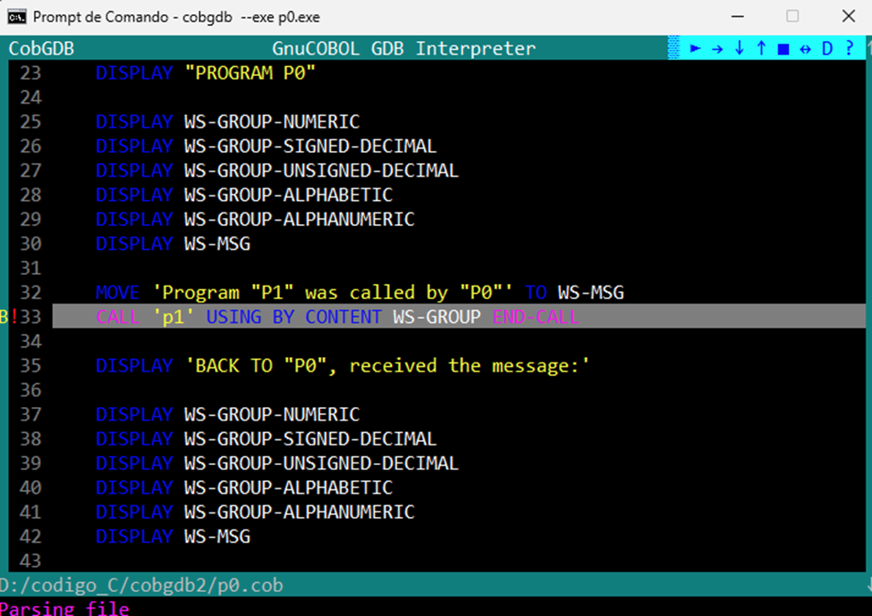

Resulting in:

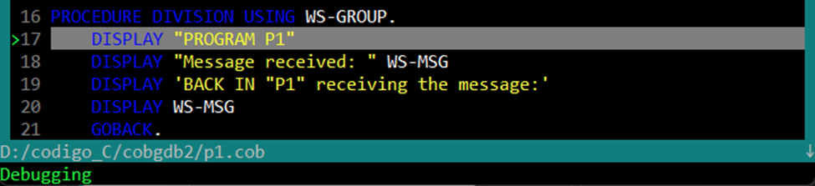

If p1.cob is already compiled as a module with:
cobc -g -fsource-location -ftraceall -v -O0 -m p1.cob
the following command also works:
cobgdb p0.cob

When you are debugging separately compiled subprograms, as shown in the previous chapter, you can use the same F File command, which you should use when debugging subprograms that have all been compiled into the same executable. With F File command you can load the source code of a module and set a breakpoint.

  - CobGDB Version

Use command option: cobgdb --version

to display CobGDB version informations as follows:

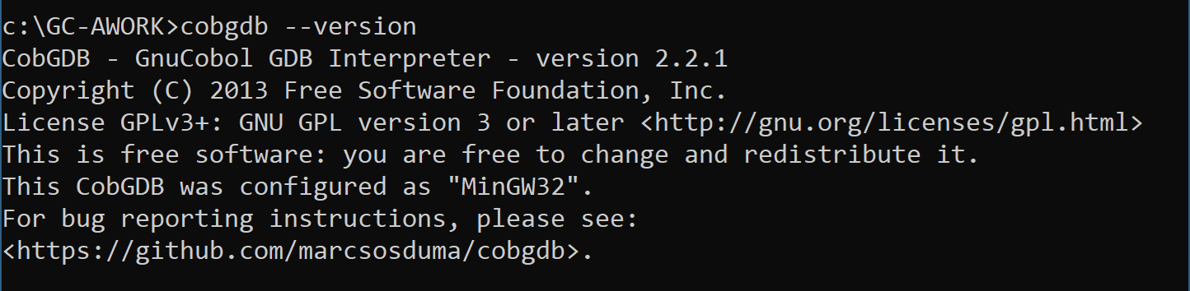

Note: from version 2.2.3 you can see the version number also in the main CobGDB screen at top left:

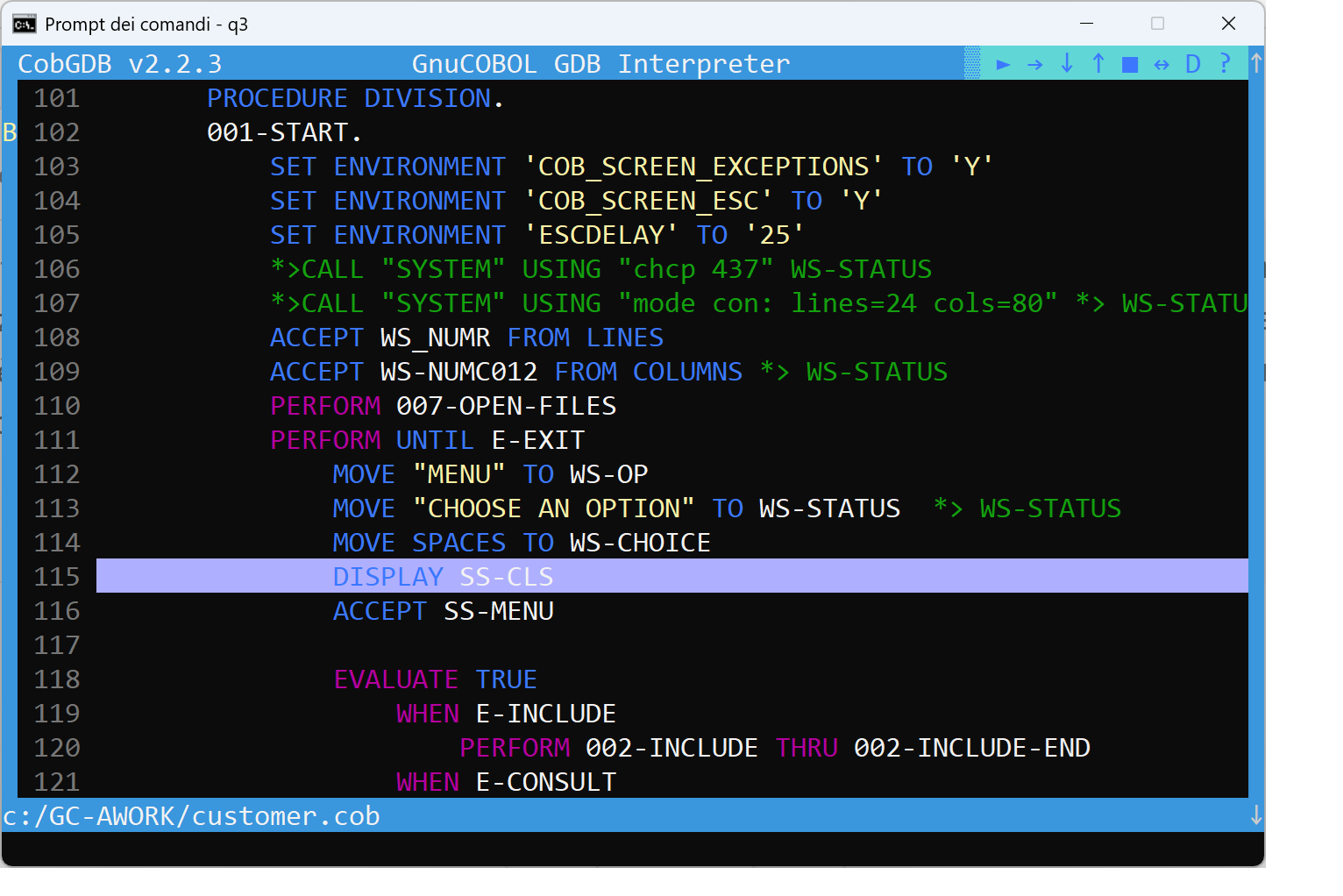

- Document Change Log

CHANGE LOG

Version 1 of 2023.12.12.
First release

. Version 2 of 2023.12.23.
Step by Step sample of use is added
Some minor changes

. Version 3 of 2024.02.18.
Restructured showing new cobgdb screens and features

. Version 4 of 2024.04.01 and 20240403.
Added EDIT subcommand at H Show Command when viewing the variable from a line of code
Added cobgdb --version option

. Version 5 of 2024.05.01.
Added the W Window size command to change User interface screen size

. Version 6 of 2024.05.05.
Added the --exe option to debug precompiled program

. Version 7 of 2025.04.24.
Added the new D command and icon useful to enable or disable automatic display variables during debugging / animation

. Version 8 of 2025.06.16.
Added the new O ( Focus ) command and icon useful to switch the focus to application screen from debugging / animation screen

. Version 9 of 2025.10.20.
Added more documentation for the A (Attach) command.

Version 10 of 2025.11.06.
Added "Debugging sub programs" Chapter.
Added F = File command also for manage breakpoints for separately compiled subprograms
Added CTRL-F and CTR-G commands

Version 11 of 2025.12.01.
Added the Windows 11 tip to change to Windows Console Host for command W
Added CTRL-S, CTRL-B and + / - commands
Added “mouse hover” on a variable name feature

Version 12 of 2026.03.25.
CobGDB version number on program screen
Added J Jump command
Scroll symbols, scroll options on source listing

