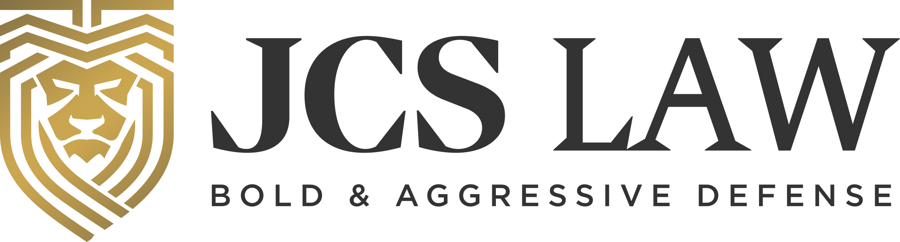
{{service_date}}

sent via electronic mail to: {{client_email}}
{{client_name}}
{{client_address}}
{{client_city_state_zip}}

Re: Driver’s License Reinstatement Requirements

Dear {{client_first_name}}:

In order to reinstate your driving privileges with the State of Missouri you must complete the following: a SATOP class, secure SR-22 insurance, and pay a Forty-Five Dollar ($45.00) reinstatement fee. You are required to maintain the SR-22 insurance for two (2) years from the date you were eligible to be reinstated. Your reinstatement date is {{service_date}}. You are eligible to begin driving on a restricted basis on {{service_date}}, IF you obtain SR-22 insurance by that date. The restricted driving privileges are not automatic and will not be given if you have not obtained SR-22 insurance.

For your SATOP requirement, we recommend using either Community Services of Missouri or EMASS (Eastern Missouri Alternative Sentencing Services) for your SATOP assessment. If are assessed in St. Charles County and they try and place you in a class higher than Level I, it is easier to appeal should you choose to do so. For your SR-22 insurance, if you have not already obtained it, you can reach out to Focus Insurance at (314) 243-9434, or use whomever you like, but we do advise that you do not contact the insurance provider you use for your regular car insurance as they will typically charge you more. Please contact us if you need assistance or have questions about securing an SR-22 insurance policy. As a reminder, if completing SATOP, obtaining SR-22 insurance, and paying the reinstatement fee are not completed before your reinstatement date, your license will convert to being suspended until they are met. You can pay the reinstatement fee online at mydmv.mo.gov.

Please let us know if you have any questions.

Sincerely,

/s/ {{attorney_name}}

