Iskolivery: A Crowdsourced Courier Service
Use Case Model

Submitted to:

Prof. Ma. Rowena C. Solamo
Faculty Member
Department of Computer Science
College of Engineering
University of the Philippines, Diliman

Submitted by:
Fernandez, Aleksei Dominic C.
Legaspi, Bridget Noelle C.
Teves, Marc

In partial fulfillment of Academic Requirements
for the course
CS 191 Software Engineering
of the
1st Semester, AY 2018-2019

This work is licensed under a Creative Commons Attribution-ShareAlike 4.0 International License.
Unique Reference:
The documents are stored in this Google Drive Link: http://bit.ly/2Ndlz0K with Group 1 - Iskolivery - Use Case Model as the filename.

Document Purpose:
This document is provided to present the different the Use-Case Diagram, list of Actors and Use-Cases.

Target Audience:
Students of University of the Philippines Diliman

Revision Control:
Revision Date | Person Responsible | Version  Number | Contribution and Modification
09/12/2018 | Aleksei Fernandez  Bridget Legaspi  Marc Teves | 1.0 | Created the Use Case Diagram
09/13/2018 | Bridget Legaspi | 2.0 | List of Actors, List of Use-Cases (1.0, 1.1, 2.0, 3.0, 4.0)
09/14/2018 | Aleksei Fernandez | 3.0 | List of Use-Cases (6.0, 8.0, 8.1, 8.2, 9.0)
09/14/2018 | Marc Teves | 4.0 | List of Use-Cases (5.0, 7.1, 7.2, 7.3)

System Name: Iskolivery: A Crowdsourced Courier Service

Description: Iskolivery connects people who need items or services (eg. photocopying, buying school supplies, car ride, tutorial, etc.) to the people who can deliver these items or services for them. In the application, requesters will be able to post a request and fulfillers may accept these requests. Requesters can choose to add a "bounty" (or incentive) to hasten the fulfillment of their requests.

Use-Case Diagram:
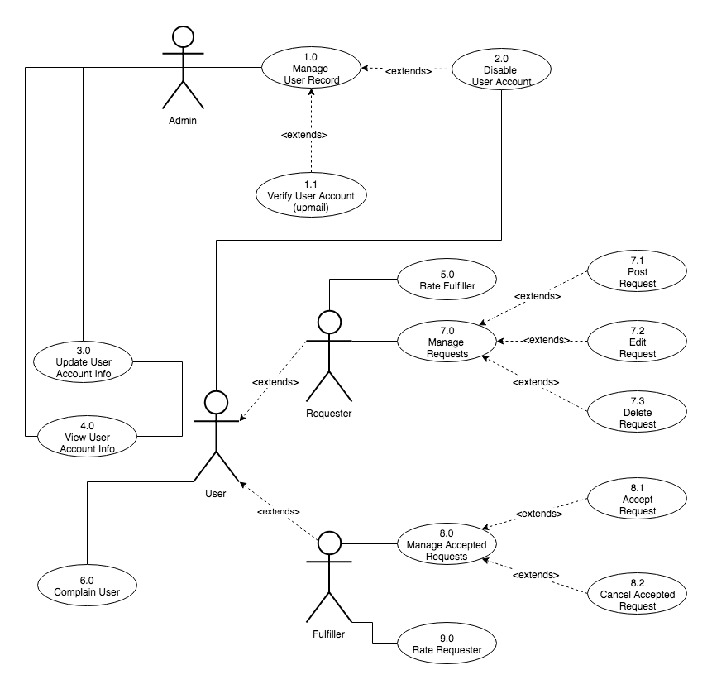

List of Actors:
Actors | Description
Admin | Can update, view, disable, and verify user accounts
General User | Can either be requester or fulfiller; can update, view, and disable his/her own account, and rate other users
Requester | Extended general user that involves all requester use-cases
Fulfiller | Extended general user that involves all fulfiller use-cases

List of Use-cases:
Use-Case | Description
Use-Case 1.0 Manage User Record | Admin can manage the records of all user accounts. This use case is extended to two more use-cases: verifying and disabling user accounts.
Use-Case 1.1 Verify User Account | One feature of Iskolivery is to make sure that the pool of users are only UP students, hence the verification of user accounts. UP Mail must be used during sign up and verified further if the registered UP Mail exists. This use case is only applicable for the admin.
Use-Case 2.0 Disable User Account | Admin can disable (with deliberation) user accounts that are complained by other users, or disable user accounts that violate the Iskolivery’s terms and conditions. General user can also opt to disable their own user account.
Use-Case 3.0 Update User Account Info | General user can update their user account information. Updated information is useful for the “matchmaking” algorithm of the application and contacting the user. The only attribute that the admin can update is whether the account is still active or disabled.
Use-Case 4.0 View User Account Info | General user can view the information of other users. This is helpful for requesters to know the rating of their fulfillers, and vice versa. For the admin side, this is useful for deliberating complained users.
Use Case 5.0 Rate Fulfiller | A requester can rate the fulfiller (ideally, based on the ease of transaction between the fulfiller and requester).
Use Case 6.0 Complain User | A user can make a complaint on another user (ideally, if the user being complained about is practicing disruptive behavior). This shall be reviewed by the administrator
Use Case 7.0 Manage Requests | A requester can manage requests he/she posted.
Use Case 7.1 Post Request | A requester can post new requests. The user must include a minimum amount of information before the request can be posted.
Use Case 7.2 Update Request | A requester can update the details of a request he/she posted.
Use Case 7.3 Delete Request | If it is not currently accepted by a fulfiller, a requester can delete a request he/she posted.
Use Case 8.0 Manage Accepted Requests | A fulfiller can manage their accepted requests. They may either accept a request or cancel an accepted request.
Use Case 8.1 Accept Request | A fulfiller can accept requests of requesters. Accepting the request will hold the fulfiller responsible for completing the request and will hide the request from other fulfillers.
Use Case 8.2 Cancel Accepted Request | A fulfiller can cancel an accepted request. Cancelling will make the request available again to other fulfillers. A fulfiller that cancels an accepted request may be penalized.
Use Case 9.0 Rate Requester | A fulfiller can rate the requester (ideally, based on the ease of transaction between the fulfiller and requester).

