BOOTSTRAPPING

1. Establish a function that returns the vector of regression coefficient
2. Then using the function to resample 1000 replications
3. Plot to determine whether the object is normally-distributed
4. A 95% confidence interval can be obtained via boot.ci()

2．.Use the function to resample 1000 replications

|  |  |  |  |
| --- | --- | --- | --- |
| ORDINARY NONPARAMETRIC BOOTSTRAP | | | |
| Call:  boot(data = ModelData, statistic = bootstrapping, R = 1000, formula = wt...7 ~  gestation + smoke + ht + drace + parity + dht + id) | | | |
| Bootstrap Statistics: | | | |
|  | original | bias | std. error |
| t1* | -9.296243e+01 | -9.667252e-01 | 3.190512e+01 |
| t2* | 4.935584e-01 | -8.284462e-03 | 8.206095e-02 |
| t3* | -4.076974e-01 | -8.284462e-03 | 8.627360e-01 |
| t4* | 9.802434e-01 | -8.304398e-04 | 3.218074e-01 |
| t5* | -4.573703e-01 | 3.582323e-03 | 2.403075e-01 |
| t6* | 6.538123e-01 | -7.900070e-04 | 4.262514e-01 |
| t7* | 2.274048e-01 | 5.097995e-03 | 3.093564e-01 |
| t8* | -5.776258e-04 | 1.084653e-05 | 3.002269e-04 |

3．.Plots

index1

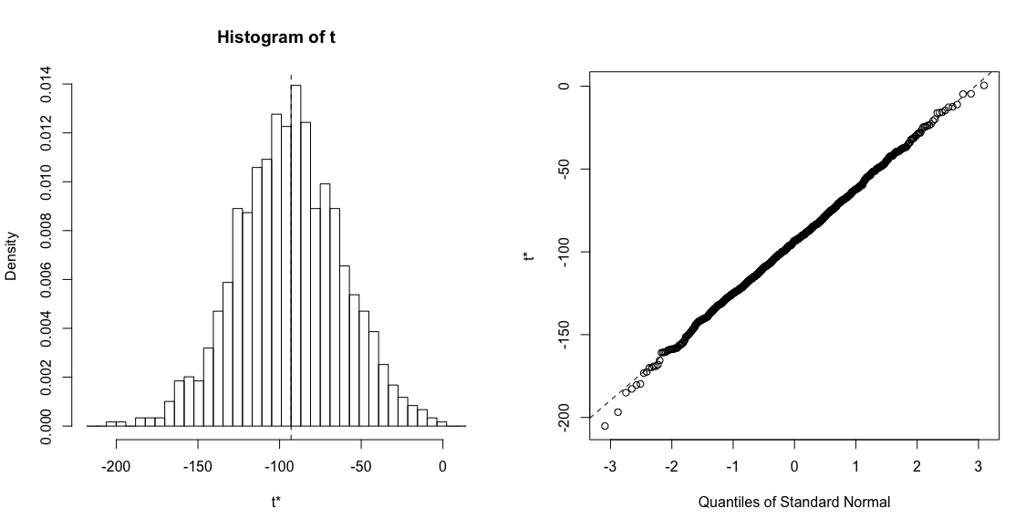

index2

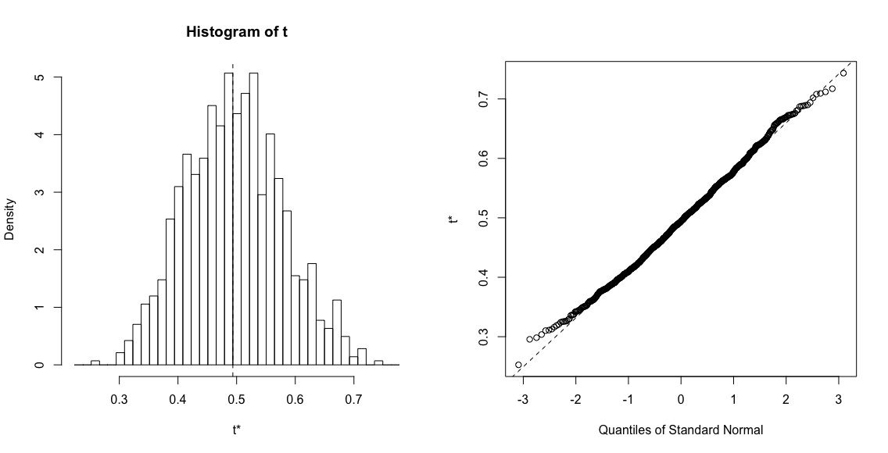

index3

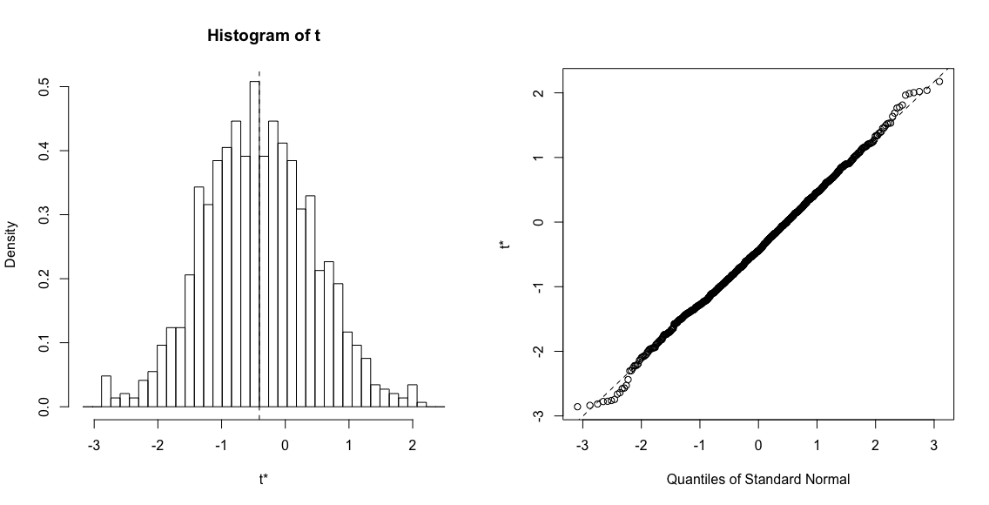

index4

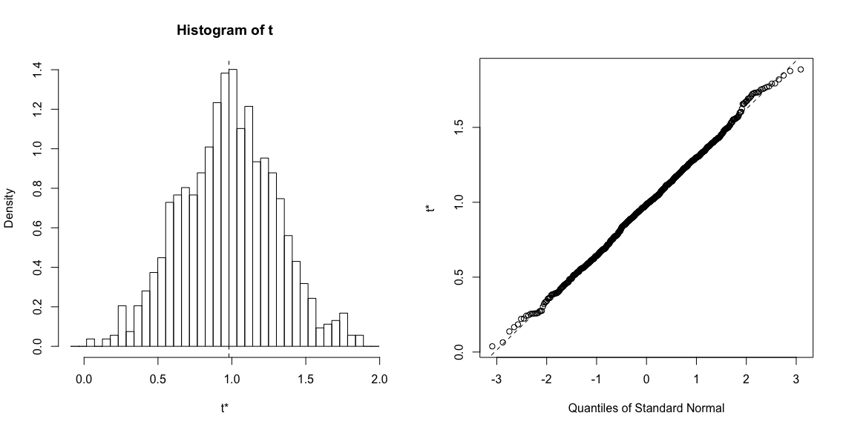

index5

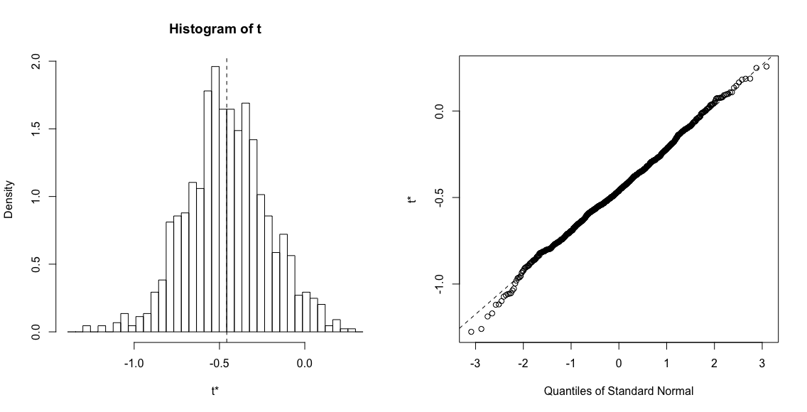

index6

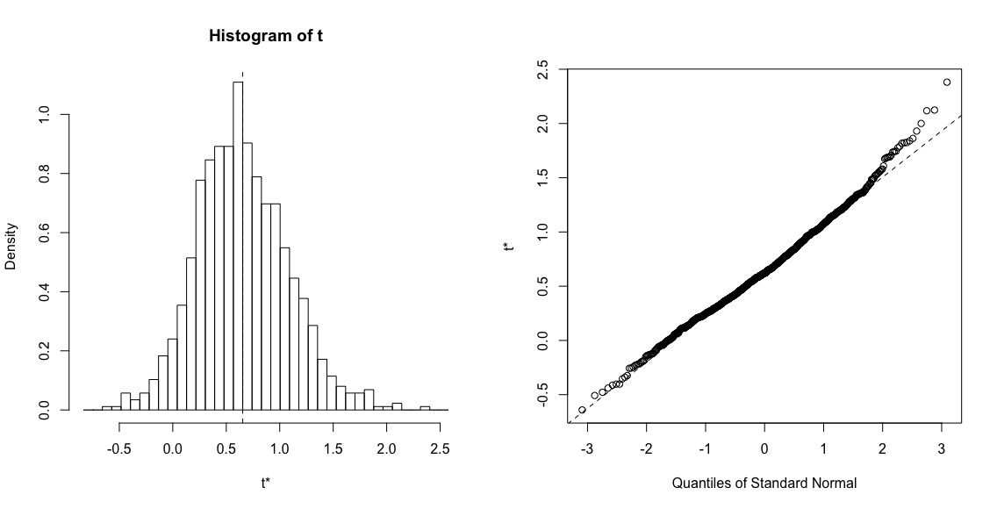

index7

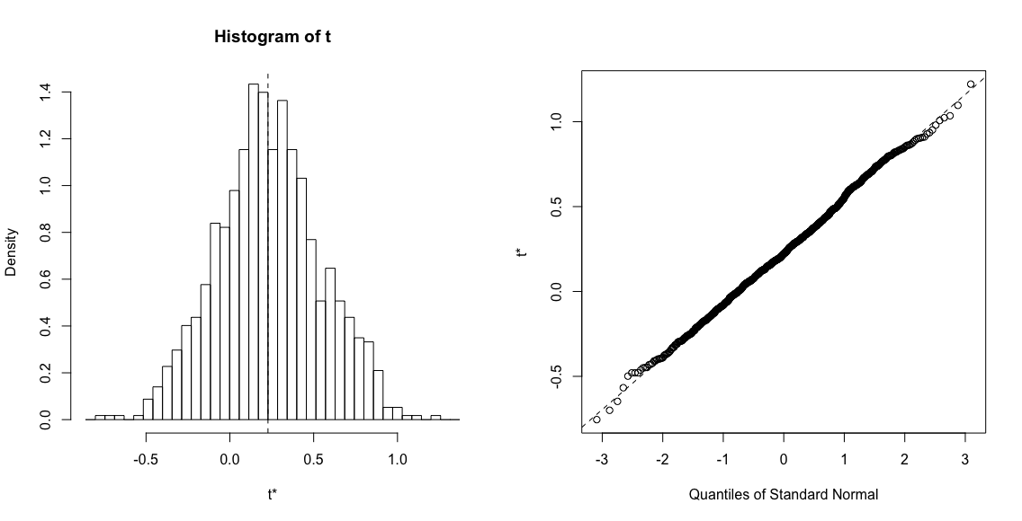

index8

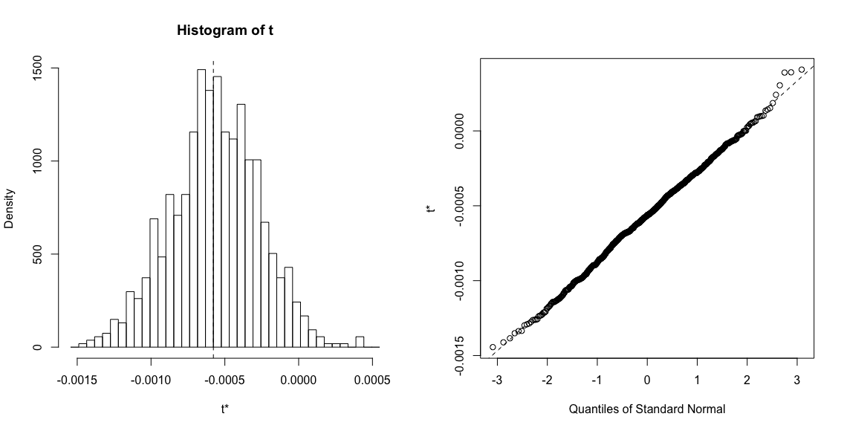

4.. A 95% confidence interval can be obtained via boot.ci()

> boot.ci(results, type = "bca", index = 1)

|  |  |
| --- | --- |
| BOOTSTRAP CONFIDENCE INTERVAL CALCULATIONS | |
| Based on 1000 bootstrap replicates | |
| CALL :  boot.ci(boot.out = results, type = "bca", index = 1) | |
| Intervals : | |
| Level | BCa |
| 95% | (-155.22, -24.59 ) |
| Calculations and Intervals on Original Scale | |

> boot.ci(results, type = "bca", index = 2)

|  |  |
| --- | --- |
| BOOTSTRAP CONFIDENCE INTERVAL CALCULATIONS | |
| Based on 1000 bootstrap replicates | |
| CALL :  boot.ci(boot.out = results, type = "bca", index = 2) | |
| Intervals : | |
| Level | BCa |
| 95% | ( 0.3257, 0.6494 ) |
| Calculations and Intervals on Original Scale | |

> boot.ci(results, type = "bca", index = 3)

|  |  |
| --- | --- |
| BOOTSTRAP CONFIDENCE INTERVAL CALCULATIONS | |
| Based on 1000 bootstrap replicates | |
| CALL :  boot.ci(boot.out = results, type = "bca", index = 3) | |
| Intervals : | |
| Level | BCa |
| 95% | (-1.9745, 1.3721 ) |
| Calculations and Intervals on Original Scale | |

> boot.ci(results, type = "bca", index = 4)

|  |  |
| --- | --- |
| BOOTSTRAP CONFIDENCE INTERVAL CALCULATIONS | |
| Based on 1000 bootstrap replicates | |
| CALL :  boot.ci(boot.out = results, type = "bca", index = 4) | |
| Intervals : | |
| Level | BCa |
| 95% | (0.3429, 1.6544 ) |
| Calculations and Intervals on Original Scale | |

> boot.ci(results, type = "bca", index = 5)

|  |  |
| --- | --- |
| BOOTSTRAP CONFIDENCE INTERVAL CALCULATIONS | |
| Based on 1000 bootstrap replicates | |
| CALL :  boot.ci(boot.out = results, type = "bca", index = 5) | |
| Intervals : | |
| Level | BCa |
| 95% | (-0.9020, 0.0427 ) |
| Calculations and Intervals on Original Scale | |

> boot.ci(results, type = "bca", index = 6)

|  |  |
| --- | --- |
| BOOTSTRAP CONFIDENCE INTERVAL CALCULATIONS | |
| Based on 1000 bootstrap replicates | |
| CALL :  boot.ci(boot.out = results, type = "bca", index = 6) | |
| Intervals : | |
| Level | BCa |
| 95% | (-0.0813, 1.6882 ) |
| Calculations and Intervals on Original Scale | |

> boot.ci(results, type = "bca", index = 7)

|  |  |
| --- | --- |
| BOOTSTRAP CONFIDENCE INTERVAL CALCULATIONS | |
| Based on 1000 bootstrap replicates | |
| CALL :  boot.ci(boot.out = results, type = "bca", index = 7) | |
| Intervals : | |
| Level | BCa |
| 95% | (-0.3655, 0.8482 ) |
| Calculations and Intervals on Original Scale | |

> boot.ci(results, type = "bca", index = 8)

|  |  |
| --- | --- |
| BOOTSTRAP CONFIDENCE INTERVAL CALCULATIONS | |
| Based on 1000 bootstrap replicates | |
| CALL :  boot.ci(boot.out = results, type = "bca", index = 8) | |
| Intervals : | |
| Level | BCa |
| 95% | (-0.0012, 0.0000 ) |
| Calculations and Intervals on Original Scale | |