**INFO8240**

***Task 1: CITL Domain Class Diagram***

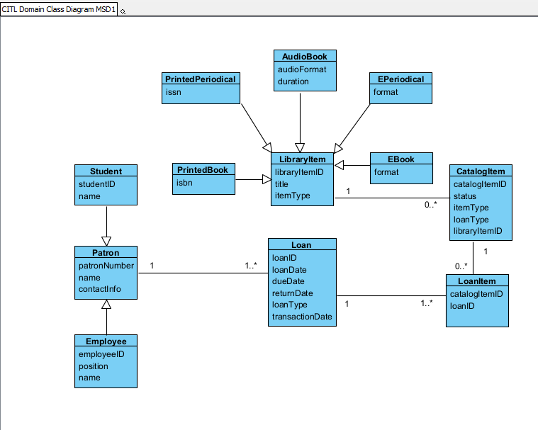

***Task 2: CITL Catalog Item Object Life Cycle***

**Task 2A: CITL Catalog Item State Table**

|  |  |  |
| --- | --- | --- |
| **State ID** | **State Name** | **Transition Causing Exit** |
| **S01** | **On Order** | **Item received.** |
| **S02** | Received | Item is cataloged as a circulating item, Item is held. |
| **S03** | Available | Item is borrowed, Item is reserved, Item is damaged, Item is ruined, Item is held. |
| **S04** | On Loan | Item is returned, Item is reserved, Item is lost, Item is held. |
| **S05** | On Reserve | Item is returned, Item is lost, Item is held. |
| **S06** | On Recall | Item is returned, Item is lost. |
| **S07** | Oh Hold | Item is borrowed, item is reserved, hold is cancelled, hold expires. |
| **S08** | Withdrawn | Item repaired. |
| **S09** | Lost | A new item has been ordered. |
| **S10** | Discarded | - |

**Task 2B: CITL Catalog Item State Machine Diagram (SMD)**

